State Water Resources Control Board  Division of Drinking Water  50 D Street, Suite 200  Santa Rosa, CA 95404-3752  60  (707) 576-2145 Fax: (707) 576-2722 |  | 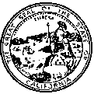

Well Concrete Base or Pad Construction Requirements

Revised January 2008

Water wells constructed for use in supplying water for public water systems must meet the requirements outlined in California Department of Water Resources Bulletins 74-81 and 74-90. A public water system is defined as "a system for the provision of piped water to the public for human consumption that has 15 or more service connections or regularly serves an average of at least 25 individuals daily at least 60 days out of the year".

A public water system well must be provided with a concrete base or pad (also known as a surface seal or pump pedestal) which is poured to surround and be in contact with the well casing and also is in direct contact and bonded to the annular seal material. The purpose is to provide a watertight bond to prevent the movement of surface water into the well. There are products available that, when prepped correctly for and used as instructed, will create a watertight bond between older annular material and fresh concrete. The specificiations as described below should be increased for larger wells or large turbine pumps:

- A concrete base pad must be constructed around the well casing at ground level and must be in contact with the annular seal.

- The concrete base must have a minimum thickness of 4 inches and shall slope away from the well casing or pump pedestal. The surface seal must extend a minimum of 2 feet laterally in all directions from the outside of the well boring.

- Contact between the concrete base, the annular seal, and the well casing must be watertight and must not cause the failure of the annular seal or well casing.

- New well construction: Where cement-based annular sealing material is used, the concrete base pad must be poured before the annular seal has set to provide a watertight bond.

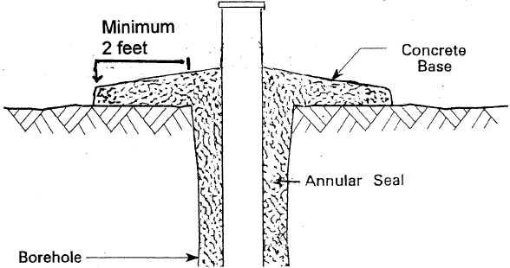
Before a new public water supply well is placed into service, Section 116550 of the California Health & Safety Code requires that the water system apply for and receive a permit from the Department of Public Health. A permit application packet for a new public water system well drilled in Lake, Mendocino, Napa, Marin or Sonoma Counties can be obtained by contacting the State Water Resources Control Board – Division of Drinking Water, at (707) 576-2145.

Staff\0 Common Links\All Tech Handouts ORIGINALS\60 Well Concrete Base\Pad Requirements

