Jar Testing Procedures and Materials (updated last 10/11/22)
Below are the jar testing procedures, methods and analysis that can be applied to most surface water treatment plants.

BY GUY SCHOTT, P.E.

Guy Schott is a civil engineer with the California State Water Resources Control Board, Division of Drinking Water (https://www.waterboards.ca.gov/drinking_water/programs/districts/mendocino_district.html), Santa Rosa, Calif.
guy.schott@waterboards.ca.gov, 707-322-2001, 707-576-2732

Jar Testing Done Right video training https://youtu.be/aGByyxhelkI

Brief Overview of Jar Testing
The purpose of jar testing is to find the optimum pre-oxidant, coagulant(s) and dose that provides the best filterability, dissolved organic carbon reduction (UVA surrogate), and settleability for plants with settling. Jar testing itself takes approximately 5.5 minutes followed by laboratory analysis.

After the coagulants are added to each jar, only 20 to 30 seconds of flash mixing (200 RPM) is needed to disperse the chemicals. Following flash mixing, 5 minutes of slow flocculation (20 to 30 RPM) is needed to create flocs for the filterability and UVA analysis. Note, the duration of flocculation in jar testing only impacts the settleability of the formed flocs. Flocculation duration over 5 minutes does not impact the filterability and the reduction of dissolved organic carbon.

Testing of four jars including analysis takes approximately 35 minutes to complete. To evaluate the floc strength and for good time management, a sample (20 mL) of flocculated water from each jar is collected soon after the flocculation process to conduct filterability and UVA analysis. Settleability analysis are the last step of the jar testing procedures.

PRACTICE
Jar testing should be performed regularly during non-water quality events to develop and maintain the necessary skills and confidence to be able to confront water quality changes. Ideally, performing at least one set of jar testing per week will help keep procedures fresh in memory and to maintain skills and confidence. A database record of pre-oxidants, coagulants, doses, filtrate turbidity, UVA/UVT, and %UVA reduction performances should be maintained for any operator/engineer to review for seasonal water quality. Initial skill and confidence building will require several hours (~100 hours) of jar testing and practice.

LABORATORY EQUIPMENT, SUPPLIES & CONSUMABLES
- Jar tester
- 1-liters beakers used as jars (Pyrex Glass Griffin Beaker)
- Swinnex Filter Holder (25 mm dia.), (Part #: SX0002500, www.sigmaaldrich.com )
- Isopore Membrane Filter, polycarbonate, Hydrophilic, 1.2 µm, 25 mm dia. (Part #: RTTP02500, www.sigmaaldrich.com ), for filterability and UVA/%UVT analysis
- Isopore Membrane Filter, polycarbonate, Hydrophilic, 0.4 µm, 25 mm dia. (Part #: HTTP02500, www.sigmaaldrich.com ), applied for source water filtering to measure %UVT/UVA and to calculate %UVA reduction (source to filtrate)
- Syringe with Luer-Lock Tip, 30 cc, w/rubber plunger (Part #: 2225800, by Hach.com, Part #: 5FVE2, by Grainger.com, Part #: 272SO3303, by techni-tool.com or other companies)
- Benchtop or portable turbidity meter (EPA 180.1 approved or equivalent)
- Sample cell or cuvette assigned to each jar for settleability analysis plus one cuvette assigned for filterability analysis
- Benchtop or portable UVT/UVA analyzer (RealTech P200, 10 mm pathlength or P300, 40 mm pathlength, https://realtechwater.com/products/p-series/ )
- Pipettes (Finnpipette F2 variable volume pipette, capacity 0.5 - 5 mL, Part #: Z678368-1EA & Finnpipette F2 variable volume pipette, capacity 100 - 1000 uL, Part #: Z678341-1EA, www.sigmaaldrich.com )
- Brand pipette tips, volume 0.5 - 5 mL, bulk (Sigma), bag of 200 (Part #: Z740085-200EA, www.sigmaaldrich.com )
- Finnpipette pipette tips, volume range 100 - 1000 uL, bag of 1000 (Part #: P2674-1000EA, www.sigmaaldrich.com )
- Volumetric flasks (100 & 200-mL)
- Scale for weight dry chemicals (i.e., OHAUS scale)
- 50-mL beakers to hold chemicals for pipetting coagulants and pre-oxidants
- Distilled water for stock solution preparation and bottled water for verifying low turbidity cuvette
- Samples of product coagulants
- Towels – for under Jar tester; whipping paddles/rods; drying jars
- Post-it notes or laboratory tape and marker – placed in front of each jar with coagulant product name, dose, and any other chemicals used
- Disposable wipes
- Glassware soap and brush for cleaning jars and beakers

JAR TESING PROCEUDURES
- Fill 1-liter beakers with source or pre-oxidized (ozone, potassium permanganate, chlorine) water and place on base of jar tester.
- Place a label in front of each jar with coagulant name and dose plus any acid and/or oxidant that may be added.
- Place a 30 mL syringe (i.e., Jar 1, Jar 2, etc.) with luer-lock tip next to each jar.
- Place a 1.2 µm Isopore membrane filter (polycarbonate, hydrophilic) onto the support screen of each filter holder and place in front of each jar. Wet filter support screen with distilled or DI water before placement of membrane filter.
- Prepare 100-200 mL of stock solution and pour sample into 50 mL beaker.
- Lower paddles into each jar and tighten.
- Set paddle jar testing speed to 20-30 RPM.
- Verify each jar is centered with no slippage of paddles.
- Using the 50 mL beaker, pipette correct amount of coagulant and add to jar #1. Repeat procedure for remaining jars.
  - Method of delivery - pipette (100-1,000 uL, 0.50-5.0 mL).
  - If a pre-oxidant and/or acid or base chemical(s) are added, inject those chemicals first into each jar before injection of coagulants.
  - If coagulant and/or filter aids are added, inject the primary coagulant first into each jar followed by the coagulant/filter aid.
  - If powder activated carbon (PAC) is added, verify best results with the addition before and after coagulant addition.
  - Note: Use same pipette for adding chemicals to each jar. It is not necessary to add coagulants and pre-oxidants simultaneous to each jar.
- Flash mix - Increase paddle speed to 200 RPM and hold for 20 – 30 seconds.
- Flocculation – Reduce paddle speed to 20-30 RPM and hold for 5 minutes.
- Turn off mixer and lift paddles from jars and secure.
- Jar testing is completed (5.5 minutes).
- If KMnO₄ or NaMnO₄ is added, longer flocculation time is required. If facility has significant contact time before the addition of coagulant, then determine hydraulic residence time (HRT) and flocculate (20 RPM) for that duration only with permanganate. At the end of the HRT for the permanganate, add coagulant and start the normal jar testing procedures as described above (9-13). If KMnO4 or NaMnO₄ is added with the coagulant, then increase flocculation from 5 minutes to at least 15 minutes or more.

SAMPLING – FILTERABILITY/SETTLEABILITY
- For direct filtration and plants with pre-roughing filter.
  - Below surface (1-inch), syringe 20-25 mL from each jar at end of the flocculation period.
- Plants with pre-settling (i.e., conventional treatment or equivalent).
  - Wait 5 minutes at end of flocculation period then syringe 20-25 mL from each jar 1 inch below surface.
  - Note: Syringe suction rate is about 24 mL/12 sec. Regardless of suction rate, be consistent for each jar.
- After 25 minutes of total settling, dip assigned cuvette into each jar below surface (1.5-2-inches). Suggestion: Move jars forward to edge of base to allow easier dipping of cuvette. Only dip cuvette once per jar.
FILTERABILITY & %UVT/UVA ANALYSIS
- The filterability and %UVT/UVA analysis are conducted during the settling period.
  - Good laboratory practice is imperative for obtaining meaningful results.
  - Use one designated clean cuvette for all jars. This is verified by measurement of low turbidity (≤ 0.06 NTU) using bottled or distilled water.
- Start with Jar #1 and complete analysis before going to the next jar.
- Attached filter holder to syringe and filter-to-waste 3-4 mL.
- Syringe remaining coagulated water directly into a clean cuvette to appropriate level.
  - Keep the filtration rate to a slow to fast drip (60 – 90 seconds to dispense 20 mL).
  - Drip rate should decrease with increase head loss due to solids removal. Do not try to maintain initial fast drip rate with increase head loss, else force floc breakthrough may result. Head loss is felt by the increase thumb pressure on the syringe plunger.
- Measure and record filtrate turbidity once reading has stabilized.
  - Wipe dry and clean outer cuvette before measurement.
  - Tilt cuvette up to 90 degrees to remove any formed micro bubbles before measurement.
  - Up to 1-2 minutes may be needed for turbidity reading to stabilize.
- Transfer remaining filtrate water from cuvette to %UVT/UVA cuvette and measure/record.
- Rinse both cuvettes with distilled water and repeat procedures for remaining jars.

SETTLEABILITY (TURBIDITY ANALYSIS)
- At the end of 25 minutes of settling, dip the assigned cuvette for each jar 1-1.5 inches below surface to fill.
  - Only dip cuvette once as floc particles will rise as cuvette is removed from jar.
- Measure turbidity from each cuvette assigned to jar. Take 3 readings and record midpoint value. For plants without settling, settleability analysis isn’t required.
SOURCE WATER ANALYSIS
- Measure and record source water pH and alkalinity when acid adjustment is applied or when pertinent.
- Measure and record source water turbidity and %UVT/UVA (non-filtered).
- Use the filterability procedures and technique and filtered source water using a 0.4 µm Isopore membrane filter (polycarbonate, hydrophilic). Measure and record results:
  - Turbidity
  - %UVT/UVA
- Calculate %UVA Reduction for each jar:
  - %UVA Reduction =
(Filtrate Source UVA – Filtrate Jar UVA)/Filtrate Source UVA * 100%

DATA RECORDING
- Jar number
- Product/coagulant dose (mg/L) and pre-oxidant/acid/base/dose if added
- Filtrate turbidity (1.2 um Isopore membrane filter)
- Filtrate %UVT/UVA (1.2 um Isopore membrane filter)
- Settled water turbidity and settling duration time (usually 25 minutes)
- Flash and floc mix durations and RPM
- Source Water
  - Turbidity
  - pH
  - Alkalinity
  - Filtrate %UVT/UVA (0.4 um Isopore membrane filter)
- Calculated %UVA Reduction for each jar

SETUP
- Place large towel on laboratory counter
- Setup jar testing equipment
- Setup turbidity meter and calibrate if needed
- Designate one clean cuvette for the filterability analysis
- Have a label cuvette prepared for each jar for settleability analysis (i.e., 1, 2, 3, …)
- Setup UVT/UVA instrument and calibrate with organic free or distilled water
- Fill each jar with source water
- Prepare stock solutions
- Place a post-it notes in front of each jar and write down name of coagulant product and dose and any other chemicals used
- Prepare filter holders and place one in front of each jar
- Place a 30 mL Luer-Lock Syringe next to each jar
- Prepare pipette(s)
- Prepare notebook for recording results

JAR TEST PROCEDURES (1-LITER JARS) - OVERVEIW
Chemical Application | Flash Mix  200 RPM  (20-30 sec) | Flocculation  20-30 RPM  (5 min) | Sampling/  Filterability, %UVT/UVA | *Sampling/  Settleability  (25 min)
Set paddle speed to 20-30 RPM and pipette coagulant into each jar one at a time. | Increase paddle speed to 200 RPM and hold for 20 to 30 seconds. | Reduce paddle speed to 20-30 RPM and hold for 5 minutes. End of period, lift paddles out of water and secure. | Using a 30 mL Luer-lock syringe assigned to each jar, sample at end of flocculation period for plants without settling. Wait 5 minutes for plants with settling. | 25 minutes at end of flocculation period, dip assigned cuvette into each jar and measure settled water turbidity.
*Sampling/Analysis are not needed for plants without settling.

STOCK SOLUTION PREPARATION
Most coagulant products are diluted to 0.1 to 1.0% (1-liter jars) or 0.2 to 2.0% (2-liter jars) for jar testing. A volume of 1 mL of water has a mass of 1 gram (1,000 mg). When coagulant products are diluted (<4%), it can be assumed the solution weight has the approximate weight of water. If 1 mL of a 1% stock solution is added to 1-liter of water, the mass dose is 10 mg into 1 liter (10 mg/L). Table 10 provides the dose for percent stock solutions.

TABLE 10. Dose vs. %Stock Solution
1-Liter Jars | 2-Liters Jars
1% Solution by Weight: 1 mL = 10 mg  Injection into 1-liter jar  - mL = 1 mg/L dose  - mL = 10. mg/L dose  0.1% Solution by Weight: 1 mL = 1 mg  Injection into 1-liter jar  - mL = 0.1 mg/L dose  - mL = 1.0 mg/L dose | 2% Solution by Weight: 1 mL = 20 mg  Injection into 2-liter jar  - mL = 1 mg/L dose  - mL = 10. mg/L dose  0.2% Solution by Weight: 1 mL = 2 mg  Injection into 2-liter jar  - mL = 0.1 mg/L dose  1.0 mL = 1.0 mg/L dose

To dilute a coagulant product, calculate the pipette amount (mL) of product that is to be added to a specific amount of water volume for the desired percent stock solution. The following is the general equation:
Stock Solution Equation:

$$\left(\%Product Strength1\right)\left(SG1\right)\left(V1\right)=\left(\%Diluted Product Strength2\right)\left(SG2\right)(V2)$$
  - %Product Strength₁, assume all coagulant products are 100% (exception, Alum/Ferric)
  - SG₁ = Product Specific Gravity
  - V₁ = mL of product to mix with water (mathematically solved)
  - %Diluted Product Strength₂ (% stock solution) = 0.1, 1.0, 0.2, 2.0%, etc.
  - SG₂ = Diluted Product (Stock Solution) Specific Gravity ≈ 1.0
  - V₂ = Stock solution volume, mL (100, 200, 500, etc.)

Except for Alum and Ferric coagulants, use 100% for coagulant product strength when preparing stock solutions. The doses will be based on product and not active ingredient(s).

Example: Coagulant Product, SG = 1.34
- Prepare a 1%, 200 mL Stock Solution
- $\left(\%Product Strength1\right)\left(SG1\right)\left(V1\right)=\left(\%Diluted Product Strength2\right)\left(SG2\right)(V2)$

$$\left(100\%\right)\left(1.34\right)\left(V1\right)=\left(1\%\right)\left(1\right)\left(200 mL\right), Solve for V1$$

$$V1=\frac{\left(1\%\right)\left(1\right)\left(200 mL\right)}{(100\%)(1.34)}=\frac{200}{(100)(1.34)}=1.49 mL$$

Pipette 1.49 mL of coagulant product and mixed with water in a 200 mL Flask w/stopper for a 1% stock solution. Invert flask several times to ensure mixing.
Pictures:

Filterability – 20 to 25 mL sample is syringed.

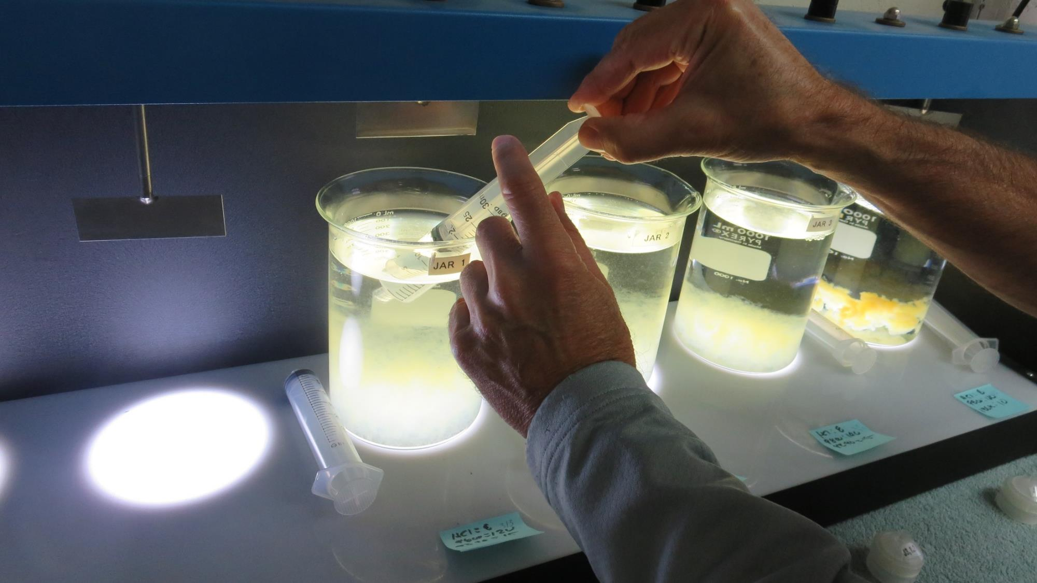

Filtered directly into cuvette and measure

Turbidity and %UVT/UVA.

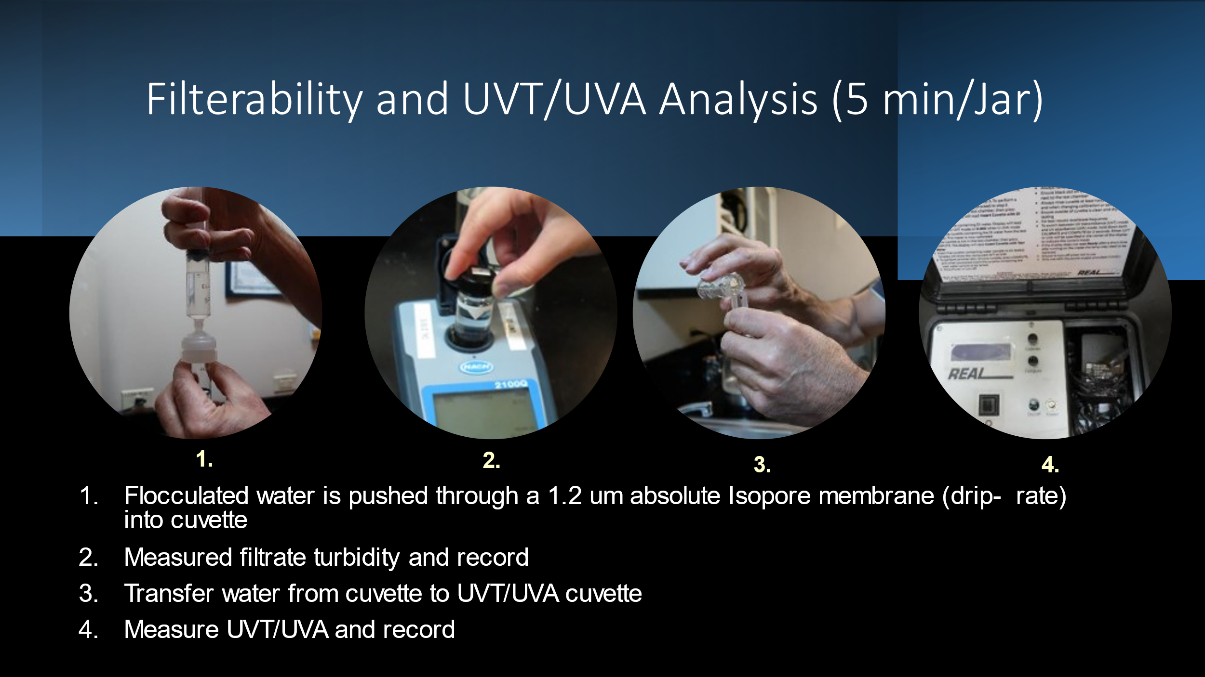

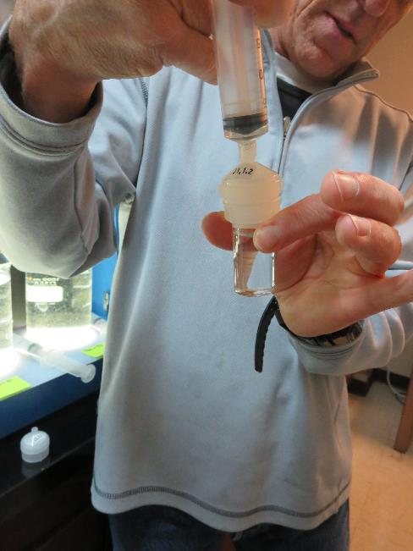

Settleability - Sampling

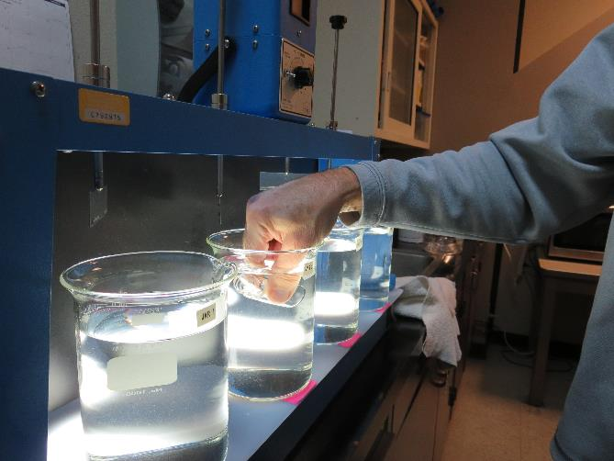

Biography

Guy Schott is a Professional Civil Engineer with the California State Water Resources Control Board, Division of Drinking Water. Mr. Schott has a Bachelor and Master of Science degrees in Civil Engineering from California State University of Fresno and holds T5 and D2 licenses in drinking water. He has been a member of the California Water Treatment Committee since 1996. His expertise is in surface and groundwater treatment applications and technologies, filter surveillance, membranes, jar testing, lead/copper corrosion control treatment, tracer studies, and Excel software application development for the drinking water industry.

