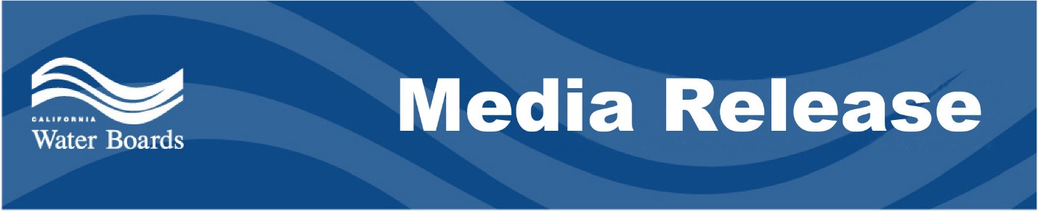

Cleanup and investigation orders issued regarding environmental impacts in Dominguez Channel
Warehouse owner ordered to clean up waste from fire
December 14, 2021 Contact: Ailene Voisin
Ailene.Voisin@waterboards.ca.gov

LOS ANGELES – The Los Angeles Regional Water Quality Control Board has ordered the owners and operators of a warehouse in Gardena to immediately clean up and abate debris from a fire on the property believed to have led to environmental impacts and strong odors around the Dominguez Channel Estuary.
The warehouse, located at 16325 South Avalon Boulevard, improperly stored a million pounds of alcohol-based products, such as hand sanitizer and anti-bacterial wipes, that caught fire on September 30, 2021.
In the days following the blaze, the South Coast Air Quality Management District (SCAQMD) began responding to the first of more than 4,600 odor complaints from residents in several nearby cities, including Carson, Gardena, Long Beach and Redondo Beach. SCAQMD determined hydrogen sulfide (also referred to as “H₂S”) was the cause of the odor and reported that the hydrogen sulfide levels reached 7,000 parts per billion in air, which is 230 times above the state nuisance standard.
High levels of contaminants, including alcohols, were found in an outfall to the Dominguez Channel. In that same area, there were low levels of dissolved oxygen and other conditions that may have contributed to the hydrogen sulfide odors. A subsequent inspection of the burned warehouse revealed huge piles of burnt debris containing alcohol-based products, much of which was exposed during recent rainfall. The storm drains from the vicinity of the warehouse drain to the “hot spot” found in the Dominguez Channel Estuary.
“The cleanup and abatement order will require that all fire-related debris is contained and that all stormwater is captured to protect the community and Dominguez Channel from polluted runoff, especially with rain in the forecast,” said Renee Purdy, the board’s executive officer. “The Los Angeles Water Board continues to take this threat to the channel’s water quality and the impacts to the surrounding community very seriously.”
Over the past six weeks, the Los Angeles Water Board issued several investigative orders requiring sampling and reports from Los Angeles County, the City of Carson and the Los Angeles County Flood Control District to help identify the source of the discharge, as well as additional information from Equilon Enterprises, LLC (dba Shell Oil Products US) to investigate any connection between the Shell Carson Terminal and the hydrogen sulfide odor in the Dominguez Channel.
On December 9, the board issued an investigative order to warehouse owner Liberty Property Limited Partnership and operator Day to Day Imports Inc. to fully understand the extent and impact of discharges of pollutants from the warehouse fire. The cleanup and abatement order issued December 9 requires the cleanup and abatement of all waste on-site and extending off-site no later than December 31, 2021.
With over 10 million residents, the Los Angeles Water Board regulates the most densely populated region in the state, including the coastal watersheds of Los Angeles and Ventura Counties and small portions of Kern and Santa Barbara Counties.

