TOTAL MAXIMUM DAILY LOAD AND IMPLEMENTATION PLAN
FOR BACTERIAL INDICATORS
COACHELLA VALLEY STORMWATER CHANNEL

Riverside County, California

DRAFT

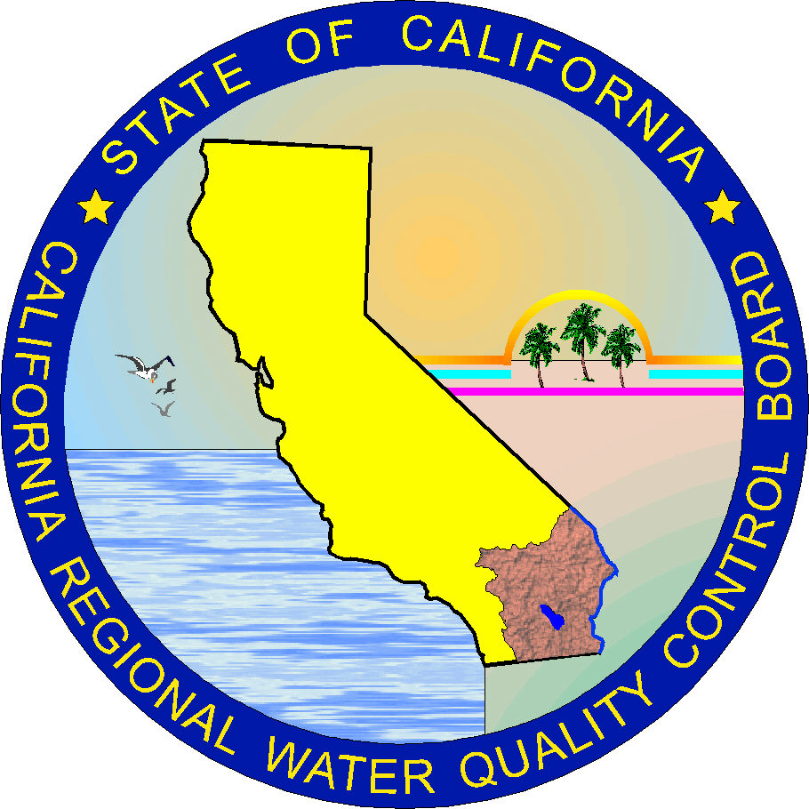

California Regional Water Quality Control Board
Colorado River Basin Region
Palm Desert, California

March 2007
THIS PAGE LEFT BLANK INTENTIONALLY

Table of Contents

LIST OF ABBREVIATIONS 2
EXECUTIVE SUMMARY 3
1. Project Definition 7
2. Watershed Description 11
3. Data Analysis 13
4. Source Analysis 23
5. Critical Conditions and Seasonal Variation 33
6. Numeric Targets 34
7. Linkage Analysis 35
8. TMDL Calculations and Allocations 36
9. Implementation Plan 39
10. Monitoring Plan 46
11. Economic Assessment 47
References 48
Appendix A: Mean Monthly Streamflows, USGS Gage 10259540 50
Appendix B: Relationship Between Bacteria Indicators and Flows 52
Appendix C: Coachella Coliform DNA Analysis Source Report 54

LIST OF Abbreviations

Basin Plan | Water Quality Control Plan
CFR | Code of Federal Regulations
CSDWTP | Coachella Sanitary District Wastewater Treatment Plant
CVSC | Coachella Valley Stormwater Channel
CVWD | Coachella Valley Water District
CWA | Federal Clean Water Act
CWC | California Water Code
DHS | California Department of Health Services
FRSH | Freshwater Replenishment
KSC | Kent SeaTech Corporation
KSCFF | Kent SeaTech Corporation Fish Farm
LAs | Load Allocations for both Nonpoint Sources and Natural Background Levels
MGD | Million Gallons per Day
ml | Milliliter
MOS | Margin of Safety
MP | Management Practice
MPN | Most Probable Number
MVWRP | Mid-Valley Water Reclamation Plant
NPDES | National Pollutant Discharge Elimination System
NPS | Non point source pollution
OAL | Office of Administrative Law
POR | Period of Record
QAPP | Quality Assurance Project Plan
RARE | Preservation of Rare, Threatened, or Endangered Species
RCFCWCD | Riverside County Flood Control and Water Conservation District
REC I | Water Contact Recreation
REC II | Water Non-Contact Recreation
Regional Board | Colorado River Basin Regional Water Quality Control Board
RWQCB | Regional Water Quality Control Board
SMR | Self Monitoring Report
State Board | State Water Resources Control Board
SWRCB | State Water Resources Control Board
TMDL | Total Maximum Daily Load
USDA | United States Department of Agriculture
USEPA | United States Environmental Protection Agency
USGS | United States Geological Survey
VSD | Valley Sanitary District Wastewater Treatment Plant
WARM | Warm Freshwater Habitat
WILD | Wildlife Habitat
WLAs | Individual Wasteload Allocations for Point Sources
WQOs | Water Quality Objectives
WQSs | Water Quality Standards
WWTF | Wastewater Treatment Facility

EXECUTIVE SUMMARY

Introduction

Coachella Valley Stormwater Channel (CVSC) is listed by the California State Water Resources Control Board (State Board), pursuant to Section 303(d) of the federal Clean Water Act (CWA) Section (42 U.S.C. section 1313(d)) for impairment by pathogens of unknown sources. The listing of the CVSC was required because the CVSC violates water quality standards (WQSs) established by the Colorado River Basin Regional Water Quality Control Board (Regional Board) to protect the water contact recreation (REC I) and water non-contact recreation (REC II) beneficial uses (BUs). The following BUs are designated by the Regional Board for CVSC: Freshwater Replenishment (FRSH), REC I, REC II, Warm Freshwater Habitat (WARM), Wildlife Habitat (WILD), and Preservation of Rare, Threatened, or Endangered Species (RARE) (Water Quality Control Plan (Basin Plan), Colorado River Basin Region, as amended to date). To address the impairment of the CVSC caused by pathogens, a Total Maximum Daily Load (TMDL) is proposed. This TMDL has been developed in accordance with State of California’s TMDL Guidance issued in June 2005 and the United States Environmental Protection Agency (USEPA) TMDL guidance published in April 2001.

CVSC is located in Coachella Valley in Riverside County, California. The Coachella Valley is bounded to the north by the San Bernardino and Little San Bernardino Mountains, and to the south by the San Jacinto and Santa Rosa Mountains, and the Salton Sea. The Coachella Valley has been heavily agricultural since the early 1900’s. Agricultural lands are irrigated by groundwater and water from the Colorado River delivered to the Valley through the Coachella Canal via the All-American Canal.

CVSC is an unlined, engineered extension of the Whitewater River, and serves as a conveyance channel for agricultural irrigation return water; treated wastewater from three permitted municipal wastewater treatment plants; wastewater discharge from one permitted fish farm; and urban and stormwater runoff. The channel extends approximately 17 miles from the City of Indio to the Salton Sea. Average annual flows in CVSC are decreasing due to changes in agricultural practices and suburban development. The CVSC and its tributary drains provide habitat for many types of wildlife including migratory songbirds, waterfowl, coyotes, raccoons, and rodents. Although recreation in the stormwater channel is unauthorized by Coachella Valley Water District (CVWD), people frequently recreate in and around the stormwater channel.

Pursuant to the federal CWA, 42 U.S.C. Section 1251 et seq., and implementing regulations set forth in Title 40 of the Code of Federal Regulations (CFR), WQSs consist of designated beneficial uses, specified numeric or narrative water quality objectives (WQOs) that protect these BUs, and antidegradation requirements to ensure that existing uses and the level of water quality necessary to protect the existing uses are maintained and protected (CWA Section 303; 40 CFR Parts 130, 131). The following Table summarizes bacteria indicator WQOs for all surface waters in the Colorado River Basin Region, excepting the Colorado River:

Bacteria Indicator Water Quality Objectives
Indicator Parameter | 30-Day Geometric Meanª | Maximum Instantaneous
E. coli | 126 MPN/100 Milliliter (ml) | 400 MPN/100 ml
Or
Enterococci | 33 MPN/100 ml | 100 MPN/100 ml
- Based on a minimum of no less than 5 samples equally spaced over a 30-day period.

The WQOs for bacteria indicators listed above were developed by the USEPA as federal Clean Water Act (CWA) water quality criteria for bathing in fresh water, and are based on a risk of eight gastrointestinal illnesses per 1,000 swimmers in fresh water. Section 13001 of the California Water Code identifies the State Water Resources Control Board (SWRCB) and all Regional Water Quality Control Boards (RWQCBs) as the principal state agencies responsible for the coordination and control of water quality.

Section 303(d)(1)(A) of the CWA requires all states to identify surface waters impaired by pollution (i.e., that do not meet WQSs), and to establish TMDLs for the pollutants causing these impairments to ensure that impaired waters attain WQSs. A TMDL quantifies the amount of a pollutant that a water body can receive and still meet WQSs, and allocates pollutant loadings of that water body to point and nonpoint sources (CWA Section 303(d)(4)(A), (B)). Accordingly, the TMDL is the sum of the individual wasteload allocations (WLAs) for point sources, load allocations (LAs) for nonpoint sources and natural background sources. The TMDL also incorporates seasonal variations and a margin of safety (MOS), which take into account any lack of knowledge concerning the relationship between effluent limitations and water quality (CWA Section 303(d)(1)(C); 40 CFR Sections 130.2(i), 130.7(c)(1)).

TMDLs can be expressed in terms of mass per time, toxicity, or other appropriate measures that relate to a state’s WQSs (40 CFR Section 130.7(c)(1)(i)). The USEPA urges all TMDLs and allocations be expressed, at least in part, in daily terms. However, it may be permissible in some situations to set TMDLs and allocations in non-daily terms. In the case of this bacteria TMDL, the most appropriate measures currently available are density-based (concentrations). Organism density (i.e., number of organisms in a given volume of water) is a more significant measure than organism mass (i.e., pounds per day) with respect to the protection of public health and beneficial uses.

A RWQCB-adopted TMDL must be approved by the SWRCB, Office of Administrative Law (OAL), and the USEPA prior to becoming legally effective (CWC Section 13245; CWA Section 303(d)(2); 40 CFR Section 131.5). Because the USEPA has oversight of the CWA Section 303(d) program, it must approve or disapprove a state’s 303(d) list and each specific TMDL. If a state fails to develop a TMDL in a timely manner, or if USEPA rejects the state’s TMDL, USEPA must develop one.

Proposed TMDL

During the development of this TMDL, water quality samples were collected monthly at eight locations in the CVSC, from February to September 2003, to evaluate bacteria loading. Eleven of the 59 samples collected exceeded the single-sample maximum Most Probable Number (MPN) of 400/100 Milliliter (ml) E. coli WQO in the Colorado River Basin Water Quality Control Plan (Basin Plan), and the proposed numeric target for this TMDL. Based on the 2004 State of California’s 303(d) Listing Policy, this exceedance rate would be sufficient to confirm the impairment identified in the 303(d) List.

To identify possible sources of these bacteria, a DNA monitoring and analysis study was conducted from October 2003 to March 2004. The study involved isolating E. coli strains in water samples from three sampling sites, followed by ribotype fingerprinting, to determine the distribution of fecal sources in the CVSC. Ribotypes were compared to the Institute of Environmental Health source library in Seattle, Washington. The following bacterial sources were identified in CVSC from the two hundred samples collected during the study: avian (40%), human (25%), rodents plus other wild mammals (25%), and livestock (<3%). This distribution gives us an idea of the possible sources of fecal bacteria in CVSC.

Regional Board staff also reviewed bacteria data provided by the three NPDES wastewater treatment facilities (WWTFs) and from the Municipal Separate Storm Sewer System (MS4) permittees discharging wastewater into CVSC. Data reviewed indicate that all three WWTFs met their applicable bacteria WQOs. Data also indicate that urban and storm water discharges contribute significant fecal coliform contamination to CVSC in violation of its applicable WQOs. These water quality violations range up to 900,000 MPN/100 ml at Avenue 52 Storm Drain in Coachella, September 1999, and 70,000 MPN/100 ml at Monroe Street Storm Drain in Indio, April 1999.

The proposed numeric targets for this TMDL are contained in the Basin Plan. The targets have been established for E. coli indicator bacteria as a log mean (Geomean) of 126 MPN/100 ml (based on a minimum of not less than five samples during a 30-day period), or maximum of 400 MPN/100 ml for a single sample. TMDL targets are applicable throughout the year for the entire stretch of CVSC.

Implementation Plan

There are limited data available to calculate and/or estimate the actual pathogenic contributions from nonpoint sources of pollution into CVSC or to establish appropriate controls. Preliminary data show contributions from urban runoff are significant. Other potential sources include bacteria re-growth, agricultural return flows, and septic system discharges. However, their contributions to CVSC are not known. For this reason, a phased approach for TMDL implementation is warranted, as recommended by USEPA Guidance (USEPA 1991).

This TMDL proposes a two-phase implementation plan that begins 90 days following USEPA approval of the TMDL. Phase I (2008 – 2010) focuses on monitoring and addressing pathogens from wastewater treatment plants, and from urban, agricultural and stormwater runoff. If WQOs are not achieved by the end of Phase I, additional actions will be implemented in Phase II (2010 – 2014) to achieve WQSs. This phased approach provides immediate assessment of known pathogenic sources while allowing time for additional monitoring to assess other potential sources of pollution, the effectiveness of Phase I implementation, and the need for TMDL revision.

Specific Phase I implementation actions require all dischargers of wastewater into CVSC, except Valley Sanitary District Wastewater Treatment Plant (VSDWTP) in Indio, Coachella Sanitary District Wastewater Treatment Plant (CSDWTP) in Coachella, Mid-Valley Water Reclamation Plant (MVWRP) in Thermal, to develop and implement monitoring programs to characterize their E. Coli bacteria contributions. Current monitoring and reporting programs for VSDWTP, CSDWTP, and MVWRP in their existing permits are considered adequate for the purpose of implementing Phase I of the TMDL. Phase I actions request that the USEPA coordinate the preparation of a report describing measures to be taken to ensure waste discharges from tribal property do not violate or contribute to a violation of this TMDL. Phase I actions also require municipal stormwater permits to be updated with any approved TMDL requirements, and issue similar stormwater permits to other entities/municipalities (if any) discharging to the impaired portion of the CVSC to ensure that these sources do not violate or contribute to a violation of this TMDL. Regional Board staff will develop a plan to monitor, track, and evaluate TMDL actions.

Proposed Basin Plan Amendment

Regional Board staff recommends that the Regional Board amend the Basin Plan to include this TMDL and implementation plan to achieve compliance with WQSs. This TMDL report:
- Identifies bacterial loading prompting TMDL development;
- Specifies in-stream numeric targets for bacterial indicators for CVSC to ensure attainment of WQSs;
- Identifies and quantifies sources of bacteria to CVSC;
- Allocates allowable loads in terms of bacteria density for pollutant sources to attain numeric targets and WQSs; and
- Provides an implementation plan to achieve TMDL compliance.

1. Project Definition

Coachella Valley Stormwater Channel (CVSC) is an unlined, engineered extension of the Whitewater River that serves as a conveyance channel for agricultural irrigation return water, treated wastewater, and urban and stormwater runoff (Montgomery 1989). The CVSC provides Coachella Valley residents with a means of flood protection, and provides habitat for wildlife including migratory songbirds, waterfowl, coyotes, raccoons, and rodents. Although recreation in the stormwater channel is unauthorized by CVWD, people frequently recreate in and around the stormwater channel. The stormwater channel is located in the Coachella Valley in Riverside County, California, and extends approximately 17 miles from the City of Indio to the Salton Sea. Coachella Valley is bounded to the north by the San Bernardino and Little San Bernardino Mountains, and to the south by the San Jacinto Mountains, Santa Rosa Mountains, and the Salton Sea. The Valley has been heavily agricultural since the early 1900s.

Bacteria, such as total coliform, fecal coliform, E. coli, and enterococci are used as indicators of the presence of fecal pollution in water bodies. High concentrations of these bacteria indicate the high likelihood of human infectious diseases. The United States Environmental Protection Agency (USEPA) recommends using E. coli or enterococci water quality objectives (WQOs) to protect bathers from gastrointestinal illness in fresh recreational waters such as CVSC, and using enterococci WQOs for marine recreational waters (USEPA 2002). Indicator bacteria are not a direct cause of illness, but high concentrations of enterococci and/or E. coli in fresh water that exceed WQOs indicate the high likelihood of infectious diseases.

CVSC is on California’s 303(d) List for impairment by pathogens of unknown sources. Eleven of the 59 water samples collected from CVSC in 2003 violated the E. coli WQO in the Basin Plan (Table 3.2). A DNA monitoring and analysis study was conducted from October 2003 to March 2004 to determine possible sources of E. coli indicator bacteria. The study involved isolating E. coli strains in water samples from three sampling sites, followed by ribotype fingerprinting, to determine the distribution of fecal sources in the CVSC. Ribotypes were compared to the Institute of Environmental Health source library in Seattle, Washington. Pathogenic sources identified from two hundred samples collected at three sampling locations include: avian (40%), human (25%), rodents plus other wild mammals (25%), and livestock (<3%) (Please see Appendix C). This distribution gives us an idea of the possible sources of fecal bacteria in CVSC.

Table 1.1 summarizes bacteria indicator WQOs for all surface waters in the Colorado River Basin Region, excepting the Colorado River. Table 1.2 summarizes CVSC BUs. WQOs for bacteria indicators listed in Table 1.1 were developed by the USEPA as federal Clean Water Act (CWA) water quality criteria for bathing in fresh water, and are based on a risk of eight gastrointestinal illnesses per 1,000 swimmers in fresh water (USEPA January 1986).

Table 1.1: Bacteria Indicator Water Quality Objectives
Indicator Parameter | 30-Day Geometric Meanª | Maximum Instantaneous
E. coli | 126 MPN/100 Milliliter (ml) | 400 MPN/100 ml
Or
Enterococci | 33 MPN/100 ml | 100 MPN/100 ml
a- Based on a minimum of no less than 5 samples equally spaced over a 30-day period.

Table 1.2: Coachella Valley Stormwater Channel Beneficial Uses
Designated Beneficial Uses of Water | Description
Freshwater Replenishment (FRSH) | Uses of water for natural or artificial maintenance of surface water quantity or quality.
Water Contact Recreation (REC I) | Uses of water for recreational activities involving body contact with water, where ingestion of water is reasonably possible. These uses include, but are not limited to, swimming, wading, water skiing, skin and scuba diving, surfing, whitewater activities, fishing, and use of natural hot springs.
Water Non-Contact Recreation (REC II) | Uses of water for recreational activities involving proximity to water, but not normally involving contact with water where ingestion of water is reasonably possible. These uses include, but are not limited to, picnicking, sunbathing, hiking, beachcombing, camping, boating, tide pool and marine life study, hunting, sightseeing, or aesthetic enjoyment in conjunction with the above activities.
Warm Freshwater Habitat (WARM) | Uses of water that support warm water ecosystems including, but not limited to, preservation or enhancement of aquatic habitats, vegetation, fish, or wildlife, including invertebrates.
Wildlife Habitat (WILD) | Uses of water that support terrestrial ecosystems including, but not limited to, the preservation and enhancement of terrestrial habitats, vegetation, wildlife (e.g., mammals, birds, reptiles, amphibians, invertebrates), or wildlife water and food sources.
Preservation of Rare, Threatened, or Endangered Species (RARE) | Uses of water that support habitats necessary, at least in part, for the survival and successful maintenance of plant or animal species established under state or federal law as rare, threatened or endangered.
Source: Water Quality Control Plan for the Colorado River Basin Region

Clean Water Act Section 303(d) List and the TMDL Process

Water Quality Standards (WQSs) as defined by the CWA, consist of designated beneficial uses, numeric or narrative WQOs that protect beneficial uses, and antidegradation requirements to ensure that existing uses and the level of water quality necessary to protect existing uses are maintained and protected. CWA Section 303(d)(A)(1) requires all states to identify surface waters impaired by pollution (i.e., that do not meet WQSs) and to establish total maximum daily loads (TMDLs) for pollutants causing the impairments. Section 13001 of the California Water Code (CWC) identifies the State Water Resources Control Board (SWRCB) and all nine Regional Water Quality Control Boards (RWQCBs) as the principal state agencies responsible for the coordination and control of water quality.

A TMDL quantifies the amount of a pollutant that a water body can receive and still meet WQSs, and allocates pollutant loadings of that water body to point and nonpoint sources. Accordingly, the TMDL is the sum of the individual wasteload allocations (WLAs) for point sources, load allocations (LAs) for nonpoint sources and natural background sources. The TMDL also incorporates seasonal variations and a margin of safety (MOS), which takes into account any lack of knowledge concerning the relationship between effluent limitations and water quality. TMDLs can be expressed in terms of mass per time, toxicity, concentration, or other appropriate measures that relate to a state’s WQSs. In the case of this TMDL, the most appropriate measure currently available is density-based (concentration), as indicated by E. coli results.

A RWQCB-adopted TMDL must be approved by the SWRCB, Office of Administrative Law (OAL), and the USEPA prior to becoming legally effective (CWC Section 13245; CWA Section 303(d)(2); 40 Code of Federal Regulations (CFR) Section 131.5). Because the USEPA has oversight of the CWA Section 303(d) program, it must approve or disapprove a state’s 303(d) list and each specific TMDL. If a state fails to develop a TMDL in a timely manner, or if USEPA rejects the state’s TMDL, USEPA must develop one.

Accordingly, the Regional Board is required to:

- Identify the Region’s water bodies that do not comply with WQSs;
- Rank the impaired water bodies, taking into account the severity of pollution and the uses made of such waters; and
- Establish TMDLs for those pollutants causing the impairments to ensure that impaired waters attain their beneficial uses.

California’s 303(d) List identifies CVSC as impaired, in part, because concentrations of pathogen-indicator bacteria violate WQSs established by the Regional Board to protect CVSC beneficial uses. Accordingly, Regional Board staff developed this bacterial indicators TMDL to address the impairment. CWA Section 303(d) and 40 CFR Part 130 specify the components and requirements of a TMDL, which is essentially a numeric target developed to achieve WQSs. The TMDL must:

Demonstrate how WQSs of concern in the specific water body will be attained;
Identify and explain the basis for the total allowable pollutant load(s) into the water body such that the water body loading capacity is not exceeded;
Identify and explain the basis for individual waste load allocations for point sources and load allocations for nonpoint sources of pollution;
Explain how an adequate MOS was determined to account for uncertainty in the analysis; and
Account for seasonal variations and critical conditions concerning the flow, loading, and other water quality parameters.

Management and Implementation Issues

Limited data are available to calculate or estimate the actual pathogenic contributions from nonpoint sources of pollution into CVSC and to establish appropriate controls. As a result, a two-phase implementation plan to achieve the TMDL is proposed. Phase I focuses on monitoring and addressing pathogens from wastewater treatment plants, and from urban, agricultural and stormwater runoff. If WQOs are not achieved by the end of Phase I, additional actions will be implemented in Phase II to control pollutant sources, and to achieve WQSs. This phased approach provides immediate assessment of known pathogenic sources while allowing time for additional monitoring to assess TMDL implementation, effectiveness, and the need for revision.

2. Watershed Description

Agricultural lands in Coachella Valley are irrigated by groundwater and water from the Colorado River that is delivered to the Coachella Valley through the Coachella Canal via the All-American Canal. Agricultural return flows dominate CVSC flows to the Salton Sea, although four permitted facilities also discharge to the channel—three municipal wastewater treatment plants and one aquaculture facility (Figure 2.1). Average annual precipitation in Coachella Valley (elevations less than 2,000 feet) is about three inches (Resources Conservation District (RCD) – Watershed Information Sharing Project 2006). Average annual evapotranspiration approximates 50 inches (United States Department of Agriculture (USDA) 1980). Soils are excessively drained to somewhat poorly drained, and consist of nearly level to moderately steep, alluvial fans, valley fill, and lacustrine deposits (Table 2.1).

Table 2.1: Soil Associations in Coachella Valley
1 | Niland-Imperial-Carsitas | Nearly level to moderately sloping | Moderately well drained to excessively drained | Sands, gravelly sands, cobbly sands, fine sands, and silty clays in lacustrine basins
2 | Carsitas-Myoma-Carrizo | Nearly level to moderately steep | Somewhat excessively drained or excessively drained | Sands, fine sands, gravelly sands, cobbly sands, stony sands on alluvial fans and valley fill
3 | Myoma-Indio-Gilman | Nearly level to rolling | Somewhat excessively drained to moderately well drained | Fine sands, very fine sandy loams, fine sandy loams, silty loams on alluvial fans
4 | Gilman-Coachella-Indio | Nearly level to rolling | Somewhat excessively drained to moderately well drained | Fine sands, fine sandy loams, silt loams, loamy fine sands, and very fine sandy loams on alluvial fans
5 | Salton-Indio-Gilman | Nearly level | Somewhat poorly drained to well drained | Silty clay loams, very fine sandy loams, fine sandy loams, and silt loams in lacustrine basins
Source: USDA Soil Conservation Service, 1980, Soil Survey of Riverside County, California, Coachella Valley Area
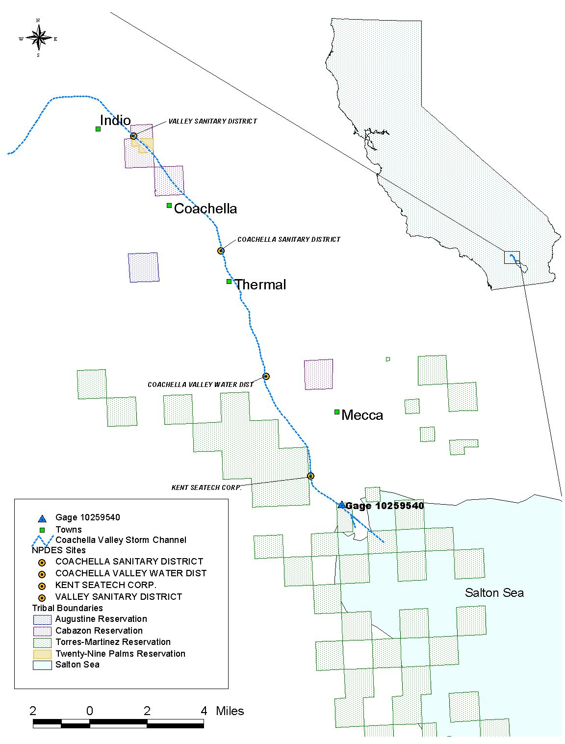
Figure 2.1: Location of CVSC Channel, Permitted Dischargers,
and USGS Flow Gage

The CVSC is maintained by the Coachella Valley Water District (CVWD) for flood protection in the Valley and serves as a master drain for the area from the City of Indio to the Salton Sea. Average annual flows in the channel are decreasing due to changes in agriculture practices and suburban development.

3. Data Analysis

A wide variety of information was analyzed to develop the CVSC pathogen TMDL including data related to water quality; point sources; land use, cover, and characteristics; meteorology; wildlife populations; septic system use statistics; and channel flow. Major sources of information include the Regional Board, Salton Sea National Wildlife Refuge, Salton Sea Authority, Department of Health Services (DHS), USGS, stormwater permittees, USEPA BASINS system, CVWD, and three wastewater treatment plants: Valley Sanitary District Wastewater Treatment Plant (VSDWTP), Indio, owned/operated by Valley Sanitary District (VSD); Coachella Sanitary District Wastewater Treatment Plant (CSDWTP), Coachella, owned/operated by the City of Coachella and the Coachella Sanitary District (CSD); and Mid-Valley Water Reclamation Plant (MVWRP), Thermal, owned/operated by CVWD. Local information was used whenever possible. CVSC flow and water quality is described below.

3.1. Flow Data

Flow information was obtained from USGS and CVWD. USGS flow gage 10259540, shown in Figure 2.1, is located near the Lincoln Street drain just north of the Salton Sea. Daily flow measurements for this gage from 10/01/1960 to 9/30/2002 are summarized in Appendix A as monthly mean values. Provisional flow values were also obtained from 10/01/2002 to 3/15/2004 for comparison to water quality observations collected by Regional Board staff during 2003. Figure 3.1 compares monthly mean flow values for the entire POR with those of the last seven years. Average flows have decreased over the period of record (POR) due to changes in agricultural, and land use practices.

Figure 3.1: Comparison of Mean Monthly Flow Values for the entire POR
and from 1996 to 2002

Water enters CVSC through several mechanisms: permitted point source discharges, irrigation return flows, and urban and stormwater runoff. Most water in CVSC is from agricultural discharges that enter the channel through groundwater flow, buried tile drains, or from four open drains located in the southern half of the drainage area.

The following statements are based on personal communication with CVWD staff (Coachella Valley Water District 2004). In 1994, CVWD estimated that groundwater comprised 30 percent of the total flow in the CVSC at USGS gage 10259540). CVWD believes less groundwater is discharged today because of changes in land uses and irrigation patterns, but the difference in discharge is unknown. Flows from tile drains occur intermittently as adjacent fields are irrigated. Tile drain flows are not monitored, so flow values are not known. Open drains also receive continuous irrigation return flows although flow measurements have not been collected. The magnitude of flows from all drains is determined by nearby irrigation activities.

Figure 3.2 shows the approximate location of the permitted point sources and the drains. Open drains are depicted by thick legend symbols, and tile drains are depicted by thin, lighter colored symbols. The Johnson Street drain is the only open drain that flows directly into the Salton Sea.

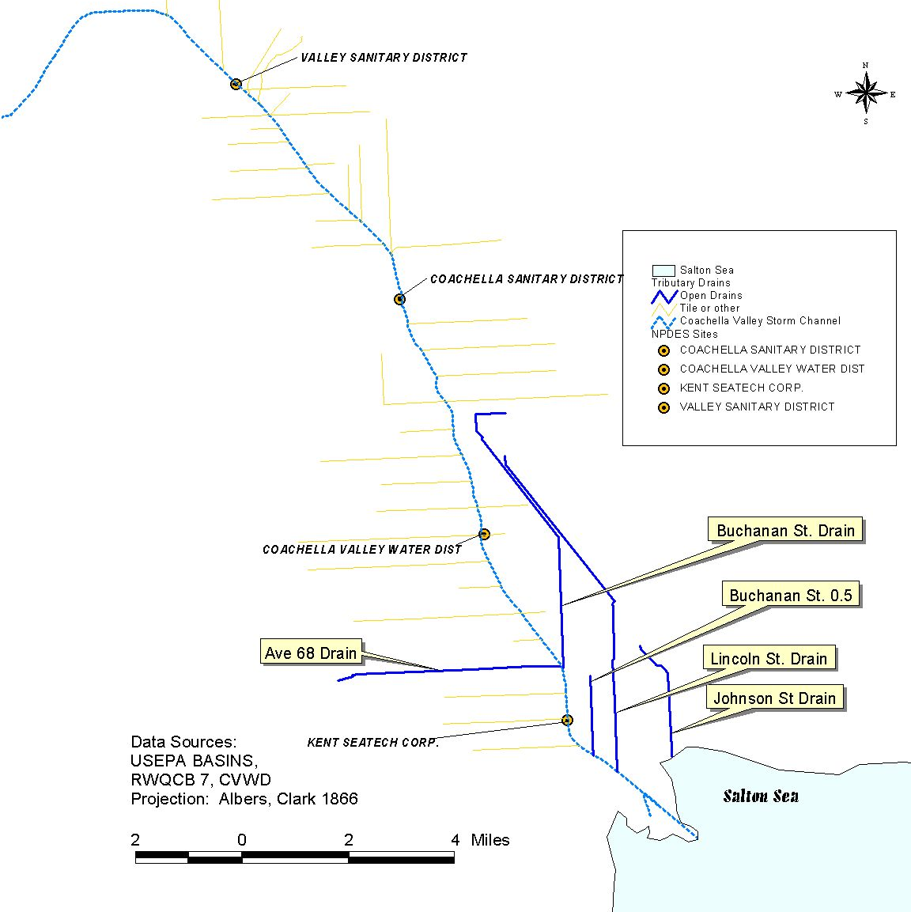
Figure 3.2: Sources of Flow to the CVSC (drain lengths are approximate)

  - Water Quality Data

To better understand bacteria loading to CVSC, Regional Board staff collected and analyzed water quality samples at eight locations from February to September 2003.

3.2.1. Regional Board Monitoring

Drains tributary to CVSC and Regional Board sampling locations are shown in Figure 3.3 and Table 3.1.

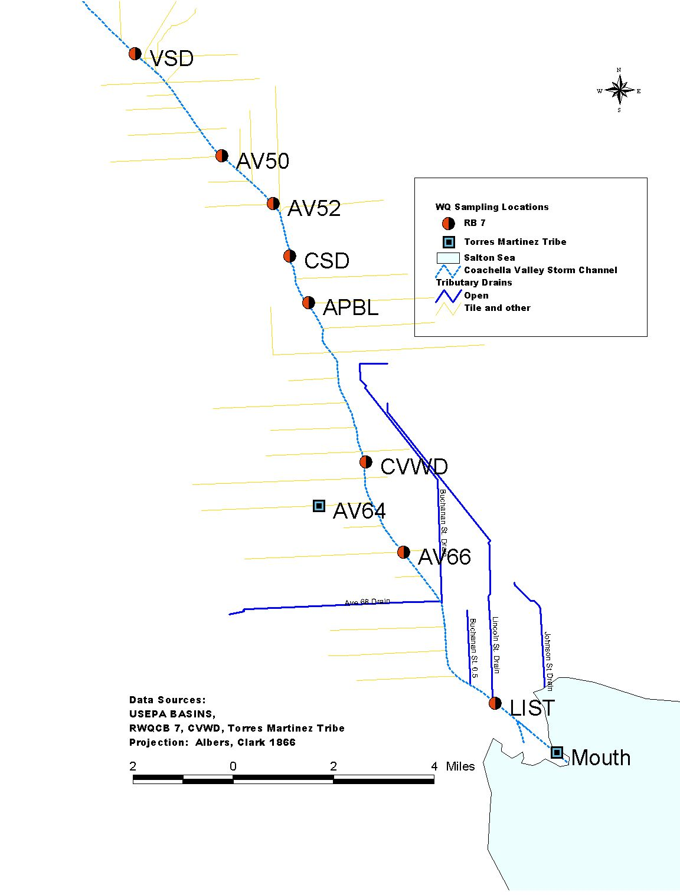
Figure 3.3: Sampling Locations

Table 3.1: CSWC Sampling Stations
Sampling Location | Description
LIST | Lincoln Street
AV66 | Avenue 66
CVWD | Upstream of CVWD’s MVWRP , near Ave. 62
APBL | Airport Boulevard, where Avenue 56 crosses storm channel
CSD | Upstream of CSD’s CSDWTP at Avenue 54
AV52 | Avenue 52
AV50 | Avenue 50
VSD | Upstream of VSD’s VSDWTP, at first water

Drains designated “open” in Figure 3.3 are considered perennially wet, having flow that is generally constant. Groundwater monitoring data are unavailable for this area.

Table 3.2 provides bacteria results for the eight sampling locations. Figure 3.4 shows monthly concentrations of E. coli bacteria for the sampling locations plotted against a log axes. Sampling locations are graphed from upstream to downstream. Comparing these observations with numeric WQOs (Table 1.2) suggests that CVSC exceeded E. coli WQOs several times. Eleven of the 59 samples collected exceeded the 400 MPN/100 ml single sample maximum E. coli WQO in the Basin Plan and the proposed numeric target for this TMDL. According to Table 3.2 of the California 303(d) Listing Policy (SWRCB 2004), water bodies with this number of exceedences of the WQOs must be listed in the 303(d) List and a TMDL must be developed to address such impairments.

Table 3.2: E. Coli Concentrations for CVSC Water Quality Samples Collected in 2003
(MPN/100 ml)
Date | Sampling Station
Date | VSD | AV50 | AV52 | CSD | APBL | CVWD | AV66 | LIST
2-3-03 | 220 | 400 | 400 | 600 | 110 | 400 | 220 | 170
3-18-03 | 130 | 300 | 230 | 300 | 90 | 110 | 170 | 140
4-22-03 | 800 | 800 | 80 | 130 | 800 | 20 | 40 | 170
5-16-03 | 3000 | 170 | 80 | 230 | 170 | 110 | 40 | 300
6-12-03 | 500 | 110 | 230 |  | 170 | 800 | 300 | 300
7-21-03 | 340 | 110 | 130 |  | 170 | 500 | 230 | 13000
8-19-03 | 300 | 40 | 110 |  | 130 | 500 | 170 | 2200
9-30-03 |  | 70 | 110 |  | 170 | 230 | 90 | 400

Figure 3.4: E. coli concentrations for CVSC sample locations

Figure 3.5 graphs monthly E. coli concentrations in water quality samples collected from 2/2003 through 9/2003 from CVSC. The sample locations are arranged from left to right, upstream to downstream. E. coli concentrations vary significantly at each station, and from one station to another. The reasons for these fluctuations are unknown given the limited data, but may reflect nearby tile drain discharges, bacteria re-growth, locally deposited fecal matter by domestic animals or wildlife, and/or urban and stormwater runoff.

Figure 3.5: E. coli concentration vs. sampling locations for all sampling events

The relationship between fecal violations and flow levels was examined by pairing available water quality observation data with USGS flow measurements at the gage near the Lincoln Street drain. Graphical summaries for E. coli are presented in Appendix B. Flow values are ranked from highest to lowest and divided into percentiles. For each percentile range, average flow is shown, and the minimum and maximum range for that percentile. Concentration data are represented by bar graph for each percentile range. The table above the graph provides statistics for flows and concentrations. The mean concentration listed in the table represents the flow-weighted average concentration. For example, for the flows and concentrations in the 0-10 percentile range, loads are calculated and summed, flows are summed, and the total load is divided by the total flow to derive the flow-weighted average concentration. When flow is low, the graph displays an inverse relationship between flow percentiles and concentration (i.e., as flow increases, concentration decreases.) When flow is high, the graph displays increasing concentrations with increased flow. In each of the figures, concentrations fluctuate in spite of relatively steady flow suggesting bacteria loading and flow are unrelated.

Water quality data were also evaluated for seasonal patterns (Appendix B). Observations were grouped by month, and then plotted against flow. For point source dominated loads, concentration and flow should be opposite one another (i.e., low flows with high concentrations). For runoff driven loads, concentration and flow should mirror one another. Ideally, analyses should compare sampling data collected over time with numerous samples collected each month of the year. However, due to the small number of samples collected, a single sample represents a month. Higher E. coli concentrations are observed in July and August. Whether this increase is statistically valid, or if seasonal variations exist, cannot be determined because only one sample per month was used to characterize bacteria concentrations.

3.2.2. Wastewater Treatment Plant Monitoring

Data from Self Monitoring Reports (SMRs) are available for the three wastewater treatment plants that discharge into CVSC. Monthly averages are provided in Tables 3.3a and 3.3b for data collected from January 2003. No violations of the 30-day Geomean are indicated for fecal coliform (200 MPN/100 ml) or E. coli (126 MPN/100 ml).

Table 3.3a: E. Coli 30-day Geomean effluent data in MPN/100 ml
obtained from SMRs for Wastewater Treatment
Plants in lower CVSC watershed

Period (Month/Year) | MVWRP | CSDWTP | VSDWTP
2/06 | See Table 3.3b | 14.5 | 2.18
1/06 | See Table 3.3b | 5.2 | 2.16
12/05 | See Table 3.3b | 9.7 | 2.18
11/05 | See Table 3.3b | 4.7 | 3.08
10/05 | See Table 3.3b | 11 | 2
9/05 | See Table 3.3b | 5.6 | 2
8/05 | See Table 3.3b | 3.4 | 2.27
7/05 | See Table 3.3b | 19.1 | 2

Table 3.3b: Fecal coliform 30-day geomean effluent data in MPN/100 ml obtained
from SMR for Wastewater Treatment Plants in lower CVSC watershed
Period: Month/Year | MVWRP | CSDWTP | VSDWTP
10/05 | <0.1 | Not available | See Table 3.3a
9/05 | <2 | Not available | See Table 3.3a
8/05 | <2 | Not available | See Table 3.3a
7/05 | <2 | Not available | See Table 3.3a
6/05 | <2 | Not available | See Table 3.3a
5/05 | <2 | 4.8 | 3.2
4/05 | <2 | 2
3/05 | <2 | 3.1 | 9.8
2/05 | 28 | 2.1 | 6
1/05 | < 2 | 2 | 3.5
12/04 | < 2 | 2 | 4.6
11/04 | < 2 | 3.6 | 2.3
10/04 | < 2 | 2.8 | 7.5
9/04 | < 2 | 2.1 | 6.3
8/04 | < 2 | 2.6 | 35.3
7/04 | < 2 | 2.4 | 14
6/04 | < 2 | 2.4 | 6.5
5/04 | Not available | 2.1 | 6.37
4/04 | <2 | 6.4 | 2.4
3/04 | < 2 | 14.2 | 5.2
2/04 | < 2 | 4.6 | 5.7
1/04 | < 2 | 3.4 | 6.86
12/03 | < 2 | 2.2 | 6.3
11/03 | < 2 | 5 | 5.3
10/03 | < 2 | Nd | 2.8
9/03 | < 2 | 4.2 | 3.2
8/03 | < 2 | 2 | 3.1
7/03 | < 2 | 2 | 4
6/03 | < 2 | 5.4 | 3.8
5/03 | < 0.1 | 3 | 6.2
4/03 | < 2 | 2.9 | 3.9
3/03 | < 2 | 5.6 | 3
2/03 | 4.0 | 4.6 | 3
1/03 | < 2 | 4.8 | 7.5
3.2.3. Stormwater Monitoring

Monitoring data collected from Avenue 52 Storm Drain in Coachella and Monroe Street Storm Drain in Indio, provided pursuant to Municipal Stormwater National Pollution Discharge Elimination System (NPDES) Permit Order # 01-077, are summarized in Table 3.4 below. Violations of WQOs for Fecal Coliform bacteria occur at both sampling locations.

Table 3.4: Fecal coliform, E. coli, and fecal strepotococci data from the
Stormwater NPDES Permit Progress Report
Location | Pathogen Indicator | Date | Concentration  (MPN/100 ml)
Avenue 52 Storm Drain –Coachella, CVWD | Fecal Coliform | 9/22/99 | 900000
Avenue 52 Storm Drain –Coachella, CVWD | Fecal Coliform | 11/22/99 | 5000
Avenue 52 Storm Drain –Coachella, CVWD | Fecal Coliform | 5/9/2000 | 80000
Avenue 52 Storm Drain –Coachella, CVWD | Fecal Coliform | 5/22/02 | <20
Avenue 52 Storm Drain –Coachella, CVWD | Fecal Coliform | 5/21/03 | 30
Monroe St SD –Indio, CVWD | Fecal Coliform | 12/15/98 | 170
Monroe St SD –Indio, CVWD | Fecal Coliform | 2/5/99 | 5000
Monroe St SD –Indio, CVWD | Fecal Coliform | 4/12/99 | 70000
Monroe St SD –Indio, CVWD | Fecal Coliform | 5/12/99 | 2200
Monroe St SD –Indio, CVWD | Fecal Coliform | 10/29/02 | 22000
Monroe St SD –Indio, CVWD | Fecal Coliform | 5/21/03 | 1100

4. Source Analysis

Fecal bacteria can enter surface waters from point and nonpoint sources. Point sources discharge at a specific location from pipes, outfalls, and conveyance channels from municipal wastewater treatment plants or industrial facilities. All point sources must have an NPDES permit to discharge pollutants to the CVSC. Nonpoint sources are diffuse sources with multiple routes of entry into surface waters. In the Coachella Valley, bacteria from nonpoint sources may enter CVSC through surface runoff, subsurface flow via tile drainage, surface drains, and/or groundwater.

4.1. Permitted Point Sources

Four NPDES facilities have Regional Board permits to discharge into CVSC. Three are wastewater treatment facilities and the fourth is a 160-acre aquaculture facility (Kent SeaTech Corporation Fish Farm (KSCFF) owned/operated by Kent SeaTech Corporation (KSC)). NPDES permits for VSDWTP and CSDWTP were updated in June 2005. E. coli replaced fecal coliform as the pathogen indicator bacteria in both permits following USEPA’s recommendation. Design flow for VSDWTP in the updated permit is 8.5 Million Gallons per Day (MGD), and 13.5 MGD following expansion. Design flow for CSDWTP in the updated permit is 2.4 MGD, and 4.5 MGD following expansion. The Regional Board will consider updating the NPDES permit for MVWRP in 2007, with E. coli replacing fecal coliform as the pathogen indicator bacteria. Design flow for MVWRP in the proposed permit is 7.0 MGD, and 9.9 MGD following expansion. These facilities are listed in Table 4.1, with their permit design flows and bacteria limits.

Table 4.1: NPDES Permitted Facilities in the Lower CVSC Watershed
Facility | NPDES  ID | Design Flow: ( MGD) | E. Coli Permit Limit  (MPN/ 100 ml)
VSDWTP | CA0104477 | 8.5, and 13.5 following expansion | 400 (single sample)  126 (30 day geometric mean)
CSDWTP | CA0104493 | 2.4, and 4.5 following expansion | 400 (single sample)  126 (30 day geometric mean)
MVWRP | CA0104973 | 7.0, and 9.9 following expansion | 400 (single sample)  126 (30 day geometric mean)
(KSCFF) | CA7000010 | 10.5 | None

Bacteria limits are currently not included in the permit for the aquaculture operation because bacteria indicators apply to warm-blooded animals only, which do not include fish. Thus, these indicators are not expected in this facility’s discharge. Total coliform bacteria may be present in effluent, but are less of a concern as indicators of potential human-health risk. The KSC facility periodically flushes settling manure solids from their tanks, which then flow into an open channel where a portion of the particulates is removed by tilapia and/or carp. Wastewater then flows into a treatment system for removal of ammonia and nitrates and finally, into constructed wetlands where additional solids settle out. Treated wastewater is recycled back to the tanks or distributed to nearby users (e.g., farms and duck ponds). Wastewater not recycled or provided to nearby users is “overflow” that is discharged to CVSC and is of the same quality as that used for the fish. The tanks are covered to protect the fish from predation. Birds are free to inhabit the constructed wetlands (66.2 acres) and 15 ponds (approximately 25 acres) on the property. It is not known whether any fecal bacteria from these animals reaches CVSC. At this time, Regional Board staff is recommending revisions to KSCFF’s NPDES permit to include E. coli limitations and monitoring.

4.2. Nonpoint Sources

Nonpoint sources are diffuse sources that enter surface waters through multiple routes rather than a single defined outlet. Potential nonpoint sources of bacteria in the drainage area include urban and stormwater runoff, agriculture, failing septic systems (including illicit discharges), domestic animals, wildlife (mammals and birds), and bacterial regrowth.

To identify possible nonpoint sources of fecal contamination into CVSC, Regional Board staff referred to the Final Draft Coachella Valley Multi Species Habitat Conservation Plan (Table 4.2) and USGS Multi-Resolution Land Characterization (MRLC) data maps to determine land use in the Whitewater River drainage basin (Figure 4.1). The Valley is dominated by deciduous shrub-land (desert scrub), reflecting the desert region in which Coachella Valley is located. Most of this area lies outside of the inner Valley. The inner Valley is where activities and land use are more likely to impact water quality in the channel. Approximately 18 percent of the land area in the drainage basin is used for agricultural purposes and this use occurs primarily in the inner Valley. Other major land uses near CVSC, as defined by the USGS MRLC, include residential, bare rock, sand or clay, and grassland. Evergreen forests occur along the southwest edge of the drainage area.

Table 4.2: Coachella Valley Existing Land Uses
Use | Total Area (acres) | Percent of Total Area (%)
Urban (mostly tourist and resort residential communities dominated by low- and medium-density residential development, and supported by a full range of commercial services, light industrial, and hotel/resort development) | 67,400 | 6.00
Rural, Rural Residential (includes development areas that are tightly clustered, but most are largely limited to low- and very low-density residential development, highly dispersed homesteads and mobile home and RV parks, some of which are supported by equally outlying convenient commercial uses) | 12,500 | 1.00
Agriculture (focuses on cultivation of dates, grapes, citrus, and other fruit and vegetable crops) | 84,900 | 7.50
Lake (includes Salton Sea) | 43,500 | 4.00
Reservoir | 800 | 0.00
Wind Energy Uses | 4,400 | 0.50
Quarry | 900 | 0.00
Landfill | 400 | 0.00
Public and Private Non-Conservation Lands | 320,600 | 28.00
Open Space-Public and Private Conservation Lands | 601,000 | 53.00
TOTAL AREA COVERED BY PLAN | 1,136,400 | 100.00
Indian Reservation Lands – Non Part of Plan | 69,600
TOTAL OF ALL ACRES IN PLAN AREA | 1,206,000
Source: Draft Final Coachella Valley Multi Species Habitat Conservation Plan, CVAG, 2006

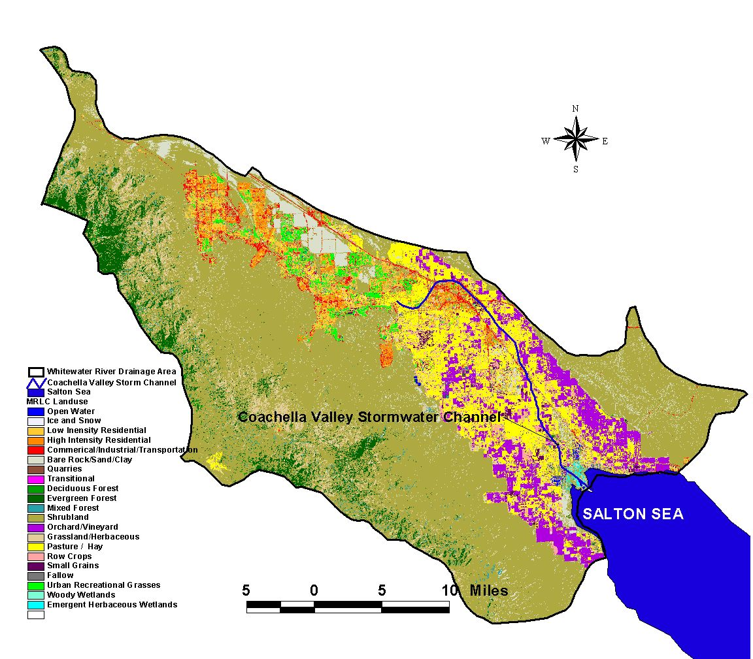
Figure 4.1: Land Uses in the Coachella Valley

4.2.1. Urban and Stormwater Runoff

Urban and storm water discharges are generated by runoff from land or impervious areas such as paved streets or buildings, following rainfall or anthropogenic activity utilizing water (e.g., washing automobiles or irrigating lawns). Urban and storm water discharges frequently contain pollutants in quantities that adversely impact water quality. These impacts may be reduced or eliminated by implementing management practices.

On September 5, 2001, the Regional Board adopted a Municipal Separate Storm Sewer System (MS4) NPDES permit for Riverside County Flood Control and Water Conservation District (RCFCWCD); the County of Riverside; CVWD; and the Cities of Banning, Cathedral City, Coachella, Desert Hot Springs, Indian Wells, Indio, La Quinta, Palm Desert, Palm Springs, and Rancho Mirage (Cities); and for the portion of the Whitewater River Basin located within Riverside County. The NPDES Permit (Order No. 01-077) designates RCFCWCD and Riverside County as “Principal Permittees” and the CVWD and incorporated cities as “Permittees”. The NPDES Permit requires all Permittees to implement a Storm Water Management Plan (SWMP), developed by the Permittees describing Management Practices (MPs) to control storm water pollution. The Principal Permittees have agreed to be responsible for coordinating Permittee activities.

The objective of the MS4 NPDES permit is to manage the quality of urban runoff to prevent impacts to receiving waters. Water quality monitoring stations were established mainly in the downstream area of the MS4 system, or in the receiving water. Currently, the MS4 monitoring station relevant to this TMDL includes CVSC at the Avenue 52 bridge. The permit requires wet-weather samples to be collected from a minimum of two storm events per year. Dry weather flow indicates a source not related to rainfall, which may reflect an illicit connection or an illegal discharge.

Bacteria data for urban and storm water discharges to CVSC are provided in Table 3.4. The data repeatedly indicate very high concentrations of fecal coliform being discharged into CVSC that violate WQSs. These water quality violations range up to 900,000 MPN/100 ml at Avenue 52 Storm Drain in Coachella, September 1999, and 70,000 MPN/100 ml at Monroe Street Storm Drain in Indio, April 1999. These data strongly suggest urban and storm water discharges contribute significant fecal contamination to CVSC.

4.2.2. Agriculture

Land application of manure to agricultural land is a possible source of fecal contamination. Irrigation drainage from fields with recent application of manure may carry bacteria to CVSC through direct runoff or subsurface flow via tile drains. No sampling data for irrigation runoff are available.

A second mechanism through which bacteria may enter drains from croplands is from pests (mice, rabbits, rats, etc.) foraging in fields and depositing fecal matter, which is carried into drains during irrigation. Studies indicate that the more rapid the transport of water through the soil matrix, and the shallower the groundwater, the more likely bacteria will survive (Howell et al., 1996, Novotny and Olem, 1994). While this is a potential source of bacteria to the drains, it is likely to be minor relative to other sources.

4.2.3. Septic Systems

Riverside County requires permits approved and issued by the County’s Building Code Department to install septic systems. Septic systems occur in areas surrounding CVSC, outside the service boundaries of wastewater treatment facilities. Unpermitted septic systems are considered illegal and may function improperly for various reasons, including inadequate leach line setbacks. Illegal systems may also function properly, but without appropriate certification, adequate wastewater treatment is not ensured.

Approximately 4,756 septic systems occur in the vicinity of the CVSC, from the city of Indio to the Salton Sea (Riverside County Department of Health Services, 2004). Waste discharges from these systems may contribute bacteria to CVSC through surface discharge or by contaminating groundwater that recharges the channel. Although further study is needed to accurately assess the water quality threat septic tanks pose to CVSC, preliminary surveys by Regional Board staff indicate that the threat posed is minor since septic tanks are not located at the periphery of CVSC where water quality impacts are more likely.

Quantifying bacteria loading (if any) to CVSC from failing and/or illegal septic systems clearly requires a level of information and understanding that does not yet exist. A study to define the number and location of improperly functioning systems in the CVSC area of influence may determine if and how bacteria from septic systems reach the channel. Such a study is unwarranted until more threatening contaminant sources are evaluated, such as urban and stormwater runoff, which have demonstrated high levels of bacteria in discharges to CVSC on numerous occasions (Table 3.4).

4.2.4. Wildlife and Domestic Animals

The CVSC and its tributary drains provide habitat for many types of wildlife including migratory songbirds and waterfowl. Other wildlife such as coyotes, raccoons and rodents also frequent the drains. Fecal coliform bacteria are found in natural areas due to the presence of animal sources such as these. It is expected that fecal contributions from wildlife and domestic animals comprise a portion of bacteria loading to CVSC.

Birds, especially waterfowl, have very high impacts to water quality by contributing fecal matter with viable pathogens and high levels of bacteria (Fleming, 2001). Potential impacts are especially high in areas where birds are concentrated and on small bodies of water with less dilution capacity. Wildlife census information is not available specific to this area; however an evaluation of biological resources conducted in 1988 for Valley Sanitary District, the City of Coachella, and CVWD included an avian census at eight locations along the channel to identify bird numbers and species. Each study area was approximately 3,000 ft. in length. Bird numbers are provided in Table 4.3 for each study area.

Table 4.3: Bird Census Data for the CVSC (1988)
 |  | Sightings-# birds all species
Study Area | Location Description | 20-Sep | 3-Oct | 25-Oct | 24-Jan | 24-Mar | 12-May | 16-May | Total
1 | 1/4 mile South of Auto Center Road above VSD | 19 | 17 | 29 | 63 | 2 | 49 | 33 | 212
2 | South of Dillon Road, below VSD | 11 | 10 | 4 | 13 | 3 | 1 | 1 | 43
3 | North of Avenue 54, above CSD | 8 | 8 | 7 | 21 | 1 | 16 | 8 | 69
4 | South of Airport Road, below CSD | 29 | 94 | 91 | 76 | 44 | 22 | 16 | 372
5 | North of Ave 62, above CVWD No. 4 | 53 | 30 | 34 | 27 | 23 | 57 | 36 | 260
6 | North of Hwy 195, below CVWD No. 4 | 62 | 69 | 59 | 31 | 17 | 43 | 41 | 322
7 | Lincoln St. | 24 | 21 | 8 | 14 | 14 | 13 | 6 | 100
8 | Channel Mouth at Salton Sea | 105 | 97 | 44 | 84 | 191 | 112 | 127 | 760
 | Total | 311 | 346 | 276 | 329 | 295 | 313 | 268 | 2138
Source: Montgomery 1989

According to the census, the abundance and species of birds present in a given study area is largely due to differences in riparian vegetation. Routine maintenance of CVSC involves periodic clearing of the stream banks of vegetation. This cycle of clearing and reestablishment of vegetation impacts bird life along CVSC. Where marsh or riparian vegetation is absent, fewer marsh and riparian bird species are observed. Study Area 2 was entirely cleared of vegetation, and had the fewest bird sightings of all areas (Table 4.3). Similarly, Study Area 3 was repeatedly plowed during the census period, and most birds observed were migrants or visitors from nearby fields.

Depth and velocity of flow in the channel was also used to predict specie occurrence. For example, herons are occasionally observed in the upper stretches of CVSC, where water is shallow, slow, and more conducive to fishing. However, their numbers are low when compared to the northern edge of the Salton Sea where fish are more abundant.

The southern part of the CVSC drainage area is flanked by numerous privately owned duck ponds managed for recreational duck hunting. These ponds provide habitat for large numbers of waterfowl. The USDA soil survey indicates soils are well drained with no impermeable layers separating upper saturation zones from groundwater (USDA, 1980). Bacteria introduced into the ponds from waterfowl may migrate to shallow groundwater discharging into nearby tributary drains. The waterfowl themselves likely occur in the drains as well as the ponds. No estimates are available regarding duck pond populations or their occurrence in tributary drains.

The Salton Sea National Wildlife Refuge, which borders the CVSC drainage area to the south, provides habitat for over 375 bird species including shorebirds, waterfowl, and the endangered Yuma clapper rail. Bird counts are conducted on a regular basis for the Salton Sea and its surrounding shoreline. Monthly population trends from 2000 to 2003 (Figure 4.2) reflect the over-wintering nature of the waterfowl at the Sea.

Figure 4.2: Monthly Waterfowl Population Estimates for the Salton Sea (2000-2003)
Source: Salton Sea Authority, Wildlife Disease Surveillance Program

The avian census indicates waterfowl from the Sea and nearby ponds visit CVSC and its tributaries. Given seasonal trends in waterfowl population, and assuming populations in CVSC and tributary drains mirror those for the Sea, bacteria from waterfowl in CVSC should be highest in winter and lowest in summer. This is not supported by water quality data, however, which indicate that other significant sources of bacteria to CVSC exist.

The CVSC and its tributary drains to the south are attractive to coyotes, dogs and rodents. Although these animals may contribute bacteria to CVSC, their contributions are assumed to be small because they are not aquatic. Typical fecal coliform production rates for various sources are given in Table 4.4.

Table 4.4: Estimated daily fecal coliform production rates for various sources
Animal | Fecal Coliform Production Rate (colony forming unit (cfu)/animal or human-day) | Source
Ducks | 2.4 x 10⁹ | Zeckoski et al., 2005
Geese | 8 x 10⁸ | Zeckoski et al. 2005
Racoon | 5 x 10⁷ | Zeckoski et al. 2005
Muskrat | 2.5 x 10⁷ | Zeckoski et al. 2005
Beaver | 2 x 10⁵ | Zeckoski et al. 2005
Pets | 4.5 x 10⁸ | Benham et al., 2005
Human | 2 x 10⁹ | Benham et al., 2005

4.2.5 Controllable vs. Non-controllable Sources of Bacteria

For the purposes of this TMDL, controllable sources of pathogens (background and otherwise) are identified as anthropogenic activities (e.g., domestic wastes), domestic pets (e.g. cats and dogs), and livestock (cows, horses, pigs, etc.). Non-controllable sources consist of wildlife (e.g., birds, waterfowl, rabbits, and squirrels) whose populations are not otherwise actively controlled to prevent the spread of serious disease or virus (e.g. mosquitoes for West Nile virus, rodent for hantavirus, bird flu).

4.2.6. Bacterial Re-growth

Nutrients, organic matter, and temperature may stimulate bacteria survival in aquatic environments (Crane and Moore, 1986). Where aquatic vegetation lines the channel and nutrient levels are elevated, bacteria re-growth may impact bacteria concentrations in CVSC.

4.3. Bacteria Source Tracking

To further identify possible sources of bacteria to CVSC, California Polytechnic State University was contracted to conduct a DNA monitoring and analysis study. Two hundred water samples were collected from three sites along CVSC from October 2003 through March 2004. E. coli strains were isolated from water samples, ribotypes fingerprinted, and then compared to the source library at the Institute of Environmental Health in Seattle, Washington. The DNA monitoring and analysis study determined the percentage distribution of fecal sources in the CVSC. The following bacterial sources were identified in CVSC from the two hundred samples collected during the study: avian (40%), human (25%), rodents plus other wild mammals (25%), and livestock (<3%). (Pleases see Appendix C). This distribution gives us an idea of the possible sources of bacteria in CVSC. Human sources appear to have a significant role, but their actual contribution and contributions from other point and nonpoint sources require further characterization.

Most microbial or bacteria source tracking methods, including the method used in this TMDL, match fingerprints from bacterial strains isolated from a water system to those isolated from hosts such as humans, cows, geese, chicken, or municipal wastewater. Although scientific studies support the use of ribotype-based Microbial Source Tracking (MST) methods, there are concerns regarding their accuracy due to spatial and temporal vectors, stability of the markers, and sampling design (USEPA 2005). This information will be considered when interpreting CVSC DNA ribotyping data and tracking microbial sources during implementation. If resources are available, different MST tools will be applied and compared during TMDL implementation.

5. Critical Conditions and Seasonal Variation

The climate in the Coachella Valley is arid with hot summers and warm winters. The water in the CVSC originates from irrigation return flows, treated wastewater, and urban and storm water runoff. Analysis of available water quality data suggests slightly higher concentrations of bacteria in warm months, but no patterns are apparent with flow. Additionally, data indicate a progressive lowering of water quality as the channel approaches the Salton Sea with water quality violations occurring year-round.

The goal of a TMDL is to determine the assimilative capacity of a waterbody and to identify load allocations that enable the waterbody to achieve WQSs under all conditions. The critical condition is the set of environmental conditions in which controls designed to protect water quality ensure attainment of objectives for all other conditions. This is typically the period in which the stream exhibits the most vulnerability.

Water quality data show year-round violations of bacteria objectives in all areas of CVSC. Assuming bacteria loading into CVSC results from wildlife and urban and storm water runoff, critical loading conditions occur during periods of low flow when dilution is minimal. This is supported by monthly water quality data, which indicate higher concentrations of bacteria in summer (Appendix A). Therefore, critical conditions occur during the summer months when flow is the lowest, since bacterial measurements taken at that time show higher levels than at other times of the year. Accordingly, TMDL numeric targets are required to be met all year, including during these critical periods.

Phase I Implementation of this TMDL (Please see Section 9) will target data collection during wet weather conditions. As new data become available during TMDL implementation, we will further evaluate them for seasonality.

Flows from the CVSC contribute to the salt budget of the Salton Sea on an annual basis as described in the Draft Programmatic Environmental Impact Report (PEIR) for the Salton Sea Ecosystem Restoration Program (California Department of Water Resources (DWR) 2006). Under the Salton Sea Restoration’s no-action alternative, DWR projects increases in CVSC flows and salt loads as a result of California’s Quantification Settlement Agreement (QSA) conservation and transfer projects and CVWD’s water conservation plan, the Coachella Valley Water Management Plan. Inflows to the Salton Sea from CVSC are critical to maintaining the current health of the Sea. The possibility exists that future population growth in the Coachella Valley could reduce flows from CVSC to the Salton Sea (California Department of Water Resources (DWR) 2006).

6. Numeric Targets

The designated beneficial uses for CVSC are FRSH, REC I, REC II, WARM, WILD, and RARE. The REC I beneficial use has the most stringent WQOs for bacteria and includes activities such as swimming, wading, and fishing. This section provides numeric targets to reduce bacterial loads into CVSC to meet WQOs that protect CVSC beneficial uses. Research recommends using either E. coli or enterococci WQOs to protect fresh recreational waters, and enterococci WQOs for marine recreational waters (USEPA 2002). This TMDL uses WQOs specified for E. coli in the Basin Plan as numeril targets to protect CVSC beneficial uses (Table 6.1).

Table 6.1: TMDL Numeric Targets

Parameter | Geometric Meanª (generally not less than 5 samples equally spaced over a 30-day period)  (MPN/100 ml) | Or | Single Sample  (MPN/100 ml)
E. Coli | 126 | Or | 400
a- Geometric mean or log mean, used in most bacteria calculations, tends to dampen the effect of very high values, which might bias the mean if a straight average (arithmetic mean) were calculated.

Numeric targets listed in Table 6.1 are water WQOs for bacteria indicators that were developed by the USEPA for use as CWA water quality criteria for freshwater bathing, and are based on risk analysis for gastrointestinal illness discussed previously.

7. Linkage Analysis

The linkage analysis establishes the connection between pollutant loading and the protection of beneficial uses. Such information is useful in evaluating the degree and duration of required effort, including mitigation options, to achieve WQOs. For this TMDL, the connection between pollutant loading and protection of beneficial uses is established by the fact that TMDL numeric targets and allocations are equal to WQOs for the most stringent BU of CVSC in the Basin Plan. Therefore, this TMDL’s numeric targets protect all beneficial uses of CVSC.

This one-to-one relationship between load allocations and numeric targets ensures that the TMDL achieves WQOs. For example, a 30-day geometric mean wasteload/load allocation of no more than 126 MPN/100 ml for E. coli at the points of discharge making it more likely that 126 MPN/100 ml or less will be present in the CVSC. The potential for increased concentration downstream due to bacteria growth is diluted by agricultural discharges and operational spills.

No bacteria indicator water quality criteria exist for the protection of aquatic life. There is a link between microbial loads and oxygen depleting wastes, however. This link is Biochemical Oxygen Demand (BOD), which is a measurement of the amount of oxygen consumed by microorganisms in decomposing organic matter in stream water (USEPA, 1997). BOD directly affects the level of dissolved oxygen in rivers and streams. The greater the BOD, the more rapidly oxygen is depleted in the stream, and the less oxygen is available for higher forms of aquatic life. The consequences of high BOD are the same as those for low dissolved oxygen; i.e., aquatic organisms become stressed, suffocate, and die.

Sources of BOD include: leaves and woody debris; dead plants and animals; animal manure; effluents from wastewater treatment plants, feedlots, food-processing plants, and pulp and paper mills; failing septic systems; and urban storm water runoff. To satisfy human health criteria and adequately protect aquatic habitats, management practices (MPs) that reduce bacterial indicators and organic waste will be implemented for this TMDL.

8. TMDL Calculations and Allocations

As previously discussed, a TMDL is a numeric calculation that describes the loading capacity of a water body to assimilate a given pollutant and still attain WQSs. A TMDL equals the sum of individual WLAs for point sources; LAs for nonpoint sources and natural background sources; and a MOS to address uncertainties. Thus, it can be mathematically expressed as follows:

TMDL = ∑  WLAs + ∑  LAs + MOS

Margin of Safety (MOS)

TMDLs include a margin of safety to account for data uncertainty, re-growth, critical conditions, and lack of knowledge. This TMDL includes an implicit MOS, meaning that the MOS is incorporated into the conservative processes used to develop the TMDL. Therefore, the MOS is not quantified. This TMDL uses an implicit MOS for the following reasons:

- The TMDL numeric targets and allocations are based on the USEPA’s E. coli recommendations and the Colorado River Basin Region Basin Plan’s WQOs for the most protective human health beneficial use, which is REC I;

- For this TMDL, data uncertainty exists regarding bacteria die-off and re-growth in CVSC, and more knowledge is needed on other sources of bacteria into CVSC;

- All wastewater treatment plants discharging into CVSC have E. coli effluent limits in their revised permits and WLAs in this TMDL equal to the TMDL numeric target. We believe that setting an explicit MOS and lowering the allocations accordingly, without enough supporting evidence and data, is unreasonable at this time; and

- The TMDL provides an aggressive monitoring and review plan to ensure that needed data are collected and that revisions are made, if necessary, during TMDL Implementation.

Waste Load Allocations and Load Allocations (WLAs and LAs)

To develop a TMDL, loads for all pollutant sources that cumulatively equal the TMDL must be determined to provide a means to establish water quality-based controls. TMDLs can be expressed in terms of mass per time, toxicity, or other appropriate measures that relate to a state’s WQSs. For bacteria, TMDLs are expressed in terms of organism counts, or density. This TMDL assigns allocations for bacteria expressed as density-based concentrations to ensure protection of BUs. Bacteria loadings are measured as a density-based Most Probable Number (MPN) of organisms in a given volume of water (i.e., 100 ml). This means that bacteria source measurements reveal the most probable density of organisms in that volume of water at any given point in time, not the amount of bacteria a discharger "produces." Other pollutants such as sediment, pesticides, and nutrients are generally expressed as mass-based measurements (i.e., pounds per day). Mass-based bacteria measurements can be misleading because a discharger typically contributes not only bacteria to a waterbody, but also organic material which could lead to further bacteria growth. If mass-based bacteria measurements from dischargers were to be calculated, the total mass would also include bacteria growth arising from discharged organic material.

All current and future point and nonpoint sources of pollution that discharge to CVSC shall not exceed the numeric targets identified in Table 6.1, which apply throughout CVSC. These numeric targets are based on extensive epidemiological studies conducted by the USEPA and others (USEPA 1986). This TMDL sets WLAs and LAs equal to the numeric targets. The WLAs and the LAs for E. coli in the CVSC for both point and nonpoint sources (including NPDES permitted facilities, MS4 stormwater permittees, agricultural dischargers, and discharges from Tribal Land boundaries) are:

- the log mean (Geomean) of samples collected shall not exceed 126 MPN/100 ml (based on a minimum of not less than five samples during a 30-day period), or

- 400 MPN/100 ml for a single sample.

The WLAs and the LAs for E. coli in the CVSC from septic system dischargers is zero MPN/100 ml.

Setting LAs and WLAs equal to numeric targets reduces the uncertainty whether the TMDL and individual allocations will attain WQSs. Using a conservative approach to establish LAs and WLAs, even for relatively minor loading sources, helps ensure numeric objectives will be attained. To address the uncertainty concerning bacterial die-off and re-growth dynamics in CVSC, and to better address critical conditions and seasonal variations, this TMDL provides a MOS by including a monitoring and review plan that uses data collected during TMDL Implementation to evaluate TMDL effectiveness and the need for revision.

As mentioned eabove, four National Pollutant Discharge Elimination System (NPDES) permitted facilities discharge wastewater to CVSC: VSDWTP, CSDWTP, MVWRP, and KSCFF. All four NPDES facilities have a WLA for E. coli in their discharge waters as follows:

- the log mean (Geomean) of samples collected shall not exceed 126 MPN/100 ml (based on a minimum of not less than five samples during a 30-day period), or

- 400 MPN/100 ml for a single sample.

Indian Tribal Lands
There are four Indian tribes in the CVSC Watershed: Augustine; Cabazon; Torres-Martinez, and Twenty-Nine Palms. Pursuant to the CWA, Indian tribes are treated as states and given some of the regulatory authority delegated to states. The USEPA has the authority and responsibility to review tribal CWA programs to ensure compliance with USEPA WQSs. Any discharge from tribal lands to non-tribal lands is treated as a nonpoint source at the tribal boundary. Occurrences of illicit discharges from tribal lands to CVWD agricultural drains and/or the CVSC exist. Recently (February 2007), USEPA investigated and verified the existence of an unauthorized sewer line connection from Torres Martinez Desert Cahuilla Indian Reservation to waters of the United States (an agricultural drain tributary to the CVSC). This discharge, which occurred for an unknown period of time, most likely contributed to pathogen pollution in the CVSC.

Bacteria LAs exist for any discharges from tribal lands, applicable at tribal boundaries. The bacteria LAs are:

- the log mean (Geomean) of samples collected shall not exceed 126 MPN/100 ml (based on a minimum of not less than five samples during a 30-day period), or

- 400 MPN/100 ml for a single sample.

9. Implementation Plan

Legal Authority and Requirements

Regional Water Quality Control Boards have the responsibility and authority for regional water quality control and planning, pursuant to the Porter-Cologne Water Quality Control Act, Division 7 of CWC, Section 13000 et seq. The Colorado River Basin Regional Board establishes WQOs by amending the region’s Basin Plan. Regional Boards control point source pollution by implementing a variety of regulatory programs, such as the NPDES permit program for point source discharges into surface waters of the United States. Nonpoint source (NPS) pollution is managed through the State Plan for California NPS Pollution Control Program (State Water Resources Control Board 2000) (NPS Program Plan), and by the Policy for Implementation and Enforcement of the NPS Pollution Control Program (State Water Resources Control Board 2004) (Policy). The Policy explains how the NPS Program Plan will be implemented and enforced through compliance with Waste Discharge Requirements (WDRs), issuance of WDR waivers, or implementation of a Basin Plan prohibition. Furthermore, the Policy recognizes the need for non-waste discharger Third-Party NPS Implementation Programs that include five elements for effective NPS pollution control, specifically:

- Setting program objectives to be protected and achieved, including beneficial uses and WQOs;
- Establishing verifiable management practices (MPs);
- Imposing time schedules with milestones;
- Incorporating feedback mechanisms to determine if program objectives are being achieved, and if additional or different MPs or other actions are needed; and
- Stipulating consequences for failing to achieve program objectives.

Overview of the Proposed Implementation Plan

The Regional Board must approve an implementation plan to achieve adopted WQOs (CWC Section 13242) that includes, at a minimum:

- Necessary actions to achieve WQOs, including recommendations for public or private entities;
- Time schedules for actions to be taken; and
- Monitoring and surveillance to determine compliance.

The implementation plan proposed for the CVSC bacterial indicators TMDL consists of two phases and begins 90 days following USEPA approval of the TMDL. Phase I actions will take three years to complete and focus on monitoring and addressing pathogens associated with wastewater discharges from NPDES facilities and from urban, agricultural, and storm water runoff to the impaired portion of the CVSC (Indio to the Salton Sea). Regional Board staff will coordinate closely with tribal representatives and/or USEPA to address waste discharges from tribal lands. If WQOs are not achieved by the end of Phase I, Regional Board staff will implement additional actions to control pathogenic sources in Phase II. Enforcement action will be taken against violators of the TMDL in both phases, if necessary. This approach provides for immediate assessment of known pathogenic sources while allowing time for additional monitoring to assess TMDL implementation, effectiveness, and the need for modification.

Phase I Implementation Actions

Phase I actions occur over three years, and begin 90 days after USEPA approves the TMDL. Phase I requires:

- Conducting a two year bacteria indicator water quality monitoring program to properly characterize bacterial contributions to CVSC from anthropogenic or municipal sources;
- Obtaining a written report coordinated by USEPA describing measures to be taken to ensure waste discharges from tribal property do not violate or contribute to a violation of this TMDL;
- Revise KSCFF’s NPDES permit to include E. coli limitations and monitoring;
- Revising municipal stormwater permits for Riverside County Flood Control and Water Conservation District (RCFCWCD), CVWD, and co-permittees to include monitoring and reporting for E. coli, and issuing similar stormwater permits to other entities/municipalities (if any) discharging to the impaired portion of the CVSC; and
- Monitoring, tracking, and surveying CVSC to determine if Phase I activities achieve bacteria WQOs.

Phase I Implementation Responsible Parties

Urban and Stormwater Dischargers: MS4 permittees are the only entities with municipal stormwater permits that allow them to discharge storm water into the CVSC watershed. Cities and municipalities in the area are co-permittees that coordinate their stormwater protection through the MS4 Program.
CVWD discharges stormwater, operates irrigation canals, and maintains agricultural drains that discharge to the CVSC. CVWD, RCFCWCD, City of Indio, and City of Coachella are responsible parties for the purposes of implementing this TMDL.

NPDES Dischargers: As mentoned above, three WWTFs have NPDES permits to discharge treated domestic wastewater into CVSC: VSDWTP, CSDWTP, and MVWRP. An aquaculture facilty, KSCFF, owned by KSC also has an NPDES permit to discharge to CVSC. However, monitoring for bacteria is not required in KSCFF’s NPDES permit. The owners and operators of these facilities are identified jointly in their permits as "discharger", and are therefore responsible parties for the purposes of implementing this TMDL.

Indian Tribes: As explained in the TMDL Load Calculations and Allocations Section, there are four Indian tribes in the CVSC Watershed: Augustine, Cabazon, Torres-Martinez, and Twenty-Nine Palms. . These four Indian Tribes, mentioned above, are responsible parties for the purposes of implementing this TMDL.

California Transportation Department (Caltrans): Caltrans has a general permit to discharge waste into CVSC. As a result, Caltrans is considered a responsible party for the purposes of implementing this TMDL.

Agricultural Land Owners: Agricultural land owners, not in tribal lands, who discharge wastewater to the impaired portion of the CVSC (Indio to the Salton Sea) are responsible parties for the purposes of implementing this TMDL.

Phase I implementation responsible parties, with the exception of the three WWTPs, are required to develop and implement bacteria water quality monitoring programs to properly characterize their bacterial contributions to CVSC from anthropogenic or municipal sources over the period of two years. Monitoring reports shall be submitted quarterly to the Regional Board’s Executive Officer for his review and approval by the 15th of the month (January, April, July, October).

If the discharger feels its existing permit’s Monitoring and Reporting Program requirements satisfy the criteria listed above for this TMDL’s responsible party monitoring requirements, the responsible party may submit a written request to the Regional Board’s Executive Officer to use the existing permit’s Monitoring and Reporting Program to fulfill both their permit and TMDL monitoring and reporting requirements.

Quality assurance project plans (QAPPs) to implement the two year water quality monitoring programs must be developed by the responsible parties and submitted to the Regional Board’s Executive Officer for his review and approval within 90 days after USEPA approves the TMDL.

Monitoring data collected over the two year period will be used to (1) assess bacteria loading to CVSC from anthropogenic or municipal sources (stormwater, agricultural drains, urban runoff, and others), and (2) determine if CVSC qualifies for delisting bacterial indicators from the State’s 303(d) List pursuant to the State Board’s 303(d) Listing Policy (State Board, 2004).

Phase I Implementation Actions for Regional Board Staff

Regional Board staff will develop a plan to conduct TMDL surveillance and track TMDL activities. The plan is due 90 days after USEPA approves the TMDL, and includes the following:
- Assess, track, and account for practices already in place;
- Measure milestone attainment;
- Determine compliance with WLAs and LAs; and
- Determine progress toward achieving WQSs.

Phase I Implementation Schedule

The time schedule and responsible party for implementing Phase I actions are provided in Table 8.1 below.

Table 8.1: Phase I Actions and Time Schedules
Due | Action
90 days after USEPA approves the TMDL | Pursuant to requests from the Regional Board, the responsible parties, with the exception of the three WWTPs, shall develop two-year long, bacteria indicator water quality monitoring programs. QAPPs shall be developed and submitted to the Regional Board Executive Officer for review and approval. Monitoring data will be provided to Regional Board staff on a quarterly basis and will be used to assess contributions of bacteria to CVSC from anthropogenic or municipal sources (stormwater, agricultural drains, urban runoff, and others).
90 days after USEPA approves the TMDL | Regional Board staff develops a plan to conduct TMDL surveillance and track TMDL activities. The objectives of the plan are to assess monitoring data, measure milestone attainment, and determine compliance with the TMDL.
90 days after USEPA approves the TMDL | Pursuant to a request from the Regional Board, the USEPA submits a technical report describing measures to ensure that waste discharges to CVSC from tribal land do not violate or contribute to a violation of this TMDL.
90 days after USEPA approves the TMDL | Regional Board staff will start the process of revising KSCFF’s NPDES permit to include bacteria effluent limitations and monitoring.
3 years after USEPA approves the TMDL | Regional Board staff submits a written report to the Regional Board describing monitoring results, milestone attainment, and the need to revise the TMDL, if necessary.

Phase I Implementation Cost Estimates

The estimated cost for the first monitoring event (one day) of each monitoring program (group or individual), which includes developing a QAPP, is $12,281 as shown in Table 8.2 below. Estimated cost for each subsequent monitoring event is $2,281. These cost estimates were based on charges made by Regional Board staff for collecting the water samples and managing contracts, and E.S. Babcock & Sons, Inc. Laboratories in Riverside for lab analysis of the samples
Table 8.2: Estimated Cost of CVSC Bacterial Indicators TMDL of Monitoring
One Sampling Event per Month
Task: | Cost/month
Write and develop Quality Assurance Project Plan (QAPP) | **$10,000.00
Project management- 1 staff @ $125k/year * 10% time/month | $1,042.00
Field sampling team- 2 staff @ $125k/year * 5% time/month | $1,042.00
Field sampling vehicle- 60 mile trip @ $0.485/mile | $29.00
Lab Analysis: E.S. Babcock & Sons, Inc., Riverside, CA
5 Fecal/E.coli Confirmation for MTF (SM 9221E&F) @ $20 | $100.00
Delivery of Water Samples to E.S. Babcock Lab
vehicle 140 mile round trip @ $0.485/mile | $68.00
Total Cost for first monthly sampling event | $12,281.00
Total Cost for each subsequent monthly sampling event | $2,281.00
**QAPP is a one-time cost

Phase II Implementation Actions

Controlling NPS pollution is challenging due to data uncertainties, information gaps, inter-agency coordination, and economics. The main challenges are:
- identifying sources of pollution and responsible parties given the diffuse nature of NPS pollution across the watershed; and
- developing, recommending, and evaluating effective and feasible management practices (MPs) to control pollution.

As discussed in the source analysis, there are several potential sources of bacterial pollution to CVSC including: agricultural, urban and storm water runoff, wastewater from NPDES facilities, septic systems, wildlife, and domestic animals. Likewise, there are several parties that are potentially responsible for these pollution sources. These parties include: CVWD; Caltrans; Riverside County; cities, towns, and Indian tribes in the lower CVSC watershed; owners and operators of NPDES facilities; homeowners; pet owners; and farmers.

Also, as discussed in this TMDL Basin Plan Amendment’s CEQA Checklist and Determination, Phase II actions may include enforcement actions and revision of WQOs (e.g., development of site-specific objectives). Phase II actions may also include revising MS4 permit effluent limitations, potentially expressed in terms of management practice (MP) requirements. Phase II actions may include implementation of new/additional MPs following characterization of the sources of impairment and whether these sources can be controlled to attain load allocations/reductions.

Management practices designed to control NPS pollution may be structural, nonstructural, or a combination of both. Examples of structural MPs include: detention dry ponds, wet ponds, infiltration trenches, wetlands, and sand infiltration systems. Nonstructural MPs implement public education pollution prevention programs, or provide information on nutrient budgets and irrigation management. The Porter Cologne Water Quality Control Act prohibits the Regional Board from prescribing the particular manner in which compliance may be had with any requirement, including WQSs and this TMDL (CWC Section 13360). Dischargers may implement any legally authorized action to achieve compliance. Actions taken in Phase I should identify sources of bacterial pollution, determine whether WQSs are achieved, and whether any additional actions are required in Phase II to meet WQOs.

If Phase I actions identify violations of WQOs by any NPDES, MS4, or CalTrans permitee, those violations will be addressed by implementing MPs identified in the discharger’s existing Regional or State Board permit. Other violations of WQOs by NPS dischargers, such as irrigated agriculture, animal facilities not regulated by the NPDES program, and/or domestic animals, will be addressed through implementing measures provided in the SWRCB’s Nonpoint Source Program Plan and/or Nonpoint Source Program Strategy and Implementation Plan (PROSIP). The Regional Board may consider revising WQOs for CVSC to address non-controllable natural background sources of bacteria. This revision will be accomplished through a Site-Specific Objective (SSO) after completing a Use Attainability Study (UAS). The SSO will be developed by 2014 if needed and based on fund availability.

Phase II actions will be implemented from 2010 to 2014.

Financial Assistance

The Division of Financial Assistance (DFA) at the State Water Resources Control Board in coordination with the Regional Board, awards and manages grants for projects to improve water quality in California through the federal CWA Section 319(h) program and State Propositions 13, 40, and 50. Currently, about $11 million of Proposition 13 funds have been allocated to the cities of Cathedral City, Desert Hot Springs, and Blythe to phase out septic systems. Regional Board staff will assist authorities in the CVSC Watershed to obtain funding (grants) for TMDL implementation if necessary.

TMDL Review Schedule

Annual reports will be provided to the Regional Board describing progress in attaining milestones. The reports will assess:

- Water quality improvement in terms of E. coli concentration;
- Milestones achieved, delayed, or not achieved, and why; and
- Compliance with Regional Board orders and requests.

Triennial Review

Federal law requires states to hold public hearings to review WQSs, and modify/adopt standards as appropriate (CWA Section 303; 40 CFR Part 130). State law requires formulating and periodically reviewing and updating regional water quality control plans (CWC Section 13240). All basin plan amendments and supporting documents adopted by the Regional Board must be submitted to the SWRCB, and then OAL, for review and approval. The USEPA has final approval authority for basin plan amendments dealing with surface waters.

The first review of this TMDL is scheduled for completion three years after USEPA approves the TMDL to provide adequate time for implementation and data collection. Subsequent reviews will be conducted concurrently with the Triennial Review of the basin plan. The TMDL review schedule is shown below in Table 8.3.

Table 8.3: TMDL Review Schedule

Activity | Date
USEPA Approval | 2007
Terminate First TMDL Review, and conduct Regional Board Public Hearing | 2010-2011
Terminate Second Review and Conduct Regional Board Public Hearing | 2013-2014
Etc.

Monitoring results and progress toward milestone attainment will be provided during Triennial Review public hearings. If TMDL progress is insufficient, Regional Board staff will recommend to the Regional Board additional MPs to control pollutant sources, enforcement action, TMDL revision, or other means to achieve WQOs.

This proposed review schedule reflects the Regional Board’s commitment to periodic review and refinement of this TMDL via the basin plan amendment process.

10. Monitoring Plan

TMDLs can be revised as new information and data are collected. The implementation plan for this TMDL requires development of water quality monitoring plans to provide the necessary information and data needed to better analyze and identify sources of bacteria loading into CVSC. In addition, data from this monitoring will enable Regional Board staff to better understand the relationship between the bacteria levels detected and the effect of re-growth and contributions from all sources of waste into CVSC.

The monitoring plans will include a sufficient number of monitoring stations and monitoring events to adequately address all potential sources of bacteria during a two year period. The collected water samples will be analyzed for bacteria indicator organisms such as E. coli.

Monitoring data will be provided to Regional Board staff on a quarterly basis and will be used to: (1) assess delisting CVSC for pathogens from the State’s 303(d) List based on the requirements of the State Board’s 303(d) Listing Policy (State Board 2004); and (2) assess contributions of bacteria to CVSC from anthropogenic or municipal sources (stormwater, agricultural drains, urban runoff, and others). If Phase I monitoring results don’t identify sources of bacteria indicator pollution, a DNA study to characterize human-controlled contributions, a bacteria regrowth study, a wildlife inventory, and a domestic pet census may be conducted during the Phase II of TMDL implementation.

Ninety days after USEPA approves the TMDL, and pursuant to a request from the Regional Board, the responsible parties must develop and submit QAPPs to implement their monitoring plans as required by the TMDL. The QAPPs shall be developed and submitted to the Regional Board Executive Officer for his review and approval.

11. Economic Assessment

Implementing the Monitoring Plan for Phase I of this TMDL could cost each responsible party about $12,000 for the first monitoring event and about $2,281 for each subsequent monitoring event as described in Table 8.2.. No other initial economic impacts to responsible parties for implementing Phase I of this TMDL are expected. However, if Phase I activities do not reduce bacterial discharges to achieve water quality goals by the end of Phase I, bacterial discharges will be further assessed and additional management practices with significant costs for implementing may be developed.

Phase I

- Implementing the Water Quality Monitoring Plans. Responsible parties will develop and implement QAPPs for this TMDL Monitoring Plans. The cost to each responsible party is about $12,000 for the first monitoring event and about $2,281 for each subsequent monitoring event. Regional Board staff will coordinate with responsible parties on funding needed to accomplish the monitoring.

- Developing A Technical Report on Waste Discharges from Tribal Land. USEPA will coordinate submittal a technical report describing measures to ensure that waste discharges to CVSC from tribal land do not violate or contribute to a violation of this TMDL.

- Implemention Tracking Plan. Regional Board staff will develop an Implementation Tracking Plan. TMDL Implementation staff will be assigned this task.

Phase II

Phase II will be implemented if Phase I actions do not achieve the TMDL goals. Potential Phase II implementation actions that may require significant funding (several thousands to millions of dollars) and time commitment are:

- Revise Basin Plan WQOs for CVSC; and
- Implement MPs for wastewater storage, treatment, and disposal.

At the completion of Phase I, responsible parties will reconsider actions for Phase II based on: alternatives suggested in the TMDL Implementation Plan or proposed by stakeholder groups; current legislation; and cost.

References

Benham, B.L., K.M. Brannan, G Yagow, R.W. Zeckoski, T.A. Dillaha, S. Mostaghimi, and J.W. Wynn. 2005. Development of Bacteria and Benthic Total Maximum Daily Loads: A Case Study, Linville Creek, Virginia. Journal of Environmental Quality, 34:18601872 (2005).

California Department of Water Resources. 2006. Salton Sea Ecosystem Restoration Program Draft Programmatic Environmental Impact Report, Appendix H-Hydrology and Hydrologic Models. p. 12, 23, 24, 41,42, 64

Coachella Valley Association of Governments. 2006. Draft Final Coachella Valley Multiple Conservation Plan and Natural Community Conservation Plan. 73-710 Fred Waring Drive Suite 200, Palm Desert, CA. http://www.cvmshcp.org/prdplan/draftfinal.htm

Coachella Valley Water District. 2004. Personal Communication between Teresa Rafi, Tetra Tech Inc., and Steve Bigley, CVWD Water Quality Specialist. February 13, 2004.

Colorado River Basin – Region 7. Water Quality Control Plan, Colorado River Basin- Region 7, Includes Amendments Adopted by the Regional Board through October 2005.

Crane, S.R., and J.A. Moore. 1986. Modeling enteric bacterial die-off: A Review. Journal of Water, Air, and Soil Pollution. February 1986. 27:411-439.

Kitts, C., A. Shaffner, M. Samadpour, and I. Reyburn. 2004. Fecal Contamination Source Tracking by Ribotype Fingerprints of Environmental E. Coli from the Coachella Valley Stormwater Channel. Final Report. State Water Resources Control Board Contract Agreement # 02-118-257-1

Fleming, R. and H. Fraser. 2001. The Impact of Waterfowl on Water Quality: Literature Review. Ridgetown College, University of Guelph.

Howell, J.M., M.S. Coyne, and P.L. Cornelius. 1996. Effect of sediment particle size and temperature on fecal bacteria mortality rates and the fecal coliform/fecal streptococci ratio. Journal of Environmental Quality 25:1216-1220.

Montgomery, James M. 1989. Report for the Water Quality and Biological Resources Evaluation, Coachella Valley Stormwater Channel, February 1989. JMM Consulting Engineers Inc.

Novotny, V., and H. Olem. 1994. Water Quality: Prevention, Identification, and Management of Diffuse Pollution. Van Nostrand Reinhold, New York.

RCD – Watershed Information Sharing Project. 2006. Coachella Valley Resource Conservation District. http://www.carcd.org/wisp/cochellavalley/index.html

Riverside County Department of Health Services. 2004. Personal Communication between Nadim Zeywar, Regional Board, and Don Park, Department of Health Services. December 29, 2004.

State Water Resources Control Board. 2000. Nonpoint Source Program Strategy and Implementation Plan, 1998-2013 (PROSIP). State Water Resources Control Board, California Environmental Protection Agency. January 2000
http://www.waterboards.ca.gov/nps/protecting.html

State Water Resources Control Board. 2004. Policy for implementation and enforcement of the Nonpoint Source Pollution Control Program. State Water Resources Control Board, California Environmental Protection Agency. May 20, 2004.
http:www.waterboards.ca.gov/nps/protecting.html

State Water Resources Control Board. 2004. Water Quality Control Policy for Developing California’s Clean Water Act Section 303(d) List. State Water Resources Control Board, California Environmental Protection Agency. September 2004.
http://www.waterboards.ca.gov/tmdl/303d_listing.html

United States Department of Agriculture. 1980. Soil Survey of Riverside County, California, Coachella Valley Area. United States Department of Agriculture, Soil Conservation Service. U.S. Government Printing Office, Washington D.C.

USEPA. 1986. Ambient Water Quality Criteria for Bacteria – 1986. Office of Water, Regulations and Standards, Criteria and Standards Division, Washington, DC 20460. January 1986.

USEPA. 1991. Guidance for Water Quality-Based Decisions: The TMDL Process. Office of Water, Regulations and Standards, Washington, DC 20460. April 1991.

USEPA. 1997. Volunteer Stream Monitoring: A Methods Manual. Office of Water 4503F. U.S. Environmental Protection Agency. EPA 841-B-97-003. November 1997 http://www.epa.gov/volunteer/stream/index.html

USEPA. 2002. Implementation Guidance for Ambient Water Quality Criteria for Bacteria. U.S. Environmental Protection Agency, Office of Water (4305T), 1200 Pennsylvania Avenue, NW, Washington, DC 20460, EPA-823-B-02-003. May 2002 Draft.

USEPA. 2005. Microbial Source Tracking, Guide Document. United States Environmental Protection Agency, Office of Research and Development, Cincinnati, OH. EPA/600-R-05-064, June 2005, www.epa.gov

Zeckoski, R.W., B.L. Benham, S.B. Shah, M.L. Wolfe, K.M. Brannan, M. Al-Smadi, T.A. Dillaha, S. Mostaghimi, and C.D. Heatwole. 2005. BSLC: A Tool for Bacteria Source Characterization for Watershed Management. American Society for Agricultural Engineers ISSN 0883-8542, Vol. 21(5): 879-889.

Appendix A: Mean Monthly Streamflows, USGS Gage 10259540

YEAR | Monthly mean streamflow, in ft³/s
YEAR | Jan | Feb | Mar | Apr | May | Jun | Jul | Aug | Sep | Oct | Nov | Dec
1960 |  |  |  |  |  |  |  |  |  | 53.9 | 44.4 | 45.4
1961 | 51.4 | 56.6 | 71.8 | 77.9 | 87.5 | 72.3 | 83.2 | 85.7 | 90.3 | 73.6 | 65.5 | 67.6
1962 | 76.3 | 88.6 | 93.4 | 103 | 107 | 103 | 103 | 115 | 117 | 93.7 | 76.1 | 77.9
1963 | 77.4 | 92.6 | 104 | 92.3 | 110 | 110 | 113 | 125 | 124 | 111 | 93.2 | 102
1964 | 106 | 119 | 105 | 104 | 102 | 101 | 95.4 | 110 | 118 | 106 | 86.5 | 92.4
1965 | 96.7 | 108 | 126 | 123 | 123 | 125 | 120 | 133 | 132 | 113 | 149 | 111
1966 | 107 | 108 | 112 | 116 | 97.4 | 111 | 121 | 127 | 113 | 93.5 | 99.5 | 107
1967 | 108 | 119 | 117 | 122 | 122 | 110 | 99.7 | 113 | 108 | 94.2 | 94.2 | 107
1968 | 101 | 116 | 125 | 125 | 117 | 109 | 112 | 112 | 113 | 96.5 | 88.6 | 108
1969 | 236 | 165 | 125 | 113 | 105 | 102 | 103 | 110 | 112 | 97.1 | 108 | 91.6
1970 | 104 | 116 | 115 | 115 | 117 | 103 | 99.9 | 107 | 111 | 94 | 89.1 | 83.9
1971 | 101 | 109 | 121 | 112 | 117 | 112 | 104 | 114 | 110 | 106 | 104 | 109
1972 | 115 | 126 | 133 | 127 | 133 | 121 | 132 | 133 | 133 | 125 | 108 | 117
1973 | 121 | 128 | 137 | 143 | 154 | 140 | 131 | 151 | 141 | 124 | 120 | 113
1974 | 128 | 141 | 137 | 138 | 137 | 128 | 116 | 134 | 135 | 118 | 115 | 89.5
1975 | 115 | 126 | 131 | 132 | 139 | 145 | 134 | 141 | 149 | 147 | 140 | 132
1976 | 147 | 173 | 159 | 172 | 173 | 130 | 135 | 150 | 220 | 136 | 114 | 113
1977 | 122 | 128 | 140 | 150 | 147 | 139 | 122 | 176 | 143 | 116 | 89.9 | 87.9
1978 | 120 | 126 | 222 | 140 | 126 | 113 | 107 | 128 | 114 | 112 | 106 | 109
1979 | 121 | 128 | 147 | 144 | 123 | 113 | 198 | 166 | 112 | 95.6 | 95.1 | 95
1980 | 160 | 396 | 125 | 139 | 161 | 115 | 106 | 123 | 120 | 105 | 89.1 | 112
1981 | 118 | 128 | 134 | 152 | 148 | 132 | 128 | 138 | 137 | 110 | 116 | 101
1982 | 102 | 141 | 130 | 139 | 144 | 137 | 117 | 121 | 112 | 102 | 125 | 141
1983 | 112 | 131 | 196 | 150 | 160 | 112 | 64.6 | 183 | 119 | 117 | 100 | 102
1984 | 107 | 124 | 126 | 115 | 105 | 101 | 124 | 107 | 93.5 | 80.6 | 72.9 | 83.9
1985 | 86.3 | 89.6 | 108 | 97.1 | 89.6 | 80.3 | 82.9 | 85.2 | 90.7 | 96 | 82.3 | 74.4
1986 | 86.1 | 168 | 104 | 99.4 | 105 | 73.8 | 95.3 | 117 | 112 | 89.6 | 81.3 | 71.8
1987 | 87.2 | 90.4 | 86.8 | 91.2 | 87.5 | 66.9 | 57.4 | 83.5 | 84.2 | 80.8 | 89 | 71.2
1988 | 87 | 105 | 106 | 108 | 101 | 87.4 | 90.4 | 107 | 80 | 80.5 | 71.6 | 92.7
1989 | 84.3 | 87.9 | 95.4 | 94.9 | 95.8 | 99 | 101 | 94.5 | 95.5 | 84 | 78.4 | 76.5
1990 | 73.3 | 91.1 | 92.9 | 99.5 | 92.5 | 77.4 | 86.6 | 87.8 | 84.3 | 75.7 | 73.6 | 73.7
1991 | 77 | 82.6 | 144 | 80.4 | 83.6 | 76.8 | 83.7 | 94.7 | 79.3 | 70 | 72.3 | 82.6
1992 | 74.5 | 97.9 | 87.6 | 89.9 | 80.7 | 75.9 | 69.3 | 80.3 | 74.1 | 68 | 79 | 88.5
1993 |  |  | 106 | 111 | 94.9 | 78.7 | 80.3 | 102 | 92.1 | 86.5 | 84.6 | 82.7
1994 | 83.1 | 92.4 | 95.4 | 99.7 | 102 | 96.5 | 91.4 | 94.1 | 88.2 | 93.3 | 84.9 | 82.9
1995 |  | 92.2 |  | 98.7 | 90 | 76.6 | 86.9 | 91 | 74.2 | 76.2 | 80.6 | 74.8
1996 | 73.8 | 86.3 | 88.1 | 91.5 | 87.9 | 72.1 | 81 | 86.2 | 84.6 | 67 | 78.8 | 77.1
1997 | 74.5 | 78.9 | 85.2 | 78.8 | 68.1 | 57.9 | 70.4 | 72.2 |  | 59.4 | 57.5 | 59.6
1998 | 73.8 |  | 68.1 | 74.8 | 71.5 | 58.4 | 69.1 | 63.1 | 83.4 | 74.1 | 72.6 | 76.1
1999 | 68.7 | 78.5 | 79.8 | 72.6 | 70.4 | 77.3 | 80.5 | 74.3 | 69.1 | 67.1 | 70.2 | 64.6
2000 | 70.6 | 72.4 | 76.2 | 74.3 | 69.8 | 65.1 | 68.1 | 74.7 | 72.1 | 70.6 | 65.5 | 69.9
2001 | 71.3 | 77.1 | 78.6 | 75.2 | 69.9 | 62.7 | 69.2 | 72.9 | 63 | 61.6 | 59.5 | 63.8
2002 | 68.8 | 72 | 74.3 | 75 | 70.3 | 69.8 | 62.8 | 67.7 | 62.5
Mean Monthly POR | 99.8 | 116 | 115 | 111 | 109 | 98.5 | 99.9 | 111 | 106 | 93.4 | 89.8 | 90
Mean Monthly 7yrs | 72 | 78 | 79 | 77 | 73 | 66 | 72 | 73 | 72 | 67 | 67 | 69

Appendix B: Relationship Between Bacteria Indicators and Flows

Table C1: E. coli data from 2/3/03 to 9/30/03 (8 observations)
at Lincoln Street Drain (LIST)
Flow Range | # Obs
Percentile | Count | Flow (cfs) | Concentration (MPN/100 ml)
0-10 | 1 | 56 | 13000
10-20 | 1 | 57 | 300
20-30 | 1 | 57 | 2200
30-40 | 0 | No Data | No Data
40-50 | 1 | 62 | 170
50-60 | 1 | 63 | 140
60-70 | 0 | No Data | No Data
70-80 | 1 | 64 | 300
80-90 | 1 | 65 | 400
90-100 | 1 | 66 | 170

Figure C1. Comparison of E. coli Concentrations with Discharge at Lincoln Street Drain

Table C2: E. coli data from 2/3/03 to 9/30/03 (8 observations)
for location LIST
Time Period | # Obs
Month | Count | Flow (cfs) | Concentration (MPN/100 ml)
February | 1 | 62 | 170
March | 1 | 63 | 140
April | 1 | 66 | 170
May | 1 | 64 | 300
June | 1 | 57 | 300
July | 1 | 56 | 13000
August | 1 | 57 | 2200
September | 1 | 65 | 400

Figure C2. Comparison of E. coli Concentrations with Discharge at Lincoln Street Drain

Appendix C: Coachella Coliform DNA Analysis Source Report

A summary of
Fecal Contamination Source Tracking by Ribotype Fingerprints of Environmental E. coli from the Coachella Valley Stormwater ChanneL
Kitts, C., A. Shaffner, M. Samadpour, and I. Reyburn. 2004. Fecal Contamination Source Tracking by Ribotype Fingerprints of Environmental E. Coli from the Coachella Valley Stormwater Channel. Final Report. State Water Resources Control Board Contract Agreement # 02-118-257-1

Executive Summary
Because of high coliform counts in the Coachella Valley Stormwater Channel (CVSC), this study was undertaken to determine the distribution of fecal contamination sources and to assist in the formulation of a total maximum daily load plan for the area. Two hundred water samples were collected from three sites along the CVSC over a period of four months, from October 2003 through March 2004. These samples were sent to Dr. Mansour Samadpour’s Institute for Environmental Health (IEH) in Seattle, Washington for isolation of E. coli followed by ribotype fingerprinting of the isolated bacterial strains. Over five hundred strains of E. coli were isolated, fingerprinted and their ribotypes compared to those in the IEH source library. Only 6% of the E. coli strains isolated in this study did not match fingerprints in the IEH source library. The two dominant sources of E. coli in the study were avian (40%), human (25%) and rodents plus other wild mammals (25%). Livestock sources accounted for less than 3% of the E. coli across the entire study, with a statistically higher proportion (5%) at Site 3, the most rural sampling site. The total contribution from human controlled sources (humans, livestock and domestic animals) across the entire study was 29%. Human sources were at a maximum of 29% at Site 2, down stream of the town of Coachella. Domestic animal sources accounted for less than 2% of the E. coli across the entire study, with a significantly higher proportion (5%) at Site 2. When the data were analyzed by sampling month, only livestock sources showed a significantly higher contribution (10%) in March. Significant differences in source contribution by site and sampling month may be artifacts of low number of strains isolated in this study (only 539 across three sites and five months). Fecal coliform counts were significantly higher at Site 1 and significantly higher at all three sites in January. Analysis of ribotype distributions across sampling sites indicated that avian and rodent E. coli contributions came consistently from the same or very similar host animals; although whether this is on an individual or a species level remains unclear.
Introduction

Because a TMDL plan was mandated for the area and previous studies showed that the fecal coliform counts were consistently exceeding water quality objectives, this study was undertaken to determine the distribution of fecal sources in the Coachella Valley Stormwater Channel (CVSC). Ribotyping of E. coli strains isolated from the CVSC was the method chosen for source determination. Dr. Mansour Samadpour’s Institute for Environmental Health (IEH) was chosen as the subcontractor for this work since the IEH maintains a ribotype library of over 100,000 E. coli strains from known fecal sources. The size of the IEH library ensures that a minimal number of E. coli strains isolated in the study will not match an identified source. Although the IEH uses a direct match protocol for assigning sources to E. coli strains, the ribotype method has also been evaluated using a statistical approach (Parveen et. al. 2000). The statistical method was verified at over 84% accurate with a very limited library. The advantage of the direct match method employed by IEH is that poor matches are discarded as unknown.

Literature Validation of E. coli as an Indicator Organism

This study relies upon the fingerprinting of E. coli strains as indicators for determining the sources of fecal contamination to the CVSC. Total coliforms and fecal coliforms have been the indicators traditionally used for bacterial water quality monitoring. As more data on the efficacy of these traditional indicators is amassed, their suitability is being questioned. In a recent review Leclerc et al. (2001) question the use of both total and fecal coliforms as indicators of fecal contamination because of the number of bacterial species that meet the culture requirements but are not of intestinal origin and grow commonly in the external environment. For example, many species of Klebsiella and Citrobacter meet all the functional criteria to be counted as fecal coliforms and yet have been commonly isolated from a variety of non-intestinal environments and shown to be indigenous to these environments. In contrast, E. coli is a permanent member of the intestinal microflora and is rarely if ever found growing in the external environment. Although several recent papers point out that E. coli will grow in the environment under special circumstances (Gauthier and Archibald 2001, Whitman et al. 2003, Solo-Gabrielle et al. 2000), it is still accepted as the best indicator organism to date because it is more exclusively intestinal in origin (Lang et al. 1999, Leclerc et al. 2001), it is a better predictor of the incidence of disease (Moe et al. 2001) and its decay in the environment better emulates some of the more prevalent pathogens of fecal origin (McLellan et al. 2001). As more work with specific pathogenic organisms is reported it has become clear that neither fecal coliforms nor E. coli are good indicators environmental contamination with human viruses and encysted parasites like Giardia and Cryptosporidia (Leclerc et al. 2001). However, E. coli is probably the best indicator available for pathogenic enterobacteria and as such remains a useful tool for water quality monitoring.

Summary of Recent Bacterial Monitoring

Regional Board staff collected bacteria, nitrate, and ammonia data for eight consecutive months beginning in February 2003. Although fecal coliforms and E. coli counts varied over the collection period, the general conclusion was that the entire length (approximately 16 miles) of the CVSC exceeds the Regional Board’s Water Quality Objectives for bacteria to protect beneficial uses and that there are multiple sources of contamination.

Sampling Sites
Sampling Site 1 is located where Avenue 50 in the City of Coachella crosses the CVSC. Site 2 is located at the southern end of the City of Coachella, just upstream of the Airport Boulevard overpass. Sampling Sites 1 and 2 represent water influenced by urban runoff, wastewater treatment facility discharges, and irrigated agriculture drainage. Site 3 is located where Avenue 66 crosses the storm channel west of the Town of Mecca and represents irrigated agriculture drainage but also includes urban runoff and potentially failing/leaking on-site sewage treatment facility discharge (Figure 1).

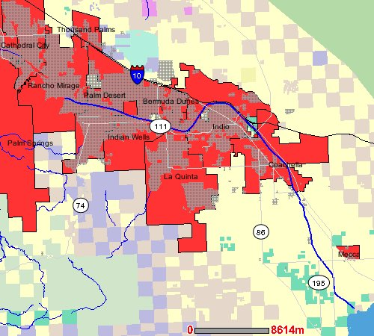
Figure 1. Maps of the sampling area — the Coachella Valley. The left panel shows land use while the right panel shows tributary drains. The CVSC is represented by a blue line in both panels. Site 1 (AV50), Site 2 (APBL) and Site 3 (AV66) are indicated by yellow circles in the left panel.

Possible Sources of Bacteria

Three wastewater treatment facilities and one fish culture facility are permitted point sources for fecal coliforms (and presumably E. coli) discharging into the CVSC. Non-point sources should reflect the land use in the area. Most of the land in the drainage area is wild desert shrub-land (57%) and very little is residential/industrial (6%) so the majority of E. coli sources are expected to be wild animals and birds. Since the sampling in this study was undertaken during months of high bird populations (over-wintering migratory birds) it is expected that birds will be a large source of E. coli. Failing septic tanks are another possible non-point source for E. coli in the CVSC and combined with the wastewater treatment discharge this makes humans likely to be another large source of E. coli.

Sampling Plan

Sampling took place over a six-month period from October 2003 to March 2004. Replicates were collected to provide a total of 200 total samples (Table 1). It was anticipated that IEH would isolate a minimum of two E. coli strains per sample for a minimum of 400 strains to be fingerprinted in the study. There was some variation from the original sampling plan due to uncertainty in funding that resulted in a stop-work after the first week of sampling in November. The funding issue was resolved in late November and sampling resumed in the first week of December, creating an offset in the sampling schedule.

Table 1. Sampling for this study.
Month 2003/04 | Site | Samples  Week 1 | Samples  Week 2 | Samples  Week 3 | Samples  Week 4 | Samples  Week 5 | Samples / Month / Site | Monthly Samples
 | 1 | 2 | 3 | 2 | 3 |  | 10 | 40
October | 2 | 4 | 3 | 4 | 4 |  | 15 | 40
 | 3 | 4 | 3 | 4 | 4 |  | 15 | 40
 | 1 | 2 |  |  |  |  | 2 | 10
November | 2 | 4 |  |  |  |  | 4 | 10
 | 3 | 4 |  |  |  |  | 4 | 10
 | 1 | 3 | 2 | 3 |  |  | 8 | 30
December | 2 | 4 | 4 | 3 |  |  | 11 | 30
 | 3 | 4 | 4 | 3 |  |  | 11 | 30
 | 1 | 2 | 2 | 3 | 3 | 3 | 13 | 49
January | 2 | 4 | 4 | 3 | 4 | 3 | 18 | 49
 | 3 | 4 | 4 | 3 | 4 | 3 | 18 | 49
 | 1 | 2 | 3 | 2 | 3 |  | 10
February | 2 | 4 | 4 | 4 | 4 |  | 16 | 42
 | 3 | 4 | 4 | 4 | 4 |  | 16
 | 1 | 2 | 2 | 3 |  |  | 7 | 29
March | 2 | 4 | 4 | 3 |  |  | 11 | 29
 | 3 | 4 | 4 | 3 |  |  | 11 | 29
Grand Total | 1 |  |  |  |  |  | 50 | 200 Samples
Grand Total | 2 |  |  |  |  |  | 75 | 200 Samples
Grand Total | 3 |  |  |  |  |  | 75 | 200 Samples

Results and Discussion

A total of 200 samples were processed by IEH. Unfortunately, four samples taken in the first week of February lost their labels in transport to IEH. Two were from Site 1 and two from Site 2 so a determination could not be made for the origin of each sample. Fecal coliforms were isolated using the membrane filtration method (Table 2). On average, membrane filter (MF) fecal coliform counts were significantly higher at Site 1 (ANOVA of log₁₀ transformed data, p=0.032) and significantly higher during the month of January (p<0.001).

Table 2. Membrane filter fecal coliform counts (per 100 mL) in Coachella samples.
Site | October | November | December | January | February | March | Average by Site
#1 | 185 | 303 | 257 | 1716 | 1100 | 530 | 615
#2 | 203 | 519 | 212 | 1052 |  | 107 | 396
#3 | 244 | 244 | 201 | 819 | 150 | 503 | 372
LFOª |  | 78 |  |  |  |  | 78
Average by Month | 214 | 313 | 220 | 1182 | 467 | 383 | 438
ª Label Fell Off, 2 samples from Site 1 and 2 samples from Site 2.

Candidate bacterial colonies were confirmed as E. coli by growth on MacConkey agar and by biochemical tests with the API20E kit. Confirmed E. coli strains were catalogued and DNA was extracted to produce ribotype fingerprints. IEH provided Cal Poly with the ribotypes and library matches to fecal sources for the 539 strains of E. coli isolated in this study (Table 3). The complete data set is attached in Appendix A. A total of 162 strains were isolated from Site 1, 167 from Site 2 and 202 strains from Site 3. The number of strains isolated was highest in January and lowest in November and March (Table 3). This was probably due to changes in fecal coliform counts in the samples as well as the number of samples collected in each month.

Table 3. Distribution E. coli strains isolated by month.
Month in 2003 | Site | Week 1 | Week 2 | Week 3 | Week 4 | Week 5 | Month Total
 | 1 | 10 | 15 | 11 | 2 |  | 38
October | 2 | 22 | 7 |  | 3 |  | 32
 | 3 | 18 | 16 |  | 11 |  | 45
 | 1 | 4 |  |  |  |  | 4
November | 2
 | 3 | 6 |  |  |  |  | 6
 | 1 | 30 | 4 | 9 |  |  | 43
December | 2 | 17 | 12 | 9 |  |  | 38
 | 3 | 7 | 12 | 9 |  |  | 28
 | 1 |  | 6 | 9 | 9 | 10 | 34
January | 2 | 5 | 12 | 8 | 12 | 9 | 46
 | 3 | 9 | 12 | 8 | 12 | 10 | 51
 | 1 | 4 | 9 | 6 | 10 |  | 29
February | 2 | 3 | 13 | 13 | 5 |  | 34
 | 3 | 12 | 9 | 8 | 16 |  | 45
 | LFOª | 8 |  |  |  |  | 8
 | 1 |  | 5 | 9 |  |  | 14
March | 2 | 1 | 8 | 8 |  |  | 17
 | 3 | 11 | 12 | 4 |  |  | 27
Grand Total |  |  |  |  |  |  | 539
ª Label Fell Off, 2 samples from Site 1 and 2 samples from Site 2.

Determination of Fecal Sources

Ribotypes from the 531 E. coli strains in the Coachella Valley samples matched to 20 different sources in the IEH library (Table 4). The four samples that lost their labels produced a total of eight E. coli strains that were not included in these analyses. A total of 33strains (6.2%) did not produce ribotypes that matched anything in the IEH source library. This is an excellent result that may reflect a lower diversity of sources at the Coachella Valley site. To facilitate statistical analysis, the 20 sources were placed into six groups.
Table 4. IEH library matches for sources of E. coli found in this study. Row headers (bold) are the groupings used for later analyses. Column numbers are either the total number of strains isolated in a category or the percent of the total for a site.
Group | Source | All Sites | (%) | Site 1 | (%) | Site 2 | (%) | Site 3 | (%)
 | avian | 207 | 39.0 | 62 | 38.3 | 58 | 34.7 | 87 | 43.1
Avian | duck | 5 | 0.9 | 0 | 0.0 | 2 | 1.2 | 3 | 1.5
 | waterfowl | 1 | 0.2 | 0 | 0.0 | 0 | 0.0 | 1 | 0.5
Domestic | dog | 7 | 1.3 | 0 | 0.0 | 6 | 3.6 | 1 | 0.5
Domestic | feline | 3 | 0.6 | 2 | 1.2 | 1 | 0.6 | 0 | 0.0
 | human | 106 | 20.0 | 33 | 20.4 | 41 | 24.6 | 32 | 15.8
Human | sewage | 20 | 3.8 | 5 | 3.1 | 8 | 4.8 | 7 | 3.5
Human | WW effluent | 3 | 0.6 | 3 | 1.9 | 0 | 0.0 | 0 | 0.0
 | WWTP sludge | 1 | 0.2 | 0 | 0.0 | 0 | 0.0 | 1 | 0.5
 | bovine | 9 | 1.7 | 0 | 0.0 | 3 | 1.8 | 6 | 3.0
Livestock | horse | 4 | 0.8 | 0 | 0.0 | 0 | 0.0 | 4 | 2.0
 | sheep | 1 | 0.2 | 0 | 0.0 | 0 | 0.0 | 1 | 0.5
 | muskrat | 2 | 0.4 | 0 | 0.0 | 2 | 1.2 | 0 | 0.0
Rodent | rabbit | 2 | 0.4 | 1 | 0.6 | 0 | 0.0 | 1 | 0.5
Rodent | rodent | 73 | 13.7 | 25 | 15.4 | 20 | 12.0 | 28 | 13.9
 | squirrel | 1 | 0.2 | 0 | 0.0 | 0 | 0.0 | 1 | 0.5
 | canine | 41 | 7.7 | 11 | 6.8 | 9 | 5.4 | 21 | 10.4
Wild Mammal | deer | 2 | 0.4 | 0 | 0.0 | 0 | 0.0 | 2 | 1.0
Wild Mammal | deer/elk | 1 | 0.2 | 0 | 0.0 | 0 | 0.0 | 1 | 0.5
 | raccoon | 9 | 1.7 | 4 | 2.5 | 2 | 1.2 | 3 | 1.5
Unknown | no match | 33 | 6.2 | 16 | 9.9 | 15 | 9.0 | 2 | 1.0
 | Site Total | 531 |  | 162 |  | 167 |  | 202

The dominant group of fecal sources in the study was clearly avian with an overall contribution of 213 strains (40.1%). The next most common source group was human (including sewage, wastewater effluent and wastewater treatment plant sources) with 130 strains (24.6%). When rodent (including muskrat, rabbit and squirrel) and wild mammal (canine, deer, elk and raccoon) sources were added together they contributed a total of 131 strains (24.7%). Canine sources could belong to wild (coyotes) or domestic (dog) canines and were arbitrarily grouped with wild mammals based on the rural nature of the area. Rodent sources alone produced 78 strains (14.7%). Livestock sources (including horse, bovine and sheep) contributed 14 strains (2.7%). Domestic mammals (dog and feline) contributed 10 strains (1.9%).
Distribution of Sources by Site
When the six source groupings, plus unknowns, were analyzed for site distribution, a statistical difference was detected in the composition of sources at each site (Pearson Chi-Square, p<0.001). This was mostly due to changes in the contributions from livestock at Site 3 (Pearson Chi-Square, p=0.001), and domestic animal sources at site 2 (p=0.031). Differences in the avian (p=0.175), human (p=0.099), rodent (p=0.758), and wild mammal (p=0.088) contributions by site were not significant. There was also a significantly lower number of unknown strains at Site 3 (p<0.001). Because these differences were only significant in the low abundance source groups (< 6% total contribution) their statistical significance might be an artifact of the low number of strains isolated for this study. IEH recommends that a minimum of 200 strains be isolated per site to obtain an accurate estimate of source contribution and this was not achieved for Sites 1 and 2.
Figure 2. Source group distribution by site. Each bar represents the number of E. coli from a specified source isolated at a particular site as a percentage of the total E. coli isolated at that site.

Distribution of Sources by Sampling Month
When the six source groupings, plus unknowns, were analyzed for distribution by month of collection (Figure 3), a statistical difference was detected in the source composition (Pearson Chi-Square, p=0.006). This was mostly due to a significant increase in livestock contributions for March (Pearson Chi-Square, p=0.004) and a significantly larger unknown contribution in December (p=0.007). All other groups did not have significantly different contributions across sampling month. The total number of strains isolated declined in March (Figure3, Table 3) due in part to an offset in the sampling schedule created by the stop-work in November. The difference in livestock contributions for March may be an artifact because of the lower number of strains isolated in March and the overall low number of strains isolated from livestock sources.
Figure 3. Source group distribution by sampling month. Each bar represents the number of E. coli from a specified source isolated in a particular month as a percentage of the total E. coli isolated in that month (scale on the left). The line represents the total number of E. coli strains isolated in each month (scale on right).

Distribution of Ribotypes

A total of 141 different ribotype fingerprints were produced from the 539 strains isolated in this study (Table 5). Most ribotypes (110) were found only at a single site. Only 15 ribotypes were found at all three sites and all of these ribotypes were from the most abundant source groups: avian, human or rodent/wild mammal. Avian and rodent source groups showed a ratio of ribotypes per strain of about 1:5, avian with 39 ribotypes per 214 strains and rodent with 18 ribotypes per 78 strains. Conversely, the other source groups showed ratios greater than 1:3. There are two possible explanations for this difference. First, the fecal input from avian and rodent sources may be restricted to consistent input from fewer host animals or fewer species, producing a limited number of ribotypes for the large number of strains isolated. Alternatively, there may be generally less variation in E. coli strains from avian and rodent sources. However, the second possibility is unlikely since the avian source category in particular covers many species while the human source category covers only one host species but still showed a higher ratio (~1:3). However, the differences in ribotype to strain ratio between source groups may not be significant considering the low number of strains isolated in this study.

Table 5. E. coli ribotypes seen in this study, as distributed by source group and sample site.
Seen at | Avian | Domestic | Human | Livestock | Rodent | Wild | Unknown | Total
Site 1 | 12 | 1 | 12 | 0 | 8 | 5 | 7 | 45
1 only | 6 | 1 | 6 | 0 | 4 | 2 | 6 | 25
Site 2 | 16 | 6 | 23 | 2 | 9 | 7 | 7 | 70
2 only | 8 | 6 | 12 | 1 | 4 | 3 | 6 | 40
Site 3 | 24 | 1 | 19 | 7 | 10 | 9 | 1 | 71
3 only | 17 | 1 | 9 | 6 | 4 | 7 | 1 | 45
1 & 2 | 1 | 0 | 1 | 0 | 0 | 2 | 1 | 5
1 & 3 | 0 | 0 | 0 | 0 | 1 | 0 | 0 | 1
2 & 3 | 2 | 0 | 5 | 1 | 2 | 0 | 0 | 10
All 3 Sites | 5 | 0 | 5 | 0 | 3 | 2 | 0 | 15
Sum | 39 | 8 | 38 | 8 | 18 | 16 | 14 | 141

Conclusions
Dominant Fecal Sources
- Avian and human sources clearly dominated all three sites.
- Rodent and wild mammal sources together were as abundant as human sources.
- Domestic animal and livestock contributions were minimal.
Source Distribution by Site and Month
- Differences in contribution by site were only significant for the low abundance sources: domestic animals and livestock. These differences might not be significant if more strains were isolated.
- Differences in contribution by collection month were only significant for livestock (a very low abundance source) and so may also be artifactual.
Ribotype Distributions
- Avian and rodent sources were possibly contributed consistently from the same or very similar host animals. It is unclear if this means the same individual animals or just animals of the same species.

MS4 Permittees who discharge to the impaired portion of the CVSC are Riverside County Flood Control and Water Conservation District (RCFCWCD), Coachella Valley Water District (CVWD), the City of Indio, and the City of Coachella.
The term “provisional” indicates that the data are preliminary and have not received final approval by USGS.
Tribal areas are not subject to County permitting regulations.
Also, 40 CFR Section 130.6(c)(6) requires identification of implementation measures necessary to carry out a Water Quality Control Plan, including financing, the time needed to implement the Plan, and the economic, social and environmental impact of carrying out the Plan in accordance with CWA Section 208(b)(2)(E).

