CALIFORNIA REGIONAL WATER QUALITY CONTROL BOARD
SAN DIEGO REGION

2375 Northside Drive, Suite 100, San Diego, CA 92108
Phone (619) 516-1990 ∙ Fax (619) 516-1994
https://www.waterboards.ca.gov/sandiego

Tentative ORDER NO. R9-2021-0220
AMENDING

CEASE AND DESIST ORDER NO. R9-2021-0107

UNITED STATES SECTION OF THE INTERNATIONAL BOUNDARY AND WATER COMMISSION SOUTH BAY INTERNATIONAL WASTEWATER TREATMENT PLANT DISCHARGE TO THE PACIFIC OCEAN THROUGH THE SOUTH BAY OCEAN OUTFALL
The California Regional Water Quality Control Board, San Diego Region (San Diego Water Board), finds that:

Background
- The International Boundary and Water Commission, United States Section (USIBWC) owns and operates the South Bay International Wastewater Treatment Plant (SBIWTP) and the associated infrastructure located in the United States (U.S.). Together, these facilities comprise a federally-owned treatment works.
- The SBIWTP discharges secondary-treated wastewater to the Pacific Ocean through the South Bay Ocean Outfall. Discharges from the SBIWTP are regulated by National Pollutant Discharge Elimination System (NPDES) Permit No. CA0108928, Order No. R9-2021-0001, Waste Discharge Requirements for the United States Section of the International Boundary and Water Commission South Bay International Discharge to the Pacific Ocean Through the South Bay Ocean Outfall (NPDES Permit), adopted by the San Diego Water Board on May 12, 2021.
- The San Diego Water Board adopted Cease and Desist Order (CDO) No. R9-2021-0107 on May 12, 2021, addressing discharges from the SBIWTP that threaten to take place in violation of the requirements of the NPDES Permit. The CDO requires USIBWC submit a Compliance Assurance Report that identifies all shortcomings, inadequacies, and maintenance issues with regard to control measures that need to be addressed to attain consistent compliance with the effluent limitations contained in the NPDES Permit. The Compliance Assurance Report is required to include a schedule for retaining appropriate contractors and designing, installing, and putting into operation the new or modified control measures, and estimated project costs. The CDO also requires USIBWC make necessary repairs to the SBIWTP by specific dates and comply with reporting requirements and effluent limitations contained in the NPDES Permit.
- On October 7, 2021, USIBWC submitted a revised Compliance Assurance Report which identified anticipated completion dates for various actions. Some of the completion dates identified in the revised Compliance Assurance Report exceeded the time schedule contained in the CDO.
- On October 14, 2021, USIBWC requested that the time schedule contained in the CDO be amended. USIBWC stated that the deadline date in the time schedule for the repair of Junction Box 1 was unattainable because the design for the repair is scheduled to be completed on January 31, 2022, and the repair cannot be completed until the design is completed and the repair is funded. Additionally, USIBWC stated that the deadline date in the time schedule for the replacement of the influent meter and associated piping and valves was unattainable because the COVID-19 pandemic has impacted supply chains causing delays in procuring the valves necessary to complete the project.
- The California Code of Regulations (CCR) title 23, division 3, chapter 9.1, article 1, section 2243 states that a time schedule should always be included in a CDO unless there is a lack of information upon which to base a schedule in which case the discharger should be instructed to comply forthwith. “Forthwith” means as soon as is reasonably possible.

Purpose of this Order
- This Order makes modifications to the time schedule contained in the CDO as requested by USIBWC on October 14, 2021. USIBWC was unable to comply with the time schedule contained in the CDO for the repair of Junction Box 1 and the replacement of the influent meter and associated piping and valves.
- This Order also modifies the CDO to include three additional time schedule tasks. The revised Compliance Assurance Report submitted by USIBWC on October 7, 2021, included several repair, replacement, and/or improvement projects that have not been scheduled or funded. Therefore, this Order modifies the CDO to require USIBWC to submit a revised Compliance Assurance Report once per quarter that includes information on scheduling and project costs as the projects are planned and funded. Additionally, one of the projects listed in the Compliance Assurance Report that has not been funded or scheduled is the replacement of the diffusers in the aeration tanks. Deficient diffusers may result in effluent limitation exceedances including, but not limited to, limitation exceedances for carbonaceous biochemical oxygen demand (CBOD₅), total suspended solids (TSS), settleable solids, and turbidity. Therefore, this Order modifies the CDO to require that the replacement of the diffusers be completed forthwith. Lastly, this Order modifies the CDO to require that USIBWC complete the design of the Junction Box 1 repairs no later than January 31, 2022.
- This Order also modifies the CDO to remove the term “forthwith” from the CDO directives to comply with the transboundary flow reporting requirements, violations reporting requirements, and 5-Day Report requirements of the NPDES Permit. Immediate compliance by USIBWC with these directives is reasonably practicable.
- This Order also modifies the CDO to clarify that immediate compliance with effluent limitations in the NPDES Permit is required for all parameters, except for flow, settleable solids, TSS, turbidity, and CBOD₅. The time schedule contained in the CDO establishes a deadline of January 3, 2022, for USIBWC to achieve consistent compliance with the effluent limitations for flow, settleable solids, TSS, turbidity, and CBOD_{5.}
- This Order also modifies the CDO to include a description of the other needed and/or planned repairs and preventative maintenance as described in the Compliance Assurance Report submitted by USIBWC on October 7, 2021.
- This Order also modifies the CDO to clarify that the San Diego Water Board may amend the CDO if it is determined that the failure to comply with the time schedule contained in the CDO is due to a force majeure or some other reason that the San Diego Water Board agrees is out of USIBWC’s control.
- This Order also modifies the CDO to include a definition of the term “forthwith”.

Legal Authorities
- The CDO is not being reopened for any other purpose than the revisions contained herein. Except as contradicted or superseded by the findings and directives set forth in this Order, all the previous findings and directives of the CDO shall remain in full force and effect.

California Environmental Quality Act
- As an enforcement action, this CDO is exempt from the provisions of the California Environmental Quality Act (Public Resources Code § 21000 et seq.) in accordance with Title 14 of the California Code of Regulations, section 15321.

Public Participation
- The San Diego Water Board has notified all known interested parties of its intent to adopt this Order.
- The San Diego Water Board released this Order for a 12-day public comment period on October 20, 2021. Public comments were due no later than 5:00 PM on November 1, 2021.
- The San Diego Water Board, in a public meeting on December 8, 2021, heard and considered all comments pertaining to the adoption of this Order.
- Any person aggrieved by this action of the San Diego Water Board may petition the State Water Resources Control Board (State Water Board) to review the action in accordance with Water Code section 13320 and California Code of Regulations, title 23, sections 2050 et seq. The State Water Board must receive the petition by 5:00 p.m., 30 days after the adoption date of this Order. Copies of the law and regulations applicable to filing petitions may be found on the Internet at: https://www.waterboards.ca.gov/public_notices/petitions/water_quality or will be provided upon request.
IT IS HEREBY ORDERED:
- This Order amends the CDO as described in the revised version included as Attachment 1 to this Order. Added text to the CDO is displayed in redline text and deleted text is displayed as strikeout text. Modifications to the CDO were made to the following sections:

Page No. | Section No.
1 | Title
2 through 12 | Heading
8 | Section 12
8 | Section 14
8 | Section 16
8 | Section 17
8 through 9 | Section 18
10 through 11 | Section 1, Table 2
11 | Section 2
11 | Section 3
11 | Section 4
11 | Section 5
11 through 12 | Section 6
12 | Certification Statement
A-1 | Attachment A Heading
B-1 | Attachment B Heading

- The amended version of the CDO included as an attachment to this Order shall become effective on December 8, 2021.
- San Diego Water Board staff is directed to prepare and post a conformed copy of the CDO incorporating the revisions made by this Order.

I, David W. Gibson, Executive Officer, do hereby certify that this Order is a full, true, and correct copy of an Order adopted by the California Regional Water Quality Control Board, San Diego Region, on December 8, 2021.

Tentative
David W. Gibson, Executive Officer

CALIFORNIA REGIONAL WATER QUALITY CONTROL BOARD
SAN DIEGO REGION
CEASE AND DESIST ORDER NO. R9-2021-0107
AS AMENDED BY ORDER NO. R9-2021-0220
UNITED STATES SECTION OF THE
INTERNATIONAL BOUNDARY AND WATER COMMISSION
SOUTH BAY INTERNATIONAL WASTEWATER TREATMENT PLANT
DISCHARGE TO THE PACIFIC OCEAN THROUGH THE SOUTH BAY OCEAN OUTFALL
WHEREAS the California Regional Water Quality Control Board, San Diego Region (San Diego Water Board) finds the following:
Background
- The International Boundary and Water Commission, United States Section (USIBWC) owns and operates the South Bay International Wastewater Treatment Plant (SBIWTP) and the associated infrastructure in the United States (U.S.). Together, these facilities comprise a federally-owned treatment works. These facilities are collectively referred to as the Facility or Facilities in this Cease and Desist Order (CDO).
- The SBIWTP discharges secondary-treated wastewater to the Pacific Ocean through the South Bay Ocean Outfall. Attachment A provides a map of the area around the Facility. Attachment B provides collection system flow schematics of the Facility and infrastructure in Mexico.
- USIBWC was previously regulated by National Pollutant Discharge Elimination System (NPDES) Permit No. CA0108928 which was issued by the San Diego Water Board as Order No. R9-2014-0009, as amended by Order Nos. R9-2014-0094, R9-2017-0024 and R9-2019-0012, Waste Discharge Requirements for the United States Section of the International Boundary and Water Commission, South Bay International Discharge to the Pacific Ocean Via the South Bay Ocean Outfall (2014 Permit). The 2014 Permit expired on July 31, 2018 but remained in effect until such time as it was superseded by a reissued NPDES permit.
- On May 12, 2021, the San Diego Water Board reissued NPDES Permit No. CA0108928, as Order R9-2021-0001, Waste Discharge Requirements for the United States Section of the International Boundary and Water Commission South Bay International Discharge to the Pacific Ocean Through the South Bay Ocean Outfall (2021 Permit).
- The 2014 and 2021 Permits established requirements for the discharge of 25 million gallons per day (MGD) of treated wastewater from the SBIWTP through the South Bay Ocean Outfall to the Pacific Ocean and include discharge prohibitions, effluent limitations calculated from secondary treatment standards, and other more stringent limits necessary to meet water quality standards, receiving water limitations for ocean waters, an effluent and receiving water monitoring program, reporting requirements, and other miscellaneous provisions.
Effluent Limitation Violations
- The 2021 Permit contains the following numeric effluent limitations, among others, with compliance measured at Monitoring Location EFF-001, as described in the 2021 Permit’s Monitoring and Reporting Program (MRP, Attachment E):
Table 1. Numeric Effluent Limitations at Discharge Point 001
Parameter | Units | Average Monthly  Effluent Limitation (AMEL) | Average Weekly  Effluent Limitation (AWEL) | Instantaneous Maximum Effluent Limitation (IMEL)
Flow | MGD | 25 | - | -
Carbonaceous  Biochemical Oxygen  Demand (5-Day at  20°C) (CBOD₅) | milligrams/ liter (mg/L) | 25 | 40 | -
CBOD₅ | pounds/ day (lbs/day) | 5,213 | 8,340 | -
CBOD₅ | percent removal | ≥ 85 | - | -
Total Suspended Solids (TSS) | mg/L | 30 | 45 | -
TSS | lbs/day | 6,255 | 9,383 | -
TSS | percent removal | ≥ 85 | - | -
Settleable Solids | milliliters/liter (mL/L) | 1.0 | 1.5 | 3.0
Turbidity | nephelometric  turbidity unit (NTU) | 75 | 100 | 225
- Based on the data collected at Monitoring Location EFF-001, USIBWC threatens to violate the 2021 Permit effluent limitations, in Table 1 of this CDO. Between November 2020 and January 2021, USIBWC reported 46 exceedances of effluent limitations contained in the 2014 Permit for the parameters listed in Table 1. USIBWC attributed the primary cause of these effluent limitation exceedances to excess influent flow volume beyond the design capacity of the secondary treatment processes. Compliance with the 2021 Permit effluent limitations is unlikely until the sluice gates in Junction Box 1 have been repaired and flows into the SBIWTP are reduced to a monthly average of 25.0 MGD. Thus, until USIBWC completes the actions described in Table 2 of this CDO, discharges from the Facility threaten to continue taking place in violation of the requirements of the 2021 Permit.
  - In November 2020, USIBWC reported the following 20 violations of effluent limitations contained in the 2014 Permit for Discharge Point 001:
- Flow exceeded the AMEL of 25 million MGD with a result of 30.95 MGD at Discharge Point 001.
- CBOD₅ exceeded the AMEL of 25 mg/L with a result of 44 mg/L.
- CBOD₅ exceeded the AMEL of 5,213 lbs/day with a result of 11,422 lbs/day.
- CBOD₅ exceeded the AWEL of 40 mg/L with a result of 51 mg/L for the week of November 15 through November 21, 2020.
- CBOD₅ exceeded the AWEL of 40 mg/L with a result of 81 mg/L for the week of November 22 through November 28, 2020.
- CBOD₅ exceeded the AWEL of 8,340 lbs/day with a result of 13,069 lbs/day for the week of November 15 through November 21, 2020.
- CBOD₅ exceeded the AWEL of 8,340 lbs/day with a result of 21,328 lbs/day for the week of November 22 through November 28, 2020.
- CBOD₅ did not achieve the required average monthly percent removal of no less than 85 percent with a result of 80.8 percent removal.
- TSS exceeded the AMEL of 30 mg/L with a result of 97 mg/L.
- TSS exceeded the AMEL of 6,255 lbs/day with a result of 25,137 lbs/day.
- TSS exceeded the AWEL of 45 mg/L with a result of 143 mg/L for the week of November 15 through November 21, 2020.
- TSS exceeded the AWEL of 45 mg/L with a result of 175 mg/L for the week of November 22 through November 28, 2020.
- TSS exceeded the AWEL of 9,383 lbs/day with a result of 36,667 lbs/day for the week of November 15 through November 21, 2020.
- TSS exceeded the AWEL of 9,383 lbs/day with a result of 46,089 lbs/day for the week of November 22 through November 28, 2020.
- TSS did not achieve the required average monthly percent removal of no less than 85 percent with a result of 67.2 percent removal.
- Settleable Solids exceeded the IMEL of 3.0 mL/L with a result of 3.5 mL/L on November 18, 2020.
- Settleable Solids exceeded the IMEL of 3.0 mL/L with a result of 15 mL/L on November 19, 2020.
- Settleable Solids exceeded the IMEL of 3.0 mL/L with a result of 7.5 mL/L on November 20, 2020.
- Turbidity exceeded the AWEL of 100 NTU with a result of 107.96 for the week of November 22 to November 28, 2020.
- Turbidity exceeded the IMEL of 225 NTU with a result of 270 NTU on November 22, 2020.
  - In December 2020, USIBWC reported the following 17 violations of effluent limitations contained in the 2014 Permit for Discharge Point 001:
- Flow exceeded the AMEL of 25 MGD with a result of 28.15 MGD at Discharge Point 001.
- CBOD₅ exceeded the AMEL of 25 mg/L with a result of 34 mg/L.
- CBOD₅ exceeded the AMEL of 5,213 lbs/day with a result of 7,864 lbs/day.
- CBOD₅ exceeded the AWEL of 40 mg/L with a result of 48.71 mg/L for the week of November 29 through December 5, 2020.
- CBOD₅ exceeded the AWEL of 8,340 lbs/day with a result of 11,746 lbs/day for the week of November 29 through December 5, 2020.
- CBOD₅ exceeded the AWEL of 8,340 lbs/day with a result of 8,943 lbs/day for the week of December 6 through December 12, 2020.
- CBOD₅ did not achieve the required average monthly percent removal of no less than 85 percent with a result of 84.6 percent removal.
- TSS exceeded the AMEL of 30 mg/L with a result of 67 mg/L.
- TSS exceeded the AMEL of 6,255 lbs/day with a result of 15,719 lbs/day.
- TSS exceeded the AWEL of 45 mg/L with a result of 106 mg/L for the week of November 29 through December 5, 2020.
- TSS exceeded the AWEL of 45 mg/L with a result of 71 mg/L for the week of December 6 through December 12, 2020.
- TSS exceeded the AWEL of 45 mg/L with a result of 59 mg/L for the week of December 20 through December 26, 2020.
- TSS exceeded the AWEL of 9,383 lbs/day with a result of 25,582 lbs/day for the week of November 29 through December 5, 2020.
- TSS exceeded the AWEL of 9,383 lbs/day with a result of 16,500 lbs/day for the week of December 6 through December 12, 2020.
- TSS exceeded the AWEL of 9,383 lbs/day with a result of 10,074 lbs/day for the week of December 13 through December 19, 2020.
- TSS exceeded the AWEL of 9,383 lbs/day with a result of 13,559 lbs/day for the week of December 20 through December 26, 2020.
- TSS did not achieve the required average monthly percent removal of no less than 85 percent with a result of 76.6 percent removal.
  - In January 2021, USIBWC reported the following nine violations of effluent limitations contained in the 2014 Permit for Discharge Point 001:
- CBOD₅ exceeded the AWEL of 40 mg/L with a result of 64.27 mg/L for the week of January 24 through January 30, 2021.
- CBOD₅ exceeded the AWEL of 8,340 lbs/day with a result of 13,274 lbs/day for the week of January 24 through January 30, 2021.
- TSS exceeded the AMEL of 30 mg/L with a result of 46.4 mg/L.
- TSS exceeded the AMEL of 6,255 lbs/day with a result of 9,175 lbs/day.
- TSS exceeded the AWEL of 45 mg/L with a result of 148.8 mg/L for the week of January 24 through January 30, 2021.
- TSS exceeded the AWEL of 9,383 lbs/day with a result of 29,353 lbs/day for the week of January 24 through January 30, 2021.
- Settleable Solids exceeded the IMEL of 3.0 mL/L with a result of 15.5 mL/L on January 25, 2021.
- Settleable Solids exceeded the IMEL of 3.0 mL/L with a result of 38 mL/L on January 29, 2021.
- Turbidity exceeded the IMEL of 225 NTU with a result of 400 NTU on January 30, 2021.
Reporting Violations
- Sections VI.C.2.d.iii. and VI.C.2.d.iv of the 2014 Permit required USIBWC to submit a preliminary report within three business days of becoming aware of certain spill and transboundary flow events, including Type A transboundary flows (i.e., dry weather transboundary flows at the canyon collector systems), and submit a certified report for certain spill and flow events within 15 calendar days of the spill or flow end date, and requested this information for dry weather transboundary flows at other locations.
Under the 2014 Permit, USIBWC failed to timely submit 11 preliminary reports and 11 certified reports for Type A transboundary flows occurring between September 2020 and December 2020.
The following canyon collector transboundary flows reports were submitted untimely in violation of the 2014 Permit:
- 33,900-gallon transboundary flow at Stewart’s Drain on September 5, 2020.
- 2,500-gallon transboundary flow at Stewart’s Drain on November 10, 2020.
- 141,750-gallon transboundary flow at Stewart’s Drain on November 16, 2020.
- 25,000-gallon transboundary flow at Stewart’s Drain on November 23, 2020.
- 314,000-gallon transboundary flow at Stewart’s Drain on November 26, 2020.
- 900-gallon transboundary flow at Stewart’s Drain on November 28, 2020.
- 539-gallon transboundary flow at Stewart’s Drain on December 15, 2020.
- 43,354-gallon transboundary flow at Stewart’s Drain on December 19, 2020.
- 600-gallon transboundary flow at Stewart’s Drain from December 20 to December 21, 2020.
- 33,000-gallon transboundary flow at Stewart’s Drain from December 21 to December 22, 2020.
- 325,380-gallon transboundary flow at Stewart’s Drain on December 26, 2020.
Sections 6.3.2.4.3 and 6.3.2.4.4 of the 2021 Permit similarly requires USIBWC to submit a preliminary report within three business days of becoming aware of a transboundary flow that reaches a surface water and submit a certified report for the transboundary flow within 15 calendar days of the transboundary flow end date.
- Sections VIII.A.2 and VIII.B.7 of Attachment E of the 2014 Permit required USIBWC to clearly identify violations of waste discharge requirements and discuss corrective actions taken or planned to address the noncompliance in monitoring report cover letters.
Under the 2014 Permit, USIBWC failed to clearly identify violations of waste discharge requirements and discuss corrective actions taken or planned to address the noncompliance in monitoring report cover letters at least twice between February 2020 and January 2021.
On February 7, 2020, USIBWC exceeded the settleable solids IMEL of 3.0 ml/L with a result of 6.5 ml/L at Discharge Point 001. USIBWC failed to clearly identify the violation and describe the corrective actions taken or planned to address the noncompliance. Instead, USIBWC reported that there were no unusual effluent conditions observed in the month of February 2020.
USIBWC also failed to clearly identify the turbidity IMEL violation on January 30, 2021, and the settleable solids IMEL violation on January 25, 2021 (see Finding 7.c above), in the January 2021 monitoring report.
Section 7.2.7.2, of Attachment E, of the 2021 Permit, similarly requires USIBWC to clearly identify violations of waste discharge requirements and discuss corrective actions taken or planned to address the noncompliance in the monitoring report cover letter.
- Section V.E.1 of Attachment D of the 2014 Permit required USIBWC to report any noncompliance which may endanger health or the environment within 24 hours and to provide a written report within five days of becoming aware of the circumstances (5-Day Report) that includes a description of the noncompliance and its cause; the period of noncompliance, including exact dates and times, and if the noncompliance has not been corrected, the anticipated time it is expected to continue; and steps taken or planned to reduce, eliminate, and prevent reoccurrence of the noncompliance.
As described in Finding 7 of this CDO, USIBWC reported 46 effluent violations from November 2020 through January 2021 that endangered the environment. To date, USIBWC has not submitted any 5-Day Reports addressing the violations and has not responded to the San Diego Water Board’s requests for the 5-Day Reports.
Section 5.5.1 of Attachment D of the 2021 Permit includes similar requirements to report any noncompliance that may endanger the health or the environment within 24 hours and provide a 5-Day Report.
CDO Authority
- Water Code section 13301 authorizes the San Diego Water Board to issue a CDO when it finds that a waste discharge is taking place, or threatening to take place, in violation of San Diego Water Board requirements or discharge prohibitions prescribed by the San Diego Water Board. The San Diego Water Board may, in a CDO, direct that those persons not complying with the requirements or discharge prohibitions to a) comply forthwith, b) comply in accordance with a time schedule set by the Board, or c) in the event of a threatened violation, take appropriate remedial or preventive action.
- Based on recent reports from USIBWC regarding the condition of the Facilities, Finding 7 explains that discharges at Discharge Point 001 occurred in violation of the 2014 Permit requirements. As conditions at the Facility will continue until USIBWC conducts and performs necessary maintenance, repairs, and other deliverables at the Facilities, USIBWC is threatening to violate the 2021 Permit effluent limitations. “Forthwith” means as soon as is reasonably possible.
- This CDO establishes a time schedule for USIBWC to conduct and perform necessary maintenance, repairs, and other deliverables to ensure that USIBWC will cease threatening to violate the 2021 Permit requirements.
- The volume of influent flow into the SBIWTP cannot be controlled until USIBWC completes the actions listed in Table 2 of this CDO. If the volume of influent flows continues to exceed the design capacity of the secondary treatment processes at the Facility, discharges from the Facility threaten to continue taking place in violation of the 2021 Permit effluent limitations or any reasonable interim effluent limits. Thus, this CDO requires USIBWC to comply with numeric effluent limitations in the 2021 Permit for flow, settleable solids, TSS, turbidity, and CBOD₅ through timely completion of the actions listed in Table 2 of this CDO.
- The time schedule in Table 2 is as short as possible, based on reasonably expected times needed to select contractors, and for new or modified control measures to be designed, installed, and put into operation. The San Diego Water Board may modify the tasks and time schedule for completing the tasks if it receives new information.
- Finding 8 explains that USIBWC failed to timely submit dry weather canyon collector transboundary flow reports in violation of the 2014 Permit. Pursuant to the 2021 Permit, USIBWC is required to provide similar reports for all types of transboundary flows. Based on USIBWC’s pattern of failing to timely submit transboundary flow reports, USIBWC threatens to violate the 2021 Permit requirements. This CDO requires USIBWC to comply with the transboundary flow reporting requirements in the 2021 Permit.
- Finding 9 explains that USIBWC failed to clearly identify violations of waste discharge requirements and discuss corrective actions taken or planned to address the noncompliance in violation of the 2014 permit. Pursuant to the 2021 Permit, USIBWC is required to provide similar notifications of noncompliance. Based on USIBWC’s pattern of failing to report all violations of waste discharge requirements and discussing the corrective actions taken or planned to address the noncompliance, USIBWC threatens to violate the 2021 Permit. This CDO requires USIBWC to comply with the violation reporting requirements in the 2021 Permit.
- Finding 10 explains that USIBWC has failed to submit to the San Diego Water Board 5-Day Reports addressing the 46 effluent limitation violations that threaten the environment in violation of the 2014 Permit. Pursuant to the 2021 permit, USIBWC is required to submit the same 5-Day Report for any violation that threatens the environment. Based on USIBWC’s pattern of failing to submit the 5-Day Report after multiple requests by the San Diego Water Board, USIBWC threatens to violate the 2021 Permit. This CDO requires USIBWC to comply with the requirement to submit a 5-Day Report in the 2021 Permit.
- Water Code section 13383, subdivision (a), authorizes the San Diego Water Board to “establish monitoring, inspection, entry, reporting, and recordkeeping requirements . . . for any person who discharges, or proposes to discharge, to navigable waters . . . .” The San Diego Water Board “may require any person subject to this section to establish and maintain monitoring equipment or methods, including, where appropriate, biological monitoring methods, sample effluent as prescribed, and provide other information as may be reasonably required.” (Water Code, § 13383, subd. (b); see also 33 U.S.C. § 1318(a); 40 C.F.R. § 122.41(h).) This CDO requires USIBWC to submit a Compliance Assurance Report. The Compliance Assurance Report will assist USIBWC and the San Diego Water Board in identifying the actions needed for the Facility to attain consistent compliance with the effluent limitations in the 2021 Permit in a timely manner, and to protect water quality and beneficial uses in the receiving water. The San Diego Water Board may amend Table 2 of this CDO based on the information in the Compliance Assurance Report. Water Code section 13383 does not require the San Diego Water Board to consider costs of compliance. However, the San Diego Water Board strives to ensure that costs of compliance are reasonable and warranted. The San Diego Water Board estimates the cost of providing the Compliance Assurance Report will range from $1,200 and $2,000. USIBWC may also rely on existing reports to develop the Compliance Assurance Report, which may reduce costs. The burden, including cost, of the Compliance Assurance Report is reasonable and warranted based on the need to ensure compliance with the 2021 Permit effluent limits, and to protect water quality and beneficial uses in the receiving water.
- As an enforcement action, this CDO is exempt from the provisions of the California Environmental Quality Act (Public Resources Code § 21000 et seq.) in accordance with Title 14 of the California Code of Regulations, section 15321.
- The San Diego Water Board notified USIBWC and interested persons of its intent to consider adoption of this CDO and provided an opportunity to appear and provide comments at a public hearing. The San Diego Water Board, at a public hearing, heard and considered all comments.
IT IS HEREBY ORDERED, in accordance with Water Code sections 13301 and 13383, that USIBWC shall cease and desist from discharging and threatening to discharge wastes in violation of the 2021 Permit by complying with the following provisions:
- USIBWC shall complete the actions listed in Table 2 of this CDO in accordance with the time schedule provided therein to consistently comply with all effluent limitations contained in the 2021 Permit, and to protect water quality and beneficial uses in the receiving water. USIBWC shall implement all actions set forth for each deliverable.
Table 2: Time Schedule and Prescribed Actions
Task | Deadline
Submit a Compliance Assurance Report that identifies all shortcomings, inadequacies, and maintenance issues with regard to control measures that need to be addressed to attain consistent compliance with the effluent limitations contained in the 2021 Permit. The report shall also include a schedule for retaining appropriate contractors and designing, installing, and putting into operation the new or modified control measures and estimated project costs. | June 30, 2021
Submit a revised Compliance Assurance Report. The Compliance Assurance Report shall be continuously revised to include information on scheduling and project costs as it is determined, and any additional Facility deficiencies not already included in the Compliance Assurance Report. The revised Compliance Assurance Report shall be submitted quarterly until this CDO is terminated. | Once per quarter on January 1, April 1, July 1, and October 1 of each year  until the termination of this CDO
Complete supervisory control and data acquisition (SCADA) upgrades | December 31, 2021
Replace two influent pumps | October 1, 2021
Complete design for Junction Box 1 repairs | January 31, 2022
Complete repairs of Junction box 1  i. Repair 72-inch Sluice Gate  ii. Repair 96-inch Sluice Gate | Comply forthwith
Replace the influent meter  i. Replace the temporarily repaired influent pipe  ii. Replace the two valves on the replaced influent pipe | February 13, 2023
Replace belt filter press | January 3, 2022
Replace diffusers in aeration tanks | Comply forthwith
Other needed/planned repairs including, but not limited to, upgrading the secondary treatment process aeration blower, refurbishing bar screens 1, 2, and 3, replacing the unstabilized sludge storage tank (USST) valves and piping, repairing the secondary treatment process main breaker and ground fault, and replacing the conduit and wiring in the solids processing building. | Comply forthwith
Other needed/planned preventive maintenance including, but not limited to, cleaning the USST, improving the electrical for influent pumps 1, 3, and 5, and isolating the switchgear transformer for the headworks treatment process needed for corrective and preventative maintenance on downstream equipment. | Comply forthwith
Achieve consistent compliance with the 2021 Permit effluent limitations for flow, settleable solids, TSS, turbidity, and CBOD₅ as described in Table 1 of this CDO | January 3, 2022
- USIBWC shall comply with the 2021 Permit effluent limitations, except for the effluent limitations for flow, settleable solids, TSS, turbidity, and CBOD₅.
- USIBWC shall comply with the transboundary flow reporting requirements in the 2021 Permit.
- USIBWC shall comply with the violation reporting requirements in the 2021 Permit.
- USIBW shall comply with the 5-Day Report requirements in the 2021 Permit.
Consequences of Non-Compliance
- USIBWC shall submit a written statement within 10 days after each compliance date in Table 2 of the CDO documenting compliance or noncompliance with the specified task. If USIBWC is delayed, interrupted, or prevented from meeting the provisions and time schedule of this CDO due to a force majeure or some other reason out of USIBWC’s control, USIBWC shall notify the Executive Officer in writing within ten days of the date USIBWC first knows of the force majeure or other reason. USIBWC shall demonstrate that timely compliance with the CDO or any affected deadlines will be actually and necessarily delayed, and that it has taken measures to avoid or mitigate the delay by exercising all reasonable precautions and efforts, whether before or after the occurrence of the force majeure or other reason. If the San Diego Water Board agrees that the failure to complete the action by the deadline listed in Table 2 was due to a force majeure or some other reason out of USIBWC’s control, the San Diego Water Board may amend this CDO to modify the time schedule for the action.
- If USIBWC fails to comply with the provisions of this CDO, the San Diego Water Board Executive Officer is hereby authorized to take enforcement action or to request the Attorney General to take appropriate actions against USIBWC in accordance with Water Code sections 13308, 13331, 13350, 13385, and 13386. Such actions may include injunctive and civil remedies, if appropriate, or the issuance of an Administrative Civil Liability Complaint for the San Diego Water Board’s consideration.
Effective Date
- This CDO shall become effective on May 12, 2021.
I do hereby certify the foregoing is a full, true, and correct copy of a CDO adopted by the California Regional Water Quality Control Board, San Diego Region on May 12, 2021, and amended on December 8, 2021.

David W. Gibson, Executive Officer

Attachment A – Map of the South Bay International Treatment Plant and Associated Facilities

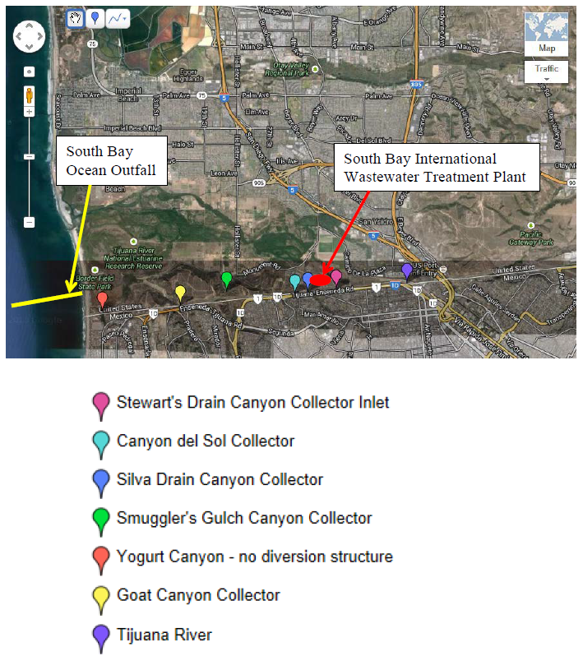

Attachment B – Collection System Flow Schematic
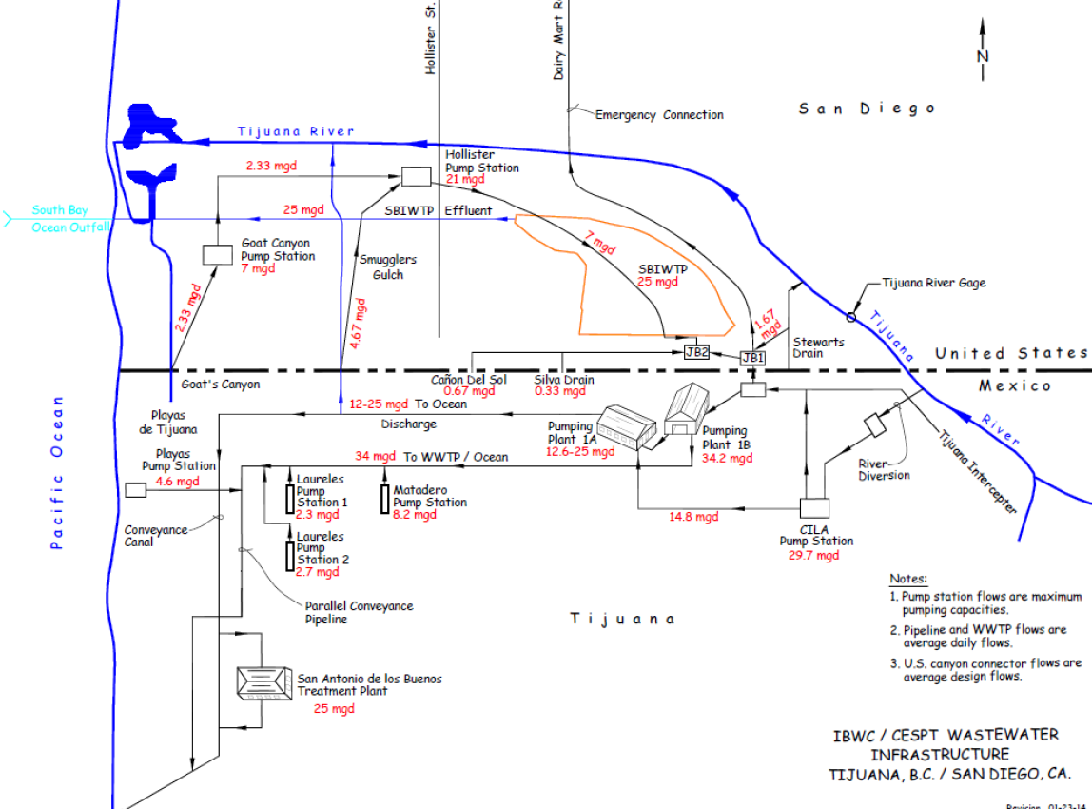

Infrastructure in the U.S. includes, but is not limited to, South Bay International Wastewater Treatment Plant; five canyon collector systems located at Stewart’s Drain, Canyon del Sol, Silva’s Drain, Smugglers Gulch, and Goat Canyon; Hollister Street Pump Station and Goat Canyon Pump Station; Junction Box 1 and 2; South Bay Land Outfall; South Bay Ocean Outfall; and other associated infrastructure such as pipes and conveyances between the diversion structures, pump stations, and the wastewater treatment plant (see Attachment F section 1.1 of the 2021 Permit).
USIBWC also failed to timely submit reports for transboundary flows occurring between December 2018 and January 2019. USIBWC provided notice to the San Diego Water Board that the federal government shutdown from December 22, 2018, to January 25, 2019, resulted in reduced staffing at USIBWC. The San Diego Water Board acknowledged the federal government shutdown may have caused delays in transboundary flow reporting in a letter to Mr. Carlos Pena, USIBWC on March 1, 2019.
This estimate is based on the assumption that the Compliance Assurance Report will take approximately 20 hours to complete by a professional engineer at an estimated cost of $60 to $100 per hour.
Table 2 establishes the deadline for USIBWC to achieve consistent compliance with the effluent limitations for flow, settleable solids, TSS, turbidity, and CBOD₅.
A “force majeure” is an event that could not have been anticipated by and is beyond the control of USIBWC, including an act of God; earthquake, flood, or other natural disaster; civil disturbance or strike; fire or explosion; declared war within the United States; embargo; or other event of similar import and character. “Force majeure” does not include delays caused by funding, contractor performance, equipment delivery and quality, weather, permitting, other construction-related issues, CEQA challenges, initiative litigation, adverse legislation, or legal matters (with the exception of an injunction issued by a court of law specifically preventing construction from occurring).

