Eutrophication indicator thresholds protective of biological integrity in California wadeable streams

Authors:

Raphael D. Mazor1,2, Martha Sutula1, Susana Theroux1, Marcus Beck1, Peter R. Ode2, OTHERS

1 Southern California Coastal Water Research Project. Costa Mesa, California

2 California Department of Fish and Wildlife. Rancho Cordova, California

For submittal to Freshwater Science

# Abstract:

Eutrophication is one of the most pervasive stressors impacting streams in much of the world, including California, and can lead to loss of biodiversity or change in natural functions. To protect against these impacts, managers can set targets for environmental indicators related to eutrophication that are likely to maintain high biological integrity. To identify thresholds as the basis for potential management targets, we evaluated the responses of four bioassessment indices (one for benthic macroinvertebrates and three for benthic algae assemblages) to five eutrophication indicators (total nitrogen [TN], total phosphorus [TP], benthic chlorophyll-a [chl-a], benthic ash-free dry mass [AFDM], and percent macroalgal cover [% cover] of the streambed); specifically, we used a bioassessment data set of hundreds of sites in California to model the likelihood of achieving a range of biointegrity goals for each index along increasing gradients of each indicator, set thresholds where gradients were associated with a 90% relative likelihood of achieving the goal; we then validated the thresholds with relative risk assessment, and selected the lowest validated threshold across the four indices. All eutrophication indicators were significantly associated with increased risks to biointegrity, resulting in a set of validated thresholds for each biointegrity goal. For example, to achieve index scores above the 10th percentile of reference (a biointegrity goal that has been used in certain regulatory applications), thresholds of 0.32 mg/L TN, 0.08 mg/L TP, 28 mg/m2 benthic chl-a, 2 mg/cm2 AFDM, and 13 % cover would be required. Unexpectedly, the benthic macroinvertebrate index often had a stronger relationship with eutrophication indicators than the algal indices, and nutrient concentrations had stronger relationships than measures of organic matter; both patterns may reflect the greater challenges in producing algal taxonomic and organic matter data, respectively. Applying thresholds to a statewide dataset showed that % cover was the most pervasively exceeded threshold (46% of sites), although exceedances of the other organic matter thresholds were common in the urbanized South Coast region (73% of sites), and nutrient exceedances were common in the agricultural Central Valley (67% of sites). Although each threshold was independently validated, sites that exceeded a single threshold were still frequently (i.e., 71%) in good condition (i.e., they met biointegrity goals when measured with all four indices), suggesting a high error rate associated with these thresholds; the frequency dropped to 38% when two thresholds were exceeded. Error rates were particularly high for % cover and AFDM thresholds (i.e., ~77%). Therefore, consideration of multiple thresholds may be useful to avoid erroneous determinations of eutrophication impacts.

# Key words:

Eutrophication, wadeable streams, water quality goals, benthic macroinvertebrates, benthic diatoms, soft-bodied algae, biological integrity

# Introduction

Eutrophication is a major environmental concern in wadeable stream ecosystems worldwide (Dodds and Welch 2000) and in California (Rehn XXX), with demonstrated links between anthropogenic land use changes in the upstream watershed and adverse impacts to ecosystem condition and services. Mitigating these impacts by setting management targets that limit the factors that drive eutrophication may therefore have profound and large-scale impacts on the ecological condition of streams. However, setting targets appropriately requires an understanding of the links between indicators of eutrophication (e.g., nutrient concentrations or organic matter accumulation) and broad-scale measures of biological integrity, such as bioassessment indices based on benthic macroinvertebrates or algal assemblages.

Eutrophication may degrade stream ecosystems through diverse pathways (Figure 1), such as restructuring algal and aquatic plant communities, resulting in high biomass of soft-bodied filamentous algae (Stevenson et al. 1996) that can outcompete benthic diatoms and smother habitat for invertebrates and fish (Quinn and Hickey 1990). Increased autotrophic and heterotrophic production result in wide fluctuation in dissolved oxygen (DO) or chronically low DO (Heiskary and Bouchard 2015). Stream benthic macroinvertebrate (BMI) assemblages change in direct response to increased nutrient enrichment and eutrophication towards an increase in pollution tolerant taxa, but often lowered total BMI diversity, density, and biomass (Miltner and Rankin 1998, Chambers et al. 2006). Fish-kills and lowered fishery production (Quinn and Gillian 1989) occur, along with increased frequency and extent of toxic harmful algal blooms, and poor water quality (Bates et al. 1989, Bates et al. 1991, Trainer et al. 2002, Heiskary and Bouchard 2013, Speer 2015).

Assessment approaches and water quality goals (WQG) are needed to prevent wadeable stream eutrophication from occurring and to provide numeric targets to restore watersheds where adverse effects have occurred. Whereas nutrient pollution (including forms of nitrogen and phosphorus) is a leading cause of eutrophication, scientific literature has demonstrated the shortcomings of using ambient nutrient concentrations alone to diagnose this problem (Welch et al. 1989, Fevold 1998, Chetelat et al. 1999, Heiskary and Markus 2001, Dodds et al. 2002, Heiskary and Bouchard 2013). Other factors that can cause or significantly contribute to eutrophication are associated with the conversion of watersheds to developed land uses, such as hydromodification, altered water temperature, and light availability, etc. (Paerl et al. 2011). In addition, biological response to nutrients (e.g., autotrophic and heterotrophic productivity) depends on a variety of mitigating indicators such as basin morphology and substrate characteristics, stream hydrology, biological community structure, algal predation rates and dispersal from source populations. Thus, high nutrient concentrations are not always an indicator of eutrophication, and low concentrations do not necessarily indicate absence of eutrophication (Heiskary and Bouchard 2013). Indicators that assess the degree of organic matter accumulation (OM) in wadeable streams, such as benthic chlorophyll-a (chl-a), benthic ash-free dry mass (AFDM) and percent macrolagal cover (% cover), can provide multiple lines of evidence that integrate autotrophic and heterotrophic production, thus strengthening eutrophication assessments. However, little published literature exists on the comparative strength of these OM indicators to assess eutrophication impacts on biointegrity of wadeable streams and the scientific bases with which to establish numeric WQG to protect aquatic life.

State-adopted BMI and algal bioassessment indices provide tools to measure and assess attainment of management goals to protect wadeable stream aquatic life from eutrophication (EPA 2002). Bioassessment indices have widespread global use in stream management, used in routine interpretation of stream bioassessment data, in regulatory biocriteria (Davis and Simon 1995, Council of European Communities 2000, USEPA 2002, Yoder and Barbour 2009), pollution discharge permits, stream restoration targets, and as the basis for nutrient WQG development (Heiskary and Bouchard 2015, Jessup et al. 2015). Bioassessment indices can score the condition of aquatic life, e.g. benthic macroinvertebrates (BMI), benthic algae, fish, and other resident organisms based on assemblage structure, relative to structure at minimally disturbed reference sites with comparable environmental settings (Reynoldson et al. 1997, Hawkins et al. 2010). Although both algal and BMI bioassessment indices have demonstrated strong linkages with stream nutrient concentrations in a variety of different environments (e.g. Smucker et al. 2013, Miltner 2010, Jessup et al. 2015), few published studies have comprehensively tested the strength of the relationship between wadeable stream algal and BMI indices with OM indicators, for the purposes of establishing WQG to protect against eutrophication (e.g. Caskey et al. 2013)

California represents an optimal test-bed to undertake such analyses. First, the California State Water Resources Control Board (Water Board) staff is proposing to adopt a statewide numeric guidance to interpret a narrative WQG to protect its wadeable streams against eutrophication, referred to as a “biostimulatory objective” (SWRCB 2014). Second, the Water Board has adopted the use of the California Stream Condition Index (CSCI; Mazor et al. 2016) to score the condition of BMI bioassessment data and is currently supporting the development of its algal complement, the Algal Stream Condition Index (ASCI, Theroux et al. in prep). BMI and algal bioassessment have seen widespread implementation in California water quality protection programs, including routine ambient condition assessments (e.g. Mazor et al. 2017), waterbody biointegrity impairment listings and associated regulatory actions, and routine monitoring in point source and nonpoint source discharge permits. The implementation program for stream bioassessment is supported by well-established protocols, training and quality assurance, and a broad network of minimally disturbed reference sites (Ode et al. 2016b). As a result, a robust statewide bioassessment dataset exists, representing both BMI and algal assemblage and OM responses as well as a comprehensive set of eutrophication drivers (e.g., nutrients, flow, and water temperature) with which to undertake such analyses. Finally, California wadeable streams represent a tremendous diversity of topographic elevation, climate, hydrogeomorphology and biotic communities (Ode et al. 2016b). Superimposed on these natural gradients are developed land uses including significant urban, agriculture and timber that represents regions of large-scale nutrient import (Salah and Domagalski 2015) and other drivers that may exacerbate eutrophication (Paerl et al. 2011).

In this study, our goals are: (1) to identify and validate numeric thresholds for eutrophication indicators associated with a range of biointegrity goals for BMI and algal indices; (2) to evaluate errors associated with these thresholds (i.e., the rate at which biointegrity goals are met, despite thresholds being exceeded), (3) to compare these thresholds to reference distributions and changepoints associated with biological responses beyond bioassessment indices, and (4) to assess the extent of eutrophication impacts in California wadeable streams. Our ultimate objective is to provide policy-makers with information to set numeric targets for eutrophication indicators that are likely to protect biointegrity goals. Throughout, “thresholds” refer to numeric values derived through scientific analyses, whereas “targets” refer to management or policy decisions.

# Methods

To evaluate thresholds for eutrophication indicators that are likely to maintain good biological integrity, we first assembled a data set to characterize biointegrity, as well as eutrophication pressures. Biointegrity was characterized with four bioassessment indices: the California Stream Condition Index (CSCI; Mazor et al. 2016) for benthic macroinvertebrates, and thee Algal Stream Condition Indices (ASCIs; Theroux et al. in prep) for diatoms (ASCI_D), soft-bodied algae (ASCI_S), and the two assemblages combined (ASCI_H). We characterized eutrophication pressures with two indicators related to nutrients (total nitrogen [TN] and total phosphorus [TP]), as well as three indicators related to organic matter (benthic chlorophyll-a [chl-a], benthic ash-free dry mass [AFDM], and percent macroalgal cover [% cover]). We classified sites as attaining or not attaining a biointegrity goal, and then modeled the likelihood of attainment based on a eutrophication indicator using logistic regression, one indicator at a time. Numeric values of each eutrophication indicator associated with a high probability of attaining biointegrity goals was then identified and validated using relative risk analysis. The most conservative (i.e., lowest) validated value across bioassessment indices was then selected as a threshold. To provide options to policy makes, we evaluated several approaches for selecting biointegrity goals, and calculated thresholds for each of these goals.

## Study area

California contains continental-scale environmental diversity within 424,000 km2, encompassing some of the most extreme gradients in elevation and climate found in the United States. It supports temperate rainforests in the North Coast, deserts in the east, and chaparral, oak woodlands, and grasslands with a Mediterranean-climate in coastal parts of the state (Omernik 1987). Although large regions of the state are publicly owned, vast regions of the state have been converted to agricultural (e.g., the Central Valley) or urban (e.g., the South Coast and the San Francisco Bay Area) land uses (Sleeter et al. 2011). Forestry, grazing, mining, and other resource extraction activities, as well as intensive recreation, occur throughout rural regions of the state, along with increasing development on the fringes of urban areas. For convenience, the state was divided into six regions and ten subregions based on ecoregional (Omernik 1987) and hydrologic boundaries (California State Water Resources Control Board 2013) (Figure 2A).

## Data collection

Under a variety of sampling programs, up to five eutrophication indicators and four biointegrity measures were assessed at 1256 unique sites across California (Figure 2b). Of these sites, 524 met the definition of reference used in California’s bioassessment programs (Ode et al. 2016b), and another 462 met the definition of stressed (or high human activity) sites, as defined in Mazor et al. (2016); these definitions are largely based on measures of land use in the catchment, as well as local habitat disturbance. Eutrophication indicators were measured as water column concentrations of TN, TP, benthic AFDM, benthic chl-a, and % cover. Biointegrity was measured as scores for bioassessment indices based on benthic macroinvertebrates (BMI) and benthic algae (both diatom and soft-bodied algal [SBA] assemblages). BMI data were available at 1248 of these sites, whereas algae data were available at 1038 sites~~.~~ Both BMI and algal assemblages, as well as algal biomass, were sampled according to Ode et al. (2016a). Briefly, 11 equidistant transects were laid out on a 150- to 250-m reach, and BMI samples were collected systematically with a D-frame net from locations at 25%, 50%, or 75% of the width along each transect; in low-gradient streams, samples were collected from locations at 0%, 50%, or 100% of the width along each transect. A total of 1.02 m2 of streambed were sampled for BMI. Algae were collected by scraping exposed surfaces using appropriate delimiters to standardize sampled areas (i.e., a rubber delimiter for cobbles, a hard-plastic delimiter for sand, and a syringe scrubber for bedrock). A range of 90 to 190 cm2 of exposed surfaces were sampled for algae. Aliquots (generally, 50 mL) of algae samples were partitioned for taxonomic analysis, as well as for assessment of benthic chl-a and AFDM. At five points along each transect and along 10 inter-transects (105 locations total), the presence of macroalgae was noted to estimate the percent algae cover. BMI were identified to the standard taxonomic resolution specified in Richards and Rogers (2011); that is, most taxa were identified to species, and Chironomidae were identified to family. Algae were identified to the highest practical level (generally species).

BMI samples were scored with the California Stream Condition Index (CSCI) following Mazor et al. (2016). The CSCI is a predictive index that compares observed taxa and metrics to values expected under reference conditions based on site-specific landscape-scale environmental variables, such as watershed area, geology, and climate. It includes two components: a ratio of observed-to-expected taxa (O/E), and a predictive multi-metric index (MMI) made up of 6 metrics related to ecological structure and function of the benthic macroinvertebrate assemblage. Because the CSCI and all its components are based on site-specific reference expectations, they are minimally influenced by major natural gradients, and can therefore be used as a measure of biological alteration under anthropogenic stress. CSCI scores close to 1 indicate that a sample is likely to be from a site in reference condition, whereas lower scores may indicate degradation.

Algae samples were scored according to Theroux et al. (in prep). Specifically, three indices were calculated: a diatom index (ASCI_D), a soft-bodied algal index (ASCI_S), and a hybrid index that includes metrics based on both assemblages (ASCI_H). In contrast to the CSCI, the algae indices have an MMI component alone (i.e., without an O/E component), and the metrics are non-predictive, meaning that the same reference expectations are applied to all streams in California. Despite the non-predictive nature of the ASCIs, there is little evidence of bias from many natural gradients, such as climate or geology (Theroux et al. in prep). As with the CSCI, ASCI scores close to 1 indicate that a sample is likely to be from a site in reference condition, whereas lower scores indicate degradation.

To provide regulators with options when considering eutrophication targets, several biointegrity goals were used to identify intact or altered condition. First, we evaluated scores corresponding to the 30th, 10th, and 1st percentiles at reference sites (Mazor et al. 2016; Theroux et al. in prep). In addition, we evaluated goals based on expert-derived biological condition gradient models (Paul et al. in prep). Every sample was classified as meeting or not meeting each of these goals. Numeric values associated with biointegrity goals are presented in Table 1.

## Modeling biointegrity responses to eutrophication indicators

For modeling purposes, 1184 sites were used to model responses of the benthic macroinvertebrate index to TN, TP, AFDM, and benthic chl-a, and 766 sites were used to model responses to percent macroalgal cover. For algal indices, 765 sites were used to model response to most eutrophication variables, and 672 sites were used to model responses to percent macroalgal cover. These data sets were split into calibration and validation data sets by withholding a random 25% of sites, stratifying by region. Where multiple samples were available for a site, one sample was randomly designated for analysis.

### Descriptive analyses

The overall relationships between biointegrity index scores and eutrophication indicators was assessed by visual examination of scatterplots, overlaid with a fit from a general additive model. In addition, Spearman rank correlation coefficients were calculated. These evaluations were used to verify that biointegrity scores show a negative response to increasing concentrations of eutrophication indicators, and to identify potential change points in the relationship. Plots were generated using the ggplot2 package in R (Wickham 2016, R Core Team 2017).

### Logistic regressions

We developed logistic regressions to calculate the probability of meeting biointegrity thresholds at increasing levels of eutrophication indicators. The glm function in R, with a binomial error distribution and a logit link function (R Core Team, 2017) was used for all logistic regressions. Models with significant coefficients (i.e., p < 0.05) were then used to identify thresholds for eutrophication indicators. First, we established a range of values to evaluate for each indicator (from 0 to a maximum of 3 mg/L TN, 1.5 mg/L TP, 300 mg/m2 benthic chl-a, 75 mg/cm2 AFDM, or 100% cover), and ran the models for 1000 values along this range, as well as 95% confidence limits (as 1.96 times the standard error); predictions and confidence limits were expressed in terms of the linear predictors before transforming into probabilities through an inverse-link function. To account for background levels of stress that may degrade biointegrity when the eutrophication indicator was undetectable, model outputs were divided by the calculated probability when the indicator was set to zero (transformations were calculated on model outputs and confidence intervals expressed in the scale of the linear predictors, which were then transformed into probabilities using an inverse link function). These relativized probabilities represent the likelihood of attaining the biointegrity goal, given background levels of other types of disturbance. We tentatively set eutrophication thresholds at concentrations corresponding 90% relative probabilities, reflecting policy makers’ tolerance for risk of failing to meet biointegrity goals. Other probabilities are presented in supplemental material.

Thresholds were validated by assessing the relative risk of failing biointegrity goals when the associated eutrophication threshold was exceeded in both calibration and withheld validation data sets. Relative risk ratios (calculated as the frequency of sites that fall short of biointegrity goals where eutrophication thresholds are exceeded divided by their frequency where eutrophication thresholds are met) greater than 1 were interpreted to mean that the thresholds were valid. Specifically, the lower 95% confidence limit of the ratio needed to be greater than 1 for both calibration and validation data sets. Relative risk analyses were conducted with the relrisk.est function in the spsurvey package, using even weights for all sites and assuming simple random sampling (Kincaid and Olsen 2017). To determine if regionally derived thresholds would be useful, modeling and threshold validation was repeated, restricting data to each of the six regions shown in Figure 2A.

Validated eutrophication thresholds were applied to sites across California to assess the percent of sites likely to meet biointegrity thresholds. Because four thresholds were derived for each eutrophication indicator (i.e., one for each biointegrity index), the lowest, most protective (i.e., lowest) threshold was used. These analyses were conducted statewide, as well as for the 6 major regions of the state. To evaluate the importance of each eutrophication indicator on overall biointegrity, we calculated the proportion of sites passing all 4 biointegrity indices for each of the 32 possible combinations of passing or failing the 5 eutrophication thresholds.

### Comparison of derived eutrophication thresholds for bioassessment indices to reference distributions and taxon-specific changepoints

Although thresholds derived as described above provide a known level of certainty about the ability to meet biointegrity goals as measured with standard bioassessment indices, other analytical approaches can provide additional context about the protective value of these derived thresholds. For example, evaluation of eutrophication indicators at reference sites can determine levels associated with natural streams, which can be an effective way to set benchmarks for naturally occurring stressors (Hawkins et al. 2010). We calculated the 90th percentile of eutrophication indicators at reference sites (following the definitions in Ode et l. 2016b). These values provide estimates of the upper range of background, natural levels of biostimulatory indicators,

Although bioassessment indices provide an integrative and holistic measure of condition based on assemblage structure, they may not reflect responses from the most sensitive species within the assemblage. For example, highly intolerant taxa may disappear at low levels of stress, without this impact resulting in large changes in bioassessment index scores. To assess responses at the level of individual taxa, we estimated “changepoints” using Threshold Indicator Taxa Analysis (TITAN; Baker et al. 2015). TITAN identifies numeric values along gradients where taxa exhibit a change in their abundance (either increasing or decreasing), and is an extension of indicator species analysis (Dufrêne and Legendre 1997). TITAN calculates changepoints along a gradient for each taxon, and classifies it as an increaser or a decreaser. It also calculates assemblage-wide average changepoints for all increaser or decreaser taxa. We used the TITAN2 package in R (Baker et al. 2015) to calculate changepoints for diatoms, soft-bodied algae, and benthic macroinvertebrate assemblages. Algal data were aggregated to the genus level, and benthic macroinvertebrate data were aggregated to operational taxonomic units used to calculate the CSCI (i.e., genus for most taxa, subfamily for Chironomidae; Mazor et al. 2016). Taxa appearing in fewer than 5% of sites were excluded from analysis. To assess the protectiveness of these thresholds, the number of taxa with detectable changepoints above or below eutrophication thresholds was tallied; taxa with changepoints below thresholds were vulnerable under the derived thresholds (i.e., likely to increase or decrease in abundance).

# Results

## Eutrophication gradients in California

Although most sites in the study had low nutrient concentrations or levels of organic matter, eutrophication pressures were very high at a few sites. For example, the median concentration of TN was 0.14 mg/L, but 25 sites (nearly all in the urban South Coast region) had values over 10 mg/L (maximum: 50 mg/L) (Figure 3). At reference sites, eutrophication indicators were typically present at very low levels. For example, 90% of reference sites had TN concentrations below 0.25 mg/L and AFDM below 2.7 mg/cm2.

## Relationships between eutrophication indicators and biointegrity indices

Biointegrity index scores exhibited a negative, but noisy, relationship with eutrophication indicators (Figure 4). The wedge-shaped relationships suggest that other indicators (e.g., habitat degradation, contaminants) may limit biointegrity scores when measurements of eutrophication pressure are low. Although high scores were sometimes observed at sites with high eutrophication pressure, these observations were comparatively rare. Scatterplots suggested a consistent response across indices; for example, all four indices showed a steep decline at low levels of TP, flattening out at concentrations between 0.1 and 0.2. Spearman correlations between biointegrity index scores and eutrophication indicators were always negative, ranging from -0.60 (between ASCI_H and TN) and -0.12 (between ASCI_H and percent macroalgae cover). In general, stronger relationships were observed for nutrient concentrations than for measures of organic matter and were similar across indices (Table 2).

Despite the high variability of these relationships, logistic regression models were usually successful in predicting the likelihood of attaining a biointegrity goal (Table 3, Figure 5, Supplement 1). As a general exception, models to predict attainment of biointegrity goal that were particularly high (e.g., BCG2) or particularly low (e.g., BCG5) were usually unsuccessful for algal indices, and these goals were excluded from analyses. Nearly all benthic macroinvertebrate models had a statistically significant coefficient and intercept (p < 0.05). Among the models with statistically significant coefficients, accuracy ranged from 54% to 99% at both calibration and validation sites. At sites with multiple samples, mean within-site accuracy ranged from 54% to 99% at calibration sites, and between 50% and 99% at validation sites. In general, accuracy was highest when the biointegrity threshold was lower (e.g., a model to predict attainment of a threshold based on the 1st percentile of reference scores was more accurate than a model to predict attainment of a threshold based on the 30th percentile of reference scores); models for the diatom index sometimes had worse precision (resulting in curves with wider confidence intervals) than the other indices.

Based on these models, we identified 20 potential eutrophication thresholds for each of the 5 eutrophication indicators (i.e., one for each combination of the 4 biointegrity indices and 5 biointegrity goals). Accounting for background levels of poor biointegrity (i.e., biointegrity impacts unrelated to eutrophication) resulted in small increases to these thresholds (Supplement 2). Of these 100 potential thresholds, 81 passed validation criteria (Table 4, Supplement 3). All but 2 thresholds to meet higher biointegrity goals (i.e., Ref10, Ref 30, and BCG3) were validated, whereas fewer than half thresholds to meet the lowest biointegrity goal (i.e., BCG4) could be validated. Validation success rate varied considerably across indicators; every threshold for the benthic macroinvertebrate index (i.e., the CSCI) was validated, as did all but two of the thresholds for the hybrid algal index (i.e., ASCI_H). In contrast, only 15 of the 25 thresholds for the diatom index (i.e., ASCI_D) could be validated. No thresholds based on BCG4 for the diatom nor the soft-bodied algal indices could be validated. Validation success rates were comparable across eutrophication indicators, ranging from 75% of thresholds for TP, up to 85% for TN and benthic chl-a.

Numeric values of eutrophication thresholds to meet biointegrity goals were generally consistent across most indices, although models for diatom indices often resulted in higher thresholds than for other indices (Table 4, Figure 6), particularly when biointegrity goals were low. For example, the benthic chl-a threshold to achieve scores better than the 1st percentile of reference was 122 mg/m2 for ASCI_H, but only 65 for the CSCI (Supplement 3). Perhaps surprisingly, thresholds for the algal indices were often higher than corresponding thresholds for the invertebrate index.

Regional models rarely resulted in thresholds that could be validated, with thresholds only meeting validation requirements in data-rich regions, such as the South Coast and the Chaparral. Furthermore, thresholds that could be validated varied very little across regions, nor did they vary much from thresholds established from a statewide dataset (Supplement 4).

## Application of eutrophication thresholds to California

Across California, 32 % of sites met thresholds for all 5 eutrophication indicators, and 23% failed a single threshold; 10% of sites failed all 5 thresholds. Exceedances of the macroalgae cover threshold was the most pervasive indicator of eutrophication across the state, affecting 46% of sites (Table 5, Figure 7, Supplement 5); in contrast, only 23% of sites exceeded the threshold for TP. Exceedances were most common in the two most heavily developed regions—the agricultural Central Valley and urbanized South Coast. These two regions differed in that nutrient concentration exceedances were particularly widespread in the Central Valley, whereas benthic organic matter exceedances were notably common in the South Coast. Exceedances of any threshold were least common in the two most heavily forested regions—the North Coast and the Sierra Nevada.

Although thresholds for all five eutrophication indicators were validated for the Ref10 biointegrity goal, exceedances of some indicators were more useful in predicting poor biointegrity than others. For example, the majority of sites exceeding a single eutrophication threshold nonetheless passed biointegrity thresholds for all four indices (Figure 8). Exceeding nutrient thresholds were associated with a higher frequency of failing biointegrity goals than exceeding those for organic matter, particularly for percent macroalgae cover (Figure 9).

## Comparison of derived eutrophication thresholds with reference distributions and taxon-specific changepoints

As might be expected, the 90th percentile of values of eutrophication indicators at reference sites were generally similar to thresholds derived to protect biointegrity goals set at the 10th percentile of reference (Table 6, Figure 10). Notably, reference distributions for nutrients were slightly higher than the derived eutrophication threshold, whereas they were higher for organic matter—much higher in the case of % cover. Within certain regions, derived thresholds for organic matter indicators were sometimes considerably lower than the 90th percentiles of reference sites. An extreme example was ash-free dry mass in the South Coast region, where 40% of reference sites would exceed the derived Ref10 threshold. These results suggest that a proportion of reference sites may exhibit levels of organic matter associated with increased risk to biointegrity, despite their ability to support high bioassessment index scores.

TITAN analyses showed that assemblage-wide changepoints were typically at or slightly above the derived Ref10 thresholds, meaning that this threshold would protect most taxa from eutrophication impacts (Table 6, Figure 10). However, a number of taxa had changepoints below even the most stringent thresholds, suggesting that some biological response may not be prevented (Figure 11). In general, “decreaser” taxa (i.e., taxa that decrease in abundance as eutrophication indicators increase) had lower changepoints than increaser taxa (i.e., taxa that increase in abundance), and changepoints were increasers were typically more variable (Supplement 6).

By some measures, algal taxa were more responsive than BMI taxa. Whereas more BMI taxa (83) had detectable changepoints than diatom (57) or soft-bodied algae (37), relatively few algal taxa could be analyzed (58 diatom and 44 soft-bodied algae taxa vs. 129 BMI taxa) due to the requirement that taxa occur in at least 5% of calibration sites. Among those taxa that could be analyzed, 98% of diatom taxa and 84% of soft-bodied algae taxa had detectable changepoints, compared with 64% of BMI taxa (Figure 11, Supplement 6). The number of vulnerable taxa (i.e., taxa with changepoints below the derived eutrophication thresholds) ranged from 19 (for the % cover threshold) to 72 (for the total P) threshold), with respect to thresholds based on the Ref10 biointegrity goal. The number of vulnerable taxa increases if the Ref01 threshold is used, and decreases if the Ref30 threshold is used.

# Discussion

## Eutrophication Gradients Are Strongly Linked to Wadeable Stream Biointegrity

California wadeable stream BMI and algal communities, as measured by bioassessment indices, responded strongly to eutrophication gradients. While noisy, these statistically significant relationships were maintained within a relatively tight range of nutrient and OM concentrations, despite the tremendous heterogeneity of natural gradients found in wadeable streams across the California landscape. Total nutrients, benthic chl-a and AFDM demonstrative strong coherence in predicting risk of failing biointegrity. The causal mechanisms for the decline are well documented (Figure 1), including direct effects of nutrients et al. eutrophication drivers on algal species composition (Stevenson 1996, Pan et al. 1996, Stevenson and Smol 2001), notably enhanced growth and accumulation of filamentous algae (Dodds and Gudder 1992), benthic cyanobacteria (Fetscher et al. 2016), and aquatic plants (Figure 1, e.g. Vitousek et al., 1997; Nijboer & Verdonschot, 2004, Allan 2004, Heiskary and Bouchard 2016), alteration of physical and chemical habitat (e.g. reduction in velocity; Dodds and Biggs 2002, diel DO and pH swings and lowered DO; Mallin et al. 2006, Dodds 2006), and enhanced heterotrophic bacteria biomass (Olapade and Leff 2005, Davis et al. 2010, Suberkropp et al. 2010). Changes in BMI assemblage composition include declines in diversity, with well documented impacts to clean water taxa and grazers to favor scrapers and detritivores (e.g., Oligochaeta, Lumbriculidae; Miltner and Rankin 1998, Chambers et al. 2006). In general, the noisy nature of these relationships can be attributed to several indicators, including the response to the BMI and algal communities to other pollutants et al. anthropogenic drivers unrelated to eutrophication (e.g., pesticides; Cuffney et al. 1984).

Despite the challenges of relating spot-measurements of water column nutrient concentrations with more spatially and temporally integrative biological measurements, TN and TP had statistically stronger relationships than benthic chl-a, AFDM, and % cover. Our findings, along with those in recent studies (Jessup et al. 2015), suggest that nutrients may exert direct effects on BMI and algal communities, or may impact them via indirect pathways of organic matter accumulation that are more precisely measured with TN and TP than benthic chl-a (e.g., via increases in primary production and concomitant reduction in dissolved oxygen levels; Dodds and Welch 2000). Direct effects of stream nutrients can occur through pollution intolerance (van Dam et al. 1994, Kelly and Whitton 1995, (Pan and Stevenson 1996, Kelly et al. 1998, Winter and Duthie 2000) and nutrient toxicity (Camargo and Alonso 2006). Nutrient enrichment can also precipitate changes in instream food quality. That is, eutrophication may stimulate the growth of low-quality food (e.g., cyanobacteria, outcompeting more nutritious algal food sources (e.g., diatoms), thus favoring benthic macroinvertebrates with lower nutrient demands (Sterner and Elser 2002). This change results in altered competitive interactions among species (Evans-White et al. 2009), which, in turn, decrease diversity and cause shifts in benthic community structure (Gafner and Robinson 2007, Singer and Battin 2007). Another factor behind the comparatively weak responses to OM gradients may be related to challenges in measuring OM indicators that are patchily distributed across sampling reaches. Fetscher et al. (2009) found relatively poor precision in streams with benthic chl-a values exceeding approximately 50 mg/m2. Therefore, a higher density of measuring than is currently done in standard protocols (e.g., Ode et al. 2016a) may be needed to better estimate the potential impacts of OM on biointegrity (Sheath et al. 1986, Wehr and Sheath 2003).

The weakness of thresholds of effect of macroalgal percent cover on biointegrity detected in this study may be a consequence of the way this biomass type is currently measured. The rapid, point-intercept procedure that assesses macroalgal presence/absence along a predetermined grid of 105 points (Fetscher et al. 2009) considers only two-dimensional (areal) cover, ignoring thickness, which is potentially an important determinant of biomass. Improved field protocols may obtain higher precision information about stream algal biomass, albeit with an increase in field effort. Macroalgal percent cover still has great relevance for impacts to the aesthetics of recreational use (Biggs 2000, Lembi 2003, Suplee et al. 2009).

## Nutrient and Organic Matter Thresholds Protective of BMI and Algal Assemblage Structure

Eutrophication thresholds characterize the risk of adverse effects to biointegrity and can help focus management attention and protect wadeable streams from biological degradation (Heiskary and Bouchard 2016). Our study that produced a suite of thresholds and estimate uncertainty for TN, TP, benthic chl-a and AFDM with a proscribed probability of aquatic life protection; specific thresholds varied on level of desired protection (30th versus 1st percentile of reference), which ultimately is a policy decision. Nominally, choosing the 10th percentile of reference yields TN and TP thresholds for the 4 bioassessment indices (0.32 to 0.80 and 0.08 to 0.19, respectively) that are closely aligned with change point analyses on this same data set (median of 0.3-0.5 mg/L TN and 0.05-0.08 mg/L TP; Fetscher et al. 2014) and with the collective ranges of values from the literature (0.41 - 1.79 mg/L for TN; 0.0082 - 0.28 mg/L for TP; Table 7**Error! Reference source not found.**), thus lending additional support for the numbers we derived. TN thresholds exceeded the 75th percentile of TN among California Reference stream reaches (0.162 mg/L), while the 75th percentile of TP at Reference sites (0.033 mg mg/L) was within the lower end of the range of TP thresholds we observed. The close agreement in nutrient thresholds between those identified in our study and what is presented in the literature is somewhat surprising, given that all but one of the studies were conducted in different biogeographic provinces (i.e., east of the Rocky Mountains) and across a diverse array of stream types (Evans-White et al. 2013). Several studies were conducted in regions with cooler climates and/or those with higher levels of precipitation year-round than that which represents the bulk of our study region, and some were conducted in rivers rather than wadeable streams. Among studies in the Western United States, Black et al. (2011) reported ranges of thresholds of effects on diatom communities in agriculturally-dominated to low-impact wadeable streams in the western U.S. were 0.03-0.28 mg/L for TP and 0.59-1.79 mg/L for TN. The range of numeric nutrient criteria for 12 states that were established between 2010 and 2018 range from 0.01 to 0.49 mg/L TP and from 0.13 to 5 mg/L TN. Jessup et al. (2015) reported ranges for New Mexico wadeable streams ranging from 0.029 - 0.067 mg/L TP and 0.26 - 0.52 mg/L TN, for a range of “volcanic”, “flat” and “steep” streams.

While benthic chl-a is a commonly measured parameter in eutrophication assessments of wadeable streams, far less literature has been devoted to quantifying thresholds protective of aquatic life, compared to nutrients. Benthic chl-a protective of the 10th percentile of CSCI and ASCI reference (28 to 53 mg/m2) were similar to changepoint thresholds detected on the same dataset (19-40 mg/m2; Fetscher et al. 2014). These numbers are somewhat higher than the mean monthly benthic chl-a of 13-20 mg/m2 were associated with a 50% reduction in the percentage of Ephemeroptera, Plecoptera, and Trichoptera (EPT) taxa in New Zealand streams (Biggs 2000), but within the same range (40 mg/m2) of predicted benthic chl-a that is protective of having a low percent (< 5%) of cyanobacteria abundance (Carleton et al. 2009). They are substantially lower than that of Miltner (2010), who found a change point at 107 mg/m2 related to changes in the abundance of EPT taxa in Ohio streams. CSCI and ASCI-derived benthic chl-a thresholds exceeded the 75th percentile among Reference stream reaches statewide (14.6 mg/m2; Fetscher et al. 2014). The distinction between mean versus peak is critical in interpreting impacts. Biggs (2000) found that benthic invertebrates can continue to thrive when benthic algal abundance is elevated for a short duration, but that more substantial adverse effects would occur with chronic algal blooms. Unfortunately, repeat sampling that would be helpful to relate the one-time sample taken during the perennial stream assessment spring-summer index period to mean monthly or maximum statistics has not been conducted for California.

Although thresholds arising from the present study were derived based on changes specifically to algal and benthic macroinvertebrate assemblage composition, comparison can be made to literature linked to other aquatic life. For example, Biggs (2000) asserted that protection of salmonids affords a slightly higher algal biomass than is protective of benthic invertebrate “clean water species; mean monthly benthic algal biomass in New Zealand streams that are “renowned for their trout fisheries” was 23 mg/m2, with average maximum biomass of 171 mg/m2. Quinn and McFarlane (1989) at 21°C link abundance of macroalgae > 120 mg/m2 chl-a to depressed DO (i.e., < 5 mg/L). For the California streams, algal indicators of both oxygen-saturated waters and oxygen-depleted waters showed benthic chl-a exhaustion thresholds of 45 and 115 mg/m2, respectively (Fetscher et al. 2014). Although temperature and other site-specific factors play a role in determining the amount of algal biomass that would result in depression of stream DO, the scientific basis for establishing separate biomass endpoints for COLD and WARM wadeable streams remains unclear, and our study does not further inform this debate.

AFDM is an alternative measure of biomass, incorporating live as well as dead autochthonous and allochthonous organic matter, including not only algal but also fungal and bacteria biomass, which are also stimulated by nutrient over-enrichment (Gulis and Suberkropp 2004, Carr et al. 2005). In fact, in their recent review of stream nutrient criteria development approaches, Evans-White et al. (2013) asserted that “heterotrophic bases for criteria establishment should be considered in conjunction with the more traditional autotrophic bases for criteria establishment.” AFDM has the added advantage that it is less susceptible to degradation than benthic chl-a, or to variability in the algal C:chl-a ratio (Lesutienė e al. 2015). As with benthic chl-a, peer-reviewed literature provided little in the way of examples of wadeable stream studies using quantitative methods to detect AFDM thresholds of effect on BMI and algal assemblage structure. The range found to be protective of 90th percentile of CSCI and ASCI reference (20 to 37 g/m2, Table 4) aligned with Fetscher et al. (2014) change points 7-34 g/m2 but greater than that of Biggs (2000), in which a 50% reduction in the number of EPT taxa was found to correspond to AFDM levels > 5 g/m2, with similar caveats as those stated above regarding mismatch between our two studies in terms of temporal sampling.

As an indicator, AFDM is not without challenges, however. The 90th percentile value of reference sites (2.7 g/cm2) was greater than the derived thresholds (and much higher in the South Coast region), suggesting that some wadeable streams may be naturally carbon-enriched (e.g., forests with terrestrial carbon inputs). This would render AFDM an indicator prone to false positives, without controlling for exogenous factors. It is worth noting that Biggs (2000) does not recommend specific criteria for AFDM, because “AFDM is more prone to large measurement error with low biomass accrual.” It may be advisable to determine under what circumstances to use AFDM as one of multiple lines of evidence and to move California’s PSA program toward piloting a carbon-enrichment measure that provides information on carbon source as well as biomass. For example, benthic C:N ratio can be used to indicate algal (labile) versus terrestrial (refractory) sources of carbon to sediments (e.g., Ruttenberg and Goñi 1997). More work may also be needed on detrital-based headwater streams which in other regions of the country have shown long-term declines in organic matter in response to moderate nutrient enrichment as detritivore activity increases if primary consumers are decoupled from production of higher trophic levels.

## Implications of Thresholds For Percent of California Stream Sites Classified as Eutrophic

Statewide, less than a third of sites met all five eutrophication thresholds, despite the fact 51% of sites in our study met biointegrity goals for all four indices. Furthermore, the eutrophication indicators with the most widespread exceedances (i.e., % cover and AFDM) had the lowest relative risks and the highest error rates associated compared to other indicators (Figure 8, Figure 9). In light of these observations, there is potential for unnecessary intervention if single eutrophication indicators are considered in isolation in regulatory decisions. Evaluation of multiple indicators (e.g., triggering interventions when two thresholds are exceeded) may be a simple and effective way to protect biological integrity while safeguarding against erroneous determinations.

# Acknowledgments

This study was funded by the State Water Resources Control Board of California. [TO BE COMPLETED]

# Cited literature

Allan, J.D., 2004. Landscapes and Riverscapes: The Influence of Land Use on Stream Ecosystems. Annual Review of Ecology, Evolution, and Systematics 35, 257–284. <https://doi.org/10.1146/annurev.ecolsys.35.120202.110122>

Baker, M.E., King, R.S., and Kahle D. 2015. TITAN2: Threshold Indicator Taxa Analysis. R package version 2.1. <https://CRAN.R-project.org/package=TITAN2>

Bates, S.S., Bird, C.J., Freitas, A.S.W. de, Foxall, R., Gilgan, M., Hanic, L.A., Johnson, G.R., McCulloch, A.W., Odense, P., Pocklington, R., Quilliam, M.A., Sim, P.G., Smith, J.C., Rao, D.V.S., Todd, E.C.D., Walter, J.A., Wright, J.L.C., 1989. Pennate Diatom Nitzschia pungens as the Primary Source of Domoic Acid, a Toxin in Shellfish from Eastern Prince Edward Island, Canada. Can. J. Fish. Aquat. Sci. 46, 1203–1215. <https://doi.org/10.1139/f89-156>

Bates, S.S., Freitas, A.S.W. de, Milley, J.E., Pocklington, R., Quilliam, M.A., Smith, J.C., Worms, J., 1991. Controls on Domoic Acid Production by the Diatom Nitzschia pungens f. multiseries in Culture: Nutrients and Irradïance. Can. J. Fish. Aquat. Sci. 48, 1136–1144. <https://doi.org/10.1139/f91-137>

Biggs, B.J.F., 2000. New Zealand Periphyton Guideline: Detecting, Monitoring and Managing the Enrichment of Streams. Ministry for the Environment Publication, Wellington, NZ.

Black, R.W., Moran, P.W., Frankforter, J.D., 2011. Response of algal metrics to nutrients and physical factors and identification of nutrient thresholds in agricultural streams. Environ Monit Assess 175, 397–417. <https://doi.org/10.1007/s10661-010-1539-8>

California State Water Resources Control Board. 2013. Regional Water Quality Control Board Boundaries. Sacramento, CA. Available from: <http://www.waterboards.ca.gov/waterboards_map.shtml>

Camargo, J.A., Alonso, Á., 2006. Ecological and toxicological effects of inorganic nitrogen pollution in aquatic ecosystems: A global assessment. Environment International 32, 831–849. <https://doi.org/10.1016/j.envint.2006.05.002>

Carleton, J.N., Park, R.A., Clough, J.S., 2009. Ecosystem Modeling Applied to Nutrient Criteria Development in Rivers. Environmental Management 44, 485–492. <https://doi.org/10.1007/s00267-009-9344-2>

Carr, G.M., Morin, A., Chambers, P.A., 2005. Bacteria and algae in stream periphyton along a nutrient gradient. Freshwater Biology 50, 1337–1350. <https://doi.org/10.1111/j.1365-2427.2005.01401.x>

Caskey, B.J., Bunch, A.R., Shoda, M.E., Frey, J.W., Selvaratnam, S., Miltner, R.J., 2013. Identifying Nutrient Reference Sites in Nutrient-Enriched Regions: Using Algal, Invertebrate, and Fish-Community Measures to Identify Stressor-Breakpoint Thresholds in Indiana Rivers and Streams, 2005-9 (No. Geological Survey Scientific Investigations Report 2012–5243).

Chambers, P.A., Meissner, R., Wrona, F.J., Rupp, H., Guhr, H., Seeger, J., Culp, J.M., Brua, R.B., 2006. Changes in Nutrient Loading in an Agricultural Watershed and Its Effects on Water Quality and Stream Biota. Hydrobiologia 556, 399–415. <https://doi.org/10.1007/s10750-005-1202-5>

Chételat, J., Pick, F.R., Morin, A., Hamilton, P.B., 1999. Periphyton biomass and community composition in rivers of different nutrient status. Canadian Journal of Fisheries and Aquatic Sciences 56, 560–569.

Cuffney, T., Wallace, J., & Webster, J. 1984. Pesticide Manipulation of a Headwater Stream: Invertebrate Responses and Their Significance for Ecosystem Processes. Freshwater Invertebrate Biology, 3(4), 153-171. doi:10.2307/1467120

Davis, W.S., Simon, T.P., 1995. Biological Assessment and Criteria: Tools for Water Resource Planning and Decision Making. CRC Press.

Dodds, W.K., 2006. Eutrophication and trophic state in rivers and streams. Limnology and Oceanography 51, 671–680. <https://doi.org/10.4319/lo.2006.51.1_part_2.0671>

Dodds, W.K., Gudder, D.A., 1992. THE ECOLOGY OF CLADOPHORA. Journal of Phycology 28, 415–427. <https://doi.org/10.1111/j.0022-3646.1992.00415.x>

Dodds, W.K., Smith, V.H., Lohman, K., 2002. Nitrogen and phosphorus relationships to benthic algal biomass in temperate streams. Can. J. Fish. Aquat. Sci. 59, 865–874. <https://doi.org/10.1139/f02-063>

Dodds, W.K.K., Welch, E.B., 2000. Establishing nutrient criteria in streams. Journal of the North American Benthological Society 19, 186–196. <https://doi.org/10.2307/1468291>

Dufrêne, M., and Legendre, P. 1997. Species assemblages and indicator species: The need for a flexible asymmetrical approach. Ecological Monogrpahs. DOI: [https://doi.org/10.1890/0012-9615(1997)067[0345:SAAIST]2.0.CO;2](https://doi.org/10.1890/0012-9615(1997)067%5b0345:SAAIST%5d2.0.CO;2)

Evans-White, M.A., Dodds, W.K., Huggins, D.G., Baker, D.S., 2009. Thresholds in macroinvertebrate biodiversity and stoichiometry across water-quality gradients in Central Plains (USA) streams. Journal of the North American Benthological Society 28, 855–868. <https://doi.org/10.1899/08-113.1>

Evans-White, M.A., Haggard, B.E., Scott, J.T., 2013. A Review of Stream Nutrient Criteria Development in the United States. Journal of Environmental Quality 42, 1002–1014. <https://doi.org/10.2134/jeq2012.0491>

Fetscher, A.E., Busse, L., Ode, P., 2009. Standard Operating Procedures for Collecting Stream Algae Samples and Associated Physical Habitat and Chemical Data for Ambient Bioassessments in California (No. Bioassessment SOP 002). California State Water Resources Control Board Surface Water Ambient Monitoring Program (SWAMP).

Fetscher, A.E., Howard, M.D.A., Stancheva, R., Kudela, R.M., Stein, E.D., Sutula, M.A., Busse, L.B., Sheath, R.G., 2015. Wadeable streams as widespread sources of benthic cyanotoxins in California, USA. Harmful Algae 49, 105–116. https://doi.org/10.1016/j.hal.2015.09.002

Fetscher, A.E., Sutula, M.A., Sengupta, A., 2014. Linking Nutrients to Alterations in Aquatic Life in California Wadable Streams (Report for USEPA No. 0834). Southern California Coastal Water Research Project, Costa Mesa, CA.

Fevold, K.L., 1998. Sub-surface controls on the distribution of benthic algae in floodplain back channel habitats of the Queets River (Master’s thesis). University of Washington, Seattle.

Gafner, K., Robinson, C.T., 2007. Nutrient enrichment influences the responses of stream macroinvertebrates to disturbance. Journal of the North American Benthological Society 26, 92–102. [https://doi.org/10.1899/0887-3593(2007)26[92:NEITRO]2.0.CO;2](https://doi.org/10.1899/0887-3593(2007)26%5b92:NEITRO%5d2.0.CO;2)

Gulis, V., Suberkropp, K., 2004. Effects of whole-stream nutrient enrichment on the concentration and abundance of aquatic hyphomycete conidia in transport. Mycologia 96, 57–65. <https://doi.org/10.1080/15572536.2005.11832997>

Hawkins, C. P., J. R. Olson, and R. A. Hill. 2010a. The reference condition: Predicting benchmarks for ecological and water-quality assessments. Journal of the North American Benthological Society 29: 312-343.

Heiskary, S., Bouchard, R.W., Markus, H., 2013. Minnesota Nutrient Criteria Development for Rivers. Minnesota Pollution Control Agency, Environmental Analysis and Outcomes Division.

Heiskary, S., Markus, H., 2001. Establishing Relationships Among Nutrient Concentrations, Phytoplankton Abundance, and Biochemical Oxygen Demand in Minnesota, USA, Rivers. Lake and Reservoir Management 17, 251–262. <https://doi.org/10.1080/07438140109354134>

Heiskary, S.A., Bouchard, R.W., 2015. Development of eutrophication criteria for Minnesota streams and rivers using multiple lines of evidence. Freshwater Science 34, 574–592. <https://doi.org/10.1086/680662>

Jessup, B., 2015. New Mexico Nutrient Thresholds for Perennial Wadeable Streams (Final Report). Tetra Tech, New Mexico Environment Department and U.S. EPA Region 6 and the N-STEPS Program.

Kelly, M.G., Cazaubon, A., Coring, E., Dell’Uomo, A., Ector, L., Goldsmith, B., Guasch, H., Hürlimann, J., Jarlman, A., Kawecka, B., Kwandrans, J., Laugaste, R., Lindstrøm, E.-A., Leitao, M., Marvan, P., Padisák, J., Pipp, E., Prygiel, J., Rott, E., Sabater, S., van Dam, H., Vizinet, J., 1998. Recommendations for the routine sampling of diatoms for water quality assessments in Europe. Journal of Applied Phycology 10, 215. <https://doi.org/10.1023/A:1008033201227>

Kincaid, T.M. and A.R. Olsen. 2017. spsurvey: Spatial survey design and analysis. R package version 3.4.

Lembi, C.A., 2003. Control of nuisance algae, in: Freshwater Algae of North America Ecology and Classification. Academic Press, New York, NY, pp. 805–834.

Lesutienė, J., Gorokhova, E., Stankevičienė, D., Bergman, E., Greenberg, L., 2014. Light Increases Energy Transfer Efficiency in a Boreal Stream. PLOS ONE 9, e113675. <https://doi.org/10.1371/journal.pone.0113675>

Mallin, M.A., Johnson, V.L., Ensign, S.H., MacPherson, T.A., 2006. Factors contributing to hypoxia in rivers, lakes, and streams. Limnology and Oceanography 51, 690–701. <https://doi.org/10.4319/lo.2006.51.1_part_2.0690>

Mazor, R.D., A.C. Rehn, P.R. Ode, M. Engeln, K.C. Schiff, E.D. Stein, D.J. Gillett, D.B. Herbst, and C.P. Hawkins. 2016. Bioassessment in complex environments: Designing an index for consistent meaning in different settings. Freshwater Science 35(1): 249-271

Mazor, R.D., Stein, E.D., Southern California Stormwater Monitoring Coalition, 2017. 2015 Report on the Stormwater Monitoring Coalition Regional Stream Survey (Technical Report No. 963). Southern California Coastal Water Research Project, Costa Mesa, CA.

Miltner, R.J., 2010. A Method and Rationale for Deriving Nutrient Criteria for Small Rivers and Streams in Ohio. Environmental Management 45, 842–855. <https://doi.org/10.1007/s00267-010-9439-9>

Miltner, R.J., Rankin, A.E.T., 1998a. Primary nutrients and the biotic integrity of rivers and streams. Freshwater Biology 40, 145–158. <https://doi.org/10.1046/j.1365-2427.1998.00324.x>

Miltner, R.J., Rankin, A.E.T., 1998b. Primary nutrients and the biotic integrity of rivers and streams. Freshwater Biology 40, 145–158. <https://doi.org/10.1046/j.1365-2427.1998.00324.x>

Nijboer, R.C., Verdonscho, P.F.M., 2004. Variable selection for modelling effects of eutrophication on stream and river ecosystems. Ecological Modelling 177, 17–39.

Ode, P.R., Fetscher, E.A., and Busse, L.B. 2016a. Standard operating procedures (SOP) for the collection of field data for bioassesments of California wadeable streams: Benthic macroinvertebrates, algae, and physical habitat. Report SWAMP-SOP-SB-2016-0001. California Water Resources Control Board. Sacramento, CA. Available from: <https://www.waterboards.ca.gov/water_issues/programs/swamp/bioassessment/docs/combined_sop_2016.pdf>

Ode, P.R., Rehn, A.C., Mazor, R.D., Schiff, K.C., Stein, E.D., May, J.T., Brown, L.R., Herbst, D.B., Gillett, D., Lunde, K., and Hawkins, C.P. 2016b. Evaluating the adequacy of a reference-site pool for ecological assessments in environmentally complex regions. Freshwater Science 35: 237-248. DOI: 10.1086/684003.

Olapade, O.A., Leff, L.G., 2005. Seasonal Response of Stream Biofilm Communities to Dissolved Organic Matter and Nutrient Enrichments. Appl. Environ. Microbiol. 71, 2278–2287. <https://doi.org/10.1128/AEM.71.5.2278-2287.2005>

Omernik, J.M., 1987. Ecoregions of the Conterminous United States. Annals of the Association of American Geographers, Map (scale 1:7,500,000) 77, 118–125. <https://doi.org/10.1111/j.1467-8306.1987.tb00149.x>

R Core Team. 2017. R: A Language and Environment for Statistical Computing. R Foundation for Statistical Computing. Version 3.4.2. Vienna, Austria.

Paerl, H.W., Hall, N.S., Calandrino, E.S., 2011. Controlling harmful cyanobacterial blooms in a world experiencing anthropogenic and climatic-induced change. Science of The Total Environment 409, 1739–1745. <https://doi.org/10.1016/j.scitotenv.2011.02.001>

Pan, Y., Stevenson, R.J., Hill, B.H., Herlihy, A.T., Collins, G.B., 1996a. Using Diatoms as Indicators of Ecological Conditions in Lotic Systems: A Regional Assessment. Journal of the North American Benthological Society 15, 481–495. <https://doi.org/10.2307/1467800>

Pan, Y., Stevenson, R.J., Hill, B.H., Herlihy, A.T., Collins, G.B., 1996b. Using Diatoms as Indicators of Ecological Conditions in Lotic Systems: A Regional Assessment. Journal of the North American Benthological Society 15, 481–495. <https://doi.org/10.2307/1467800>

Paul, M., Zheng, L., 2007. Development of Nutrient Endpoints for the Northern Piedmont Ecoregion of Pennsylvania: TMDL Application. Tetra Tech, Owing Mills, MD.

Paul M.J., Jessup B., Brown L., Carter C., Cantonati M., Charles D.F., Gerritsen J., Herbst D., Howard J., Isham B., Lowe R., Mazor R., Mendez P., O’Dowd A., Olson J., Pan Y., Rehn A., Spaulding S., Sutula M., Stancheva Hristova R., and Theroux S. In Prep. Development of benthic macroinvertebrate and algal biological condition models for California streams. For submission for Freshwater Science.

Qian, S.S., King, R.S., Richardson, C.J., 2003. Two statistical methods for the detection of environmental thresholds. Ecological Modelling 166, 87–97. <https://doi.org/10.1016/S0304-3800(03)00097-8>

Quinn, J., Mcfarlane, P., 1989. Effects of slaughterhouse and dairy factory wastewaters on epilithon: A comparison in laboratory streams. Water Research 23, 1267–1273. <https://doi.org/10.1016/0043-1354(89)90188-7>

Quinn, J.M., Gilliland, B.W., 1989. The Manawatu River Cleanup - Has It Worked? Transactions of the Institution of Professional Engineers New Zealand: Civil Engineering Section 16, 22.

Quinn, J.M., Hickey, C.W., 1990. Magnitude of effects of substrate particle size, recent flooding, and catchment development on benthic invertebrates in 88 New Zealand rivers. New Zealand Journal of Marine and Freshwater Research 24, 411–427. <https://doi.org/10.1080/00288330.1990.9516433>

Reynoldson, T. B., R. H. Norris, V. H. Resh, K. E. Day, and D. M. Rosenberg. 1997. The reference condition: A comparison of multimetric and multivariate approaches to assess water-quality impairment using benthic macroinvertebrates. Journal of the North American Benthological Society 16: 833-852.

Richards, A. B., and D. C. Rogers. 2011. List of freshwater macroinvertebrate taxa from California and adjacent states including standard taxonomic effort levels. Southwest Association of Freshwater Invertebrate Taxonomists. Chico, CA. Available from [www.safit.org](http://www.safit.org).

Richardson, C.J., King, R.S., Qian, S.S., Vaithiyanathan, P., Qualls, R.G., Stow, C.A., 2007. Estimating Ecological Thresholds for Phosphorus in the Everglades. Environ. Sci. Technol. 41, 8084–8091. <https://doi.org/10.1021/es062624w>

Ruttenberg, K.C., Goñi, M.A., 1997. Phosphorus distribution, C:N:P ratios, and δ13Coc in arctic, temperate, and tropical coastal sediments: tools for characterizing bulk sedimentary organic matter. Marine Geology 139, 123–145. <https://doi.org/10.1016/S0025-3227(96)00107-7>

Saleh, D., Domagalski, J., 2015. SPARROW Modeling of Nitrogen Sources and Transport in Rivers and Streams of California and Adjacent States, U.S. JAWRA Journal of the American Water Resources Association 51, 1487–1507. <https://doi.org/10.1111/1752-1688.12325>

Sheath, R.G., Morison, M.O., Korch, J.E., Kaczmarczyk, D., Cole, K.M., 1986. Distribution of stream macroalgae in south-central Alaska. Hydrobiologia 135, 259–269. <https://doi.org/10.1007/BF00006538>

Singer, G.A., Battin, T.J., 2007. Anthropogenic Subsidies Alter Stream Consumer–Resource Stoichiometry, Biodiversity, and Food Chains. Ecological Applications 17, 376–389. <https://doi.org/10.1890/06-0229>

Sleeter, B.M., Wilson, T.S., Soulard, C.E., Liu, J., 2011. Estimation of late twentieth century land-cover change in California. Environ Monit Assess 173, 251–266. <https://doi.org/10.1007/s10661-010-1385-8>

Smith, A.J., Bode, R.W., Kleppel, G.S., 2007. A nutrient biotic index (NBI) for use with benthic macroinvertebrate communities. Ecological Indicators 7, 371–386. <https://doi.org/10.1016/j.ecolind.2006.03.001>

Smith, A.J., Tran, C.P., 2010. A weight-of-evidence approach to define nutrient criteria protective of aquatic life in large rivers. Journal of the North American Benthological Society 29, 875–891. <https://doi.org/10.1899/09-076.1>

Smucker, N.J., Becker, M., Detenbeck, N.E., Morrison, A.., 2013. Using Algal Metrics and Biomass to Evaluate Multiple Ways of Defining Concentration-Based Nutrient Criteria in Streams and their Ecological Relevance. Ecological Indicators 32, 51–61.

Southern California Stormwater Monitoring Coalition, 2017.

Sterner, R.W., Elser, J.J., 2002. Ecological Stoichiometry: The Biology of Elements from Molecules to the Biosphere. Princeton University Press.

Stevenson, R.J., 1996. An introduction to algal ecology in freshwater benthic habitats, in: Algal Ecology: Freshwater Benthic Ecosystem. Academic Press, San Diego, CA, pp. 3–30.

Stevenson, R.J., Hill, B.H., Herlihy, A.T., Yuan, L.L., Norton, S.B., 2008. Algae–P relationships, thresholds, and frequency distributions guide nutrient criterion development. Journal of the North American Benthological Society 27, 783–799. <https://doi.org/10.1899/07-077.1>

Stevenson, R.J., Smol, J.P., 2001. Use of Algae in Ecological Assessments, in: Freshwater Algae of North America: Ecology and Classification. Academic Press, San Diego, CA, pp. 921–952.

Suberkropp, K., Gulis, V., Rosemond, A.D., Benstead, J.P., 2010. Ecosystem and physiological scales of microbial responses to nutrients in a detritus-based stream: Results of a 5-year continuous enrichment. Limnology and Oceanography 55, 149–160. <https://doi.org/10.4319/lo.2010.55.1.0149>

Suplee, M.W., Watson, V., Teply, M., McKee, H., 2009. How Green is Too Green? Public Opinion of What Constitutes Undesirable Algae Levels in Streams1. JAWRA Journal of the American Water Resources Association 45, 123–140. <https://doi.org/10.1111/j.1752-1688.2008.00265.x>

Theroux, S., Mazor, R.D., Ode, P., Sutula, M.A., Stein, E.D., n.d. A statewide algal bioassessment index for statewide wadable streams. In prep for submission to Ecological Indicators. In prep for submission to Ecological Indicators.

Trainer, V.L., Hickey, B.M., Horner, R.A., 2002. Biological and physical dynamics of domoic acid production off the Washington coast. Limnology and Oceanography 47, 1438–1446. <https://doi.org/10.4319/lo.2002.47.5.1438>

USEPA, 2002. Summary of Biological Assessment Programs and Biocriteria Development for States, Tribes, Territories, and Interstate Commissions: Streams and Wadeable Rivers (No. EPA-822-R-02-048). U.S. Environmental Protection Agency, Office of Water, Washington, D.C.

Van Dam, H., Mertens, A., Sinkeldam, J., 1994. A coded checklist and ecological indicator values of freshwater diatoms from The Netherlands. Netherlands Journal of Aquatic Ecology 28, 117–133. <https://doi.org/10.1007/BF02334251>

Vitousek, P.M., Aber, J.D., Howarth, R.W., Likens, G.E., Matson, P.A., Schindler, D.W., Schlesinger, W.H., Tilman, D.G., 1997. Human Alteration of the Global Nitrogen Cycle: Sources and Consequences. Ecological Applications 7, 737–750. [https://doi.org/10.1890/1051-0761(1997)007[0737:HAOTGN]2.0.CO;2](https://doi.org/10.1890/1051-0761(1997)007%5b0737:HAOTGN%5d2.0.CO;2)

Wang, L., Robertson, D.M., Garrison, P.J., 2007. Linkages Between Nutrients and Assemblages of Macroinvertebrates and Fish in Wadeable Streams: Implication to Nutrient Criteria Development. Environmental Management 39, 194–212. <https://doi.org/10.1007/s00267-006-0135-8>

Wehr, J.D., Sheath, R.G., 2003. Freshwater habitats of algae, in: Freshwater Algae of North America: Ecology and Classification. Academic Press, San Diego, CA, pp. 11–57.

Weigel, B.M., Robertson, D.M., 2007. Identifying Biotic Integrity and Water Chemistry Relations in Nonwadeable Rivers of Wisconsin: Toward the Development of Nutrient Criteria. Environmental Management 40, 691–708. <https://doi.org/10.1007/s00267-006-0452-y>

Welch, E.B., Horner, R.R., Patmont, C.R., 1989. Prediction of nuisance periphytic biomass: A management approach. Water Research 23, 401–405. <https://doi.org/10.1016/0043-1354(89)90130-9>

Wickham, H. 2016. ggplot2: Elegant graphics for data analysis. Springer-Verlag. New York, NY.

Winter, J.G., Duthie, H.C., 2000. Epilithic diatoms as indicators of stream total N and total P concentration. Journal of the North American Benthological Society 19, 32–49. <https://doi.org/10.2307/1468280>

Yoder, C.O., Barbour, M.T., 2009. Critical technical elements of state bioassessment programs: a process to evaluate program rigor and comparability. Environmental Monitoring and Assessment 150, 31–42. <https://doi.org/10.1007/s10661-008-0671-1>

# Tables

Table 1. Numeric thresholds associated with biointegrity goal. BCG: Biological Condition Gradient. CSCI: California Stream Condition Index. ASCI_D: Algae Stream Condition Index (ASCI) based on diatoms. ASCI_S: ASCI based on soft-bodied algae. ASCI_H: ASCI based on both diatoms and soft-bodied algae.

Table 2. Spearman correlation coefficients between eutrophication indicators and index scores.

Table 3. Performance of selected models to predict probability of meeting biointegrity goals from eutrophication indicators. Cal: Calibration. Val: Validation. Only models for the “Ref10” biointegrity goal are shown (other models are shown in Supplement 1). P-values associated with all intercepts and coefficients shown below are < 0.05.

Table 4. Thresholds for eutrophication indicators based on a 90% relative probability of achieving the Ref10 biointegrity goal. Cal: Calibration. Val: Validation. Fail BIT: Number of sites failing the biointegrity threshold (Table 1). Fail ET: Number of sites failing the eutrophication threshold. Small text indicates 95% confidence interval around eutrophication thresholds and relative risk estimates. All thresholds shown below passed validation (i.e., the lower 95% confidence interval of the relative risk estimate was greater than 1 for both calibration and validation data sets). Bold font indicates the most conservative threshold. The full list of thresholds is presented in Supplement 3.

Table 5. Percent of sites meeting eutrophication thresholds that correspond to a 90% relative probability of meeting biointegrity goals. Results for other thresholds are shown in Supplement 5.

Table 6. Reference distribution and taxon-specific changepoints for eutrophication factors. Red text highlights reference distributions that are higher than the derived Ref10 eutrophication threshold, or taxon-specific change-points that are below the derived Ref10 eutrophication threshold. SBA: soft-bodied algae. BMI: Benthic macroinvertebrates. n: number of reference sites. CH: Chaparral. CV: Central Valley. DM: Deserts and Modoc regions. NC: North Coast. SC: South Coast. SN: Sierra Nevada.

Table 7. Quantitatively determined thresholds for stream (or river) responses to nutrient concentrations, summarized across aquatic life indicators. Min: Minimum reported threshold. Max: Maximum reported threshold.

Table 1. Numeric thresholds associated with biointegrity goal. BCG: Biological Condition Gradient. CSCI: California Stream Condition Index. ASCI_D: Algae Stream Condition Index (ASCI) based on diatoms. ASCI_S: ASCI based on soft-bodied algae. ASCI_H: ASCI based on both diatoms and soft-bodied algae.

|  |  |  |  |  |  |
| --- | --- | --- | --- | --- | --- |
| Threshold | | CSCI | ASCI_D | ASCI_S | ASCI_H |
| Reference | |  |  |  |  |
|  | 30th | 0.92 | 0.92 | 0.93 | 0.93 |
|  | 10th | 0.79 | 0.80 | 0.82 | 0.83 |
|  | 1st | 0.63 | 0.63 | 0.68 | 0.70 |
| BCG Class | | | | |  |
|  | BCG2 | 1.025 | 1.310 | 1.360 | 1.230 |
|  | BCG3 | 0.825 | 0.950 | 0.860 | 0.970 |
|  | BCG4 | 0.625 | 0.540 | 0.360 | 0.670 |
|  | BCG5 | 0.325 | NA | NA | 0.300 |

Table 2. Spearman correlation coefficients between eutrophication indicators and index scores.

|  |  |  |  |  |
| --- | --- | --- | --- | --- |
| Eutrophication indicator | ASCI_D | ASCI_H | ASCI_S | CSCI |
| TN | -0.48 | -0.60 | -0.48 | -0.49 |
| TP | -0.39 | -0.51 | -0.32 | -0.43 |
| Benthic chl-a | -0.33 | -0.33 | -0.32 | -0.34 |
| AFDM | -0.29 | -0.33 | -0.31 | -0.35 |
| % macroalgae cover | -0.19 | -0.12 | -0.23 | -0.29 |

Table 3. Performance of selected models to predict probability of meeting biointegrity goals from eutrophication indicators. Cal: Calibration. Val: Validation. Only models for the “Ref10” biointegrity goal are shown (other models are shown in Supplement 1). P-values associated with all intercepts and coefficients shown below are < 0.05.

|  |  |  |  |  |  |  |  |  |  |  |  |
| --- | --- | --- | --- | --- | --- | --- | --- | --- | --- | --- | --- |
|  |  |  |  | Accuracy Rate | | # sites | | Accuracy rate | |  |  |
|  |  | # sites | | (multiple samples) | | (multiple samples) | |  |  |
| Indicator | Index | Cal | Val | Cal | Val | Cal | Val | Cal | Val | Intercept | Coefficient |
| Total N | ASCI_D | 765 | 248 | 0.87 | 0.83 | 144 | 35 | 0.88 | 0.87 | 2.33 | -1.61 |
| Total N | ASCI_H | 765 | 248 | 0.87 | 0.86 | 144 | 35 | 0.89 | 0.89 | 2.54 | -2.90 |
| Total N | ASCI_S | 765 | 248 | 0.80 | 0.76 | 144 | 35 | 0.81 | 0.88 | 1.63 | -0.65 |
| Total N | CSCI | 1184 | 389 | 0.75 | 0.74 | 310 | 91 | 0.80 | 0.77 | 1.22 | -0.67 |
| Total P | ASCI_D | 765 | 248 | 0.83 | 0.80 | 144 | 35 | 0.86 | 0.81 | 1.92 | -6.25 |
| Total P | ASCI_H | 765 | 248 | 0.80 | 0.81 | 144 | 35 | 0.86 | 0.83 | 1.72 | -6.81 |
| Total P | ASCI_S | 765 | 248 | 0.78 | 0.71 | 144 | 35 | 0.78 | 0.82 | 1.40 | -2.33 |
| Total P | CSCI | 1184 | 389 | 0.73 | 0.71 | 310 | 91 | 0.79 | 0.74 | 1.10 | -3.54 |
| Benthic chl-a | ASCI_D | 765 | 248 | 0.81 | 0.81 | 144 | 35 | 0.84 | 0.81 | 1.78 | -0.01 |
| Benthic chl-a | ASCI_H | 765 | 248 | 0.80 | 0.82 | 144 | 35 | 0.82 | 0.87 | 1.79 | -0.02 |
| Benthic chl-a | ASCI_S | 765 | 248 | 0.79 | 0.76 | 144 | 35 | 0.79 | 0.84 | 1.64 | -0.01 |
| Benthic chl-a | CSCI | 1184 | 389 | 0.73 | 0.71 | 310 | 91 | 0.78 | 0.77 | 1.26 | -0.01 |
| AFDM | ASCI_D | 765 | 248 | 0.79 | 0.78 | 144 | 35 | 0.80 | 0.78 | 1.84 | -0.18 |
| AFDM | ASCI_H | 765 | 248 | 0.75 | 0.77 | 144 | 35 | 0.78 | 0.78 | 1.57 | -0.16 |
| AFDM | ASCI_S | 765 | 248 | 0.75 | 0.72 | 144 | 35 | 0.72 | 0.82 | 1.50 | -0.13 |
| AFDM | CSCI | 1184 | 389 | 0.71 | 0.70 | 310 | 91 | 0.76 | 0.73 | 1.23 | -0.20 |
| % cover | ASCI_D | 672 | 218 | 0.78 | 0.79 | 124 | 29 | 0.83 | 0.81 | 1.92 | -0.03 |
| % cover | ASCI_H | 672 | 218 | 0.74 | 0.77 | 124 | 29 | 0.79 | 0.84 | 1.58 | -0.02 |
| % cover | ASCI_S | 672 | 218 | 0.76 | 0.74 | 124 | 29 | 0.78 | 0.90 | 1.84 | -0.03 |
| % cover | CSCI | 766 | 250 | 0.70 | 0.69 | 160 | 43 | 0.74 | 0.71 | 1.23 | -0.03 |

Table 4. Thresholds for eutrophication indicators based on a 90% relative probability of achieving the Ref10 biointegrity goal. Cal: Calibration. Val: Validation. Fail BIT: Number of sites failing the biointegrity threshold (Table 1). Fail ET: Number of sites failing the eutrophication threshold. Small text indicates 95% confidence interval around eutrophication thresholds and relative risk estimates. All thresholds shown below passed validation (i.e., the lower 95% confidence interval of the relative risk estimate was greater than 1 for both calibration and validation data sets). Bold font indicates the most conservative threshold. The full list of thresholds is presented in Supplement 3.

|  |  |  |  |  |  |  |  |  |  |  |  |  |  |  |  |  |  |  |
| --- | --- | --- | --- | --- | --- | --- | --- | --- | --- | --- | --- | --- | --- | --- | --- | --- | --- | --- |
|  |  |  |  |  | # sites | | | | | | | |  |  |  |  |  |  |
|  |  |  |  |  | Agree | | | | Disagree | | | |  |  |  |  |  |  |
|  |  | Eutrophication | | | Pass | | Fail | | Fail BIT | | Fail ET | | Relative Risk | | | | | |
| Indicator | | Threshold | | | Cal | Val | Cal | Val | Cal | Val | Cal | Val | Cal | | | Val | | |
| Total N | |  |  |  |  |  |  |  |  |  |  |  |  |  |  |  |  |  |
|  | ASCI_D | 0.62 | 0.43 | 0.81 | 516 | 160 | 110 | 28 | 59 | 17 | 47 | 23 | 6.83 | 5.25 | 8.88 | 5.72 | 3.41 | 9.59 |
|  | ASCI_H | **0.32** | 0.24 | 0.39 | 467 | 148 | 160 | 50 | 30 | 6 | 75 | 24 | 11.28 | 7.89 | 16.13 | 17.34 | 7.78 | 38.67 |
|  | ASCI_S | 0.80 | 0.52 | 1.11 | 510 | 150 | 89 | 31 | 92 | 35 | 41 | 12 | 4.48 | 3.59 | 5.59 | 3.81 | 2.68 | 5.42 |
|  | CSCI | 0.59 | 0.39 | 0.81 | 753 | 247 | 174 | 53 | 202 | 69 | 55 | 20 | 3.59 | 3.12 | 4.14 | 3.32 | 2.58 | 4.28 |
| Total P | |  |  |  |  |  |  |  |  |  |  |  |  |  |  |  |  |  |
|  | ASCI_D | 0.159 | 0.104 | 0.228 | 528 | 169 | 67 | 13 | 102 | 32 | 35 | 14 | 4.06 | 3.23 | 5.09 | 3.02 | 1.82 | 5.01 |
|  | ASCI_H | **0.080** | 0.053 | 0.108 | 493 | 161 | 119 | 29 | 71 | 27 | 49 | 11 | 5.63 | 4.43 | 7.14 | 5.05 | 3.39 | 7.52 |
|  | ASCI_S | 0.191 | 0.117 | 0.285 | 515 | 154 | 54 | 14 | 127 | 52 | 36 | 8 | 3.03 | 2.41 | 3.82 | 2.52 | 1.70 | 3.74 |
|  | CSCI | 0.104 | 0.066 | 0.146 | 765 | 253 | 160 | 37 | 216 | 85 | 43 | 14 | 3.58 | 3.12 | 4.11 | 2.88 | 2.25 | 3.70 |
| Benthic chl-a | |  |  |  |  |  |  |  |  |  |  |  |  |  |  |  |  |  |
|  | ASCI_D | 58 | 39 | 80 | 507 | 170 | 83 | 20 | 86 | 25 | 56 | 13 | 4.12 | 3.24 | 5.23 | 4.73 | 2.99 | 7.48 |
|  | ASCI_H | 35 | 24 | 47 | 462 | 151 | 116 | 30 | 74 | 26 | 80 | 21 | 4.29 | 3.37 | 5.46 | 4.00 | 2.62 | 6.12 |
|  | ASCI_S | 47 | 31 | 64 | 481 | 150 | 90 | 30 | 91 | 36 | 70 | 12 | 3.54 | 2.80 | 4.46 | 3.69 | 2.60 | 5.24 |
|  | CSCI | **28** | 19 | 37 | 649 | 221 | 190 | 51 | 186 | 71 | 159 | 46 | 2.44 | 2.08 | 2.87 | 2.16 | 1.64 | 2.85 |
| AFDM | |  |  |  |  |  |  |  |  |  |  |  |  |  |  |  |  |  |
|  | ASCI_D | 3.5 | 2.3 | 4.6 | 465 | 155 | 96 | 23 | 73 | 22 | 98 | 28 | 3.65 | 2.82 | 4.71 | 3.63 | 2.21 | 5.96 |
|  | ASCI_H | 3.0 | 1.9 | 4.1 | 435 | 139 | 111 | 27 | 79 | 29 | 107 | 33 | 3.31 | 2.60 | 4.22 | 2.61 | 1.69 | 4.03 |
|  | ASCI_S | 3.7 | 2.3 | 5.2 | 462 | 139 | 88 | 25 | 93 | 41 | 89 | 23 | 2.97 | 2.34 | 3.76 | 2.29 | 1.56 | 3.35 |
|  | CSCI | **2.0** | 1.3 | 2.6 | 621 | 212 | 205 | 51 | 171 | 71 | 187 | 55 | 2.42 | 2.06 | 2.85 | 1.92 | 1.45 | 2.54 |
| % cover | |  |  |  |  |  |  |  |  |  |  |  |  |  |  |  |  |  |
|  | ASCI_D | 21 | 14 | 28 | 341 | 108 | 93 | 22 | 64 | 21 | 152 | 51 | 2.40 | 1.82 | 3.17 | 1.85 | 1.09 | 3.13 |
|  | ASCI_H | 20 | 12 | 28 | 330 | 105 | 96 | 27 | 75 | 24 | 149 | 46 | 2.12 | 1.64 | 2.74 | 1.99 | 1.24 | 3.18 |
|  | ASCI_S | 18 | 12 | 24 | 331 | 101 | 103 | 39 | 61 | 19 | 155 | 43 | 2.57 | 1.95 | 3.38 | 3.00 | 1.87 | 4.82 |
|  | CSCI | **13** | 7 | 19 | 310 | 108 | 164 | 43 | 105 | 34 | 187 | 65 | 1.85 | 1.51 | 2.25 | 1.66 | 1.14 | 2.42 |

Table 5. Percent of sites meeting eutrophication thresholds that correspond to a 90% relative probability of meeting biointegrity goals. Results for other thresholds are shown in Supplement 5.

|  |  |  |  |  |  |  |  |  |  |  |  |
| --- | --- | --- | --- | --- | --- | --- | --- | --- | --- | --- | --- |
|  |  | Ref30 | | Ref10 | | Ref01 | | BCG3 | | BCG4 | |
|  |  | Cal | Val | Cal | Val | Cal | Val | Cal | Val | Cal | Val |
| Total N | California | 42 | 46 | 68 | 68 | 88 | 89 | 31 | 33 | 90 | 91 |
| Total N | CH | 37 | 52 | 77 | 81 | 98 | 98 | 25 | 31 | 98 | 100 |
| Total N | CV | 7 | 9 | 33 | 18 | 91 | 73 | 2 | 9 | 96 | 73 |
| Total N | DM | 42 | 33 | 65 | 67 | 96 | 100 | 38 | 22 | 98 | 100 |
| Total N | NC | 71 | 74 | 96 | 97 | 99 | 100 | 52 | 47 | 99 | 100 |
| Total N | SC | 18 | 19 | 41 | 38 | 70 | 76 | 14 | 12 | 73 | 79 |
| Total N | SN | 76 | 79 | 98 | 98 | 100 | 100 | 59 | 69 | 100 | 100 |
| Total P | California | 44 | 44 | 77 | 82 | 93 | 96 | 34 | 31 | 93 | 96 |
| Total P | CH | 44 | 43 | 80 | 81 | 97 | 95 | 35 | 29 | 97 | 95 |
| Total P | CV | 11 | 36 | 40 | 55 | 78 | 73 | 9 | 18 | 78 | 73 |
| Total P | DM | 27 | 22 | 81 | 89 | 100 | 100 | 15 | 11 | 100 | 100 |
| Total P | NC | 61 | 74 | 98 | 97 | 100 | 100 | 46 | 53 | 100 | 100 |
| Total P | SC | 33 | 23 | 62 | 70 | 87 | 94 | 27 | 18 | 87 | 94 |
| Total P | SN | 66 | 69 | 96 | 100 | 100 | 100 | 49 | 48 | 100 | 100 |
| Chl-a | California | 49 | 52 | 68 | 70 | 83 | 88 | 63 | 65 | 83 | 88 |
| Chl-a | CH | 53 | 45 | 78 | 79 | 93 | 98 | 74 | 74 | 93 | 98 |
| Chl-a | CV | 42 | 45 | 76 | 73 | 84 | 100 | 62 | 64 | 84 | 100 |
| Chl-a | DM | 75 | 67 | 92 | 67 | 98 | 89 | 90 | 67 | 98 | 89 |
| Chl-a | NC | 62 | 65 | 83 | 79 | 92 | 100 | 78 | 74 | 93 | 100 |
| Chl-a | SC | 21 | 33 | 38 | 48 | 62 | 70 | 34 | 42 | 64 | 70 |
| Chl-a | SN | 76 | 81 | 90 | 96 | 97 | 98 | 86 | 92 | 97 | 98 |
| AFDM | California | 49 | 56 | 61 | 66 | 76 | 79 | 52 | 59 | 76 | 79 |
| AFDM | CH | 65 | 62 | 83 | 81 | 93 | 95 | 71 | 67 | 93 | 95 |
| AFDM | CV | 27 | 73 | 42 | 82 | 62 | 91 | 33 | 82 | 62 | 91 |
| AFDM | DM | 58 | 56 | 77 | 67 | 90 | 78 | 65 | 56 | 90 | 78 |
| AFDM | NC | 79 | 76 | 84 | 79 | 93 | 85 | 80 | 79 | 93 | 85 |
| AFDM | SC | 16 | 25 | 27 | 35 | 48 | 55 | 17 | 27 | 48 | 55 |
| AFDM | SN | 76 | 88 | 85 | 94 | 96 | 100 | 78 | 90 | 96 | 100 |
| % cover | California | 48 | 47 | 54 | 54 | 69 | 69 | 52 | 54 | 70 | 70 |
| % cover | CH | 54 | 64 | 59 | 64 | 71 | 83 | 59 | 64 | 71 | 83 |
| % cover | CV | 41 | 50 | 45 | 50 | 64 | 50 | 45 | 50 | 64 | 50 |
| % cover | DM | 39 | 75 | 50 | 88 | 76 | 100 | 48 | 88 | 80 | 100 |
| % cover | NC | 70 | 52 | 74 | 58 | 90 | 73 | 73 | 58 | 90 | 73 |
| % cover | SC | 27 | 25 | 33 | 37 | 48 | 52 | 32 | 37 | 51 | 53 |
| % cover | SN | 67 | 60 | 73 | 67 | 86 | 83 | 71 | 67 | 86 | 83 |

Table 6. Reference distribution and taxon-specific changepoints for eutrophication factors. Red text highlights reference distributions that are higher than the derived Ref10 eutrophication threshold, or taxon-specific change-points that are below the derived Ref10 eutrophication threshold. SBA: soft-bodied algae. BMI: Benthic macroinvertebrates. n: number of reference sites. CH: Chaparral. CV: Central Valley. DM: Deserts and Modoc regions. NC: North Coast. SC: South Coast. SN: Sierra Nevada.

|  |  |  |  |  |  |
| --- | --- | --- | --- | --- | --- |
| Benchmark | Total N | Total P | Chl-a | AFDM | % cover |
| *Derived thresholds* |  |  |  |  |  |
| Eutrophication threshold for Ref30 | 0.13 | 0.024 | 14 | 1.2 | 9 |
| Eutrophication threshold for Ref10 | 0.32 | 0.080 | 28 | 2 | 13 |
| Eutrophication threshold for Ref01 | 1.67 | 0.394 | 65 | 3.7 | 26 |
|  |  |  |  |  |  |
| *Reference distributions* |  |  |  |  |  |
| 90th percentile - Statewide (n=524) | 0.25 | 0.058 | 31 | 2.7 | 39 |
| 90th percentile - CH (n=76) | 0.24 | 0.075 | 34 | 2 | 42 |
| 90th percentile - CV (n=1) | 0.16 | 0.027 | 23 | 1.3 | 41 |
| 90th percentile - DM (n=38) | 0.51 | 0.104 | 46 | 3.5 | 50 |
| 90th percentile - NC (n=106) | 0.14 | 0.030 | 22 | 1.5 | 29 |
| 90th percentile - SC (n=115) | 0.31 | 0.039 | 34 | 6.2 | 43 |
| 90th percentile - SN (n=164) | 0.15 | 0.058 | 24 | 1.7 | 35 |
|  |  |  |  |  |  |
| *Taxon-specific changepoints* |  |  |  |  |  |
| Diatom Increasers | 0.44 | 0.082 | 47 | 1.8 | 17 |
| Diatom Decreasers | 0.38 | 0.048 | 11 | 1.1 | 18 |
| SBA Increasers | 0.58 | 0.075 | 26 | 1.9 | 16 |
| SBA Decreasers | 0.17 | 0.034 | 36 | 1.5 | 23 |
| BMI Increasers | 0.65 | 0.091 | 71 | 3.1 | 68 |
| BMI Decreasers | 0.65 | 0.080 | 31 | 2 | 28 |

Table 7. Quantitatively determined thresholds for stream (or river) responses to nutrient concentrations, summarized across aquatic life indicators. Min: Minimum reported threshold. Max: Maximum reported threshold.

|  |  |  |  |  |  |  |  |  |
| --- | --- | --- | --- | --- | --- | --- | --- | --- |
| Citation | Region | ALI measure(s) | gradient(s) | threshold detection method | min. TP | max. TP | min. TN) | max. TN |
| Fetscher et al. 2014 | California | BMI, algae | biomass, nutrients | TITAN, nCPA, CART, piecewise regression, BRT | 0.011 | 0.267 | 0.13 | 2.1 |
| Jessup et al. 2015 | New Mexico | BMI, algae, DO minima, DO diel variability | biomass, nutrients | nCPA | 0.029 | 0.067 | 0.26 | 0.52 |
| Baker et al. 2010 | Everglades | BMI | TP | TITAN and nCPA | 0.015 | 0.019 | - | - |
| Black et al. 2011 | western US | diatoms | TN,TP | piecewise regression | 0.03 | 0.28 | 0.59 | 1.79 |
| Caskey et al. 2005 | Indiana | Fish and BMI | Biomass, nutrients | nCPA | 0.083 | 0.144 | 1.03 | 2.61 |
| Miltner 2010 | Ohio | BMI | Nutrients and Biomass | nCPA | 0.048 | 0.078 | - | - |
| Evans-White et al. 2009 | KS., MS, NE | BMIs | TN,TP | nCPA | 0.05 | 0.05 | 1.04 | 1.04 |
| Paul et al. 2007 | SE PA | BMIs, diatoms | TP | nCPA | 0.038 | 0.064 | - | - |
| Qian et al. 2003 | Florida Everglades | BMIs | TP | changepoint with nonparametric & the Bayesian methods | 0.011 | 0.014 | - | - |
| Richardson et al. 2007 | algal, macrophyte and BMI | TP | Bayesian change point analysis | 0.008 | 0.024 | - | - |
| Smith et al. 2010 | New York | BMI, diatom | TN,TP | nCPA | 0.009 | 0.07 | 0.41 | 1.2 |
| Smith et al. 2007 | New York | BMIs | TP, NO3 | Hodges-Lehmann estimation | 0.065 | 0.065 | 0.98 (NO3) | 0.98 (NO3) |
| Smucker et al. 2013a | Connecticut | diatoms | TP | boosted regression trees | 0.019 | 0.082 | - | - |
| Stevenson et al. 2008 | Mid-Atlantic Highlands | diatoms | TP | lowess regression & regression trees | 0.012 | 0.027 | - | - |
| Wang et al. 2007 | Wisconsin | fish, BMIs | TN,TP | regression tree analysis & 2-dimensional KS techniques | 0.06 | 0.09 | 0.54 | 0.61 |
| Weigel and Robertson 2007 | Wisconsin | fish, BMIs | TN,TP | regression tree analysis | 0.06 | 0.06 | 0.64 | 0.64 |

# Figures

Figure 1. Conceptual model of eutrophication impacts on biological integrity [PLACEHOLDER]

Figure 2. A) Regions of California. NC: North Coast. CH: Chaparral. SC: South Coast CV: Central Valley. SN: Sierra Nevada. DM: Desert and Modoc Plateau. B) Distribution of calibration and validation sites.

Figure 3. Distribution of eutrophication indicators and biointegrity scores at reference (Ref), intermediate (Int), and stressed (Str) sites.

Figure 4. Biointegrity scores in relation to eutrophication indicators. Blue lines represent a fit from a general additive model; gray ribbons represent the 95% confidence interval around the fit

Figure 5. Relative probabilities of meeting biointegrity goals at increasing levels of eutrophication indicators. Dotted lines represent 80%, 90% and 95% relative probability.

Figure 6. Thresholds for eutrophication indicators that provide a 90% relative probability of exceeding a range of biointegrity goals. Points represent the estimated threshold, and lines represent the 95% confidence interval around the estimate. Color indicates the biointegrity index that was evaluated. Points plotted on the right edge of a panel indicate that a threshold was not found within the evaluated range of the eutrophication indicator; similarly, lines that extend to the edge of a panel indicate that the confidence limits extended past the evaluated range of the eutrophication indicator. Dark-hued symbols indicate eutrophication thresholds that met validation criteria (i.e., relative risks significantly > 1 in both calibration and validation data sets), whereas light-hued symbols indicate thresholds that did not meet validation criteria.

Figure 7. Application of validated eutrophication thresholds to sites in California.

Figure 8. Proportion of sites meeting all biointegrity thresholds when different numbers of eutrophication thresholds are met.

Figure 9. Proportion of sites scoring over the 10th percentile of reference for all biointegrity indices. Squares indicate whether eutrophication thresholds were met (white) or exceeded (black). Darker bars indicate a larger number of sites that exhibited the pattern of eutrophication threshold exceedances.

Figure 10. Reference distributions and assemblage-wide changepoints. Dotted lines represent derived eutrophication thresholds based on the 30th, 10th, and 1st percentiles of reference biointegrity goals. Horizontal lines represent 95% confidence intervals arround estimates of assemblage-wide endpoints. SBA: soft-bodied algae. BMI: benthic macroinvertebrates.

Figure 11. Number of taxa with changepoints (cp) above or below derived eutrophication thresholds. BMI: benthic macroinvertebrates. SBA: Soft-bodied algae.

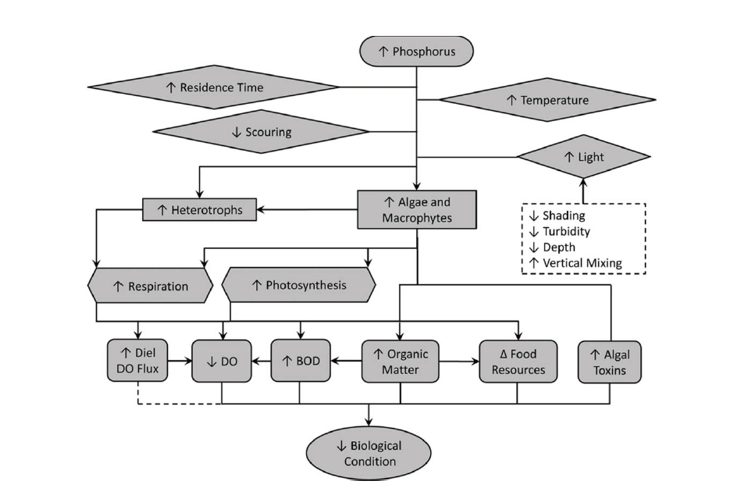

Figure 1. Conceptual model of eutrophication impacts on biological integrity [PLACEHOLDER]

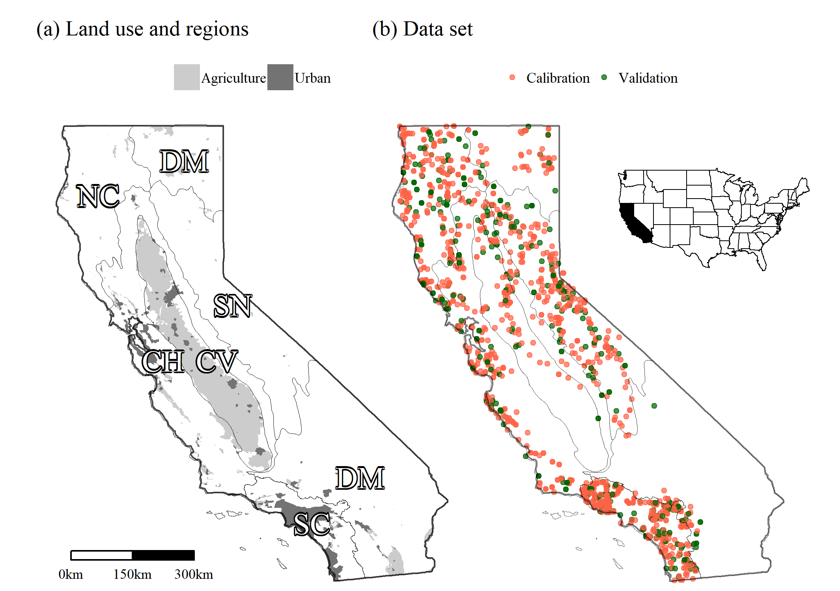

Figure 2. A) Regions of California. NC: North Coast. CH: Chaparral. SC: South Coast CV: Central Valley. SN: Sierra Nevada. DM: Desert and Modoc Plateau. B) Distribution of calibration and validation sites.

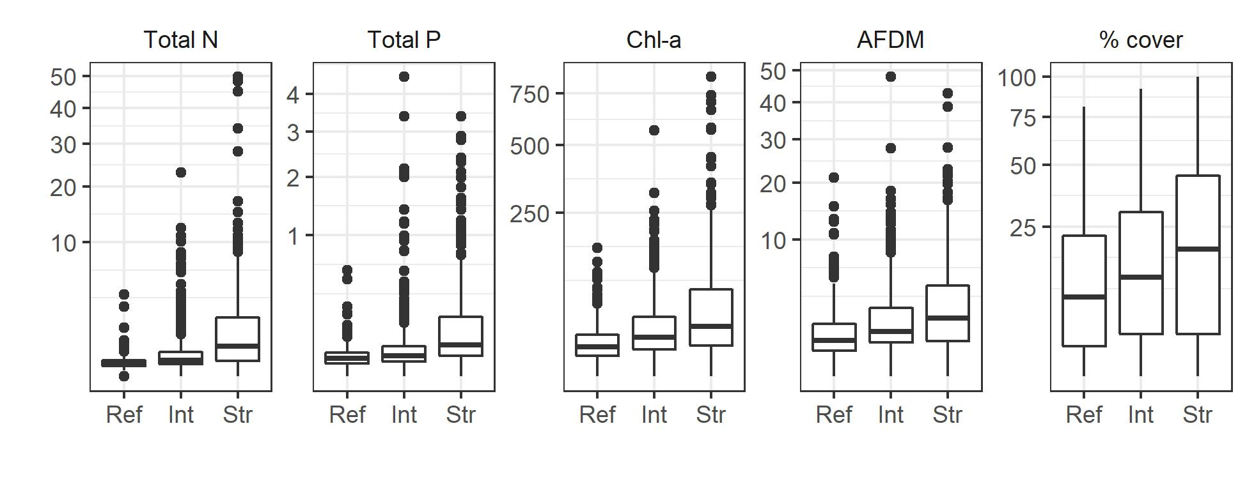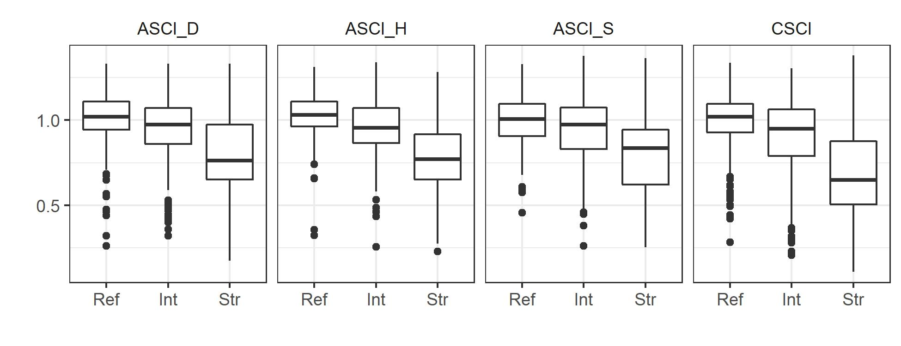

Figure 3. Distribution of eutrophication indicators and biointegrity scores at reference (Ref), intermediate (Int), and stressed (Str) sites.

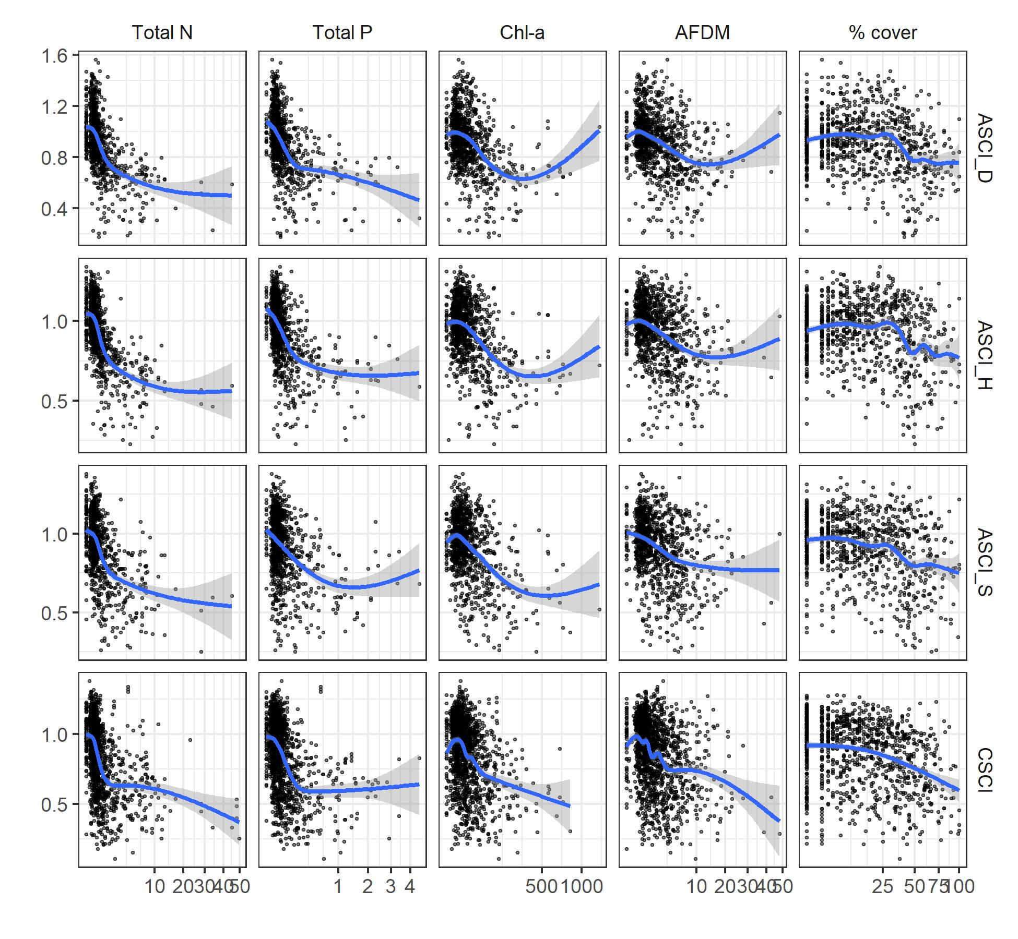

Figure 4. Biointegrity scores in relation to eutrophication indicators. Blue lines represent a fit from a general additive model; gray ribbons represent the 95% confidence interval around the fit

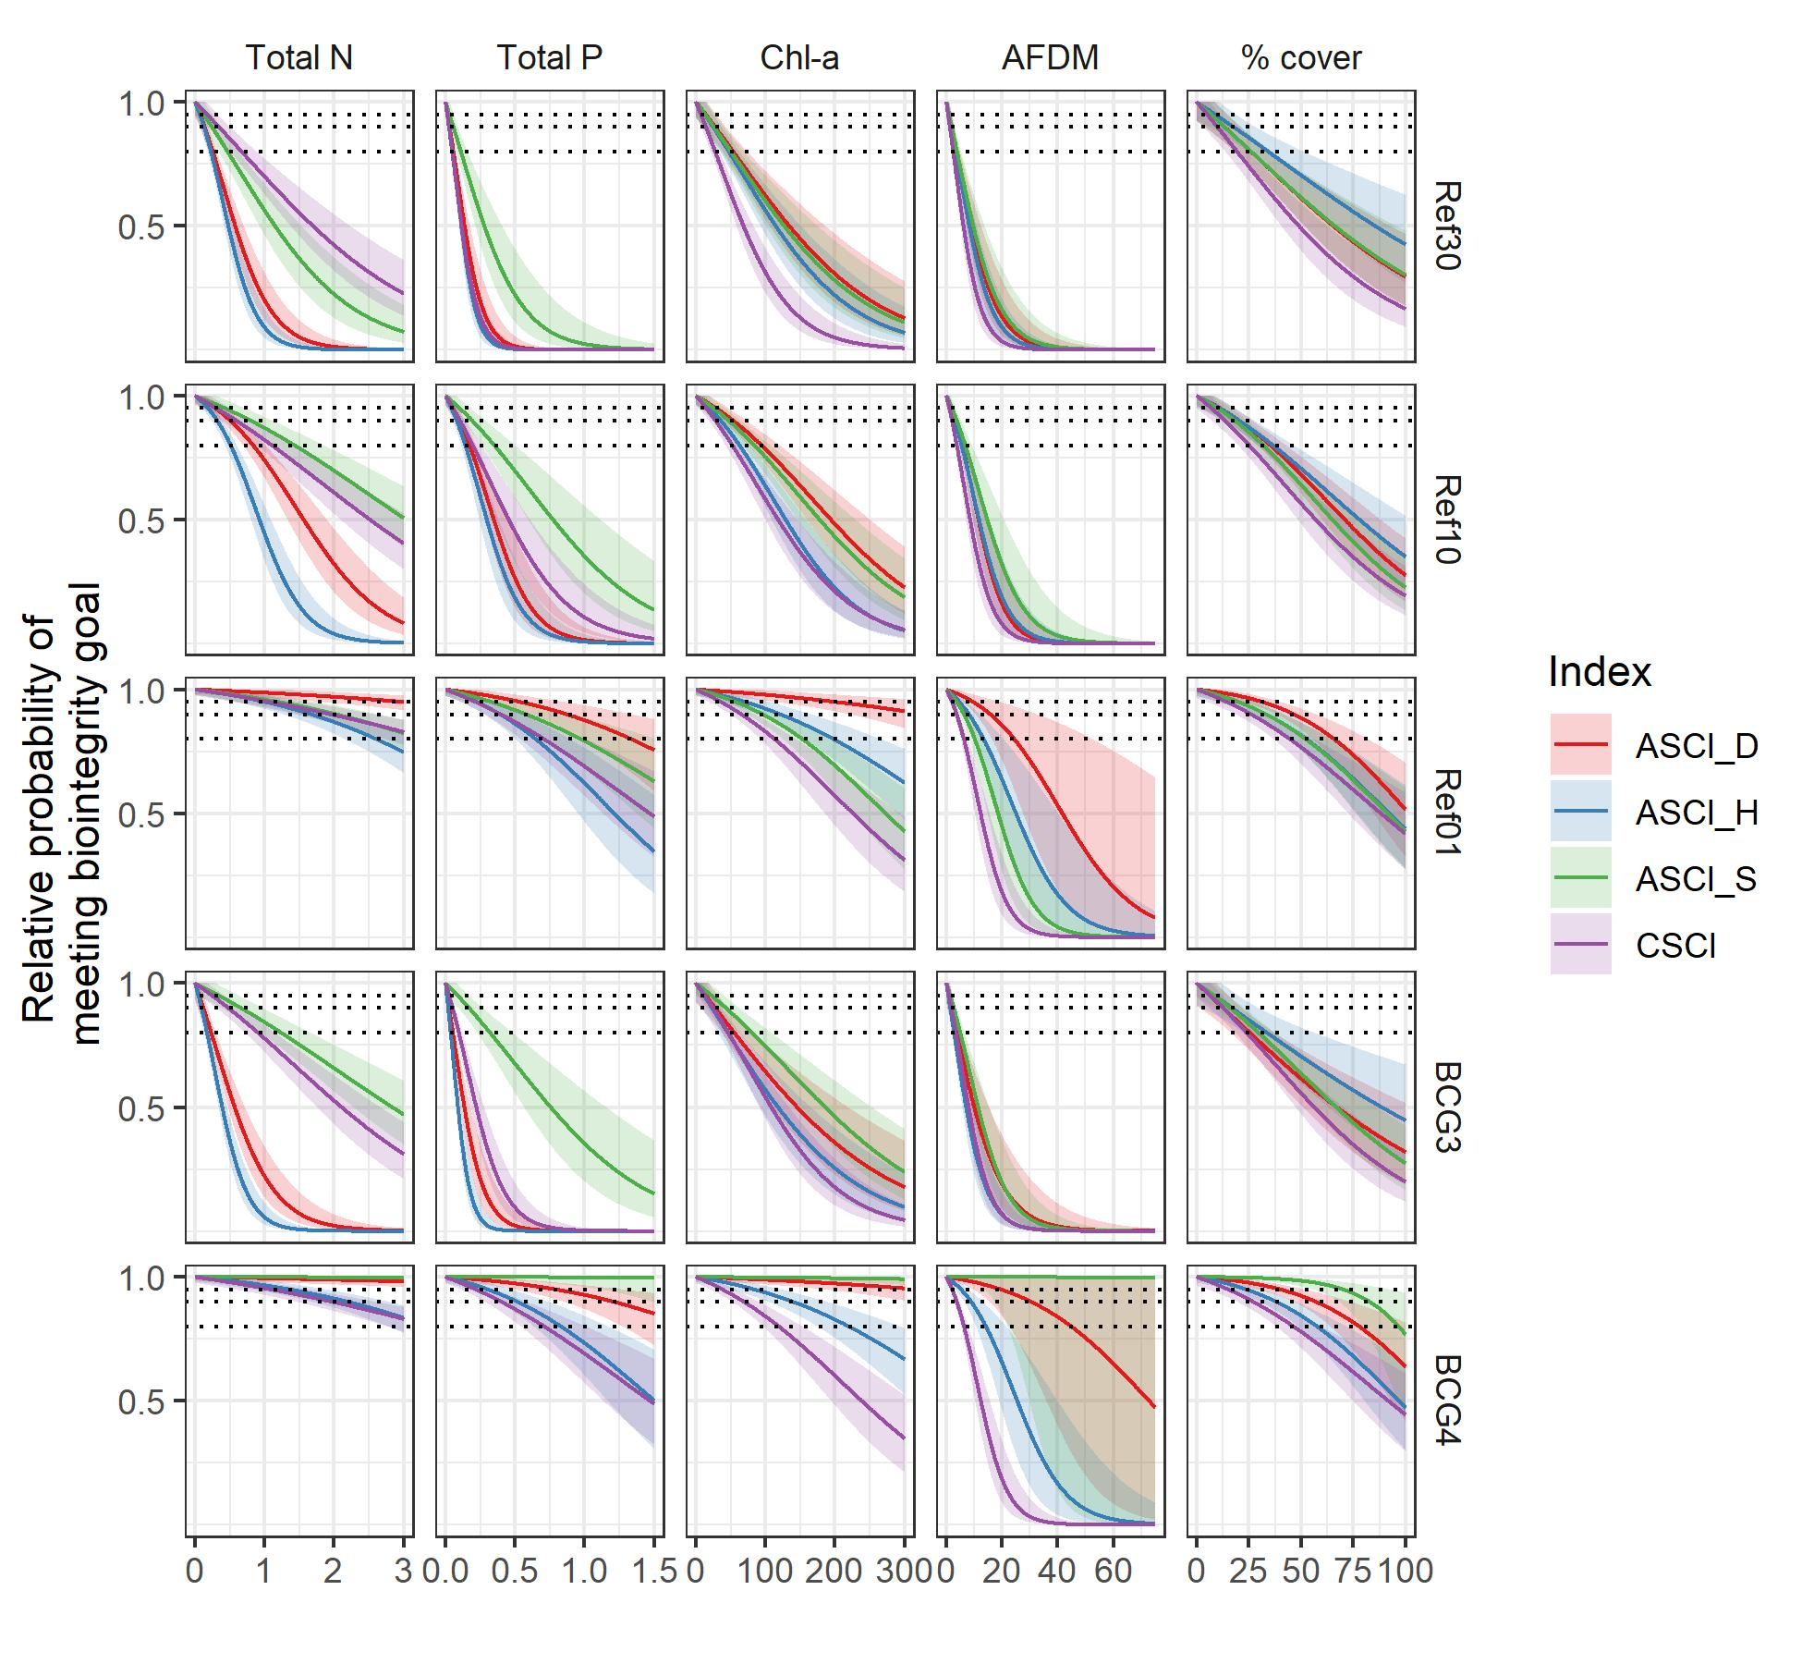

Figure 5. Relative probabilities of meeting biointegrity goals at increasing levels of eutrophication indicators. Dotted lines represent 80%, 90% and 95% relative probability.

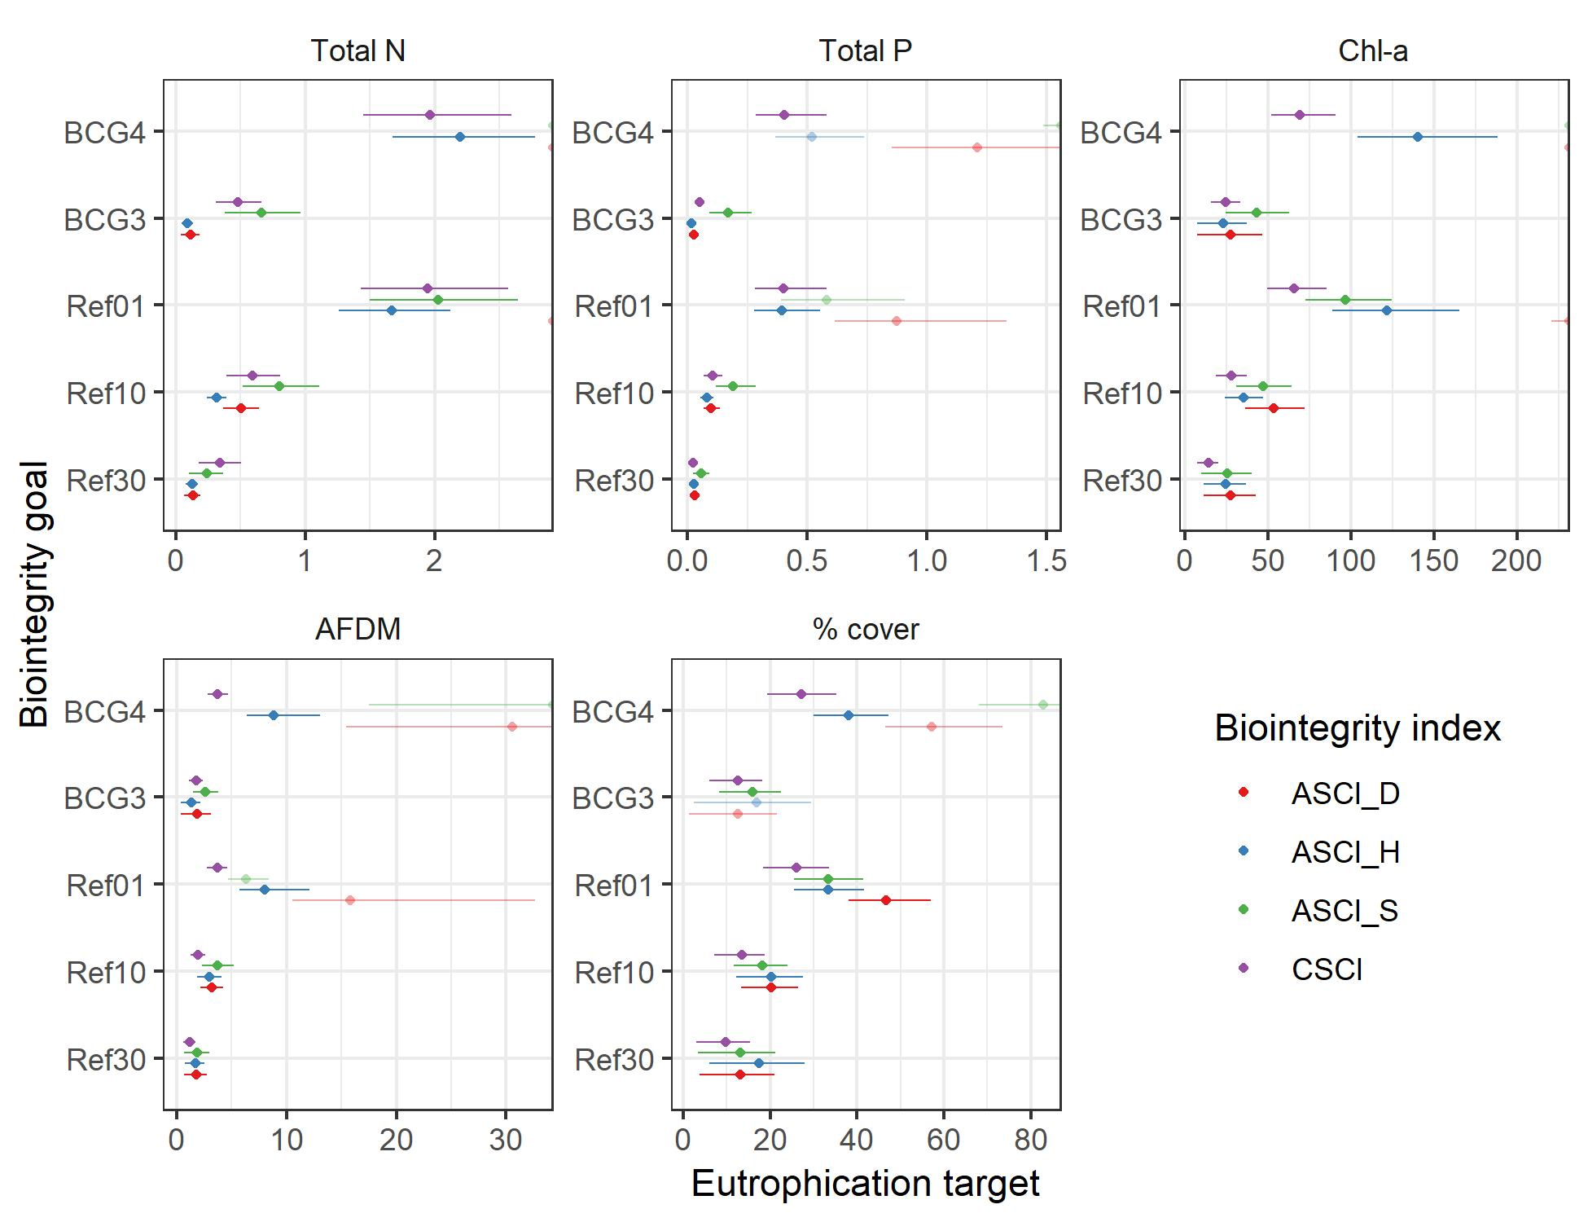

Figure 6. Thresholds for eutrophication indicators that provide a 90% relative probability of exceeding a range of biointegrity goals. Points represent the estimated threshold, and lines represent the 95% confidence interval around the estimate. Color indicates the biointegrity index that was evaluated. Points plotted on the right edge of a panel indicate that a threshold was not found within the evaluated range of the eutrophication indicator; similarly, lines that extend to the edge of a panel indicate that the confidence limits extended past the evaluated range of the eutrophication indicator. Dark-hued symbols indicate eutrophication thresholds that met validation criteria (i.e., relative risks significantly > 1 in both calibration and validation data sets), whereas light-hued symbols indicate thresholds that did not meet validation criteria.

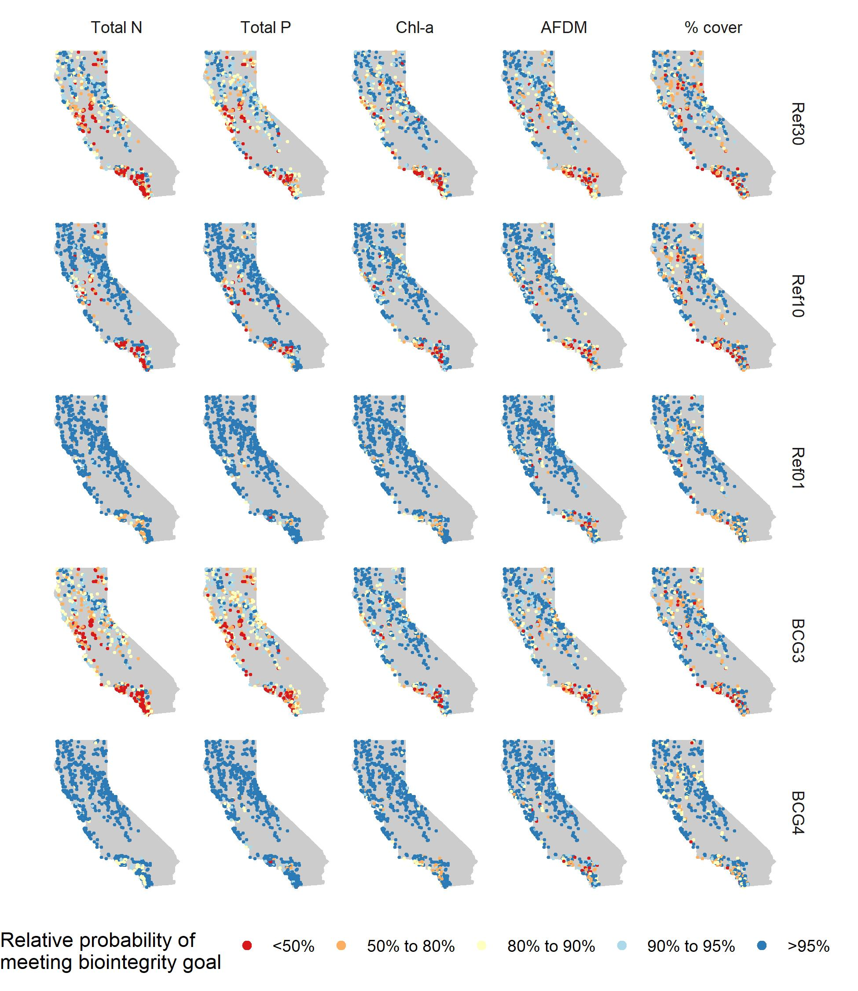

Figure 7. Application of validated eutrophication thresholds to sites in California.

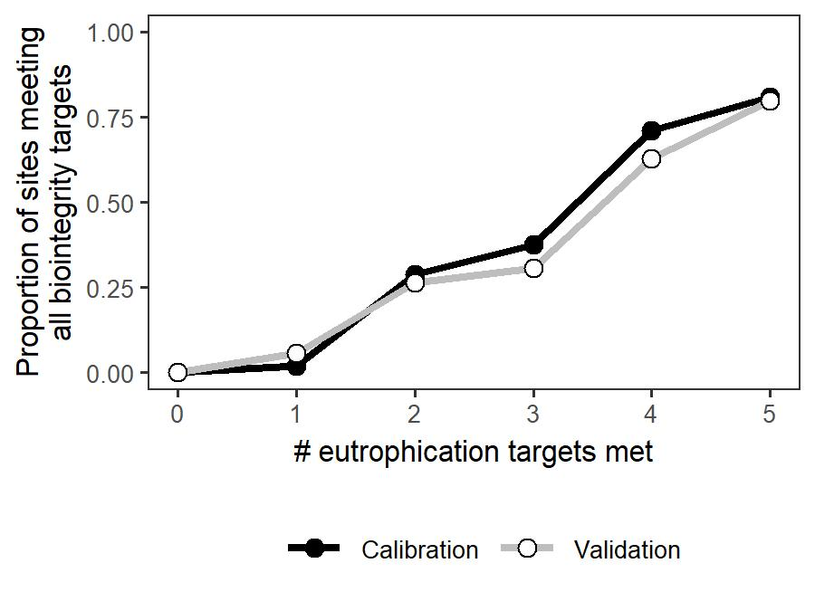

Figure 8. Proportion of sites meeting all biointegrity thresholds when different numbers of eutrophication thresholds are met.

# sites

Total N

Total P

Chl-A

AFDM

% cover

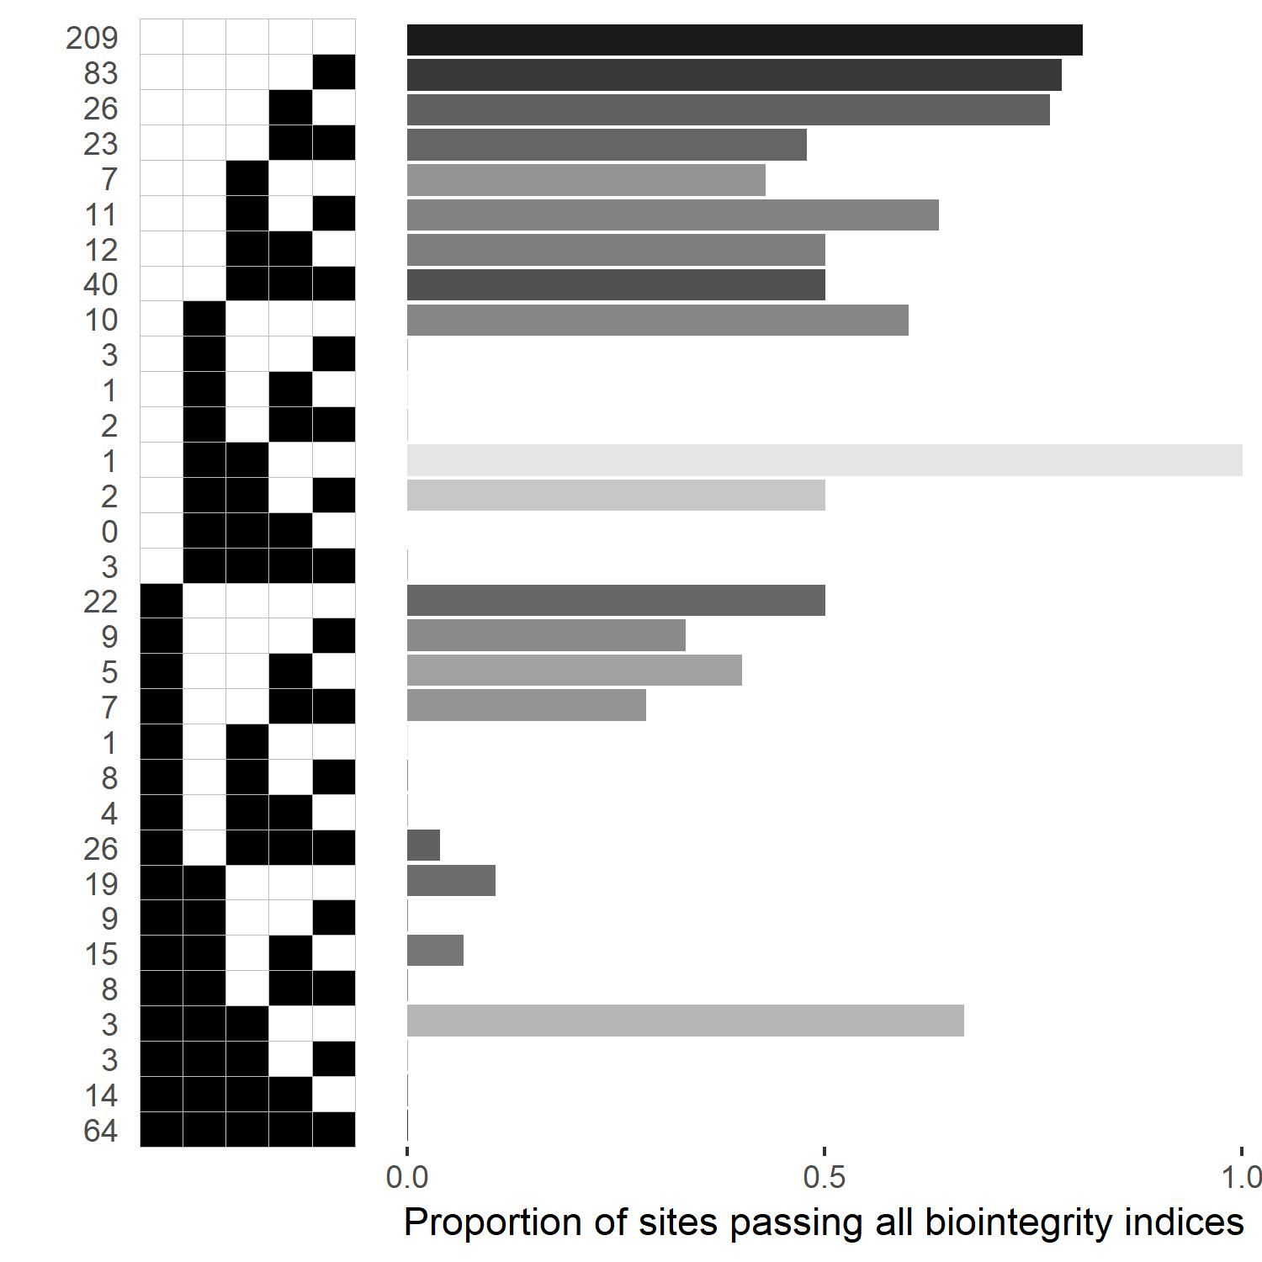

Figure 9. Proportion of sites scoring over the 10th percentile of reference for all biointegrity indices. Squares indicate whether eutrophication thresholds were met (white) or exceeded (black). Darker bars indicate a larger number of sites that exhibited the pattern of eutrophication threshold exceedances.

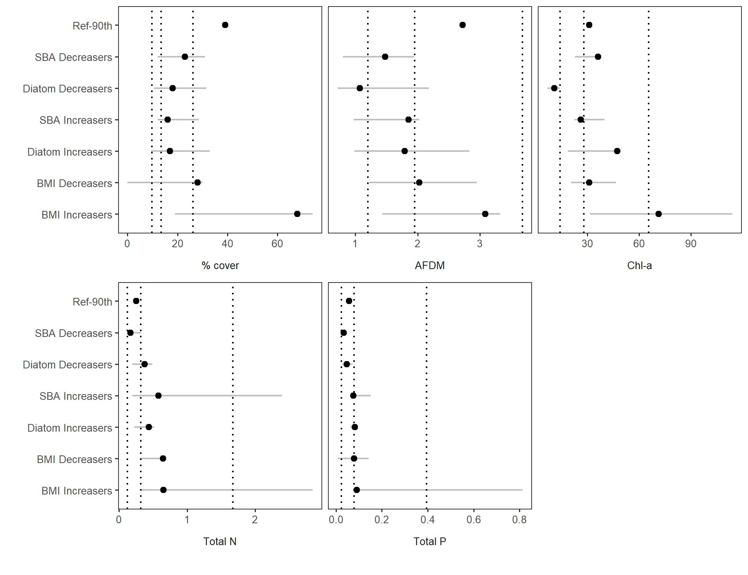

Figure 10. Reference distributions and assemblage-wide changepoints. Dotted lines represent derived eutrophication thresholds based on the 30th, 10th, and 1st percentiles of reference biointegrity goals. Horizontal lines represent 95% confidence intervals arround estimates of assemblage-wide endpoints. SBA: soft-bodied algae. BMI: benthic macroinvertebrates.

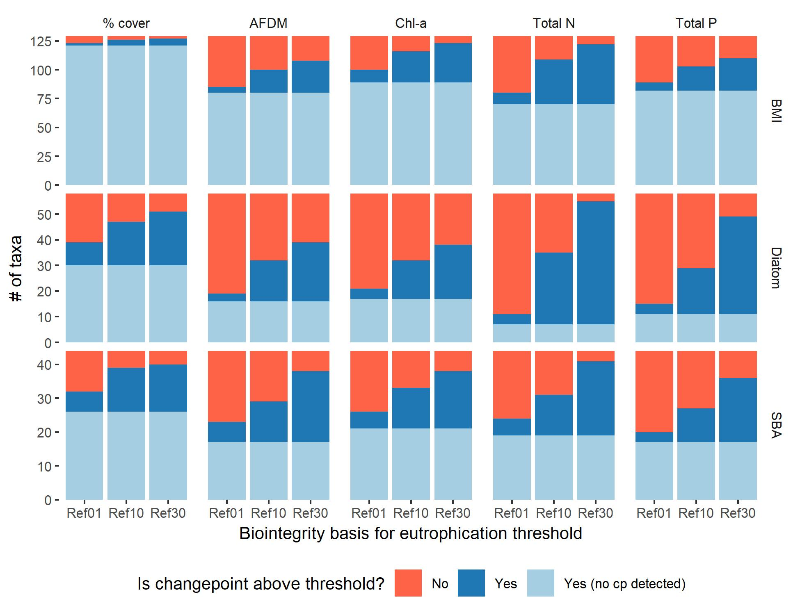

Figure 11. Number of taxa with changepoints (cp) above or below derived eutrophication thresholds. BMI: benthic macroinvertebrates. SBA: Soft-bodied algae.

# Supplements

Supplement 1. Performance of models to predict probability of meeting biointegrity goals from eutrophication indicators. Cal: Calibration. Val: Validation. Asterisks (*) indicate p-values greater than 0.05.

Supplement 2. Raw and relativized biointegrity responses to eutrophication indicators.

Supplement 3. Thresholds for eutrophication indicators based on several biointegrity goals and a range of relative probabilities of attaining these goals. Cal: Calibration. Val: Validation. Fail BIT: Number of sites failing the biointegrity threshold (Table 1). Fail ET: Number of sites failing the eutrophication threshold. Small text indicates 95% confidence interval around eutrophication thresholds and relative risk estimates. Asterisks (*) indicate thresholds that passed validation (i.e., the lower 95% confidence interval of the relative risk estimate was greater than 1 for both calibration and validation data sets). Dashes (--) indicate that the threshold could not be assessed.

Supplement 4. Regional thresholds are poorly validated, and rarely vary across regions.

Supplement 5. Table and maps indicating the percent of sites passing eutrophication thresholds by region. Rel prob: Relative probability. Cal: Calibration. Val: Validation. Abbreviations for regions are shown in Figure 2.

Supplement 6. Additional analyses to evaluate eutrophication thresholds

Supplement 1. Performance of models to predict probability of meeting biointegrity goals from eutrophication indicators. Cal: Calibration. Val: Validation. Asterisks (*) indicate p-values greater than 0.05.

|  |  |  |  |  |  |  |  |  |  |  |  |  |
| --- | --- | --- | --- | --- | --- | --- | --- | --- | --- | --- | --- | --- |
|  |  |  |  |  | Accuracy Rate | | # sites | | Accuracy rate | |  |  |
|  |  |  | # sites | | (multiple samples) | | (multiple samples) | |  |  |
| Indicator | Goal | Index | Cal | Val | Cal | Val | Cal | Val | Cal | Val | Int | Coef |
| Total N | Ref30 | ASCI_D | 765 | 248 | 0.74 | 0.71 | 144 | 35 | 0.75 | 0.69 | 1.23 | -2.93 |
| Total N | Ref30 | ASCI_H | 765 | 248 | 0.80 | 0.77 | 144 | 35 | 0.78 | 0.70 | 1.68 | -4.17 |
| Total N | Ref30 | ASCI_S | 765 | 248 | 0.71 | 0.70 | 144 | 35 | 0.69 | 0.75 | 0.75 | -1.23 |
| Total N | Ref30 | CSCI | 1184 | 389 | 0.68 | 0.62 | 310 | 91 | 0.67 | 0.62 | 0.54 | -0.77 |
| Total N | Ref10 | ASCI_D | 765 | 248 | 0.87 | 0.83 | 144 | 35 | 0.88 | 0.87 | 2.33 | -1.61 |
| Total N | Ref10 | ASCI_H | 765 | 248 | 0.87 | 0.86 | 144 | 35 | 0.89 | 0.89 | 2.54 | -2.90 |
| Total N | Ref10 | ASCI_S | 765 | 248 | 0.80 | 0.76 | 144 | 35 | 0.81 | 0.88 | 1.63 | -0.65 |
| Total N | Ref10 | CSCI | 1184 | 389 | 0.75 | 0.74 | 310 | 91 | 0.80 | 0.77 | 1.22 | -0.67 |
| Total N | Ref01 | ASCI_D | 765 | 248 | 0.94 | 0.92 | 144 | 35 | 0.95 | 0.93 | 3.03 | -0.25 |
| Total N | Ref01 | ASCI_H | 765 | 248 | 0.90 | 0.92 | 144 | 35 | 0.91 | 0.91 | 2.78 | -0.64 |
| Total N | Ref01 | ASCI_S | 765 | 248 | 0.88 | 0.87 | 144 | 35 | 0.90 | 0.93 | 2.55 | -0.46 |
| Total N | Ref01 | CSCI | 1184 | 389 | 0.83 | 0.81 | 310 | 91 | 0.87 | 0.86 | 1.89 | -0.31 |
| Total N | BCG3 | ASCI_D | 765 | 248 | 0.68 | 0.67 | 144 | 35 | 0.66 | 0.60 | 0.75 | -2.48 |
| Total N | BCG3 | ASCI_H | 765 | 248 | 0.74 | 0.73 | 144 | 35 | 0.69 | 0.69 | 1.24 | -4.33 |
| Total N | BCG3 | ASCI_S | 765 | 248 | 0.74 | 0.75 | 144 | 35 | 0.73 | 0.85 | 1.20 | -0.59 |
| Total N | BCG3 | CSCI | 1184 | 389 | 0.73 | 0.71 | 310 | 91 | 0.76 | 0.75 | 1.09 | -0.76 |
| Total N | BCG4 | ASCI_D | 765 | 248 | 0.96 | 0.94 | 144 | 35 | 0.97 | 0.93 | 3.40 | -0.15 |
| Total N | BCG4 | ASCI_H | 765 | 248 | 0.91 | 0.94 | 144 | 35 | 0.91 | 0.94 | 2.96 | -0.54 |
| Total N | BCG4 | ASCI_S | 765 | 248 | 0.99 | 0.98 | 144 | 35 | 0.99 | 0.99 | 5.05 | -0.10 |
| Total N | BCG4 | CSCI | 1184 | 389 | 0.83 | 0.81 | 310 | 91 | 0.87 | 0.88 | 1.91 | -0.32 |
| Total P | Ref30 | ASCI_D | 765 | 248 | 0.70 | 0.65 | 144 | 35 | 0.72 | 0.67 | 0.91 | -10.90 |
| Total P | Ref30 | ASCI_H | 765 | 248 | 0.73 | 0.69 | 144 | 35 | 0.71 | 0.68 | 1.21 | -14.67 |
| Total P | Ref30 | ASCI_S | 765 | 248 | 0.65 | 0.64 | 144 | 35 | 0.66 | 0.72 | 0.56 | -4.72 |
| Total P | Ref30 | CSCI | 1184 | 389 | 0.69 | 0.62 | 310 | 91 | 0.68 | 0.60 | 0.79 | -12.30 |
| Total P | Ref10 | ASCI_D | 765 | 248 | 0.83 | 0.80 | 144 | 35 | 0.86 | 0.81 | 1.92 | -6.25 |
| Total P | Ref10 | ASCI_H | 765 | 248 | 0.80 | 0.81 | 144 | 35 | 0.86 | 0.83 | 1.72 | -6.81 |
| Total P | Ref10 | ASCI_S | 765 | 248 | 0.78 | 0.71 | 144 | 35 | 0.78 | 0.82 | 1.40 | -2.33 |
| Total P | Ref10 | CSCI | 1184 | 389 | 0.73 | 0.71 | 310 | 91 | 0.79 | 0.74 | 1.10 | -3.54 |
| Total P | Ref01 | ASCI_D | 765 | 248 | 0.93 | 0.92 | 144 | 35 | 0.95 | 0.93 | 2.93 | -1.33 |
| Total P | Ref01 | ASCI_H | 765 | 248 | 0.89 | 0.90 | 144 | 35 | 0.89 | 0.91 | 2.34 | -2.07 |
| Total P | Ref01 | ASCI_S | 765 | 248 | 0.87 | 0.87 | 144 | 35 | 0.88 | 0.96 | 2.19 | -1.28 |
| Total P | Ref01 | CSCI | 1184 | 389 | 0.82 | 0.80 | 310 | 91 | 0.86 | 0.84 | 1.74 | -1.39 |
| Total P | BCG3 | ASCI_D | 765 | 248 | 0.66 | 0.58 | 144 | 35 | 0.65 | 0.50 | 0.50 | -9.56 |
| Total P | BCG3 | ASCI_H | 765 | 248 | 0.69 | 0.62 | 144 | 35 | 0.63 | 0.55 | 0.88 | -16.51 |
| Total P | BCG3 | ASCI_S | 765 | 248 | 0.72 | 0.69 | 144 | 35 | 0.72 | 0.82 | 1.01 | -2.06 |
| Total P | BCG3 | CSCI | 1184 | 389 | 0.74 | 0.70 | 310 | 91 | 0.78 | 0.73 | 1.15 | -7.42 |
| Total P | BCG4 | ASCI_D | 765 | 248 | 0.96 | 0.94 | 144 | 35 | 0.96 | 0.93 | 3.44 | -1.26 |
| Total P | BCG4 | ASCI_H | 765 | 248 | 0.90 | 0.91 | 144 | 35 | 0.91 | 0.94 | 2.54 | -1.79 |
| Total P | BCG4 | ASCI_S | 765 | 248 | 0.99 | 0.98 | 144 | 35 | 0.99 | 0.99 | 4.87 | -0.18* |
| Total P | BCG4 | CSCI | 1184 | 389 | 0.83 | 0.80 | 310 | 91 | 0.86 | 0.85 | 1.76 | -1.40 |
| Chl-a | Ref30 | ASCI_D | 765 | 248 | 0.67 | 0.65 | 144 | 35 | 0.66 | 0.69 | 0.61 | -0.01 |
| Chl-a | Ref30 | ASCI_H | 765 | 248 | 0.68 | 0.64 | 144 | 35 | 0.64 | 0.69 | 0.82 | -0.01 |
| Chl-a | Ref30 | ASCI_S | 765 | 248 | 0.63 | 0.67 | 144 | 35 | 0.63 | 0.76 | 0.58 | -0.01 |
| Chl-a | Ref30 | CSCI | 1184 | 389 | 0.65 | 0.58 | 310 | 91 | 0.66 | 0.64 | 0.71 | -0.02 |
| Chl-a | Ref10 | ASCI_D | 765 | 248 | 0.81 | 0.81 | 144 | 35 | 0.84 | 0.81 | 1.78 | -0.01 |
| Chl-a | Ref10 | ASCI_H | 765 | 248 | 0.80 | 0.82 | 144 | 35 | 0.82 | 0.87 | 1.79 | -0.02 |
| Chl-a | Ref10 | ASCI_S | 765 | 248 | 0.79 | 0.76 | 144 | 35 | 0.79 | 0.84 | 1.64 | -0.01 |
| Chl-a | Ref10 | CSCI | 1184 | 389 | 0.73 | 0.71 | 310 | 91 | 0.78 | 0.77 | 1.26 | -0.01 |
| Chl-a | Ref01 | ASCI_D | 765 | 248 | 0.93 | 0.92 | 144 | 35 | 0.95 | 0.93 | 2.87 | 0.00 |
| Chl-a | Ref01 | ASCI_H | 765 | 248 | 0.88 | 0.90 | 144 | 35 | 0.90 | 0.91 | 2.43 | -0.01 |
| Chl-a | Ref01 | ASCI_S | 765 | 248 | 0.88 | 0.87 | 144 | 35 | 0.87 | 0.96 | 2.63 | -0.01 |
| Chl-a | Ref01 | CSCI | 1184 | 389 | 0.83 | 0.81 | 310 | 91 | 0.86 | 0.86 | 1.96 | -0.01 |
| Chl-a | BCG3 | ASCI_D | 765 | 248 | 0.62 | 0.58 | 144 | 35 | 0.60 | 0.59 | 0.24 | -0.01 |
| Chl-a | BCG3 | ASCI_H | 765 | 248 | 0.63 | 0.59 | 144 | 35 | 0.56 | 0.58 | 0.40 | -0.01 |
| Chl-a | BCG3 | ASCI_S | 765 | 248 | 0.72 | 0.75 | 144 | 35 | 0.72 | 0.84 | 1.17 | -0.01 |
| Chl-a | BCG3 | CSCI | 1184 | 389 | 0.71 | 0.68 | 310 | 91 | 0.76 | 0.75 | 1.11 | -0.01 |
| Chl-a | BCG4 | ASCI_D | 765 | 248 | 0.96 | 0.94 | 144 | 35 | 0.97 | 0.93 | 3.33 | 0.00 |
| Chl-a | BCG4 | ASCI_H | 765 | 248 | 0.90 | 0.92 | 144 | 35 | 0.92 | 0.94 | 2.70 | -0.01 |
| Chl-a | BCG4 | ASCI_S | 765 | 248 | 0.99 | 0.98 | 144 | 35 | 0.99 | 0.99 | 5.08 | 0.00* |
| Chl-a | BCG4 | CSCI | 1184 | 389 | 0.83 | 0.80 | 310 | 91 | 0.87 | 0.86 | 1.96 | -0.01 |
| AFDM | Ref30 | ASCI_D | 765 | 248 | 0.64 | 0.63 | 144 | 35 | 0.65 | 0.62 | 0.62 | -0.15 |
| AFDM | Ref30 | ASCI_H | 765 | 248 | 0.67 | 0.62 | 144 | 35 | 0.64 | 0.63 | 0.82 | -0.18 |
| AFDM | Ref30 | ASCI_S | 765 | 248 | 0.62 | 0.60 | 144 | 35 | 0.59 | 0.73 | 0.55 | -0.14 |
| AFDM | Ref30 | CSCI | 1184 | 389 | 0.64 | 0.57 | 310 | 91 | 0.66 | 0.56 | 0.60 | -0.22 |
| AFDM | Ref10 | ASCI_D | 765 | 248 | 0.79 | 0.78 | 144 | 35 | 0.80 | 0.78 | 1.84 | -0.18 |
| AFDM | Ref10 | ASCI_H | 765 | 248 | 0.75 | 0.77 | 144 | 35 | 0.78 | 0.78 | 1.57 | -0.16 |
| AFDM | Ref10 | ASCI_S | 765 | 248 | 0.75 | 0.72 | 144 | 35 | 0.72 | 0.82 | 1.50 | -0.13 |
| AFDM | Ref10 | CSCI | 1184 | 389 | 0.71 | 0.70 | 310 | 91 | 0.76 | 0.73 | 1.23 | -0.20 |
| AFDM | Ref01 | ASCI_D | 765 | 248 | 0.93 | 0.92 | 144 | 35 | 0.95 | 0.93 | 2.90 | -0.07 |
| AFDM | Ref01 | ASCI_H | 765 | 248 | 0.87 | 0.90 | 144 | 35 | 0.89 | 0.91 | 2.32 | -0.10 |
| AFDM | Ref01 | ASCI_S | 765 | 248 | 0.87 | 0.86 | 144 | 35 | 0.85 | 0.96 | 2.49 | -0.14 |
| AFDM | Ref01 | CSCI | 1184 | 389 | 0.83 | 0.80 | 310 | 91 | 0.86 | 0.85 | 2.05 | -0.18 |
| AFDM | BCG3 | ASCI_D | 765 | 248 | 0.59 | 0.58 | 144 | 35 | 0.60 | 0.54 | 0.24 | -0.12 |
| AFDM | BCG3 | ASCI_H | 765 | 248 | 0.64 | 0.56 | 144 | 35 | 0.61 | 0.55 | 0.48 | -0.18 |
| AFDM | BCG3 | ASCI_S | 765 | 248 | 0.70 | 0.70 | 144 | 35 | 0.67 | 0.79 | 1.20 | -0.15 |
| AFDM | BCG3 | CSCI | 1184 | 389 | 0.68 | 0.66 | 310 | 91 | 0.74 | 0.70 | 1.08 | -0.20 |
| AFDM | BCG4 | ASCI_D | 765 | 248 | 0.96 | 0.94 | 144 | 35 | 0.97 | 0.93 | 3.29 | -0.05* |
| AFDM | BCG4 | ASCI_H | 765 | 248 | 0.90 | 0.92 | 144 | 35 | 0.91 | 0.94 | 2.59 | -0.11 |
| AFDM | BCG4 | ASCI_S | 765 | 248 | 0.99 | 0.98 | 144 | 35 | 0.99 | 0.99 | 4.85 | 0.00* |
| AFDM | BCG4 | CSCI | 1184 | 389 | 0.83 | 0.80 | 310 | 91 | 0.86 | 0.85 | 2.07 | -0.19 |
| % cover | Ref30 | ASCI_D | 672 | 218 | 0.61 | 0.62 | 124 | 29 | 0.64 | 0.59 | 0.59 | -0.02 |
| % cover | Ref30 | ASCI_H | 672 | 218 | 0.62 | 0.64 | 124 | 29 | 0.62 | 0.66 | 0.64 | -0.02 |
| % cover | Ref30 | ASCI_S | 672 | 218 | 0.59 | 0.61 | 124 | 29 | 0.59 | 0.71 | 0.52 | -0.02 |
| % cover | Ref30 | CSCI | 766 | 250 | 0.61 | 0.60 | 160 | 43 | 0.65 | 0.62 | 0.53 | -0.03 |
| % cover | Ref10 | ASCI_D | 672 | 218 | 0.78 | 0.79 | 124 | 29 | 0.83 | 0.81 | 1.92 | -0.03 |
| % cover | Ref10 | ASCI_H | 672 | 218 | 0.74 | 0.77 | 124 | 29 | 0.79 | 0.84 | 1.58 | -0.02 |
| % cover | Ref10 | ASCI_S | 672 | 218 | 0.76 | 0.74 | 124 | 29 | 0.78 | 0.90 | 1.84 | -0.03 |
| % cover | Ref10 | CSCI | 766 | 250 | 0.70 | 0.69 | 160 | 43 | 0.74 | 0.71 | 1.23 | -0.03 |
| % cover | Ref01 | ASCI_D | 672 | 218 | 0.93 | 0.92 | 124 | 29 | 0.95 | 0.91 | 3.70 | -0.04 |
| % cover | Ref01 | ASCI_H | 672 | 218 | 0.87 | 0.89 | 124 | 29 | 0.90 | 0.90 | 2.72 | -0.03 |
| % cover | Ref01 | ASCI_S | 672 | 218 | 0.88 | 0.85 | 124 | 29 | 0.89 | 0.91 | 2.76 | -0.03 |
| % cover | Ref01 | CSCI | 766 | 250 | 0.81 | 0.82 | 160 | 43 | 0.82 | 0.89 | 2.02 | -0.03 |
| % cover | BCG3 | ASCI_D | 672 | 218 | 0.54 | 0.58 | 124 | 29 | 0.56 | 0.55 | 0.21 | -0.02 |
| % cover | BCG3 | ASCI_H | 672 | 218 | 0.55 | 0.56 | 124 | 29 | 0.54 | 0.50 | 0.26 | -0.01 |
| % cover | BCG3 | ASCI_S | 672 | 218 | 0.70 | 0.71 | 124 | 29 | 0.71 | 0.90 | 1.28 | -0.03 |
| % cover | BCG3 | CSCI | 766 | 250 | 0.67 | 0.67 | 160 | 43 | 0.71 | 0.66 | 1.03 | -0.03 |
| % cover | BCG4 | ASCI_D | 672 | 218 | 0.95 | 0.94 | 124 | 29 | 0.96 | 0.91 | 4.07 | -0.04 |
| % cover | BCG4 | ASCI_H | 672 | 218 | 0.90 | 0.90 | 124 | 29 | 0.92 | 0.90 | 3.05 | -0.03 |
| % cover | BCG4 | ASCI_S | 672 | 218 | 0.99 | 0.98 | 124 | 29 | 0.99 | 0.98 | 7.00 | -0.06 |
| % cover | BCG4 | CSCI | 766 | 250 | 0.81 | 0.83 | 160 | 43 | 0.82 | 0.89 | 2.02 | -0.02 |

Supplement 2. Raw and relativized biointegrity responses to eutrophication indicators.

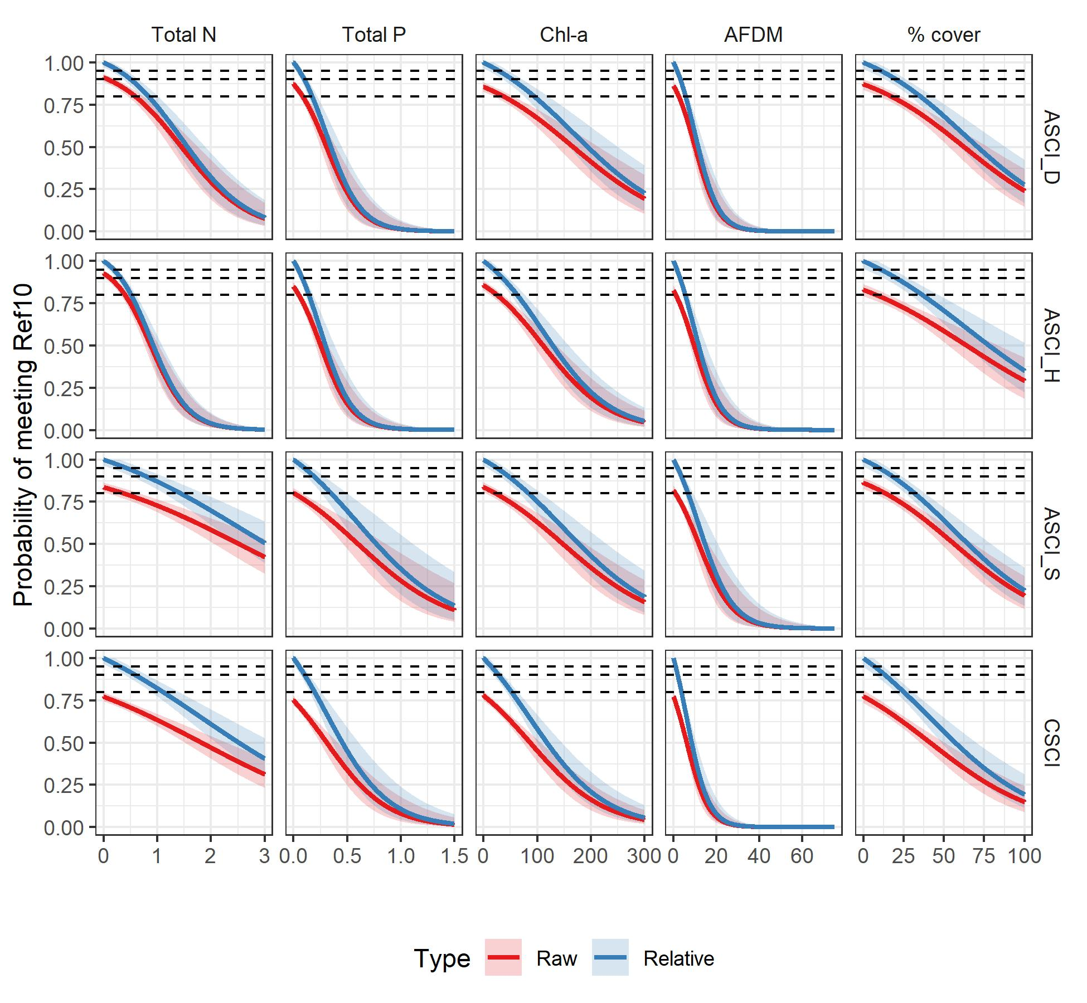

Supplement 3. Thresholds for eutrophication indicators based on several biointegrity goals and a range of relative probabilities of attaining these goals. Cal: Calibration. Val: Validation. Fail BIT: Number of sites failing the biointegrity threshold (Table 1). Fail ET: Number of sites failing the eutrophication threshold. Small text indicates 95% confidence interval around eutrophication thresholds and relative risk estimates. Asterisks (*) indicate thresholds that passed validation (i.e., the lower 95% confidence interval of the relative risk estimate was greater than 1 for both calibration and validation data sets). Dashes (--) indicate that the threshold could not be assessed.

|  |  |  |  |  |  |  |  |  |  |  |  |  |  |  |  |  |  |  |  |  |  |
| --- | --- | --- | --- | --- | --- | --- | --- | --- | --- | --- | --- | --- | --- | --- | --- | --- | --- | --- | --- | --- | --- |
|  |  |  |  |  |  |  | # sites | | | | | | | |  |  |  |  |  |  |  |
|  |  |  |  |  |  |  | Agree | | | | Disagree | | | |  |  |  |  |  |  |  |
|  | BI | Rel |  | Eutrophication | | | Pass | | Fail | | Fail BIT | | Fail ET | | Relative Risk | | | | | |  |
| Indicator | Goal | Prob | Index | Threshold | | | Cal | Val | Cal | Val | Cal | Val | Cal | Val | Cal | | | Val | | |  |
| Total N | Ref30 | 80 | ASCI_D | 0.25 | 0.20 | 0.31 | 337 | 106 | 207 | 60 | 118 | 42 | 70 | 20 | 2.9 | 2.4 | 3.4 | 2.6 | 2.0 | 3.5 | * |
| Total N | Ref30 | 80 | ASCI_H | 0.23 | 0.18 | 0.27 | 355 | 107 | 219 | 71 | 86 | 34 | 72 | 16 | 3.9 | 3.2 | 4.7 | 3.4 | 2.5 | 4.6 | * |
| Total N | Ref30 | 80 | ASCI_S | 0.47 | 0.34 | 0.62 | 367 | 119 | 158 | 46 | 173 | 54 | 34 | 9 | 2.6 | 2.2 | 3.0 | 2.7 | 2.1 | 3.4 | * |
| Total N | Ref30 | 80 | CSCI | 0.67 | 0.50 | 0.89 | 611 | 180 | 189 | 63 | 361 | 138 | 23 | 8 | 2.4 | 2.2 | 2.6 | 2.0 | 1.8 | 2.4 | * |
| Total N | Ref30 | 90 | ASCI_D | 0.14 | 0.07 | 0.19 | 248 | 79 | 247 | 71 | 78 | 31 | 159 | 47 | 2.5 | 2.1 | 3.1 | 2.1 | 1.5 | 3.0 | * |
| Total N | Ref30 | 90 | ASCI_H | 0.13 | 0.08 | 0.17 | 260 | 86 | 259 | 86 | 46 | 19 | 167 | 37 | 4.0 | 3.1 | 5.3 | 3.9 | 2.5 | 5.9 | * |
| Total N | Ref30 | 90 | ASCI_S | 0.24 | 0.10 | 0.37 | 317 | 105 | 202 | 60 | 129 | 40 | 84 | 23 | 2.4 | 2.1 | 2.9 | 2.6 | 1.9 | 3.5 | * |
| Total N | Ref30 | 90 | CSCI | 0.34 | 0.18 | 0.50 | 568 | 176 | 274 | 82 | 276 | 119 | 66 | 12 | 2.5 | 2.2 | 2.8 | 2.2 | 1.8 | 2.5 | * |
| Total N | Ref30 | 95 | ASCI_D | 0.07 | 0.00 | 0.13 | 125 | 40 | 283 | 92 | 42 | 10 | 282 | 86 | 2.0 | 1.5 | 2.6 | 2.6 | 1.5 | 4.6 | * |
| Total N | Ref30 | 95 | ASCI_H | 0.07 | 0.01 | 0.12 | 140 | 41 | 278 | 96 | 27 | 9 | 287 | 82 | 3.0 | 2.1 | 4.3 | 3.0 | 1.6 | 5.5 | * |
| Total N | Ref30 | 95 | ASCI_S | 0.12 | 0.00 | 0.25 | 217 | 74 | 250 | 72 | 81 | 28 | 184 | 54 | 2.1 | 1.7 | 2.6 | 2.1 | 1.5 | 3.0 | * |
| Total N | Ref30 | 95 | CSCI | 0.17 | 0.00 | 0.33 | 456 | 149 | 357 | 123 | 193 | 78 | 178 | 39 | 2.2 | 2.0 | 2.6 | 2.2 | 1.8 | 2.7 | * |
| Total N | Ref10 | 80 | ASCI_D | 0.83 | 0.69 | 1.01 | 541 | 162 | 102 | 26 | 66 | 24 | 23 | 16 | 7.5 | 5.9 | 9.6 | 4.8 | 3.1 | 7.5 | * |
| Total N | Ref10 | 80 | ASCI_H | 0.51 | 0.43 | 0.60 | 501 | 161 | 139 | 41 | 51 | 15 | 41 | 11 | 8.4 | 6.4 | 11.0 | 9.3 | 5.6 | 15.3 | * |
| Total N | Ref10 | 80 | ASCI_S | 1.44 | 1.13 | 1.86 | 530 | 156 | 71 | 22 | 110 | 44 | 21 | 6 | 4.5 | 3.7 | 5.5 | 3.6 | 2.6 | 4.9 | * |
| Total N | Ref10 | 80 | CSCI | 1.11 | 0.89 | 1.40 | 778 | 250 | 126 | 42 | 250 | 80 | 30 | 17 | 3.3 | 2.9 | 3.8 | 2.9 | 2.3 | 3.8 | * |
| Total N | Ref10 | 90 | ASCI_D | 0.50 | 0.37 | 0.65 | 511 | 159 | 127 | 33 | 41 | 17 | 53 | 19 | 9.5 | 7.0 | 12.9 | 6.6 | 4.0 | 10.8 | * |
| Total N | Ref10 | 90 | ASCI_H | 0.32 | 0.24 | 0.39 | 467 | 148 | 160 | 50 | 30 | 6 | 75 | 24 | 11.3 | 7.9 | 16.1 | 17.3 | 7.8 | 38.7 | * |
| Total N | Ref10 | 90 | ASCI_S | 0.80 | 0.52 | 1.11 | 510 | 150 | 89 | 31 | 92 | 35 | 41 | 12 | 4.5 | 3.6 | 5.6 | 3.8 | 2.7 | 5.4 | * |
| Total N | Ref10 | 90 | CSCI | 0.59 | 0.39 | 0.81 | 753 | 247 | 174 | 53 | 202 | 69 | 55 | 20 | 3.6 | 3.1 | 4.1 | 3.3 | 2.6 | 4.3 | * |
| Total N | Ref10 | 95 | ASCI_D | 0.29 | 0.14 | 0.42 | 460 | 139 | 147 | 40 | 21 | 10 | 104 | 39 | 13.4 | 8.7 | 20.6 | 7.5 | 4.0 | 14.3 | * |
| Total N | Ref10 | 95 | ASCI_H | 0.19 | 0.09 | 0.26 | 384 | 126 | 173 | 51 | 17 | 5 | 158 | 46 | 12.3 | 7.7 | 19.9 | 13.8 | 5.7 | 33.3 | * |
| Total N | Ref10 | 95 | ASCI_S | 0.43 | 0.12 | 0.71 | 465 | 146 | 115 | 39 | 66 | 27 | 86 | 16 | 4.6 | 3.6 | 5.9 | 4.5 | 3.1 | 6.7 | * |
| Total N | Ref10 | 95 | CSCI | 0.31 | 0.09 | 0.51 | 688 | 233 | 234 | 70 | 142 | 52 | 120 | 34 | 3.9 | 3.3 | 4.6 | 3.7 | 2.8 | 4.9 | * |
| Total N | Ref01 | 50 | ASCI_D | >3 | >3 | >3 | 680 | 209 | 0 | 0 | 52 | 19 | 0 | 0 | -- | -- | -- | -- | -- | -- |  |
| Total N | Ref01 | 50 | ASCI_H | >3 | >3 | >3 | 638 | 204 | 0 | 0 | 94 | 24 | 0 | 0 | -- | -- | -- | -- | -- | -- |  |
| Total N | Ref01 | 50 | ASCI_S | >3 | >3 | >3 | 642 | 197 | 0 | 0 | 90 | 31 | 0 | 0 | -- | -- | -- | -- | -- | -- |  |
| Total N | Ref01 | 50 | CSCI | >3 | >3 | >3 | 976 | 312 | 0 | 0 | 208 | 77 | 0 | 0 | -- | -- | -- | -- | -- | -- |  |
| Total N | Ref01 | 80 | ASCI_D | >3 | >3 | >3 | 680 | 209 | 0 | 0 | 52 | 19 | 0 | 0 | -- | -- | -- | -- | -- | -- |  |
| Total N | Ref01 | 80 | ASCI_H | 2.61 | 2.16 | >3 | 621 | 199 | 45 | 12 | 49 | 12 | 17 | 5 | 9.9 | 7.3 | 13.5 | 12.4 | 6.6 | 23.3 | * |
| Total N | Ref01 | 80 | ASCI_S | >3 | 2.64 | >3 | 642 | 197 | 0 | 0 | 90 | 31 | 0 | 0 | -- | -- | -- | -- | -- | -- |  |
| Total N | Ref01 | 80 | CSCI | >3 | 2.74 | >3 | 976 | 312 | 0 | 0 | 208 | 77 | 0 | 0 | -- | -- | -- | -- | -- | -- |  |
| Total N | Ref01 | 90 | ASCI_D | >3 | >3 | >3 | 680 | 209 | 0 | 0 | 52 | 19 | 0 | 0 | -- | -- | -- | -- | -- | -- |  |
| Total N | Ref01 | 90 | ASCI_H | 1.67 | 1.26 | 2.12 | 604 | 193 | 53 | 13 | 41 | 11 | 34 | 11 | 9.6 | 6.8 | 13.5 | 10.0 | 5.1 | 19.9 | * |
| Total N | Ref01 | 90 | ASCI_S | 2.03 | 1.50 | 2.64 | 610 | 186 | 41 | 10 | 49 | 21 | 32 | 11 | 7.6 | 5.4 | 10.6 | 4.7 | 2.6 | 8.6 | * |
| Total N | Ref01 | 90 | CSCI | 1.95 | 1.43 | 2.57 | 922 | 297 | 61 | 18 | 147 | 59 | 54 | 15 | 3.9 | 3.1 | 4.8 | 3.3 | 2.2 | 4.9 | * |
| Total N | Ref01 | 95 | ASCI_D | 2.99 | 1.80 | >3 | 641 | 204 | 19 | 10 | 33 | 9 | 39 | 5 | 6.7 | 4.1 | 11.0 | 15.8 | 7.6 | 32.9 | * |
| Total N | Ref01 | 95 | ASCI_H | 1.01 | 0.58 | 1.42 | 587 | 181 | 60 | 17 | 34 | 7 | 51 | 23 | 9.9 | 6.8 | 14.3 | 11.4 | 5.1 | 25.7 | * |
| Total N | Ref01 | 95 | ASCI_S | 1.19 | 0.64 | 1.73 | 591 | 176 | 50 | 16 | 40 | 15 | 51 | 21 | 7.8 | 5.5 | 11.2 | 5.5 | 3.0 | 10.1 | * |
| Total N | Ref01 | 95 | CSCI | 1.07 | 0.55 | 1.59 | 901 | 282 | 85 | 29 | 123 | 48 | 75 | 30 | 4.4 | 3.5 | 5.5 | 3.4 | 2.3 | 4.9 | * |
| Total N | BCG3 | 80 | ASCI_D | 0.23 | 0.17 | 0.30 | 286 | 89 | 222 | 73 | 156 | 52 | 68 | 14 | 2.2 | 1.9 | 2.5 | 2.3 | 1.8 | 2.9 | * |
| Total N | BCG3 | 80 | ASCI_H | 0.17 | 0.13 | 0.21 | 280 | 86 | 260 | 83 | 103 | 37 | 89 | 22 | 2.8 | 2.3 | 3.3 | 2.6 | 2.0 | 3.5 | * |
| Total N | BCG3 | 80 | ASCI_S | 1.24 | 0.94 | 1.66 | 480 | 148 | 80 | 27 | 152 | 45 | 20 | 8 | 3.3 | 2.8 | 3.9 | 3.3 | 2.4 | 4.5 | * |
| Total N | BCG3 | 80 | CSCI | 0.91 | 0.72 | 1.15 | 740 | 236 | 147 | 47 | 267 | 92 | 30 | 14 | 3.1 | 2.8 | 3.5 | 2.7 | 2.2 | 3.4 | * |
| Total N | BCG3 | 90 | ASCI_D | 0.12 | 0.04 | 0.18 | 192 | 63 | 287 | 91 | 91 | 34 | 162 | 40 | 2.0 | 1.7 | 2.4 | 2.0 | 1.5 | 2.7 | * |
| Total N | BCG3 | 90 | ASCI_H | 0.09 | 0.04 | 0.13 | 174 | 58 | 307 | 103 | 56 | 17 | 195 | 50 | 2.5 | 2.0 | 3.2 | 3.0 | 1.9 | 4.6 | * |
| Total N | BCG3 | 90 | ASCI_S | 0.66 | 0.38 | 0.97 | 458 | 141 | 109 | 34 | 123 | 38 | 42 | 15 | 3.4 | 2.8 | 4.1 | 3.3 | 2.3 | 4.6 | * |
| Total N | BCG3 | 90 | CSCI | 0.48 | 0.31 | 0.66 | 711 | 229 | 211 | 62 | 203 | 77 | 59 | 21 | 3.5 | 3.1 | 4.0 | 3.0 | 2.4 | 3.7 | * |
| Total N | BCG3 | 95 | ASCI_D | 0.06 | 0.00 | 0.13 | 88 | 25 | 332 | 115 | 46 | 10 | 266 | 78 | 1.6 | 1.3 | 2.1 | 2.1 | 1.2 | 3.6 | * |
| Total N | BCG3 | 95 | ASCI_H | 0.05 | 0.00 | 0.09 | 75 | 22 | 336 | 115 | 27 | 5 | 294 | 86 | 2.0 | 1.4 | 2.8 | 3.1 | 1.4 | 6.9 | * |
| Total N | BCG3 | 95 | ASCI_S | 0.35 | 0.03 | 0.63 | 417 | 133 | 143 | 43 | 89 | 29 | 83 | 23 | 3.6 | 2.9 | 4.5 | 3.6 | 2.5 | 5.3 | * |
| Total N | BCG3 | 95 | CSCI | 0.25 | 0.06 | 0.42 | 625 | 215 | 269 | 80 | 145 | 59 | 145 | 35 | 3.5 | 2.9 | 4.1 | 3.2 | 2.5 | 4.2 | * |
| Total N | BCG4 | 50 | ASCI_D | >3 | >3 | >3 | 699 | 213 | 0 | 0 | 33 | 15 | 0 | 0 | -- | -- | -- | -- | -- | -- |  |
| Total N | BCG4 | 50 | ASCI_H | >3 | >3 | >3 | 654 | 206 | 0 | 0 | 78 | 22 | 0 | 0 | -- | -- | -- | -- | -- | -- |  |
| Total N | BCG4 | 50 | ASCI_S | >3 | >3 | >3 | 725 | 224 | 0 | 0 | 7 | 4 | 0 | 0 | -- | -- | -- | -- | -- | -- |  |
| Total N | BCG4 | 50 | CSCI | >3 | >3 | >3 | 979 | 315 | 0 | 0 | 205 | 74 | 0 | 0 | -- | -- | -- | -- | -- | -- |  |
| Total N | BCG4 | 80 | ASCI_D | >3 | >3 | >3 | 699 | 213 | 0 | 0 | 33 | 15 | 0 | 0 | -- | -- | -- | -- | -- | -- |  |
| Total N | BCG4 | 80 | ASCI_H | >3 | 2.77 | >3 | 654 | 206 | 0 | 0 | 78 | 22 | 0 | 0 | -- | -- | -- | -- | -- | -- |  |
| Total N | BCG4 | 80 | ASCI_S | >3 | >3 | >3 | 725 | 224 | 0 | 0 | 7 | 4 | 0 | 0 | -- | -- | -- | -- | -- | -- |  |
| Total N | BCG4 | 80 | CSCI | >3 | 2.76 | >3 | 979 | 315 | 0 | 0 | 205 | 74 | 0 | 0 | -- | -- | -- | -- | -- | -- |  |
| Total N | BCG4 | 90 | ASCI_D | >3 | >3 | >3 | 699 | 213 | 0 | 0 | 33 | 15 | 0 | 0 | -- | -- | -- | -- | -- | -- |  |
| Total N | BCG4 | 90 | ASCI_H | 2.20 | 1.68 | 2.78 | 624 | 199 | 42 | 13 | 36 | 9 | 30 | 7 | 10.7 | 7.4 | 15.5 | 15.0 | 7.3 | 30.8 | * |
| Total N | BCG4 | 90 | ASCI_S | >3 | >3 | >3 | 725 | 224 | 0 | 0 | 7 | 4 | 0 | 0 | -- | -- | -- | -- | -- | -- |  |
| Total N | BCG4 | 90 | CSCI | 1.96 | 1.45 | 2.59 | 925 | 300 | 61 | 18 | 144 | 56 | 54 | 15 | 3.9 | 3.1 | 5.0 | 3.5 | 2.3 | 5.1 | * |
| Total N | BCG4 | 95 | ASCI_D | >3 | >3 | >3 | 699 | 213 | 0 | 0 | 33 | 15 | 0 | 0 | -- | -- | -- | -- | -- | -- |  |
| Total N | BCG4 | 95 | ASCI_H | 1.35 | 0.81 | 1.87 | 607 | 192 | 48 | 15 | 30 | 7 | 47 | 14 | 10.7 | 7.2 | 16.0 | 14.7 | 6.5 | 33.1 | * |
| Total N | BCG4 | 95 | ASCI_S | >3 | >3 | >3 | 725 | 224 | 0 | 0 | 7 | 4 | 0 | 0 | -- | -- | -- | -- | -- | -- |  |
| Total N | BCG4 | 95 | CSCI | 1.08 | 0.56 | 1.60 | 906 | 285 | 84 | 29 | 121 | 45 | 73 | 30 | 4.5 | 3.6 | 5.7 | 3.6 | 2.5 | 5.3 | * |
| Total P | Ref30 | 80 | ASCI_D | 0.057 | 0.042 | 0.074 | 359 | 106 | 166 | 38 | 159 | 64 | 48 | 20 | 2.5 | 2.2 | 2.9 | 1.7 | 1.3 | 2.3 | * |
| Total P | Ref30 | 80 | ASCI_H | 0.050 | 0.039 | 0.062 | 369 | 106 | 170 | 48 | 135 | 57 | 58 | 17 | 2.8 | 2.4 | 3.3 | 2.1 | 1.6 | 2.7 | * |
| Total P | Ref30 | 80 | ASCI_S | 0.110 | 0.077 | 0.158 | 375 | 123 | 113 | 27 | 218 | 73 | 26 | 5 | 2.2 | 1.9 | 2.5 | 2.3 | 1.8 | 2.9 | * |
| Total P | Ref30 | 80 | CSCI | 0.047 | 0.038 | 0.059 | 552 | 160 | 265 | 76 | 285 | 125 | 82 | 28 | 2.2 | 2.0 | 2.5 | 1.7 | 1.4 | 2.0 | * |
| Total P | Ref30 | 90 | ASCI_D | 0.029 | 0.012 | 0.044 | 277 | 84 | 220 | 67 | 105 | 35 | 130 | 42 | 2.3 | 1.9 | 2.7 | 2.1 | 1.5 | 2.9 | * |
| Total P | Ref30 | 90 | ASCI_H | 0.026 | 0.014 | 0.038 | 270 | 83 | 226 | 80 | 79 | 25 | 157 | 40 | 2.6 | 2.1 | 3.2 | 2.9 | 2.0 | 4.2 | * |
| Total P | Ref30 | 90 | ASCI_S | 0.056 | 0.023 | 0.090 | 339 | 105 | 154 | 37 | 177 | 63 | 62 | 23 | 2.1 | 1.8 | 2.4 | 1.6 | 1.2 | 2.2 | * |
| Total P | Ref30 | 90 | CSCI | 0.024 | 0.012 | 0.035 | 421 | 122 | 371 | 120 | 179 | 81 | 213 | 66 | 2.1 | 1.9 | 2.4 | 1.6 | 1.3 | 2.0 | * |
| Total P | Ref30 | 95 | ASCI_D | 0.015 | 0.000 | 0.030 | 156 | 42 | 271 | 88 | 54 | 14 | 251 | 84 | 2.0 | 1.6 | 2.6 | 2.0 | 1.3 | 3.3 | * |
| Total P | Ref30 | 95 | ASCI_H | 0.014 | 0.000 | 0.026 | 145 | 36 | 267 | 94 | 38 | 11 | 282 | 87 | 2.3 | 1.7 | 3.1 | 2.2 | 1.3 | 3.8 | * |
| Total P | Ref30 | 95 | ASCI_S | 0.029 | 0.000 | 0.060 | 255 | 80 | 204 | 61 | 127 | 39 | 146 | 48 | 1.8 | 1.5 | 2.1 | 1.7 | 1.3 | 2.3 | * |
| Total P | Ref30 | 95 | CSCI | 0.012 | 0.000 | 0.023 | 248 | 60 | 446 | 161 | 104 | 40 | 386 | 128 | 1.8 | 1.5 | 2.2 | 1.4 | 1.1 | 1.8 | * |
| Total P | Ref10 | 80 | ASCI_D | 0.173 | 0.138 | 0.221 | 538 | 170 | 70 | 16 | 98 | 34 | 26 | 8 | 4.7 | 3.8 | 5.9 | 4.0 | 2.6 | 6.1 | * |
| Total P | Ref10 | 80 | ASCI_H | 0.141 | 0.113 | 0.182 | 514 | 168 | 84 | 23 | 106 | 33 | 28 | 4 | 4.4 | 3.6 | 5.4 | 5.2 | 3.7 | 7.4 | * |
| Total P | Ref10 | 80 | ASCI_S | 0.350 | 0.260 | 0.500 | 533 | 157 | 37 | 8 | 144 | 58 | 18 | 5 | 3.2 | 2.5 | 4.0 | 2.3 | 1.4 | 3.7 | * |
| Total P | Ref10 | 80 | CSCI | 0.195 | 0.152 | 0.260 | 786 | 258 | 97 | 24 | 279 | 98 | 22 | 9 | 3.1 | 2.7 | 3.6 | 2.6 | 2.0 | 3.5 | * |
| Total P | Ref10 | 90 | ASCI_D | 0.099 | 0.068 | 0.134 | 518 | 165 | 102 | 21 | 66 | 29 | 46 | 13 | 6.1 | 4.7 | 7.8 | 4.1 | 2.7 | 6.3 | * |
| Total P | Ref10 | 90 | ASCI_H | 0.080 | 0.053 | 0.108 | 493 | 161 | 119 | 29 | 71 | 27 | 49 | 11 | 5.6 | 4.4 | 7.1 | 5.0 | 3.4 | 7.5 | * |
| Total P | Ref10 | 90 | ASCI_S | 0.191 | 0.117 | 0.285 | 515 | 154 | 54 | 14 | 127 | 52 | 36 | 8 | 3.0 | 2.4 | 3.8 | 2.5 | 1.7 | 3.7 | * |
| Total P | Ref10 | 90 | CSCI | 0.104 | 0.066 | 0.146 | 765 | 253 | 160 | 37 | 216 | 85 | 43 | 14 | 3.6 | 3.1 | 4.1 | 2.9 | 2.2 | 3.7 | * |
| Total P | Ref10 | 95 | ASCI_D | 0.054 | 0.020 | 0.086 | 470 | 145 | 125 | 28 | 43 | 22 | 94 | 33 | 6.8 | 5.0 | 9.3 | 3.5 | 2.2 | 5.6 | * |
| Total P | Ref10 | 95 | ASCI_H | 0.044 | 0.012 | 0.069 | 433 | 136 | 141 | 41 | 49 | 15 | 109 | 36 | 5.5 | 4.2 | 7.4 | 5.4 | 3.2 | 9.1 | * |
| Total P | Ref10 | 95 | ASCI_S | 0.101 | 0.021 | 0.179 | 484 | 150 | 78 | 21 | 103 | 45 | 67 | 12 | 3.1 | 2.4 | 3.9 | 2.8 | 1.9 | 4.0 | * |
| Total P | Ref10 | 95 | CSCI | 0.053 | 0.014 | 0.090 | 707 | 226 | 217 | 53 | 159 | 69 | 101 | 41 | 3.7 | 3.2 | 4.4 | 2.4 | 1.8 | 3.2 | * |
| Total P | Ref01 | 80 | ASCI_D | 1.338 | 0.986 | >1.5 | 674 | 208 | 7 | 0 | 45 | 19 | 6 | 1 | 8.6 | 4.8 | 15.3 | 0.0 | -- | -- |  |
| Total P | Ref01 | 80 | ASCI_H | 0.650 | 0.502 | 0.895 | 627 | 203 | 23 | 1 | 71 | 23 | 11 | 1 | 6.7 | 4.8 | 9.2 | 4.9 | 1.2 | 20.8 | * |
| Total P | Ref01 | 80 | ASCI_S | 0.974 | 0.709 | >1.5 | 630 | 196 | 13 | 0 | 77 | 31 | 12 | 1 | 4.8 | 3.1 | 7.4 | 0.0 | -- | -- |  |
| Total P | Ref01 | 80 | CSCI | 0.709 | 0.539 | 1.006 | 953 | 305 | 25 | 1 | 183 | 76 | 23 | 7 | 3.2 | 2.4 | 4.4 | 0.6 | 0.1 | 4.0 |  |
| Total P | Ref01 | 90 | ASCI_D | 0.872 | 0.614 | 1.333 | 658 | 208 | 9 | 0 | 43 | 19 | 22 | 1 | 4.7 | 2.5 | 8.8 | 0.0 | -- | -- |  |
| Total P | Ref01 | 90 | ASCI_H | 0.395 | 0.279 | 0.554 | 619 | 197 | 29 | 3 | 65 | 21 | 19 | 7 | 6.4 | 4.6 | 8.8 | 3.1 | 1.1 | 8.7 | * |
| Total P | Ref01 | 90 | ASCI_S | 0.581 | 0.390 | 0.908 | 625 | 195 | 20 | 1 | 70 | 30 | 17 | 2 | 5.4 | 3.7 | 7.8 | 2.5 | 0.5 | 12.9 |  |
| Total P | Ref01 | 90 | CSCI | 0.401 | 0.281 | 0.580 | 942 | 303 | 35 | 8 | 173 | 69 | 34 | 9 | 3.3 | 2.5 | 4.3 | 2.5 | 1.5 | 4.4 | * |
| Total P | Ref01 | 95 | ASCI_D | 0.535 | 0.312 | 0.847 | 651 | 206 | 11 | 1 | 41 | 18 | 29 | 3 | 4.6 | 2.6 | 8.3 | 3.1 | 0.5 | 18.0 |  |
| Total P | Ref01 | 95 | ASCI_H | 0.227 | 0.113 | 0.348 | 598 | 192 | 38 | 5 | 56 | 19 | 40 | 12 | 5.7 | 4.1 | 8.0 | 3.3 | 1.4 | 7.7 | * |
| Total P | Ref01 | 95 | ASCI_S | 0.329 | 0.153 | 0.551 | 612 | 189 | 27 | 5 | 63 | 26 | 30 | 8 | 5.1 | 3.5 | 7.3 | 3.2 | 1.5 | 6.9 | * |
| Total P | Ref01 | 95 | CSCI | 0.218 | 0.105 | 0.345 | 928 | 298 | 59 | 17 | 149 | 60 | 48 | 14 | 4.0 | 3.2 | 5.0 | 3.3 | 2.2 | 4.9 | * |
| Total P | BCG3 | 80 | ASCI_D | 0.053 | 0.036 | 0.071 | 310 | 86 | 177 | 45 | 201 | 80 | 44 | 17 | 2.0 | 1.8 | 2.3 | 1.5 | 1.2 | 1.9 | * |
| Total P | BCG3 | 80 | ASCI_H | 0.036 | 0.027 | 0.047 | 300 | 84 | 218 | 71 | 145 | 49 | 69 | 24 | 2.3 | 2.0 | 2.7 | 2.0 | 1.6 | 2.6 | * |
| Total P | BCG3 | 80 | ASCI_S | 0.320 | 0.228 | 0.482 | 483 | 151 | 43 | 8 | 189 | 64 | 17 | 5 | 2.5 | 2.1 | 3.1 | 2.1 | 1.3 | 3.3 | * |
| Total P | BCG3 | 80 | CSCI | 0.096 | 0.077 | 0.120 | 734 | 237 | 179 | 40 | 235 | 99 | 36 | 13 | 3.4 | 3.0 | 3.9 | 2.6 | 2.0 | 3.2 | * |
| Total P | BCG3 | 90 | ASCI_D | 0.027 | 0.008 | 0.042 | 237 | 72 | 248 | 83 | 130 | 42 | 117 | 31 | 1.9 | 1.6 | 2.2 | 2.0 | 1.5 | 2.6 | * |
| Total P | BCG3 | 90 | ASCI_H | 0.018 | 0.006 | 0.029 | 171 | 50 | 286 | 99 | 77 | 21 | 198 | 58 | 1.9 | 1.6 | 2.3 | 2.1 | 1.5 | 3.1 | * |
| Total P | BCG3 | 90 | ASCI_S | 0.168 | 0.092 | 0.267 | 467 | 147 | 65 | 15 | 167 | 57 | 33 | 9 | 2.5 | 2.1 | 3.1 | 2.2 | 1.5 | 3.3 | * |
| Total P | BCG3 | 90 | CSCI | 0.051 | 0.033 | 0.069 | 676 | 208 | 232 | 55 | 182 | 84 | 94 | 42 | 3.4 | 2.9 | 3.9 | 2.0 | 1.5 | 2.5 | * |
| Total P | BCG3 | 95 | ASCI_D | 0.014 | 0.000 | 0.029 | 121 | 29 | 316 | 107 | 62 | 18 | 233 | 74 | 1.7 | 1.4 | 2.1 | 1.5 | 1.1 | 2.3 | * |
| Total P | BCG3 | 95 | ASCI_H | 0.009 | 0.000 | 0.020 | 71 | 16 | 331 | 114 | 32 | 6 | 298 | 92 | 1.7 | 1.3 | 2.3 | 2.0 | 1.0 | 4.1 | * |
| Total P | BCG3 | 95 | ASCI_S | 0.087 | 0.003 | 0.168 | 433 | 142 | 96 | 23 | 136 | 49 | 67 | 14 | 2.5 | 2.0 | 3.0 | 2.4 | 1.7 | 3.4 | * |
| Total P | BCG3 | 95 | CSCI | 0.026 | 0.006 | 0.044 | 516 | 160 | 299 | 86 | 115 | 53 | 254 | 90 | 3.0 | 2.5 | 3.6 | 2.0 | 1.5 | 2.6 | * |
| Total P | BCG4 | 80 | ASCI_D | >1.5 | 1.273 | >1.5 | 699 | 213 | 0 | 0 | 33 | 15 | 0 | 0 | -- | -- | -- | -- | -- | -- |  |
| Total P | BCG4 | 80 | ASCI_H | 0.832 | 0.637 | 1.170 | 640 | 205 | 18 | 1 | 60 | 21 | 14 | 1 | 6.6 | 4.4 | 9.7 | 5.4 | 1.3 | 22.9 | * |
| Total P | BCG4 | 80 | ASCI_S | >1.5 | >1.5 | >1.5 | 725 | 224 | 0 | 0 | 7 | 4 | 0 | 0 | -- | -- | -- | -- | -- | -- |  |
| Total P | BCG4 | 80 | CSCI | 0.712 | 0.542 | 1.009 | 956 | 308 | 25 | 1 | 180 | 73 | 23 | 7 | 3.3 | 2.4 | 4.4 | 0.7 | 0.1 | 4.1 |  |
| Total P | BCG4 | 90 | ASCI_D | 1.210 | 0.851 | >1.5 | 691 | 212 | 6 | 0 | 27 | 15 | 8 | 1 | 11.4 | 5.6 | 23.2 | 0.0 | -- | -- |  |
| Total P | BCG4 | 90 | ASCI_H | 0.518 | 0.368 | 0.736 | 633 | 201 | 21 | 1 | 57 | 21 | 21 | 5 | 6.1 | 4.1 | 9.0 | 1.8 | 0.3 | 11.1 |  |
| Total P | BCG4 | 90 | ASCI_S | >1.5 | 1.485 | >1.5 | 725 | 224 | 0 | 0 | 7 | 4 | 0 | 0 | -- | -- | -- | -- | -- | -- |  |
| Total P | BCG4 | 90 | CSCI | 0.402 | 0.284 | 0.581 | 945 | 306 | 35 | 8 | 170 | 66 | 34 | 9 | 3.3 | 2.5 | 4.4 | 2.7 | 1.5 | 4.6 | * |
| Total P | BCG4 | 95 | ASCI_D | 0.788 | 0.489 | 1.266 | 674 | 212 | 7 | 1 | 26 | 14 | 25 | 1 | 5.9 | 2.8 | 12.5 | 8.1 | 1.8 | 35.4 | * |
| Total P | BCG4 | 95 | ASCI_H | 0.303 | 0.162 | 0.465 | 620 | 196 | 29 | 3 | 49 | 19 | 34 | 10 | 6.3 | 4.3 | 9.2 | 2.6 | 0.9 | 7.7 |  |
| Total P | BCG4 | 95 | ASCI_S | >1.5 | 1.111 | >1.5 | 725 | 224 | 0 | 0 | 7 | 4 | 0 | 0 | -- | -- | -- | -- | -- | -- |  |
| Total P | BCG4 | 95 | CSCI | 0.219 | 0.108 | 0.347 | 931 | 300 | 59 | 16 | 146 | 58 | 48 | 15 | 4.1 | 3.2 | 5.1 | 3.2 | 2.1 | 4.8 | * |
| Chl-a | Ref30 | 80 | ASCI_D | 53 | 38 | 74 | 377 | 119 | 115 | 30 | 210 | 72 | 30 | 7 | 2.2 | 1.9 | 2.5 | 2.2 | 1.7 | 2.7 | * |
| Chl-a | Ref30 | 80 | ASCI_H | 47 | 35 | 62 | 390 | 114 | 122 | 32 | 183 | 73 | 37 | 9 | 2.4 | 2.1 | 2.8 | 2.0 | 1.6 | 2.5 | * |
| Chl-a | Ref30 | 80 | ASCI_S | 50 | 36 | 69 | 361 | 121 | 111 | 30 | 220 | 70 | 40 | 7 | 1.9 | 1.7 | 2.2 | 2.2 | 1.7 | 2.8 | * |
| Chl-a | Ref30 | 80 | CSCI | 28 | 22 | 34 | 531 | 162 | 247 | 72 | 303 | 129 | 103 | 26 | 1.9 | 1.7 | 2.2 | 1.7 | 1.4 | 2.0 | * |
| Chl-a | Ref30 | 90 | ASCI_D | 27 | 11 | 43 | 333 | 104 | 162 | 47 | 163 | 55 | 74 | 22 | 2.1 | 1.8 | 2.4 | 2.0 | 1.5 | 2.6 | * |
| Chl-a | Ref30 | 90 | ASCI_H | 24 | 11 | 37 | 332 | 95 | 161 | 49 | 144 | 56 | 95 | 28 | 2.1 | 1.8 | 2.5 | 1.7 | 1.3 | 2.2 | * |
| Chl-a | Ref30 | 90 | ASCI_S | 26 | 10 | 40 | 318 | 100 | 164 | 46 | 167 | 54 | 83 | 28 | 1.9 | 1.7 | 2.2 | 1.8 | 1.3 | 2.3 | * |
| Chl-a | Ref30 | 90 | CSCI | 14 | 7 | 20 | 385 | 136 | 350 | 116 | 200 | 85 | 249 | 52 | 1.7 | 1.5 | 1.9 | 1.8 | 1.5 | 2.2 | * |
| Chl-a | Ref30 | 95 | ASCI_D | 14 | 0 | 29 | 246 | 75 | 218 | 60 | 107 | 42 | 161 | 51 | 1.9 | 1.6 | 2.3 | 1.5 | 1.1 | 2.0 | * |
| Chl-a | Ref30 | 95 | ASCI_H | 12 | 0 | 25 | 245 | 74 | 215 | 69 | 90 | 36 | 182 | 49 | 2.0 | 1.7 | 2.5 | 1.8 | 1.3 | 2.4 | * |
| Chl-a | Ref30 | 95 | ASCI_S | 13 | 0 | 27 | 229 | 79 | 221 | 65 | 110 | 35 | 172 | 49 | 1.7 | 1.5 | 2.1 | 1.9 | 1.3 | 2.6 | * |
| Chl-a | Ref30 | 95 | CSCI | 7 | 0 | 14 | 245 | 76 | 426 | 155 | 124 | 46 | 389 | 112 | 1.6 | 1.3 | 1.8 | 1.5 | 1.2 | 2.0 | * |
| Chl-a | Ref10 | 80 | ASCI_D | 94 | 75 | 120 | 543 | 174 | 66 | 16 | 102 | 34 | 21 | 4 | 4.8 | 3.9 | 5.9 | 4.9 | 3.4 | 7.1 | * |
| Chl-a | Ref10 | 80 | ASCI_H | 62 | 51 | 77 | 500 | 167 | 91 | 23 | 99 | 33 | 42 | 5 | 4.1 | 3.3 | 5.1 | 5.0 | 3.5 | 7.1 | * |
| Chl-a | Ref10 | 80 | ASCI_S | 84 | 67 | 108 | 519 | 160 | 67 | 22 | 114 | 44 | 32 | 2 | 3.8 | 3.0 | 4.7 | 4.3 | 3.2 | 5.7 | * |
| Chl-a | Ref10 | 80 | CSCI | 52 | 43 | 64 | 744 | 246 | 125 | 27 | 251 | 95 | 64 | 21 | 2.6 | 2.3 | 3.0 | 2.0 | 1.5 | 2.7 | * |
| Chl-a | Ref10 | 90 | ASCI_D | 53 | 36 | 72 | 508 | 165 | 89 | 24 | 79 | 26 | 56 | 13 | 4.6 | 3.6 | 5.8 | 4.8 | 3.1 | 7.3 | * |
| Chl-a | Ref10 | 90 | ASCI_H | 35 | 24 | 47 | 462 | 151 | 116 | 30 | 74 | 26 | 80 | 21 | 4.3 | 3.4 | 5.5 | 4.0 | 2.6 | 6.1 | * |
| Chl-a | Ref10 | 90 | ASCI_S | 47 | 31 | 64 | 481 | 150 | 90 | 30 | 91 | 36 | 70 | 12 | 3.5 | 2.8 | 4.5 | 3.7 | 2.6 | 5.2 | * |
| Chl-a | Ref10 | 90 | CSCI | 28 | 19 | 37 | 649 | 221 | 190 | 51 | 186 | 71 | 159 | 46 | 2.4 | 2.1 | 2.9 | 2.2 | 1.6 | 2.9 | * |
| Chl-a | Ref10 | 95 | ASCI_D | 29 | 9 | 46 | 444 | 144 | 109 | 32 | 59 | 18 | 120 | 34 | 4.1 | 3.1 | 5.3 | 4.4 | 2.6 | 7.2 | * |
| Chl-a | Ref10 | 95 | ASCI_H | 19 | 6 | 31 | 368 | 117 | 135 | 37 | 55 | 19 | 174 | 55 | 3.4 | 2.5 | 4.4 | 2.9 | 1.8 | 4.7 | * |
| Chl-a | Ref10 | 95 | ASCI_S | 25 | 7 | 41 | 419 | 129 | 116 | 41 | 65 | 25 | 132 | 33 | 3.5 | 2.7 | 4.5 | 3.4 | 2.3 | 5.2 | * |
| Chl-a | Ref10 | 95 | CSCI | 15 | 4 | 24 | 505 | 185 | 257 | 79 | 119 | 43 | 303 | 82 | 2.4 | 2.0 | 2.9 | 2.6 | 1.9 | 3.6 | * |
| Chl-a | Ref01 | 80 | ASCI_D | >300 | >300 | >300 | 680 | 209 | 0 | 0 | 52 | 19 | 0 | 0 | -- | -- | -- | -- | -- | -- |  |
| Chl-a | Ref01 | 80 | ASCI_H | 198 | 156 | 265 | 624 | 202 | 23 | 4 | 71 | 20 | 14 | 2 | 6.1 | 4.4 | 8.5 | 7.4 | 3.7 | 15.0 | * |
| Chl-a | Ref01 | 80 | ASCI_S | 153 | 125 | 193 | 625 | 192 | 27 | 4 | 63 | 27 | 17 | 5 | 6.7 | 4.8 | 9.3 | 3.6 | 1.6 | 8.1 | * |
| Chl-a | Ref01 | 80 | CSCI | 113 | 92 | 144 | 934 | 302 | 39 | 13 | 169 | 64 | 42 | 10 | 3.1 | 2.4 | 4.1 | 3.2 | 2.1 | 4.9 | * |
| Chl-a | Ref01 | 90 | ASCI_D | >300 | 220 | >300 | 680 | 209 | 0 | 0 | 52 | 19 | 0 | 0 | -- | -- | -- | -- | -- | -- |  |
| Chl-a | Ref01 | 90 | ASCI_H | 122 | 89 | 165 | 610 | 197 | 30 | 10 | 64 | 14 | 28 | 7 | 5.4 | 3.9 | 7.7 | 8.9 | 4.7 | 16.9 | * |
| Chl-a | Ref01 | 90 | ASCI_S | 96 | 72 | 124 | 601 | 186 | 43 | 9 | 47 | 22 | 41 | 11 | 7.1 | 5.0 | 10.0 | 4.3 | 2.3 | 8.0 | * |
| Chl-a | Ref01 | 90 | CSCI | 65 | 49 | 85 | 885 | 295 | 69 | 17 | 139 | 60 | 91 | 17 | 3.2 | 2.5 | 4.0 | 3.0 | 2.0 | 4.4 | * |
| Chl-a | Ref01 | 95 | ASCI_D | 200 | 114 | >300 | 654 | 205 | 11 | 2 | 41 | 17 | 26 | 4 | 5.0 | 2.8 | 9.0 | 4.4 | 1.3 | 14.8 | * |
| Chl-a | Ref01 | 95 | ASCI_H | 70 | 37 | 105 | 575 | 191 | 55 | 15 | 39 | 9 | 63 | 13 | 7.3 | 5.1 | 10.5 | 11.9 | 5.8 | 24.6 | * |
| Chl-a | Ref01 | 95 | ASCI_S | 57 | 32 | 81 | 557 | 176 | 57 | 13 | 33 | 18 | 85 | 21 | 7.2 | 4.9 | 10.6 | 4.1 | 2.2 | 7.6 | * |
| Chl-a | Ref01 | 95 | CSCI | 36 | 19 | 53 | 804 | 270 | 105 | 31 | 103 | 46 | 172 | 42 | 3.3 | 2.6 | 4.2 | 2.9 | 2.0 | 4.3 | * |
| Chl-a | BCG3 | 80 | ASCI_D | 55 | 37 | 81 | 328 | 97 | 119 | 29 | 259 | 96 | 26 | 6 | 1.9 | 1.7 | 2.1 | 1.7 | 1.4 | 2.0 | * |
| Chl-a | BCG3 | 80 | ASCI_H | 46 | 32 | 64 | 332 | 101 | 128 | 36 | 235 | 84 | 37 | 7 | 1.9 | 1.6 | 2.1 | 1.8 | 1.5 | 2.3 | * |
| Chl-a | BCG3 | 80 | ASCI_S | 81 | 62 | 108 | 467 | 153 | 70 | 22 | 162 | 50 | 33 | 3 | 2.6 | 2.2 | 3.2 | 3.6 | 2.7 | 4.7 | * |
| Chl-a | BCG3 | 80 | CSCI | 47 | 38 | 57 | 704 | 228 | 155 | 36 | 259 | 103 | 66 | 22 | 2.6 | 2.3 | 3.0 | 2.0 | 1.5 | 2.6 | * |
| Chl-a | BCG3 | 90 | ASCI_D | 27 | 8 | 46 | 288 | 84 | 170 | 50 | 208 | 75 | 66 | 19 | 1.7 | 1.5 | 2.0 | 1.5 | 1.2 | 1.9 | * |
| Chl-a | BCG3 | 90 | ASCI_H | 23 | 7 | 37 | 280 | 82 | 179 | 54 | 184 | 66 | 89 | 26 | 1.7 | 1.5 | 1.9 | 1.5 | 1.2 | 1.9 | * |
| Chl-a | BCG3 | 90 | ASCI_S | 43 | 25 | 62 | 430 | 143 | 106 | 31 | 126 | 41 | 70 | 13 | 2.7 | 2.2 | 3.2 | 3.2 | 2.3 | 4.4 | * |
| Chl-a | BCG3 | 90 | CSCI | 25 | 16 | 33 | 607 | 201 | 212 | 60 | 202 | 79 | 163 | 49 | 2.3 | 2.0 | 2.6 | 2.0 | 1.5 | 2.5 | * |
| Chl-a | BCG3 | 95 | ASCI_D | 14 | 0 | 32 | 212 | 64 | 237 | 72 | 141 | 53 | 142 | 39 | 1.6 | 1.3 | 1.8 | 1.4 | 1.1 | 1.8 | * |
| Chl-a | BCG3 | 95 | ASCI_H | 11 | 0 | 26 | 200 | 60 | 242 | 77 | 121 | 43 | 169 | 48 | 1.6 | 1.3 | 1.8 | 1.5 | 1.1 | 1.9 | * |
| Chl-a | BCG3 | 95 | ASCI_S | 23 | 1 | 41 | 371 | 118 | 141 | 42 | 91 | 30 | 129 | 38 | 2.7 | 2.1 | 3.3 | 2.6 | 1.8 | 3.8 | * |
| Chl-a | BCG3 | 95 | CSCI | 13 | 2 | 21 | 432 | 162 | 293 | 93 | 121 | 46 | 338 | 88 | 2.1 | 1.8 | 2.5 | 2.3 | 1.7 | 3.1 | * |
| Chl-a | BCG4 | 80 | ASCI_D | >300 | >300 | >300 | 699 | 213 | 0 | 0 | 33 | 15 | 0 | 0 | -- | -- | -- | -- | -- | -- |  |
| Chl-a | BCG4 | 80 | ASCI_H | 220 | 175 | 293 | 642 | 204 | 19 | 2 | 59 | 20 | 12 | 2 | 7.3 | 5.0 | 10.6 | 5.6 | 1.9 | 16.3 | * |
| Chl-a | BCG4 | 80 | ASCI_S | >300 | >300 | >300 | 725 | 224 | 0 | 0 | 7 | 4 | 0 | 0 | -- | -- | -- | -- | -- | -- |  |
| Chl-a | BCG4 | 80 | CSCI | 119 | 97 | 153 | 937 | 304 | 32 | 11 | 173 | 63 | 42 | 11 | 2.8 | 2.1 | 3.7 | 2.9 | 1.8 | 4.7 | * |
| Chl-a | BCG4 | 90 | ASCI_D | >300 | >300 | >300 | 699 | 213 | 0 | 0 | 33 | 15 | 0 | 0 | -- | -- | -- | -- | -- | -- |  |
| Chl-a | BCG4 | 90 | ASCI_H | 140 | 104 | 188 | 632 | 200 | 27 | 6 | 51 | 16 | 22 | 6 | 7.4 | 5.1 | 10.6 | 6.8 | 3.2 | 14.1 | * |
| Chl-a | BCG4 | 90 | ASCI_S | >300 | >300 | >300 | 725 | 224 | 0 | 0 | 7 | 4 | 0 | 0 | -- | -- | -- | -- | -- | -- |  |
| Chl-a | BCG4 | 90 | CSCI | 69 | 52 | 90 | 892 | 296 | 65 | 15 | 140 | 59 | 87 | 19 | 3.2 | 2.5 | 4.0 | 2.7 | 1.7 | 4.1 | * |
| Chl-a | BCG4 | 95 | ASCI_D | >300 | 182 | >300 | 699 | 213 | 0 | 0 | 33 | 15 | 0 | 0 | -- | -- | -- | -- | -- | -- |  |
| Chl-a | BCG4 | 95 | ASCI_H | 83 | 47 | 121 | 602 | 193 | 47 | 12 | 31 | 10 | 52 | 13 | 9.7 | 6.5 | 14.5 | 9.7 | 4.7 | 20.2 | * |
| Chl-a | BCG4 | 95 | ASCI_S | >300 | >300 | >300 | 725 | 224 | 0 | 0 | 7 | 4 | 0 | 0 | -- | -- | -- | -- | -- | -- |  |
| Chl-a | BCG4 | 95 | CSCI | 38 | 20 | 56 | 814 | 275 | 97 | 28 | 108 | 46 | 165 | 40 | 3.2 | 2.5 | 4.0 | 2.9 | 1.9 | 4.2 | * |
| AFDM | Ref30 | 80 | ASCI_D | 3.6 | 2.6 | 4.9 | 350 | 109 | 123 | 32 | 202 | 70 | 57 | 17 | 1.9 | 1.6 | 2.2 | 1.7 | 1.3 | 2.2 | * |
| AFDM | Ref30 | 80 | ASCI_H | 3.4 | 2.5 | 4.4 | 371 | 107 | 140 | 39 | 165 | 66 | 56 | 16 | 2.3 | 2.0 | 2.7 | 1.9 | 1.4 | 2.4 | * |
| AFDM | Ref30 | 80 | ASCI_S | 3.8 | 2.7 | 5.3 | 345 | 109 | 119 | 29 | 212 | 71 | 56 | 19 | 1.8 | 1.5 | 2.1 | 1.5 | 1.1 | 2.1 | * |
| AFDM | Ref30 | 80 | CSCI | 2.4 | 1.9 | 3.0 | 528 | 159 | 229 | 66 | 321 | 135 | 106 | 29 | 1.8 | 1.6 | 2.0 | 1.5 | 1.3 | 1.8 | * |
| AFDM | Ref30 | 90 | ASCI_D | 1.8 | 0.7 | 2.8 | 289 | 93 | 180 | 47 | 145 | 55 | 118 | 33 | 1.8 | 1.5 | 2.1 | 1.6 | 1.2 | 2.1 | * |
| AFDM | Ref30 | 90 | ASCI_H | 1.7 | 0.8 | 2.6 | 298 | 92 | 182 | 51 | 123 | 54 | 129 | 31 | 2.0 | 1.7 | 2.4 | 1.7 | 1.3 | 2.2 | * |
| AFDM | Ref30 | 90 | ASCI_S | 1.9 | 0.7 | 3.0 | 294 | 93 | 189 | 45 | 142 | 55 | 107 | 35 | 2.0 | 1.7 | 2.3 | 1.5 | 1.1 | 2.0 | * |
| AFDM | Ref30 | 90 | CSCI | 1.2 | 0.6 | 1.7 | 430 | 144 | 347 | 104 | 203 | 97 | 204 | 44 | 2.0 | 1.7 | 2.2 | 1.7 | 1.4 | 2.1 | * |
| AFDM | Ref30 | 95 | ASCI_D | 0.9 | 0.0 | 1.9 | 209 | 72 | 220 | 66 | 105 | 36 | 198 | 54 | 1.6 | 1.3 | 1.9 | 1.7 | 1.2 | 2.3 | * |
| AFDM | Ref30 | 95 | ASCI_H | 0.9 | 0.0 | 1.7 | 228 | 74 | 219 | 71 | 86 | 34 | 199 | 49 | 1.9 | 1.6 | 2.3 | 1.9 | 1.4 | 2.6 | * |
| AFDM | Ref30 | 95 | ASCI_S | 1.0 | 0.0 | 2.0 | 235 | 75 | 237 | 64 | 94 | 36 | 166 | 53 | 2.1 | 1.7 | 2.5 | 1.7 | 1.2 | 2.3 | * |
| AFDM | Ref30 | 95 | CSCI | 0.6 | 0.0 | 1.2 | 252 | 80 | 446 | 158 | 104 | 43 | 382 | 108 | 1.8 | 1.5 | 2.2 | 1.7 | 1.3 | 2.2 | * |
| AFDM | Ref10 | 80 | ASCI_D | 5.6 | 4.6 | 7.0 | 524 | 161 | 58 | 17 | 110 | 33 | 40 | 17 | 3.4 | 2.7 | 4.3 | 2.9 | 1.9 | 4.7 | * |
| AFDM | Ref10 | 80 | ASCI_H | 5.5 | 4.4 | 7.0 | 499 | 156 | 59 | 18 | 131 | 38 | 43 | 16 | 2.8 | 2.2 | 3.5 | 2.7 | 1.8 | 4.1 | * |
| AFDM | Ref10 | 80 | ASCI_S | 6.8 | 5.3 | 9.2 | 513 | 151 | 36 | 14 | 145 | 52 | 38 | 11 | 2.2 | 1.7 | 2.9 | 2.2 | 1.4 | 3.3 | * |
| AFDM | Ref10 | 80 | CSCI | 3.8 | 3.1 | 4.6 | 721 | 237 | 117 | 34 | 259 | 88 | 87 | 30 | 2.2 | 1.9 | 2.5 | 2.0 | 1.5 | 2.6 | * |
| AFDM | Ref10 | 90 | ASCI_D | 3.2 | 2.2 | 4.2 | 460 | 148 | 101 | 27 | 67 | 23 | 104 | 30 | 3.9 | 3.0 | 5.0 | 3.5 | 2.2 | 5.6 | * |
| AFDM | Ref10 | 90 | ASCI_H | 3.0 | 1.9 | 4.1 | 435 | 139 | 111 | 27 | 79 | 29 | 107 | 33 | 3.3 | 2.6 | 4.2 | 2.6 | 1.7 | 4.0 | * |
| AFDM | Ref10 | 90 | ASCI_S | 3.7 | 2.3 | 5.2 | 462 | 139 | 88 | 25 | 93 | 41 | 89 | 23 | 3.0 | 2.3 | 3.8 | 2.3 | 1.6 | 3.4 | * |
| AFDM | Ref10 | 90 | CSCI | 2.0 | 1.3 | 2.6 | 621 | 212 | 205 | 51 | 171 | 71 | 187 | 55 | 2.4 | 2.1 | 2.9 | 1.9 | 1.4 | 2.5 | * |
| AFDM | Ref10 | 95 | ASCI_D | 1.7 | 0.5 | 2.7 | 376 | 127 | 123 | 31 | 45 | 19 | 188 | 51 | 3.7 | 2.7 | 5.0 | 2.9 | 1.8 | 4.8 | * |
| AFDM | Ref10 | 95 | ASCI_H | 1.6 | 0.3 | 2.6 | 350 | 120 | 134 | 37 | 56 | 19 | 192 | 52 | 3.0 | 2.3 | 3.9 | 3.0 | 1.9 | 4.9 | * |
| AFDM | Ref10 | 95 | ASCI_S | 2.0 | 0.3 | 3.3 | 387 | 123 | 120 | 39 | 61 | 27 | 164 | 39 | 3.1 | 2.4 | 4.1 | 2.8 | 1.8 | 4.2 | * |
| AFDM | Ref10 | 95 | CSCI | 1.1 | 0.2 | 1.7 | 482 | 174 | 276 | 79 | 100 | 43 | 326 | 93 | 2.7 | 2.2 | 3.3 | 2.3 | 1.7 | 3.2 | * |
| AFDM | Ref01 | 80 | ASCI_D | 24.4 | 16.4 | 52.5 | 675 | 209 | 0 | 0 | 52 | 19 | 5 | 0 | 0.0 | -- | -- | -- | -- | -- |  |
| AFDM | Ref01 | 80 | ASCI_H | 13.3 | 10.0 | 20.6 | 622 | 199 | 7 | 2 | 87 | 22 | 16 | 5 | 2.5 | 1.3 | 4.7 | 2.9 | 0.8 | 9.9 |  |
| AFDM | Ref01 | 80 | ASCI_S | 10.2 | 8.1 | 13.6 | 622 | 186 | 16 | 1 | 74 | 30 | 20 | 11 | 4.2 | 2.7 | 6.4 | 0.6 | 0.1 | 4.1 |  |
| AFDM | Ref01 | 80 | CSCI | 6.2 | 5.2 | 7.7 | 923 | 294 | 42 | 18 | 166 | 59 | 53 | 18 | 2.9 | 2.2 | 3.8 | 3.0 | 2.0 | 4.5 | * |
| AFDM | Ref01 | 90 | ASCI_D | 15.8 | 10.5 | 32.7 | 666 | 207 | 1 | 0 | 51 | 19 | 14 | 2 | 0.9 | 0.1 | 6.3 | 0.0 | -- | -- |  |
| AFDM | Ref01 | 90 | ASCI_H | 8.0 | 5.7 | 12.1 | 602 | 190 | 18 | 7 | 76 | 17 | 36 | 14 | 3.0 | 1.9 | 4.6 | 4.1 | 1.9 | 8.7 | * |
| AFDM | Ref01 | 90 | ASCI_S | 6.3 | 4.7 | 8.4 | 585 | 176 | 29 | 7 | 61 | 24 | 57 | 21 | 3.6 | 2.4 | 5.2 | 2.1 | 1.0 | 4.4 |  |
| AFDM | Ref01 | 90 | CSCI | 3.7 | 2.8 | 4.6 | 851 | 273 | 83 | 25 | 125 | 52 | 125 | 39 | 3.1 | 2.5 | 3.9 | 2.4 | 1.6 | 3.6 | * |
| AFDM | Ref01 | 95 | ASCI_D | 9.7 | 5.6 | 19.1 | 646 | 196 | 8 | 2 | 44 | 17 | 34 | 13 | 3.0 | 1.5 | 5.9 | 1.7 | 0.4 | 6.6 |  |
| AFDM | Ref01 | 95 | ASCI_H | 4.6 | 2.3 | 7.2 | 543 | 173 | 40 | 10 | 54 | 14 | 95 | 31 | 3.3 | 2.3 | 4.7 | 3.3 | 1.6 | 6.8 | * |
| AFDM | Ref01 | 95 | ASCI_S | 3.7 | 1.9 | 5.3 | 521 | 162 | 56 | 13 | 34 | 18 | 121 | 35 | 5.2 | 3.5 | 7.6 | 2.7 | 1.4 | 5.1 | * |
| AFDM | Ref01 | 95 | CSCI | 2.0 | 1.1 | 2.9 | 728 | 243 | 127 | 35 | 81 | 42 | 248 | 69 | 3.4 | 2.6 | 4.3 | 2.3 | 1.5 | 3.4 | * |
| AFDM | BCG3 | 80 | ASCI_D | 3.8 | 2.6 | 5.5 | 304 | 88 | 125 | 33 | 253 | 92 | 50 | 15 | 1.6 | 1.4 | 1.8 | 1.3 | 1.1 | 1.7 | * |
| AFDM | BCG3 | 80 | ASCI_H | 2.7 | 2.0 | 3.7 | 308 | 88 | 168 | 43 | 195 | 77 | 61 | 20 | 1.9 | 1.7 | 2.2 | 1.5 | 1.2 | 1.8 | * |
| AFDM | BCG3 | 80 | ASCI_S | 5.0 | 3.8 | 6.5 | 451 | 138 | 72 | 20 | 160 | 52 | 49 | 18 | 2.3 | 1.9 | 2.8 | 1.9 | 1.3 | 2.8 | * |
| AFDM | BCG3 | 80 | CSCI | 3.4 | 2.8 | 4.2 | 684 | 220 | 143 | 41 | 271 | 98 | 86 | 30 | 2.2 | 1.9 | 2.5 | 1.9 | 1.4 | 2.4 | * |
| AFDM | BCG3 | 90 | ASCI_D | 1.9 | 0.4 | 3.2 | 250 | 77 | 192 | 54 | 186 | 71 | 104 | 26 | 1.5 | 1.3 | 1.7 | 1.4 | 1.1 | 1.8 | * |
| AFDM | BCG3 | 90 | ASCI_H | 1.4 | 0.4 | 2.2 | 242 | 75 | 223 | 60 | 140 | 60 | 127 | 33 | 1.7 | 1.5 | 2.0 | 1.5 | 1.1 | 1.8 | * |
| AFDM | BCG3 | 90 | ASCI_S | 2.6 | 1.5 | 3.8 | 392 | 122 | 124 | 32 | 108 | 40 | 108 | 34 | 2.5 | 2.0 | 3.0 | 2.0 | 1.4 | 2.8 | * |
| AFDM | BCG3 | 90 | CSCI | 1.8 | 1.1 | 2.4 | 584 | 194 | 231 | 58 | 183 | 81 | 186 | 56 | 2.3 | 2.0 | 2.7 | 1.7 | 1.3 | 2.2 | * |
| AFDM | BCG3 | 95 | ASCI_D | 0.9 | 0.0 | 2.2 | 179 | 62 | 243 | 79 | 135 | 46 | 175 | 41 | 1.4 | 1.2 | 1.6 | 1.5 | 1.2 | 2.0 | * |
| AFDM | BCG3 | 95 | ASCI_H | 0.7 | 0.0 | 1.5 | 171 | 50 | 267 | 88 | 96 | 32 | 198 | 58 | 1.6 | 1.3 | 1.9 | 1.5 | 1.1 | 2.1 | * |
| AFDM | BCG3 | 95 | ASCI_S | 1.4 | 0.0 | 2.5 | 317 | 107 | 167 | 44 | 65 | 28 | 183 | 49 | 2.8 | 2.2 | 3.6 | 2.3 | 1.5 | 3.4 | * |
| AFDM | BCG3 | 95 | CSCI | 0.9 | 0.2 | 1.6 | 417 | 148 | 312 | 92 | 102 | 47 | 353 | 102 | 2.4 | 2.0 | 2.9 | 2.0 | 1.5 | 2.6 | * |
| AFDM | BCG4 | 80 | ASCI_D | 45.0 | 22.6 | >75 | 698 | 213 | 0 | 0 | 33 | 15 | 1 | 0 | 0.0 | -- | -- | -- | -- | -- |  |
| AFDM | BCG4 | 80 | ASCI_H | 14.2 | 10.7 | 21.5 | 642 | 201 | 6 | 1 | 72 | 21 | 12 | 5 | 3.3 | 1.7 | 6.6 | 1.8 | 0.3 | 11.1 |  |
| AFDM | BCG4 | 80 | ASCI_S | >75 | 22.0 | >75 | 725 | 224 | 0 | 0 | 7 | 4 | 0 | 0 | -- | -- | -- | -- | -- | -- |  |
| AFDM | BCG4 | 80 | CSCI | 6.3 | 5.3 | 7.8 | 926 | 297 | 42 | 16 | 163 | 58 | 53 | 18 | 3.0 | 2.3 | 3.9 | 2.9 | 1.9 | 4.4 | * |
| AFDM | BCG4 | 90 | ASCI_D | 30.6 | 15.5 | >75 | 696 | 213 | 0 | 0 | 33 | 15 | 3 | 0 | 0.0 | -- | -- | -- | -- | -- |  |
| AFDM | BCG4 | 90 | ASCI_H | 8.9 | 6.4 | 13.1 | 621 | 192 | 13 | 6 | 65 | 16 | 33 | 14 | 3.0 | 1.8 | 5.0 | 3.9 | 1.7 | 8.9 | * |
| AFDM | BCG4 | 90 | ASCI_S | >75 | 17.5 | >75 | 725 | 224 | 0 | 0 | 7 | 4 | 0 | 0 | -- | -- | -- | -- | -- | -- |  |
| AFDM | BCG4 | 90 | CSCI | 3.7 | 2.9 | 4.7 | 853 | 274 | 82 | 23 | 123 | 51 | 126 | 41 | 3.1 | 2.5 | 4.0 | 2.3 | 1.5 | 3.5 | * |
| AFDM | BCG4 | 95 | ASCI_D | 19.5 | 9.6 | >75 | 689 | 211 | 0 | 0 | 33 | 15 | 10 | 2 | 0.0 | -- | -- | 0.0 | -- | -- |  |
| AFDM | BCG4 | 95 | ASCI_H | 5.2 | 2.9 | 7.9 | 571 | 179 | 33 | 10 | 45 | 12 | 83 | 27 | 3.9 | 2.6 | 5.8 | 4.3 | 2.0 | 9.2 | * |
| AFDM | BCG4 | 95 | ASCI_S | >75 | 13.4 | >75 | 725 | 224 | 0 | 0 | 7 | 4 | 0 | 0 | -- | -- | -- | -- | -- | -- |  |
| AFDM | BCG4 | 95 | CSCI | 2.0 | 1.1 | 2.9 | 729 | 244 | 125 | 33 | 80 | 41 | 250 | 71 | 3.4 | 2.6 | 4.3 | 2.2 | 1.5 | 3.3 | * |
| % cover | Ref30 | 80 | ASCI_D | 26 | 18 | 36 | 275 | 85 | 123 | 38 | 171 | 55 | 81 | 24 | 1.6 | 1.3 | 1.8 | 1.6 | 1.2 | 2.1 | * |
| % cover | Ref30 | 80 | ASCI_H | 34 | 24 | 51 | 314 | 96 | 92 | 35 | 181 | 55 | 63 | 16 | 1.6 | 1.4 | 1.9 | 1.9 | 1.4 | 2.5 | * |
| % cover | Ref30 | 80 | ASCI_S | 26 | 18 | 36 | 263 | 89 | 119 | 37 | 183 | 51 | 85 | 25 | 1.4 | 1.2 | 1.7 | 1.6 | 1.2 | 2.2 | * |
| % cover | Ref30 | 80 | CSCI | 19 | 14 | 25 | 284 | 90 | 187 | 59 | 192 | 70 | 103 | 31 | 1.6 | 1.4 | 1.8 | 1.5 | 1.2 | 1.9 | * |
| % cover | Ref30 | 90 | ASCI_D | 13 | 4 | 21 | 221 | 66 | 166 | 50 | 128 | 43 | 135 | 43 | 1.5 | 1.3 | 1.8 | 1.4 | 1.0 | 1.8 | * |
| % cover | Ref30 | 90 | ASCI_H | 18 | 6 | 28 | 241 | 74 | 133 | 46 | 140 | 44 | 136 | 38 | 1.3 | 1.1 | 1.6 | 1.5 | 1.1 | 2.0 | * |
| % cover | Ref30 | 90 | ASCI_S | 13 | 3 | 21 | 216 | 74 | 169 | 53 | 133 | 35 | 132 | 40 | 1.5 | 1.2 | 1.7 | 1.8 | 1.3 | 2.5 | * |
| % cover | Ref30 | 90 | CSCI | 10 | 3 | 15 | 221 | 71 | 233 | 76 | 146 | 53 | 166 | 50 | 1.5 | 1.3 | 1.7 | 1.4 | 1.1 | 1.8 | * |
| % cover | Ref30 | 95 | ASCI_D | 7 | 0 | 15 | 158 | 48 | 188 | 59 | 106 | 34 | 198 | 61 | 1.2 | 1.0 | 1.5 | 1.2 | 0.9 | 1.6 |  |
| % cover | Ref30 | 95 | ASCI_H | 9 | 0 | 19 | 187 | 55 | 161 | 56 | 112 | 34 | 190 | 57 | 1.2 | 1.0 | 1.5 | 1.3 | 0.9 | 1.8 |  |
| % cover | Ref30 | 95 | ASCI_S | 7 | 0 | 15 | 167 | 56 | 205 | 62 | 97 | 26 | 181 | 58 | 1.4 | 1.2 | 1.7 | 1.6 | 1.1 | 2.3 | * |
| % cover | Ref30 | 95 | CSCI | 5 | 0 | 11 | 170 | 55 | 280 | 87 | 99 | 42 | 217 | 66 | 1.5 | 1.3 | 1.8 | 1.3 | 1.0 | 1.7 | * |
| % cover | Ref10 | 80 | ASCI_D | 35 | 29 | 43 | 419 | 128 | 70 | 22 | 84 | 25 | 77 | 27 | 2.9 | 2.2 | 3.7 | 2.7 | 1.7 | 4.4 | * |
| % cover | Ref10 | 80 | ASCI_H | 37 | 29 | 46 | 405 | 126 | 70 | 24 | 101 | 27 | 74 | 25 | 2.4 | 1.9 | 3.1 | 2.8 | 1.8 | 4.3 | * |
| % cover | Ref10 | 80 | ASCI_S | 32 | 26 | 38 | 399 | 120 | 83 | 33 | 81 | 25 | 87 | 24 | 2.9 | 2.3 | 3.7 | 3.4 | 2.2 | 5.1 | * |
| % cover | Ref10 | 80 | CSCI | 25 | 20 | 31 | 388 | 136 | 131 | 34 | 138 | 43 | 109 | 37 | 2.1 | 1.7 | 2.5 | 2.0 | 1.4 | 2.8 | * |
| % cover | Ref10 | 90 | ASCI_D | 20 | 13 | 27 | 344 | 106 | 93 | 24 | 61 | 23 | 152 | 49 | 2.5 | 1.9 | 3.3 | 1.8 | 1.1 | 3.0 | * |
| % cover | Ref10 | 90 | ASCI_H | 20 | 12 | 28 | 330 | 105 | 96 | 27 | 75 | 24 | 149 | 46 | 2.1 | 1.6 | 2.7 | 2.0 | 1.2 | 3.2 | * |
| % cover | Ref10 | 90 | ASCI_S | 18 | 12 | 24 | 331 | 101 | 103 | 39 | 61 | 19 | 155 | 43 | 2.6 | 1.9 | 3.4 | 3.0 | 1.9 | 4.8 | * |
| % cover | Ref10 | 90 | CSCI | 13 | 7 | 19 | 310 | 108 | 164 | 43 | 105 | 34 | 187 | 65 | 1.8 | 1.5 | 2.3 | 1.7 | 1.1 | 2.4 | * |
| % cover | Ref10 | 95 | ASCI_D | 11 | 3 | 18 | 282 | 88 | 108 | 31 | 46 | 16 | 214 | 67 | 2.4 | 1.8 | 3.3 | 2.1 | 1.2 | 3.5 | * |
| % cover | Ref10 | 95 | ASCI_H | 11 | 1 | 18 | 265 | 78 | 112 | 32 | 59 | 19 | 214 | 73 | 1.9 | 1.4 | 2.5 | 1.6 | 0.9 | 2.6 |  |
| % cover | Ref10 | 95 | ASCI_S | 10 | 2 | 16 | 265 | 81 | 119 | 45 | 45 | 13 | 221 | 63 | 2.4 | 1.8 | 3.3 | 3.0 | 1.7 | 5.2 | * |
| % cover | Ref10 | 95 | CSCI | 7 | 0 | 13 | 252 | 89 | 185 | 50 | 84 | 27 | 245 | 84 | 1.7 | 1.4 | 2.1 | 1.6 | 1.1 | 2.4 | * |
| % cover | Ref01 | 80 | ASCI_D | 66 | 56 | 82 | 581 | 175 | 7 | 3 | 39 | 14 | 23 | 10 | 3.7 | 1.8 | 7.6 | 3.1 | 1.0 | 9.5 | * |
| % cover | Ref01 | 80 | ASCI_H | 53 | 44 | 65 | 515 | 166 | 22 | 6 | 63 | 16 | 50 | 14 | 2.8 | 1.8 | 4.3 | 3.4 | 1.5 | 7.7 | * |
| % cover | Ref01 | 80 | ASCI_S | 52 | 44 | 64 | 519 | 157 | 23 | 3 | 59 | 25 | 49 | 17 | 3.1 | 2.1 | 4.7 | 1.1 | 0.4 | 3.3 |  |
| % cover | Ref01 | 80 | CSCI | 45 | 37 | 56 | 556 | 174 | 49 | 13 | 99 | 35 | 62 | 28 | 2.9 | 2.2 | 3.9 | 1.9 | 1.1 | 3.3 | * |
| % cover | Ref01 | 90 | ASCI_D | 47 | 38 | 57 | 538 | 160 | 18 | 9 | 28 | 8 | 66 | 25 | 4.3 | 2.5 | 7.5 | 5.6 | 2.3 | 13.4 | * |
| % cover | Ref01 | 90 | ASCI_H | 33 | 26 | 42 | 452 | 139 | 47 | 15 | 38 | 7 | 113 | 41 | 3.8 | 2.6 | 5.6 | 5.6 | 2.4 | 13.0 | * |
| % cover | Ref01 | 90 | ASCI_S | 33 | 26 | 41 | 454 | 136 | 46 | 18 | 36 | 10 | 114 | 38 | 3.9 | 2.6 | 5.8 | 4.7 | 2.3 | 9.6 | * |
| % cover | Ref01 | 90 | CSCI | 26 | 18 | 34 | 453 | 154 | 72 | 21 | 76 | 27 | 165 | 48 | 2.1 | 1.6 | 2.8 | 2.0 | 1.2 | 3.4 | * |
| % cover | Ref01 | 95 | ASCI_D | 31 | 21 | 40 | 465 | 138 | 31 | 10 | 15 | 7 | 139 | 47 | 5.8 | 3.2 | 10.5 | 3.6 | 1.5 | 9.1 | * |
| % cover | Ref01 | 95 | ASCI_H | 20 | 10 | 28 | 375 | 123 | 55 | 16 | 30 | 6 | 190 | 57 | 3.0 | 2.0 | 4.6 | 4.7 | 1.9 | 11.5 | * |
| % cover | Ref01 | 95 | ASCI_S | 20 | 10 | 28 | 379 | 121 | 56 | 20 | 26 | 8 | 189 | 53 | 3.6 | 2.3 | 5.5 | 4.4 | 2.0 | 9.5 | * |
| % cover | Ref01 | 95 | CSCI | 15 | 5 | 22 | 371 | 122 | 90 | 26 | 58 | 22 | 247 | 80 | 2.0 | 1.5 | 2.7 | 1.6 | 1.0 | 2.7 |  |
| % cover | BCG3 | 80 | ASCI_D | 25 | 17 | 37 | 234 | 70 | 135 | 43 | 209 | 68 | 72 | 21 | 1.4 | 1.2 | 1.6 | 1.4 | 1.1 | 1.7 | * |
| % cover | BCG3 | 80 | ASCI_H | 34 | 22 | 56 | 266 | 79 | 103 | 36 | 224 | 67 | 57 | 20 | 1.4 | 1.2 | 1.6 | 1.4 | 1.1 | 1.8 | * |
| % cover | BCG3 | 80 | ASCI_S | 30 | 23 | 38 | 346 | 113 | 92 | 33 | 120 | 31 | 92 | 25 | 1.9 | 1.6 | 2.4 | 2.6 | 1.8 | 3.9 | * |
| % cover | BCG3 | 80 | CSCI | 24 | 18 | 30 | 358 | 125 | 141 | 38 | 155 | 49 | 112 | 38 | 1.8 | 1.6 | 2.2 | 1.8 | 1.3 | 2.5 | * |
| % cover | BCG3 | 90 | ASCI_D | 13 | 1 | 22 | 179 | 55 | 182 | 57 | 162 | 54 | 127 | 36 | 1.2 | 1.1 | 1.4 | 1.2 | 1.0 | 1.6 |  |
| % cover | BCG3 | 90 | ASCI_H | 17 | 3 | 30 | 199 | 63 | 151 | 49 | 176 | 54 | 124 | 36 | 1.2 | 1.0 | 1.4 | 1.2 | 1.0 | 1.6 |  |
| % cover | BCG3 | 90 | ASCI_S | 16 | 8 | 23 | 285 | 94 | 122 | 41 | 90 | 23 | 153 | 44 | 1.8 | 1.5 | 2.3 | 2.5 | 1.6 | 3.8 | * |
| % cover | BCG3 | 90 | CSCI | 13 | 6 | 18 | 287 | 103 | 177 | 48 | 119 | 39 | 183 | 60 | 1.7 | 1.4 | 2.0 | 1.6 | 1.2 | 2.3 | * |
| % cover | BCG3 | 95 | ASCI_D | 6 | 0 | 15 | 128 | 39 | 208 | 68 | 136 | 43 | 178 | 52 | 1.0 | 0.9 | 1.2 | 1.1 | 0.8 | 1.4 |  |
| % cover | BCG3 | 95 | ASCI_H | 8 | 0 | 20 | 154 | 46 | 182 | 60 | 145 | 43 | 169 | 53 | 1.1 | 0.9 | 1.2 | 1.1 | 0.8 | 1.4 |  |
| % cover | BCG3 | 95 | ASCI_S | 8 | 0 | 15 | 229 | 73 | 142 | 48 | 70 | 16 | 209 | 65 | 1.7 | 1.4 | 2.2 | 2.4 | 1.4 | 3.9 | * |
| % cover | BCG3 | 95 | CSCI | 7 | 0 | 12 | 221 | 82 | 206 | 58 | 90 | 29 | 249 | 81 | 1.6 | 1.3 | 1.9 | 1.6 | 1.1 | 2.3 | * |
| % cover | BCG4 | 80 | ASCI_D | 78 | 64 | 100 | 604 | 183 | 1 | 0 | 31 | 13 | 14 | 6 | 1.4 | 0.2 | 9.4 | 0.0 | -- | -- |  |
| % cover | BCG4 | 80 | ASCI_H | 58 | 49 | 72 | 538 | 170 | 16 | 5 | 53 | 15 | 43 | 12 | 3.0 | 1.9 | 4.9 | 3.6 | 1.5 | 8.8 | * |
| % cover | BCG4 | 80 | ASCI_S | 97 | 79 | 100 | 642 | 196 | 1 | 0 | 6 | 4 | 1 | 2 | 54.0 | 10.9 | 267.4 | 0.0 | -- | -- |  |
| % cover | BCG4 | 80 | CSCI | 47 | 38 | 59 | 566 | 176 | 41 | 10 | 104 | 37 | 55 | 27 | 2.8 | 2.1 | 3.7 | 1.6 | 0.8 | 2.9 |  |
| % cover | BCG4 | 90 | ASCI_D | 57 | 46 | 74 | 565 | 175 | 6 | 3 | 26 | 10 | 53 | 14 | 2.3 | 1.0 | 5.4 | 3.3 | 1.0 | 10.8 |  |
| % cover | BCG4 | 90 | ASCI_H | 38 | 30 | 47 | 484 | 150 | 38 | 13 | 31 | 7 | 97 | 32 | 4.7 | 3.0 | 7.2 | 6.5 | 2.7 | 15.3 | * |
| % cover | BCG4 | 90 | ASCI_S | 83 | 68 | 100 | 634 | 194 | 1 | 0 | 6 | 4 | 9 | 4 | 10.7 | 1.4 | 80.8 | 0.0 | -- | -- |  |
| % cover | BCG4 | 90 | CSCI | 27 | 19 | 35 | 465 | 155 | 69 | 20 | 76 | 27 | 156 | 48 | 2.2 | 1.6 | 2.9 | 2.0 | 1.2 | 3.3 | * |
| % cover | BCG4 | 95 | ASCI_D | 40 | 29 | 51 | 511 | 155 | 22 | 9 | 10 | 4 | 107 | 34 | 8.9 | 4.3 | 18.3 | 8.3 | 2.7 | 25.8 | * |
| % cover | BCG4 | 95 | ASCI_H | 24 | 14 | 32 | 409 | 128 | 46 | 15 | 23 | 5 | 172 | 54 | 4.0 | 2.5 | 6.4 | 5.8 | 2.2 | 15.3 | * |
| % cover | BCG4 | 95 | ASCI_S | 70 | 56 | 92 | 621 | 190 | 2 | 0 | 5 | 4 | 22 | 8 | 10.4 | 2.1 | 51.1 | 0.0 | -- | -- |  |
| % cover | BCG4 | 95 | CSCI | 15 | 5 | 23 | 376 | 126 | 86 | 25 | 59 | 22 | 245 | 77 | 1.9 | 1.4 | 2.6 | 1.6 | 1.0 | 2.8 |  |

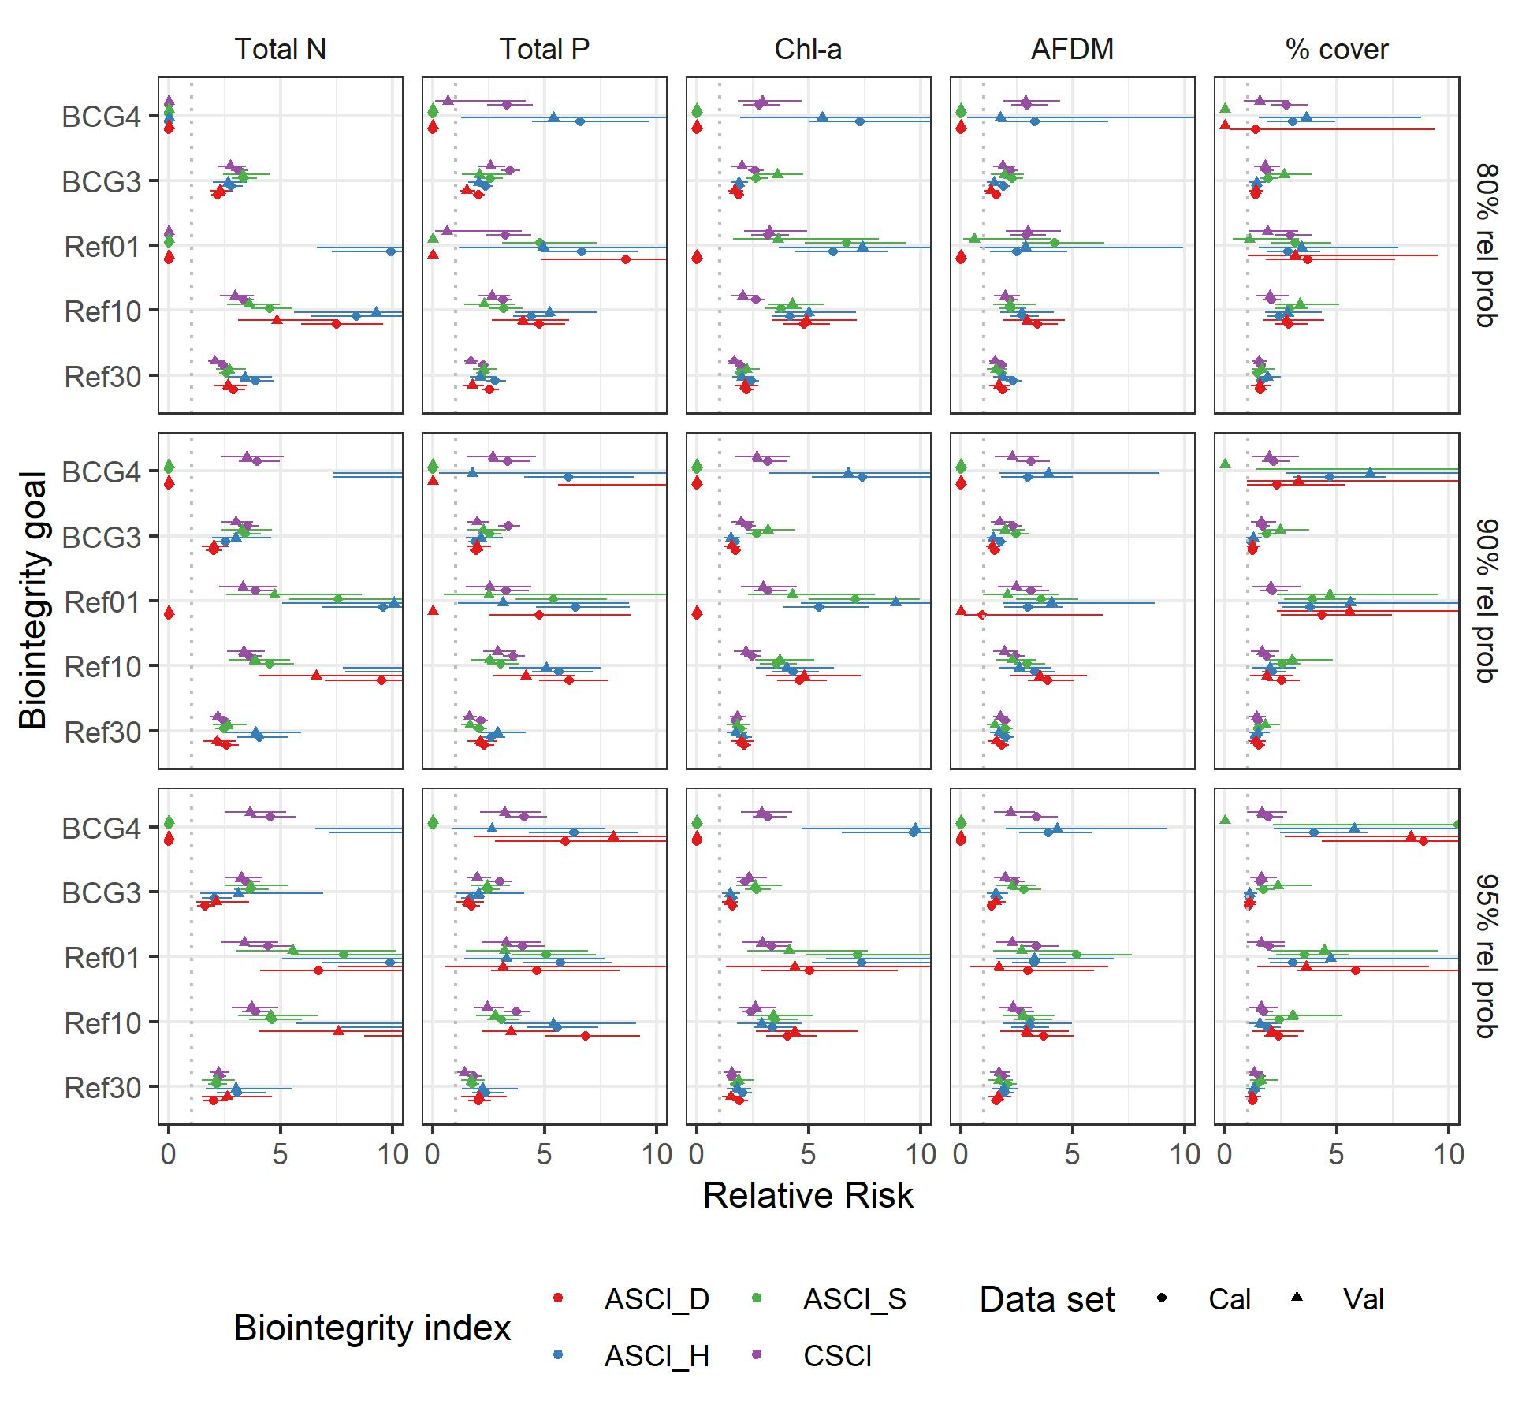

Relative risk of failing to meet biointegrity goals when eutrophication thresholds (Supplement 3) are exceeded. Dotted lines indicate a relative risk of 1. Dots indicate the risk estimate, and lines indicate the 95% confidence interval.

Supplement 4. Regional thresholds are poorly validated, and rarely vary across regions.

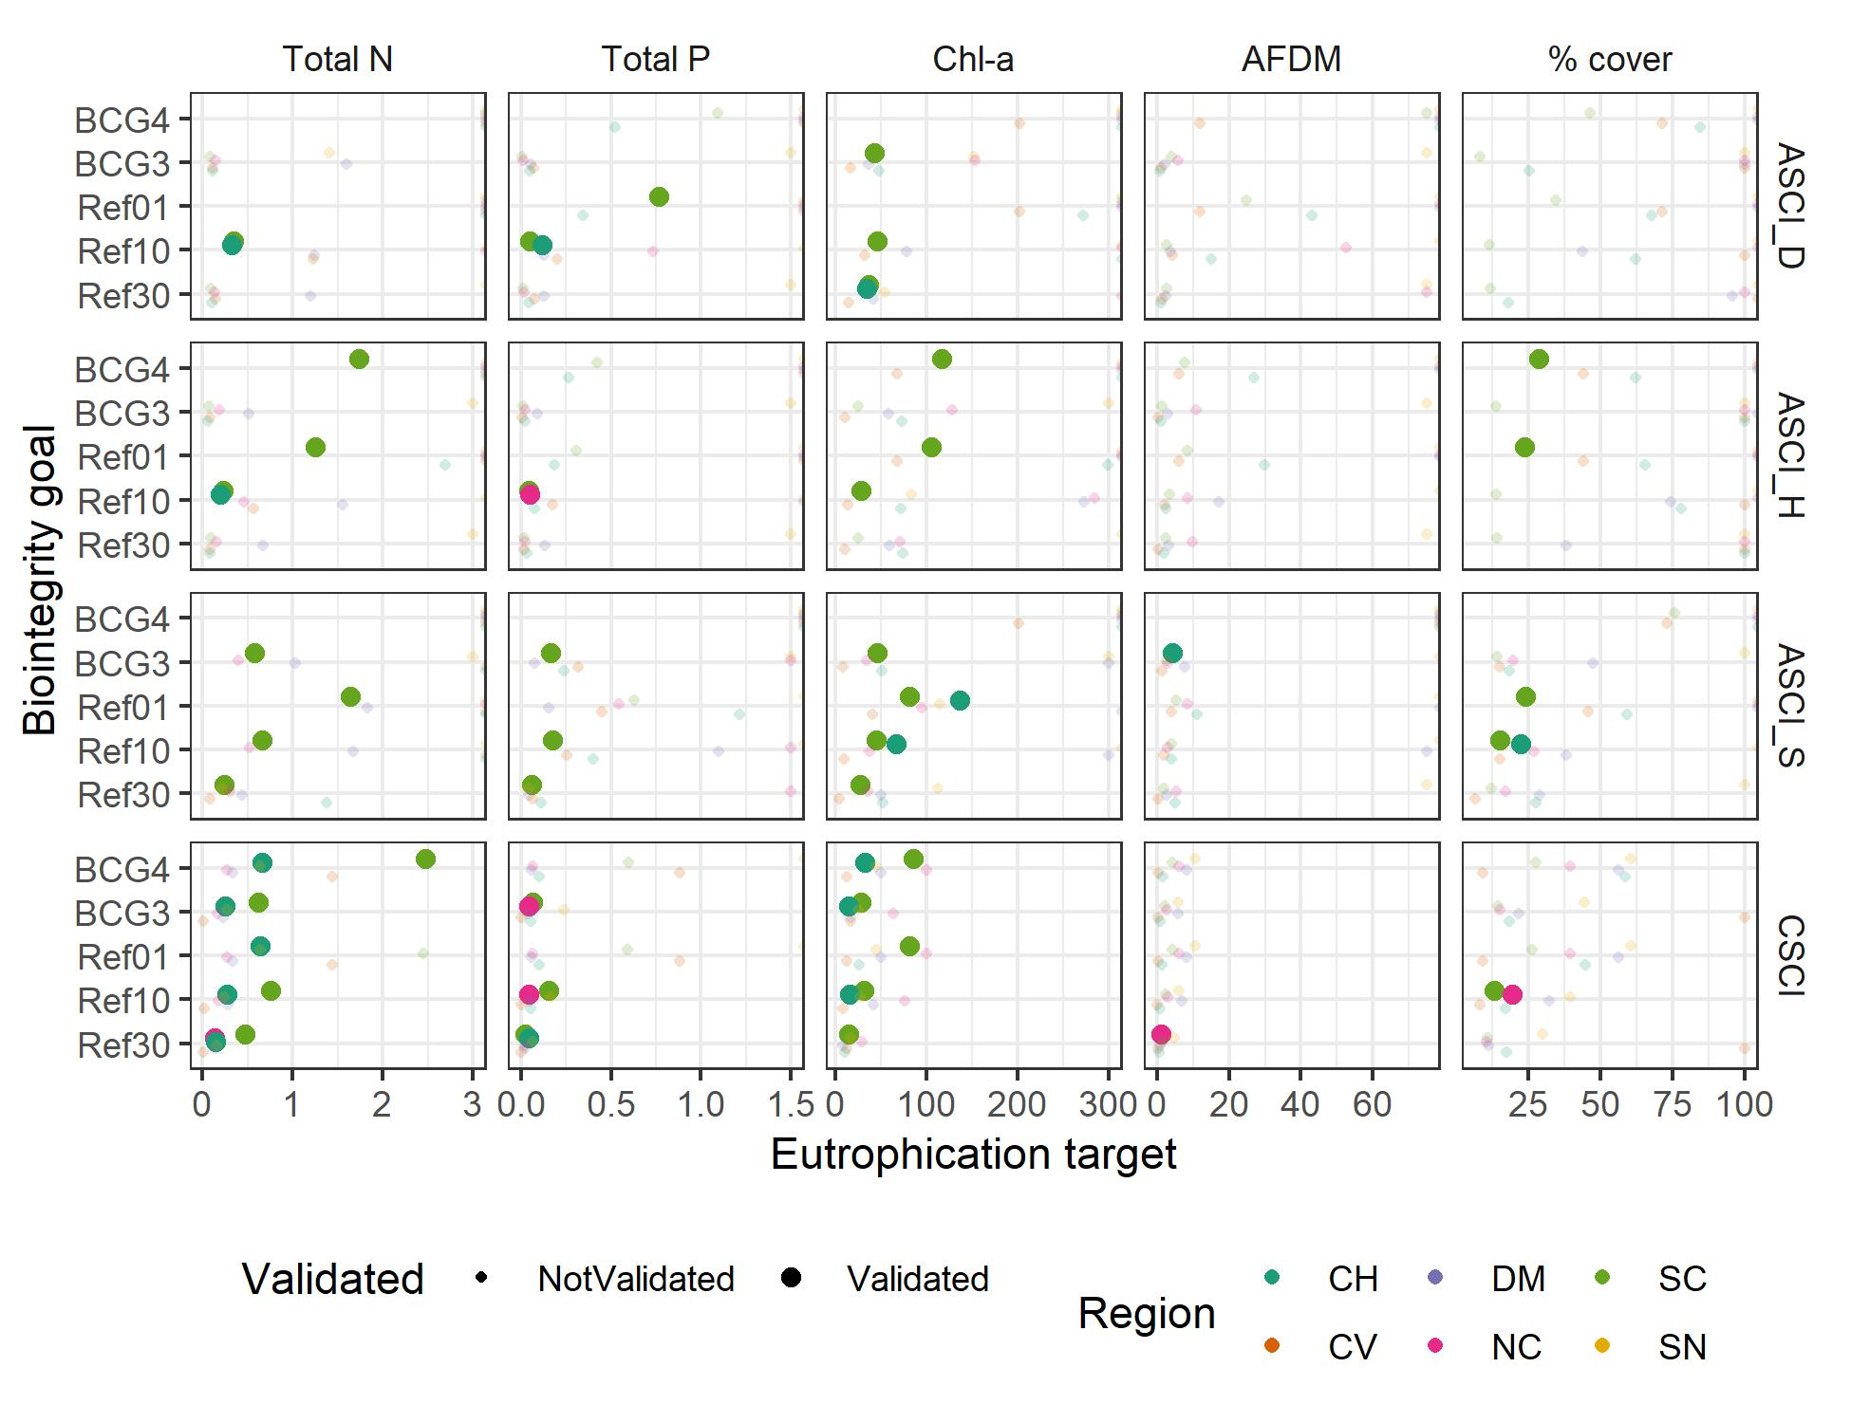

Supplement 5. Table and maps indicating the percent of sites passing eutrophication thresholds by region. Rel prob: Relative probability. Cal: Calibration. Val: Validation. Abbreviations for regions are shown in Figure 2.

|  |  |  |  |  |  |  |  |  |  |  |
| --- | --- | --- | --- | --- | --- | --- | --- | --- | --- | --- |
|  |  |  | # sites | | 80% rel prob | | 90% rel prob | | 95% rel prob | |
|  |  |  | Cal | Val | Cal | Val | Cal | Val | Cal | Val |
| Total N | Ref30 | California | 732 | 228 | 60 | 62 | 42 | 46 | 23 | 22 |
| Total N | Ref30 | CH | 129 | 42 | 64 | 67 | 37 | 52 | 15 | 10 |
| Total N | Ref30 | CV | 45 | 11 | 22 | 18 | 7 | 9 | 2 | 0 |
| Total N | Ref30 | DM | 48 | 9 | 58 | 56 | 42 | 33 | 23 | 22 |
| Total N | Ref30 | NC | 107 | 34 | 92 | 97 | 71 | 74 | 39 | 35 |
| Total N | Ref30 | SC | 255 | 84 | 32 | 33 | 18 | 19 | 13 | 10 |
| Total N | Ref30 | SN | 148 | 48 | 95 | 94 | 76 | 79 | 41 | 50 |
| Total N | Ref10 | California | 732 | 228 | 75 | 77 | 68 | 68 | 55 | 57 |
| Total N | Ref10 | CH | 129 | 42 | 87 | 93 | 77 | 81 | 56 | 64 |
| Total N | Ref10 | CV | 45 | 11 | 40 | 45 | 33 | 18 | 11 | 9 |
| Total N | Ref10 | DM | 48 | 9 | 83 | 78 | 65 | 67 | 54 | 56 |
| Total N | Ref10 | NC | 107 | 34 | 99 | 100 | 96 | 97 | 86 | 85 |
| Total N | Ref10 | SC | 255 | 84 | 51 | 51 | 41 | 38 | 27 | 31 |
| Total N | Ref10 | SN | 148 | 48 | 99 | 100 | 98 | 98 | 92 | 90 |
| Total N | Ref01 | California | 732 | 228 | 92 | 93 | 88 | 89 | 85 | 82 |
| Total N | Ref01 | CH | 129 | 42 | 98 | 100 | 98 | 98 | 95 | 95 |
| Total N | Ref01 | CV | 45 | 11 | 96 | 82 | 91 | 73 | 78 | 55 |
| Total N | Ref01 | DM | 48 | 9 | 100 | 100 | 96 | 100 | 94 | 100 |
| Total N | Ref01 | NC | 107 | 34 | 99 | 100 | 99 | 100 | 99 | 100 |
| Total N | Ref01 | SC | 255 | 84 | 78 | 82 | 70 | 76 | 65 | 61 |
| Total N | Ref01 | SN | 148 | 48 | 100 | 100 | 100 | 100 | 100 | 100 |
| Total N | BCG3 | California | 732 | 228 | 52 | 54 | 31 | 33 | 14 | 12 |
| Total N | BCG3 | CH | 129 | 42 | 53 | 60 | 25 | 31 | 6 | 2 |
| Total N | BCG3 | CV | 45 | 11 | 11 | 9 | 2 | 9 | 0 | 0 |
| Total N | BCG3 | DM | 48 | 9 | 52 | 44 | 38 | 22 | 15 | 11 |
| Total N | BCG3 | NC | 107 | 34 | 86 | 82 | 52 | 47 | 21 | 21 |
| Total N | BCG3 | SC | 255 | 84 | 24 | 27 | 14 | 12 | 10 | 6 |
| Total N | BCG3 | SN | 148 | 48 | 89 | 88 | 59 | 69 | 26 | 27 |
| Total N | BCG4 | California | 732 | 228 | 100 | 100 | 90 | 91 | 86 | 83 |
| Total N | BCG4 | CH | 129 | 42 | 100 | 100 | 98 | 100 | 96 | 95 |
| Total N | BCG4 | CV | 45 | 11 | 100 | 100 | 96 | 73 | 80 | 64 |
| Total N | BCG4 | DM | 48 | 9 | 100 | 100 | 98 | 100 | 96 | 100 |
| Total N | BCG4 | NC | 107 | 34 | 100 | 100 | 99 | 100 | 99 | 100 |
| Total N | BCG4 | SC | 255 | 84 | 100 | 100 | 73 | 79 | 65 | 61 |
| Total N | BCG4 | SN | 148 | 48 | 100 | 100 | 100 | 100 | 100 | 100 |
| Total P | Ref30 | California | 732 | 228 | 67 | 69 | 44 | 44 | 21 | 18 |
| Total P | Ref30 | CH | 129 | 42 | 66 | 71 | 44 | 43 | 19 | 17 |
| Total P | Ref30 | CV | 45 | 11 | 29 | 45 | 11 | 36 | 7 | 9 |
| Total P | Ref30 | DM | 48 | 9 | 67 | 67 | 27 | 22 | 4 | 0 |
| Total P | Ref30 | NC | 107 | 34 | 92 | 94 | 61 | 74 | 28 | 32 |
| Total P | Ref30 | SC | 255 | 84 | 52 | 56 | 33 | 23 | 15 | 8 |
| Total P | Ref30 | SN | 148 | 48 | 88 | 79 | 66 | 69 | 35 | 29 |
| Total P | Ref10 | California | 732 | 228 | 85 | 88 | 77 | 82 | 66 | 66 |
| Total P | Ref10 | CH | 129 | 42 | 88 | 95 | 80 | 81 | 65 | 67 |
| Total P | Ref10 | CV | 45 | 11 | 58 | 55 | 40 | 55 | 29 | 45 |
| Total P | Ref10 | DM | 48 | 9 | 98 | 100 | 81 | 89 | 67 | 67 |
| Total P | Ref10 | NC | 107 | 34 | 99 | 97 | 98 | 97 | 91 | 91 |
| Total P | Ref10 | SC | 255 | 84 | 71 | 77 | 62 | 70 | 51 | 54 |
| Total P | Ref10 | SN | 148 | 48 | 99 | 100 | 96 | 100 | 85 | 75 |
| Total P | Ref01 | California | 732 | 228 | 95 | 99 | 93 | 96 | 89 | 92 |
| Total P | Ref01 | CH | 129 | 42 | 99 | 100 | 97 | 95 | 92 | 95 |
| Total P | Ref01 | CV | 45 | 11 | 82 | 91 | 78 | 73 | 69 | 64 |
| Total P | Ref01 | DM | 48 | 9 | 100 | 100 | 100 | 100 | 100 | 100 |
| Total P | Ref01 | NC | 107 | 34 | 100 | 100 | 100 | 100 | 100 | 100 |
| Total P | Ref01 | SC | 255 | 84 | 90 | 99 | 87 | 94 | 78 | 86 |
| Total P | Ref01 | SN | 148 | 48 | 100 | 100 | 100 | 100 | 99 | 100 |
| Total P | BCG3 | California | 732 | 228 | 61 | 58 | 34 | 31 | 14 | 10 |
| Total P | BCG3 | CH | 129 | 42 | 57 | 64 | 35 | 29 | 9 | 7 |
| Total P | BCG3 | CV | 45 | 11 | 16 | 45 | 9 | 18 | 4 | 0 |
| Total P | BCG3 | DM | 48 | 9 | 56 | 56 | 15 | 11 | 2 | 0 |
| Total P | BCG3 | NC | 107 | 34 | 85 | 85 | 46 | 53 | 21 | 21 |
| Total P | BCG3 | SC | 255 | 84 | 47 | 37 | 27 | 18 | 10 | 5 |
| Total P | BCG3 | SN | 148 | 48 | 84 | 75 | 49 | 48 | 26 | 17 |
| Total P | BCG4 | California | 732 | 228 | 96 | 99 | 93 | 96 | 89 | 92 |
| Total P | BCG4 | CH | 129 | 42 | 100 | 100 | 97 | 95 | 92 | 95 |
| Total P | BCG4 | CV | 45 | 11 | 84 | 91 | 78 | 73 | 69 | 64 |
| Total P | BCG4 | DM | 48 | 9 | 100 | 100 | 100 | 100 | 100 | 100 |
| Total P | BCG4 | NC | 107 | 34 | 100 | 100 | 100 | 100 | 100 | 100 |
| Total P | BCG4 | SC | 255 | 84 | 90 | 99 | 87 | 94 | 78 | 86 |
| Total P | BCG4 | SN | 148 | 48 | 100 | 100 | 100 | 100 | 99 | 100 |
| Chl-a | Ref30 | California | 732 | 228 | 68 | 70 | 49 | 52 | 33 | 28 |
| Chl-a | Ref30 | CH | 129 | 42 | 78 | 79 | 53 | 45 | 32 | 24 |
| Chl-a | Ref30 | CV | 45 | 11 | 76 | 73 | 42 | 45 | 31 | 27 |
| Chl-a | Ref30 | DM | 48 | 9 | 92 | 67 | 75 | 67 | 50 | 33 |
| Chl-a | Ref30 | NC | 107 | 34 | 83 | 79 | 62 | 65 | 43 | 26 |
| Chl-a | Ref30 | SC | 255 | 84 | 38 | 46 | 21 | 33 | 13 | 11 |
| Chl-a | Ref30 | SN | 148 | 48 | 90 | 96 | 76 | 81 | 59 | 60 |
| Chl-a | Ref10 | California | 732 | 228 | 80 | 84 | 68 | 70 | 51 | 53 |
| Chl-a | Ref10 | CH | 129 | 42 | 92 | 95 | 78 | 79 | 57 | 45 |
| Chl-a | Ref10 | CV | 45 | 11 | 82 | 100 | 76 | 73 | 42 | 45 |
| Chl-a | Ref10 | DM | 48 | 9 | 98 | 89 | 92 | 67 | 75 | 67 |
| Chl-a | Ref10 | NC | 107 | 34 | 90 | 94 | 83 | 79 | 65 | 68 |
| Chl-a | Ref10 | SC | 255 | 84 | 58 | 63 | 38 | 48 | 23 | 35 |
| Chl-a | Ref10 | SN | 148 | 48 | 95 | 98 | 90 | 96 | 77 | 81 |
| Chl-a | Ref01 | California | 732 | 228 | 91 | 92 | 83 | 88 | 73 | 79 |
| Chl-a | Ref01 | CH | 129 | 42 | 98 | 98 | 93 | 98 | 85 | 86 |
| Chl-a | Ref01 | CV | 45 | 11 | 89 | 100 | 84 | 100 | 80 | 91 |
| Chl-a | Ref01 | DM | 48 | 9 | 98 | 100 | 98 | 89 | 98 | 78 |
| Chl-a | Ref01 | NC | 107 | 34 | 98 | 100 | 92 | 100 | 86 | 88 |
| Chl-a | Ref01 | SC | 255 | 84 | 79 | 80 | 62 | 70 | 46 | 58 |
| Chl-a | Ref01 | SN | 148 | 48 | 100 | 100 | 97 | 98 | 91 | 98 |
| Chl-a | BCG3 | California | 732 | 228 | 77 | 81 | 63 | 65 | 44 | 45 |
| Chl-a | BCG3 | CH | 129 | 42 | 91 | 90 | 74 | 74 | 50 | 36 |
| Chl-a | BCG3 | CV | 45 | 11 | 82 | 91 | 62 | 64 | 36 | 45 |
| Chl-a | BCG3 | DM | 48 | 9 | 98 | 89 | 90 | 67 | 62 | 67 |
| Chl-a | BCG3 | NC | 107 | 34 | 87 | 94 | 78 | 74 | 59 | 56 |
| Chl-a | BCG3 | SC | 255 | 84 | 53 | 60 | 34 | 42 | 17 | 25 |
| Chl-a | BCG3 | SN | 148 | 48 | 94 | 98 | 86 | 92 | 70 | 77 |
| Chl-a | BCG4 | California | 732 | 228 | 92 | 93 | 83 | 88 | 75 | 80 |
| Chl-a | BCG4 | CH | 129 | 42 | 98 | 98 | 93 | 98 | 88 | 90 |
| Chl-a | BCG4 | CV | 45 | 11 | 89 | 100 | 84 | 100 | 82 | 91 |
| Chl-a | BCG4 | DM | 48 | 9 | 98 | 100 | 98 | 89 | 98 | 78 |
| Chl-a | BCG4 | NC | 107 | 34 | 98 | 100 | 93 | 100 | 86 | 88 |
| Chl-a | BCG4 | SC | 255 | 84 | 81 | 81 | 64 | 70 | 48 | 60 |
| Chl-a | BCG4 | SN | 148 | 48 | 100 | 100 | 97 | 98 | 92 | 98 |
| AFDM | Ref30 | California | 732 | 228 | 66 | 68 | 49 | 56 | 32 | 30 |
| AFDM | Ref30 | CH | 129 | 42 | 88 | 81 | 65 | 62 | 34 | 33 |
| AFDM | Ref30 | CV | 45 | 11 | 51 | 82 | 27 | 73 | 11 | 18 |
| AFDM | Ref30 | DM | 48 | 9 | 79 | 67 | 58 | 56 | 33 | 22 |
| AFDM | Ref30 | NC | 107 | 34 | 87 | 82 | 79 | 76 | 61 | 44 |
| AFDM | Ref30 | SC | 255 | 84 | 33 | 40 | 16 | 25 | 7 | 6 |
| AFDM | Ref30 | SN | 148 | 48 | 89 | 94 | 76 | 88 | 57 | 62 |
| AFDM | Ref10 | California | 732 | 228 | 76 | 79 | 61 | 66 | 47 | 52 |
| AFDM | Ref10 | CH | 129 | 42 | 93 | 95 | 83 | 81 | 61 | 57 |
| AFDM | Ref10 | CV | 45 | 11 | 62 | 91 | 42 | 82 | 24 | 64 |
| AFDM | Ref10 | DM | 48 | 9 | 90 | 78 | 77 | 67 | 50 | 56 |
| AFDM | Ref10 | NC | 107 | 34 | 93 | 85 | 84 | 79 | 79 | 76 |
| AFDM | Ref10 | SC | 255 | 84 | 49 | 55 | 27 | 35 | 14 | 19 |
| AFDM | Ref10 | SN | 148 | 48 | 96 | 100 | 85 | 94 | 74 | 83 |
| AFDM | Ref01 | California | 732 | 228 | 88 | 88 | 76 | 79 | 62 | 66 |
| AFDM | Ref01 | CH | 129 | 42 | 98 | 98 | 93 | 95 | 85 | 81 |
| AFDM | Ref01 | CV | 45 | 11 | 84 | 100 | 62 | 91 | 47 | 82 |
| AFDM | Ref01 | DM | 48 | 9 | 94 | 89 | 90 | 78 | 77 | 67 |
| AFDM | Ref01 | NC | 107 | 34 | 98 | 94 | 93 | 85 | 84 | 79 |
| AFDM | Ref01 | SC | 255 | 84 | 73 | 71 | 48 | 55 | 28 | 35 |
| AFDM | Ref01 | SN | 148 | 48 | 97 | 100 | 96 | 100 | 86 | 94 |
| AFDM | BCG3 | California | 732 | 228 | 69 | 72 | 52 | 59 | 36 | 36 |
| AFDM | BCG3 | CH | 129 | 42 | 89 | 88 | 71 | 67 | 43 | 43 |
| AFDM | BCG3 | CV | 45 | 11 | 51 | 82 | 33 | 82 | 16 | 27 |
| AFDM | BCG3 | DM | 48 | 9 | 81 | 78 | 65 | 56 | 42 | 33 |
| AFDM | BCG3 | NC | 107 | 34 | 93 | 85 | 80 | 79 | 67 | 53 |
| AFDM | BCG3 | SC | 255 | 84 | 36 | 45 | 17 | 27 | 8 | 10 |
| AFDM | BCG3 | SN | 148 | 48 | 90 | 94 | 78 | 90 | 62 | 67 |
| AFDM | BCG4 | California | 732 | 228 | 88 | 88 | 76 | 79 | 62 | 66 |
| AFDM | BCG4 | CH | 129 | 42 | 98 | 98 | 93 | 95 | 85 | 81 |
| AFDM | BCG4 | CV | 45 | 11 | 84 | 100 | 62 | 91 | 47 | 82 |
| AFDM | BCG4 | DM | 48 | 9 | 94 | 89 | 90 | 78 | 77 | 67 |
| AFDM | BCG4 | NC | 107 | 34 | 98 | 94 | 93 | 85 | 84 | 79 |
| AFDM | BCG4 | SC | 255 | 84 | 73 | 71 | 48 | 55 | 28 | 35 |
| AFDM | BCG4 | SN | 148 | 48 | 97 | 100 | 96 | 100 | 86 | 94 |
| % cover | Ref30 | California | 650 | 202 | 62 | 61 | 48 | 47 | 35 | 34 |
| % cover | Ref30 | CH | 123 | 36 | 66 | 69 | 54 | 64 | 40 | 53 |
| % cover | Ref30 | CV | 44 | 10 | 52 | 50 | 41 | 50 | 34 | 40 |
| % cover | Ref30 | DM | 46 | 8 | 59 | 88 | 39 | 75 | 28 | 50 |
| % cover | Ref30 | NC | 86 | 33 | 84 | 70 | 70 | 52 | 49 | 36 |
| % cover | Ref30 | SC | 219 | 73 | 41 | 44 | 27 | 25 | 18 | 18 |
| % cover | Ref30 | SN | 132 | 42 | 83 | 74 | 67 | 60 | 52 | 40 |
| % cover | Ref10 | California | 650 | 202 | 68 | 68 | 54 | 54 | 44 | 43 |
| % cover | Ref10 | CH | 123 | 36 | 71 | 83 | 59 | 64 | 46 | 58 |
| % cover | Ref10 | CV | 44 | 10 | 64 | 50 | 45 | 50 | 41 | 40 |
| % cover | Ref10 | DM | 46 | 8 | 76 | 100 | 50 | 88 | 37 | 62 |
| % cover | Ref10 | NC | 86 | 33 | 87 | 73 | 74 | 58 | 63 | 45 |
| % cover | Ref10 | SC | 219 | 73 | 47 | 49 | 33 | 37 | 25 | 23 |
| % cover | Ref10 | SN | 132 | 42 | 86 | 83 | 73 | 67 | 64 | 60 |
| % cover | Ref01 | California | 650 | 202 | 85 | 81 | 69 | 69 | 62 | 64 |
| % cover | Ref01 | CH | 123 | 36 | 85 | 94 | 71 | 83 | 66 | 78 |
| % cover | Ref01 | CV | 44 | 10 | 73 | 80 | 64 | 50 | 52 | 50 |
| % cover | Ref01 | DM | 46 | 8 | 93 | 100 | 76 | 100 | 59 | 100 |
| % cover | Ref01 | NC | 86 | 33 | 98 | 91 | 90 | 73 | 84 | 70 |
| % cover | Ref01 | SC | 219 | 73 | 74 | 62 | 48 | 52 | 42 | 47 |
| % cover | Ref01 | SN | 132 | 42 | 96 | 93 | 86 | 83 | 83 | 74 |
| % cover | BCG3 | California | 650 | 202 | 66 | 66 | 52 | 54 | 41 | 41 |
| % cover | BCG3 | CH | 123 | 36 | 69 | 81 | 59 | 64 | 46 | 53 |
| % cover | BCG3 | CV | 44 | 10 | 59 | 50 | 45 | 50 | 41 | 40 |
| % cover | BCG3 | DM | 46 | 8 | 76 | 100 | 48 | 88 | 35 | 62 |
| % cover | BCG3 | NC | 86 | 33 | 87 | 70 | 73 | 58 | 57 | 45 |
| % cover | BCG3 | SC | 219 | 73 | 45 | 48 | 32 | 37 | 23 | 22 |
| % cover | BCG3 | SN | 132 | 42 | 85 | 79 | 71 | 67 | 57 | 55 |
| % cover | BCG4 | California | 650 | 202 | 91 | 92 | 70 | 70 | 66 | 66 |
| % cover | BCG4 | CH | 123 | 36 | 90 | 97 | 71 | 83 | 69 | 81 |
| % cover | BCG4 | CV | 44 | 10 | 89 | 100 | 64 | 50 | 59 | 50 |
| % cover | BCG4 | DM | 46 | 8 | 96 | 100 | 80 | 100 | 76 | 100 |
| % cover | BCG4 | NC | 86 | 33 | 99 | 97 | 90 | 73 | 87 | 70 |
| % cover | BCG4 | SC | 219 | 73 | 84 | 79 | 51 | 53 | 45 | 48 |
| % cover | BCG4 | SN | 132 | 42 | 98 | 100 | 86 | 83 | 85 | 79 |

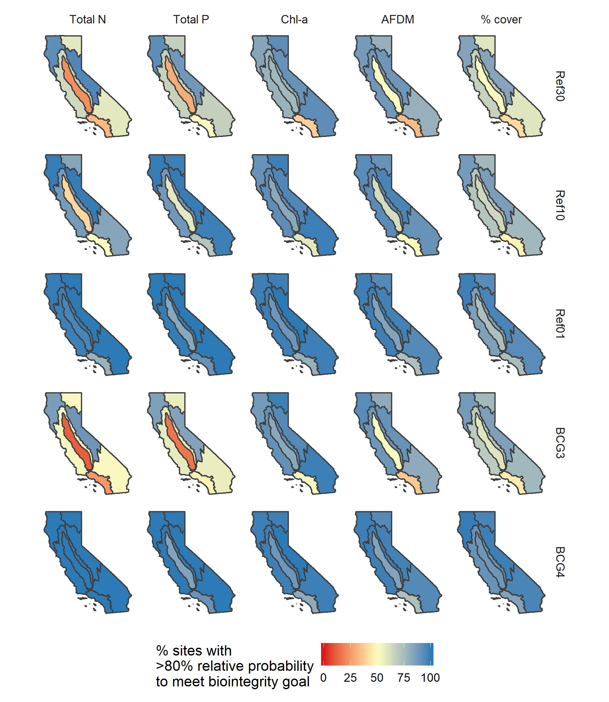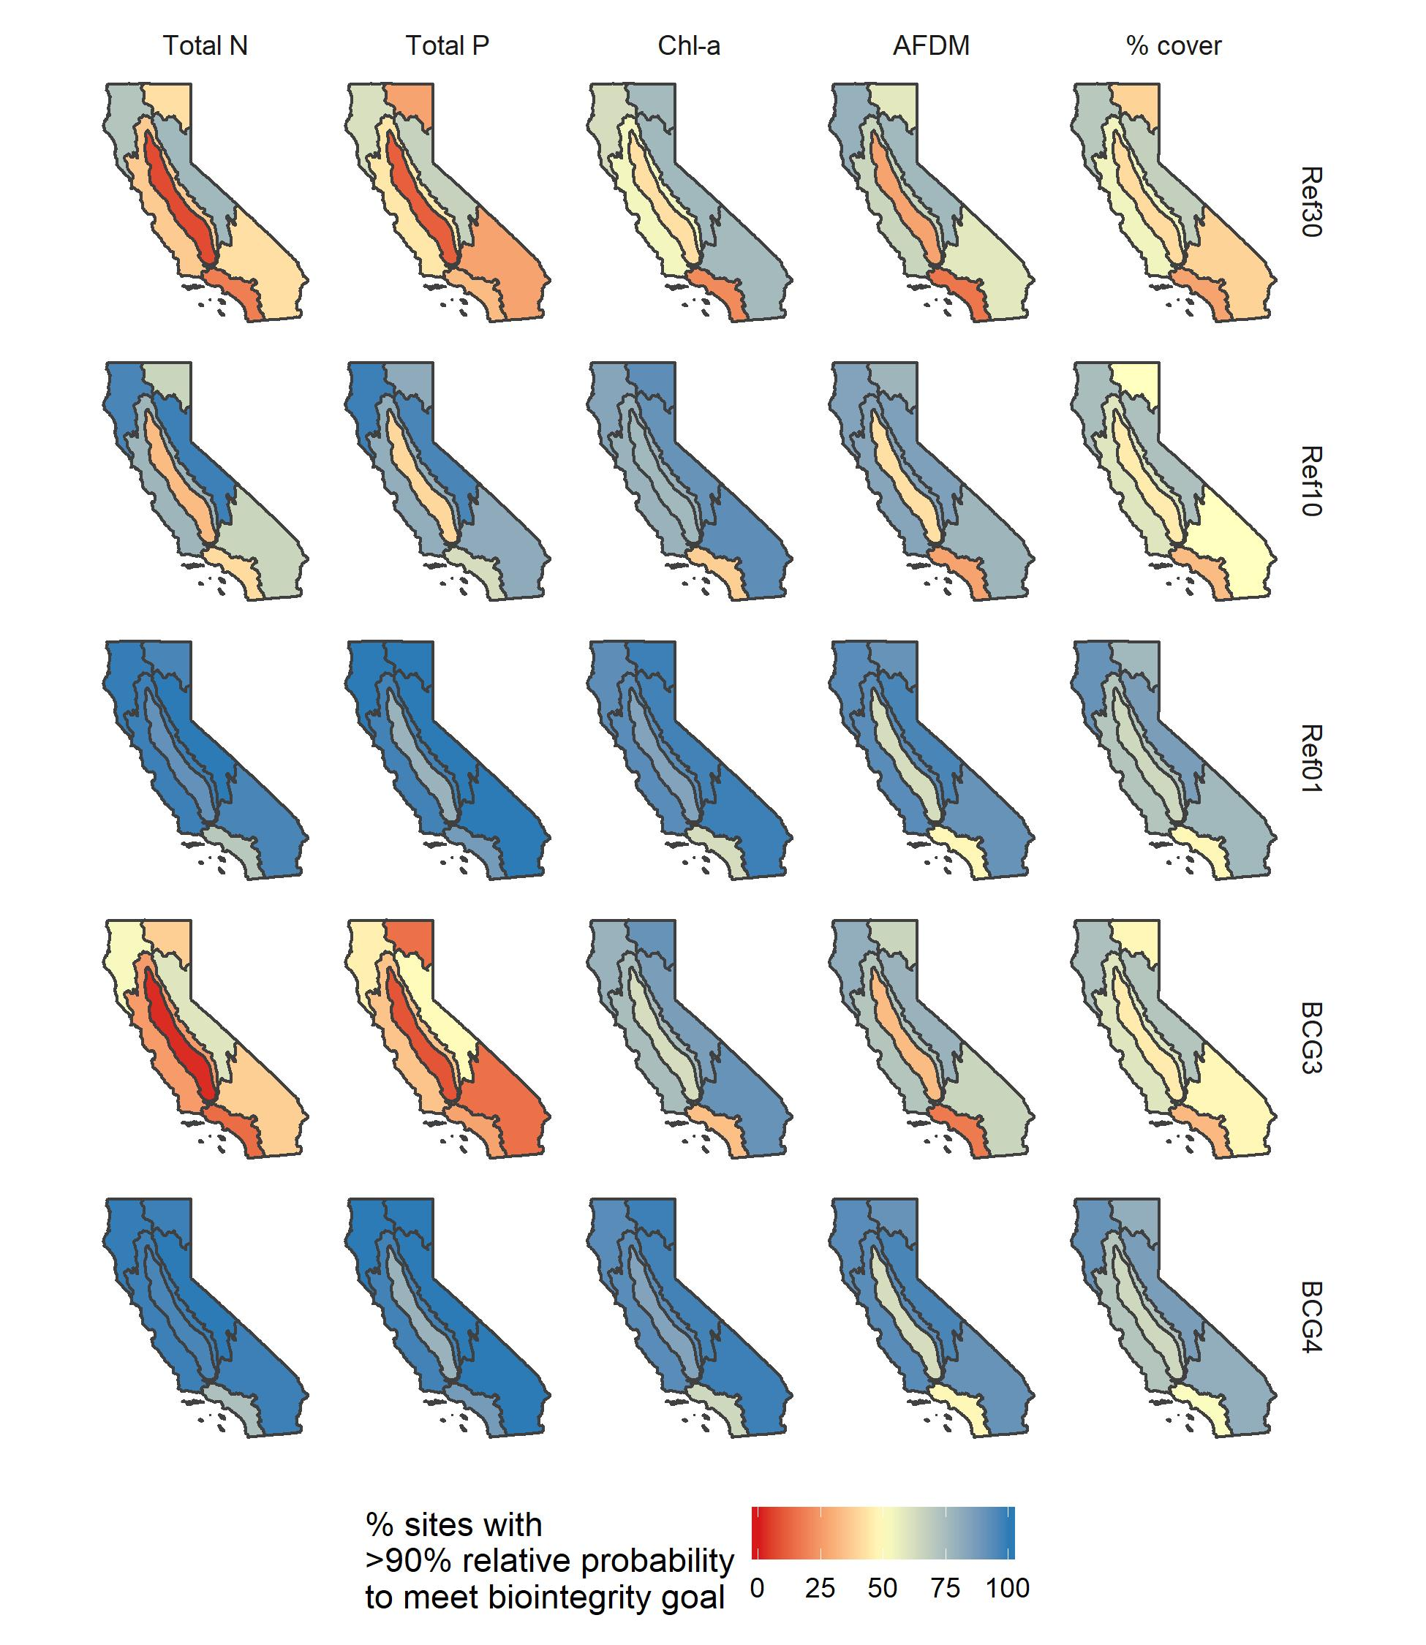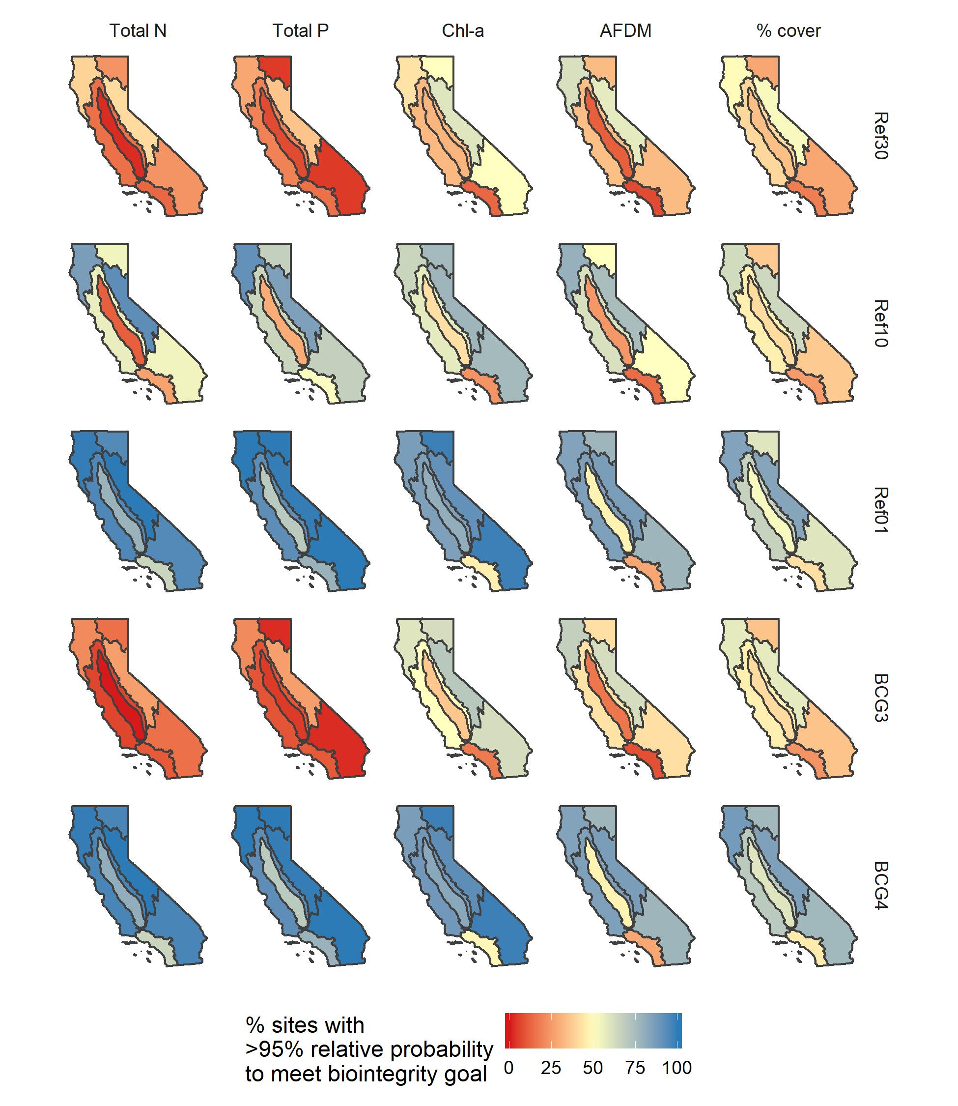

Supplement 6. Additional analyses to evaluate eutrophication thresholds

W calculated “changepoints” using Threshold Indicator Taxa Analysis (TITAN; Baker et al. 2015). TITAN identifies numeric values along gradients where taxa exhibit a change in their abundance (either increasing or decreasing), and is an extension of indicator species analysis (Dufrêne and Legendre 1997). TITAN calculates changepoints along a gradient for each taxon, and classifies it as an increaser or a decreaser. It also calculates assemblage-wide average changepoints for all increaser or decreaser taxa. We used the TITAN2 package in R (Baker et al. 2015) to calculate changepoints for diatoms, soft-bodied algae, and benthic macroinvertebrate assemblages. Algal data were aggregated to the genus level, and benthic macroinvertebrate data were aggregated to operational taxonomic units used to calculate the CSCI (i.e., genus for most taxa, subfamily for Chironomidae; Mazor et al. 2016). Taxa with indicator values (a measure of the purity and reliability of the indication provided by the presence of the taxon) greater than 10 are plotted below.

Baker, M.E., King, R.S., and Kahle D. 2015. TITAN2: Threshold Indicator Taxa Analysis. R package version 2.1. <https://CRAN.R-project.org/package=TITAN2>

Dufrêne, M., and Legendre, P. 1997. Species assemblages and indicator species: The need for a flexible asymmetrical approach. Ecological Monogrpahs. DOI: [https://doi.org/10.1890/0012-9615(1997)067[0345:SAAIST]2.0.CO;2](https://doi.org/10.1890/0012-9615(1997)067%5b0345:SAAIST%5d2.0.CO;2)

Mazor, R.D., A.C. Rehn, P.R. Ode, M. Engeln, K.C. Schiff, E.D. Stein, D.J. Gillett, D.B. Herbst, and C.P. Hawkins. 2016. Bioassessment in complex environments: Designing an index for consistent meaning in different settings. Freshwater Science 35(1): 249-271

Ode, P.R., Rehn, A.C., Mazor, R.D., Schiff, K., Stein, E.D., May, J.T. Brown, L.R., Herbst, D.B., Gillett, D., Lunde, K, and Hawkins, C.P. 2016. Evaluating the adequacy of a reference-site pool for ecological assessment in environmentally complex regions. Freshwater Science DOI: 10.1086/684003

