Briefing Materials for Water Board Members

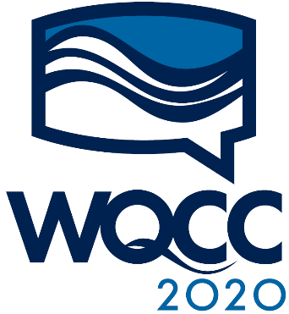

October 27 and 28

California Water Boards

Water Quality
Coordinating Committee

Before the Meeting

Basics
Contact WQCC@WaterBoards.CA.gov with any issues, comments, or questions.

Briefing materials: https://www.waterboards.ca.gov/wqcc/.

“Renaming” yourself in the Zoom meeting
How you are named (labeled) by Zoom in the meeting is important! It helps the meeting organizers clearly identify you as a Board Member or a member of the Boards’ staff.
Please use this format: ORGANIZATION ROLE NAME
For example: RB5 Chair Karl Longley
To rename yourself in Zoom in the WQCC format:
- Enter the meeting. (Board Members and staff, check your Outlook Calendar item for the link.)
- Click on the “Participants” button at the top or bottom of the Zoom window. A list of participants will appear.
- Place your mouse over your name in the “Participants” list (you may be at the top). Click on “More >” and then “Rename.”
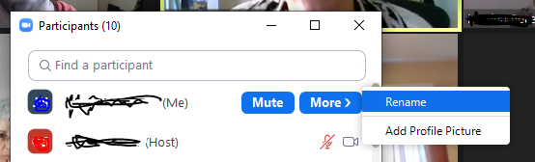

- Enter the name you’d like to appear in the Zoom meeting and click on “OK.”

Assignment to do before WQCC to prepare for the racial equity discussion
In preparation for our session focused on racial equity and the Water Boards’ commitment and practice, we ask that you do at least one of the following pre-session activities:

- View Segregated by Design (17 minutes), an animated film created by Mark Lopez and narrated by Richard Rothstein, author of The Color of Law: How the Government Segregated America.
- View an excerpt of The House We Live In (26 minutes), from “Race: The Power of An Illusion.”
- View The Difference Between Us (57 minutes), from “Race: The Power of An Illusion.”

Table of Contents
(Control-click an item below to jump to section.)

Before the Meeting 2
Basics 2
“Renaming” yourself in the Zoom meeting 2
Assignment to do before WQCC to prepare for the racial equity discussion 3
Agenda 6
Board Member Biographies 8
State Water Board 8
North Coast Regional Water Quality Control Board (Region 1) 11
San Francisco Bay Regional Water Quality Control Board (Region 2) 13
Central Coast Regional Water Quality Control Board (Region 3) 17
Los Angeles Regional Water Quality Control Board (Region 4) 19
Central Valley Regional Water Quality Control Board (Region 5) 21
Lahontan Regional Water Quality Control Board (Region 6) 24
Colorado River Regional Water Quality Control Board (Region 7) 27
Santa Ana Regional Water Quality Control Board (Region 8) 29
San Diego Regional Water Quality Control Board (Region 9) 32
Regional Water Board Updates 35
North Coast Regional Water Quality Control Board (Region 1) 35
San Francisco Bay Regional Water Quality Control Board (Region 2) 36
Central Coast Regional Water Quality Control Board (Region 3) 36
Los Angeles Regional Water Quality Control Board (Region 4) 38
Central Valley Regional Water Quality Control Board (Region 5) 40
Lahontan Regional Water Quality Control Board (Region 6) 40
Colorado River Regional Water Quality Control Board (Region 7) 41
Santa Ana Regional Water Quality Control Board (Region 8) 43
San Diego Regional Water Quality Control Board (Region 9) 44
Day 1 Sessions 47
Water Boards in the Age of COVID-19 47
Legislative Updates 54
Day 2 Sessions 60
Facilitated Discussion about Racial Equity 60
Office of Chief Counsel Updates and Discussions 60
Topics Not on the WQCC Agenda 62
Per- and Polyfluoroalkyl Substances (PFAS) 62
Sustainable Groundwater Management Act (SGMA) 63
Salton Sea 64
Safe and Affordable Funding for Equity and Resilience (SAFER) 65
Maximum Contaminant Levels 68

Agenda

October 27

9:30 | - Welcome | Joaquin Esquivel, Chair, State Water Board
9:40 | - Appointments Updates | Kristi Stauffacher, Governor’s Appointments Advisor
10:00 | - California Environmental Protection Agency Updates  - To hear about and discuss policy direction. | Jared Blumenfeld, CalEPA Secretary
10:30 | BREAK
11:00 | - Flash Regional Water Board Updates (Part 1: Regions 1, 2, and 3) | EO from each Region
11:20 | - Water Boards in the Age of COVID-19  - Remote Board Meetings  - Remote enforcement  - Remote training courses and the new Water Leadership Program  - Sewershed testing for Covid-19  - Budget and workforce topics | Michael Lauffer, Chief Counsel, Water Boards  Yvonne West, Director, State Water Board  Katy Landau, Training & Technical Services Manager, State Water Board  Jon Bishop, Chief Deputy Director, State Water Board
12:30 | LUNCH BREAK
2:00 | - Flash Regional Water Board Updates (Part 2: Regions 4, 5, and 6) | EO from each Region
2:20 | - Legislative Updates  - To hear and discuss the legislative context. | Rob Egel, Legislative Director, Water Boards
2:40 | - Flash Regional Water Board Updates (Part 3: Regions 7, 8, and 9) | EO from each Region
3:00 | END OF DAY 1

October 28

9:00 | - Facilitated Discussion about Racial Equity | Yana Garcia, CalEPA Deputy Secretary  Deldi Reyes, CalEPA Co-Lead of the Cross-Agency Racial Equity Work Group  Greg Gearheart, Director, State Water Board
1:00 | LUNCH BREAK
2:00 | - Office of Chief Counsel Updates and Discussions | Michael Lauffer, Chief Counsel, Water Boards  Jennifer Fordyce, Assistant Chief Counsel, Water Boards  Emel Wadhwani, Assistant Chief Counsel, Water Boards
3:00 | - Final reflections and closing | Joaquin Esquivel, Chair, State Water Board
3:15 | END OF DAY 2

Board Member Biographies

State Water Board
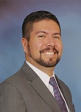  Joaquin Esquivel, Chair | Joaquin Esquivel was appointed to the State Water Resources Control Board by Governor Jerry Brown in March 2017 and designated by Governor Gavin Newsom as Chair in February 2019. Previously, he served as Assistant Secretary for federal water policy at the California Natural Resources Agency in the Governor’s Washington, D.C. office, where he facilitated the development of policy priorities between the agency, the Governor’s Office, the California Congressional delegation, and federal stakeholder agencies. For more than eight years prior to that he worked for U.S. Senator Barbara Boxer of California, most recently as her legislative assistant covering the agriculture, Native American, water, oceans, and nutrition portfolios, in addition to being the director of information and technology. He was born and raised in California’s Coachella Valley. He holds a B.A. from the University of California, Santa Barbara, in English.
Dorene D'Adamo,  Vice Chair | Dorene D'Adamo was appointed to State Water Resources Control Board by Governor Brown in 2013 and reappointed in 2018. She serves as the Vice-Chair and also as the agriculture member of the board. Ms. D’Adamo is on the Board of the California Partnership for the San Joaquin Valley and on the Board of the Pacific Forest and Watershed Lands Stewardship Council, and she also served on the Governor’s Drought Task Force. She was a member of the California Air Resources Board from 1999-2013 under the Brown, Schwarzenegger and Davis Administrations, where she was instrumental in the board's air quality and climate change programs and regulations. Ms. D'Adamo served in various capacities for Members of Congress from the San Joaquin Valley over a 20-year period, working primarily on environmental, water and agricultural legislative policy. Ms. D'Adamo earned a Bachelor of Arts degree from the University of California at Davis and a Juris Doctor from the University of the Pacific, McGeorge School of Law.
Tam M. Doduc | Tam Doduc serves as the civil engineer on the State Water Resources Control Board. Ms. Doduc most recently served as Deputy Secretary at the California Environmental Protection Agency (Cal/EPA), where she directed the agency's environmental justice and external scientific peer review activities. She also coordinated various environmental quality initiatives, and provided general oversight of children's environmental health programs. Ms. Doduc began her career in 1989 as an environmental consultant. She then joined the staff of the State Water Resources Control Board and, later, the California Air Resources Board. From 1998 to 2002, Ms. Doduc provided technical and business assistance to environmental technology developers and manufacturers, serving in the Office of Environmental Technology and, later, as Cal/EPA's Assistant Secretary for Technology Certification. From 2002 to 2004, Ms. Doduc served as Cal/EPA’s Assistant Secretary for Agriculture, Air and Chemical Programs. A licensed civil engineer, Ms. Doduc earned a Bachelor of Science in BioEngineering from the University of California at Berkeley, and a Master of Science in Civil Engineering from the California State University in Sacramento. She also earned a Master of Business Administration from the University of California at Berkeley.
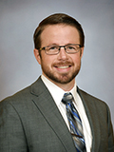  Sean Maguire | Sean Maguire was appointed to the State Water Resources Control Board in December 2018 by Governor Brown and is a registered civil engineer. Mr. Maguire has had a diverse career both in both public service and as an engineering consultant, which provides a valuable perspective of the administrative challenges facing a government agency and needs of a broad array of water interests. From 2015-2018, Mr. Maguire worked for the State Water Resources Control Board as a manager of the Storm Water Grant Program in the Division of Financial Assistance, and later as a manager in the Division of Water Rights where he oversaw administration of water right change petitions, licensing, and cannabis cultivation permitting. Prior to joining the Board, from 2003-2015, he worked for an engineering consulting firm serving a variety of municipalities and water agencies throughout the state, focused on water resources planning, drinking water, and wastewater infrastructure projects. Much of his work revolved around integrated water management and developing long term water supply solutions to meet the needs of both water users and the environment. Mr. Maguire has a Bachelor of Science in Civil Engineering from California State University, Sacramento.
Laurel Firestone | Laurel Firestone was appointed to the State Water Resources Control Board by Governor Gavin Newsom in February 2019. Prior to joining the Board, Laurel co-founded and co-directed, from 2006-2019, the Community Water Center (CWC), a statewide non-profit environmental justice organization. Based in California’s Central Valley and Central Coast, the CWC helps disadvantaged communities gain access to safe, clean, and affordable drinking water and build civic engagement and leadership to achieve the human right to water. Laurel has received a variety of awards and recognitions, including the James Irvine Foundation’s Leadership Award in 2018, and the Gary Bellow Public Service Award by the Harvard Law School in 2013. She also received an Equal Justice Works fellowship to start the Rural Poverty Water Project in the Central Valley in 2004-06 as part of the Center for Race, Poverty and the Environment. Laurel served on the Tulare County Water Commission from 2007‐2012 and co‐chaired the Governor’s Drinking Water Stakeholder Group from 2012‐2014. She served on a variety of state policy advisory committees and partnered with universities to develop research and clinical programs to ensure the human right to water. In 2009, Laurel authored the comprehensive Guide to Community Drinking Water Advocacy and has written a variety of articles relating to safe drinking water and the environment. Laurel graduated with honors from Harvard Law School and holds a B.A. magna cum laude in Environmental Studies from Brown University.

North Coast Regional Water Quality Control Board (Region 1)
Executive Officer: Matthias Saint John
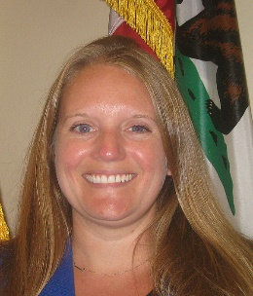  Valerie L. Quinto  Chair | Valerie L. Quinto, of Petaluma, has been program director at the Sonoma Resource Conservation District since 2012, where she has held multiple positions since 2008, including conservation project manager and project coordinator. She was an environmental science intern at the North Coast Regional Water Quality Control Board from 2006 to 2008. Quinto is a fellow of the Leadership Institute for Ecology and the Economy and a member of Leadership Santa Rosa.
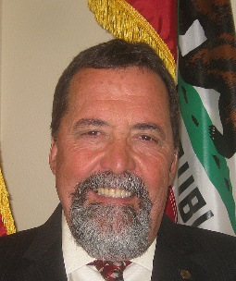  Gregory Giusti  Vice-Chair | Gregory Giusti, of Kelseyville, has been an advisor and director of forest and wildlands ecology at the University of California Cooperative Extension since 1985. He was an agricultural biologist at the San Mateo County Department of Agriculture from 1981 to 1985 and chief biologist at the Marine Ecological Institute from 1979 to 1981. He earned a Master of Arts degree in ecology and population biology from California State University, San Francisco. Mr. Giusti was appointed to the Regional Water Board on November 25, 2013.
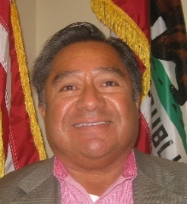  Hector Bedolla | Hector Bedolla, of Healdsburg, has been vineyard manager at North Pacific Vineyard Management since 2016. He was a crop advisor and agronomist at Crop Production Services from 2013 to 2016 and vineyard and ranch manager at Stuhlmuller Vineyards from 2011 to 2013. He was a consulting viticulturist at Windsor Oaks Vineyards in 2011 and an agricultural biologist in the Sonoma County Agricultural Commissioner's Office in 2010. He was a vineyard manager at Kendall-Jackson Wine Estates from 2000 to 2010 and at Stag's Leap Wine Cellars from 1999 to 2000. He was vice president of vineyard operations at Hambrecht Vineyards from 1995 to 1999. He was vineyard manager at Hambrecht and Peterson Vineyards from 1988 to 1995 and at Iron Horse Vineyards from 1983 to 1988. Mr. Bedolla was appointed to the Regional Water Board on December 2, 2016.
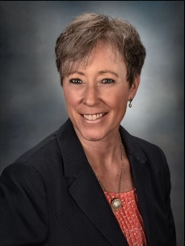  Kelli Gant | Kelli Gant, of Trinity Center, was a director and technical writer for various software companies for over twenty years before moving to Trinity County. She earned a BS in Economics from UC Davis. She currently serves as a Board member for the Trinity County Chamber of Commerce and the Shasta Cascade Wonderland Association; is President of the Trinity Lake Revitalization Alliance; a member of the Trinity Collaborative; is a federally appointed member of the Trinity River Adaptive Management Working Group (TAMWG); and is an elected Board Director for the Trinity Public Utilities District. Ms. Gant was appointed to the Regional Water Board on November 25, 2015.
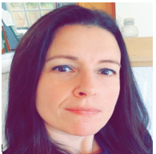  Shaunna McCovey | Shaunna O. McCovey, of McKinleyville, has been the Director of Natural Resources and Governmental Affairs at Resighini Rancheria since 2020. McCovey has worked for Tribal Governments, environmental non-profits and the Federal Government, including Trinidad Rancheria, where she was the Deputy CEO, the Department of the Interior, Indian Affairs, Office of Self-Governance, where she negotiated compacts with Tribal nations, she worked in marine planning and tribal affairs while at the Portland, OR based non-profit, Ecotrust, and as a Policy Manager for Marine Spatial Planning at Ocean Conservancy in Washington, DC. She held multiple positions for the Yurok Tribe including acting Executive Director, Deputy Executive Director, Self-Governance Officer and staff attorney. McCovey has also been an associate professor at Humboldt State University. She earned a Juris Doctorate and a Master of Studies in Environmental Law degree from Vermont Law School and a Master of Social Work degree from Arizona State University.

San Francisco Bay Regional Water Quality Control Board (Region 2)
Executive Officer: Michael Montgomery
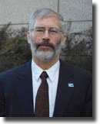  Jim McGrath  Chair | Mr. McGrath, of Berkeley, has worked in the environmental field for over 30 years, starting at the U.S. Environmental Protection Agency in 1972. He spent five years with U.S. EPA, fourteen years with the California Coastal Commission, and sixteen years with the Port of Oakland, working on a variety of projects and addressing a range of environmental issues. Mr. McGrath received his formal education at the University of California, Berkeley, initially in the Chemistry Department, and received a B.A. in History in 1973 and a M.S. in Civil Engineering in 1983. During his career he has had the opportunity to work on a number of habitat restoration projects including the Martin Luther King, Jr., shoreline in Oakland, the Sonoma Baylands, Middle Harbor, Hamilton and Montezuma wetland projects, and the South Bay Salt Pond Restoration Project. Since retiring from the Port of Oakland in 2005, he has volunteered at Le Conte Elementary School in Berkeley. He also serves on various non-profit boards including the San Francisco Estuary Institute, US Windsurfing, San Francisco Boardsailors Association, and Bay Access as well as the City of Berkeley's Waterfront Commission. He windsurfs and kayaks and spends over 150 days on San Francisco Bay each year.
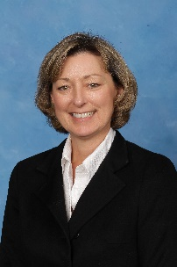  Jayne Battey  Vice-Chair | Jayne Battey is the owner and founder of Miramar Farms on the San Mateo Coast near Half Moon Bay. Using the farm as a uniquely restorative backdrop, Ms. Battey provides a combination of senior leadership coaching and program facilitation for organizations working on environmental, health, housing, education and other critical societal issues. She currently serves on the board of American Leadership Forum-Silicon Valley, and previously served on the boards of the Silicon Valley Community Foundation, Youth Outside, and Cabrillo Education Foundation. Prior to starting Miramar Farms in 2013, Ms. Battey held executive positions in a number of environmental organizations, including Essex Environmental, Pacific Forest and Watershed Lands Stewardship Council, and Pacific Gas & Electric Company. She has extensive experience in environmental planning and compliance management for large-scale infrastructure projects, as well as expertise in a wide-range of state and federal natural resource protection regulations. Ms. Battey holds a bachelor's degree from Boston College and a master's degree from the London School of Economics and Political Science. She is a senior fellow of American Leadership Forum - Silicon Valley (Class XXIV).
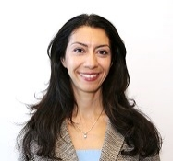  Newsha  Ajami Ph.D. | Dr. Ajami, of San Francisco, is the Director of Urban Water Policy with the Water in the West and NSF-ReNEUWIt initiatives at Stanford University. She is a hydrologist specializing in sustainable water resource management and has been working on the improvement of the science-policy-stakeholder interface through relevant and effective communication for many years. She worked as a Senior Research Associate at the Pacific Institute from 2011-2013. Prior to joining the Pacific Institute, Dr. Ajami served as a Science and Technology fellow at the California State Senate's Natural Resources and Water Committee and as a post doctorate researcher with the Berkeley Water Center, UC Berkeley, focusing on improving the management of California's water resources by developing an integrated operational platform encouraging collaboration between engineers, economists, and operational agencies. Dr. Ajami received her Ph.D in Civil and Environmental Engineering from the University of California, Irvine, an M.S. in Hydrology and Water Resources from the University of Arizona, and a B.S. in Civil and Environmental Engineering from Tehran Polytechnic. She has published many highly cited peer-reviewed papers and was the recipient of the 2010 William R. Gianelli Water Leaders scholarship, 2005 NSF funding for the AMS Science and Policy Colloquium, and the ICSC-World Laboratory Hydrologic Science and Water Resources Fellowship from 2000-2003.
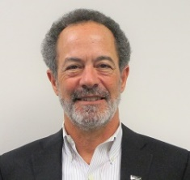  Andrew  Gunther  Ph.D. | Dr. Gunther received his Ph.D. in Energy and Resources from the University of California at Berkeley in 1987, and he has worked at the intersection of environmental science and policy since 1979. He has extensive experience in applying science to the development of air, water, and endangered species policy, including in the Bay Area.  In 1986 he was hired as the first staff scientist for the San Francisco Estuary Institute, where he completed landmarks studies of estuarine water quality for the State of California and the U.S. EPA. He was the first manager of the State of California’s program that monitors for toxic substances in San Francisco Bay, and served as Assistant Chief Scientist for the Exxon Valdez Oil Spill Restoration Program. From 2001-2006 he was the coordinator of the Clean Estuary Partnership, where he developed and managed a joint research and analysis program for the Regional Board, the Bay Area Clean Water Agencies, and the Bay Area Stormwater Management Agencies Association. From 2011-2017 Dr. Gunther served as executive coordinator of the Bay Area Ecosystems Climate Change Consortium, assisting this interagency group develop and implement initiatives to build resiliency to climate change in the Bay Area.  In 2017, Andy became the ninth person to win Jean Auer Environmental Award from the San Francisco Estuary Partnership, which honors his “significant contribution toward improving environmental quality in the Bay-Delta Estuary.” More about Dr. Gunther’s career and activities is available at www.andrewgunther.com.
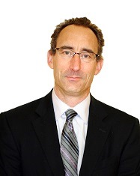  William Kissinger | William Kissinger of Marin County is a partner at the law firm of Morgan Lewis and Bockius. Before that he was a partner at Bingham McCutchen from 2003 to 2014, and an associate and then a partner at the legacy McCutchen Doyle Brown and Enersen firm from 1989 to 1997. He was senior deputy legal affairs secretary at the Office of Governor Gray Davis from 2001 to 2003. Kissinger served as senior advisor for international economic policy for the National Economic Council at the White House from 2000 to 2001 and was special assistant to the Legal Adviser at the U.S. Department of State from 1997 to 2000. He was staff attorney for the U.S. 9th Circuit Court of Appeals from 1987 to 1988. Kissinger earned a Juris Doctor degree from the University of California, Berkeley School of Law, and a B.A. in Politics/American Studies cum laude from Princeton University.
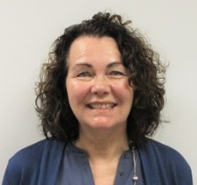  Alexis  Strauss-Hacker | Alexis Strauss Hacker, Piedmont, held several leadership roles at the U.S. Environmental Protection Agency from 1979 to 2019, including acting regional administrator, deputy regional administrator, water division director, and manager of Superfund enforcement programs. She has been recognized with several leadership and management awards in her federal career. She earned a Master of Arts degree in urban planning and a Bachelor of Arts in geography from the University of California, Los Angeles.

Central Coast Regional Water Quality Control Board (Region 3)
Executive Officer: Matt Keeling
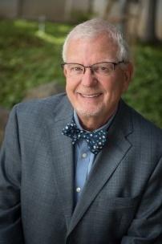  Jean-Pierre  Wolff, Ph.D.  Chair | Dr. Wolff, Ph.D., of San Luis Obispo, has been the owner and vintner of Wolff Vineyards since 1999. He was an independent consultant providing technical consulting services for privately held corporations from 2000 to 2002, senior vice president for Global Energy Services, a division of Emerson Electric from 1998 to 2000 and Vice President and corporate officer for Electro-Test from 1981 to 1998.  He is a member of the Coastal San Luis Resource Conservation District and the Agriculture Liaison Advisory Board, Cal Poly Center for Sustainability, Cal Poly College of Agriculture, Food and Environmental Science, Dean's Executive Advisory Board, Central Coast Salmon Enhancement, San Luis Obispo Vintners Association and the Central Coast Wine Growers Association.
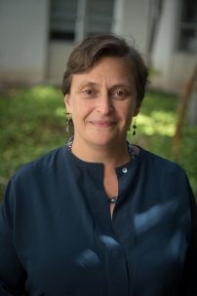  Jane Gray  Vice-Chair | Ms. Jane Gray, of Goleta, is a regional planner and project manager and has been working at Dudek since 2006. She was a planner at the Santa Barbara County Long Range Planning Division from 2004 to 2006, a policy planner for planning and environmental services for the County of Fresno from 2003 to 2004. Ms. Gray was an English-language arts and English as a Second Language teacher for private language schools in the US and Germany. She earned a Master of Science degree in regional planning and management from the Technical University of Dortmund.
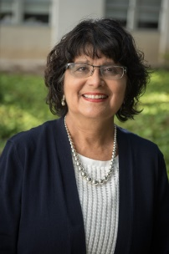  Monica  Hunter, Ph.D. | Dr. Hunter, Ph.D., of Los Osos, is the central coast Senior Program Advisor for the Planning and Conservation League Foundation and since 2005 has conducted numerous stakeholder processes in support of sustainable coastal watershed resource management. Dr. Hunter was a consultant to the Morro Bay National Estuary Program in 2001, and a former member of the Executive Committee, serving on the Education and Stewardship Committee. She is currently on the Executive Board of the Carmel River Watershed Conservancy and a member of the Carmel River Task Force. In 2012-13, she served on the Governor's Drinking Water Stakeholder Group.
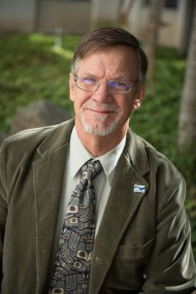  Michael Johnston | Mr. Johnston, of Watsonville, is currently a consultant for Teamsters Local 948 and the California Teamsters State Council of Cannery and Food Processing Unions. He was a campaign coordinator at the International Brotherhood of Teamsters from 2006 to 2009, and a business representative for Teamsters Local 890 from 1988 until 2005.
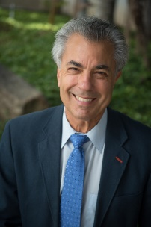  Jeffrey Young | Mr. Young, of Santa Barbara, is a practicing attorney and focuses on small business and regulatory matters related to the aquaculture industry in California. He is a former owner and operator of Pacific Seafood Industries Inc., a small company that grows oysters and mussels in the Santa Barbara Channel. Mr Young is a member of the Morro Bay Technical Advisory Committee to the Central Coast Regional Water Quality Control Board. He also serves on the Sewer Testing and Maintenance Committee of Project Clean Water for the county of Santa Barbara and the cities of Santa Barbara and Carpinteria.

Los Angeles Regional Water Quality Control Board (Region 4)
Executive Officer: Renee Purdy
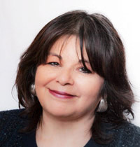  Irma Muñoz  Chair | Irma Muñoz is CEO and founder of Mujeres de la Tierra, an environmental equity organization that teaches women and their children to take ownership and leadership of neighborhood issues and challenges. She currently serves as Chair of the Santa Monica Mountains Conservancy, a member of the Mountains and Recreation Conservation Authority and serves as a mentor to many young people of color.
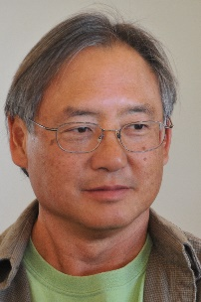  Lawrence Yee  Vice-Chair | Lawrence Yee is retired from the University of California Cooperative Extension where he directed the Ventura County office and the UC Hansen Agricultural Center. He was a 2017 Fulbright Specialist serving at the University of Caldas, Colombia. He is a founding member of the Ojai Valley Water Advisory Group, a quasi-think tank focused on water supply issues. He is the Co-founder and past President of The Food Commons, a national organization supporting the development of regional food systems. Lawrence received his BS in Biology from UC Davis and MBA from Santa Clara University.
Charles Stringer | Charles Stringer is Principal and General Counsel with the Renewable Resources Group. He began his career as a commercial litigator, and then served as legal counsel and senior policy advisor to the US Environmental Protection Agency and over 20 American Indian tribes in the western United States.
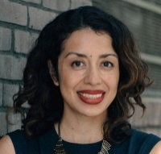  Cynthia Guzmán | Cynthia Guzmán is a Principal at Estolano Advisors, an urban planning and public policy firm based in Los Angeles. Estolano works with public agencies, non-profits, philanthropies, and businesses craft innovative solutions to address complex problems. Cynthia leads a diverse portfolio of sustainability, economic and workforce development projects. Through her work in strategic planning, stakeholder engagement design and implementation, she has collaborated with clients to develop programs and policies for equitable economic development, hiring and workforce training, and sustainability. Cynthia received her bachelor's degree in English and master's degree in Urban and Regional Planning from UCLA.
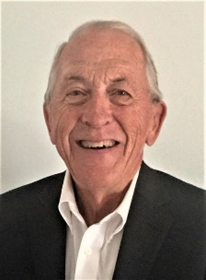  James Stahl | James Stahl is a Registered Professional Engineer in California, a Board-Certified Environmental Engineer of the American Academy of Environmental Engineers and Scientists and a Member of the National Academy of Engineering. He is President of JFS Environmental Engineering and the former Chief Engineer & General Manager of the Los Angeles County Sanitation Districts. Jim has extensive experience in the planning, design, operation and management of cost effective and environmentally sound wastewater collection and treatment, water reuse and solid waste systems. He has a BS in Civil Engineering from Loyola Marymount University and a MS in Environmental Engineering from Stanford.

Central Valley Regional Water Quality Control Board (Region 5)
Executive Officer: Patrick Pulupa
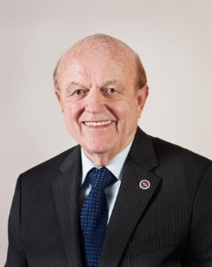  Karl E. Longley  Chair | Karl E. Longley, of Fresno, is a emeritus professor and dean of engineering and he is the founding director of the California Water Institute at California State University, Fresno. Dr. Longley is a member of the American Water Works Association, the American Society of Civil Engineers, the Nature Conservancy, the American Academy of Environmental Engineers, and the Water Environment Federation. Dr. Longley earned a Bachelor of Science degree from the University of New Mexico, a Master of Science degree and Doctor of Science degree from the Johns Hopkins University, and he is a Board Certified Environmental Engineer. Dr. Longley's professional practice has focused upon water and wastewater treatment and supply.
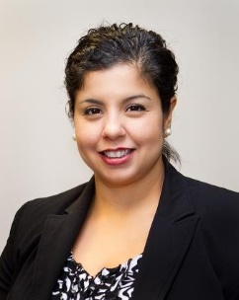  Carmen L. Ramirez  Vice-Chair | Carmen Ramirez is a partner at the Law Offices of Kelsey Souders & Ramirez. She works almost exclusively in the civil litigation area of the law with an emphasis on real property and commercial cases. Ms. Ramirez has been an attorney since 2009. Previously she was employed by the City of Merced where she was involved environmental remediation and water quality issues.  Ms. Ramirez received her law degree from San Joaquin College of Law in Clovis, California. She received her bachelor's degree from UCLA. Ms. Ramirez resides in Atwater.
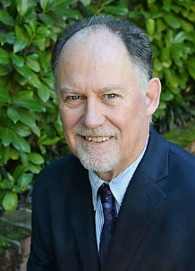  Mark Bradford | Mr. Bradford graduated from U.C. Davis with a B.S. degree in Renewable Natural Resources. He served as a Program Director for Ecology & Environment, Inc. in San Francisco from 1979 - 1992, and as a Principal at ERM-West, Inc. (ERM), in Sacramento from 1992 - 2016. His consulting experience in Northern California involved managing large, complex site investigation/ remediation programs, as well as projects addressing compliance, permitting, and environmental management systems for a wide range of government and private sector clients. These services involved complex multidisciplinary teams including Geologists, Hydrogeologists, Engineers, Toxicologists and a variety of other scientific disciplines. Regulatory agency coordination and negotiation was a key component of these programs. Mr. Bradford has extensive expertise in program organization, budgeting, cost control and contract negotiations.  As a Principal at ERM, he managed the Sacramento office and participated in strategic senior management discussions for 24 years during a period of strong growth. He was also the partner in charge of coordinating ERM's US government sector sales and delivery.
Raji Brar | Raji Brar is owner and operator at Countryside Market & Restaurants. She has previously served as a City Council Member for the City of Arvin, Vice-Chair for the Arvin Redevelopment Agency and as a Governing Board Member for the San Joaquin Valley Air Pollution Control District. Brar obtained her Bachelor of Science in Biology and Masters of Science in Health Care Administration from Cal State University Bakersfield. She has previously worked as a Chemist for BC Laboratories and as an Executive Assistant at ClinicaSierra Vista. She was appointed by Governor Brown to serve on the 15th District Agricultural Association Governing Board. Brar also serves on the Governing Board of Kern Health Systems. She also co-founded and is Director of the Bakersfield Sikh Women's Association. The Sikh Women's Association is a non-profit which gives out needs based scholarships to deserving students throughout Bakersfield and partners with the Bakersfield Homeless Center.
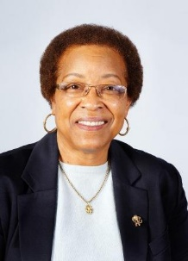  Denise Kadara | Denise Kadara currently serves on the board of the Tulare Basin Wildlife Partners and president of the Allensworth Progressive Association, a non-profit organization serving community needs. Her career spans over 25 years of public service from entry level positions to senior planner, senior management analyst, and consultant for cities in Los Angeles, San Bernardino and San Mateo counties in California. Her expertise includes housing, economic and community planning, policy development and program implementation. She received her education in urban/regional planning and public administration from California State Polytechnic University, Pomona and University of La Verne, La Verne, CA respectively. She is retired and moved to Allensworth in May 2010 with her husband where they now devote their time toward improving the quality of life of residents in the community and other disadvantaged communities. Since 2010, she and her husband have focused on community issues pertaining to water quality, distressed housing, infrastructure, youth/leadership development, environmental justice and economic development. She recently served as a member of the Tulare Lake Basin Disadvantaged Community Water Study -Stakeholders Oversight Advisory Committee (SOAC).

Lahontan Regional Water Quality Control Board (Region 6)
Acting Executive Officer: Mike Plaziak
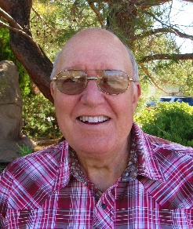  Peter C. Pumphrey  Chair | Peter Pumphrey lives near Bishop, California. He is a retired attorney, most recently having been a Deputy District Attorney in the Environmental Prosecutions unit of the San Joaquin County Office of the District Attorney. He is currently the chair of the Lahontan Regional Water Quality Control Board. He is an advisor to the Executive Committee of the Environmental Law Section of the State Bar of California. He serves as the conservation chair of the Eastern Sierra Audubon Society, participates in the Bi-state sage grouse working group and is a member of the Lands Committee of the Eastern Sierra Land Trust. He has worked as a volunteer docent with the Eastern Sierra Institute for Collaborative Education. He enjoys being retired and living in the Eastern Sierra where he works in his garden and on art projects and hikes, skis and backpacks in the Sierra backcountry.
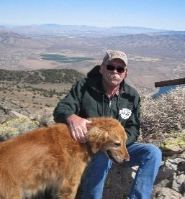  Don Jardine  Vice-Chair | Don Jardine, of Alpine County, recently retired from the Alpine County Board of Supervisors, where he was a member for 33 year and 6 months (the longest serving county supervisor in California). While he was a member of the Board of Supervisors, he served as a board representative on the Carson Water Subconservancy District and Alpine County Water Agency. He is currently a member of the Veterans of Foreign Wars, American Legion, Alpine County Local Agency Formation Commission, Alpine Fire Safe Council and of the Markleeville Volunteer Fire Department. He is also a volunteer for the Alpine Watershed Group. In past years, he has served with Alpine County Search and Rescue and Alpine County Library Commission, and as an Alpine County Reserve Deputy Sheriff and Alpine County Emergency Medical Technician.
Kimberly  Cox, DPA | Dr. Kimberly Cox, of Helendale, has been a resident of the High Desert (San Bernardino County) since 1985 and was appointed to the Lahontan Regional Water Quality Control Board in July 2013. Dr. Cox has been a Board member since 2003 at the Mojave Water Agency (a State Water Contractor) and is known as an expert in water management. Currently, Dr. Cox serves as the General Manager for the Helendale Community Services District, a position she has held since 2007. She previously worked in city and federal government and is adjunct faculty at a university. Additionally, Dr. Cox has served on the San Bernardino County Local Agency Formation Commission (LAFCO) representing special districts since 2004. She also represents special districts serving on the San Bernardino County Solid Waste Task Force. She holds a Master’s degree in Public Administration with an emphasis in Water Resource Management and a Doctorate in Public Administration.
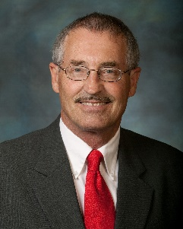  Keith Dyas | Keith Dyas, of Rosamond, has been an environmental and civil engineer at Edwards Air Force Base for 20 years. Previously, he was an engineer at Occidental Petroleum Corp. He has served on many local boards including the Antelope Valley-East Kern Water Agency and the Eastern Kern County Resource Conservation District. Mr. Dyas served as a director of the Rosamond Town Council. Mr. Dyas earned a Bachelor of Science degree in Civil Engineering from Cal Poly, Pomona and a Master of Science degree in Mechanical Engineering from Fresno State University.
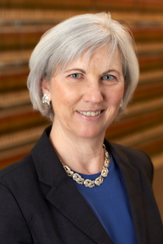  Amy Horne, Ph.D. | Dr. Amy Horne, Ph.D., J.D., of Truckee, has been a Board Member of the Lahontan Regional Water Quality Control Board since 2003. She recently earned a Juris Doctor degree at the William S. Boyd School of Law, University of Nevada, Las Vegas. While in law school, Horne interned for Senator Harry Reid in Washington, DC, for the Natural Resources Defense Council in San Francisco, and the Delta Water Master at the State Water Resources Control Board. Dr. Horne has worked more than 30 years on issues of natural resource management and policy, emphasizing water, forestry, sustainable development and dispute resolution. As Research Director at the Sierra Business Council from 1998 to 2005, Horne published an innovative guide to sustainable rural economic development. While a Research Forester at the U.S. Forest Service Pacific Northwest Research Station from 1993 to 1997, Horne earned awards for the many articles she published about ecosystem management. Horne earned a Doctor of Philosophy degree in forestry and a Master of Forest Science degree from the Yale School of Forestry and Environmental Studies and a Master of Public Administration degree in natural resource policy and management from the University of Wisconsin-Madison.
Eric Sandel, P.E. | Eric Sandel, of Truckee, has been a member of the Lahontan Regional Water Quality Control Board since 1992. He is the principal of S.A. Engineering, an electrical engineering firm in Truckee. He is a member of the Institute of Electrical and Electronic Engineers (IEEE) and the International Association of Electrical Inspectors (IAEI). He earned a Bachelor of Arts degree from the University of Massachusetts.

Colorado River Regional Water Quality Control Board (Region 7)
Executive Officer: Paula Rasmussen
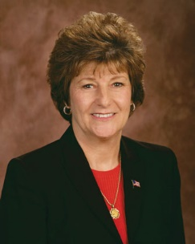  Nancy Wright  Chair | Nancy Wright is co-owner of a family owned General Contracting company, since 1977. Wright was vice-president of Pete Wright General Contractor, Inc. from 1997 to 2016 and co-owner of the Wright Window Company from 1994 to 2014. Wright is a Commissioner and past Chair of the Riverside County Local Agency Formation Commission and a 29-year member of the Mission Spring Water District Board of Directors.
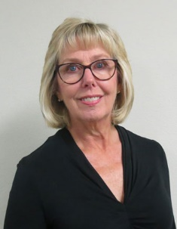  Jane Powell  Vice-Chair | Jayne Powell has been an environmental and aggregate resources manager at Granite Construction Inc. since 2007. She was owner and environmental consultant at Resource Recovery Inc. from 2003 to 2006 and an environmental safety and quality manager at Foster Wheeler Environmental Corporation from 1997 to 2003. Powell was an environmental engineering group manager at Dames and Moore from 1990 to 1997 and an environmental manager at the Atlas Powder Company from 1988 to 1990. She is a member of the California Stormwater Quality Association. Powell earned a Master of Science degree in biology from Murray State University.
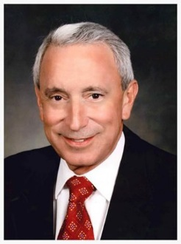  Edward Muzik | Edward Muzik has been general manager of the Hi-Desert Water District of Yucca Valley since 2007, where he was chief financial officer from 2002 to 2006. He was director of operations and finance at Vicom Systems Inc. from 1993 to 2002 and a controller at Ashford Development from 1990 to 1993 and at Cobble Knoll from 1985 to 1990. Muzik was accounting supervisor at Motorola from 1984 to 1985 and at S and C Electric from 1978 to 1984.
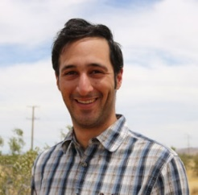  Peter Satin | Peter Satin, has held several positions at the Mojave Desert Land Trust since 2017, including director of land management and land stewardship supervisor. He was a wildlife technician at the U.S. Forest Service Pacific Northwest Research Station in 2016, a community health educator for the Peace Corps in Cambodia from 2012 to 2014 and an HIV/AIDS prevention and child survival health extension agent for the Peace Corps in Honduras from 2011 to 2012. Satin earned a Master of Environmental Management degree in ecosystem science and conservation from the Nicholas School of the Environment at Duke University.
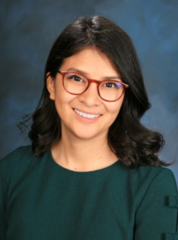  Sahara Huazano | Sahara Huazano has been the Director of Programs at Alianza Coachella Valley as of 2019. She has also held multiple positions at Building Healthy Communities, Coachella Valley from 2015 to 2018, including Project Manager for Environmental Justice and Project Manager for Education Equity. She is a fellow at Water Solutions Network, and a member of the City of Coachella Planning Commission and the Disadvantaged Communities Infrastructure Committee at the Coachella Valley Water District.

Santa Ana Regional Water Quality Control Board (Region 8)
Executive Officer: Hope Smythe
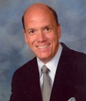  William Ruh  Chair | William Ruh of Montclair, CA, was appointed to the Santa Ana Regional Water Quality Control Board in 2002. Mr. Ruh also has served on the Citrus Valley Association of Realtors as director of governmental affairs since 2001 as a consultant for the State Assembly Select Committee on the Alameda Corridor East since 1999 and has served on the Montclair City Council since 1998. Previously, he served on the Board of Directors for the Monte Vista Water District from 1991 to 1998 and the Planning Commission for the City of Montclair from 1988 to 1998.
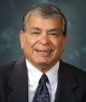  Tom M. Rivera | Dr. Tom M. Rivera of Grand Terrace, CA, was appointed to the Santa Ana Regional Water Quality Control Board in 2013. Dr. Rivera was a Peace Corps volunteer serving in South America from 1963 through 1965. He retired in 2011 from California State University, San Bernardino after 39 years as the Associate Dean of Undergraduate Studies. He has an extensive record of active participation as a board member and volunteer in numerous community organizations. He is a charter member of the Kiwanis Club of Greater San Bernardino founded in 1967. Dr. Rivera earned a Doctor of Education degree from the University of California, Los Angeles in 1973. Dr. Rivera and his wife Lily have been married 52 years, have three children, and two grandchildren.
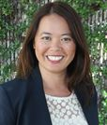  Lana Ong Peterson | Lana Ong Peterson of Orange, CA, was appointed to the Santa Ana Regional Water Quality Control Board, where she has served since 2016. Ms. Peterson has been director of public affairs at the Kaiser Permanente Downey Medical Center since 2017, where she has held several positions since 2010, including senior public affairs representative and senior communications specialist. She held several positions at Cox Communications from 2004 to 2010, including senior communications specialist, communications specialist and public relations coordinator. She earned a Master of Business Administration degree from Chapman University.
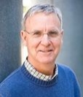  Daniel Selmi |  | Daniel Selmi of Newport Beach, CA, was appointed to the Santa Ana Regional Water Quality Control Board in 2016. Mr. Selmi has been a professor of Law at Loyola Law School, Los Angeles since 1983. He was a deputy attorney general in the California Department of Justice, Office of the Attorney General from 1976 to 1983 and a judicial law clerk for The Honorable Manuel L. Real at the U.S. District Court, Central District of California from 1975 to 1976. Mr. Selmi earned a Master of Public Administration degree from the Harvard University, Kennedy School of Government and a Juris Doctor degree from the Santa Clara University School of Law.
Kris Murray |  | Kristine (Kris) Murray of Anaheim, was appointed to the Santa Ana Regional Water Quality Control Board in 2018. Ms. Murray is president and chief executive officer at KLM Strategies since 2018 and has more than 25 years of executive management experience, serving public agencies across Southern California. Ms. Murray began her career in Washington, D.C. as a senior legislative aide to U.S. Representative Steve Horn (CA-38). Most recently, Ms. Murray served as an at-large member of the Anaheim City Council serving more than 350,000 residents from 2010 - 2018. During her tenure, she chaired the Orange County Council of Governments Board of Directors, Southern California Water Committee Water Energy Task Force and served on the boards of the Metropolitan Water District of Southern California, Southern California Association of Governments (SCAG), Association of California Cities–Orange County (ACC-OC), League of California Cities, and Transportation Corridor Agencies. Prior to her service on the city council, she was a member of the Anaheim Public Utilities Commission, serving as Vice-chair of the board.
Joe Kerr |  | Joe Kerr of Coto de Caza, is a second-generation professional firefighter who served as a Fire Captain with the Orange County Fire Authority and Orange County Fire Department for 34 years. He was elected as the first President of the Orange County Professional Firefighters Association where he served 17 years, and he has also served in numerous other leadership positions as a former Vice President of the California Professional Firefighters Association, as the Southern Director for the California State Firefighters Association, and as the10th District Field Service Representative for the International Association of Firefighters. Kerr has been a business agent at the Orange County Professional Firefighters Association since 2012, and he was a member of the California Workforce Investment Board from 2003 to 2004. He has been a member of the Honor Society – Washington D.C. since 2018 and is a 2005 graduate of the Harvard Trade Union Program. Kerr's appointment is pending Senate confirmation.

San Diego Regional Water Quality Control Board (Region 9)
Executive Officer: David Gibson
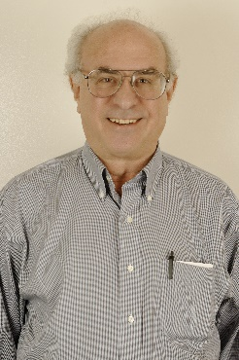  Henry Abarbanel  Chair | Henry Abarbanel, of Del Mar, was appointed to the San Diego Regional Water Quality Control Board in November 2011. He has been a professor of physics at the University of California, San Diego and a research physicist at the Scripps Institution of Oceanography since 1983. Mr. Abarbanel served on the Del Mar City Council from 1992 to 1996 and 2000 to 2008. He was chair of the San Diego Metro Wastewater Commission from 2005 to 2008. Mr. Abarbanel received his doctorate in physics at Princeton University.
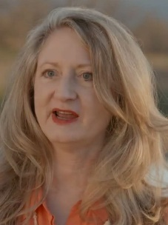  Celeste Cantú  Vice-Chair | Celeste Cantú, of Temecula, was general manager of the Santa Ana Watershed Project Authority from 2006 to 2017. She was executive director of the California State Water Resources Control Board from 2001 to 2006, state director at the U.S. Department of Agriculture Rural Development from 1998 to 2001, executive director at the Imperial Valley Housing Authority from 1978 to 1998 and planning director at the City of Calexico from 1977 to 1978. Cantú currently serves on the Public Policy Institute of California's Water Policy Center Advisory Council, President, Water Education Foundation, Vice President, The Water Foundation, the UC Presidents Advisory Council for Agriculture & Natural Resources and is a UCCE Master Gardener, Riverside County. She is a partner and facilitator for the Water Solutions Network. She earned a Master of Public Administration degree from the Harvard University, Kennedy School of Government and a BA at Yale University.
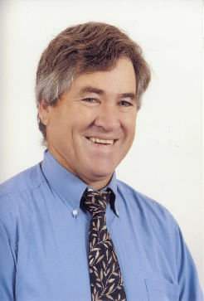  Eric Anderson | Eric Anderson, of Elfin Forest, is vice president of La Costa Flower Shop and Nursery, a horticulture business, which specializes in the production, harvest, breeding, and processing of ornamental seeds and seedlings. He is serving as director of the San Diego County Farm Bureau and was president from 1996-1998. He also has served on the County of San Diego Sunset Review Commission and on the Resource Protection Review Committee. Mr. Anderson has served on the Elfin Forrest Harmony Grove Town Council. He is a past President of the San Diego Flower and Plant Association and a member of the International Palm Society. Mr. Anderson earned a bachelor of science degree from California State Polytechnic University, Pomona.
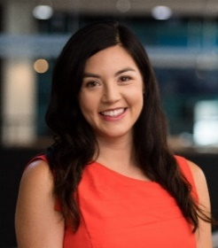  Megan Blair | Megan Blair, of San Diego, has been chief development officer at the San Diego Public Library Foundation since 2008. She was capital campaign and major gifts manager at Girl Scouts, San Diego – Imperial Council from 2007 to 2008, where she was a fund development associate from 2006 to 2007. Blair was a development associate and environmental analyst at Save the Harbor, Save the Bay from 2003 to 2005. She is a member of the United Way of San Diego Board of Directors, Women Give San Diego and the Junior League of San Diego.
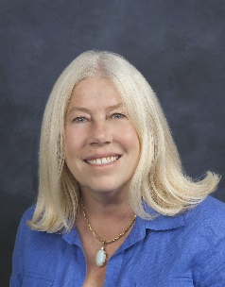  Betty Olson | Betty H. Olson, of Trabuco Canyon, was appointed to the San Diego Regional Water Quality Control Board in December 2014. Olson has been a professor at the University of California, Irvine Henry Samueli School of Engineering’s Department of Civil and Environmental Engineering since 2006. She was a professor at the University of California, Irvine School of Social Ecology from 1974 to 2006. Olson is president of the Santa Margarita Water District Board of Directors and a member of the Orange County Water Association and the Association of California Water Agencies. She earned Doctor of Philosophy and Master of Science degrees in environmental health science from the University of California, Berkeley.
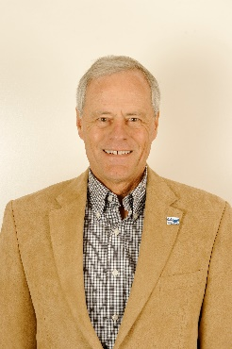  Gary Strawn | Gary Strawn, of Santee, is a retired aerospace program manager. He worked for Hamilton Sundstrand Power Systems in San Diego from 1988 to 2006, after serving as an officer in the U.S. Navy from 1968 to 1988. Mr. Strawn is a member of Trout Unlimited, San Diego Fly Fishers, San Diego River Park Foundation, San Diego Stream Team, California Golden Trout and Southern California Steelhead Recovery Projects and Friends of Santee River Park. Mr. Strawn has a bachelors degree from San Jose State University and a Master of Science degree from the U.S. Naval Postgraduate School.
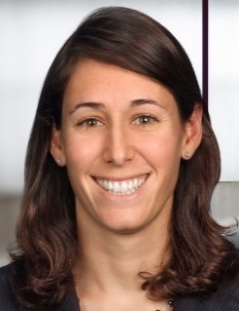  Stefanie Warren | Stefanie Warren, of San Diego, was appointed to the San Diego Regional Water Quality Control Board in July 2013. Warren has been an attorney at McKenna Long and Aldridge LLP since 2006. She was a law clerk for the Honorable Irma E. Gonzalez from 2005 to 2006. Warren earned a Juris Doctorate degree from Emory University, School of Law.

Regional Water Board Updates

North Coast Regional Water Quality Control Board (Region 1)

FY 2019/2020 Accomplishment Highlights
NPDES Storm Water Program – having filled key vacancies within the NPDES Storm Water Program, RB1 Program staff have taken an intentionally proactive approach to working with municipalities, industries, and operators of construction sites, focusing on site and facility inspections in all corners of the region, while also pursuing progressive enforcement where necessary. Given the relatively large number of storm water facilities in the region, storm water staff utilize mapping tools, databases, and screening criteria to prioritize inspections, exceeding inspection targets. Further, delivering on the Board’s prioritization for enforcement of storm water violations, the team successfully completed numerous enforcement actions over the past year, including several high dollar penalty cases. Finally, RB1’s MS4 program manager has provided critical input as a subcommittee member assisting State Board staff in the development of the revised CalTrans and Phase 2 MS4 permits.
Technical and Financial Assistance to Disadvantaged Communities – In 2019 RB1 approved a Resolution acknowledging the Human Right to Water (HRTW) as a core value and directing staff to engage with communities that lack adequate, affordable, or safe drinking water, including providing community outreach, technical assistance and financial resources. Predominantly a rural region, many of the communities and counties in the region face financial hardship and are considered small and economically disadvantaged or severely disadvantaged, often lacking the financial resources, staffing and technical expertise to successfully develop approvable projects and complete loan and grant applications that address water supply and sanitation. Over the past several years RB1 staff has coordinated with the Division of Financial Assistance, other funding agencies, and technical assistance providers to assist small and disadvantaged communities to plan, fund and complete much needed water and wastewater infrastructure projects, wastewater recycling projects, as well as storm water capture, infiltration, and reuse projects throughout the region.
Addressing Impaired Water Bodies – In 2019 RB1 adopted the Russian River Pathogen TMDL which documents widespread violation of fecal indicator bacteria standards and prevalence of human-sources waste. The TMDL’s program of implementation focuses on a comprehensive assessment program of on-site wastewater treatment systems (OWTS) and establishes performance standards for upgrades of failing or sub-standard OWTS. Further, RB1 staff have made significant progress in the development of nutrient, sediment, and temperature TMDLs for the Laguna de Santa Rosa, the largest tributary to the Russian River. Finally, RB1 staff and contractors have made important gains in developing the Elk River Sediment Reduction Strategy, and the Board adopted revised WDRs for the two industrial timber companies in the watershed, key components of the approved Upper Elk River Sediment TMDL Action Plan.

FY 2020/2021 Priorities
Klamath Basin Restoration – Having completed the Public Review Draft Upper Klamath Watershed Action Plan, and the Preferred List of Water Quality Projects pursuant to the Klamath River Hydroelectric Settlement Agreement, RB1 staff in coordination with State Board staff and other partners are focusing now on project implementation, as well as permitting of the Lower Klamath Lake Treatment Wetlands project, the Fall Creek Fish Hatchery, and the Construction General Permit for Klamath dam removal activities that are not covered by the State Board’s 401 for the Lower Klamath Project.
Addressing Fuels Management and Post-Fire Recovery Projects – RB1 staff are revising WDRs and the Conditional Waiver for these activities on federal and private lands, respectively, working closely with the federal land management agencies and CalFire. In addition, staff are initiating coordination with CalFire as well as resource conservations districts to address necessary water quality protections associated with fire suppression lines installed on private property.
Cannabis Program - In response to the 50% reduction in staffing levels, RB1 staff have shifted work plan commitments to focus on increasing enrollments and conducting enforcement actions on illegal operations.
Policy Development – priority policy development efforts include: Climate Change Adaptation and Resilience Strategy and Groundwater Protection Strategy.

San Francisco Bay Regional Water Quality Control Board (Region 2)
A recorded update is available here: https://youtu.be/hJx2YLAdwHU. This will be shown at the WQCC meeting.

Central Coast Regional Water Quality Control Board (Region 3)

Highlights from the last year
Our changing workforce – In addition to COVID driven telework this was a year of major change associated with a high level of staff turnover and hiring due to retirements – and they keep coming. In total, eight staff retired over the last year and three more are pending. Almost 30% of our workforce has less than five years of Water Board experience and our management team is in state flux associated with promotions.
Some of our core regulatory accomplishments – Over the last year we:
- Adopted 1) revised MS4 permit for the City of Salinas, 2) revised general waiver of WDRs for specific types of discharges, 3) three general WDRs (management and beneficial reuse of petroleum impacted soils on active oil leases; active class 3 landfills; municipal wastewater facilities with flows greater than 100K), 4) five NPDES permits, 5) OWTS Policy LAMP for San Luis Obispo County, 6) one TMDL, and 7) issued 36 401 certifications.
- Released draft Agricultural Order 4.0 and EIR for public comment and held seven full days of public meetings devoted to the order development process.
- Supported statewide implementation of PFAS investigations for 12 landfills, four airports and 30 POTWs.
- Closed 12 groundwater investigation and cleanup cases.
Environmental Justice Initiatives
- Conducted October 3, 2019 workshop titled, Challenges and Solutions: The Intersection of Water Quality and People Experiencing Homelessness on the Central Coast.
- Central Coast Domestic Well Testing Program: over 276 wells tested since October 2018 (nitrate, arsenic, chromium VI, perchlorate, 1,2,3-TCP and general minerals).
- Replacement Water Facilitation: UCLA drinking water system pilot project, local and regional bottled water and interim replacement water programs, settlement agreements, etc.
- EJ capacity building.

The year ahead
Consistent with the last year we will continue to focus on hiring, onboarding and mentoring staff while also focusing on our highest water quality priorities. We are currently in the process of an office-wide prioritization effort to inform and support our work in the coming year while also addressing the resource constraints associated with the pandemic and challenges of a rapidly changing workforce.

Los Angeles Regional Water Quality Control Board (Region 4)

FY 19-20 Highlights

Industrial Sites Task Force and Non-Filer Initiative
The Industrial Sites Task Force (ITF), consisting of representatives from industries, environmental groups, and municipalities, was brought together our Board Chair, Irma Muñoz, to identify and facilitate enrollment of non-filers into the NPDES General Permit for Storm Water Discharges Associated with Industrial Activities (also known as the “IGP”). The ITF meets quarterly, recently via Zoom, and has grown to include local elected officials and State Board Member Maguire and an additional Regional Board member, Cynthia Guzmán. The ITF spawned the concept for SB205, passage of which has raised the enrollment rate of businesses under the IGP by over 200% in the Los Angeles Region, with similar results across the state. Our staff have been coordinating with State Board staff to develop informative web pages, FAQs in English, Spanish, Korean and Chinese, and workshops for municipalities and stakeholders.

Enforcement and Supplemental Environmental Projects (SEPs)
On October 10, 2019, the LA Regional Board approved the Region’s first SEP List geared toward benefiting local disadvantaged communities (DACs), and launched a program to promote the allocation of SEP monies to DACs in partnership with the Rose Foundation for Communities and the Environment. Over the fiscal year, the LA Regional Board issued over 1,500 formal and informal enforcement actions. Of those, 37 Expedited Payment Letters were issued for mandatory minimum penalties totaling $1.038 million, and $696,000 in penalties were collected. On June 29, 2020, the LA Regional Board settled an enforcement case against GKFG LLC for violations of the General Permit for Stormwater Discharges Associated with Construction and Land Disturbance Activities (CGP) in the amount of $262,657. On December 23, 2019, the Port of Los Angeles (POLA) satisfied the SEP component of a Settlement Agreement totaling $189,000. Of the total assessed penalty, $102,000 was directed to a SEP for Litter Control Measures, which aim to reduce the trash and litter loading from landside activities into the harbors.

Activities to Promote Water Resiliency

Proposition 1 and Proposition 68 Groundwater Projects
During the 2019 and 2020 timeframe, the LA Regional Board’s Proposition 1 (Prop 1) Team provided technical support for groundwater projects totaling over $300,000,000 to address impacted water supply wells, cleanup of emerging chemicals such as perchlorate and hexavalent chromium, cleanup of backlogged cases, and projects to protect groundwater from seawater intrusion. These projects clean up contaminated groundwater that serves as a source of drinking water in the Central Basin, San Gabriel and San Fernando Basins, and Ventura County. Staff are also working with the City of Huntington Park, a disadvantaged community, on a Prop 68 grant to upgrade their existing water supply treatment system.

General NPDES Permit for Discharges of Groundwater from Cleanup and Water Supply Operations in the San Gabriel Valley Groundwater Basin
The General Permit, adopted in June 2020, expedites the cleanup of contaminated groundwater in the San Gabriel Basin to restore local water supply and increase water resiliency. The General Permit allows temporary discharges of groundwater to surface water during well start-up and testing before it infiltrates back into the groundwater basin. Given the elevated concentrations of some pollutants in the groundwater, the discharges are only allowed when there is little to no flow in the surface waters, such that discharges will not mix with in-stream flow. Once the groundwater treatment systems are fully functional, up to 90,000 acre-feet per year of treated groundwater will be available for potable use.

Individual Recycled Water Permitting Actions
The Board adopted Order R4-2019-0118 on October 10, 2019 for the Camrosa Water Reclamation Facility (WRF). The permit regulates the use of almost 100% of the tertiary-treated effluent produced at the WRF for crop and landscape irrigation. The Order requirements, in conjunction with the operation of a groundwater desalter, will address salt loading to the underlying groundwater basin on a regional basis to protect groundwater quality while allowing for the increased use of recycled water. In April 2020, the Board adopted two permits related to recycled water. Order R4-2020-0049 regulates the discharge of disinfected, tertiary-treated wastewater generated at the Vista Canyon Water Factory for onsite and offsite landscape irrigation and other non-potable applications. The Water Factory will produce approximately 86.9 acre-feet per year for onsite irrigation and 420 acre-feet per year for offsite irrigation, which will reduce the need for imported water in the Santa Clarita Valley. The Board also adopted Order R4-2020-0051 for the City of Oxnard’s Groundwater Recovery Enhancement and Treatment (GREAT) Program. The Program’s objectives include increased reliability, reduced costs, improved dependability, and enhanced stewardship of the local water supply through recycling and reusing a substantial portion of the region’s wastewater. The Program’s Advanced Water Treatment Facility currently produces up to 6.25 mgd of advanced treated wastewater, which is used for irrigation. This particular order additionally permits the use of advanced treated wastewater for injection into the Santa Clara River Valley Basin using a demonstration well for aquifer storage and recovery.

Regional Municipal Separate Storm Sewer System (MS4) Permit
The LA Regional Board continued work on a Regional MS4 Permit by conducting extensive stakeholder outreach and releasing a working proposal of the permit in December 2019. Staff held seven Board agenda items and a large workshop in January with over 100 attendees. Board members and staff also contributed to the implementation of LA County’s Safe Clean Water Program (Measure W, passed in November 2018), to fund MS4 compliance projects. Staff reviewed project applications and stormwater investment plans and provided input at various committee meetings. In addition, our Board Chair is a member of the Regional Oversight Committee for the program.

Litigation Success in the Los Angeles Region
In the last fiscal year, we have had some major successes on litigation in the Los Angeles Region. Notably, with statewide significance, is the Tesoro case, decided last winter. This case provides a court of appeals precedent for the famed Zoecon State Board Order. Zoecon is the order that holds that passive migration is a discharge for purposes of Water Code section 13304, governing cleanup and abatement orders. The Tesoro case favorably cited Zoecon and a few other precedential State Board orders. It is the first Court of Appeals decision upholding the concept of passive migration, giving the Water Boards even stronger footing for our cleanup and abatement orders.

FY 20-21 Priorities
The LA Water Board’s overarching priorities for FY 20-21 include focusing on our core work that (1) supports use of the region’s groundwater resources as an increasing source of local water supply; (2) ensures protection of public health by remediating impacted water supply wells in disadvantaged communities, implementing vapor intrusion guidance in site cleanups, addressing emerging contaminants such as PFAS, and developing regulatory plans to restore impaired waters for fish consumption and recreation; and (3) addresses key sources of water quality impairment, including municipal and industrial stormwater. In each of these areas, the Board is also redoubling its efforts to ensure that our actions are equitable and focus on our communities most impacted by water pollution, our decision-making is inclusive, and we collaborate with fellow state agencies as well as local governments and community based organizations to achieve our common goals.

Central Valley Regional Water Quality Control Board (Region 5)
Water Board employees, view the RB5 update here. Members of the public should tune into the WQCC broadcast to see this update.

Lahontan Regional Water Quality Control Board (Region 6)

Highlights from 2019-2020
Leviathan Mine Cleanup Water Board staff oversaw and managed the contract for treatment of 3.3 million gallons of Acid Mine Drainage (AMD) which resulted in the disposal of over 1,400 tons of sludge. An Early Final Remedial Action (EFRA) test achieved successful results and will be used to continuously remediate AMD throughout the year.

City of Victorville $1.5M Settlement Agreement Water Board finalized a Settlement Agreement with the City of Victorville in the amount of $1,500,000 (to include a $750,000 Supplemental Environmental Project) addressing previous spills from the City’s sewer collection system.

Water Board-Navy DoD Partnering at China Lake Naval Weapons Center
Water Board staff and Navy DoD remedial program managers embarked on relationship building to foster improved communications and decision-making on cleanup actions.

Revised WDRs – Briggs Mine WDR authorized bioleaching processes to extract gold from ore on the existing heap leach pad, the first of its kind in the region. A secondary effect of the bioleaching process will be to effectively detoxify cyanide in the heap in anticipation of closure.

Adoption of Climate Change and Mitigation Response Plan Water Board adopted Resolution No. R6T-2019-0277 which recognizes the impact of climate change on beneficial uses and provides guidance on the development and implementation of actions to address climate change.

Priorities for the year ahead
Tahoe Keys Lagoons Aquatic Weed Control Methods Test Project Adoption of an EIS/EIR, proposed Basin Plan prohibition exemption, and an NPDES permit in early 2021 that will allow a pilot project using both mechanical means and aquatic pesticides to combat the spread of invasive aquatic weeds in the Tahoe Keys Lagoons area of Lake Tahoe. Lake Tahoe is designated an Outstanding National Resource Water (ONRW).

Irrigated Lands Regulatory Program Develop a regulatory strategy to address the water quality challenges from irrigated agriculture, grazing and Combined Animal Feeding Operations in priority watersheds and groundwater basins in the region.

Leviathan Mine Cleanup Continue EFRA activities to simultaneously treat 5 separate AMD sources. Oversee site maintenance projects to facilitate continued remediation actions.

Completion of USGS Chromium Background Study in Hinkley USGS will complete the hexavalent chromium background study under contract with the Lahontan Water Board. The study has taken over 5 years to conclude and its results will inform existing cleanup actions in the community.

Colorado River Regional Water Quality Control Board (Region 7)

Highlights from last year
Irrigated Lands A high priority for the regional board has been continuing to focus on development of irrigated lands general orders and implementation of the general orders that have been adopted. General orders have been adopted for two coalitions: Bard and Palo Verde Valley. These general orders established a foundation for continued efforts through the region. Last fiscal year the draft order for Coachella Valley coalition was circulated for comment, with a target of adoption by June 2020. Engagement with stakeholders allowed for dialogue on critical issues, and a request for additional time for adoption was made. Regional board staff are responding to comments received on the draft.
2018 Integrated Report A workshop was held to allow for stakeholder input on the integrated report. At a later meeting, the board adopted the integrated report and submitted it to the SWRCB.
Salt and Nutrient Management Regional board staff-initiated collaboration with the Coachella Valley Basin Salt and Nutrient Management (SNMP) Stakeholders. The regional board provided comments on a 2015 SNMP which did not meet the recycled water policy requirements and requested modifications. Recently a consultant began development of a plan to develop a SNMP and a groundwater monitoring workplan. Work will focus on methods to evaluate existing water quality, estimate salt and nutrient loading, and determine the assimilative capacity of the aquifer to receive salts and nutrients.
Triennial Review Initiated outreach last fiscal year.
New River Improvement Project Funding was allocated in this year’s governors’ budget.

Priorities for the year ahead
2020 Triennial Review A workshop was held in October and adoption is planned for this calendar year.
Basin Plan Amendment Incorporate the SWRCB Water Quality Objectives for Bacteria. (Completed)
Irrigated Lands Adopt the Coachella Valley Irrigated Lands General Order and release for comments of a draft general order for the Imperial Valley.
New River Coordinate with stakeholders as construction is implemented for the New River Improvement Project. Staff will engage with the City of Calexico on regional board permitting requirements and ensure that SWRCB water rights staff and the city are engaged.
Salton Sea Engage with Natural Resources Agency on Salton Sea Habitat Restoration Project to identify required Regional Board permits and the timing of restoration projects.
SNMP Submit a plan for development of a Coachella SNMP and a monitoring plan. Staff are developing a concurrent workplan with USGS for GW monitoring to fill data gaps. A contract with USGS to complete the sampling is pending.
2018 Integrated Report Adopt the 2018 Integrated Report by the SWRCB.
Confined Animal Facilities Revise the existing CAFO General Order this fiscal year.

Santa Ana Regional Water Quality Control Board (Region 8)
Regional MS4 Storm Water Permit - Currently, there are three active MS4 Storm Water Permits in the Santa Ana Region that cover portions of Orange, Riverside and San Bernardino Counties. A new Regional MS4 Permit will reconcile the requirements from all three County Permits to create one MS4 Permit for all large municipalities within the Santa Ana Region. The Santa Ana Water Board expects to start the approval process for the Regional MS4 permit in January 2021. The Regional MS4 Permit will incorporate TMDL provisions and statewide precedential order requirements.

Human Right to Water – In December 2019, the Santa Ana Water Board adopted the Human Right to Water Resolution, embracing the human right to water as a core value. The Resolution directed staff to implement a 2-year Work Plan with specific tasks to ensure that the Santa Ana Water Board programs are equitably and consistently administered and are supportive of the Human Right to Water in all communities. The Resolution also directed staff to provide annual updates to the Santa Ana Water Board.

PFAS – the Executive Officer has issued PFAS investigation orders for landfills, and airports in the region; selected bulk fuel terminals are next. Board staff are also coordinating with State Board on the State Board issued investigation Orders. Elevated PFAS concentrations have been detected in groundwater and surface water in the vicinity of the city of Corona and in the Orange County Groundwater Management Zone where further investigation of potential sources is underway. In addition, a plume of PFAS emanating from the March Air Reserve Base/former March Air Force Base has impacted two off-site domestic wells and two public supply wells. The Air Force is providing treatment and/or replacement water and Staff have asked the Air Force to perform further investigation and remediation.

Orange County North Basin – the US EPA has added the Orange County North Basin to its National Priorities List (Superfund List). The site is a comingled groundwater plume of chlorinated solvents and other contaminants covering approximately 5 square miles beneath parts of the cities of Anaheim and Fullerton. Staff will continue working with US EPA to address the contamination.

Poseidon Desalination NPDES permit – The reissuance of the Poseidon Desalination Facility at Huntington Beach is nearing its conclusion at the Santa Ana Water Board. A public hearing was held for Santa Ana Water Board consideration of the Tentative Order and is to be continued pending Board direction that Poseidon prepare a revised Marine Life Mitigation Plan that describes the projects they will mitigate damage caused by the intake of 100 million gallons per day of ocean water and the discharge of 50 million gallons per day of concentrated brine.

Total Maximum Daily Loads (TMDLs) – the Santa Ana Water Board will consider adoption of several TMDLs including Copper TMDLs for Newport Bay to address impacts from recreational boat paints and revisions to the existing 2004 Lake Elsinore/Canyon Lake Nutrient TMDLs.

San Diego Regional Water Quality Control Board (Region 9)

Accomplishments 2019-2020
The San Diego Water Board uses its Practical Vision as a tool to focus limited resources onto the region’s highest priorities. The following priority projects were undertaken during 2019-2020 to help achieve the goals of the Practical Vision.
Tijuana River Border Pollution Control Efforts. The San Diego Water Board is involved in several efforts to address transboundary flows carrying sewage, trash, and sediment into the Tijuana River Valley from Mexico that have polluted the area for decades, particularly after storms.
Innovative Liability Settlement Terms for Construction Storm Water Program. Staff found contractors for a United States Army Corps of Engineers flood control construction project in Murrieta Creek continually failed to protect habitats and ecosystems from sediment discharges and issued a $741,466 Administrative Civil Liability Settlement Agreement with the contractor.
Development and Release of Public Data Visualization Tools. Staff released several data visualization tools that share volumes of data collected by the Board. The applications are available on the San Diego Water Board Monitoring and Assessment webpage (https://www.waterboards.ca.gov/sandiego/water_issues/programs/mon_assess/#data_info).
Lower San Diego River Watershed Human Fecal Material, Investigative Order. The San Diego Water Board issued an Investigative Order to 10 cities and agencies to investigate and quantify the relative contributions of actual and suspected sources of human fecal material discharges from their respective jurisdictions to the Lower San Diego River Watershed.
Plume Tracking included in Reissuance of National Pollutant Discharge Elimination System (NPDES) Permits. The San Diego Water Board reissued NPDES permits for several discharges to the Pacific Ocean that required receiving water monitoring programs that use plume tracking technology.
Santa Margarita River Estuary Alternative TMDL Strategy. Instead of a traditional TMDL to dictate restoration efforts in a high priority water body, the Board issued an Investigative Order to seven local, county, and military municipal storm water program permittees.
Board Member Outreach. The San Diego Water Board convened four pre-COVID-19 in person outreach events with local and state elected officials and agencies to solicit feedback and share information regarding the Water Board’s priorities and efforts.
Tribal Summit. The San Diego Water Board convened a Tribal Summit in February 2020 attended by three San Diego Water Board Members, CalEPA Deputy Secretary Yana Garcia, Adriana Renteria State Water Board Director of the Office of Public Participation and leaders and representatives of over 18 Tribes and Bands from throughout the San Diego Region.
City of San Diego North City Water Reclamation Plant and Pure Water Facility. The San Diego Water Board issued an NPDES Permit to the City of San Diego to augment Miramar Reservoir, a drinking water reservoir, with advanced treated recycled water.
Reissuance of the NPDES Permit for the Carlsbad Desalination Plant. The San Diego Water Board reissued an NPDES Permit to Poseidon Resources LP for the discharge of brine wastewater to the Pacific Ocean from the Carlsbad Desalination Plant.
Memorandum of Understanding with Marine Corps Base, Camp Pendleton. In July 2019, the San Diego Water Board and Commanding General for Marine Corps Base, Camp Pendleton, agreed to a Memorandum of Understanding to conduct an environmental assessment of the Stuart Mesa Agricultural Fields.
San Diego Bay Sediment Investigative Orders. In October 2019, the San Diego Water Board issued three investigative orders requiring the assessment of impacts to sediments within the Laurel Hawthorn Embayment area of San Diego Bay.

Priorities for 2020-2021
- San Diego Water Board Consideration of Biological Water Quality Objectives
- San Diego Bay Efforts
  - Ongoing sediment investigations and remediation
  - San Diego Bay Fish Tissue Study
  - Internal San Diego Bay Workgroup
  - SD Bay Sediment Data in GIS to Track Pollutant Reductions
  - Sediment Quality Objectives Implementation
- Increasing Local Drinking Water Supply
  - Review of Salt and Nutrient Management Plans
  - Expansion of Recycled Water Production and Purveyance
- NPDES Permit Reissuance for discharges through the South Bay Ocean Outfall South Bay International Wastewater Treatment Plant (International Boundary and Water Commission) and City of San Diego
- 2 Tijuana River (bacterial indicators and solid waste) TMDLs and 1 Santa Margarita River Watershed (nutrients) TMDL
- Regional Storm Water Permit for FY 21-22 Consideration
- Next Generation Monitoring

Day 1 Sessions

Water Boards in the Age of COVID-19

Remote Board Meetings
No materials were provided for this topic.

Remote Enforcement

Requests for Regulatory Relief due to COVID-19
State and Regional Water Board representatives (Water Board staff) met at the beginning of remote work activities to develop a consistent and streamlined response approach to requests for regulatory relief due to complications related to COVID-19. This coordinated approach alleviates the extra workload on staff still adapting to working remotely by providing consistent information for responding to the public during uncertain times. Generally, Water Board staff directed the regulated community to continue completing feasible compliance work since the protection of water quality and quantity is an essential service. Other actions could be delayed such as paying a permit fee late or extending the comment period on a proposed Board action. Some monitoring and reporting activities could be delayed until they are able to be performed safely. Alternatively, some dischargers proposed alternate methods for compliance such as using alternate sampling methods to meet performance objectives or submitting electronic signatures in lieu of wet signatures to meet prescriptive requirements.
Water Board staff continue to receive many requests for relief from Water Board requirements in response to COVID-19-related impacts. Water Board staff compile the requests into a central database and State Water Board staff report summary information to CalEPA. The requests are separated into categories based on the topic and assigned a status. Table 1 shows the number of requests received and the status per Region or Division as of October 9, 2020. Table 2 shows summary information reported to CalEPA.
Table 1. Status of Requests Received
Region, Office, or Division | Approved | Denied | Requested More Information | Pending | Withdrawn | Completed
Region 1 | 10 | 6 | 7 | 2 | 2 | 0
Region 2 | 32 | 0 | 1 | 11 | 1 | 0
Region 3 | 11 | 3 | 0 | 1 | 0 | 18
Region 4 | 106 | 29 | 0 | 2 | 29 | 0
Region 5 | 45 | 7 | 1 | 5 | 2 | 2
Region 6 | 12 | 1 | 1 | 0 | 3 | 0
Region 7 | 9 | 0 | 0 | 1 | 0 | 4
Region 8 | 7 | 19 | 0 | 1 | 0 | 12
Region 9 | 16 | 10 | 3 | 4 | 2 | 0
Administrative Hearing Office | 0 | 0 | 1 | 0 | 0 | 0
DAS | 3 | 0 | 0 | 0 | 0 | 0
DDW | 21 | 13 | 0 | 1 | 0 | 12
DFA | 5 | 1 | 0 | 9 | 1 | 0
DWQ | 15 | 1 | 0 | 8 | 1 | 1
DWR | 9 | 0 | 0 | 2 | 0 | 0
Total | 301 | 90 | 14 | 47 | 41 | 49 | 542
The majority of requests received are categorized as Monitoring and/or Reporting Relief (e.g., delays in submitting monitoring reports due to lack of staff in the office or delays in sampling activities due to social distancing requirements).

Table 2. Summary of Requests Received by Category and Status
Request Category | Approved | Denied | Requested More Information | Pending | Withdrawn | Completed
Suspend debt collection | 1 | 0 | 0 | 0 | 0 | 0
Delay issuing invoices | 1 | 0 | 0 | 0 | 0 | 0
Accommodate reasonable payment requests | 4 | 0 | 1 | 0 | 0 | 0
Monitoring and/or reporting relief | 246 | 75 | 12 | 33 | 37 | 41
Delay implementation | 20 | 3 | 0 | 2 | 1 | 3
Certification extension and/or waiver | 1 | 0 | 0 | 3 | 0 | 1
Water Right Order D-1641 | 0 | 0 | 0 | 1 | 0 | 0
Payment deferment/loan refinance | 2 | 1 | 0 | 6 | 1 | 0
Remediation relief | 15 | 8 | 0 | 2 | 1 | 0
Extend Comment Period | 6 | 3 | 1 | 0 | 1 | 3
Disaster Waiver/Order | 4 | 0 | 0 | 0 | 0 | 0
Backflow testing relief | 1 | 0 | 0 | 0 | 0 | 0
Suspend fluoridation | 0 | 0 | 0 | 0 | 0 | 1
Total | 301 | 90 | 14 | 47 | 41 | 49 | 542

Water Board staff continue to meet regularly to discuss any new issues that may arise and to maintain consistency in our communication efforts.

Remote training courses and the new Water Leadership Program
Training Services provides statewide training and related services that promote employee, program, and organizational development in support of the Water Boards’ mission. Training Services delivers and offers access to training events and services that address the unique and multidisciplinary challenges facing Water Boards’ staff––including those in technical, analytical, legal, and administrative classifications––and ensure staff have the knowledge, skills, and information to effectively and efficiently contribute to the protection of the State’s waters and public health. It is composed of the Training Academy and Training Office:
- The Training Academy works with experienced Water Boards staff to provide “internal” staff training events, such as customized training for Water Board employees, develop targeted program development projects, and other educational events.
- The Training Office processes staff training requests for “external” training events and conferences.
The Water Boards’ Deputy Management Committee (DMC) provides executive oversight of the training program. Since March 2020, Training Services has transitioned to an entirely online training program. The Training Office partnered with the Division of Information Technology (DIT) to develop and implement paperless training request forms and electronic routing procedures. The Training Academy transitioned to 100% virtual, instructor led training program, offering more than 150 trainings on a wide range of technical, leadership, communication, administrative, and remote-work topics. Additionally, the Training Academy launched two new training initiatives in 2020:

Water Boards 101
Water Boards 101 is an introductory-level series intended for new and current staff seeking to gain a basic understanding of the Water Boards’ organizational structure, programs, function, and responsibilities, and to highlight emerging staff. The courses are open to all Water Boards staff, but they are primarily intended for new employees. Courses are developed in partnership between the Training Academy and programs, divisions, offices, or regions and are taught be program staff. Programs or organizations interested in developing and teaching a Water Boards 101 course should contact the Training Academy.

Water Leadership Program
Furthering the Water Boards’ missions in an increasingly complex world requires a robust team of technical and managerial employees—those who value cutting edge science, pursue science-based policy, and develop collaborative, equitable, and innovative solutions to sustain California's future by protecting water resources. The Water Leadership Program (WLP) advances this commitment by:
- Developing passionate, inclusive, and collaborative leaders
- Promoting technical and managerial leadership skills that align with Water Boards' values
- Empowering employees to actively engage all stakeholders through collaboration and influence ​​​​​​​
The WLP has a flexible suite of development resources targeted to five types of leaders: emerging leaders, project managers and supervisors, technical experts, managers, and executives.
- WLP 100 "Leading Self" certificate series: This 6-course series introduces leadership fundamentals to participants and teaches emerging leaders how to enhance their contributions to the Water Boards. Open to all staff. Launched September 2020.
- WLP 200 "Leading Others" certificate series: This 8-course series builds on the fundamentals and prepares staff serving as project managers and supervisors to achieve lasting results through other people. Open to current supervisors and managers and to WLP 100 graduates. Launched September 2020.
- WLP 300 "Leading Collaboratively" cohort: Focuses on developing the abilities of senior specialists and technical experts to manage projects, consult on policy recommendations and technical decisions, build collaborative skills, and identify ways to support team dynamics. Open to current senior specialists that have completed the "Leading Others" certificate series. Pilot cohort will begin September 2021.
- WLP 300 "Leading Managers" cohort: Focuses on strengthening the abilities of current Water Boards managers to manage complexity, balance competing priorities and collaborate up, down and across the organization to drive tangible results. Open to current Water Boards managers that have completed the "Leading Others" certificate series. Pilot cohort will begin September 2021.
- WLP 400 "Leading Organizations" cohort: Focuses on enhancing the abilities of senior leaders of Water Boards' organizations and the Executive Office to balance short- and long-term strategic perspectives, and ways to maximize personal leadership power to accelerate the Water Boards’ commitment, alignment and results. Open to current senior leaders of Water Boards Regions, Divisions, and Offices and Executive Office leaders. Pilot cohort will begin in 2022.
More information on these programs and other Training Services resources is available to Water Boards staff on the Training Services intranet site at http://waternet.waterboards.ca.gov/training/ and the Training Services SharePoint site at https://cawaterboards.sharepoint.com/training (Water Boards email account required to access).

Sewershed Testing for COVID-19

Wastewater-Based Epidemiology for COVID-19
Background: Researchers and utilities in California and elsewhere in the world are monitoring for SARS-CoV-2 in untreated wastewater to inform COVID-19 epidemiology. This novel type of public health surveillance, known as Wastewater-Based Epidemiology (WBE), can provide early detections of COVID-19 and be used to identify trends of COVID-19 in the populations contributing to the wastewater. In addition to earlier detection than data based on case reporting, wastewater detections can result from infections that are asymptomatic, subclinical, or in people with limited access to healthcare and testing.
In California, current SARS-CoV-2 monitoring efforts in untreated wastewater are largely independent or localized and are targeting individual goals such as demonstrating virus removal through a wastewater treatment system or addressing specific research questions. Other states (e.g., Utah, Oregon, Ohio, Nevada) that have launched coordinated WBE projects are starting to detect and establish trends, identify hotspots, identify impacts of medical and social interventions, and make decisions on where to allocate resources.
A coordinated statewide WBE program for COVID-19 in California would provide data for many uses:
- An early warning system to detect the presence of the virus in communities thought to be free of it
- Identify increasing trends of COVID-19 sooner than is possible using clinical data alone
- Confirm declines in infection as case data shows COVID-19 incidence declines, including during and after vaccine availability
- Identify resurgence of infections in communities or in specific areas with higher-risk populations (e.g., skilled nursing facilities, prisons, etc.)
Status: Since April, the Water Board has been collaborating with the California Department of Public Health to coordinate among the various entities conducted sampling and analysis for SARS-CoV-2 and to initiate a statewide WBE program for COVID-19. We have been seeking input from CDPH and CDC on how to develop a WBE program for CA that could be used to inform public health decisions.
CDPH agrees WBE is one of many tools that could be used for the pandemic response. The biggest impediment to implementing a program throughout California is lack of resources. This month CDC awarded CDPH $200k to hire an epidemiologist to coordinate these efforts and additional funding may be available in the upcoming fiscal year. The California Association of Sanitation Agencies also are seeking funding for facilities conducting the monitoring. The Water Boards and CDPH also are seeking additional funding sources.
The Water Board has taken the lead in developing standard operating procedures, quality assurance protocols, and data standards with the intent to support collection of data of known quality that is comparable across the state. Some of the CDC funding will be used to hire a data scientist to assist with the data flows.
Proposed Phased Monitoring Approach: Below is a strawman proposal that will need to be refined after identifying and prioritizing public health needs and use cases, conducting a statewide prioritization of monitoring to reduce unnecessary testing and prevent supply chain disruptions, and assessing laboratory capacity, cost, and resources needed to run the program.
Phase I: Establish and identify SARS-CoV-2 trends using quantitative analyses at five of the Largest Wastewater Treatment Plants in California (this would cover approximately 37.5% of California’s population).
- Facilities: San Francisco Public Utilities Commission, LA County Sanitation District, LA City, Orange County Sanitation District, City of San Diego
- These five facilities are currently monitoring for SARS-CoV-2 in untreated wastewater and will continue to do so through January 2021 pursuant to a grant agreement with the State Water Board and the Water Research Foundation.
- The first phase of the WBE Program would transition these facilities from conducting quantitative SARS-CoV-2 analyses twice per month to three times per week.
- NOTE: The Water Board is initiating Phase I of this proposal. Staff are in the process of scheduling meetings with these five facilities and the relevant public health officials to initiate the discussion of increasing the frequency and number of samples collected and analyzed to support public health decisions.
Phase II: Establish and SARS-CoV-2 trends using quantitative analyses geographically throughout the state to cover more of California’s population.
- Determine who is already conducting monitoring, how long they have been monitoring, and determine if they should continue monitoring under the statewide sampling plan.
- Identify additional sentinel wastewater treatment facilities that are geographically spread throughout the state and align with local and/or state public health needs and priorities to conduct quantitative SARS-CoV-2 analyses three times per week.
- Monitoring could also be used to inform the Governor’s color-coded, tiered system for reopening counties and to support re-closure decisions.
Phase III: This phase would target CDPH’s highest priority public health needs and use cases once identified. Monitoring for SARS-CoV-2 (quantitative or presence/absence analyses) could target specific public health decisions like these:
- At skilled nursing facilities, prisons, or other high-risk category sub-populations in the state.
- In smaller, rural, or underserved communities with limited access to clinical testing or where such testing is cost prohibitive.
- At dorms or educational institutions to make decisions about reopening or continuing to implement distance learning.

Budget and workforce topics
No materials were provided for this topic.

Legislative Updates
COVID-19, not surprisingly, impacted and disrupted the California Legislature’s processes, just as it has disrupted all other aspects of work and life. Some Legislators and some Legislative staff tested positive for COVID 19, and some Legislators were prohibited from coming into the Capitol due to possible exposure to other Legislators who tested positive for COVID 19. Overall, the Legislature had to grapple with changing their processes to allow for remote operations and public engagement, just as the Water Boards have had to do. The Senate and Assembly significantly reduced the number of bills that they considered this year, and they had to significantly constrain the bill hearing processes and bill deadlines. In the end, the Legislature passed only 8 high priority bills for the Water Boards. This is roughly ¼ of the high priority bills that are passed in a normal year. The last day for the Governor to sign or veto bills was last Wednesday (September 30th).

Bills Signed by the Governor

AB 2560 (Quirk) Water quality: notification levels and response levels: procedures
The bill requires the State Water Board to take specified actions prior to establishing or revising a notification level or a response level for a drinking water contaminant. Specifically, the bill requires the State Water Board to: (1) notify interested persons when it begins to develop a notification or response level by posting information on the Board’s website and sending out an email notification, (2) notify interested persons and post on its website a draft notification or response level once developed, along with links to the studies that were considered in developing the draft notification level or response level, and (3) hold at least one public workshop prior to finalizing the notification level or response level. The hearing must be scheduled no sooner than 30 days after posting the required information on the Board’s website.

AB 3220 (Committee on ESTM) Hazardous materials: underground storage tanks: pesticides
This bill extends the sunset date for the Replacing, Removing, or Upgrading of Underground Storage Tanks (RUST) loan and grant program from January 1, 2022 to January 1, 2026, expands RUST program eligibility, and makes clarifying changes. It also provides the State Water Board with enforcement authority to prevent and address fraud against the RUST program. This bill also extends, from January 1, 2021 to January 1, 2023, the sunset date of the reporting and registration provisions of the pesticide worker protection program known as the California Medical Supervision Program.

SB 115 (Senate Committee on Budget and Fiscal Review) Budget Trailer Bill
This is a budget trailer bill. Among its provisions, this bill would authorize a loan of up to $32.5 million per quarter from the Underground Storage Tank Cleanup Fund to the Safe and Affordable Drinking Water Fund, to the extent that transfers from the Greenhouse Gas Restoration Fund to the Safe and Affordable Drinking Water Fund each quarter falls short of that amount.

SB 974 (Hurtado) California Environmental Quality Act: small disadvantaged community water systems: state small water systems: exemption
This bill exempts from the California Environmental Quality Act (CEQA) qualified projects that primarily benefit small disadvantaged community water systems or state small water systems by improving the system’s water supply, water quality, and/or water reliability; encouraging conservation; or providing service where there is evidence of contaminated or depleted drinking water wells. The exemption would not apply if the project is intended to serve future growth, irrigation, or would deliver surface water. The bill requires CEQA lead agencies to contact the State Water Board to determine whether claiming the exemption will affect the project’s ability to receive federal financial assistance.

SB 1044 (Allen) Firefighting equipment and foam: PFAS chemicals
This bill prohibits, beginning January 1, 2022, the manufacture, sale, distribution or use in the state of class B firefighting foam to which per- or polyfluoroalkyl substances (PFAS) chemicals have been intentionally added. This bill requires manufacturers of class B firefighting foam containing PFAS to recall the product by March 1, 2022 and reimburse the retailer or any other purchaser for the product for their costs. The bill requires manufacturers, petroleum terminals, and oil refineries with remaining unused PFAS-containing firefighting foams to safely store the unused product until the California Environmental Protection Agency (CalEPA) formally identifies a safe disposal technology.

SB 1301 (Hueso) Tijuana River Valley: watershed action plan
This bill requires the California Environmental Protection Agency (CalEPA) and the California Natural Resources Agency (CNRA) and their “subsidiary agencies,” upon an appropriation by the Legislature, to create a Tijuana River Valley Watershed Action Plan, to be reviewed and updated on a 3-year cycle. Upon completion of the Action Plan, this bill would require CalEPA and CNRA to consult with other federal, state, and local agencies on both sides of the border to create a common watershed action plan. The bill specifies that it does not require the expenditure of state funding or the development of any specific project without an appropriation by the Legislature.

AB 92 (Committee on the Budget)
This bill is the resources trailer bill for the 2020-21 budget. Among its provisions, the bill would allow the State Water Resources Control Board (State Water Board) to issue a water quality certification (certification) under Section 401 of the Clean Water Act, even if the associated CEQA document has not yet been completed. The bill also would require the State Water Board to include, as part of its water rights fees, an additional fee to pay for the Department of Fish and Wildlife’s costs of reviewing temporary water right permits and change applications pursuant to Chapter 678, Statutes of 2019 (AB 658, Arambula).

SB 74 (Committee on Budget and Fiscal Review)
This is the 2020-21 Budget Bill.

Bills Vetoed by the Governor

AB 2296 (Quirk) State Water Resources Control Board: local primacy delegation: funding stabilization program
This bill would have established a program to stabilize funding for local drinking water regulatory agencies which have been delegated responsibility for overseeing small drinking water systems (referred to as “local primacy agencies” (LPAs)). Under the bill, beginning in fiscal year 2022-23, LPAs could have applied to enter into an agreement with the State Water Board, whereby the State Water Board would provide funding to an LPA to carry out a detailed annual workplan for regulating small public water systems within their jurisdictions. The program would be funded from fees on public water systems, consistent with the manner in which the State Water Board’s drinking water regulatory program is funded, and public water systems within the participating LPAs’ jurisdictions would pay fees to the State Water Board in lieu of paying fees to the LPA.
AB 2296 VETO MESSAGE
To the Members of the California State Assembly:
I am returning Assembly Bill 2296 without my signature.
This bill would authorize Local Primacy Agency (LPA) counties to elect to participate in a funding stabilization program, administered by the State Water Resources Control Board (State Water Board), to fund regulatory oversight of small public drinking water systems.
The goal of stabilizing the funding that is needed to assist LPA's with providing proper regulatory oversight of small water systems is laudable and fits into the state's overarching goal of achieving clean drinking water for every Californian. However, to the extent that LPA counties choose to participate in the new funding stabilization program authorized by the bill, the State Water Board would need to raise fees to cover the costs of the program. If participation among LPAs is high, the total funding needed from the Safe Drinking Water Account to administer the funding stabilization program would almost certainly exceed the statutory funding cap and as a result the State Water Board would be unable to implement the program.
For this reason, I am returning AB 2296 without my signature.

AB 3005 (Rivas) Leroy Anderson Dam and Reservoir: permitting, environmental review, and public contracting
This bill would have expedited state environmental regulatory processes required for work to retrofit, repair, or replace the Leroy Anderson Dam and Reservoir (Anderson Dam) in Santa Clara County. Among its provisions, the bill would have required the State Water Board to issue a water quality certification for the Anderson Dam project within 180 days of receiving a certification application. The bill also would require the California Department of Fish and Wildlife (CDFW) to issue a permit for the project within a specified timeframe and would expedite the California Environmental Quality Act (CEQA) administrative and judicial review for this project. Additionally, the bill would require Santa Clara Valley Water District (Valley Water) to petition the State Water Board to amend its water rights to implement portions of a 2003 settlement agreement with resource agencies and environmental organizations.
AB 3005 VETO MESSAGE
To the Members of the California State Assembly:
I am returning Assembly Bill 3005 without my signature.
This bill would modify contracting requirements and prescribe expedited California Environmental Quality Act (CEQA) review and regulatory processes for various state agencies to facilitate projects for the Leroy Anderson Dam and Reservoir.
Notwithstanding the importance of completing projects at the Anderson Dam, the bill sets unrealistic timelines for state entities to expedite deliverables. This will require staff to be diverted away from other critical projects throughout the state that are going through the CEQA process. Although the Anderson Dam projects are a key element of dam safety, it is problematic to set a precedent for a special process and timeline for one project that may undermine the quality of review by departments.
Furthermore, a public works project of this magnitude will have significant environmental impacts, and therefore, review through the full CEQA process is necessary.
For these reasons, I am returning Assembly Bill 3005 without my signature.

AB 995 (Garcia) - Hazardous waste
This bill would have created the Board of Environmental Safety in CalEPA to oversee the Department of Toxic Substances Control; review specified policies, processes, and programs within the hazardous waste control laws; propose statutory, regulatory, and policy changes; and hear and decide appeals of hazardous waste facility permit decisions and certain financial assurance decisions. While this bill is focused on DTSC reform, it would have had impacts on the State and Regional Water Board Site Cleanup programs. Of particular note, the bill had required the new Board of Environmental Safety to use a public process to review:

- DTSC's duties and responsibilities and to propose statutory, regulatory, and policy changes to improve the department’s ability to meet those duties and responsibilities. The bill specifically required the review to include how DTSC’s cleanup programs may overlap with the State Water Board’s groundwater site mitigation and restoration authority, and
- How DTSC is coordinating with other regulatory agencies, including, but not limited to, the State Water Board and CalRecycle
AB 995 VETO MESSAGE
To the Members of the California State Assembly:
I am returning Assembly Bill 995 without my signature.
This bill would create the Board of Environmental Safety within the California Environmental Protection Agency (CalEPA) to provide policy direction to and oversight of the Department of Toxic Substances Control (DTSC).
I applaud the author's diligence in seeking to increase transparency and accountability in DTSC. However, the bill as written falls short of the goals we have previously set for needed changes to better protect public health and safety. Without necessary funding, DTSC will be unable to deliver on the promise of this legislation - cleaning up too many abandoned sites adversely impacting the health of low-income communities across our state and better protecting Californians from dangerous chemicals going forward.
Understanding that governance and fiscal changes are both necessary and inextricably tied to achieving the mandates DTSC is currently responsible for, my 2020 Budget proposed a comprehensive approach to achieve a more transparent decision-making process through the creation of a board and restructured fees to adequately fund this Department.
AB 995 seeks to impose changes to governance but lacks necessary fiscal reform. To accomplish comprehensive change and make progress on the more than 150,000 brownfield sites where no responsible party exists, we will need comprehensive fiscal reform to support adequate revenues. Over the last year, we were able to reach agreement with the Legislature on many of the key elements of DTSC reform. I am confident that in the upcoming legislative session we will achieve the much needed fiscal and governance reforms to better protect communities across our state.
Therefore, I am returning this bill without my signature.

Day 2 Sessions

Facilitated Discussion about Racial Equity
In preparation for our session focused on racial equity and the Water Boards’ commitment and practice, we ask that you do at least one of the following pre-session activities:
- View Segregated by Design (17 minutes), an animated film created by Mark Lopez and narrated by Richard Rothstein, author of The Color of Law: How the Government Segregated America.
- View an excerpt of The House We Live In (26 minutes), from “Race: The Power of An Illusion.”
- View The Difference Between Us (57 minutes), from “Race: The Power of An Illusion.”

Office of Chief Counsel Updates and Discussions
(Double-click embedded files to open them.)

Ex Parte Q&A Memo
(24 pages)

Conflicts Memo
(34 pages)

Private Email Policy
(9 pages)

Roles and responsibilities of Regional Water Board Members and Executive Officers
(5 pages)

Topics Not on the WQCC Agenda

Per- and Polyfluoroalkyl Substances (PFAS)
On October 7, 2020, State Water Board Division of Water Quality (DWQ) and Division of Drinking Water (DDW) staff presented a State Board Informational Item titled, California Water Board’s Per-and Polyfluoroalkyl Substances (PFAS) Investigation Data Summary (video broadcast). Staff shared an awareness of the timing and occurrence of PFAS impacting the environment; a summary of the statewide investigations at airports, landfills and public water systems (PWS); and highlights on the data analysis tools being used by Water Board staff. A summary of the source investigation and public water system sampling highlights is included in Figures 1 & 2 below.

Figure 1. Source Investigation Order Highlights
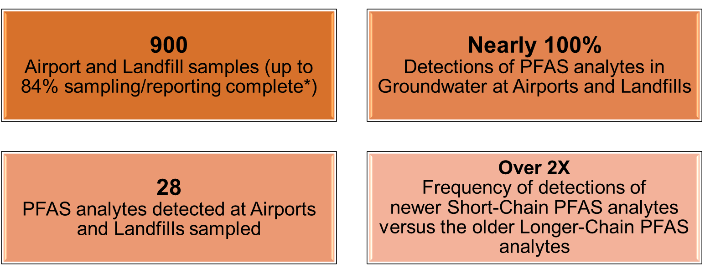

Figure 2. Public Water System Investigation Highlights
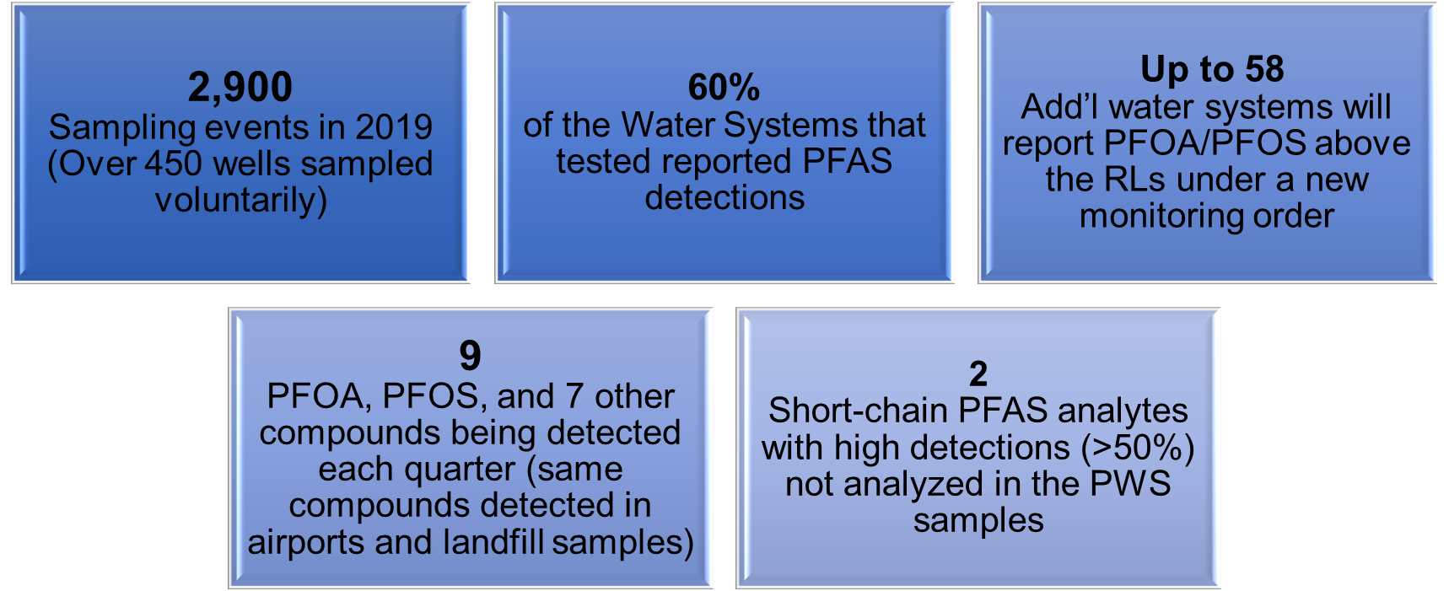

Recent PFAS efforts include issuance of statewide source investigative Orders in July 2020 to 248 publicly owned treatment works to sample influent, effluent, biosolids, groundwater, and reverse osmosis concentrate for PFAS. DDW also issued an Order in September 2020 for public water systems to sample 890 wells based on the detection of PFAS resulting from the 2018/2019 sampling efforts; and to report any exceedance of the PFOA and PFOS Notification Levels (NLs) lowered in August 2019, and Response Levels (RLs) lowered in February 2020. By the end of 2020, DWQ intends to issue approximately 160 investigative orders to bulk fuel terminals and refineries to sample soil, groundwater, and stormwater due to the use of PFAS- containing aqueous film-forming foam.

Additional information on the Water Board’s PFAS efforts is available through the Water Board PFAS webpage at https://www.waterboards.ca.gov/pfas/.

Sustainable Groundwater Management Act (SGMA)
Implementation of the Sustainable Groundwater Management Act (SGMA) is underway.

In January 2020, all Critically Overdrafted basins (shown below) had to submit their Groundwater Sustainability Plans to the Department of Water Resources (DWR), unless DWR had already accepted an alternative plan for the basin. Some basins chose to submit more than one plan per basin. In all, 47 plans were submitted covering all the Critically Overdrafted basins, as well as three additional basins. One coordination agreement was missing a signature, but mediation at the local level resolved this in June, and Board staff ultimately did not recommend pursing a probationary determination from the Board. This basin’s plans were subsequently passed back to DWR for review.

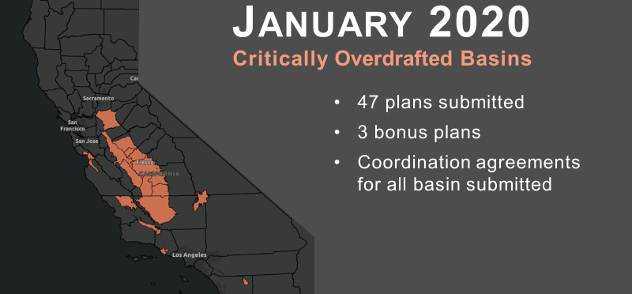

While DWR is the agency responsible for determining plan adequacy, State Water Board staff are working to support DWR’s review of plans, while also continuing work essential to the Board’s implementation of SGMA. This work includes outreach to GSAs and interested parties.

The SGMA team has released several fact sheets:
- Overview of Submittal and Evaluation of Groundwater Sustainability Plans
- Water Quality Frequently Asked Questions
- Probationary Designation and Groundwater Regulation by the State Water Board
- Stakeholder Inclusion
- State and Regional Water Boards Basics
More information on the Groundwater Management Program’s implementation of SGMA can be found on our SGMA Website. For any questions about plan review or about SGMA implementation generally, please contact sgma@waterboards.ca.gov.

Salton Sea

Introduction
The Salton Sea is California’s largest lake. Due to multiple factors, including a long-term water transfer administered by the Division of Water Rights (Division), the sea is shrinking and creating a smaller and saltier sea which is causing fish and wildlife impacts. The exposed lakebed may also be causing air quality concerns related to public health.

State Water Board’s Role at the Salton Sea
The State Water Board’s role at the Salton Sea has historically been regulatory in nature, although more recently the State Water Board has also taken an oversight role. A document between Colorado River water users, called the Quantification Settlement Agreement (QSA), was signed to help keep California within its water allocations for the Colorado River. The QSA led to a long-term water transfer, approved by the State Water Board, for the transfer of conserved water from agricultural use to municipal use. Many years after approval of the long-term water transfer, the State Water Board was then tasked with holding annual workshops to provide a public forum and better transparency on the state’s actions at the sea. The California Natural Resources Agency (CNRA) is the lead state agency implementing projects for the restoration and mitigation efforts covered under the Salton Sea Management Program (SSMP). The State Water Board’s annual workshops occur in order to hear a progress update by CNRA on its implementation of the SSMP, and also to provide opportunity to receive oral and written comments on the SSMP by interested parties and the public.

Current Status of the Salton Sea
The State Water Board held its annual workshop on the Salton Sea (virtually) on August 19, 2020. CNRA provided a presentation on its progress implementing the SSMP. The workshop also had several panels with participants from local, state, and federal organizations to provide additional information on the implementation of the SSMP. The workshop also provided an opportunity for public comments during both day and evening sessions, along with simultaneous Spanish interpretation to better communicate with affected communities.

CNRA’s first fish and wildlife project, Species Conservation Habitat Project, is set to start construction this fall. Located at the southern end of the sea along both sides of the New River, the 3,770-acre project is aimed at creating habitat and suppressing dust to prevent further degradation of air quality. The project will use water from the New River, surrounding agricultural drains, and the Salton Sea. This project is one of the first of many projects by CNRA that will cover approximately 30,000 acres of exposed lakebed by the end of 2028.

The Colorado River Basin Regional Water Quality Control Board (Colorado River Basin Water Board) is conducting a Triennial Review of its Basin Plan with a public comment period that began on September 25, 2020 and concludes on October 24, 2020. The Basin Plan will provide descriptions of the water bodies and surrounding environments, actions and policies implementing water quality standards, monitoring plans to ensure that water quality standards are being met, and other pertinent information that may relate to and affect implementation of the SSMP. The Colorado River Basin Water Board intends to consider adopting the 2020 Triennial Review during a public hearing that is expected to occur on December 10, 2020. In addition to the Triennial Review of the Basin Plan, the Colorado River Basin Water Board is an active participant in implementing the New River Improvement Project which targets restoring flow into the river channel and improving public health in and around Calexico.

Safe and Affordable Funding for Equity and Resilience (SAFER)
The primary purpose of the Safe and Affordable Funding for Equity and Resilience (SAFER) program is to bring true environmental justice to California and address the continuing disproportionate environmental burdens in the state by creating a fund that will assist in providing safe drinking water in every California community, for every Californian.
SAFER funds will help water systems provide a safe, accessible, and affordable supply of drinking water to communities in both the near and long terms by accelerating implementation of short- and long-term drinking water solutions, moving water systems to more efficient modes of operation, providing short-term operation and maintenance support as a bridge until long-term sustainable solutions are in place, and providing long-term operation and maintenance support when necessary.
The SAFER program supports permanent and sustainable drinking water solutions that ensure all Californians have access to safe, affordable, and reliable drinking water.
The SAFER Program builds upon the successful regulatory and financial assistance efforts of the Division of Drinking Water (DDW) and the Division of Financial Assistance (DFA) that have resulted in 98% of Californians served by community drinking water systems having access to safe and reliable sources of drinking water. Unfortunately, at the same time, there are approximately one million people in California without access to safe drinking water. Many of these people are served by small water systems with 500 or fewer connections. There are approximately 3,000 community water systems in California and approximately 300 of them are in violation of drinking water standards. The majority of traditional funding sources are only available for capital improvements and there has been very little funding available for planning and other preliminary steps that are necessary before embarking on a capital project.
In July 2019 SB 200 was passed by the Legislature and signed by the Governor. SB 200 established a fund of up to $130 million per year to address water systems serving disadvantaged communities and established new regulatory authorities as well. The SAFER program is utilizing the funding and regulatory authorities to create a comprehensive program that will address drinking water issues in disadvantaged communities.
There are a number of overlapping work areas within the SAFER program. Success in each of these areas depends on coordination throughout many divisions at the State Water Board.
- Regulatory (DDW lead)
  - Consolidations – Originally authorized through SB 88 (2015). The Board has the authority to order small water systems who fail to consistently provide adequate drinking water to consolidate with other drinking water systems, when voluntary consolidation efforts don’t work.
  - Administrators – Administrator can be named through a public process to take over the operations of a failing water system and put it on a path to long tern sustainability.
- Funding (DFA lead)
  - Fund Expenditure Plan: Each year the Board is required to adopt a Fund Expenditure Plan which will guide staff work in the SAFER program over the fiscal year.
  - SB 200 Funding: One of the innovations of SB 200 is the flexibility in the funding that it provides. Funds in the Safe and Affordable Drinking Water Fund can be used for both capital and non-capital expenses including paying for administrators, technical assistance (including project planning and pre-planning), and operations and maintenance.
  - Other Funding Sources: In addition to SB 200 funding other funding sources including bond funding, the Drinking Water State Revolving Fund and some general funds are available for projects under the SAFER program. Most of these funds are limited to capital projects but some funding sources have the flexibility to be used for other purposes.
- Outreach and Engagement (Office of Public Participation [OPP] lead)
  - SB 200 Advisory Group: SB 200 calls for the Board to name an advisory group to advise it on the development of the Fund Expenditure Plan and other aspects of the SAFER program.
  - Community Engagement: Community engagement is a cornerstone of the SAFER program. OPP works with staff in DDW Engagement units to ensure that community members can engage in finding solutions to issues with their drinking water systems.
- Data and Needs Assessment (DDW lead)
  - Affordability and Cost Assessments: Development of an Affordability Threshold is required for each year’s Fund Expenditure Plan. Cost estimates for different solution types are also being developed.
  - Risk Assessment: The risk assessment utilizes a variety of indicators of risk of failure for drinking water systems. The development of list of “at risk” water systems will allow DDW and DFA to work on solutions for drinking water systems and put them on the path to long term sustainability, before they violate drinking water standards.
  - Data Gathering and Dissemination: One key to the SAFER program is bringing disparate data systems together in order to find drinking water solutions and to track program progress. Disseminating the data to the public in ways that are easy to digest and understand is also critical to the success of the program.
Accomplishments of the SAFER program to date include:
- Encumbering $130 million for projects in fiscal year 2019-2020
- Continuing assessment and reassessment of all drinking water systems with violations through quarterly meetings between DDW, DFA and others
- Adoption of Fund Expenditure Plan for fiscal year 2020-2021 https://www.waterboards.ca.gov/water_issues/programs/grants_loans/sustainable_water_solutions/docs/sadwfep_2020_07_07.pdf
- Five public meetings of SB200 Advisory Group
- Development of publicly available visualizations for program tracking https://www.waterboards.ca.gov/safer/dw_systems_violations_tool.html
Goals for fiscal year 2020-21 include
- Providing interim water supplies to 150 additional communities
- Funding planning and technical assistance for 150 communities
- Developing long term solutions for 100 communities
- Development of Risk Assessment metrics and a list of at-risk drinking water systems
More information on SAFER can be found at: https://www.waterboards.ca.gov/safer/.

Maximum Contaminant Levels

Maximum Contaminant Levels
Health and Safety Code (HSC) section 116365 requires establishment of maximum contaminant levels (MCLs) as close to the public health goal (PHG) as is technologically and economically feasible. The following table lists contaminants with MCL development or revision either underway or planned for the near future. All dates are tentative.
Contaminant | PHG  (μg/l) | MCL  (μg/l) | Rulemaking  Notice | Board  Meeting | Effective
Chromium,  Hexavalent | 0.02 | -- | Mar-2021 | July 2021 | 1-Jan-2022
Cadmium | 0.04 | 5 | May-2021 | Sep-2021 | 1-Jan-2022
Styrene | 0.5 | 100 | May-2021 | Sep-2021 | 1-Jan-2022
NDMA | 0.003 | -- | Aug-2021 | Dec-2021 | 1-Apr-2022
PFOA* | -- | -- | Jun-2023 | Oct-2023 | 1-Apr-2024
PFOS* | -- | -- | Jun-2023 | Oct-2023 | 1-Apr-2024
1,4-Dioxane* | -- | -- | Sep-2023 | Jan-2024 | 1Apr-2024
* 18-24 months from PHG to Notice of Proposed Rulemaking and 6-12 months from Notice to filing with Secretary of State; assumes final PHG by end of 2021/early 2022

Detection Limits for Purposes of Reporting
HSC 116365 also requires periodic review of MCLs to determine whether they can be moved closer to their corresponding PHGs. The review of many MCLs is currently limited by detection limits for purposes of reporting (DLR) at concentrations higher than corresponding PHGs. Preliminary rulemaking work is underway to lower DLRs for the following metals under a single action, in preparation for possible MCL revision.

Contaminant | PHG  (μg/l) | DLR  (μg/l) | MCL  (μg/l)
Antimony | 1 | 6 | 6
Arsenic | 0.004 | 2 | 10
Cadmium | 0.04 | 1 | 5
Lead** | 0.2 | 5 | 15
Mercury | 1.2 | 1 | 2
Nickel | 12 | 10 | 100
Thallium | 0.1 | 1 | 2
** Lead has an action level rather than an MCL

Notice of the proposed rulemaking is tentatively planned for April 2021, with Board consideration in August 2021, and an effective date of 1 January 2022.

Public Health Goals and Notification Levels
In addition to the rulemaking work described above, the Office of Environmental Health Hazard Assessment (OEHHA) is currently preparing, or has recently completed, revised or new PHGs for the following contaminants:

Contaminant | PHG  (μg/l) | DLR  (μg/l) | MCL  (μg/l) | Final PHG Issuance
Total Trihalomethanes | -- | -- | 80
Bromoform | 0.5 (cancer)  430 (non-cancer^) | 1.0 | --
Chloroform | 0.4 (cancer)  170 (non-cancer^) | 1.0 | -- | 7-Feb-2020
Dibromochloromethane | 0.1 (cancer)  0.2 (non-cancer^) | 1.0 | --
Dichlorobromomethane | 0.06 (cancer)  13 (non-cancer^) | 1.0 | --
Haloacetic Acids (HAA5) | -- | -- | 60
Monochloroacetic Acid | 53 (cancer)  (no non-cancer) | 2.0 | --
Dichloroacetic Acid | 0.2 (cancer)  115 (non-cancer^) | 1.0 | -- | Early 2021
Trichloroacetic Acid | 0.1 (cancer)  0.2 (non-cancer^) | 1.0 | --
Monobromoacetic Acid | 25 (cancer)  (no non-cancer) | 1.0 | --
Dibromoacetic Acid | 0.03 (cancer)  5 (non-cancer^) | 1.0 | --
N-nitrosodimethylamine (NDMA) | 0.003 | -- | -- | 2021
1,4-Dioxane | -- | -- | -- | 2022
^ Not a PHG; non-cancer based, health-protective concentrations

OEHHA also expects to provide notification level recommendations for DDW consideration for anatoxin-a and PFBS later this year.

