Lahontan Water Board Program Fact Sheet
FY 2017-18
Basin Planning
Overview
The Water Quality Control Plan for the Lahontan Region (Basin Plan) contains the beneficial uses and water quality objectives to protect those beneficial uses. The Basin Plan also outlines control measures to achieve water quality objectives. The Water Board sets planning priorities in its Triennial Review last adopted in December 2015.
Funding for the Basin Planning program is from the state Waste Discharge Permit Fee account, which has allocated 4.3 PY to complete both Basin Planning and TMDL program work. 1.8 PY are identified for Basin Planning work in FY 17-18.
Key Efforts
Staff is making progress on projects that are identified as management priorities or listed on the 2015 Triennial Review priority list. These efforts include:

- 2018 Triennial Review – Conduct stakeholder outreach, workshops, and present to the Water Board for adoption in November 2018
- Continue working on Mojave River Basin Plan Amendments for beneficial uses and water quality objectives
- Finalize Mean of Monthly Means Recommendations
- Participation in State Board Standards Unit project to address nutrients with a biostimulatory substances objective and develop a program to implement biological integrity.
- Lake Tahoe Shoreline Basin Plan Amendment to remove the prohibition on pier development in fish habitat, to be consistent with the Tahoe Regional Planning Agency’s (TRPA) Lake Tahoe Shoreline Plan

Other Triennial Review priorities may be assigned to seek consistency or clarification related to State Board actions, in response to recommendations in the Climate Change Adaptation Strategy, or in response to Water Board direction.

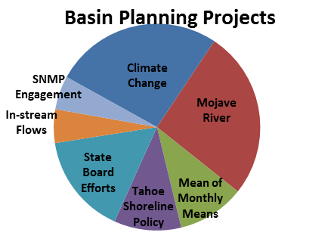
Accomplishments
Squaw Valley Groundwater Withdrawal and Instream Flow – November 2017 Board Workshop included presentations from State Board and Region 1 on the development and implementation programs for instream flow criteria related to cannabis cultivation and other water quality factors.
Mojave River Watershed – Investigated and developed recommendations to address three Triennial Review prioritized projects related to Mojave River surface waters. Started work on a fourth priority evaluating the need to establish groundwater objectives.
State Board Standards Projects – Provided input into State Board efforts to adopt:
- Statewide bacteria objectives for the REC-1 Beneficial Use (Anticipated adoption summer 2018)
- Statewide mercury objectives and accompanying Tribal Cultural, Tribal Subsistence Fishing, and Subsistence Fishing Beneficial Uses (Adopted May 2017)
Lake Tahoe Shoreline Plan – The Project will require independent scientific peer review and a Basin Plan Amendment related to its pier prohibition.
Climate Change Adaptation Planning - During September and October of 2017, the Lahontan Regional Board hosted a series of public meetings throughout the region in Truckee, Bishop, and Apple Valley. The meetings were held to consider public input and foster productive relationships as we further develop key elements to include in the Climate Change Mitigation and Adaptation Strategy.
Performance targets FY 15/16 and 16/17
Target Description | Targets | Achieved
# of Water Quality Objectives Adopted 0 0
Unaddressed Work
Triennial Review List adopted by the Water Board in 2015 identified several basin planning projects not currently assigned:
- Establish or revise site specific objectives for numerous surface waters
- Biological indicators
- Region-wide approach to TDS objectives in surface waters
- Designate Tribal beneficial uses
- Evaluate bacteria objectives
- Associate beneficial uses with existing water quality objectives

