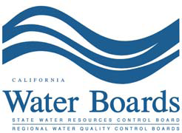 AGENDA

San Francisco Bay Stakeholder Advisory Group
SF Bay Nutrient Project
March 8, 2013
9:00—12:00 PM

Location: San Francisco Bay Regional Water Quality Control Board,
Meeting Room 9, Second Floor, 1515 Clay Street, Oakland, CA 94612

Meeting Goals:
- Discuss Suisun Bay studies
- Discuss and provide input on direction of future Suisun Bay studies

- 9:00 Introductions, meeting goals (Naomi Feger)
- 9:10 Suisun Bay studies – overview (Karen Taberski)
- 9:30 SWAMP 2011-12 study (Romberg Tiburon Center)
- 9:50 State and Federal Contractors Water Agency (SFCWA)/Central San/BACWA study (Val Connor)
- 10:10 Central San study (Mary Lou Esparza)
- Break 10 minutes
- 10:30 Suisun Synthesis (David Senn)
- 10:50 2013 Collaborative Studies (10 minutes each)
- Raphe Kudela and Mine Berg (funded by IEP and SFCWA)
- Dick Dugdale (funded by IEP and SFCWA)
- USGS collaborative study/ Alex Parker (funded by IEP)
- Dave Senn/ Carol Kendall/ Marianne Guerin (funded by IEP)
- 11:30 Panel Discussion - Meeting Wrap Up

