# Water Loss Performance Standards

**Draft Regulatory Text**

## Title 23. Waters

## Division 3. State Water Resources Control Board and Regional Water Quality Control Boards

## Chapter 3.5. Urban Water Use Efficiency and Conservation

## Article 1. Water Loss Performance Standards for Urban Retail Water Suppliers

## § 980. Definitions

As used in this Article:

1. “Active leak detection” means a leak control strategy utilizing the appropriate combination of leak detection surveys and continuous monitoring of flows~~the industry approach used~~ to proactively detect and locate leaks in water distribution systems owned or operated by urban retail water suppliers.
2. “Annual audit” means the validated annual water loss audit submitted by an urban retail water supplier pursuant to Water Code 10608.34, subdivision (b).
3. “Annual background leakage” means~~is~~ the estimated~~total~~ fraction of real loss that is not detected by active leak detection in a distribution system, in acre-feet per year. The default value shall be the value calculated in accordance with section 982, subdivision (a)(1).
4. “Annual reported leakage” means~~is~~ the total volume of real loss occurring due to reported leaks on mains and reported leaks in lateral and service lines, in acre-feet per year. Reported leakage is a component of real loss. The default value shall be the value calculated in accordance with section 982, subdivision (a)(2).
5. “Annual unreported leakage” means~~is~~ the average baseline real loss that remains after deducting the annual reported leakage and the annual background leakage from the average baseline real loss, in acre-feet per year. Unreported leakage is a component of real loss. The default value shall be the value calculated in accordance with section 982, subdivision (a)(3).
6. “Apparent losses” mean~~s~~ losses in customer consumption attributed to inaccuracies associated with customer metering, systematic data handling errors, plus unauthorized consumption (theft or illegal use of water), ~~the type of inaccuracies associated with customer metering and billing inaccuracies, in addition to water loss to theft,~~ as reported in the annual audit as “apparent losses.”
7. "Appurtenances” are valves (for example, isolation, automatic control, and air), fire hydrants, meters, and any other asset associated with the water distribution and transmission network that are additional to the pipe assets themselves. Leaks on appurtenances may be accounted for in the “mains” or “laterals and service lines” categories, as long as the accounting stays consistent.
8. “Average annual rise in price of water” means the average expected increase in water price in real (inflation-adjusted) terms, ~~over the lifetime of the model,~~ expressed as a percent. Unless a supplier uses its own value in accordance with section 984(b)(1), the default value shall be 4.2 percent.
9. “Average baseline apparent loss” means the average of the apparent losses reported in the annual audits submitted for the baseline period~~fiscal or calendar years 2017, 2018, 2019, and 2020~~. ~~If one year of real loss is removed before calculating the baseline real loss pursuant to subdivision (i) of this section, that same year must be removed from the average baseline apparent loss calculation.~~
10. “Average baseline real loss” means the average of the real losses reported in the annual audits submitted for the baseline period~~fiscal or calendar years 2017, 2018, 2019, and 2020~~. If the real loss submitted for any year is a negative value, that value will be replaced by zero for purposes of averaging the baseline real loss. ~~The urban retail water supplier may choose to calculate the average baseline real loss using three out of the four years of 2017, 2018, 2019, and 2020 if the value not used varies by over 10 gallons per service connection per day for suppliers reporting in gallons per connection per day or 740 gallons per mile per day for suppliers reporting in gallons per mile per day from the each of the values for the other three years or if the value not used is negative.~~
11. “Average duration between reporting and repair of reported leaks on laterals and service lines” means the average duration between the time when the urban retail water supplier becomes aware of a leak occurring on lateral and service lines and the time when it repairs the leak, in days, rounded to the closest whole number~~, in days~~. Unless a supplier uses its own values as indicated in this article, the default value shall be 8 days.
12. “Average duration between reporting and repair of reported leaks on mains” means the average duration between the time when the urban retail water supplier becomes aware of a leak occurring on mains and the time when it repairs the leak, in days, rounded to the closest whole number~~, in days~~. Unless a supplier uses its own values as indicated in this article, the default value shall be 3 days.
13. “Average flow rate for reported leaks on laterals and service lines” means the average real loss ~~per unit time~~ from reported leaks occurring on lateral or service lines, in gallons per minute per leak. Unless a supplier uses its own values as indicated in this article, the default value shall be 7 gallons per minute per leak.
14. “Average flow rate for reported leaks on mains” means the average real loss ~~per unit time~~ from reported leaks occurring on mains, in gallons per minute per leak. Unless a supplier uses its own values as indicated in this article, the default value shall be 50 gallons per minute per leak.
15. “Average leak detection survey frequency” is the average rate at which a supplier conducts active leak detection on a length of pipeline~~s on which the urban retail water supplier can conduct active leak detection~~, in miles per month. Unless a supplier uses its own values as indicated in this article, the default values shall be as follows:
    1. For urban retail water suppliers with average length of mains less than 500 miles, average length of mains, in miles, divided by 24 months;
    2. For urban retail water suppliers with average length of mains equal to or more than 500 miles, but less than 1,000 miles, average length of mains, in miles, divided by 30 months;
    3. For urban retail water suppliers with average length of mains equal to or more than 1,000 miles, but less than 4,000 miles, average length of mains, in miles, divided by 36 months; and
    4. For urban retail water suppliers with average length of mains equal to or more than 4,000 miles, but less than 6,000 miles, 114 miles per month.
    5. For urban retail water suppliers with average length of mains equal to or more than 6,000 miles, 130 miles per month.
16. “Average length of mains” means the average of the values of total length of pipelines owned or operated by the urban retail water supplier reported as “length of mains” in the annual audits submitted for the baseline period~~fiscal or calendar years 2017, 2018, 2019, and 2020~~, in miles~~, unless the values provided are negative the audit has not been submitted~~.
17. “Average number of service connections” means the average of the values of the total number of customer service connections supplied by the urban retail water supplier reported as “number of active and inactive service connections” in the annual audits submitted for the baseline period~~fiscal or calendar years 2017, 2018, 2019, and 2020, unless the values provided are negative or the audit has not been submitted~~.
18. “Average operating pressure” means the average of the values of the pressure in the distribution system owned or operated by the urban retail water supplier reported as “average operating pressure” in the annual audits submitted for the baseline period~~fiscal or calendar years 2017, 2018, 2019, and 2020~~, in pounds per square inch~~, unless the values provided are negative or the audit has not been submitted~~.
19. “Average unit cost of leak detection surveying” is the average total cost incurred by the urban retail water supplier to conduct active leak detection, including equipment and labor costs and additional administrative costs associated with active leak detection, per unit mile of pipeline owned or operated by the urban retail water supplier, in dollars per mile surveyed. Unless a supplier uses its own values as indicated in this article, the default value shall be 595 dollars per mile surveyed.
20. “Average unit leak repair costs for mains” means the average total cost incurred by the urban retail water supplier to repair each occurring leak on mains, including equipment and labor costs and additional administrative costs associated with repair, in dollars per leak. Unless a supplier uses its own values as indicated in this article, the default value shall be 5,946 dollars per leak.
21. “Average unit leak repair costs for laterals and service lines” means the average total cost incurred by the urban retail water supplier to repair each occurring leak on laterals and service leaks, including equipment and labor costs and additional administrative costs associated with repair, in dollars per leak. Unless a supplier uses its own values as indicated in this article, the default value shall be 2,330 dollars per leak.
22. “Average variable production cost” means the average of the values of the cost to produce and supply the next unit of water for the urban retail water supplier reported as “variable production cost” in the annual audits submitted for the baseline period~~fiscal or calendar years 2017, 2018, 2019, and 2020~~, in dollars per acre-foot~~, unless the values provided are negative or the audit has not been submitted~~.
23. "Baseline period” means a four-year period of data to be used in the water loss model as inputs, and generally refers to the years for which data are reported in the annual audits submitted for the fiscal or calendar years 2017, 2018, 2019, and 2020, except as otherwise specified in this article.
24. “Board” means the State Water Resources Control Board.
25. “Compliance Period” means the three-year period preceding the date that compliance with the water loss standard is assessed. The first compliance period consists of the years 2025, 2026, and 2027 ~~and the data that corresponds to those years~~.
26. “Department” means the Department of Water Resources.
27. “Detected” means leaks found on the water distribution system owned or operated by an urban retail water supplier using active leak detection.
28. “Efficiency of leak detection equipment” is the average ratio of occurring leaks discovered by the urban retail water supplier on excavation solely due to active leak detection to the total number of leaks detected by active leak detection, in percent. Unless a supplier uses its own values as indicated in this article, the default value shall be 70 percent.
29. “Executive Director” means the board’s executive director.
30. “Exported water” means the volume of water sold to another agency as reported by the urban retail water supplier in the annual audit as “water exported.”
31. “Full cycle of leak detection” means completing a survey of all mains in a distribution system. Other technologies can also be considered a “full cycle of leak detection” if they provide leakage data on the full distribution system.
32. “Imported water” means the volume of water purchased from another agency as reported by the urban retail water supplier in the annual audit as “water imported.”
33. “Infrastructure condition factor” (ICF) means the ratio between the actual volume of background leakage in a zone or district metered area and the calculated unavoidable background leakage volume of a well-maintained system. Several methods can be used to quantify the ICF. The more accurate methods require a greater data collection effort.~~is a factor that relates the total background leakage with the unavoidable background leakage based on distribution system characteristics. It can be determined by assessing the distribution system’s condition. Infrastructure condition factor is calculated as the total background leakage divided by the unavoidable background leakage for the distribution system owned or operated by the urban retail water supplier.~~ Unless a supplier uses its own values as indicated in this article, the default value shall be 1.
34. “Laterals and~~or~~ service lines” means the pipelines in the water distribution system owned or operated by the urban retail water supplier that convey water from mains to service connections.
35. “Leak” means failure of pipeline or other parts of water distribution infrastructure that leads to real loss from the water distribution system owned or operated by the urban retail water supplier.
36. “Mains” means pipelines in the water distribution system owned or operated by the urban retail water supplier that conveys water from the point of input to the distribution system to smaller lateral pipelines that distribute water throughout the urban retail water supplier’s service area.
37. “Marginal avoided cost of water” means the value of per unit volume of water saved due to reduced real loss, including the current variable production cost of water and anticipated costs for providing safe, accessible water ~~and improving groundwater basin sustainability in compliance with the Sustainable Groundwater Management Act~~, in dollars per acre-foot. Unless a supplier uses its own values as indicated in this article, the default value shall be 1,275 dollars per acre-foot.
38. “Median household income determination” means the calculation conducted by the Board to determine the median household income for each urban retail water supplier service area based on the median household income data for counties of California and census tract data.
39. “Metered” means when the water furnished or delivered through a part of the water distribution system is measured through a water meter. “Water meter” has the same meaning as in Water Code Section 516.
40. “Month of implementation” means the month after the end of 2021 to implement water loss control, and ranges from 1 to 360. January of 2022 is the first month of implementation.
41. “Number of reported leaks on laterals and service lines” means the number of leaks that are found without active leak detection and are reported to the urban retail water supplier by the general public or the supplier’s own personnelor contractors on its lateral or service lines, in leaks per thousand average number of service connections per year. Unless a supplier uses its own values as indicated in this article, the default value shall be 2.3 leaks per thousand ~~average number of~~ service connections per year.
42. “Number of reported leaks on mains” means the number of leaks that are found without active leak detection and are reported to the urban retail water supplier by the general public or the supplier’s own personnel or contractors on its mains, in leaks per mile of average length of mains per year. Unless a supplier uses its own values as indicated in this article, the default value shall be 0.2 leaks per mile of ~~average length of~~ mains per year.
43. “Number of unreported leaks on mains” means the number of leaks that are found through active leak detection on its mains, in leaks per mile of average length of mains per year. Unless a supplier uses its own values as indicated in this article, the default value shall be 0.01 leaks per 100 miles of mains per year.
44. “Number of unreported leaks on laterals and service lines” means the number of leaks that are found through active leak detection on its lateral or service lines, in leaks per thousand average number of service connections per year. Unless a supplier uses its own values as indicated in this article, the default value shall be 0.75 leaks per thousand service connections per year.
45. “Owned or operated” refers to components of the water distribution system that the urban retail water supplier owns or uses, or both, to distribute water to its service area.
46. “Rate of rise of leakage” means the rate at which real loss rises over time in the distribution system owned or operated by the urban retail water supplier, in gallons per service connection per day per year. This is equivalent to the volume of leakage that rises per unit time between two leak detection surveys, after repairing all detected leaks through the preceding active leak detection and repair effort in portions of the distribution system. Unless a supplier uses its own values as indicated in this article, the default value shall be 5 gallons per connection per day.
47. “Real loss” means the volume of annual leakage ~~volume~~ due to physical leakage, not including apparent losses, reported in the annual audit as “current annual real loss.” Real loss has three components: reported, unreported, and background leakage. When real loss in this article is expressed in gallons per connection per day, it can be converted to gallons per mile per day such that one gallon per connection per day equals 74 gallons per mile per day.
48. “Repair” means an action taken and/or paid for to stop real loss~~using the appropriate method to fix a leak to stop real loss occurring from it~~.
49. “Reported leaks” means leaks discovered~~occurring~~ in the water distribution system ~~owned or operated by the urban retail water supplier that are found~~ without the aid of active leak detection and that are reported to the urban retail water supplier by the general public or the supplier’s personnel, staff, or contractors.
50. “Service area” means the geographical area in which an urban retail water supplier supplies water and has distribution system infrastructure and/or service connections.
51. “Service connection” has the same meaning as in Health and Safety Code section 116275.
52. “System” has the same meaning as Public Water System in Health and Safety Code section 116275.
53. “Unavoidable background leakage” (UBL) means the minimum volume out of the average baseline real loss that is not detected by active leak detection in a distribution system.
54. “Unbilled metered water” means the volume of water supplied by the urban retail water supplier that is not billed but metered as reported by the urban retail water supplier in the annual audit as “unbilled metered consumption.”
55. “Unreported leakage for 2027” means the sum of the twelve months of Monthly unreported real loss with intervention, as calculated pursuant to section 982, subdivision (a)(10), as follows:

(1) For urban retail water suppliers reporting by calendar year, the sum of the twelve months of Monthly unreported real loss with intervention for the months of January through December of 2027.

(2) For urban retail water suppliers reporting by fiscal year, the sum of the twelve months of Monthly unreported real loss with intervention summed for the months of July 2026 through June 2027.

1. “Urban retail water supplier” or “supplier” ~~means a supplier that meets the definition set forth in Water Code section 10608.12.~~has the same meaning as in Water Code section 10608.12, subdivision (t) as further clarified hereafter:

(1) If the supplier owns and operates at least one public water system that has provided an average annual total of 3,000 AF of water or more for municipal purposes for the previous two years, or has served an annual average of 3,000 or more municipal service connections (i.e., residential (single or multifamily), commercial, institutional, industrial, or landscape irrigation) for the previous two years.

(2) Multiple public water systems that are owned and operated by the same supplier are, together, considered an urban retail water supplier, provided they:

(A) Individually serve 200 connections or more;

(B) Collectively, meet the criteria in paragraph (1); and

(C) Meet one or more of the criteria below:

(i) The systems are permanently interconnected;

(ii) The service area boundaries are adjacent;

(iii) The supplier is using the system’s data, such as population or landscape area, to calculate its urban water use objective pursuant to Water Code section 10609.20.

1. “Water from own sources” means the volume of water withdrawn from water resources controlled by the urban retail water supplier as reported by the urban retail water supplier in the annual audit as “volume from own sources.”

### Authority: Section 1058, Water Code.

### References: Article X, Section 2, California Constitution; Sections 116275 and 116902, Health and Safety Code; Sections 102, 104, 105, 350, 516, 1846, 10608.12, ~~and~~ 10608.34, ~~and~~10609.2, and 10609.4, Water Code.

## § 981. Volumetric Water Loss Performance Standards

* 1. No later than January 1, 2028, each urban retail water supplier shall reduce real loss from its distribution systems to no greater than the real water loss standard identified in section 982~~this article~~, as reflected in the supplier’s reported real loss in its annual audit submitted for 2027.
  2. If the urban retail water supplier’s real loss reported in its 2027 annual audit exceeds the supplier’s real water loss standard calculated in accordance with section 982, the supplier will be in compliance with subdivision (a) of this section if the supplier has achieved its real water loss standard as reflected in the real loss levels reported in its annual audit submitted for either 2025 or 2026.
  3. After 2028, each urban retail water supplier’s compliance with its real water loss standard shall be assessed in every third year based on an average of the real losses reported in its three most recent annual audits. A supplier shall maintain, for each compliance assessment, real loss that is no greater than 5 gallons per connection per day above the supplier’s real water loss standard.
  4. At the time compliance with real water loss standards is assessed, apparent losses will also be evaluated. ~~If the average apparent losses for any compliance period are greater than~~Each supplier’s apparent loss standard is the average of the supplier’s baseline apparent losses plus an allowed variation of 2~~5~~ gallons per connection per day. If the average apparent losses for any compliance period are greater than this standard, ~~then~~ the supplier must submit an inventory of ~~all~~ apparent losses. ~~and any calculations and data used to determine apparent losses for that compliance period within 6 months of being informed by the State Water Board of exceeding the apparent losses standard.~~
     1. The apparent losses inventory shall include any calculations and data used to determine apparent losses for the water loss audits spanning the compliance period for which the standards have been evaluated. Each inventory item shall include the type of apparent loss (for example, metering inaccuracies, data handling errors, theft), the estimated volume of loss, and how each value was determined (for example, direct measurement, calculation based on specific equation(s), visual estimate).

(2) The apparent losses inventory must be submitted on a spreadsheet readable by the Board within 6 months of the supplier being informed by the Board that the supplier has exceeded its apparent loss standard. The Board will make a template available on its website.

* 1. An urban retail water supplier’s real water loss standard may be adjusted to include changes to the default parameter inputs identified in section 982(c), pursuant to section 984.
  2. An urban retail water supplier may calculate the average baseline real loss using three out of the four years of the baseline period by removing an outlier value that varies by over 10 gallons per service connection per day from the each of the adjacent values for the other three years or that is negative. If one year of real loss is removed from a supplier’s calculated baseline real loss, that same year must be removed from the baseline average length of mains, average service connections, average operating pressure, average variable production cost, and average apparent loss calculations.
  3. In accordance with section 985, an urban retail water supplier may seek approval of a variance to its real water loss standard in response to unexpected adverse conditions and to its apparent water loss standard if apparent loss data quality improves.

(h) An urban retail water supplier whose service area meets the following criteria shall achieve compliance with this section no later than January 1, 2031:

* + - 1. The service area has a disadvantaged communities (DAC) or severely disadvantaged communities (SDAC) designation owing to the median household income of the supplier’s service area being less than or equal to 80 percent of the median household income of California per the median household income determination conducted by the board;
      2. The service area has a calculated benefit to cost ratio until 2028, pursuant to section 982, subdivision (a)(24), of less than 2; and
      3. The urban retail water supplier’s real water loss standard calculated pursuant to section 982, subdivision (b) is lower than the supplier’s average baseline real loss by 25% or more.

(i) Suppliers that do not meet their real~~water~~ loss standard by January 1, 2028, will be considered in compliance for the first compliance period if:

1. The supplier’s real water loss standard is lower than the supplier’s average baseline real loss by 30% or more;
2. The supplier’s 2025, 2026, or 2027 water loss audits show progress as a reduction of real loss by at least 30% of the difference between the average baseline real loss and the real water loss standard;
3. The supplier’s data validity scores are at Level 3 or the supplier has demonstrated improving data validity scores. When determining eligibility, consideration will be given to data validity score reductions related to water audits prepared using different versions of the water auditing software;
4. The supplier has completed one~~two~~ full cycle of leak detection surveys; and
5. The supplier has submitted a written request for this compliance pathway to the Board and received approval prior to January 1, 2028. The request shall include:
6. Why the supplier was unable to meet its real water loss standard;
7. A list of leakage prevention activities the supplier has engaged in to prevent water loss;
8. How the supplier is being a good steward with respect to other pieces of Water Code, division 6, part 2.55, chapter 9; and
9. A plan for how it will meet its real water loss standard no later than January 1, 2031.

(j) For systems that do not meet the criteria to be considered an urban retail water supplier in section 980(ccc) until after the effective date of this section, this section applies beginning five (5) years after the system meets the criteria to be considered a supplier, except that the supplier must submit annual water loss audits starting with data for the first full year (calendar year or fiscal year, depending on how the supplier chooses to report its audits) it meets the criteria to be considered a supplier.

(1) The baseline period for suppliers subject to this subdivision consists of the first four years of submitted data.

(2) For suppliers subject to this subdivision, compliance with their real water loss standards will be assessed pursuant to subdivision (c) at the end of the first full compliance period after the standard is assigned except that if there is less than one full year between the standard being assigned and the start of the first full assessment period, compliance will be assessed at the end of the next full compliance period.

Authority: Sections 1058, 10608.34, Water Code.

### References: Article X, Section 2, California Constitution; Section 116275, Health and Safety Code; Sections 102, 104, 105, 350, 516, 1846, 10608.12, and 10608.34, Water Code.

## § 982. Economic Model

* 1. Except as provided in subdivision (d), each urban retail water supplier’s real water loss standard shall be based on the formula identified in subdivision (b), with the following inputs based on each supplier’s own data or the default value:
     1. Annual background leakage:

Annual background leakage shall be calculated as follows:

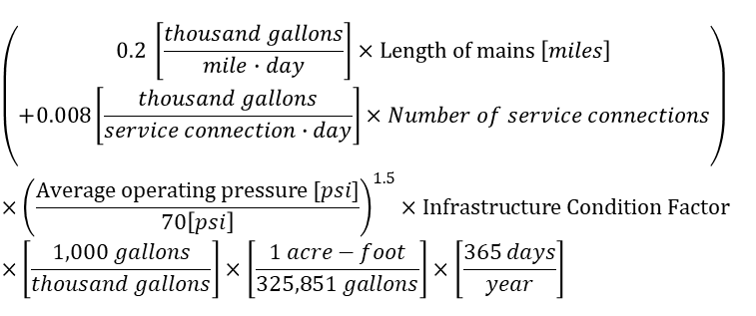

* + 1. Annual reported leakage:

Annual reported leakage shall be calculated as follows:

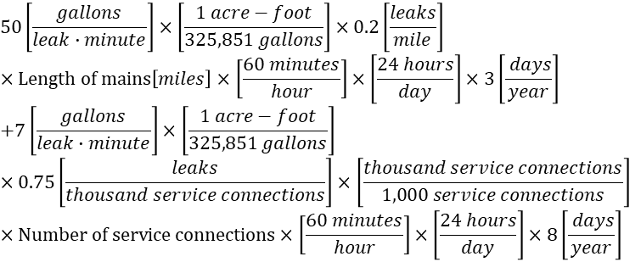

* + 1. Annual unreported leakage:

Annual unreported leakage shall be calculated by deducting annual background leakage and annual reported leakage from average baseline real loss.

* + 1. Months taken to survey whole system:

Months taken to survey whole system shall be calculated by dividing average length of mains by average leak detection survey frequency.

* + 1. Part of system:

Each part represents the amount of the system that can be surveyed each month, such that the number of parts in a system is equal to the number of months needed to survey the whole system.

* + 1. Unreported leakage per part of system:

Unreported leakage per part of system shall be calculated by dividing annual unreported leakage by months taken to survey whole system.

* + 1. Rate of rise of leakage per part of system:

Rate of rise of leakage per part of system shall be calculated by dividing rate of rise of leakage by months taken to survey whole system.

* + 1. Monthly water lost due to backlog of unreported leakage:

Monthly water lost due to backlog of unreported leakage shall be calculated as follows:

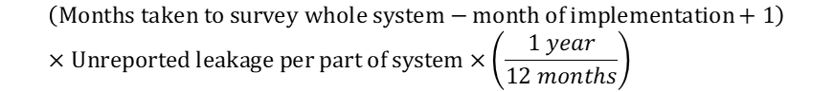

* + 1. Monthly water lost from rising leakage in never surveyed parts of the system:

Monthly water lost from rising leakage prior to first leak survey shall be calculated as follows:

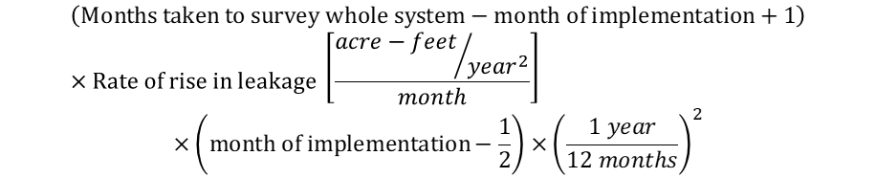

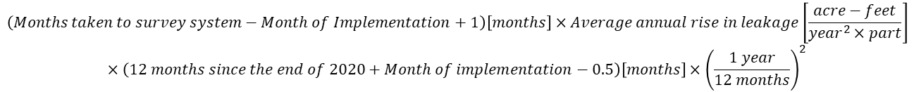

* + 1. Monthly water lost from rising leakage in previously surveyed parts of the system:

(A) Before one full leak detection survey has been completed, the monthly water lost from rising leakage in previously surveyed parts of the system shall be calculated as follows:

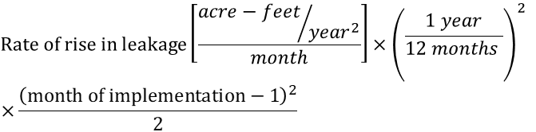

(B) After the entire system has been surveyed once, the monthly water lost from rising leakage in previously surveyed parts of the system shall be calculated as follows:

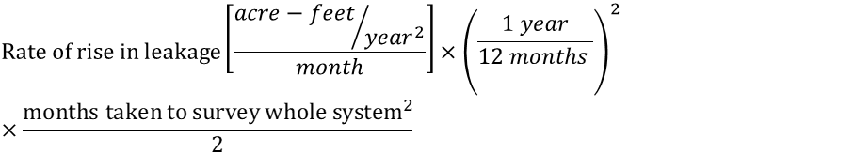

* + 1. Monthly unreported real loss with intervention:

Monthly unreported real loss with intervention shall be the sum of monthly water lost due to backlog of unreported leakage, monthly water lost from rising leakage in never surveyed parts of the system, and monthly water lost from rising leakage in previously surveyed parts of the system.

* + 1. Monthly unreported real loss without intervention:

Monthly unreported real loss without intervention shall be calculated as follows:

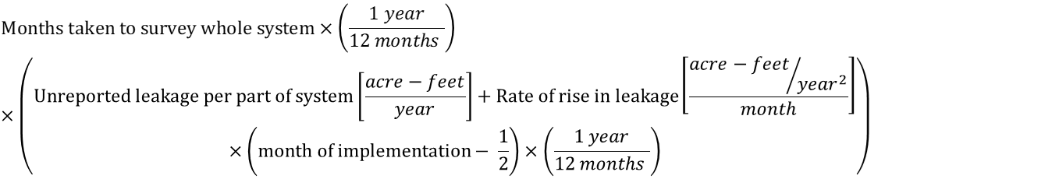

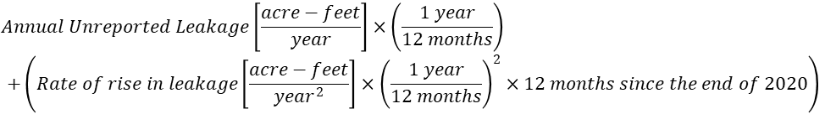

(13) Water saved in month of implementation:

Water saved in month of implementation shall be calculated by deducting monthly unreported real loss with intervention from monthly unreported real loss without intervention.

(14) Marginal avoided cost of water:

(A) At the beginning of 2022, the marginal avoided cost of water shall be calculated as follows:



(B) After 2022 begins, the marginal avoided cost of water shall be calculated as follows:



(15) Value of water loss reduced in each month:

Value of water loss reduced in each month shall be calculated as follows:

Water loss occurring without intervention minus water loss occurring with intervention times marginal cost of water in each time step.

(16) Present value of water loss reduced each month:

Present value of water loss reduced each month shall be calculated as follows:

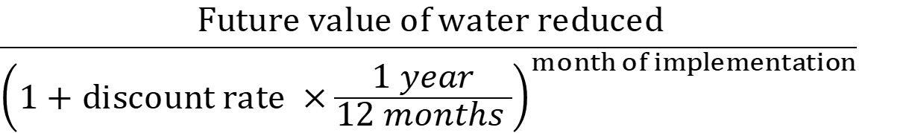

(17) Cost of leak detection during each month:

Cost of leak detection during each month shall be the product of average leak detection survey frequency in miles surveyed each month and average cost of leak detection surveying per mile.

(18) Initial leakage level for part surveyed each month:

(A) Before one full leak detection survey has been completed, then unreported leakage per month shall be calculated as follows:

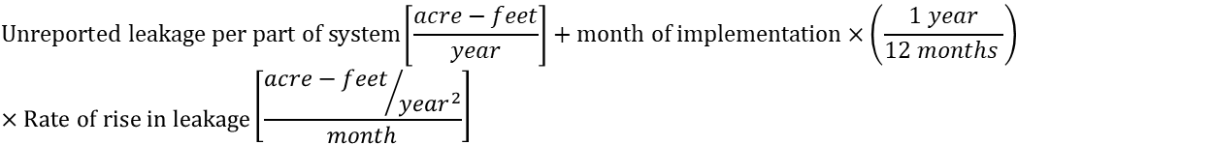

(B) After the entire system has been surveyed once, unreported leakage per month shall be calculated as follows:



(19) Average volume per leak per year:

Average volume per leak per year shall be calculated as follows:



(20) Volume of leakage from mains:

Volume of leakage from mains per leak per year shall be calculated as follows:



(21) Volume of leakage from service connections:

Volume of leakage from service connections per leak per year shall be calculated as follows:



(22) Leaks found per part of the system:  
Leaks found per part of the system is calculated for each month as follows:

Initial leakage for part of system surveyed divided by annual unreported leakage times number of total unreported leaks on mains and service connections.



(23) Cost of leak repair during each month:

Cost of leak repair during each month shall be calculated as follows:

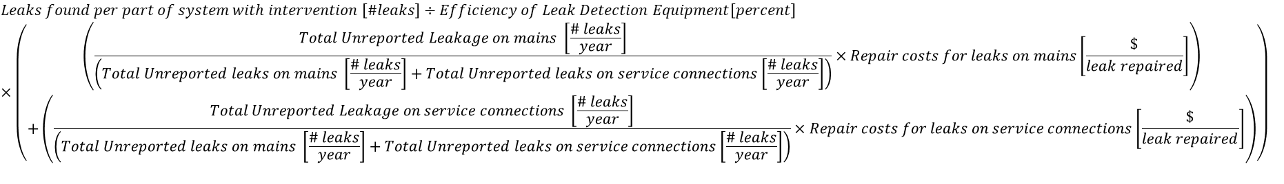

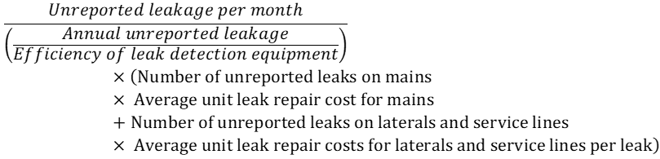

(24) Total leak detection and repair cost for each month:

Total leak detection and repair cost for each month shall be the sum of cost of leak detection during each month plus cost of leak repair during each month.

(25) Present value of cost for each month:

Present value of cost for each month shall be calculated as follows:

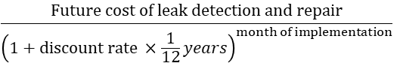

(26) Present value of net benefit in month of implementation:

Present value of net benefit in month of implementation shall be calculated by deducting present value of cost for each month from present value of benefit for each month.

(27) Present value of net benefit over 30 years:

Present value of net benefit over 30 years is the sum of present value of net benefit in month of implementation summed from January 1, 2022, through December 31, 2051.

(28) Benefit to cost ratio until 2028:

The Benefit to cost ratio until 2028 is the sum of present value of benefit for each month from January 2022 through December 2027 divided by the sum of the p~~P~~resent value of cost for each month from January 2022 through December 2027.

* 1. Each urban retail water supplier’s real water loss standard shall be as follows:

(1) If the present value of net benefit over 30 years is negative, ~~the real water loss standard is increased to the point at which the present value of the net benefit is positive, if possible. If a non-negative net benefit is not possible,~~ the real water loss standard is equal to the average baseline real loss.

(2) If the present value of net benefit over 30 years is zero or positive, the real water loss standard is equal to the sum of annual background leakage plus annual reported leakage plus unreported leakage for 2027.

* 1. For purposes of subdivision (a) of this section, each input value, except real discount rate, average annual rise in price of water, and effective timeline for lifecycle benefit-cost analysis, shall be either the default value identified in section 980, or the supplier’s own value if adequately supported by documentation submitted to the board. Average annual rise in price of water shall be either the default value identified in section 980 or the supplier’s own value if the requirements in section 984 subdivision (b) are met. If the board concludes that any specific value used by a supplier is not adequately supported by documentation, the board shall promptly communicate that deficiency to the supplier with a timeline within which to cure the deficiency.
  2. (1) Suppliers may apply for a real water loss standard of 16 gallons per connection per day if the supplier has an average baseline real loss of 16 gallons per connection per day or less and~~The real water loss standard for an urban retail water supplier whose average baseline real loss is 16 gallons per connection per day or less, or, for an urban retail water supplier that reports real loss in gallons per mile per day in the annual audit, 1,184 gallons per mile per day or less, is not less than 16 gallons per connection per day, or, for an urban retail water supplier that reports real loss in gallons per mile per day in the annual audit, 1,184 gallons per mile per day, assessed on a three-year average basis every three years beginning 2028, if~~ the supplier also meets the following criteria for its annual audits:
     + 1. The supplier does not show a year-to-year variability higher than 10 gallons per connection per day ~~for suppliers reporting in gallons per connection per day or 740 gallons per mile per day for suppliers reporting in gallons per mile per day~~ for real loss on any annual audit for the years used to calculate the average real loss pursuant to paragraph (3) of this subdivision ~~2017, 2018, 2019, and 2020~~.
       2. For a supplier that has reported a negative value for ~~the~~its real loss for any of the years used to calculate the average real loss pursuant to paragraph (3) of this subdivision~~2017, 2018, 2019, or 2020~~, it has identified the cause for the negative value and documented the steps taken to correct it.
       3. The supplier’s water from own sources, imported water, and exported water are completely metered.
       4. If the supplier’s water from own sources is greater than 5% of the total water supplied, the supplier demonstrates that meters measuring at least 95% of the total produced volume are tested on at least an annual basis.
       5. If the supplier’s imported water volume is greater than 5% of the total water supplied, the supplier demonstrates that meters measuring at least 95% of the total imported volume are calibrated on at least an annual basis.
       6. If the supplier’s exported water volume is greater than 5% of the total water supplied, the supplier demonstrates that meters measuring at least 95% of the total exported volume are tested on at least an annual basis.
       7. All customer accounts, excluding those providing fire-flow, are metered, with at least 90% success rates in meter reading.
       8. A statistically significant sample of customer meters, as determined by the supplier, or 300 meters, whichever is lower, are tested annually.
       9. If the unbilled metered water volume is higher than 1% of the total water supplied, the supplier reads the meters for accounts that are supplied through unbilled metered water accounts at the same or greater frequency as the supplier reads the meters for the majority of customers.
     1. ~~This subdivision shall only apply to urban retail water suppliers that submit, on or before January 1, 2023, supporting documentation to demonstrate they meet the real loss and data quality criteria of this subdivision.~~ If a supplier that ~~would otherwise~~ meets the ~~above~~ criteria of this subdivision, except that it is unable to meet the criteria for ~~subdivision (d)(1)~~ paragraphs~~sections~~ (D), (E), or (F) of subdivision (d)(1) due to aspects outside of its control, such as not having access to calibrate water meters owned by other entities or not being able to move large meters, then it may petition to be exempted from criteria involving only those aspects outside of their control. This petition may be granted at the discretion of the Board and may include provisions, such as a requirement to calibrate rather than test a meter or to request in writing that water meters be tested and/or calibrated by the entities that own them.
     2. For the purposes of this subdivision, average real loss shall be calculated using the following years of data:
        1. The original baseline period, which consists of data for the years 2017, 2018, 2019, and 2020, provided the submission is received by July 1, 2023; or
        2. Data for any three consecutive years, provided those years are within five years of the submission date.
     3. ~~An urban retail water supplier whose average real loss reported for the years 2021 and 2022 is 16 gallons per connection per day or less, or, for an urban retail water supplier that reports real loss in gallons per mile per day in the annual audit, 1,184 gallons per mile per day or less, shall maintain real loss at or not less than 16 gallons per connection per day, or, for an urban retail water supplier that reports real loss in gallons per mile per day in the annual audit, 1,184 gallons per mile per day, assessed on a three-year average basis every three years beginning 2028, provided that the supplier also meets the criteria identified in subdivision (d)(1) of this section in its annual audits, except that for subdivisions (d)(1)(A) and (B) the supplier’s data shall be for the years 2021 and 2022.~~

1. This subdivision shall only apply to urban retail water suppliers that submit supporting documentation to demonstrate that their average baseline real loss is 16 gallons per connection per day or less and that they have met the data quality criteria of this subdivision. Submissions on or before July 1, 2023, will take effect immediately. Submissions received after July 1, 2023, will take effect in the next compliance period, exempting suppliers from the reporting requirements in section 983 for subsequent compliance periods.

Authority: Sections 1058, 10608.34, Water Code.

References: Article X, Section 2, California Constitution; Section 116275, Health and Safety Code; Sections 102, 104, 105, 350, 516, 1846, 10608.12, and 10608.34, Water Code.

## § 983. Questionnaires and Reporting Requirements

* 1. Each urban retail water supplier, except those meeting the criteria in section 982, subdivision (d), shall submit responses to specific questions developed by the board on metering practices and data handling that influence data quality for water loss audits by July 1, 2023. Questions shall solicit information on the following:
     1. The proportion of source/production water withdrawals that is metered
     2. The program for regular flow testing of its production and source meters for accuracy
     3. Frequency with which source meters are tested
     4. The program for regular electronic calibration of secondary instrumentation that supports source or production meters, including the frequency of calibration
     5. The proportion of authorized consumption that is measured by customer meters
     6. The program for regular flow testing of customer meters for accuracy
     7. Frequency with which customer meters are flow tested to determine accuracy
     8. Types of data handling and billing errors identified in the prior year
  2. Each urban retail water supplier, except those meeting the criteria in section 982, subdivision (d), shall submit responses to specific questions developed by the board on pressure management practices and associated estimated real loss reduction that influence data quality for water loss audits by July 1, 2023, and updated responses by July 1, 2026. Questions shall solicit information on the following:
     1. Devices used to control pressure transients in the water distribution system
     2. Inspection, maintenance and repair of devices installed for controlling pressure transients in the distribution system
     3. Inspection, maintenance and repair of pressure reducing/modulating valves in the distribution system
     4. Frequency with which each device for controlling pressure transients is inspected
     5. Portions of the system that have high operating pressure
     6. Potential for reducing or modulating pressure to reduce leakage
     7. For update response due by July 1, 2026, approach to reduce leakage in high leakage zones
     8. For update response due by July 1, 2026, whether pressure management can be implemented while meeting water quality and fire flow requirements for the distribution system
     9. Estimated feasible water loss reduction as a result of pressure management, projected to 2035.
  3. Each urban retail water supplier, except those meeting the criteria in section 982, subdivision (d), shall submit responses to specific questions developed by the board on asset management practices and associated estimated real loss reduction that influence data quality for water loss audits by July 1, 2024, and updated responses by July 1, 2027. Questions shall solicit information on the following:
     1. Maintenance of records regarding distribution infrastructure failures
     2. Data fields included in infrastructure failure records
     3. Approach to identifying and prioritizing replacement, rehabilitation, or protection of water distribution infrastructure components that break or leak, including system and environmental factors
     4. Any other supplier cost related to asset management or information that may suggest water loss control past the point of long term cost-effectiveness.
     5. For update response due by July 1, 2027, total projected length of water distribution pipe in miles replaced in each year between 2027 and 2035
     6. For update response due by July 1, 2027, the actual length of water distribution pipe in miles replaced on an average basis annually between 2024 and 2027
     7. For update response due by July 1, 2027, projections regarding distribution infrastructure components that will be replaced, rehabilitated, or provided enhanced protection through 2035
     8. For update response due by July 1, 2027, estimated feasible water loss reduction, projected to 2035
  4. Each urban retail water supplier, except those meeting the criteria in section 982, subdivision (d), shall ~~annually~~ submit a~~their~~ registry of breaks, repairs, and estimated water losses to the Board every three years.
     1. The registry shall contain the latest three years of data, beginning with data for ~~2023~~2025, 2026, and 2027 due by January 1, 2029.
     2. The registry shall be submitted on a spreadsheet readable by the Board that contains at a minimum the following data: break identifier (for example, name, number, cross street), date and time the break was found, date and time the break was repaired, estimated duration of the break, and estimated water volume lost through the break. The Board will make a template available on its website.
     3. The deadline for this submission is identical to the water audit submission deadline for the third~~same~~ year’s audit, as described in Water Code section 10608.34, subdivision (b).

### Authority: Sections 1058, 10608.34, Water Code.

### References: Article X, Section 2, California Constitution; Section 116275, Health and Safety Code; Sections 102, 104, 105, 350, 516, 1846, 10608.12, and 10608.34, Water Code.

## § 984. Adjustments

* 1. An urban retail water supplier may submit to the Board~~, no later than July 1, 2023,~~ a request for a parameter adjustment to its real water loss standard based on system-specific conditions affecting operations and system conditions.
  2. A request for a parameter adjustment must include a description of specific ~~default~~ parameter~~s~~ input(s) or data that would be adjusted, documentation supporting the request, and an assessment of changes~~impacts~~ from the adjustment of input(s).
     + 1. A supplier may request~~apply~~ to use a different rise in price of water if the supplier demonstrates that the alternative value:
       2. Is not less than the real discount rate, 3.5 percent; and
       3. Has been developed and certified by a licensed engineer.
  3. Parameter adjustment requests submitted after July 1, 2023, will not be accepted unless accompanied by a satisfactory explanation for the supplier’s inability to submit that request prior to that date. Satisfactory explanations include that the supplier, with reasonable diligence, did not yet have access to measured data necessary for parameter calculations or that the supplier is replacing obsolete data with more recent, higher-quality data.
  4. ~~The executive director, or executive director's designee, shall provide a decision on a request to adjust an urban retail water supplier’s real water loss standard made pursuant to subdivision (a) within 90 days of receiving the request and supporting documentation. This may be extended by the executive director or the executive director’s designee upon a determination that the supporting documentation is insufficient.~~
  5. Suppliers that have completed a hydraulic consolidation shall report to the Board within one year and submit the following information:

1. The names and identification numbers of all involved systems;
2. The date of consolidation;
3. Map(s) showing service areas of all involved systems.
   1. If a supplier hydraulically consolidates another system within its service area, the supplier will have a period of 5 years before being given new water loss standards.
4. The supplier must continue to submit annual water loss audits, incorporating the consolidated system into its own audit no more than one year after consolidation.
5. In the time period after the consolidation occurs but before the new water loss standards are given, the supplier will have no water loss standards and will not be evaluated for compliance with a water loss standard.
6. For each year the supplier has no real water loss standard, it must survey at least as frequently as the previous period and submit documentation of this requirement to the Board within 6 months of the end of each year.
7. New real water loss standards will be assessed pursuant to section 981 subdivision (c) starting one full compliance period after the new real water loss standard is assigned.
   1. Any other adjustment requests may be submitted to the Board at any time and will be considered based on the merits of the proposed change.
      * 1. Suppliers that have model inputs that changed significantly from the baseline period may request an adjustment to their water loss standards by submitting a request that includes the following:
           1. Data for a new baseline period, which consists of 4 consecutive years of water audit data;
           2. An explanation for why the data in the new baseline period is more appropriate than the data in the previous baseline period. Satisfactory explanations include better data quality in the new baseline period and that more recent data can better represent a system that has changed.
        2. Staff can initiate an adjustment process for any system that has significant changes in data compared to the baseline if at least 3 compliance assessments have passed.
   2. The executive director, or executive director's designee, shall provide a written decision on a request to adjust an urban retail water supplier’s real water loss standard made pursuant to subdivision (a) within 90 days of receiving the request and supporting documentation. This may be extended by the executive director or the executive director’s designee upon a determination that the supporting documentation is insufficient.

### Authority: Sections 1058, 10608.34, Water Code.

### References: Article X, Section 2, California Constitution; Section 116275, Health and Safety Code; Sections 102, 104, 105, 350, 516, 1846, 10608.12, and 10608.34, Water Code.

## § 985. Variances

* + - * 1. An urban retail water supplier may seek approval of a variance to its real water loss standard if needed to respond to unexpected adverse conditions out of the system’s control or where a supplier’s real water loss standard has been set according to section 982 (b)(1). Examples of adverse conditions out of the system’s control include major damage to the system’s distribution system or storage infrastructure, major unexpected changes in avoided water costs, and major changes in the system’s financial situation (for example, bankruptcy or substantial loss of revenue). Drought shall not generally support a variance pursuant to this section.
        2. Any request for a variance for adverse conditions~~real loss standards~~ shall include a description and assessment of impacts from the identified adverse condition, a clearly identified need for the revision, a proposed schedule, or milestones, for return to the usual real water loss standard, and documentation supporting the request.
        3. Any request for a variance based on a real water loss standard being set according to section 982 (b)(1) shall include a description of water loss control activities during the baseline period, the costs of water loss control activities during the baseline period, and an evaluation of the monetary value of water saved by those water loss control activities. To be approved, the request must demonstrate that the water loss control activities during the baseline period were not cost-effective long term.
        4. ~~The~~A variance for adverse conditions~~real loss standards~~ shall be in the form of an extension of the compliance period. Notwithstanding section 981(c), a supplier with an approved variance based on subdivision (c) of this section shall maintain, for each compliance assessment, real loss that is no greater than 10 gallons per connection per day above the supplier’s average baseline real loss.~~or an temporary adjustment of the real loss standard identified in section 982 for the urban retail water supplier.~~
        5. An urban retail water supplier may seek approval of a variance to its apparent loss standard if increases from the average baseline apparent loss level are attributable to improvements in data validity. A variance may be approved after finding that for two consecutive years the supplier’s validated annual audits show data entries have improved to a data grading value of 6 or higher for the following audit data entries:

(1) customer metering inaccuracies; or

(2) all entries under the heading “water supplied”:

(A) volume from own sources;

(B) master meter and supply error adjustment;

(C) water imported (when more than 5% of total water supplied); and

(D) water exported (when more than 5% of total water supplied).

* + - * 1. The variance for apparent loss standards shall be in the form of an adjustment of the apparent loss standard identified in section 981(d).
        2. The executive director, or the executive director's designee, shall provide prompt decisions on requests for variances.

### Authority: Sections 1058, 10608.34, Water Code.

### References: Article X, Section 2, California Constitution; Section 116275, Health and Safety Code; Sections 102, 104, 105, 350, 516, 1846, 10608.12, and 10608.34, Water Code.

## § 986. Additional Conservation Tools

(a)(1) When an urban retail water supplier does not meet its real water loss standard required by section 981, the executive director, or the executive director's designee, may issue conservation orders requiring additional actions by the supplier to come into compliance with its real water~~water~~ loss standard. Prior to issuance of a conservation order, the Board will provide the supplier an indication of their noncompliance and seek to resolve the noncompliance informally, including through alternative enforceable agreements with the supplier. Informal resolutions of noncompliance will be sought for all systems, and particularly for suppliers that have met the provisions of section 981 (~~g~~h) or (~~h~~i).

(2) A decision or order issued under this article by the board or an officer or employee of the board is subject to reconsideration under article 2 (commencing with section 1122) of chapter 4 of part 1 of division 2 of the Water Code.

(b) The executive director, or the executive director’s designee, may issue an informational order requiring an urban retail water supplier to submit additional information relating to water loss. The failure to provide the information requested within 30 days or any additional time extension granted is a violation subject to civil liability of up to $500 per day for each day the violation continues pursuant to Water Code section 1846.

(c) Submitting any information pursuant to this article that the person who submits the information knows or should have known is materially false is a violation of this article and is punishable by civil liability of up to five hundred dollars ($500) for each day in which the violation occurs. Every day that the error goes uncorrected constitutes a separate violation. Civil liability for the violation is in addition to and does not supersede or limit any other remedies, civil or criminal.

### Authority: Sections 1058, 10608.34, Water Code.

### References: Article X, Section 2, California Constitution; Section 116275, Health and Safety Code; Sections 102, 104, 105, 350, 516, 1846, 10608.12, and 10608.34, Water Code.

## Title 23. Waters

## Division 3. State Water Resources Control Board and Regional Water Quality Control Boards

## Chapter 3.5. Urban Water Use Efficiency and Conservation

**~~Article 1~~Article 2. Reporting**

**…**

**~~Article 2~~ Article 3. Prevention of Drought Wasteful Water Uses**

**…**