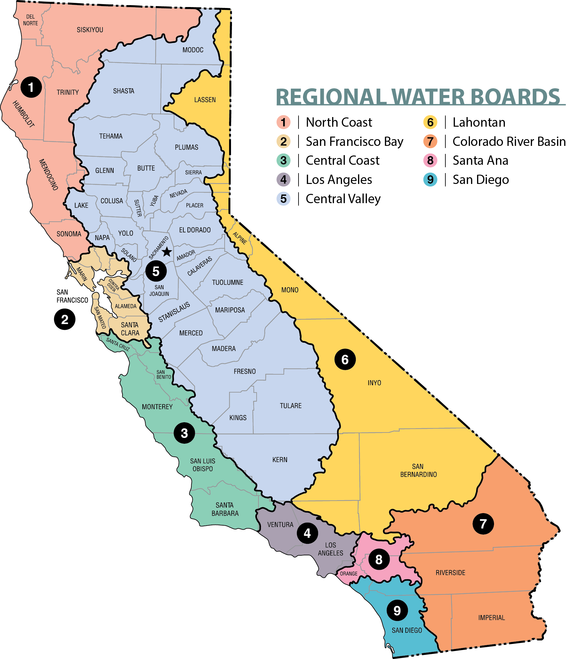
DRAFT Attachment C – Regional Water Board Boundary Map

