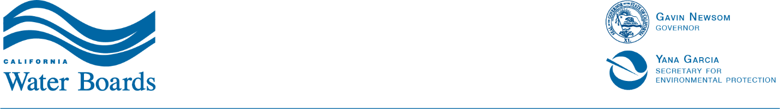

State Water Resources Control Board
REVISED
Public Notice of Application for
Water Quality Certification and Waste Discharge Requirements for the
The Ivanpah Underground Waterline and 69kV Overhead Powerline Rights-of-Way Project for Castle Mountain Mine

State Water Resources Control Board
Division of Water Quality
Water Quality Certification Program
Original Date Posted: August 25, 2026
Revised Date Posted: September 1, 2026
Affected County: San Bernardino
The following information is provided in satisfaction of the public notice requirements of section 3858, title 23, of the California Code of Regulations, which governs the State’s Water Quality Certification Program.
State Water Resources Control Board (State Water Board) received an application for the Project described below. The State Water Board will consider all comments submitted in writing and received during a 21-day 30-day comment period that begins began on August 25, 2026 and ends at 5:00 p.m. on September 15, 2026 September 24, 2026.
To submit comments, or if you have questions, please contact the State Water Board staff person listed below.
State Water Resources Control Board Contact:
Aida Tavakoli
Environmental Scientist
1001 I Street
Sacramento, CA 95814
Phone: (916) 341-5484
Email: Aida.Tavakoli@waterboards.ca.gov
Project Name: The Ivanpah Underground Waterline and 69kV Overhead Powerline Rights-of-Way Project for Castle Mountain Mine (SWRCB ID: SB26033IN)
Background: On July 30, 2026, Castle Mountain Venture (Applicant) submitted an application for Clean Water Act section 401 water quality certification for the Ivanpah Underground Waterline and 69kV Overhead Powerline Rights-of-Way Project for
Castle Mountain Mine.
Project Description: Castle Mountain Venture is proposing to develop utility infrastructure to support expanding mining operations. The Applicant proposes to construct an approximately 31.5-mile long underground water pipeline extending from the Walking Box Ranch area in Clark County, Nevada, to the Castle Mountain Mine in San Berdandino, California. An approximately 16.5-mile long 69-kilovolt (kV) overhead transmission line connecting existing electrical infrastructure in Nevada to the mine is also proposed.
The utilities would be located primarily within existing utility, transportation, and
access-road rights-of-way on lands administered by the Bureau of Land Management in Nevada and California.
Impacts from utility infrastructure development will be limited to temporary ephemeral stream impacts from excavation activities. Restoration and reclamation of pipeline
right-of-way areas will focus on soil stabilization, native vegetation re-establishment, and long-term ecosystem recovery using site-specific techniques and monitoring.
Table 1:Total Project Temporary and Permanent Impacts to Waters of the State.
Aquatic Resource Type | Stream Channel
Acres of temporary impact | 1.30 acre
Linear feet of temporary impact | 11,105
Acres of permanent impact | 0
Linear feet of permanent impact | 0
A Certification or Denial will be issued by the State Water Board for the Ivanpah Underground Waterline and 69kV Overhead Powerline Rights-of-Way Project for
Castle Mountain Mine in response to this application.
Applicant: Castel Mountain Venture
Applicant Contact: Aren Hall, Environmental & Permitting Manager
Telephone: (702) 763-9313
Email: Aren.Hall@equinoxgold.com
Note: No regulatory decision on the application is implied or intended in this public notice.
Pursuant to federal law (title 33, United States Code, section 1341; Clean Water Act section 401), applicants for a federal license or permit for activities which may discharge to waters of the United States must seek water quality certification (Certification) from the state or Indian tribe with jurisdiction. Such Certification is based on a finding that the discharge will meet water quality standards and other applicable requirements.
In California, Regional Water Quality Control Boards (Regional Water Boards) issue or deny Certification for discharges within their geographical jurisdiction. The State Water Board has this responsibility for projects affecting waters within multiple Regional Water Board jurisdictions.
KEEP INFORMED OF PROJECT MILESTONES
To be informed of milestones in the development of this proposed Certification, any interested persons should enroll in the State Water Board’s 401 Program e-mail notification service.
Click the Submit button after entering a valid email address under the Subscribe to he 401 Water Quality Certification and Wetland Program Email List banner on the 401 Program webpage at:
https://www.waterboards.ca.gov/water_issues/programs/cwa401/
By enrolling in this list, you will receive notices for all Certification applications, including the Project announced in this notice. You will need a valid e-mail address to use this service. If you do not have internet access or do not wish to participate in the email notification service, contact the staff person named in the notice to express your interest in receiving notices by other means. You can enroll or un-enroll at any time.

