ATTACHMENT C

CONTACTS
NATIONAL POLLUTANT DISCHARGE ELIMINATION (NPDES)
GENERAL PERMIT FOR STORMWATER DISCHARGES ASSOCAITED
WITH CONSTRUCTION AND LAND DISTURBANCE ACTIVITIES
(GENERAL PERMIT)

State Water Resources Control Board
www.waterboards.ca.gov
P.O. Box 1977
Sacramento, CA 95812-1977
stormwater@waterboards.ca.gov
Division of Financial Assistance: (916) 341-5700
Division of Water Quality: (916) 341-5455
Office of Enforcement: (916) 341-5272
Office of Public Affairs: (916) 341-5254
Office of Legislative Affairs: (916) 341-5251
Office of the Ombudsman: (916) 341-5254

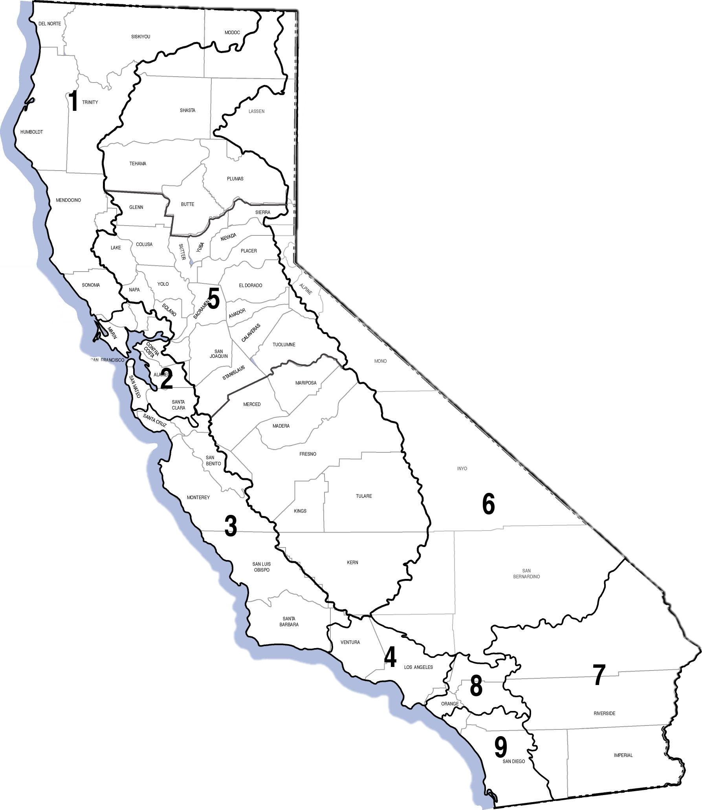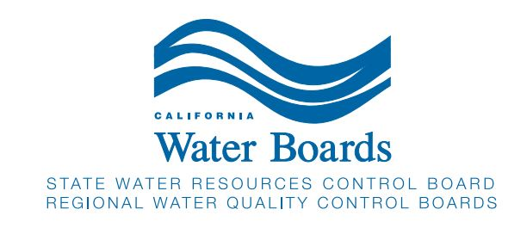

ATTACHMENT C
Regional Water Quality Control Board Stormwater Program Contacts
NORTH COAST REGION (1)
r1_stormwater@waterboards.ca.gov
5550 Skylane Boulevard, Suite A
Santa Rosa, CA 95403
(707) 576-2220
CENTRAL COAST REGION (3)
r3_stormwater@waterboards.ca.gov
895 Aerovista Place, Suite 101
San Luis Obispo, CA 93401
(805) 549-3147
CENTRAL VALLEY REGION (5S)
r5s_stormwater@waterboards.ca.gov
11020 Sun Center Drive, Suite 200
Rancho Cordova, CA 95670-6114
(916) 464-3291
FRESNO BRANCH OFFICE (5F)
r5f_stormwater@waterboards.ca.gov
1685 E Street
Fresno, CA 93706
(559) 445-5116
VICTORVILLE BRANCH OFFICE (6V)
r6b_stormwater@waterboards.ca.gov
15095 Amargosa Road—Bldg 2,
Suite 210
Victorville, CA 92394
(760) 241-6583
SANTA ANA REGION (8)
r8_stormwater@waterboards.ca.gov
3737 Main Street, Suite 500
Riverside, CA 92501-3348
(951) 782-4130

SAN FRANCISCO BAY REGION (2)
r2stormwater@waterboards.ca.gov
1515 Clay Street, Suite 1400
Oakland, CA 94612
(510) 622-2402
LOS ANGELES REGION (4)
r4_stormwater@waterboards.ca.gov
320 W. 4th Street, Suite 200
Los Angeles, CA 90013
(213) 576-6600
REDDING BRANCH OFFICE (5R)
r5r_stormwater@waterboards.ca.gov
364 Knollcrest Drive, Suite 205
Redding, CA 96002
(530) 224-4845
LAHONTAN REGION (6SLT)
r6a_stormwater@waterboards.ca.gov
2501 Lake Tahoe Blvd
South Lake Tahoe, CA 96150
(530) 542-5400
COLORADO RIVER REGION (7)
r7_stormwater@waterboards.ca.gov
73-720 Fred Waring Drive, Suite 100
Palm Desert, CA 92260
(760) 346-7491
SAN DIEGO REGION (9)
r9_stormwater@waterboards.ca.gov
2375 Northside Drive, Suite 100
San Diego, CA 92108-2700
(619) 516-1990
STORMWATER STAFF DIRECTORY
https://www.waterboards.ca.gov/water_issues/programs/stormwater/contact.html

