ATTACHMENT E.1
LINEAR UNDERGROUND AND OVERHEAD PROJECT AREA OR SEGMENT AREA TYPE DETERMINATION
NATIONAL POLLUTANT DISCHARGE ELIMINATION SYSTEM (NPDES)
GENERAL PERMIT FOR STORMWATER DISCHARGES ASSOCIATED
WITH CONSTRUCTION AND LAND DISTURBANCE ACTIVITIES
(GENERAL PERMIT)

Part 1
- Will ≥70 percent of the construction activity occur on paved surfaces or will <30 percent of the soil disturbance occur on unpaved surfaces?
  - If Yes, proceed to question 2
  - If No, proceed to question 3
- Will areas disturbed be returned to pre-construction condition or equivalent condition at the end of each day?
  - If Yes, this is a Project Type 1 Linear Underground and Overhead Project
  - If No, proceed to Part 2 on page 2
- Will the construction activity occur on unpaved improved roads, including shoulders or land immediately adjacent to the roads?
  - If Yes, proceed to question 5
  - If No, proceed to question 4
- Will >30 percent of the construction activity occur within non-paved shoulders or land immediately adjacent to paved surfaces?
  - If Yes, proceed to question 5
  - If No, proceed to Part 2 on page 2
- Will areas disturbed be returned to pre-construction conditions or equivalent conditions at the end of the day?
  - If Yes, proceed to question 6
  - If No, proceed to Part 2 on page 2
- Will areas of established vegetation disturbed by the construction activity be stabilized and revegetated by the end of the project?
  - If Yes, proceed to question 7
  - If No, proceed to Part 2 on page 2
- When required, will adequate temporary stabilization BMPs be installed and maintained until vegetation is established to meet minimum vegetative cover requirements in this Order for stabilization?
  - If Yes, this is a Project Type 1 Linear Underground and Overhead Project
  - If No, proceed to Part 2 on page 2

Part 2
- Calculate the Sediment Risk per Attachment D.1 or the Stormwater Multiple Application and Report Tracking System (SMARTS).
Project Sediment Risk =
LOW: <15 tons per acre; or
MEDIUM: ≥15 and <75 tons per acre; or,
HIGH: ≥75 tons per acre
- Is the project area or project segment area located within a Sediment Sensitive Watershed (refer to Attachment D.1 or SMARTS)?
  - If Yes, proceed to question 10
  - If No, Receiving Water Risk is LOW
- Is the project area or segment located within the flood plain or a flood prone area (riparian zone) of a Sensitive Receiving Water Body?
  - If Yes, Receiving Water Risk is HIGH
  - If No, Receiving Water Risk is MEDIUM
Use the combined risk matrix below to determine the site-specific type for the linear underground and overhead project.
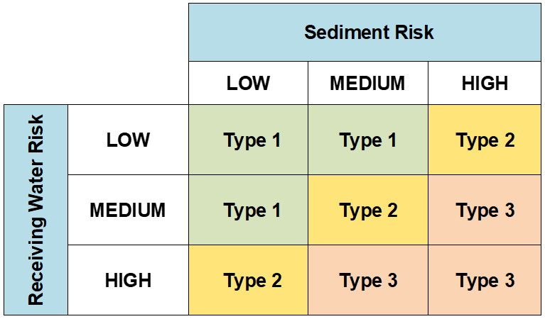

Definition of Terms
Equivalent Condition – Equivalent condition means disturbed soils such as soils from trench excavation required to be hauled away, backfilled into the trench, and/or covered (e.g., metal plates, pavement, plastic covers over spoil piles) at the end of each construction day.
Sediment Sensitive Receiving Water Body – A sediment sensitive receiving water body is defined as a water body segment that is:
- Listed as impaired on California’s 2020-2022 Clean Water Act 303(d) List of Impaired Waters for sedimentation, siltation and/or turbidity; (https://www.waterboards.ca.gov/water_issues/programs/water_quality_assessment/2020_2022_integrated_report.html)
OR
- Designated with beneficial uses of COLD, SPAWN, and MIGRATORY.
Sediment Sensitive Watershed – A sediment sensitive watershed is defined as a watershed draining into a receiving water body (or receiving water body reach):
- Listed as impaired on California’s 2020-2022 Clean Water Act 303(d) List of Impaired Waters for sedimentation, siltation, and/or turbidity; (https://www.waterboards.ca.gov/water_issues/programs/water_quality_assessment/2020_2022_integrated_report.html)>
OR
- Designated with beneficial uses of COLD, SPAWN, and MIGRATORY.

