DRAFT ATTACHMENT I
REQUIREMENTS FOR DISCHARGERS WHO HAVE BEEN GRANTED AN OCEAN PLAN EXCEPTION FOR DISCHARGES TO ASBS
NATIONAL POLLUTANT DISCHARGE ELIMINATION SYSTEM (NPDES)
GENERAL PERMIT FOR STORMWATER DISCHARGES ASSOCIATED
WITH CONSTRUCTION AND LAND DISTURBANCE ACTIVITIES
(GENERAL PERMIT)

Areas of Special Biological Significance (ASBS)
- ASBS are defined in the California Ocean Plan as “those areas designated by the State Water Resources Control Board (State Water Board) as ocean areas requiring protection of species or biological communities to the extent that alteration of natural water quality is undesirable.”
- The California Ocean Plan prohibits the discharge of waste to ASBS.
- The California Ocean Plan authorizes the State Water Board to grant an exception to Ocean Plan provisions where the Board determines that the exception will not compromise protection of ocean waters for beneficial uses and the public interest will be served.
- On March 20, 2012, the State Water Board adopted Resolution 2012-0012 (amended by Resolution 20152012-0033 on May 6, 20150031) which contained a general exception to the California Ocean Plan for discharges of stormwater and non-point sources (ASBS Exception). This resolution also contains the Special Protections that are to be implemented for discharges directly to ASBS. Resolution 2012-0012 is hereby incorporated by reference and construction stormwater dischargers discharging directly to ASBS must comply with its requirements.
- This General Permit requires dischargers who have been granted an Ocean Plan exception for discharges to ASBS to comply with the requirements contained in the Special Protections. These requirements are contained below.

ASBS Non-Stormwater Discharges
- The term “ASBS Non-Stormwater Discharges” means any waste discharges from a municipal separate storm sewer system (MS4) or other NPDES permitted storm drain system to an ASBS that are not comprised entirely of stormwater.
- Only the following ASBS Non-Stormwater Discharges are allowed, provided that the discharges are essential for emergency response purposes, structural stability, slope stability or occur naturally:
  - Discharges associated with emergency firefighting operations.
  - Foundation and footing drains.
  - Water from crawl space or basement pumps.
  - Hillside dewatering.
  - Naturally occurring groundwater seepage via a storm drain.
  - Non-anthropogenic flows from a naturally occurring stream via a culvert or storm drain, as long as there are no contributions of anthropogenic runoff.
- Authorized ASBS Non-Stormwater Discharges shall not cause or contribute to a violation of the water quality objectives in Chapter II of the Ocean Plan nor alter natural ocean water quality in an ASBS.
- At the San Clemente Island ASBS, discharges incidental to military training and research, development, test, and evaluation operations are allowed. Discharges incidental to underwater demolition and other in-water explosions are not allowed in the two military closure areas in the vicinity of Wilson Cove and Castle Rock. Discharges must not result in a violation of the water quality objectives, including the protection of the marine aquatic life beneficial use, anywhere in the ASBS.
- At the San Nicolas Island and Begg Rock ASBS, discharges incidental to military research, development, testing, and evaluation of, and training with, guided missile and other weapons systems, fleet training exercises, small-scale amphibious warfare training, and special warfare training are allowed. Discharges incidental to underwater demolition and other in-water explosions are not allowed. Discharges must not result in a violation of the water quality objectives, including the protection of the marine aquatic life beneficial use, anywhere in the ASBS.

ASBS Compliance Plan
- State Water Board Resolution 2012-0012 grants an exception to the Ocean Plan’s prohibition on discharges to ASBS (ASBS Exception) to applicants who were identified as dischargers of construction stormwater to ASBS (ASBS dischargers). Each ASBS discharger shall specifically address the prohibition of ASBS Non-Stormwater Discharges and the requirement to maintain natural water quality for construction stormwater discharges to an ASBS in an ASBS Compliance Plan to be included in the ASBS discharger’s SWPPP. The ASBS Compliance Plan is subject to approval by the Executive Director of the State Water Board. The ASBS Compliance Plan shall include:
  - A map of surface drainage of stormwater runoff, showing areas of sheet runoff and priority discharges, and a description of any structural Best Management Practices (BMPs) already employed and/or BMPs to be employed in the future. Priority discharges are those that pose the greatest water quality threat, and which are identified as requiring installation of structural BMPs. The map shall also show the stormwater conveyances in relation to other features such as service areas, sewage conveyances and treatment facilities, landslides, areas prone to erosion, and waste and hazardous material storage areas, if applicable. The SWPPP shall also include a procedure for updating the map and plan when changes are made to the stormwater conveyance facilities.
  - A description of the measures by which all unauthorized ASBS Non-Stormwater Discharges (e.g., dry weather flows) has been eliminated, how these measures will be maintained over time, and how these measures are monitored and documented.
  - A description of how pollutant reductions in stormwater runoff, that are necessary to comply with these special conditions, will be achieved through BMPs. Structural BMPs need not be installed if the discharger can document to the satisfaction of the Executive Director that such installation would pose a threat to health or safety. BMPs to control stormwater runoff discharges (at the end-of-pipe) during a design storm shall be designed to achieve on average the following target levels:
    - Table 1 Instantaneous Maximum Water Quality Objectives in Chapter II of the Ocean Plan; or
    - A 90 percent reduction in pollutant loading during storm events, for the applicant’s total discharges.
  - A description of how the ASBS discharger will address erosion and the prevention of anthropogenic sedimentation in the ASBS. The natural habitat conditions in the ASBS shall not be altered as a result of anthropogenic sedimentation.
  - A description of the non-structural BMPs currently employed and planned in the future (including those for construction activities), and an implementation schedule. The ASBS Compliance Plan shall also describe the structural BMPs, including any low impact development measures, currently employed and planned for higher threat discharges and include an implementation schedule. To control stormwater runoff discharges (at the end-of-pipe) during a design storm, ASBS dischargers must first consider using low impact development practices to infiltrate, use, or evapotranspiration stormwater runoff on-site. The BMPs and implementation schedule shall be designed to ensure that natural water quality conditions in the receiving water are achieved and maintained by either reducing flows from impervious surfaces or reducing pollutant loading, or some combination thereof.

Reporting
If the results of the receiving water monitoring described in Section E. below (Sampling and Analysis Requirements) indicate that the stormwater runoff is causing or contributing to an alteration of natural ocean water quality in the ASBS, the ASBS discharger shall submit a report to the State Water Board within 30 days of receiving the results.
- The report shall identify the constituents in stormwater runoff that alter natural ocean water quality and the sources of these constituents.
- The report shall describe BMPs that are currently being implemented, BMPs that are identified in the SWPPP for future implementation, and any additional BMPs that may be added to the SWPPP to address the alteration of natural water quality. The report shall include a new or modified implementation schedule for the BMPs.
- The ASBS discharger shall revise its ASBS Compliance Plan to incorporate any new or modified BMPs that have been or will be implemented, the implementation schedule, and any additional monitoring required within 30 days of the approval of the report by the Executive Director.
- The discharger does not have to repeat the same procedure for continuing or recurring exceedances of natural ocean water quality conditions due to the same constituent when the ASBS discharger is in compliance with the procedures described above and is implementing the revised SWPPP.
- Compliance with this Section does not excuse violations of any term, prohibition, or special condition contained in the Special Protections of the ASBS Exception.

Sampling and Analysis Requirements
- Monitoring is mandatory for all ASBS dischargers to assure compliance with the Ocean Plan. Monitoring requirements include both: (1) Core Discharge Monitoring and (2) Ocean Receiving Water Monitoring (see Sections below). The State Water Board and Regional Water Quality Control Boards (Regional Water Boards) must approve sampling site locations and any adjustments to the monitoring programs. All ocean receiving water and reference area monitoring must be comparable with the Water Boards’ Surface Water Ambient Monitoring Program (SWAMP).
- Sample locations and sampling periods must be determined considering safety issues. Sampling may be postponed upon notifying the State Water Board Executive Director or the appropriate Regional Water Board Executive Officer that hazardous conditions prevail.
- All constituents must be analyzed using the lowest minimum detection limits comparable to the Ocean Plan water quality objectives and in compliance with U.S. EPA sufficiently sensitive method requirements in 40 Code of Federal Regulations Part 136. All samples being analyzed for metals (including stormwater effluent, reference samples, and ocean receiving water samples) must use an approved analytical method with the lowest minimum detection limits (currently Inductively Coupled Plasma/Mass Spectrometry) described in the Ocean Plan.

Core Discharge Monitoring Program
- General sampling requirements for timing and storm size:
Runoff must be collected during a storm event that is greater than 0.1 inch and generates runoff, and at least 72 hours from the previously measurable storm event. Runoff samples shall be collected during the same storm and approximately at the same time as the post-storm receiving water and reference site samples being analyzed for the same constituents as described in Section G below.
- Runoff samples – storm events
  - For outfalls1 equal to or greater than 18 inches (0.46m) in diameter or width:
    - Samples of stormwater runoff shall be collected during the same storm as receiving water samples and analyzed for oil and grease, total suspended solids, and, if within the range of the southern sea otter, indicator bacteria or some other measure of fecal contamination; and
    - Samples of stormwater runoff shall be collected and analyzed for critical life stage chronic toxicity (one invertebrate or algal species) at least once during each storm season when receiving water is sampled in the ASBS.
  - For outfalls equal to or greater than 36 inches (0.91m) in diameter or width:
    - Samples of stormwater runoff shall be collected during the same storm as receiving water samples and analyzed for turbidity, pH, and, if within the range of the southern sea otter, indicator bacteria or some other measure of fecal contamination; and
    - Samples of stormwater runoff shall be further collected during the same storm as receiving water samples and analyzed for Ocean Plan Table 1 metals (provided at the end of this Attachment) for protection of marine life, Ocean Plan polynuclear aromatic hydrocarbons (PAHs), currently used pesticides (pyrethroids and organophosphate pesticides), and nutrients (ammonia, nitrate and phosphates); and
    - Samples of stormwater runoff shall be collected and analyzed for critical life stage chronic toxicity (one invertebrate or algal species) at least once during each storm season when receiving water is sampled in the ASBS.
    - If an ASBS discharger has no outfall greater than 36 inches, then stormwater runoff from the discharger’s largest outfall shall be further collected during the same storm as receiving water samples and analyzed for Ocean Plan Table 1 metals (provided at the end of this Attachment) for protection of marine life, Ocean Plan polynuclear aromatic hydrocarbons (PAHs), current use pesticides (pyrethroids and organophosphate pesticides), and nutrients (ammonia, nitrate and phosphates).
  - For a discharger applicant not participating in a regional integrated monitoring program (see below in Section G.3). in addition to the sampling requirements in Section F.2.a. and b. above, a minimum of the two largest outfalls or 20 percent of the larger outfalls, whichever is greater, shall be sampled (flow weighted composite samples) at least three times annually during wet weather (storm event) and analyzed for all Ocean Plan Table 2 constituents, Table 1 constituents (Table 1 and 2 constituents are provided at the end of this Attachment) for marine aquatic life protection (except for toxicity, only chronic toxicity for three species shall be required), DDT, PCBs, Ocean Plan PAHs, organophosphate pesticides, pyrethroids, nitrates, phosphates, and Ocean Plan indicator bacteria. For parties discharging to ASBS in more than one Regional Water Board region, at a minimum, one (the largest) such discharge shall be sampled annually in each region.
  - The Executive Director may reduce or suspend core monitoring once the storm runoff is fully characterized. This determination may be made at any point after the discharge is fully characterized but is best made after the monitoring results from the first permit cycle are assessed.

Ocean Receiving Water and Reference Area Monitoring Program
- All ASBS dischargers must perform ocean receiving water monitoring in addition to performing the Core Discharge Monitoring Program in Section F. above. ASBS dischargers may choose either (1) an individual monitoring program, or (2) participation in a regional integrated monitoring program to fulfill the requirements for monitoring the physical, chemical, and biological characteristics of the ocean receiving waters within their ASBS.
- Individual Monitoring Program
  - The requirements listed below are for those ASBS dischargers who elect to perform an individual monitoring program to fulfill the requirements for monitoring the physical, chemical, and biological characteristics of the ocean receiving waters within the affected ASBS. In addition to Core Discharge Monitoring, the following additional monitoring requirements shall be met:
    - The receiving water at the point of discharge from the outfalls described in Section F.2. above shall be: sampled three times annually during wet weather (storm events); analyzed for Ocean Plan Table 1 constituents and Table 2 constituents (Table 1 and 2 constituents are provided at the end if this Attachment) for marine aquatic life, DDT, PCBs, Ocean Plan PAHs, organophosphate pesticides, pyrethroids, nitrates, phosphates, salinity, chronic toxicity (three species), and Ocean Plan indicator bacteria.
    - The sample location for the ocean receiving water shall be in the surf zone at the point of discharges; this must be at the same location where stormwater runoff is sampled. Receiving water shall be sampled prior to (pre-storm), and during (or immediately after) the same storm (post-storm). Post-storm sampling shall be representative of the same storm and at approximately the same time as when the runoff is sampled. Reference water quality shall also be sampled three times annually and analyzed for the same constituents as the pre-storm and post-storm sampling, during the same storm seasons when receiving water is sampled. Reference stations will be determined by the State Water Board’s Division of Water Quality and the applicable Regional Water Board(s).
    - The sediment sampling shall occur at least three times during every five-year period. The subtidal sediment (sand or finer, if present) at the discharge shall be sampled and analyzed for Ocean Plan Table 1 constituents (provided at the end of this Attachment) for marine aquatic life, DDT, PCBs, PAHs, pyrethroids, and organophosphate pesticides. Only an acute toxicity test using the amphipod Eohaustorius estuarius must be performed for sediment toxicity testing.
    - A quantitative survey of intertidal benthic marine life shall be performed at the discharge and reference site(s). The survey shall be performed at least once during every five-year period. The survey design is subject to approval by the Regional Water Board and the State Water Board’s Division of Water Quality. The results of the survey shall be completed and submitted to the State Water Board and Regional Water Board at least six months prior to the end of the permit cycle.
    - A bioaccumulation study shall be conducted to determine the concentrations of metals and synthetic organic pollutants at representative discharge and reference sites once during each five-year period. The study design is subject to approval by the Regional Water Board and the State Water Board’s Division of Water Quality. The bioaccumulation study may include California mussels (Mytilus californianus) and/or sand crabs (Emerita analoga or Blepharipoda occidentalis). Based on the study results, the Regional Water Board and the State Water Board’s Division of Water Quality, may adjust the study design in subsequent permits, or add or modify additional test organisms (such as shore crabs or fish), or modify the study design appropriate for the area and best available sensitive measures of contaminant exposure.
    - Representative quantitative observations for debris/trash by type and source shall be performed along the coast of the ASBS within the influence of the ASBS discharger’s outfall(s). The design, including locations and frequency, of the trash/debris observations is subject to approval by the Regional Water Board and State Water Board’s Division of Water Quality.
    - The monitoring requirements of this Section’s Individual Monitoring Program are minimum requirements. After a minimum of one year of continuous water quality monitoring of the discharges and ocean receiving waters, the Executive Director of the State Water Board may require additional monitoring, or adjust, reduce or suspend receiving water and reference station monitoring. This determination may be made at any point after the discharge and receiving water is fully characterized but is best made after the monitoring results from the first permit cycle are assessed.
- Regional Integrated Monitoring Program
  - An ASBS discharger may elect to participate in a regional integrated monitoring program, in lieu of an individual monitoring program, to fulfill the requirements for monitoring the physical, chemical, and biological characteristics of the ocean receiving waters within their ASBS. This regional approach shall characterize natural water quality, pre- and post-storm, in-ocean reference areas near the mouths of identified open space watersheds and the effects of the discharges on natural water quality (physical, chemical, and toxicity) in the ASBS receiving waters, and should include benthic marine aquatic life and bioaccumulation components. The design of the ASBS stratum of a regional integrated monitoring program may deviate from the otherwise prescribed individual monitoring approach (in Section G.2.) if approved by the State Water Board’s Division of Water Quality and the Regional Water Board(s).
  - Ocean reference areas shall be located at the drainages of flowing watersheds with minimal development (in no instance more than 10 percent development) and shall not be located in Clean Water Act Section 303(d) listed waterbodies or have tributaries that are 303(d) listed. Reference areas shall be free of wastewater discharges and anthropogenic non-stormwater runoff. A minimum of low threat stormwater runoff discharges (e.g., stream highway overpasses and campgrounds) may be approved by the Regional Water Board and the State Water Board’s Division of Water Quality on a case-by-case basis. Reference areas shall be located in the same region as where the ASBS receiving water monitoring occurs. The reference areas for each Region are subject to approval by the participants in the regional integrated monitoring program, the State Water Board’s Division of Water Quality and the applicable Regional Water Board(s). A minimum of three ocean reference water samples must be collected from each station, each from a separate storm during the same storm season that receiving water is sampled. A minimum of one reference location shall be sampled for each ASBS receiving water site sampled per responsible party. For parties discharging to ASBS in more than one Regional Water Board region, at a minimum, one reference station and one receiving water station shall be sampled in each region.
  - ASBS ocean receiving water must be sampled in the surf zone at the location where the runoff makes contact with ocean water (i.e. at “point zero”). Ocean receiving water stations must be representative of worst-case discharge conditions (i.e. co-located at a large drain greater than 36 inches, or if drains greater than 36 inches are not present in the ASBS then the largest drain greater than18 inches.) Ocean receiving water stations are subject to approval by the participants in the regional monitoring program and the State Water Board’s Division of Water Quality and the applicable Regional Water Board(s). A minimum of three ocean receiving water samples must be collected during each storm season from each station, each from a separate storm. A minimum of one receiving water location shall be sampled in each ASBS per responsible party in that ASBS. For parties discharging to ASBS in more than one Regional Water Board region, at a minimum, one reference station and one receiving water station shall be sampled in each region.
  - Reference and receiving water sampling shall commence during the first full storm season following the adoption of these special conditions, and post-storm samples shall be collected during the same storm event when stormwater runoff is sampled. Sampling shall occur in a minimum of two storm seasons. Sampling may be limited to only one storm season for ASBS dischargers that have already participated in the Southern California Bight 2008 ASBS regional monitoring effort.
  - Receiving water and reference samples shall be analyzed for the same constituents as stormwater runoff samples. At a minimum, constituents to be sampled and analyzed in reference and discharge receiving waters must include turbidity, pH, Ocean Plan Table 1 metals (provided at the end of this Attachment) for protection of marine life, Ocean Plan PAHs, pyrethroids, organophosphate pesticides, ammonia, nitrate, phosphates, and critical life stage chronic toxicity for three species. In addition, within the range of the southern sea otter, indicator bacteria or some other measure of fecal contamination shall be analyzed.

Special Protection Section E.6 Flowchart to Determine Compliance with Natural Water Quality
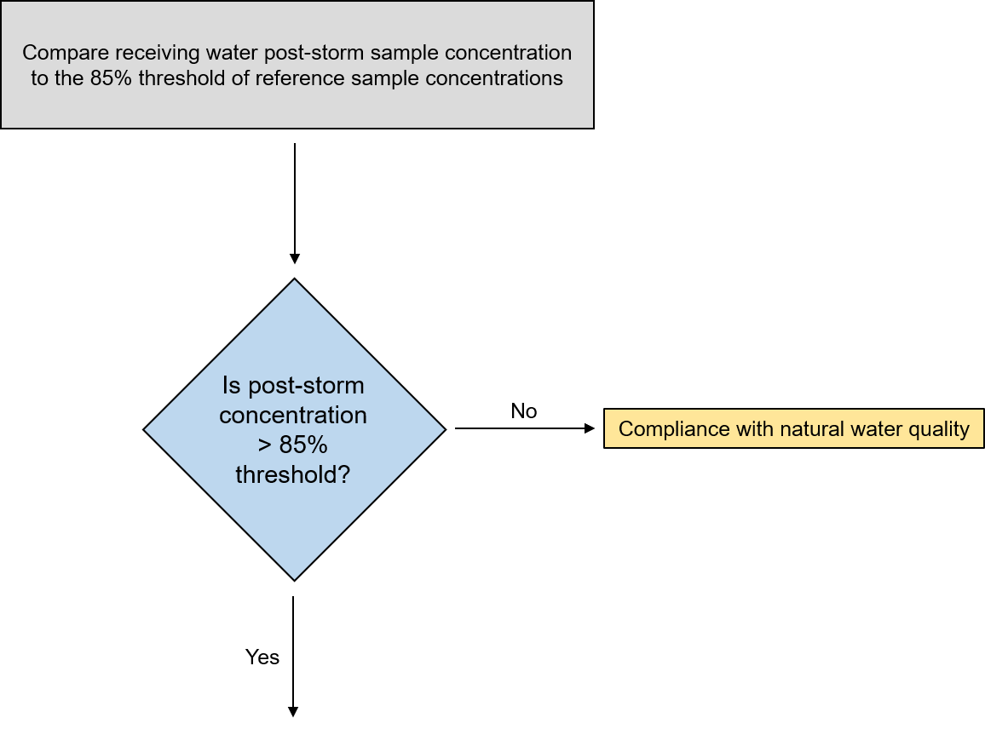
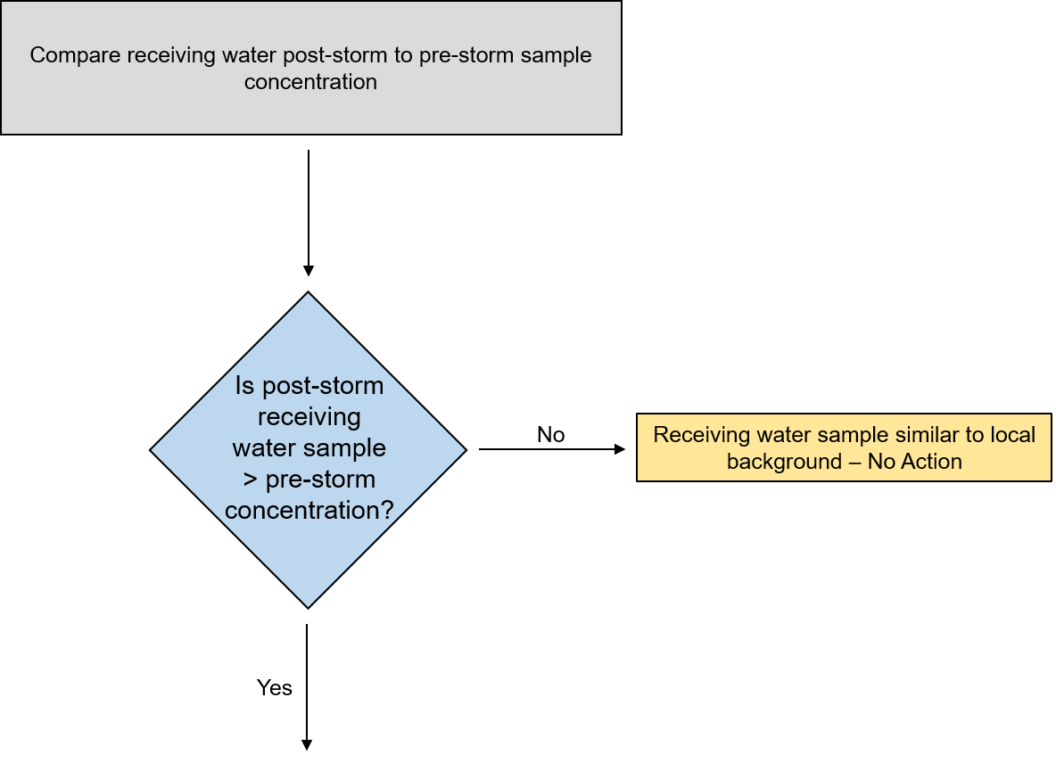
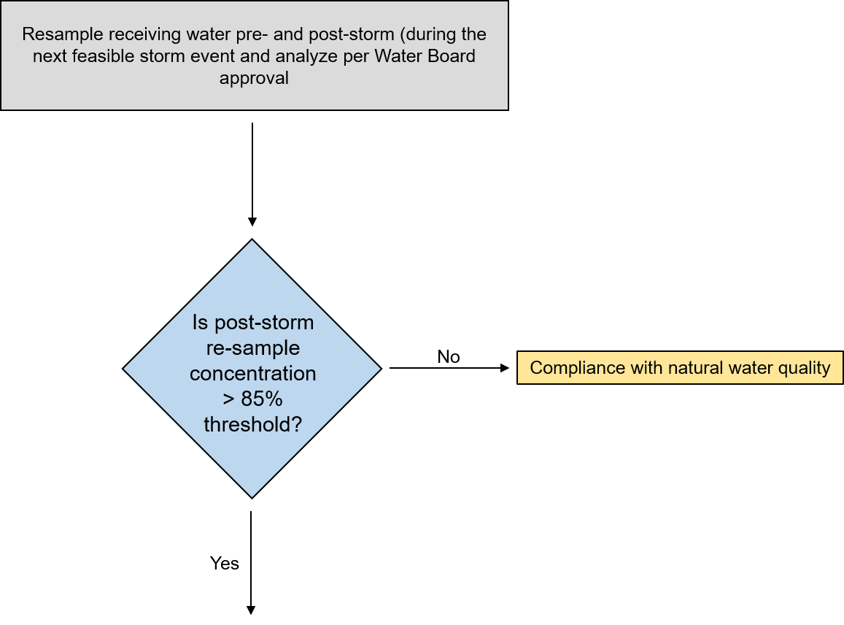
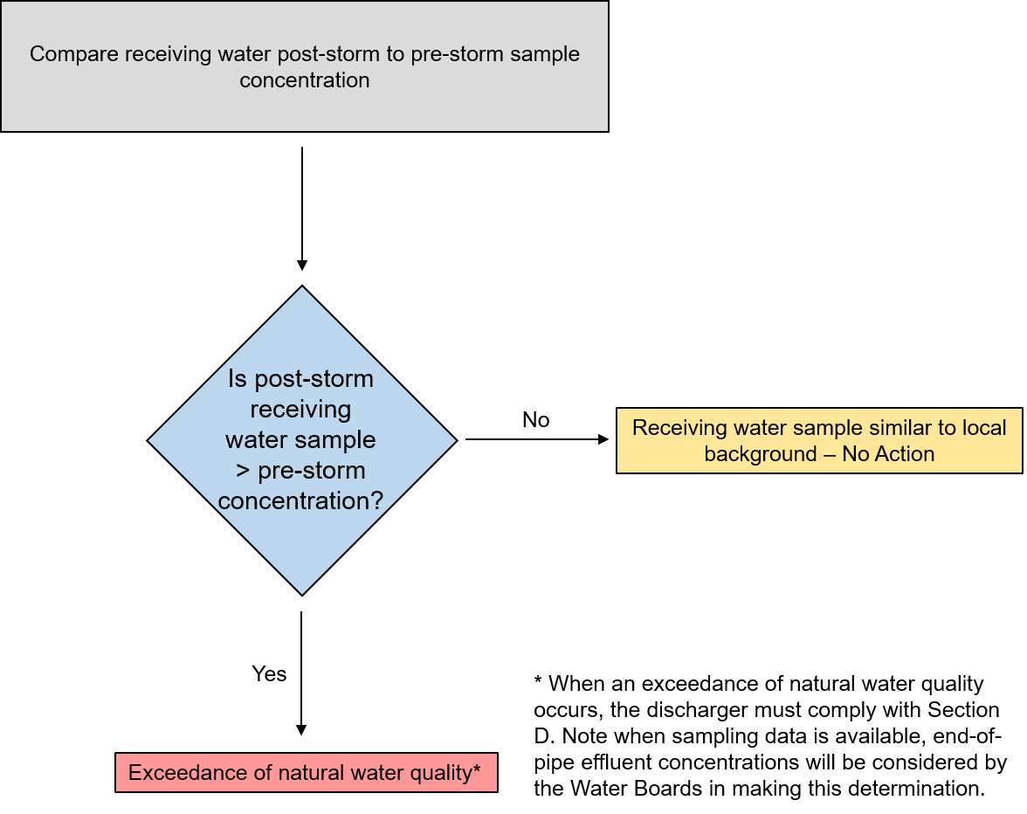
Table 1 - Monitoring Constituent List
(Excerpted from California Ocean Plan dated 2015)
Constituent | Units
Arsenic | µg/L
Cadmium | µg/L
Chromium (Hexavalent) | µg/L
Copper | µg/L
Lead | µg/L
Mercury | µg/L
Nickel | µg/L
Selenium | µg/L
Silver | µg/L
Zinc | µg/L
Cyanide | µg/L
Total Chlorine Residual | µg/L
Ammonia (as N) | µg/L
Acute Toxicity | TUa
Chronic Toxicity | TUc
Phenolic Compounds  (non-chlorinated) | µg/L
Chlorinated Phenolics | µg/L
Endosulfan | µg/L
Endrin | µg/L
Hexachlorocyclohexane | µg/L
Radioactivity
Table 2 - Monitoring Constituent List
(excerpted from California Ocean Plan dated 2015)
Constituent | Units
Grease and Oil | mg/L
Suspended Solids | mg/L
Settleable Solids | mL/L
Turbidity | NTU
pH

1 Outfalls mean a discharge location, including, but not limited to pipes, ditches, swales, and other points of concentrated flow.

