Compliance Plan for
Areas of Special Biological Significance
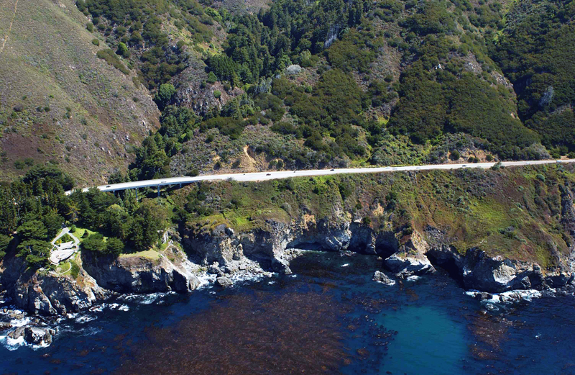
Prepared for:
California Department of Transportation
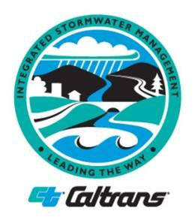

February 26, 2025

CTSW-RT-23-438-01.03

NOTICE

This document has been checked for ADA compliance using built in checkers in Microsoft Word and Adobe Acrobat Pro. For individuals with sensory disabilities, this document is available in alternate formats upon request. Please call or write to:

Stormwater Liaison
California Department of Transportation, Division of Environmental Analysis
PO Box 942874, MS-27
Sacramento, CA 94274-0001

(916) 956-6187 Voice, or dial 711 to use a relay service.

Certification

I certify under penalty of law that this document and all attachments were prepared under my direction or supervision in accordance with a system designed to assure that qualified personnel properly gather and evaluate the information submitted. Based on my inquiry of the person or persons who manage the system, or those persons directly responsible for gathering the information, the information submitted is, to the best of my knowledge and belief, true, accurate, and complete. I am aware that there are significant penalties for submitting false information, including the possibility of fine and imprisonment for knowing violations. [40 CFR § 122.22(d)]

Hardeep Takhar, Chief Environmental Engineer Date
Division of Environmental Analysis
California Department of Transportation

Table of Contents
1. Overview 1-1
1.1. Purpose of the Compliance Plan 1-1
1.2. Background 1-1
1.3. Maps of ASBS Discharge Locations (Permit Section C4 Item 2) 1-3
1.4. Regional Monitoring Groups 1-5
2. Non-Authorized Non-Stormwater Discharges (Permit Section C4 Item 4) 2-1
2.1. Non-Authorized Non-Stormwater Discharge Elimination (Permit Section C4 Item 4) 2-1
3. Inspection Frequencies (Permit Section C4 Item 5) 3-1
4. Erosion and Sediment Control (Permit Section C4 Item 7) 4-1
4.1. Maintenance Activities (Permit Section C4 Item 7) 4-1
5. Non-Structural Best Management Practices (Permit Section C4 Item 8) 5-1
5.1. Currently Employed Procedures (Permit Section C4 Item 8) 5-1
5.2. BMPs for Future Consideration (Permit Section C4 Item 8) 5-4
6. ASBS Compliance Strategy (Permit Section C4 Item 10) 6-1
6.1. Key Terms and Relationships 6-1
6.2. Implementation Strategies (Permit Section C4 Item 10) 6-1
6.3. Enhanced BMP Siting and Selection at Impacted ASBS (Permit Section C4 Item 1) 6-2
7. Corrective Action Plan (Permit Section C4 Items 6, 10) 7-1
7.1. ASBS 8, Redwoods National Park (Permit Section C4 Items 6, 10) 7-3
7.2. ASBS 9, James V. Fitzgerald (Permit Section C4 Items 6, 10) 7-4
7.3. ASBS 15, Año Nuevo (Permit Section C4 Items 6, 10) 7-5
7.4. ASBS 34, Carmel Bay (Permit Section C4 Items 6, 10) 7-6
7.5. ASBS 24, Laguna Point to Latigo Point (Permit Section C4 Items 6, 10) 7-8
7.6. Cooperative Agreements 7-11
8. Implementation Schedule (Permit Section C4 Items 3, 9) 8-1
8.1. Environmental Planning Process 8-3
9. Adaptive Management (Permit Section C4 Item 11) 9-1
9.1. Open-Graded Friction Course (Permit Section C4 Item 11) 9-1
9.2. Pervious Asphalt Pavement (Permit Section C4 Item 11) 9-1
9.3. Alternative Media (Permit Section C4 Item 11) 9-2
10. Bibliography 10-1

Tables and Figures
Table 1. Storm Events Sampled at Receiving Water Sites 1-3
Table 2. Summary of ASBS Locations 1-4
Table 3. Areas of Special Biological Significance with Exceedances 6-2
Table 4. Caltrans Coupled Outfall Locations Associated with the Ocean Receiving Water Sites 6-3
Table 5. ASBS 8 Coupled Outfall and Receiving Water Demonstration of Compliance Strategy 7-4
Table 6. ASBS 9 Coupled Outfall and Receiving Water Demonstration of Compliance Strategy 7-5
Table 7. ASBS 15 Coupled Outfall and Receiving Water Demonstration of Compliance Strategy 7-6
Table 8. ASBS 34 Coupled Outfall and Receiving Water Demonstration of Compliance Strategy 7-8
Table 9. ASBS 24 Coupled Outfall and Receiving Water Demonstration of Compliance Strategy 7-9
Table 10. Implementation Schedule 8-2
Table A-1. ASBS Priority Discharge Locations (Caltrans Permit, Table C-1) A-1
Figure A-1. RED028 A-2
Figure A-2. FIT012 A-3
Figure A-3. ANO033 A-4
Figure A-4. CAR007B A-5
Figure A-5. MUG010 A-6
Table B-1. Slopes Prone to Erosion FY23 B-1
Figure C-1. SITE ID 1-322 (ASBS 8) C-2
Figure C-2. SITE ID 4-341 (ASBS 9) C-3
Figure C-3. SITE ID 4-345 (ASBS 15) C-4
Figure C-4. SITE ID 5-304 (ASBS 34) C-5
Figure C-5. SITE ID 7-345 (ASBS 24) C-6
Table D-1. Treatment and Institutional BMPs D-1
Figure D-1. Schematic of a Design Pollution Prevention Infiltration Area D-2
Figure D-2. Schematic of a Design Pollution Prevention Infiltration Area D-3
Figure D-3. Schematic of an Infiltration Basin D-5
Figure D-4. Schematic of an Infiltration Trench D-6
Figure D-5. Caltrans Media Filters (Austin Sand Filter [left], Delaware Sand Filter [right]) D-7
Figure D-6. Schematic of an Austin Sand Filter—Full Sedimentation (Earthen Type) D-8
Figure D-7. Schematic of an Austin Sand Filter—Partial Sedimentation (Earthen Type) D-9
Figure D-8. Schematic of a Delaware Sand Filter D-10
Figure D-8. Schematic of a Delaware Sand Filter (Continued) D-11
Figure E-1. Before 5/22/19 E-7
Figure E-2. Before 5/22/19 E-8
Figure E-3. Before 5/22/19 E-9
Figure E-4. Before 5/22/19 E-10
Figure E-5. Before 2/19/21 E-11
Figure E-6. Before 2/19/21 E-12
Figure E-7. After 12/09/21 E-13
Figure E-8. After 12/09/21 E-14
Figure E-9. After 12/09/21 E-15
Figure E-10. After 12/09/21 E-16
Figure E-11. After 12/09/21 E-17
Figure G-1. Typical Section of a Rock Lined Design Pollution Prevention Infiltration Area G-2
Figure G-2. Typical Section of an Embankment Design Pollution Prevention Infiltration Area G-2
Table G-1. Low-impact Development BMP Options in the Storm Water Management Model G-3
Figure G-3. The Storm Water Management Model Representation of Design Pollution Prevention Infiltration Areas G-3
Table G-2. Hypothetical Storm Water Management Model Results of Interest G-4
Table G-3. Hypothetical Demonstration of Compliance G-4
Appendices
Appendix A: ASBS Locations (Permit Section C4 Item 1)
Appendix B: Erosion-Prone Areas
Appendix C: Preliminary BMP Feasibility Studies
Appendix D: Best Management Practices to Control Stormwater Runoff (Permit Section C4 Items 9, 11)
Appendix E: BMPs Installed or Proposed in ASBS Areas (Permit Section C4 Item 2)
Appendix F: Applicability of the Ocean Plan to Inland Discharges
Appendix G: ASBS Demonstration of Compliance (Permit Section C4 Item 10)

Overview

Purpose of the Compliance Plan
The California Department of Transportation (Caltrans) Compliance Plan for Areas of Special Biological Significance (ASBS Compliance Plan or “Plan”) describes Caltrans’ strategy to comply with Provision C4 of the National Pollutant Discharge Elimination System (NPDES) Statewide Stormwater Permit and Waste Discharge Requirements for State of California Department of Transportation, Order 2022-0033-DWQ, NPDES No. CAS000003 (Caltrans NPDES Permit or “Permit”) issued by the California State Water Resources Control Board (SWRCB) (SWRCB, 2022).
The Plan describes how Caltrans proposes to comply with the ASBS-related Permit requirements based on the analysis of existing water quality monitoring data. It includes proposed structural and non-structural treatment controls to address pollutant discharge concentrations observed in monitoring data, and a corresponding implementation schedule.
The Plan is a revision based on additional water quality data collected to characterize discharges and determine appropriate controls necessary to achieve Natural Water Quality in the ASBS.

Background

Regulatory Background
The California Ocean Plan–Water Quality Control Plan, Ocean Waters of California (Ocean Plan) was first adopted in 1972 by the SWRCB (SWRCB, 2019). It establishes water quality objectives for California’s ocean waters and provides the basis for regulation of wastes discharged into the state’s coastal waters. It prohibits waste discharges, including trash, into these coastal areas and states that discharges composed of stormwater runoff will not alter Natural Water Quality in an ASBS. Since 1983, the Ocean Plan has prohibited the discharge of both point and nonpoint source discharges of waste to ASBS, unless the SWRCB grants an exception.
On October 18, 2004, the SWRCB notified a number of parties that they must cease the discharge of stormwater and nonpoint source waste into ASBS or request an exception to the prohibition. Of these parties, 27, including Caltrans, submitted applications to the SWRCB for an exception. In April 2012, the SWRCB approved State Water Resources Control Board Resolution No. 2012-0012, Approving Exceptions to the California Ocean Plan for Selected Discharges into Areas of Special Biological Significance, including Special Protections for Beneficial Uses, and Certifying a Program Environmental Impact Report (SWRCB, 2012), hereinafter referred to as Special Protections (as amended by State Water Resources Control Board Resolution No. 2012-0031 on June 19, 2012). This resolution adopted the general exception to the Ocean Plan prohibition against waste discharges to ASBS for discharges of stormwater and nonpoint source waste. Approved applicants are required to comply with the provisions in the general exception. Caltrans applied for an exception, which was granted by the SWRCB. Under the exception, Caltrans is allowed to discharge to ASBS if such discharges are deemed conditionally exempt stormwater or non-stormwater discharges. A list of all the applicants is in Attachment A of the Special Protections. The main provisions for compliance with the general exception are contained in Attachment B of Special Protections.
Conditionally exempt stormwater discharges are those from existing stormwater outfalls (constructed or under construction prior to January 1, 2005), provided the discharges are essential for flood control or slope stability, are designed to prevent soil erosion, occur only during wet weather, and are composed of only stormwater runoff. Any proposed or new stormwater runoff discharge will be routed to existing storm water discharge outfalls and will not result in any new contribution of waste to an ASBS (i.e., no additional pollutant loading beyond what would have occurred as of January 1, 2005). A change to an existing stormwater outfall, in terms of relocation or alteration, to comply with these special conditions is allowed and does not constitute a new discharge.
Conditionally exempt non-stormwater discharges include discharges from emergency firefighting operations, foundation drains, hillside dewatering, and groundwater seepage and other naturally occurring flows that enter storm drains. Additionally, non-stormwater discharges from utility vaults and underground structures are conditionally exempt provided they are in compliance with the General NPDES Permit for Discharges from Utility Vaults and Underground Structures to Surface Water, NPDES CAG990002, and are deemed not to alter natural ocean water quality or cause or contribute to an exceedance of a water quality objective.
Additional non-stormwater discharges from Caltrans’ facilities with a direct discharge to an ASBS are allowed only to the extent the relevant Regional Water Quality Control Board finds that the discharge does not alter natural ocean water quality in the ASBS. The Ocean Plan allows the SWRCB to grant exceptions to this prohibition, provided the exception will not compromise protection of ocean waters for beneficial uses and the public interest will be served.
The Caltrans NPDES Permit contains requirements for the control of conditionally exempt discharges from Caltrans’ municipal separate storm sewer system (MS4). The 2012 Caltrans NPDES Permit identified representative monitoring locations where the Department has priority discharges to ASBS. Priority discharges are those that pose the greatest threat to water quality in the ASBS and which the State Water Board identifies to require monitoring and potential installation of structural or nonstructural controls. Caltrans discharges stormwater into ten ASBS. Note that only seven of the ten Caltrans ASBS contain priority discharge locations that represent sites having significant potential to impact the ASBS. Caltrans was not required to monitor in the other three ASBS because there are no priority discharges in those ASBS.
All ten ASBS are listed below, and the seven with priority discharge locations are indicated with an asterisk:
- Redwood National Park ASBS*
- Saunders Reef ASBS*
- James V. Fitzgerald ASBS*
- Año Nuevo ASBS*
- Carmel Bay ASBS*
- Point Lobos ASBS
- Julia Pfeiffer Burns ASBS
- Salmon Creek Coast ASBS
- Laguna Point to Latigo Point ASBS*
- Irvine Coast ASBS*
The Permit requires the Department to submit an ASBS Compliance Plan to the State Water Board Executive Director for approval within 12 months after the adoption date of the Permit.

2016 Compliance Plan
Caltrans submitted a Draft ASBS Compliance Plan in September 2013, as adequate monitoring data could not be collected due to prevailing drought conditions. In a letter dated June 25, 2013, Caltrans requested an extension of the ASBS Compliance Plan submittal date until September 20, 2015. The SWRCB granted the extension. In subsequent discussions, Caltrans requested further extension of the submittal date to 2016 because of incomplete characterization monitoring due to drought conditions. During discussions in July 2015, the SWRCB agreed to allow Caltrans to submit an Amended Final ASBS Compliance Plan after characterization of discharges were completed.
Caltrans submitted an Amended Final ASBS Compliance Plan on September 20, 2016. The amended ASBS Compliance Plan was based on the results of runoff and receiving water monitoring during the 2012–2013 through the 2015–2016 wet seasons. The 2014–2015 wet season was a very dry year, with some ASBS monitoring locations receiving no measurable runoff.

From 2016 Compliance Plan to 2023
With the exception of ASBS 24, characterization monitoring of all ASBS was completed in the 2016–2017 wet season as sufficient monitoring data had been collected. Characterization monitoring of ASBS 24 was completed in the 2019–2020 wet season. Per Section A4.5.2.a.ii of the Caltrans Permit, the Department has fulfilled its obligations and no additional monitoring is needed.
The minimum number of storm events have been captured at all ASBS. Table 1 presents the number of storm events sampled in each ASBS.

Table 1. Storm Events Sampled at Receiving Water Sites
ASBS Name | Total | Sampling Completed
ASBS 5, Saunders Reef | 9 | 12/7/2016
ASBS 8, Redwood National Park | 6 | 1/18/2017
ASBS 9, Fitzgerald: Ocean Receiving Water Site | 9 | 4/6/2017
ASBS 15, Año Nuevo: Ocean Receiving Water Site | 8 | 1/18/2017
ASBS 34, Carmel Bay | 6 | 4/7/2017
ASBS 24, Laguna Point to Latigo Point | 15 | 4/5/2020
ASBS 33, Irvine Coast: Ocean Receiving Water Site | 15 | 1/9/2017

Maps of ASBS Discharge Locations (Permit Section C4 Item 2)
Attachment III of the 2012 Caltrans NPDES Statewide Stormwater Permit identifies 77 Priority Discharge Locations that are located within seven Caltrans ASBS. Table 2 contains a summary description of the ASBS and preliminary estimate of drainage area and discharge locations identified in each ASBS. In accordance with provision E.5.b of the 2012 Permit, alternative locations may be authorized by the SWRCB where access limitations or safety considerations make it infeasible to conduct monitoring (SWRCB, 2012, 2014, 2017). During the period of the ASBS monitoring program, several discharge locations were substituted in consultation with the SWRCB. Table A-1 (Appendix A of this document) summarizes the locations identified in Attachment III of the 2012 Caltrans NPDES Statewide Stormwater Permit. Maps of discharge locations within these ASBS areas are also provided in Appendix A. Each map shows surface drainage of stormwater runoff, sheet runoff, priority discharge locations and their tributary areas, structural best management practices (BMPs) currently employed, and potential future treatment areas.

Table 2. Summary of ASBS Locations
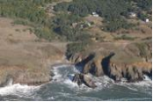 | ASBS 5: Saunders Reef  This small ASBS encompasses both rural and urban watersheds, with numerous seepages and earthen channels from bluff houses lining the coast.  - Estimated drainage area from 1.1 miles of US-101  - 10 priority discharges identified
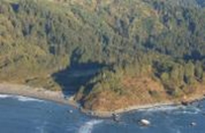 | ASBS 8: Redwoods National Park  Rugged cliffs and sparse primitive campgrounds dominate this region, and much of the coastline is limited to foot traffic.  - Estimated drainage area from 10.6 miles of US-101  - 7 priority discharges identified
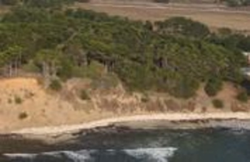 | ASBS 9: James V. Fitzgerald  This ASBS consists of a unique underwater habitat and extensive tide pools, surrounded by an array of land uses.  - Estimated drainage area from 2.5 miles of SR-1  - 1 priority discharge identified
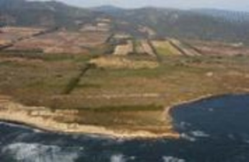 | ASBS 15: Año Nuevo  The coastline provides a unique habitat for wintering sea lions and elephant seals. Access to beaches is limited, and most visitors to the park are confined to marked footpaths.  - Estimated drainage area from 3.0 miles of SR-1  - 5 priority discharges identified
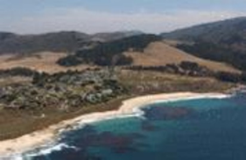 | ASBS 34: Carmel Bay  This ASBS encompasses the City of Carmel with the southern boundary occurring at the Carmel River mouth. The Pebble Beach Golf Course and the popular Carmel Beach are also located within the boundaries of this ASBS.  - Estimated drainage area from 4.5 miles of SR-1  - 2 priority discharges identified
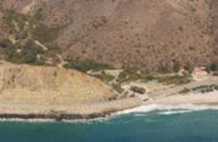 | ASBS 24: Laguna Point to Latigo Point  The largest of the mainland ASBS, this location contains extensive bluffs, and private property on bluffs and beaches.  - Estimated drainage area from 24 miles of SR-1  - 47 priority discharges identified
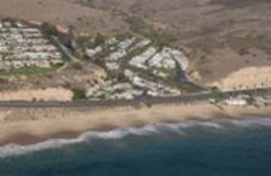 | ASBS 33: Irvine Coast  This ASBS is largely classified as an urban watershed. Additional inputs include parking lots and walkways within the park, and from the development upstream.  - Estimated drainage area from 3.0 miles of SR-1  - 5 priority discharge identified

Discharges causing or contributing to alterations of natural ocean water quality were located in five of the seven Caltrans ASBS, listed in Table C-1 of the 2022 Caltrans NPDES Permit.

Regional Monitoring Groups
Three regional monitoring groups for ASBS monitoring were set up with stakeholder and SWRCB coordination: (1) Northern California regional monitoring group, (2) Central Coast regional monitoring group, and (3) Southern California regional monitoring group. The ASBS with Caltrans discharges categorized by regional monitoring groups are listed below:
- Northern California regional monitoring group: ASBS 05, ASBS 08
- Central Coast regional monitoring group: ASBS 09, ASBS 15, ASBS 34
- Southern California regional monitoring group: ASBS 24, ASBS 33
Caltrans entered into data sharing agreements with each of the regional monitoring groups. Under these agreements, Caltrans provided the results of its Ocean Receiving Water monitoring. Caltrans did not receive Ocean Receiving Water data from the other dischargers or the Ocean Reference Area data collected by others. Caltrans received the natural water quality values developed by the regional groups that are based on an analysis of the Ocean Reference Area data.

Non-Authorized Non-Stormwater Discharges
The Caltrans NPDES Permit prohibits the discharge of non-authorized non-stormwater discharges. The Permit authorizes non-stormwater discharges from certain categories of discharges not composed entirely of stormwater but that do not pose a threat to water quality. In some cases, the discharges may require the implementation of BMPs. Requirements or exemptions of separate NPDES permits are not addressed in this plan.
The following non-stormwater discharges are allowed under the general exception if they are essential for emergency response purposes, structural stability, or slope stability, or if they occur naturally:
- Discharges or flows from emergency firefighting activities;
- Foundation and footing drains;
- Water from crawl space or basement pumps;
- Hillside dewatering;
- Naturally occurring groundwater seepage via a storm drain; and
- Non-anthropogenic flows from a naturally occurring stream via a culvert or storm drain, provided there are no contributions of anthropogenic runoff.
Additional non-stormwater discharges to a segment of the Caltrans MS4 with a direct discharge to an ASBS are allowed only to the extent the relevant Regional Water Quality Control Board finds that the discharge does not alter natural ocean water quality in the ASBS.

Non-Authorized Non-Stormwater Discharge Elimination (Permit Section C4 Item 4)
The Permit requires that the ASBS Compliance Plan describe measures Caltrans will use to eliminate all non-authorized non-stormwater discharges. Caltrans developed the Illicit Connection/Illegal Discharge and Illegal Dumping Response Plan (Caltrans, 2013) as required by the Permit. Currently, there are no non-authorized non-stormwater discharges from Caltrans facilities or activities. Caltrans continues efforts to eliminate non-authorized non-stormwater discharges by prevention, identification, and correction of the source of the non-stormwater discharge. Maintenance Supervisors will report non-stormwater discharges to their District Maintenance Stormwater Coordinators. The District Maintenance Stormwater Coordinators will coordinate the reporting of prohibited non-stormwater discharges to the Regional Water Quality Control Boards through the District Stormwater Coordinator, using the Incident Report Form (Attachment G of the Permit). Additional details on the Illicit Connection/Illegal Discharge response plan are located in Section 5.1.5.
Dry weather flow that is the result of groundwater baseflow is not a prohibited discharge. However, to avoid inundating downstream BMPs, Caltrans will consider segregating dry weather flows as identified in the individual ASBS responses described in Section 7.

Inspection Frequencies
To ensure trash and other anthropogenic debris are removed, Caltrans will inspect all stormwater outfall drains equal to or greater than 18 inches (457 mm) in diameter or width within ASBS at the following frequency:
- Once before the beginning of the rainy season; and
- Once during the rainy season.
Inspections and cleaning will be conducted in accordance with the Caltrans Statewide Stormwater Management Plan Section 8.2.8: Baseline Stormwater Drainage Facilities Inspection and Cleaning Program. This section specifies that a drainage inlet or catch basin will have all waste removed when it has accumulated to a depth of 50 percent. This does not preclude a supervisor’s judgment to clean with less accumulated material present (Caltrans, 2016b).

Erosion and Sediment Control
This section addresses erosion control and the prevention of anthropogenic sedimentation in ASBS. Natural habitat conditions in the ASBS must not be altered because of anthropogenic sources of sediment. Locations with a high probability of discharging sediment to ASBS may merit the application of temporary or permanent sediment and erosion control BMPs.

Maintenance Activities (Permit Section C4 Item 7)
2022 Caltrans NPDES Permit Provision C3.5.3.1, C5.14.5, C5.15 requires Caltrans to develop and implement runoff management programs and systems for existing roads, highways, and bridges to reduce runoff pollutant concentrations and volumes entering surface waters. These programs include:
- Collection and appropriate disposal of trash before mowing vegetated areas;
- Prioritization of pollutant reduction opportunities (e.g., improvements to existing BMPs). Priority shall be given to sites in sensitive watersheds or where there is an existing or potential threat to water quality;
- Establishment of schedules for implementing appropriate BMPs; and
- Prioritization of road segments with slopes that are prone to erosion and sediment discharge in order to stabilize these slopes to control the discharge of pollutants to the maximum extent practicable. An inventory of vulnerable road segments will be addressed in the Caltrans District Work Plans (Caltrans, 2018b). Stabilization activities are described in the Annual Report.
Road segments within each ASBS that are prone to erosion are identified in Appendix B. These locations will be monitored continuously for erosion, and, where erosion is found, slopes will be stabilized according to the Design Guidance for Final Soil Stabilization (Caltrans, 2016a).
Final soil stabilization will be achieved through the implementation of permanent perennial vegetation or the application of long-term, non-degradable materials to cover 100 percent of the disturbed soil areas. Permanent planting consists of hydroseeding with native grasses and forbs. Permanent vegetation consists of trees, shrubs, and ground cover. These plants will be installed with short-term, degradable erosion control practices consisting of compost, rolled erosion control products, and fiber rolls. The permanent vegetation is expected to establish within three years, with at least 70 percent cover after the first rainy season, and to mature over 15 years. An irrigation system will be installed to establish the planting. All of the disturbed soil areas will be covered with a combination of plantings and wood chip mulch. Long-term, non-degradable materials consist of rock slope protection (80 percent) and gore paving (20 percent) of disturbed soil areas and are expected to provide immediate cover.

Non-Structural Best Management Practices
This section describes the non-structural BMPs currently employed and those planned in the future (including those for construction activities). Non-structural BMPs are incorporated in all Caltrans design, operations, and maintenance projects. The Caltrans Statewide Stormwater Management Plan details all currently employed procedures for these BMPs (Caltrans, 2016b) and is referenced for each procedure described below.

Currently Employed Procedures (Permit Section C4 Item 8)

Accidental Spills (Caltrans Statewide Stormwater Management Plan Section 10.2) (Permit Section C4 Item 8)
Accidental spills are illicit discharges resulting from one-time deposits of materials or wastes onto roadways or the right-of-way, which could threaten water quality by potential discharge to water conveyances. Caltrans notifies the appropriate agencies of reported or discovered spills consistent with applicable California Emergency Management Agency procedures in California Water Code Sections 13271 and 13272.

Spill Response (Caltrans Statewide Stormwater Management Plan Section 10.2.1) (Permit Section C4 Item 8)
Generally, the responsible party (transporter, etc.) is required by state law to report any spill that threatens public health or the environment. When spills are discovered on Caltrans right-of-way, properly credentialed personnel are mobilized to assess the situation. The agency with jurisdiction assumes authority as the incident commander, generally the California Highway Patrol. These spills are illicit discharges resulting from one-time deposits of materials or wastes. Caltrans is the lead in charge of the cleanup activity, unless directed otherwise by the incident commander. All spilled materials are managed to protect public safety and the environment, including water quality. Caltrans coordinates with local health agencies and other local, state, and federal agencies (e.g., Department of Fish and Wildlife, Coast Guard, Regional Water Quality Control Board, etc.) as appropriate to determine the approach and level of cleanup needed. This coordination is accomplished through direct communication with the agency involved or through the California Emergency Management Agency, depending on the circumstances of the spill.

Cleanup Activities (Caltrans Statewide Stormwater Management Plan Section 10.2.2) (Permit Section C4 Item 8)
Caltrans’ District Hazardous Materials Manager within District Maintenance is in charge of the spill cleanup activity unless directed otherwise by the incident commander (e.g., California Highway Patrol for highways, etc.). Caltrans has trained in-house and contract hazardous response staff with the responsibility to manage and clean up spills to protect public safety and the environment. Caltrans coordinates with local, state, and federal agencies (e.g., County Environmental Health, County Agriculture, Department of Fish and Wildlife, Coast Guard, Regional Water Quality Control Board, etc.), as appropriate to determine the approach and level of cleanup needed. Depending on the circumstances or significance of the spill, this coordination is made directly or through the California Emergency Management Agency. Each district prepares and implements a District Hazardous Spill Contingency Plan on an annual basis for describing the details of the above activities.

Construction Projects (Caltrans Statewide Stormwater Management Plan Section 10.2.3) (Permit Section C4 Item 8)
The Resident Engineer reports accidental spills occurring on a construction project to the District Hazardous Waste Coordinator, the District NPDES Coordinator, and/or the District HazMat Manager, as appropriate. The cleanup activities described above are also applicable to construction projects.

Illegal Connections and Illegal Dumping (Caltrans Statewide Stormwater Management Plan Section 10.3) (Permit Section C4 Item 8)
Maintenance, Construction, or Encroachment Permit staff report illegal connections to the District NPDES Coordinator. The District NPDES Coordinator reports any discharges that threaten public health or the environment to the Office of Emergency Services and other agencies, as appropriate. In addition, illegal connections outside the right-of-way and up gradient flows entering Caltrans’ stormwater conveyances are reported to the Regional Water Quality Control Board for enforcement.
Illegal dumping is a type of discharge characterized by one or multiple occasions of intentional dumping of trash, debris, or other wastes on state highways or facilities. Such activity is prohibited by state and local laws and is enforced by the California Highway Patrol and/or local law enforcement agencies. Caltrans relies primarily upon the California Highway Patrol for investigation, surveillance, and apprehension of suspects believed to have illegally dumped wastes within the highway system and other Caltrans facilities. If an investigation reveals sufficient evidence, the case is referred to the District Attorney or County Environmental Health Department for enforcement. Responsible parties are billed for cleanup and disposal costs incurred.
Caltrans developed an Illicit Connection/Illegal Discharge and Illegal Dumping Response Plan (Caltrans, 2013) that includes the procedures for the following:
- Investigating reports or discoveries of Illicit Connections/Illegal Discharges or incidents of illegal dumping, for remediating or eliminating the Illicit Connections/Illegal Discharges, and for cleanup of illegal dumpsites;
- Preventing illegal dumping at sites subject to repeat or chronic incidents of illegal dumping; and
- Educating the public, raising awareness and changing behaviors regarding illegal dumping, and encouraging the public to contact the appropriate local authorities if they witness illegal dumping.

Public Education and Outreach (Caltrans Statewide Stormwater Management Plan Section 12) (Permit Section C4 Item 8)
Revisions to the public education strategy are largely based on the results of a litter reduction study discussed in the District 7 Litter Management Pilot Study Final Report (Caltrans, 2000). “Don’t Trash California” was Caltrans’ largest public education campaign to promote actions to reduce the amount of highway litter entering the highway storm drain systems. Caltrans collaborated with various organizations at both the state and local levels. The effectiveness of this campaign as well as lessons learned were documented in the Caltrans Public Education Research Study Final Report (Caltrans, 2003). These lessons have shaped subsequent public education and outreach programs.

Current Public Education and Outreach Campaigns (Permit Section C4 Item 8)
Caltrans launched the “Protect Every Drop” campaign in 2016 as a statewide comprehensive stormwater pollution prevention public education program. This program used lessons learned from the previous “Don’t Trash California” campaign and expanded the subject matter to include all stormwater pollutants. The educational materials developed by Caltrans are available free of charge to local and regional agencies and have been tailored by these agencies to target high priority pollutants in their area.
In addition to the “Protect Every Drop” campaign, Caltrans launched another campaign in October of 2021 that specifically targets trash in regards to water quality. The “Let’s Change This to That” campaign focuses on striking visual comparisons between heavily littered beaches, roadsides, and landscapes and pristine versions of the same. This is a statewide campaign with many local and regional partnerships as well as direct funding opportunities, such as the Clean California Local Grant Program.
Caltrans participates in additional statewide and district-specific public education campaigns. Statewide programs include anti-litter campaigns, such as Adopt-A-Highway, anti-litter signs, and regular employee training about stormwater management. District programs typically include collaborating with local agencies, participating in state and county fairs, sponsoring cleanup events, and distributing educational materials to local agencies and the public.

Maintenance BMPs (Caltrans Statewide Stormwater Management Plan Section 8.2.3) (Permit Section C4 Item 8)
Maintenance BMPs are implemented by Caltrans wherever maintenance activities are performed; this includes ASBS. These maintenance BMPs ensure that maintenance activities are conducted in a manner that reduces or eliminates the potential for pollutants being discharged to surface waters via stormwater drainage systems. Potential pollutants from Caltrans maintenance activities include petroleum products, sediment, trash and debris, metals, caustic and acidic substances, nutrients, solvents, paint, pesticides, and other materials. Many of these potential pollutants can be prevented from being discharged via stormwater drainage systems by selecting and implementing BMPs appropriate for the activity and task being conducted.
Maintenance activities are grouped into “families” based on crew assignment (e.g., asphalt paving is in the ‘A’ Family, which covers Flexible Pavement). Caltrans’ Division of Maintenance develops stormwater BMPs for each activity and provides training to staff about proper implementation. Maintenance Supervisors are responsible for implementation of BMPs for all maintenance activities, as identified in the Caltrans Stormwater Quality Handbook Maintenance Staff Guide (Caltrans, 2018a).

Construction Site Controls (Caltrans Statewide Stormwater Management Plan Section 5.3) (Permit Section C4 Item 8)
Caltrans implements Construction Site BMPs on every project within ASBS locations by including details and specification requirements in the project’s contract documents. Construction Site BMPs are implemented in conformance with the project Water Pollution Control Program or Storm water Pollution Prevention Plan. Construction site BMPs that Caltrans implements, as appropriate, on construction sites are listed in the Caltrans Construction Site Best Management Practices (BMP) Manual (Caltrans, 2017). These BMPs are required under the Statewide Construction General Permit and are intended to implement its technical requirements. The selected BMPs focus on reducing or eliminating pollutants in stormwater discharges.
Caltrans inspects all construction sites within ASBS as specified in Attachment D of the 2022 Construction General Permit. When the Department or a Department contractor has an industrial facility subject to the Stormwater Discharges Associated with Industrial Activities Permit (Industrial General Permit), such as a concrete batch plant or borrow area, the Department or the Department contractor complies with all of the requirements of the 2014 Industrial General Permit as specified in Section C3.4 of Attachment C of the 2022 Caltrans NPDES Statewide Stormwater Permit.
Implementation of inspection and enforcement activities are ensured through the Construction Enforcement Response Program detailed in the Caltrans Statewide Stormwater Management Plan Section 2.8.3. This program identifies and resolves compliance issues though a methodical escalating approach to ensure that conformance is achieved (Caltrans, 2016b).

BMPs for Future Consideration (Permit Section C4 Item 8)

Public Education and Outreach (Permit Section C4 Item 8)
To expand on “Let’s Change This to That” public education and outreach effort, the campaign will focus on trying to educate the public on what the most common pollutants are in each region and how to prevent them from ending up in our waterways. Solidifying close partnerships around the state is another focus of the campaign. along with solidifying close partnerships around the state. Additional campaign components will include: radio, outdoor (billboards), paid digital ads, and paid and organic social media (Facebook and Twitter).

ASBS Compliance Strategy

Key Terms and Relationships
- Ocean Receiving Water Site: The one monitoring site chosen to represent the impact that stormwater outfalls have on the ocean for that ASBS. These sites are located where the associated coupled outfall discharge meets the ocean water in the surf zone.
- Coupled Outfall: A stormwater conveyance (pipe, channel, culvert, etc.) whose discharge reaches the surf zone of the ocean during a storm event. Water quality sampling is performed at the outfall during a storm event. Ocean Receiving Water sampling is performed where the outfall water meets the ocean.
- Storm Event (Event): The date a rainstorm occurred at a specific location and caused sufficient runoff for stormwater to discharge from the outfall, reach the ocean, and be monitored.
- Natural Water Quality: A set of water quality values established to ensure the protection of the beneficial uses identified in the Ocean Plan.
- Exceedance of Natural Water Quality: Two consecutive storm events in which the constituent concentration values of the Post-Storm Ocean Receiving Water Site are greater than the Natural Water Quality value and the respective pre-storm constituent concentration values.
The ASBS Special Protections require monitoring of ASBS receiving water for a minimum of six storm events over two wet seasons to evaluate Natural Water Quality exceedances. This six-storm requirement has been met in all ASBS in which Caltrans has priority discharges.
The process for determining an exceedance of Natural Water Quality at an ASBS is detailed in the 2012 NPDES Permit (SWRCB 2012, 2014, 2017). The process relies solely on sample data for the receiving water. The assumption in this method is that if a constituent concentration in the receiving water increases during a storm event, the constituent increase must be caused by the coupled outfall, though the coupled outfall sample data is not used in this determination. However, a footnote states: “Note, when sampling data is available, end of pipe effluent concentrations will be considered by the Water Boards in making this determination” (SWRCB, 2012, 2014, 2017).
The following sections present a proposed strategy to demonstrate that Caltrans is not causing or contributing to alteration of Natural Water Quality for each location/parameter pair in Table C-1 of the Caltrans NPDES Permit. The strategy relies on generally accepted BMP approaches of treatment and source control. Compliance with Natural Water Quality is evaluated at the receiving water.

Implementation Strategies (Permit Section C4 Item 10)
The Caltrans Project Planning and Design Guide requires that all projects incorporate certain minimum measures with respect to stormwater quality, which include the following (Caltrans Project Planning and Design Guide Section 6.4.7.2):
- Minimize Impervious Surfaces: Impervious surfaces will be minimized to reduce the volume of runoff.
- Prevent Downstream Erosion: Stormwater drainage systems will be designed to avoid downstream erosion.
- Stabilize Disturbed Soil Areas: Disturbed Soil Areas will be appropriately stabilized to prevent erosion.
- Maximize Vegetated Surfaces: Vegetated surfaces will be maximized to prevent erosion, promote infiltration (which reduces runoff), and remove pollutants from stormwater.
The following site design principles shall be incorporated as feasible for all projects:
- Conserve natural areas, including existing trees, stream buffer areas, vegetation, and soils.
- Minimize the impervious footprint of projects.
- Minimize disturbances to natural drainages.
- Design pervious areas to effectively receive runoff from impervious areas, taking into consideration the pervious areas’ soil conditions, slope, and other design factors.
- Implement landscape and soil-based BMPs, such as amended soils and vegetated strips and swales, where feasible.
- Use climate-appropriate landscaping that minimizes irrigation and runoff. This promotes surface infiltration and minimizes the use of pesticides and fertilizers.
To ensure implementation of the above strategies, Caltrans uses a peer-review process of the stormwater data report that accompanies each project. This includes review by the functional groups: construction, maintenance, design, and environmental.

Enhanced BMP Siting and Selection at Impacted ASBS (Permit Section C4 Item 1)
Table 3 lists locations and parameter pairs for which the Department is required to demonstrate compliance.

Table 3. Areas of Special Biological Significance with Exceedances
Area of Special Biological Significance Index No. and Name | Ocean Receiving Water Site Identification Number | Reported Exceedances of Natural Ocean Water Quality
ASBS 08, Redwood National Park | 1-323 | Total suspended solids, arsenic, copper, lead, mercury, nickel, selenium
ASBS 09, James G. Fitzgerald | 4-342 | Dissolved orthophosphate, total suspended solids, copper, lead, zinc, toxicity
ASBS 15, Año Nuevo | 4-346 | Fecal coliform, enterococcus, total suspended solids, oil & grease, nitrogen, arsenic, cadmium, chromium, copper, lead, mercury, nickel, zinc
ASBS 34, Carmel Bay | 5-305 | Cadmium, lead, mercury, zinc
ASBS 24, Laguna Point to Latigo Point | 7-407 | Ammonia, selenium, polycyclic aromatic hydrocarbons
Source: 2022 Caltrans NPDES Permit, Table C-1.

Department discharges associated with the receiving water locations listed in Table 3 are listed in Table 4. These locations (outfalls) within ASBS could be potential candidates for enhanced BMPs, subject to technical feasibility.

Table 4. Caltrans Coupled Outfall Locations Associated with the Ocean Receiving Water Sites in Table 3
Area of Special Biological Significance Index No. and Name | Department Coupled Outfall Site Identification Number | Reported Exceedances of Natural Ocean Water Quality
ASBS 08, Redwood National Park | 1-322 | Total suspended solids, arsenic, copper, lead, mercury, nickel, selenium
ASBS 09, James G. Fitzgerald | 4-341 | Dissolved orthophosphate, total suspended solids, copper, lead, zinc, toxicity
ASBS 15, Año Nuevo | 4-345 | Fecal coliform, enterococcus, total suspended solids, oil & grease, nitrogen, arsenic, cadmium, chromium, copper, lead, mercury, nickel, zinc
ASBS 34, Carmel Bay | 5-304 | Cadmium, lead, mercury, zinc
ASBS 24, Laguna Point to Latigo Point | 7-345 | Ammonia, selenium, polycyclic aromatic hydrocarbons

BMP Selection Process (Permit Section C4 Item 10)
- Consider source control BMPs (e.g., additional sweeping or roadside erosion control) for all locations identified for enhanced BMPs.
- Consider retrofit controls with approved BMPs for locations where:
  - Source controls are not expected to reduce the discharge concentrations to a level that would be less than the Natural Water Quality value, and
  - Location is listed in the permit as a priority, and
  - Primary pollutant sources are highway, vehicle, and aerial deposition, and

  - Pollutant can be treated by an approved BMP that controls stormwater runoff discharges during a design storm, including the achievement, on average, of the following target levels (Section C4.11 of the 2022 Caltrans NPDES Permit):
        - Instantaneous Maximum Water Quality Objectives in Chapter II, Table 3, of the Ocean Plan; or
        - A 90 percent reduction in pollutant loading during storm events, for the Department’s total discharges.

- Consider retrofit controls with unapproved or enhanced approved BMPs for locations where:
  - An approved BMP is not expected to infiltrate or achieve, on average, the Instantaneous Maximum Water Quality Objectives in Chapter II, Table 3, of the Ocean Plan or a 90 percent reduction in pollutant loading during storm events, and
  - An enhanced, approved BMP or modification to a Caltrans-approved BMP includes or enhances a removal mechanism that is expected to reduce the target pollutant. Examples of enhanced or modified BMPs are alternative media filters and multi-benefit gross solids removal devices.

Corrective Action Plan
A comparison of runoff discharge quality from Caltrans outfalls to the Instantaneous Maximum Water Quality Objectives in Chapter II, Table 3, of the Ocean Plan indicates that Caltrans runoff is generally in compliance for most of the constituents identified in Table C-1 of the Permit. For these constituents, little or no additional treatment is required to meet the objectives in Chapter II, Table 3, of the Ocean Plan.
The objective of the corrective actions described below is to control stormwater runoff discharges and achieve, on average, a 90 percent reduction in pollutant loading during design storm events for constituents that do not meet Chapter II, Table 3 of the Ocean Plan objectives. Targeting a 90 percent reduction in pollutant loading through volume reduction is expected to meet water quality objectives.
In some instances, cultural/tribal and endangered species issues might preclude the installation of structural treatment measures and source control/institutional measures could be better alternatives.
Caltrans complies with several state and federal laws and directives when planning and delivering projects. The primary law that guides Caltrans cultural resource procedures on projects with a federal nexus is Section 106 of the National Historic Preservation Act. Caltrans also follows California Public Resources Code 5024 for work that takes place on Caltrans right-of-way. Caltrans supports and facilitates tribal monitoring when project-specific tribal consultation under one or both laws identifies the need. The Caltrans Native American Cultural Studies webpage provides links to the detailed policy and guidance regarding tribal engagement and consultation for project delivery (https://dot.ca.gov/programs/environmental-analysis/cultural-studies/native-american-cultural-studies#dnac).
The proposed corrective actions and the methods to demonstrate compliance for the Department’s discharges to the ASBS with exceedances of Natural Water Quality are listed in Tables 5 through 9.
The corrective actions are based on preliminary site assessments provided in Appendix C. Many potential BMPs were evaluated, including diversion, infiltration devices, media filters, bioretention, and Design Pollution Prevention Infiltration Area low-impact development BMPs (see Appendix D). BMPs that have been installed or that are proposed in ASBS areas are provided in Appendix E.
A direct discharge to an ASBS that is diverted to another water body is considered an indirect discharge to the ASBS and is not subject to the ASBS Special Protections. This is stated in the ASBS Special Protections Environmental Impact Report (SWRCB, 2012):
Historically, the State Water Board has applied the prohibition to “direct discharges” regardless of whether the discharge represents point or nonpoint source. The prohibition does not apply to upstream discharges to rivers that flow into ASBS. These indirect discharges into naturally occurring streams are regulated under the Basin Plans by the Regional Water Boards to protect downstream beneficial uses.
These concepts are underscored by findings of the State Water Board’s Office of Chief Counsel in Applicability of the Ocean Plan to Inland Discharges (SWRCB, 1999), provided in Appendix F. Diversions will be implemented only where no other treatment measures are feasible and the receiving conveyance will not be significantly impacted by the diverted flows. Caltrans will assess the receiving conveyance’s ability to convey the increased flows resulting from the diversion in terms of hydrology, hydraulic capacity, and stability. Construction activities within the conveyance will be avoided. Caltrans will follow established guidelines on assessing hydromodification impacts described in the Caltrans Hydromodification Requirements Guidance (Caltrans, 2015).
The assessments indicate that Design Pollution Prevention Infiltration Areas are generally feasible for the treatment of on-site flows. Design Pollution Prevention Infiltration Areas are structural BMPs consisting of vegetated and non-vegetated pervious areas, depending on site-specific conditions, that promote infiltration of stormwater runoff. Design Pollution Prevention Infiltration Areas can be adjacent to impervious areas to allow stormwater runoff to flow over the infiltration area as sheet flow, or Design Pollution Prevention Infiltration Areas can receive concentrated flows (e.g., from rock-lined ditches). Infiltration is the primary means of pollutant removal from the water quality volume, but additional removal by sedimentation, adsorption to soil particles, and filtration through vegetation may also occur. Design Pollution Prevention Infiltration Areas are highly effective at removing sediments, nutrients, pesticides, total and dissolved metals, mercury, pathogens, bacteria, and turbidity (Caltrans, 2023). Design Pollution Prevention Infiltration Area effectiveness varies with the amount of infiltration.
Caltrans will use the Caltrans Design Pollution Prevention Infiltration Area Design Guidance (Caltrans, 2021a) to implement Design Pollution Prevention Infiltration Areas that satisfy permit requirements while considering site-specific soil conditions and adequate maintenance protocols. The Caltrans Design Pollution Prevention Infiltration Area Design Guidance is based on Caltrans’ pilot studies of infiltration-type devices and design experience. The pilot studies and design experience have demonstrated that successful Design Pollution Prevention Infiltration Areas must be stabilized areas that promote infiltration. To achieve stabilization and infiltration, both vegetative and non-vegetative methods can be effective, depending on site-specific conditions.
Caltrans has developed and implemented the Caltrans Infiltration Tool to help engineers design Design Pollution Prevention Infiltration Areas. The Caltrans Infiltration Tool is used to help design amendments and to determine storage capacity and infiltration properties of the soils and amendments. The tool is designed to provide a hydrograph-based, design storm calculation methodology to help Caltrans designers estimate and track the volume of stormwater infiltration into amended soils. The Caltrans Infiltration Tool calculates and tracks areas (pervious, impervious, and treated) and volumes (rainfall, abstraction, infiltration, flow-through treatment, bypass, and runoff) at different scales (project, individual drainage area, and treatment BMP area).
Caltrans will use the EPA Storm Water Management Model (https://www.epa.gov/water-research/storm-water-management-model-swmm) to show compliance with either the target 90 percent reduction in pollutant loading during storm events, on average, for Caltrans’ total discharges or the Instantaneous Maximum Water Quality Objectives in Table 3 of the Ocean Plan (see Appendix G). The EPA Storm Water Management Model is a continuous simulation model that allows analyses of a full range of historical meteorological conditions, rather than just a single design storm event. Tailored to urban stormwater management, the model can simulate overland and pipe flow, perform water flow and pollutant loading calculations, and be used to assess control of site runoff using green infrastructure practices. The model also takes into account local soil conditions, land cover, and meteorology to estimate the amount of stormwater runoff generated from a site under different control scenarios. The resulting time series of rainfall and runoff can be used to report various runoff and retention statistics.
To demonstrate compliance using the EPA Storm Water Management Model, Caltrans will:
- Ensure an average 90 percent volume reduction over all storm events. The Design Pollution Prevention Infiltration Area sizing (footprint) will be adjusted, if feasible, to meet this goal.
- Evaluate pollutant load reductions and compare treatment to the Instantaneous Maximum Water Quality Objectives in Table 3 of the Ocean Plan if an average 90 percent volume reduction is not feasible (e.g., due to insufficient space).
Level 1 analysis focuses on retention to maximize pollutant load reduction but may not be feasible at all sites.
Level 2 analysis focuses on load reductions and expected discharge concentrations and may be the only feasible option at some sites. Caltrans runoff is generally in compliance for most constituents, based on a comparison of runoff discharge quality from Caltrans outfalls to the Instantaneous Maximum Water Quality Objectives in Table 3 of the Ocean Plan.

ASBS 8, Redwoods National Park (Permit Section C4 Items 6, 10)
Four seasons of monitoring data at the Redwood National Park ASBS resulted in exceedances of natural water quality for arsenic, copper, lead, mercury, nickel, selenium, and total suspended solids in this ASBS. No receiving or outfall water toxicity was detected.
Constituents Requiring Action: total suspended solids, arsenic, copper, lead, mercury, nickel, and selenium

Planned Corrective Actions (Permit Section C4 Item 6)
Source Control: Sediment control, sweeping, drain cleaning

Structural BMPs: Design Pollution Prevention Infiltration Areas individually, Design Pollution Prevention Infiltration Areas as part of a treatment train

Demonstration of Compliance Strategy (Permit Section C4 Item 10)
Permit section C4.10 requires that Caltrans develop a strategy to demonstrate and ensure that discharges are not causing or contributing to alterations of natural ocean water quality. This strategy may include modeling, receiving water monitoring, discharge monitoring, or a demonstration of no discharge. It does not necessarily require additional water quality monitoring.
Because the combining of infiltration and treatment methods is possible and may be necessary, the decision of when additional water quality monitoring is needed and what type of additional water quality monitoring is required will be based on factors such as the BMP technology selected and the required reduction in discharge.

Table 5. ASBS 8 Coupled Outfall and Receiving Water Demonstration of Compliance Strategy
Locations | Constituent | Corrective Actions | Demonstration of Compliance Method¹
1-323 (RED028RW), 1-322 (RED028) | Total suspended solids, arsenic, copper, lead, mercury, nickel | Sediment control, sweeping, drain cleaning, Design Pollution Prevention Infiltration Areas | Modeling based on available science and supported by additional monitoring, as needed
1-323 (RED028RW), 1-322 (RED028) | Selenium | Sediment control, sweeping, drain cleaning, Design Pollution Prevention Infiltration Areas  Because selenium is not a known vehicle- or roadway-based pollutant and occurs in coastal formations, erosion control is a potential corrective action | Modeling based on available science and supported by additional monitoring, as needed
¹Caltrans plans to use the EPA Storm Water Management Model to show compliance with the target 90 percent reduction in pollutant loading during storm events, on average, for Caltrans’ total discharges.

ASBS 9, James V. Fitzgerald (Permit Section C4 Items 6, 10)
Four seasons of monitoring data at the James V. Fitzgerald ASBS resulted in exceedances of natural water quality for copper, lead, zinc, total suspended solids, dissolved orthophosphate, and toxicity.
Constituents Requiring Action: copper, lead, zinc, total suspended solids, dissolved orthophosphate, and toxicity

Planned Corrective Actions (Permit Section C4 Item 6)
Source Control: Sediment control, sweeping, drain cleaning

Structural BMPs: Design Pollution Prevention Infiltration Areas individually, Design Pollution Prevention Infiltration Areas as part of a treatment train

Demonstration of Compliance Strategy (Permit Section C4 Item 10)
Permit section C4.10 requires that Caltrans develop a strategy to demonstrate and ensure that discharges are not causing or contributing to alterations of natural ocean water quality. This strategy may include modeling, receiving water monitoring, discharge monitoring, or a demonstration of no discharge. It does not necessarily require additional water quality monitoring.
Because the combining of infiltration and treatment methods is possible and may be necessary, the decision of when additional water quality monitoring is needed and what type of additional water quality monitoring is required will be based on factors such as the BMP technology selected and the required reduction in discharge.

Table 6. ASBS 9 Coupled Outfall and Receiving Water Demonstration of Compliance Strategy
Locations | Constituent | Corrective Actions | Demonstration of Compliance Method¹
4-342 (FIT012ORW),  4-341 (FIT012) | Dissolved orthophosphate, total suspended solids, copper, lead, zinc, toxicity | Sediment control, sweeping, drain cleaning, Design Pollution Prevention Infiltration Areas | Modeling based on available science and supported by additional monitoring, as needed  Toxicity is assumed to be attributed to copper, lead, or zinc
¹Caltrans plans to use the EPA Storm Water Management Model to show compliance with the target 90 percent reduction in pollutant loading during storm events, on average, for Caltrans’ total discharges.

ASBS 15, Año Nuevo (Permit Section C4 Items 6, 10)
Four seasons of monitoring data at the Año Nuevo ASBS resulted in exceedances of natural water quality for arsenic, cadmium, chromium, copper, lead, mercury, nickel, zinc, total suspended solids, oil and grease, nitrogen, fecal coliform, and enterococcus. There were no receiving water toxicity exceedances.
Constituents Requiring Action: arsenic, cadmium, chromium, copper, lead, mercury, nickel, zinc, total suspended solids, oil and grease, nitrogen, fecal coliform, and enterococcus

Planned Corrective Actions (Permit Section C4 Item 6)
Source Control: Sediment control, sweeping, drain cleaning

Structural BMPs: Design Pollution Prevention Infiltration Areas individually, Design Pollution Prevention Infiltration Areas as part of a treatment train

Demonstration of Compliance Strategy (Permit Section C4 Item 10)
Permit section C4.10 requires that Caltrans develop a strategy to demonstrate and ensure that discharges are not causing or contributing to alterations of natural ocean water quality. This strategy may include modeling, receiving water monitoring, discharge monitoring, or a demonstration of no discharge. It does not necessarily require additional water quality monitoring.
Because the combining of infiltration and treatment methods is possible and may be necessary, the decision of when additional water quality monitoring is needed and what type of additional water quality monitoring is required will be based on factors such as the BMP technology selected and the required reduction in discharge.

Table 7. ASBS 15 Coupled Outfall and Receiving Water Demonstration of Compliance Strategy
Locations | Constituent | Corrective Actions | Demonstration of Compliance Method¹
4-346 (ANO033ORW),  4-345 (ANO033) | Total suspended solids, nitrogen, arsenic, cadmium, chromium, copper, lead, mercury, nickel, zinc | Sediment control, sweeping, drain cleaning, Design Pollution Prevention Infiltration Areas | Modeling based on available science and supported by additional monitoring, as needed
4-346 (ANO033ORW),  4-345 (ANO033) | Oil & grease | Source control is sufficient to meet the Instantaneous Maximum Water Quality Objectives in Chapter II, Table 3, of the Ocean Plan | Additional monitoring for design storm events that are not infiltrated
4-346 (ANO033ORW),  4-345 (ANO033) | Fecal coliform and enterococcus | Design Pollution Prevention Infiltration Areas | Additional monitoring, as needed, for design storm events that are not infiltrated
¹Caltrans plans to use the EPA Storm Water Management Model to show compliance with the target 90 percent reduction in pollutant loading during storm events, on average, for Caltrans’ total discharges.

ASBS 34, Carmel Bay (Permit Section C4 Items 6, 10)
Three seasons of monitoring data at the Carmel Bay ASBS resulted in exceedances of natural water quality for cadmium, lead, mercury, and zinc in this ASBS. No receiving or outfall water toxicity was detected.
Constituents Requiring Action: cadmium, lead, mercury, and zinc

Planned Corrective Actions (Permit Section C4 Item 6)
Source Control: Sediment control, sweeping, drain cleaning, product replacement for items that might contribute zinc

The Caltrans outfall does not discharge directly to the ASBS and is therefore not subject to the Special Protections. In addition, upon review of the proposed alternatives and discussions with the Central Coast Regional Water Quality Control Board, it was determined that the existing vegetation and sandy soil are naturally occurring treatment and infiltration features and that a no-build option with continued implementation of institutional BMPs would be the preferred alternative for Caltrans outfall CAR007B. Maintaining the existing condition where a culvert discharges overland to San Jose Creek is preferable to disturbing ground and installing artificial features. Runoff from the Caltrans outfall travels through a substantial stretch of natural vegetation before it reaches San Jose Creek. It was observed during extended monitoring that a berm forms at the beach during the wet season and that runoff from San Jose Creek rarely reaches the surf zone. The width of the stretch of natural vegetation at its greatest point is estimated to be 430 feet. Runoff from this area of sand and natural vegetation drains to San Jose Creek, which then drains to the north end of the approximately four- to six-foot-high sand berm.

Demonstration of Compliance Strategy (Permit Section C4 Item 10)
Caltrans coupled outfall CAR007B (Caltrans ID 5-304) is located along the east side of Highway 1 and collects 0.09 acres of Caltrans impervious drainage prior to combining with off-site flows from approximately 5.5 acres. The combined flow is then conveyed through a Caltrans culvert, which discharges into a highly vegetated area of Carmel River State Beach. The location where this combined discharge could potentially connect to San Jose Creek is referred to as the Caltrans/Off-site Outfall and it is on the west side of the vegetated area along the bank of San Jose Creek.
In a meeting on January 22, 2024, Regional Board staff suggested maintaining the existing condition at the point of discharge from the culvert associated with CAR007B as the preferred option, due to the substantial treatment provided by flow through dense vegetation and highly permeable sand. In a subsequent meeting on January 27, 2025, the State Water Board suggested that Caltrans develop a monitoring approach to confirm the impact of any Caltrans flow that reaches San Jose Creek. Results of the monitoring will be used to determine if any additional institutional controls might be necessary to mitigate the impact of Caltrans discharges.
When flows from the Caltrans/Off-site Outfall are observed to discharge into San Jose Creek, samples will be collected from the Caltrans/Off-site Outfall discharge as well as from San Jose Creek upstream and downstream of the Caltrans/Off-site Outfall discharge point during three storm events. Timed grab samples will be collected and analyzed for cadmium, lead, mercury, and zinc; these are the constituents identified as causing alteration to natural water quality for Carmel Bay ASBS. Results from this sampling will estimate the impact, if any, due to Caltrans discharge.
Samples will be collected at the following locations:
- the Caltrans/Off-site Outfall,
- a monitoring location on San Jose Creek upstream of the Caltrans/Off-site Outfall, and
- a monitoring location on San Jose Creek downstream of the Caltrans/Offsite Outfall.
For a complete characterization of the site, Caltrans may also find it necessary to monitor the off-site runoff that combines with CAR007B drainage prior to discharge to San Jose Creek.
Previous experience suggests that runoff does not reach San Jose Creek until the ground is fully saturated. This happens after a cumulative precipitation of 8 to 10 inches. Monitoring will target storm events predicted to be greater than 0.5 inch within any 24-hour period after a cumulative precipitation of 8 inches has been recorded from the beginning of the wet season. Storm size of 0.5 inch has been selected because prior monitoring of 6 events found that San Jose Creek connected with the ocean for storms ranging in size from 0.55 to 3.95 inches (for reference, the BMP design storm for this area is 0.6 inch). Data collection will target the 24/25 wet season (October 1, 2024 to April 30, 2025) and will continue into the 25/26 wet season if targeted storms are not observed.
A site reconnaissance will be conducted prior to finalizing the monitoring approach.

Table 8. ASBS 34 Coupled Outfall and Receiving Water Demonstration of Compliance Strategy
Locations | Constituent | Corrective Actions | Demonstration of Compliance Method
5-305 (CAR007B-ORW),  5-304 (CAR007B),  Caltrans/Off-site Outfall (new Caltrans ID),  CAR007B-San Jose Creek Upstream (new Caltrans ID),  CAR007B-San Jose Creek Downstream (new Caltrans ID),  CAR007B-Off-site Run-on prior to comingling with CAR007B at 5-304 (optional, new Caltrans ID) | Cadmium, lead, mercury, zinc | Sediment control, sweeping, drain cleaning | Monitoring and modeling of Caltrans discharge to San Jose Creek during periods of discharge from San Jose Creek to the ASBS

ASBS 24, Laguna Point to Latigo Point (Permit Section C4 Items 6, 10)
Five seasons of monitoring data at the Laguna Point to Latigo Point ASBS resulted in exceedances of natural water quality for selenium, Polycyclic Aromatic Hydrocarbons, and ammonia in this ASBS. There were no receiving water toxicity exceedances.
Constituents Requiring Action: selenium, Polycyclic Aromatic Hydrocarbons, and ammonia

Planned Corrective Actions (Permit Section C4 Item 6)
Source Control: Sediment control, sweeping, drain cleaning
Structural BMPs: Design Pollution Prevention Infiltration Areas individually, Design Pollution Prevention Infiltration Areas as part of a treatment train

Demonstration of Compliance Strategy (Permit Section C4 Item 10)
Permit section C4.10 requires that Caltrans develop a strategy to demonstrate and ensure that discharges are not causing or contributing to alterations of natural ocean water quality. This strategy may include modeling, receiving water monitoring, discharge monitoring, or a demonstration of no discharge. It does not necessarily require additional water quality monitoring.
Because the combining of infiltration and treatment methods is possible and may be necessary, the decision of when additional water quality monitoring is needed and what type of additional water quality monitoring is required will be based on factors such as the BMP technology selected and the required reduction in discharge.

Table 9. ASBS 24 Coupled Outfall and Receiving Water Demonstration of Compliance Strategy
Locations | Constituent | Corrective Actions | Demonstration of Compliance Method¹
7-407 (MUG010RW),  7-345 (MUG010) | Selenium | Sediment control, sweeping, drain cleaning, Design Pollution Prevention Infiltration Areas  Because selenium is not a known vehicle- or roadway-based pollutant and occurs in coastal formations, erosion control is a potential corrective action | Treatment effectiveness monitoring
7-407 (MUG010RW),  7-345 (MUG010) | Ammonia | Sediment control, sweeping, drain cleaning, Design Pollution Prevention Infiltration Areas  Because ammonia is not a known vehicle- or roadway-based pollutant, erosion control, vegetation management (especially in temporary stockpiles), and animal management are also potential corrective actions | Modeling based on available science and supported by additional monitoring, as needed
7-407 (MUG010RW),  7-345 (MUG010) | Polycyclic aromatic hydrocarbons | Sediment control, sweeping, drain cleaning, Design Pollution Prevention Infiltration Areas  Because polycyclic aromatic hydrocarbons are potential roadway-based pollutants, disposal of pavement raveling or decomposition and prevention measures for asphalt concrete grindings leachate discharges and control of illegal campfires or campground debris are also potential corrective actions | Modeling based on available science and supported by additional monitoring, as needed
¹Caltrans plans to use the EPA Storm Water Management Model to show compliance with the target 90 percent reduction in pollutant loading during storm events, on average, for Caltrans’ total discharges.

Cooperative Agreements
Caltrans has started contacting other ASBS dischargers to identify possible opportunities for BMP collaborations.

Implementation Schedule
The five locations identified in the 2023 Permit for corrective actions have been included in the 2023 State Highway System Management Plan inventory, as first steps toward addressing these rehabilitation needs. The planning for these projects may have been initiated as early as 2023, depending on district priorities and funding availability. The districts prioritize projects proposed in the State Highway System Management Plan and include them in their respective Portfolio of Projects. Once that happens, Project Initiation Documents are prepared, and then projects become candidate projects to be included in the State Highway Operations and Protection Program. The Project Initiation Documents for projects addressing ASBS locations include implementation schedules with milestone dates. Caltrans has completed a preliminary site-specific feasibility evaluation of non-structural and structural controls at the five locations.
BMP implementation in accordance with Permit sections C4.3, C4.8, and C4.9 has begun with districts evaluating and preparing Project Initiation Documents to request programming in the 2026 State Highway Operations and Protection Program. The districts will then conduct site assessments and feasibility evaluations to make final decisions on alternatives. Geotechnical studies, groundwater studies, and cultural, coastal, and other environmental permitting issues must be considered by the districts in this process. Building devices on Caltrans right-of-way will be constrained by limited right-of-way space in coastal areas, safety needs of the traveling public and maintenance workers who will need to maintain the devices, and the need to avoid/minimize impacts to environmental resources (waters, wetlands, and endangered species habitat) on the roadside. Due to these constraints, it may be infeasible to build treatment BMPs on Caltrans right-of-way at some locations, and Caltrans may need to pursue watershed-based solutions in partnership with other entities to reduce pollutant loads equivalent to the pollutant loads discharged from Caltrans right-of-way. Once the districts complete their feasibility evaluations, Caltrans will provide BMP descriptions at each location, construction activities, and a final implementation schedule.
For implementation of non-structural BMPs, the Caltrans Maintenance Manual, Volume 1, Chapters D1 and F contain the following schedule/frequency of drain inlet cleaning and sweeping procedures, respectively:
- All drain inlets and catch basins are to be inspected at least once a year in urbanized areas and cleaned of waste debris if they reach 50 percent capacity or less as necessary. The ASBS stormwater outfall drains equal to or greater than 18 inches in diameter, or width, shall be inspected once prior to the beginning of the rainy season and once during the rainy season and maintained to remove trash and debris.
- Litter abatement efforts should be prioritized based on safety, litter occurrence or presence, areas of high litter accumulation, high public visibility, environmental concerns, the availability of resources, and Customer Service Requests. Districts shall establish litter removal and routine sweeping frequencies based on these priorities and available resources. Depending on traffic, weather, and available resources, sweeping frequency should usually be based upon collecting a minimum of ½ cubic yard and a maximum of one (1) cubic yard of material per mile swept.

Table 10. Implementation Schedule
ASBS Priority Discharge Location | BMP Type | BMP Description | Project Initiation Documents | Project Approval/ Environmental Documents¹ | Plans, Specifications, and Estimates | Project Completion²
8-Redwoods National Park | Non-Structural | Sediment control, sweeping, drain cleaning | N/A | N/A | N/A | Ongoing
 | Structural | Design Pollution Prevention Infiltration Areas | FY24/25 | FY25/26 | FY27/28 | 6/3/2034³
9-James V. Fitzgerald | Non-Structural | Sediment control, sweeping, drain cleaning | N/A | N/A | N/A | Ongoing
 | Structural | Design Pollution Prevention Infiltration Areas | FY24/25 | FY27/28 | FY28/29 | 12/31/2032³
15- Año Nuevo | Non-Structural | Sediment control, sweeping, drain cleaning | N/A | N/A | N/A | Ongoing
 | Structural | Design Pollution Prevention Infiltration Areas | FY24/25 | FY27/28 | FY28/29 | 12/31/2032³
34-Carmel Bay | Non-Structural | Sediment control, sweeping, drain cleaning | N/A | N/A | N/A | Ongoing
24-Laguna Point to Latigo Point | Non-Structural | Sediment control, sweeping, drain cleaning, erosion control (selenium), vegetation and animal management (ammonia), disposal of pavement raveling or decomposition and removal or capping of asphalt concrete grindings (Polycyclic Aromatic Hydrocarbons), control of illegal campfires or campground debris (Polycyclic Aromatic Hydrocarbons) | N/A | N/A | N/A | Ongoing
 | Structural | Design Pollution Prevention Infiltration Areas | FY24/25 | FY28/29 | FY29/30 | 5/15/2034⁴
¹Stormwater treatment measures (structural and non-structural) will be evaluated for feasibility based on the need to avoid impacts on environmental resources on the roadside and the need to consider traffic safety in the final design to address worker/traveler exposure to high-speed traffic in the highway right-of-way. This feasibility evaluation is expected to be completed as part of the Project Approval & Environmental Document phase in the project delivery process.
²Project completion dates are Caltrans End Project/Milestone 800 dates.
³Project completion date is from Project Timeline provided by District 1.
⁴Project completion date is from 2025 Supplemental Project Initiation Report provided by District 7.

Environmental Planning Process
For any planned activity within the coastal zone, a series of permits must be obtained. These permits include approval from the California Coastal Commission or local coastal program, and before construction, local jurisdiction’s approval. Additional agencies that may have jurisdiction include:
- California Department of Fish and Wildlife
- California Department of Parks and Recreation
- County governments
- National Marine Sanctuaries
- Regional Water Quality Control Boards
- US Army Corps of Engineers
- USDA Forest Service
- US Fish and Wildlife Service
The processing time for permits can vary from a couple months to more than a year.

Adaptive Management
Caltrans will evaluate, modify, and manage the treatment BMPs proposed in Section 7 to ensure that the goals of ASBS compliance are met. Caltrans supports adaptive management alternatives consistent with the Caltrans Statewide Stormwater Management Plan (Caltrans, 2016b).
To qualify for use, treatment BMPs must be tested and proven to be compatible with the linear nature of highway infrastructure and to efficiently remove roadway pollutants. As part of this testing process, Caltrans performs a desktop evaluation and develops BMP fact sheets summarizing key design elements, advantages, and constraints. BMP fact sheets serve as preliminary screening tools for selecting BMPs when approved BMPs cannot meet project-specific treatment performance requirements, or when they cannot be deployed due to other constraints. BMP fact sheets are presented in the Treatment BMP Technology Report (Caltrans, 2021b). Some adaptive management alternatives for potential future evaluation are open-graded friction course, pervious asphalt pavement, linear sand filters with alternative media, and linear biofiltration trenches.

Open-Graded Friction Course (Permit Section C4 Item 11)
Open-graded friction course is a porous pavement overlay that uses filtration through the void space of the open-graded friction course layer as its pollutant removal treatment mechanism. Open-graded friction course provides a water quality benefit primarily related to particulate-bound pollutants. Open-graded friction course is not effective at treating dissolved pollutants, and thus would not be used as a stand-alone BMP for treating direct discharges of these pollutants to an ASBS. Open-graded friction course may be incorporated as part of a treatment train with other structural BMPs, such as Design Pollution Prevention Infiltration Areas, to provide additional treatment that may be required to meet water quality objectives.

Pervious Asphalt Pavement (Permit Section C4 Item 11)
Pervious asphalt pavement has become popular in the area of stormwater management. The treatment method is infiltration. Pervious asphalt pavement is composed of a permeable asphalt surface placed over a granular “choke” course that is on top of a reservoir of large stone. The lower reservoir layer is designed to meet load requirements and provide water storage capacity. An overflow for the reservoir layer is recommended in case of insufficient infiltration. Pervious asphalt pavement may be designed to accept run-on from adjacent impervious areas (e.g., roofs), parking lots, park-and-ride areas, maintenance access roads, rest areas, and maintenance stations. The advantages of pervious asphalt pavement include:
- elimination of surface discharge up to the design storm when properly sized in suitable soils,
- below-grade infiltration, which inhibits access for mosquitoes,
- reduction or elimination of space needed for other BMPs,
- ability to address all pollutants (except litter), and
- a lifespan of 20 years or more.
While pervious pavement has become very popular, its applicability to the highway environment is still unclear. Additional studies are required to determine the feasibility and life-cycle costs for pervious pavement for highway application. If feasible, pervious pavement can also be used as part of a treatment train with other structural BMPs, such as Design Pollution Prevention Infiltration Areas, to provide additional treatment that may be required to meet water quality objectives.

Alternative Media (Permit Section C4 Item 11)
Alternative media, such as adsorptive manufactured media that removes dissolved metals, may be added to a conventional BMP such as an Austin Sand Filter or Design Pollution Prevention Infiltration Areas. Alternative media tested by Caltrans includes activated alumina, iron-modified activated alumina, biochar, and limestone (Caltrans, 2021b).

Bibliography
Caltrans. (2000). District 7 Litter Management Pilot Study Final Report. CT-SW-RT-00-013.
Caltrans. (2003). Caltrans Public Education Research Study Final Report. CTSW-RT-03-043. Retrieved from https://cfpub.epa.gov/npstbx/files/CALTRANSLitterSurveyResearch.pdf
Caltrans. (2013). IC/ID and Illegal Dumping Response Plan. CTSW-RT-13-999.02. Retrieved from https://assets.vbt.io/public/files/6975/CA_Resources_Municipal/CA_Caltrans_Illegal_Connection__Illicit_Discharge__and_Illegal_Dumping_Response_Plan.pdf
Caltrans. (2015). Hydromodification Requirements Guidance. CTSW-OT-14-314.05. Retrieved from https://dot.ca.gov/-/media/dot-media/programs/design/documents/f0004535-ct-hydromodification-requirements-guidance-a11y.pdf
Caltrans. (2016a). Design Guidance for Final Soil Stabilization. Retrieved from https://dot.ca.gov/-/media/dot-media/programs/design/documents/dg-final-soil-stabilization-2016-03-18-a11y.pdf
Caltrans. (2016b). Statewide Stormwater Management Plan. CTSW-RT-16-316.05.1. Retrieved from https://www.waterboards.ca.gov/water_issues/programs/stormwater/docs/caltrans/swmp/swmp_approved.pdf
Caltrans. (2017). Construction Site Best Management Practices (BMP) Manual. Retrieved from https://dot.ca.gov/-/media/dot-media/programs/construction/documents/environmental-compliance/csbmp-may-2017-final.pdf
Caltrans. (2018a). Caltrans Stormwater Quality Handbook Maintenance Staff Guide. CTSW-RT-18-314.20.1. Retrieved from https://dot.ca.gov/-/media/dot-media/programs/environmental-analysis/documents/env/maintenance-staff-guide-may-2018-a11y.pdf
Caltrans. (2018b). District Work Plans.
Caltrans. (2021a). Design Pollution Prevention Infiltration Area Design Guidance. Retrieved from https://dot.ca.gov/-/media/dot-media/programs/design/documents/5_dg-dppia_ada.pdf
Caltrans. (2021b). Treatment BMP Technology Report. CTSW-RT-21-395.01.04. Retrieved from https://www.waterboards.ca.gov/water_issues/programs/stormwater/docs/caltrans/annual_rpts/fy1718/annual_report_fy2017_2018/att_bmp_technology_rpt.pdf
Caltrans. (2023). Caltrans Stormwater Quality Handbook - Project Planning and Design Guide. Distributed by HQ Office of Hydraulics and Stormwater Design. Retrieved from https://dot.ca.gov/-/media/dot-media/programs/design/documents/ppdg_final-ada-a11y.pdf
SWRCB. (1999). Applicability of the Ocean Plan to Inland Discharges.

SWRCB. (2012). Resolution No. 2012-0012, General Exception to the California Ocean Plan for Areas of Special Biological Significance Waste Discharge Prohibition for Storm Water and Nonpoint Source Discharges, with Special Protections. Retrieved from http://www.waterboards.ca.gov/board_decisions/adopted_orders/resolutions/2012/rs2012_0012.pdf
SWRCB. (2012, 2014, 2017). National Pollutant Discharge Elimination System (NPDES) Statewide Storm Water Permit Waste Waste Discharge Requirements (WDRS) for State of California Department of Transportation.
SWRCB. (2014). National Pollutant Discharge Elimination System (NPDES) General Permit for Storm Water Discharges Associated with Industrial Activities.
SWRCB. (2019). California Ocean Plan—Water Quality Control Plan, Ocean Waters of California. Retrieved from https://www.waterboards.ca.gov/water_issues/programs/ocean/docs/oceanplan2019.pdf
SWRCB. (2022). National Pollutant Discharge Elimination System (NPDES) Statewide Stormwater Permit and Waste Discharge Requirements (WDRS) for State of California Department of Transportation. Retrieved from https://www.waterboards.ca.gov/board_decisions/adopted_orders/water_quality/2022/wqo2022-0033-dwq_att.pdf

Appendix A: ASBS Locations (Permit Section C4 Item 1)
Maps of Caltrans ASBS Current Discharge Locations and existing BMPs are presented in this Appendix. Each map shows the priority discharge locations listed in Attachment III of the 2012 Caltrans NPDES Statewide Stormwater Permit as green circles. Tributary drainage areas to the priority discharge locations are identified in red. Sheet flow from the highway is shown in blue. Areas that drain to discharge points that were identified as a safety hazard are identified in gray. Other areas that drain to non-priority discharge points are shown in green. These areas discharge indirectly to ASBS either through vegetation or infiltration into surrounding soil, or to adjacent streams.

Table A-1. ASBS Priority Discharge Locations (Caltrans Permit, Table C-1)
Sample ID | RWQCB | ASBS Name | Longitude | Latitude
RED028 | 1 | Redwoods National Park | -124.10101 | 41.59729
FIT012 | 2 | James V. Fitzgerald | -122.516861 | 37.531406
ANO033 | 3 | Año Nuevo | -122.29881 | 37.11202
CAR007B | 3 | Carmel Bay | -121.923798 | 36.52499
MUG010 | 4 | Laguna Point to Latigo Point | -119.014826 | 34.070804
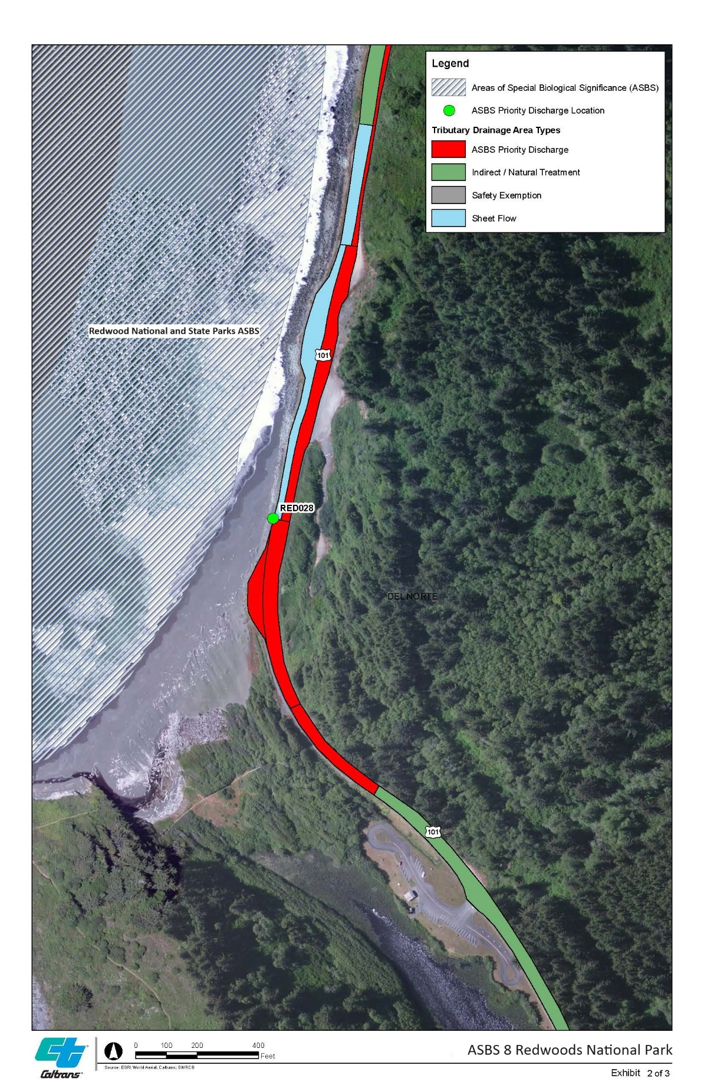
Figure A-1. RED028

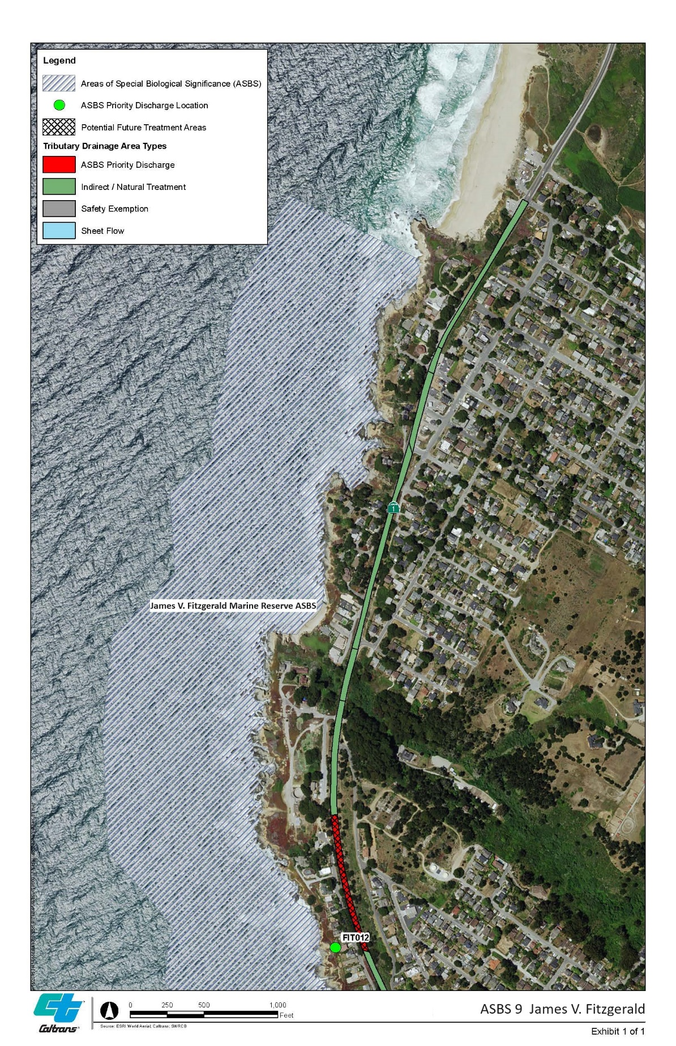
Figure A-2. FIT012

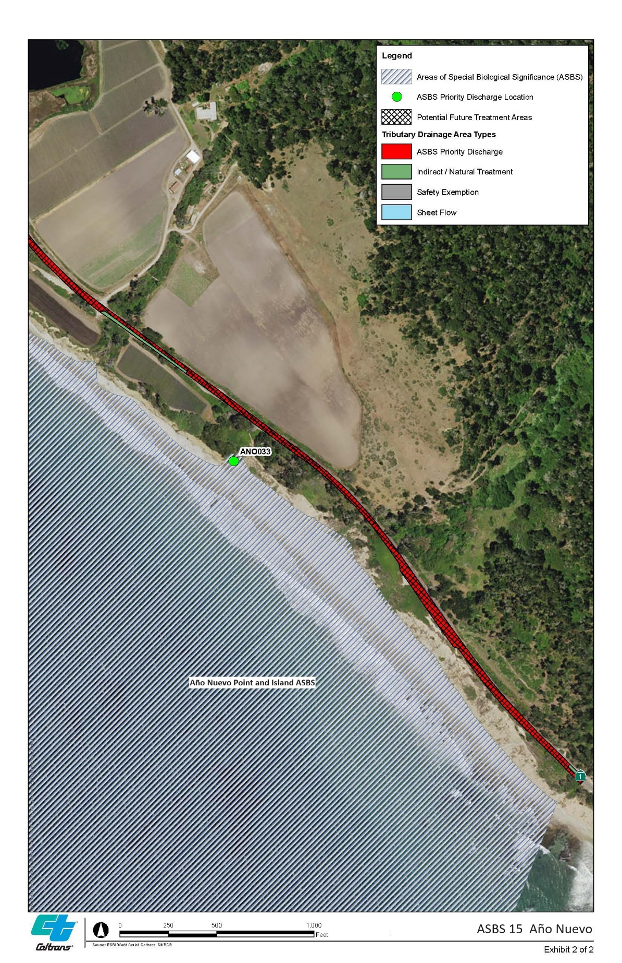
Figure A-3. ANO033

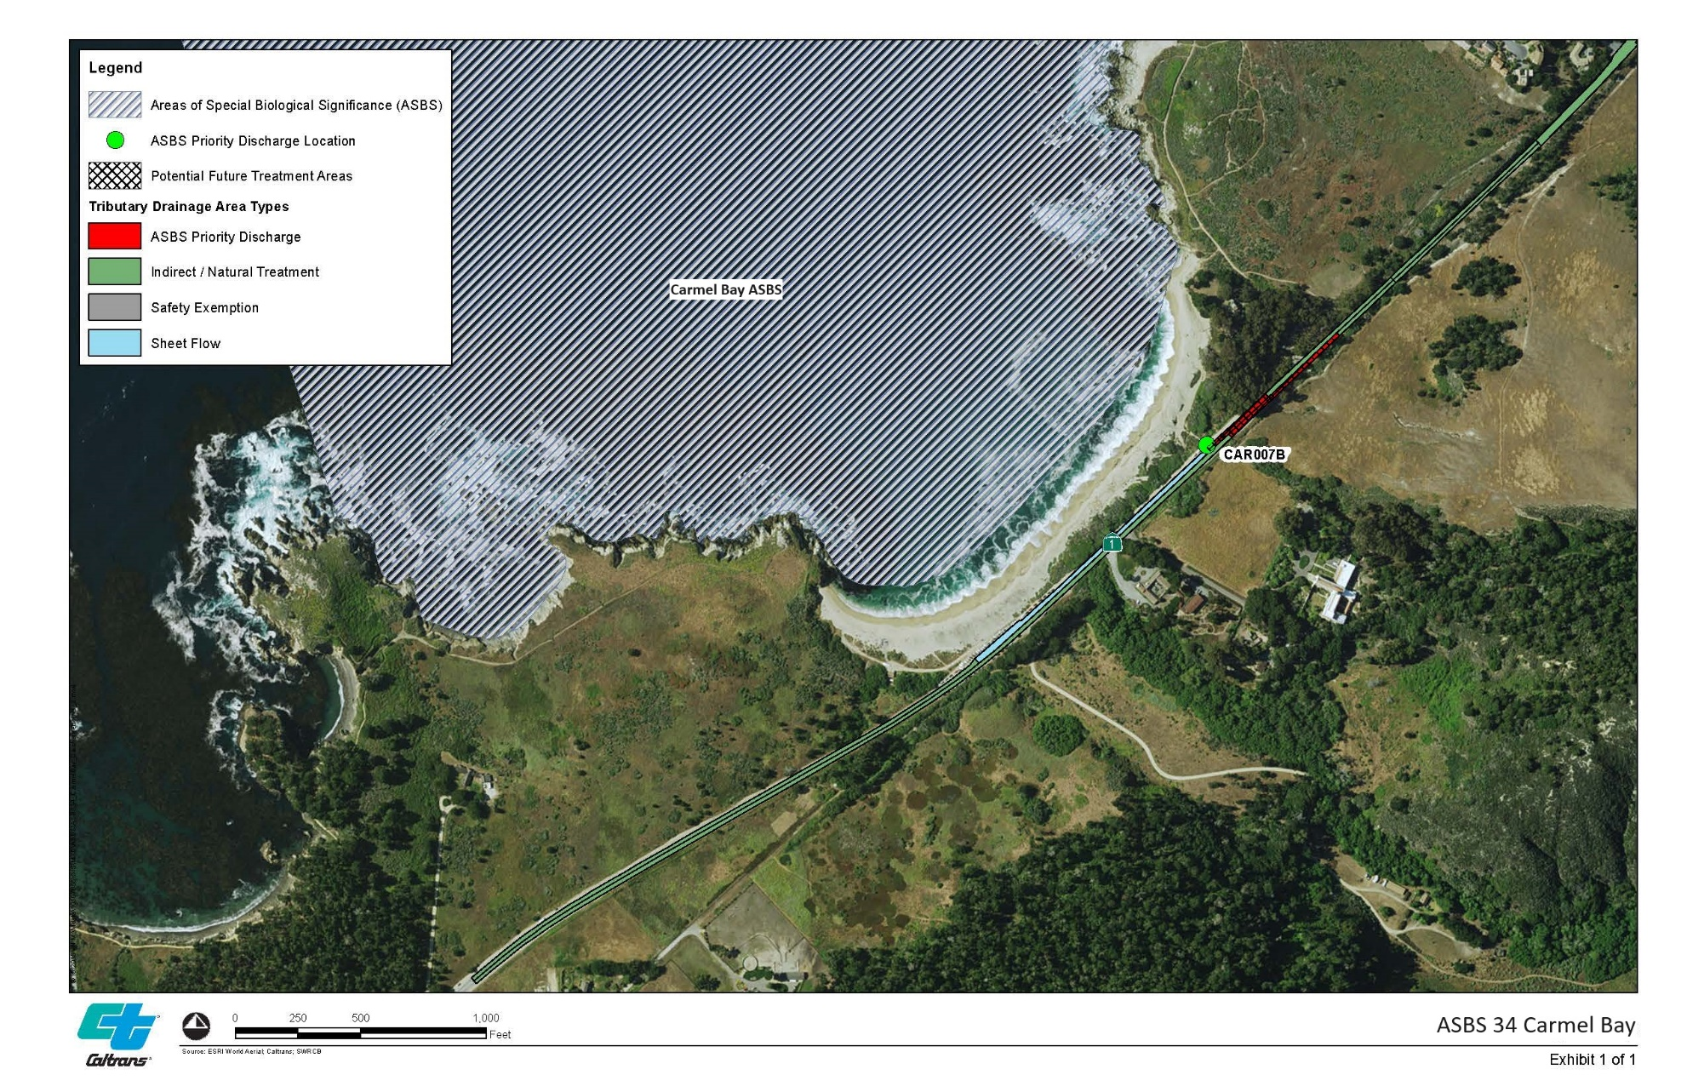
Figure A-4. CAR007B

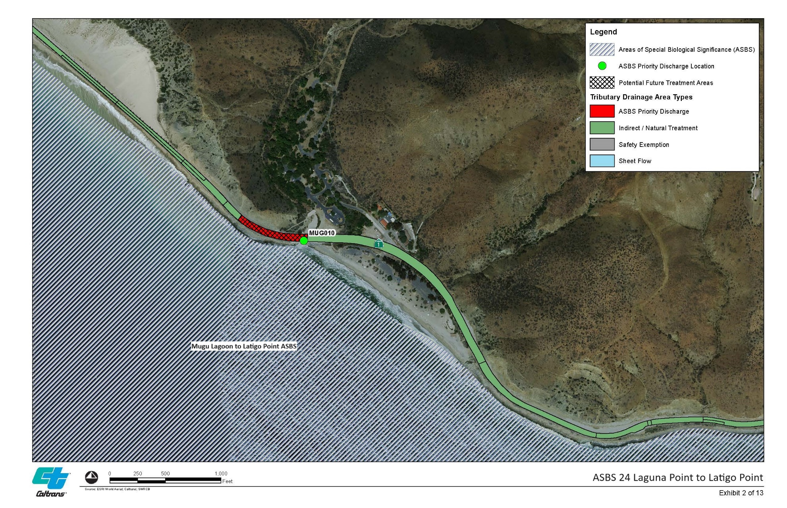
Figure A-5. MUG010

Appendix B: Erosion-Prone Areas
Areas prone to erosion within the ASBS are listed in Table B-1. Maintenance work at both locations was completed in December 2022.

Table B-1. Slopes Prone to Erosion FY23
District | Co | Route | Dist County Route | From PM | To PM | Regional Board | Watershed | Scheduled Stabilization Date | Initiation Date | Completion Date | Length
7 | VEN | 1 | 7-VEN-1 | 4.538 | 4.57 | 4 | Big Sycamore Canyon-Frontal Santa Monica Bay |  | 10/19/2020 | 12/11/2022 | 0.032
7 | VEN | 1 | 7-VEN-1 | 7 | 7.5 | 4 | Big Sycamore Canyon-Frontal Santa Monica Bay |  | 1/11/2021 | 12/11/2022 | 0.5
Source: IMMS’s past three years of segments with recurring S3 and S4 activities.

Appendix C: Preliminary BMP Feasibility Studies

This Appendix contains graphics showing the results of the Preliminary Feasibility Studies. The detailed feasibility Memoranda and high-resolution images of the Preliminary Feasibility Studies are included in the Addendum to this document (CTSW-RT-23-438-01.03-Addendum).
(Page intentionally left blank)

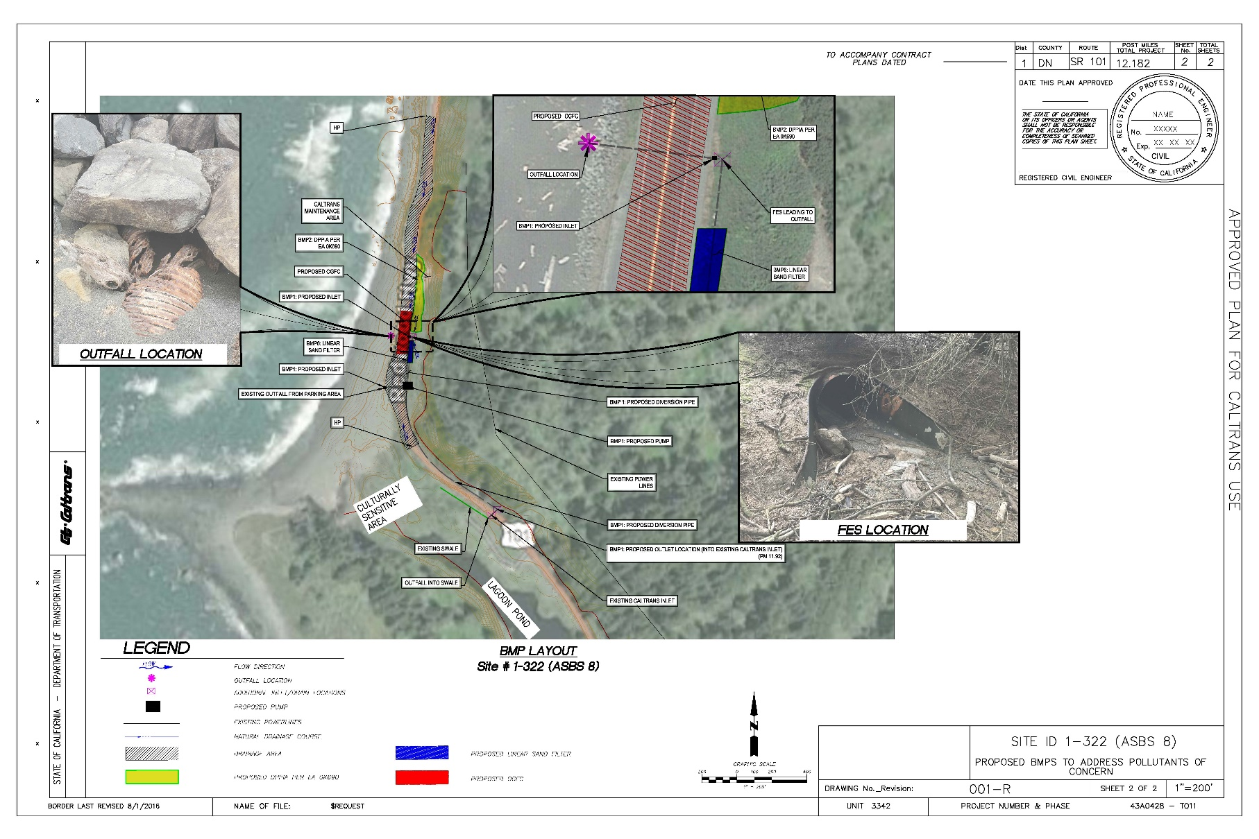
Figure C-1. SITE ID 1-322 (ASBS 8)

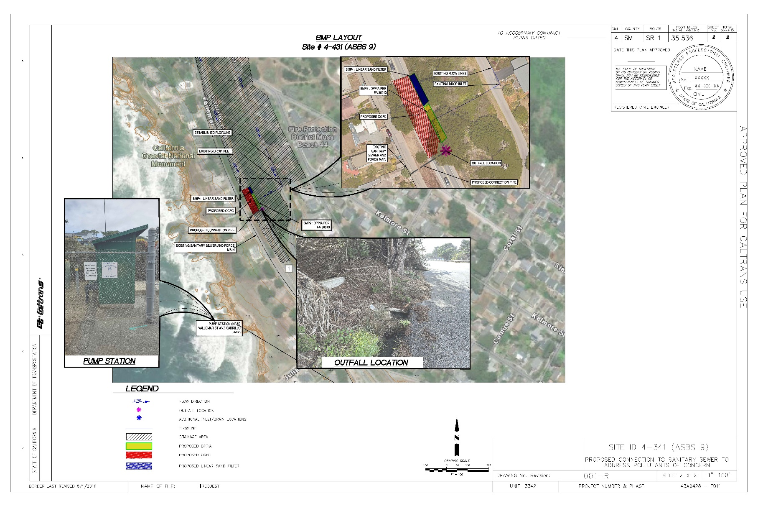
Figure C-2. SITE ID 4-341 (ASBS 9)

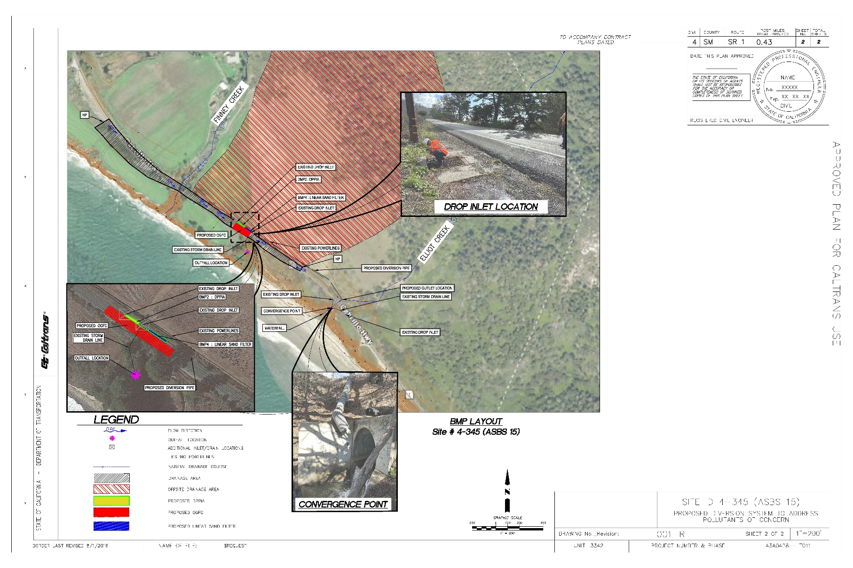
Figure C-3. SITE ID 4-345 (ASBS 15)

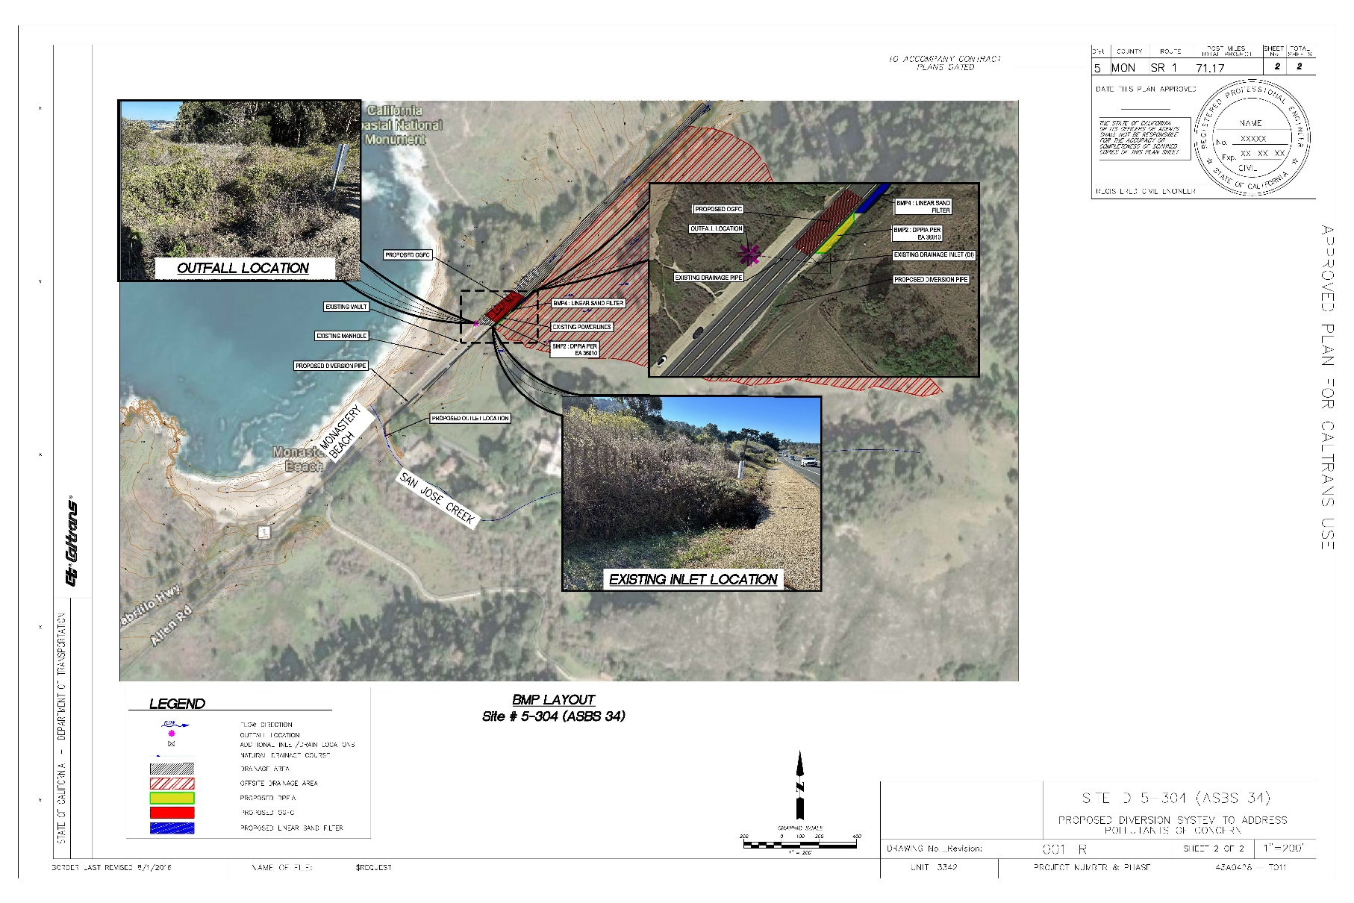
Figure C-4. SITE ID 5-304 (ASBS 34)

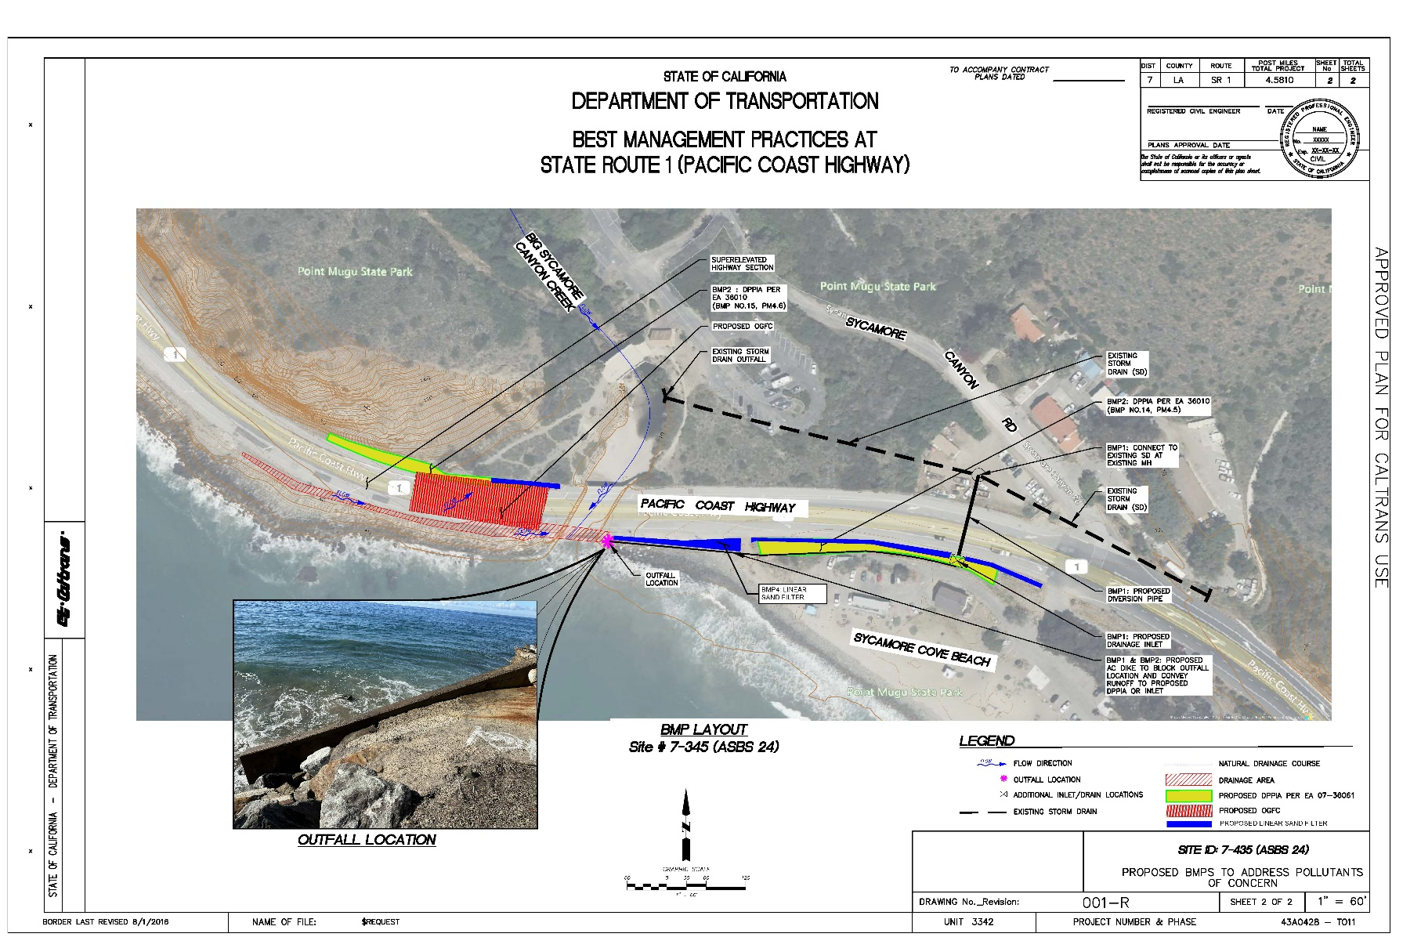
Figure C-5. SITE ID 7-345 (ASBS 24)

Appendix D: Best Management Practices to Control Stormwater Runoff (Permit Section C4 Items 9, 11)
This appendix describes the institutional and structural Best Management Practices (BMPs), including low-impact development measures, generally used by the Department (Table D-1).
BMPs are measures designed to remove pollutants from stormwater runoff prior to discharging to receiving waters. The process for establishing compliance within the ASBS relies on the comparison of water quality at the receiving water site to the appropriate reference site in order to determine exceedance of natural water quality as illustrated in Figure 2 of the Caltrans NPDES Permit. Caltrans has been monitoring at the ASBS Priority Discharge locations (as modified) to determine compliance and the need for installation of structural BMPs.
Considerations for deployment of structural BMPs are based on, but not limited to, safety, available funding, field conditions, contaminant levels, sources, regulatory approval, and space available.
Section 7 discusses specific implementation items for each ASBS location and cooperative efforts with other ASBS dischargers.

Table D-1. Treatment and Institutional BMPs
Treatment BMP – Infiltrate (Caltrans LID/Soil Based BMPs)
Biofiltration: Strips/Swales
Media Filters (earthen)
Bioretention
Design Pollution Prevention Infiltration Areas
Treatment BMP – Capture and Treat
Media Filters (vault type)
Institutional BMP
Sediment control
Sweeping
Drain cleaning
Other source control (site specific)

The following sections describe the structural BMPs, including low-impact development measures currently employed and planned for priority discharges.

Design Pollution Prevention Infiltration Areas
Design Pollution Prevention Infiltration Areas are vegetated and non-vegetated areas, depending on site-specific conditions, that have been designed or evaluated for infiltration capabilities. Pollutants are removed primarily through sedimentation, infiltration of surface discharge through the soil, and adsorption to soil particles. When vegetation is incorporated into the Design Pollution Prevention Infiltration Area, filtration through the vegetation provides additional pollutant removal.
Design Pollution Prevention Infiltration Areas are sized to capture the water quality volume, or a portion thereof, generated by the contributing drainage area. A Design Pollution Prevention Infiltration Area may be a new, modified, or existing slope, ditch, embankment, roadside area, or facility within the project limits that may be used to achieve treatment requirements. Schematic illustrations of a Design Pollution Prevention Infiltration Area are shown in Figures D-1 and D-2.

Figure D-1. Schematic of a Design Pollution Prevention Infiltration Area

Figure D-2. Schematic of a Design Pollution Prevention Infiltration Area

Design Pollution Prevention Infiltration Areas should be used to meet treatment objectives and maximize infiltration. These areas must be stabilized to prevent erosion and are most commonly used within pervious roadway embankment areas. Design Pollution Prevention Infiltration Areas are not only used as a treatment mechanism for pollutants but are used to maximize infiltration and reduce discharges downstream.

Vegetated Biofiltration Strips and Swales
Biofiltration strips and biofiltration swales are primarily effective at removing total suspended solids, particulate metals and turbidity, though infiltration can also remove nutrients and dissolved metals. Compost- or biochar-amended swales may be more effective than unamended swales in removing some pollutants. The vegetation mixes for the biofiltration strips and biofiltration swales must be approved by the District Landscape Architect to ensure it is appropriate for the climate and location.
Biofiltration swales have been installed along the northbound shoulder of ASBS 33 (Irvine Coast) to treat the runoff from State Route 1. The maps located in Appendix A show the location of these swales.

Bioretention
Bioretention is a low-impact development, vegetation and soil-based practice using the chemical and biological properties of soil, as well as its physical characteristics, to reduce pollutants and attenuate stormwater flows. The treatment mechanisms are filtration through vegetation, sedimentation, adsorption to soil particles, and infiltration. Bioretention reduces peak discharge and runoff volume by detaining water through surface ponding and storage in soil and gravel layers, and by allowing it to infiltrate into the subsoil or dissipate through evapotranspiration (Caltrans, 2021b).
A linear bioretention trench is an adaptation of existing bioretention designs, consisting of a vegetated trench into which stormwater flows as sheet flow. It is designed for the narrow right-of-way typical of roadside areas. Removal mechanisms include filtration, infiltration, and plant uptake (Caltrans, 2021b).

Infiltration Devices
An infiltration device is designed to remove pollutants from surface discharges by capturing the water quality volume, or a portion thereof, and infiltrating it directly to the soil rather than discharging it to surface waters. Because infiltration devices, including Design Pollution Prevention Infiltration Areas, are considered the most effective treatment BMP against all pollutants of concern from typical highway runoff, infiltration is always considered first when selecting treatment BMPs for a Caltrans project. Infiltration devices primarily remove total suspended solids, particulate metals, nutrients, dissolved metals, turbidity and mercury. A schematic illustration of an Infiltration Basin is shown in Figure D-3.

Figure D-3. Schematic of an Infiltration Basin

A schematic illustration of an Infiltration Trench is shown in Figure D-4.

Figure D-4. Schematic of an Infiltration Trench

Media Filters
A media filter treatment BMP device primarily removes total suspended solids pollutants (sediments and metals) from runoff by sedimentation and filtering. A media filter device is also effective for dissolved metals, litter, and potentially some nutrients (depending upon the type of media filter selected). Media filter devices are configured using two chambers. An Austin Sand Filter is usually open and at grade with no permanent pool of water. A Delaware Sand Filter is always configured with closed chambers below grade and has a permanent pool of water.
In both types of media filters, stormwater is directed into the first chamber where the larger sediments and particulates settle out, and the partially treated effluent is metered into the second chamber to be filtered through media. In the Austin Sand Filter, the first chamber may be sized for the entire water quality volume, or ‘full sedimentation’ (see Figure D-6), or as a ‘partial sedimentation’ chamber, holding only about 20 percent of the water quality volume (see Figure D-7). The Delaware Sand Filter holds the entire water quality volume in the initial chamber (see Figure D-8).
Figure D-5. Caltrans Media Filters (Austin Sand Filter [left], Delaware Sand Filter [right])

Figure D-6. Schematic of an Austin Sand Filter—Full Sedimentation (Earthen Type)

Figure D-7. Schematic of an Austin Sand Filter—Partial Sedimentation (Earthen Type)

Figure D-8. Schematic of a Delaware Sand Filter

Figure D-8. Schematic of a Delaware Sand Filter (Continued)

Appendix E: BMPs Installed or Proposed in ASBS Areas (Permit Section C4 Item 2)

(Page intentionally left blank)

ASBS 08: Proposed Culvert Rehabilitation

(Page intentionally left blank)

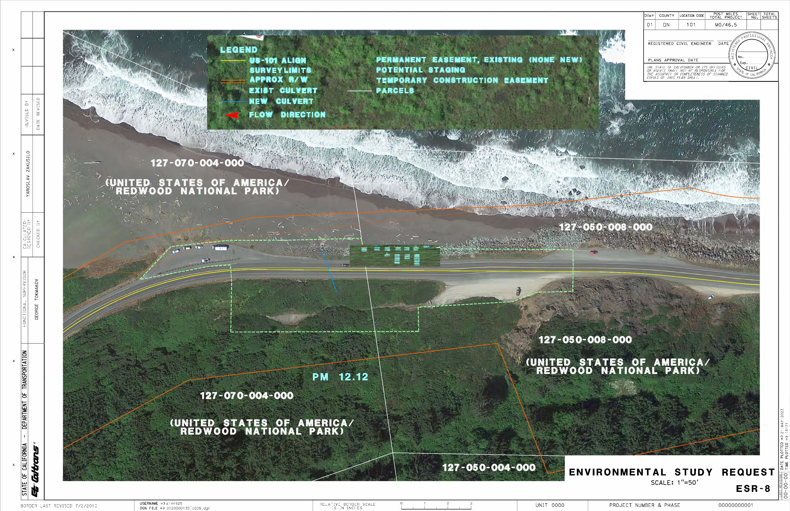

ASBS 24: Proposed Big Sycamore Creek Bridge Replacement
(Page intentionally left blank)

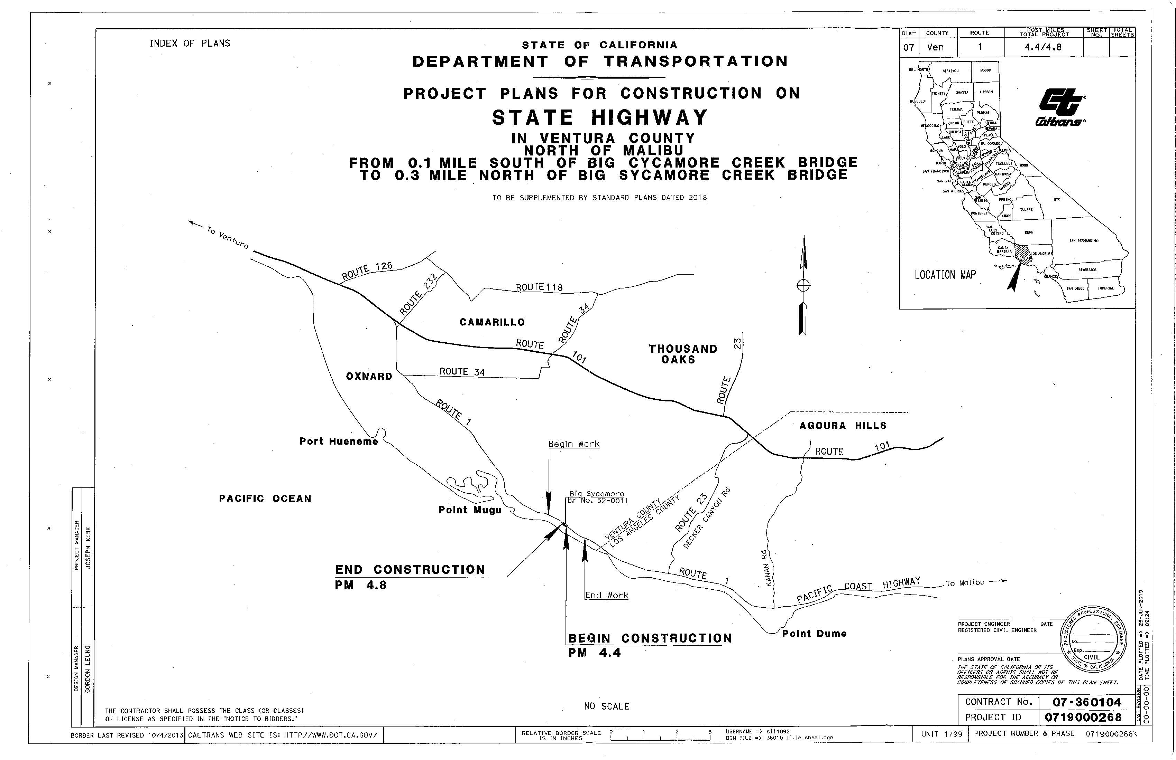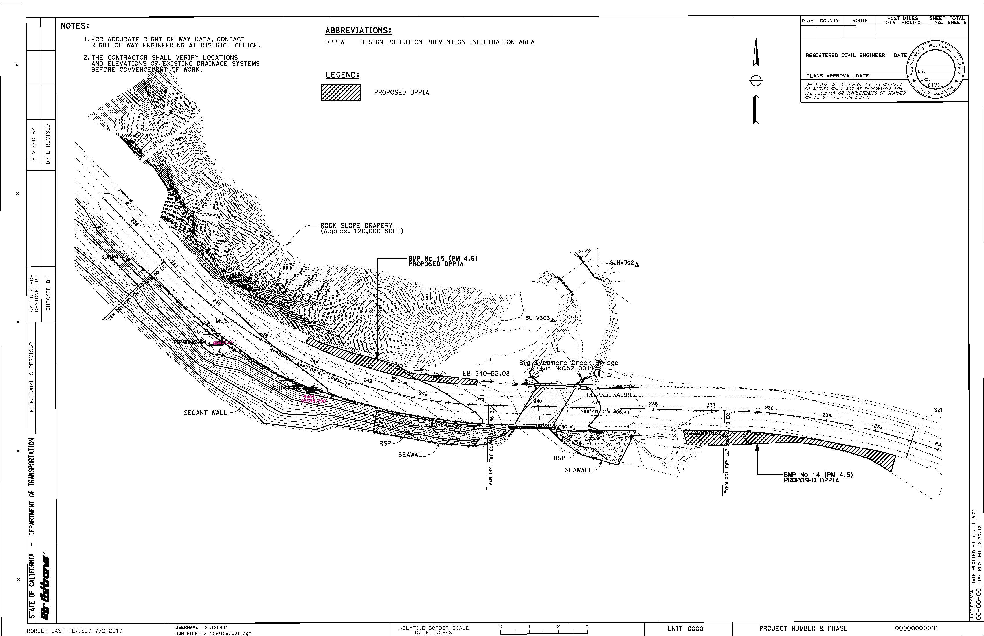

ASBS 33: Constructed Bioswale BMPs

Notice of Termination Photos
Figure E-1. Before 5/22/19

Figure E-2. Before 5/22/19

Figure E-3. Before 5/22/19

Figure E-4. Before 5/22/19

Figure E-5. Before 2/19/21

Figure E-6. Before 2/19/21

Figure E-7. After 12/09/21

Figure E-8. After 12/09/21

Figure E-9. After 12/09/21

Figure E-10. After 12/09/21

Figure E-11. After 12/09/21

Appendix F: Applicability of the Ocean Plan to Inland Discharges
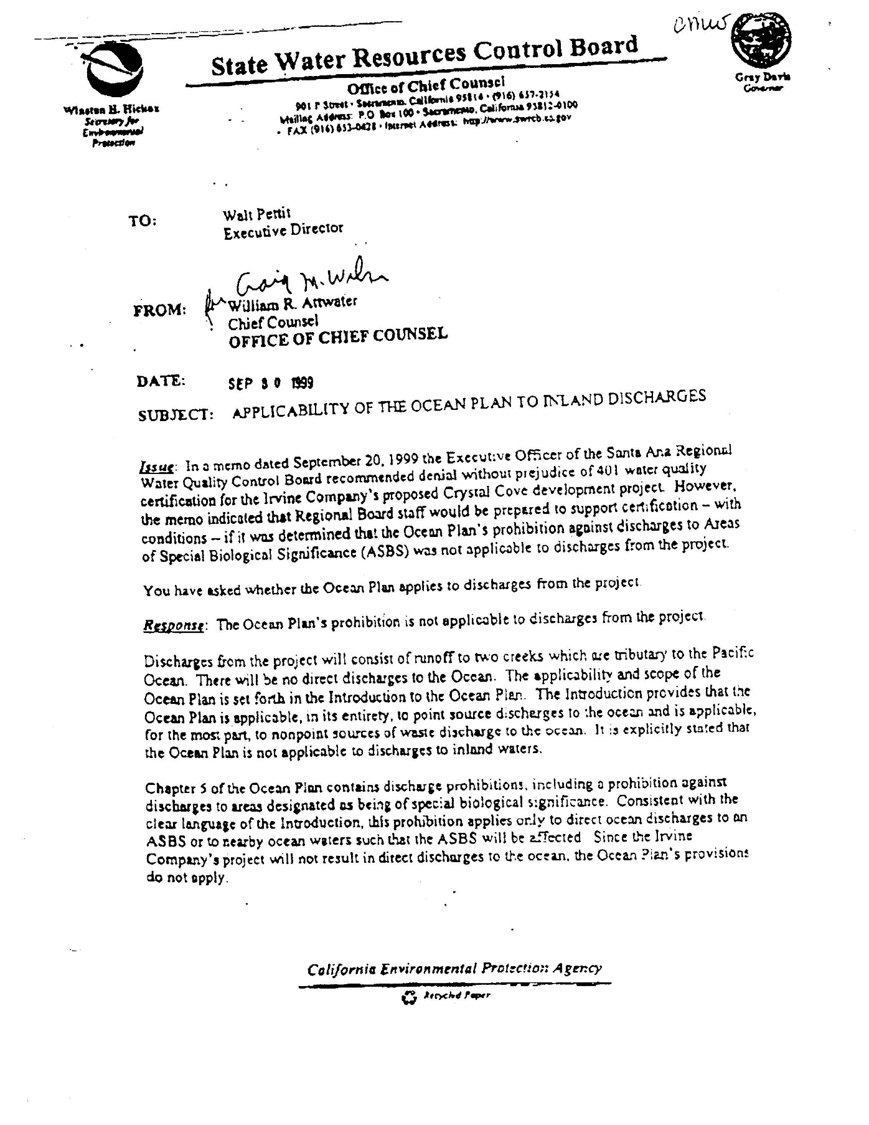

Appendix G: ASBS Demonstration of Compliance (Permit Section C4 Item 10)

Introduction
For demonstration of ASBS compliance, Section C4 Item 10 of Attachment C of the 2022 Caltrans NPDES Statewide Stormwater Permit states the following:
The Department’s strategy shall include one or more of the following to demonstrate that the Department is not causing or contributing to the alteration of natural ocean water quality for each location/parameter pair in Table C-1 and location/parameter pairs of future alterations of natural ocean water quality in Areas of Special Biological Significance to which the Department discharges: modeling, receiving water monitoring, discharge monitoring, or a demonstration of no discharge.
Caltrans has selected the modeling option to demonstrate compliance. To demonstrate compliance, Caltrans intends to use modeling to show that BMPs installed to control stormwater runoff discharges during a design storm will achieve, on average, one of the following target levels:
- Instantaneous Maximum Water Quality Objectives in Chapter II, Table 3, of the Ocean Plan; or
- A 90 percent reduction in pollutant loading during storm events, for total discharges.
This appendix provides a brief description of the modeling approach.

Model Selection
The model selected to demonstrate compliance is the widely used EPA Storm Water Management Model. The Storm Water Management Model was selected because it allows:
- Continuous simulation using the long-term rainfall record at a site
- Simulation of low-impact development BMPs like Design Pollution Prevention Infiltration Areas, bioretention, and infiltration systems
- Choice of infiltration options that includes Horton, Modified Horton infiltration, Green-Ampt, Modified Green-Ampt, and Curve Number

Modeling Approach
To ensure representative results, Caltrans will perform site surveys to confirm Caltrans drainage areas and determine soil type and properties, including saturated hydraulic conductivity, at each location prior to model set up.
The Storm Water Management Model hydrology models will be set up for each discharge location specified in Table C-1 of the 2022 Caltrans NPDES Statewide Stormwater Permit. These models will simulate runoff from the Caltrans right-of-way and initially assume default parameter values except for those determined during the field surveys. Local precipitation data will be obtained for the most recent 10-year period, which includes the period during which ASBS monitoring was conducted at these sites.
The Storm Water Management Model hydrology models will be compared against flow data at similar locations where flows are not commingled with runoff from non-Caltrans areas. Hydrology models for locations where flows commingle and Caltrans-only flow data are unavailable will not be calibrated, but modeled runoff volumes and peak flows will be compared with those from similar Caltrans drainage areas.
After calibration of the hydrology models, BMP models will be incorporated to simulate volume reduction by the proposed BMPs at each location. The primary BMP proposed by Caltrans is the Design Pollution Prevention Infiltration Area. Design Pollution Prevention Infiltration Areas consist of vegetated and non-vegetated pervious areas that promote infiltration, which is the process of pollutant removal. Figures G-1 and G-2 show examples of rock-lined and vegetated Design Pollution Prevention Infiltration Areas, respectively.

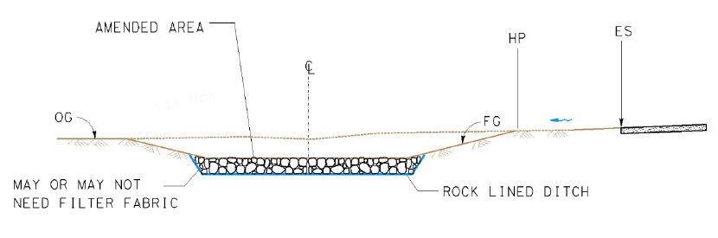
Figure G-1. Typical Section of a Rock Lined Design Pollution Prevention Infiltration Area

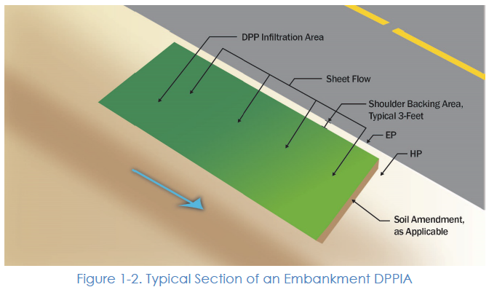
Figure G-2. Typical Section of an Embankment Design Pollution Prevention Infiltration Area

Table G-1 lists the low-impact development BMPs that can be modeled by the Storm Water Management Model:

Table G-1. Low-impact Development BMP Options in the Storm Water Management Model
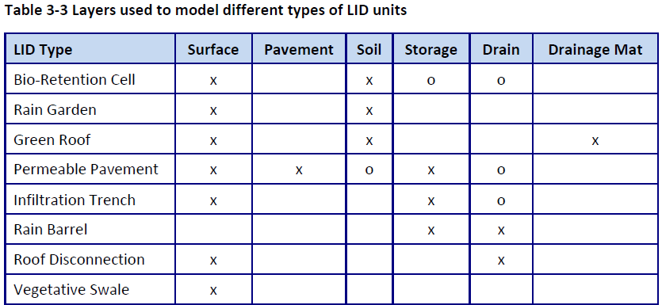
x – required; o - optional

The proposed Design Pollution Prevention Infiltration Areas at each location will be represented by the Infiltration Trench low-impact development option in the Storm Water Management Model as shown in Figure G-3. In the Storm Water management Model representation, outflows from the underdrain will not be modeled because Design Pollution Prevention Infiltration Areas do not have underdrains.

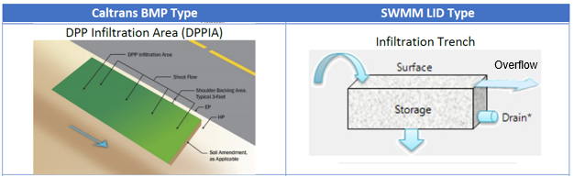
Figure G-3. The Storm Water Management Model Representation of Design Pollution Prevention Infiltration Areas

Example Demonstration
For a site with Design Pollution Prevention Infiltration Area treatment, assume that a Storm Water Management Model hydrology model has been created and the model produces runoff and Design Pollution Prevention Infiltration Area overflow results for each storm event over a 10-year simulation. The model results of interest are the volume of runoff and the overflow volume for each event. Table G-2 gives a set of hypothetical results of just 10 events to illustrate the results of interest.

Table G-2. Hypothetical Storm Water Management Model Results of Interest
Event Number | Runoff Volume (ft³) | DPPIA Overflow Volume (ft³)
1 | 3,620 | 290
2 | 1,015 | 20
3 | 690 | 0
4 | 4,527 | 498
5 | 8,964 | 1,613
6 | 2,628 | 105
7 | 3,161 | 221
8 | 4,321 | 469
9 | 3,006 | 120
10 | 1,756 | 39

To demonstrate compliance with the hypothetical results in Table G-2, the percent volume reduction is calculated for each event and the overall average is determined. This is shown in Table G-3.

Table G-3. Hypothetical Demonstration of Compliance
Event | Runoff Volume (ft³) | DPPIA Overflow Volume (ft³) | Percent Volume Reduction
1 | 3,620 | 290 | 92
2 | 1,015 | 20 | 98
3 | 690 | 0 | 100
4 | 4,527 | 498 | 89
5 | 8,964 | 1,613 | 82
6 | 2,628 | 105 | 96
7 | 3,161 | 221 | 93
8 | 4,321 | 469 | 89
9 | 3,006 | 120 | 96
10 | 1,756 | 39 | 98
 |  | Average | 93

As can be seen in Table G-3, the proposed Design Pollution Prevention Infiltration Area treatment achieves an average 93 percent volume reduction for storm events. This equates to an average 93 percent load reduction for storm events since concentration reductions for this BMP are assumed to be zero. Therefore, this hypothetical example demonstrates that the proposed Design Pollution Prevention Infiltration Area treatment achieves the target 90 percent reduction in pollutant loading during storm events.

As recommended in Section 3.3 of the Caltrans Project Planning and Design Guide, prioritize, and use where feasible, approved low-impact development practices to infiltrate, use, or evapotranspire stormwater runoff on site.
Pollutant sources from the Department properties, facilities, and activities include motor vehicles, highway surface materials such as fine particles of asphalt and concrete, highway maintenance products, construction activities, erodible shoulder materials, eroding cut and filled slopes, abrasive sand and deicing salts used in winter operations, abraded tire rubber, maintenance facilities, illegal connections, illegal dumping, fluids from accidents and spills, and landscape care products. Pollutant categories include, but are not limited to, metals (such as copper, lead, and zinc), synthetic organic compounds (pesticides), Polycyclic Aromatic Hydrocarbons from vehicle emissions, oil and grease, Total Petroleum Hydrocarbons, sediment, nutrients (nitrogen and phosphorus fertilizers), debris (trash and litter), pathogens, and oxygen-demanding substances (decaying vegetation, animal waste, and other organic matter) (Caltrans, 2012).

