Appendix L

California’s Prioritization Framework for Plans to Restore Impaired Waterbodies

**2026 California Integrated Report**

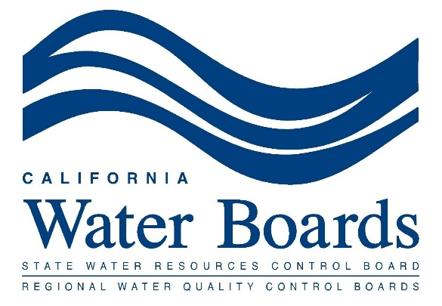

The State Water Board, in collaboration with the Regional Water Boards, developed California’s Prioritization Framework for Plans to Restore Impaired Waterbodies (“Prioritization Framework”) to fulfill the goals of the USEPA’s “A New Long-Term Vision for Assessment, Restoration, and Protection under the Clean Water Act Section 303(d) Program” (“2022-2032 Program Vision”). See 2026 California Integrated Report Staff Report section 1.1: The 303(d) List of Impaired Waters. The Prioritization Framework provides guidance for prioritizing the development of TMDLs and other plans to restore impaired waterbodies. See 2026 California Integrated Report Staff Report section 2.6: TMDLs and Other Efforts to Address Impaired Waters for more information.

The Water Boards should consider the following factors when prioritizing efforts to address impaired waters. These factors were derived from the priority factors in section 5 of the Listing Policy, the Racial Equity Action Plan, and other factors currently used to identify priorities.

# Significance and Severity of Impairment

The significance of the waterbody and the severity of impairment should be considered during the prioritization process. Prioritization factors in this category include:

* Severity that water quality objectives are not met or beneficial uses are not attained or threatened (such as the severity of the pollution or number of pollutants/stressors of concern)
* Ecologically important areas
* Relevance to human health protection
* Relevance to threatened and endangered species protection
* Intensity of use of the waterbody, such as frequency of use and number of users
* Number of beneficial uses impacted

# Environmental Justice

Factors that address racial inequalities to black, indigenous, and people of color (“BIPOC”) communities and consider the needs and concerns of tribal, disadvantaged, and other underserved communities should be prioritized. Prioritization factors in this category include:

* Use of the waterbody by California Native American Tribes
* Use of the waterbody by disadvantaged or underserved communities
* Actions that promote equity

# Climate Change

Climate change factors consider the potential to reduce greenhouse gas emissions as well as risks from hazards caused by climate change, including extreme weather events, flooding, sea level and groundwater rise; increased aridity and extreme heat; and increased wildfire. Prioritization factors in this category include:

* Adaptation: actions taken to build resilience and to adjust to the impacts of climate change. Decisions that don’t worsen the situation or transfer the challenge from one area, sector, or social group to another
* Resilience: capacity to prepare for, recover from, and grow from disruptions.
* Mitigation: actions taken to reduce the concentration of greenhouse gases in the atmosphere
* Vulnerable communities: actions to decrease heightened risk and decrease sensitivity to climate change. Measures to support communities with less capacity and fewer resources to cope with, adapt to, or recover from climate impacts
* Natural and green infrastructure solutions to enhance and protect natural resources
* Consideration of future climate conditions.
* Actions likely to reduce present and near future (within 20 years) climate change risks for all Californians

# Readiness and Potential for Success

A project’s readiness and potential for success are important considerations. Prioritization factors in this category include:

* + Water quality benefits of activities ongoing in the watershed
  + Potential for beneficial use protection and recovery
  + Availability of data and information to address the water quality problem
  + Water quality impacts and benefits
  + Feasibility
  + Have multi-benefit outcomes, such as addressing multiple impairments
  + Ability to leverage ongoing implementation

# Resource Availability

The success of restoring impaired waters depends on the resources available. Prioritization factors in this category include:

* + Availability of funding
  + Ongoing projects with allocated resources
  + Availability of staff capacity, necessary expertise, and other resources

# Public Interest and Commitment

Public interest is an important consideration. Prioritization factors in this category include:

* + Degree of public concern
  + Public interest, internal and external commitments
  + Requests of interested parties

# Regulatory and Policy Alignment

Regulatory and policy alignment should be considered in the prioritization framework. Prioritization factors in this category include:

* + Importance to the implementation of other Regional Water Board programs
  + Projects aligned with the stated priorities of the State Water Board or the U.S. EPA

The above framework categories and factors are intended to be used by Regional Water Boards and the State Water Board when developing and implementing region-specific or statewide prioritization approaches in light of regional/statewide priorities, regional/statewide strategic workplans, and input from Water Board members and the public. Furthermore, the framework may be helpful when considering regional TMDL priorities or regional/statewide water quality standards actions priorities during the triennial review processes and when setting one-year and five-year priorities via workplans.