DRAFT TECHNICAL MEMORANDUM

Summary of Flexible D-1641 X2 Standard Gaming Scenarios – Water Agency Scenarios
PREPARED FOR: | David Fullerton/MWDSC  Peter Louie/MWDSC
PREPARED BY: | Armin Munévar/SDO
DATE: | August 23, 2005

Introduction
Following the broad stakeholder group gaming scenarios on April 28th, several SWP and CVP contractors convened over a period of several days in May to participate in interactive modeling exercises to evaluate greater opportunities for flexible implementation of the D-1641 X2 standard. An interactive daily gaming model was utilized to display historical operations and Delta conditions, to allow for re-operation of SWP/CVP facilities by the stakeholders, and to dynamically simulate the system response to the operational changes. This technical memorandum provides a description of the data and the gaming tool that were used for the exercise, followed by an analysis of the gaming scenarios and results.

Summary of Gaming Scenarios
At total of seven gaming scenarios were developed and simulated during the course of several gaming exercises. The overall objective of these scenarios was to expand on the rather limited scope of flexible X2 Roe Island (Port Chicago) standard implementation simulated during the broader stakeholder games. In these stakeholder games, the flex of X2 was limited to reduction in Folsom releases and use of any conserved water was limited to a “fishery first” purpose. The participants of the gaming scenarios described herein wanted to explore greater reductions at the various facilities to evaluate the extent at which a flexible X2 standard may increase overall water supplies.
Three flex options were considered in these gaming scenarios. Flex option 1 only considered reductions in releases at Folsom reservoir, consistent with the previous gaming scenarios. Flex option 2 considered release reductions at both Folsom and Shasta reservoirs. Finally, flex option 3 considered release reductions at Folsom, Shasta, and Oroville reservoirs.
Three options were considered for the release of the conserved water in reservoir storage, similar to those in the previous gaming scenarios. Usage option 1 consisted of an “immediate and full release” of all conserved water. This option evaluated the environmental benefits of shifting X2 outflow from one month to another, but maintaining the same total volume of Delta outflow during the seasonal periods. Usage option 2 consisted of a “delayed, but full release” of all conserved water. This option allowed for any water savings to accrue, to the extent feasible, in upstream storage and be used later in the same calendar year for upstream instream fishery benefits. Finally, usage option 3 consisted of an “X2 neutral” operations in which releases of conserved water were made such that the average February through June X2 position was identical to that of the Base. This option allowed for better managed releases and results in conserved water that can then be used for multiple purposes.
The gaming scenarios, for sake of simplicity, are referred to as Games 1.3, 2.1, 2.2, 2.3, 3.1, and 3.3 , where the first number refers to the flex option and the second number refers to the usage option. Gaming scenarios 1.1 and 1.2 are described in the “Common scenarios” technical memorandum. Scenario 3.2 was not developed due to uncertainty of best pattern for release of conserved water in Oroville for fishery purposes.

Period of Analysis and Data Sources
The recent historical period of water years 2002, 2003, and 2004 was selected as the model simulation period for the gaming scenarios. This period was selected to be consistent with recent operations, including the CVPIA (b)(2) and the Environmental Water Account programs, current Delta standards, and the availability of daily hydrologic and operational data.
Daily hydrologic and operational data for the Sacramento Valley, San Joaquin Valley, and Delta were compiled from a variety of sources. Reservoir reports containing daily values for inflow, storage, and release were obtained electronically from the California Data Exchange Center (CDEC). Daily river flow data were generally obtained from the U.S. Geological Survey (USGS) gage records. Historic Delta flows, cross-channel gate operations, exports, and estimates of island consumptive use and drainage were obtained from the IEP DAYFLOW database. DWR and USBR operators provided daily electrical conductivity measurements for the Delta, additional reservoir operational conditions, and historical (b)(2) accounting sheets.

Gaming Tool
A spreadsheet-based gaming tool, developed by CH2M HILL, was employed for the gaming exercises. The tool utilizes historical daily facility operations, river flows, and Delta conditions to develop the Base scenario. The historic conditions are displayed graphically on a schematic of the Central Valley water resources system. The model schematic is shown in Figure 1. Various timeline graphics of reservoir storage levels, river flows, exports, Delta salinity, and other system parameters are included in the gaming tool for review of baseline conditions.
Gaming scenarios are developed by tiering off of the Base (historical) scenario and modifying facility operations to suit the guidelines of the particular game. The system response to changes in the facility operations is dynamically simulated and results are automatically displayed on the schematic and timeline graphs. Based on discussions in meetings prior to the gaming sessions, a simplified hydrologic routing technique was implemented in the model to approximate the time lag of flows from upstream reservoirs to the Delta. Changes to facility operations can be made on a daily basis or can span a period of any number of days.
The gaming tool incorporates computations of all major Delta constraints and standards. The salinity at various locations in the Delta is simulated through the use of the G-Model (Denton and Sullivan 1993) and is also compared to historic salinity conditions. The X2 position is computed based on the equation developed by Jassby et al (1995) relating Delta outflow and antecedent position to the current day position. The X2 position can also be approximated by interpolation of simulated salinity values at several stations in the Delta. As part of this gaming exercise, the gaming tool was integrated with a separate spreadsheet tool that provides greater assessment of the daily compliance of the X2 standard given that the standard can be achieved through either a 3-day running average of net Delta outflow, daily EC, or 14-day running average of EC values. In addition this tool, provides a dynamic computation of species abundance indices as related to change in X2 over the specific averaging period (Kimmerer 2002)

Historic (Base) Conditions
While historical data was compiled for water years 2002-04, only water years 2003 and 2004 exhibited the X2 conditions that were the focus of this gaming exercise. During early January 2003, uncontrolled runoff from the Sacramento Valley watershed flowed out of the Delta and pushed the X2 line westward. As a result of the large westward swing in the X2 position, the Roe Island standard was triggered and required 25 days of compliance. Beginning around the 10th or 11th of February, SWP and CVP operators began making increased releases from Folsom, Shasta, and Oroville reservoirs to target the Delta outflow standard. Flows on the American River, in particular, went from a nearly constant 4000 cfs prior to the 10th to nearly 5500 cfs for 5-7 days following the 10th before returning to 4000 cfs. Flows subsequent to the 20th began dropping down to 2000 cfs. All reservoirs went into flood control operation within a few months of this X2 Roe Island occurrence.
Similar to water year 2003, early April 2004 exhibited X2 Roe Island triggering that produced rather erratic flow conditions on the American River. Extremely high uncontrolled runoff in March caused a triggering of 18 days of X2 compliance at Roe Island. As a response to the triggering, rapid releases were made from Nimbus to support Delta outflow. Flows below Nimbus went from approximately 4000 cfs on April 6th, to nearly 8000 cfs on the 8th, and back down to 4000 cfs on the 20th. Flows subsequent to the 20th began dropping below 2000 cfs. Substantial stranding of juvenile Chinook salmon and isolation of Steelhead redds occurred during this event. A similarly erratic operation occurred at Keswick and Oroville facilities. Contrasting with 2003 conditions, however, none of the reservoirs went into flood control operations in 2004. See Figures 2a-d for a graphical display of conditions in 2003-04.

Summary of Game 1.3 Actions and Impacts
The following is a synopsis of the actions taken by the participants in Game 1.3 for water year 2004 and the result of these actions. Water year 2003 was omitted from the gaming scenarios described in this document since all storage reservoirs went into flood control operations later in the year and eliminated the possibility of carryover of the conserved water beyond a couple of months. A graphical representation of the operational impacts to river flows is shown in figures 3a-b.

WY 2004
Actions
- April 6-20. Reduced releases from Nimbus to maintain 4000 cfs. A total of 51 kaf was conserved in Folsom by the 20th.
- May 1–26. Increased Nimbus releases to 2600 cfs to stabilize flows. Release increases were stopped on May 27th as the average Feb-Jun X2 was equivalent to Base operations.
- July – September. Total of 29 kaf of conserved water remained in storage by May 27th and was assumed exportable during the Jul-Sep window. No beneficiaries were assigned.
Impacts
- X2 compliance: Dropped 2 days of X2 compliance at Roe, but still exceeded required days (18 days required/21 days satisfied at Roe -- 23 days satisfied in baseline).
- Period average X2 changes: Feb-Jun (0.00 km), Jan-Jun (0.00 km), Feb-May (+0.04 km), Jan-Apr (+0.05 km), Mar-May (+0.05 km)
- Change in fish abundance indices: Longfin smelt (-0.02%), American Shad (-0.12%), Pacific herring (-0.03%), Crangon (-0.28%)

Summary of Game 2.1 Actions and Impacts
The following is a synopsis of the actions taken by the participants in Game 2.1 for water year 2004 and the result of these actions. Water year 2003 was omitted from the gaming scenarios described in this document since all storage reservoirs went into flood control operations later in the year and eliminated the possibility of carryover of the conserved water beyond a couple of months. A graphical representation of the operational impacts to river flows is shown in figures 4a-c.

WY 2004
Actions
- April 6-20. Reduced releases from Nimbus to maintain 4000 cfs. A total of 51 kaf was conserved in Folsom by the 20th. Reduced releases from Keswick to 6000 cfs. A total of 121 kaf was conserved in Shasta storage by 19th. Total water conserved in both facilities was approximately 172 kaf.
- May 1 – June 17. Increased Nimbus releases to 2600 cfs to stabilize flows until the full 51 kaf of conserved water in Folsom was exhausted on June 17th. Increased Keswick releases to 12000 cfs, until the full 121 kaf of conserved water in Shasta was exhausted on May 31st.
- No export of released water assumed due to VAMP and export-inflow ratio controls at the export facilities.
Impacts
- X2 compliance: Dropped 6 days of X2 compliance at Roe, and undercomplied with the standard by one day (18 days required/17 days satisfied).
- Period average X2 changes: Feb-Jun (-0.18 km), Jan-Jun (-0.15 km), Feb-May (+0.12 km), Jan-Apr (+0.20 km), Mar-May (+0.17 km)
- Change in fish abundance indices: Longfin smelt (+1.79%), American Shad (-0.40%), Pacific herring (-0.10%), Crangon (-0.91%). Note that the Longfin smelt index rises slightly while the other indices fall slightly. This is a result of having different averaging periods for the various X2 correlations. Thus, reducing outflow in April while increasing May and June outflow moves average X2 downstream slightly for the Longfin smelt averaging period (January – June) while moving average X2 upstream slightly for Pacific herring (January – April)

Summary of Game 2.2 Actions and Impacts
The following is a synopsis of the actions taken by the participants in Game 2.2 for water year 2004 and the result of these actions. Water year 2003 was omitted from the gaming scenarios described in this document since all storage reservoirs went into flood control operations later in the year and eliminated the possibility of carryover of the conserved water beyond a couple of months. A graphical representation of the operational impacts to river flows is shown in figures 5a-c.

WY 2004
Actions
- April 6-20. Same as Game 2.1. Total water conserved was approximately 172 kaf.
- August 1 – December 9. Increased Nimbus releases to 1750 cfs in Aug, 1500 cfs in Sep and Oct, and 1750 cfs. Increased Keswick flows to 6000 cfs from Nov 2nd – Dec 9th until all conserved water in Shasta was exhausted. At end of Nov, 22 kaf of conserved water still remained in Folsom storage.
- Estimated export of water (not gamed due to inadequate data for Delta in WY 2005) is 0 kaf in Aug, 4 kaf in Sep, 8 kaf in Oct, 100 kaf in Nov, and 54 kaf in Dec. Total of 166 kaf.
Impacts
- X2 compliance: Dropped 6 days of X2 compliance at Roe, and undercomplied with the standard by one day (18 days required/17 days satisfied).
- Period average X2 changes: Feb-Jun (+0.28 km), Jan-Jun (+0.22 km), Feb-May (+0.31 km), Jan-Apr (+0.20 km), Mar-May (+0.42 km)
- Change in fish abundance indices: Longfin smelt (-2.68%), American Shad (-1.01%), Pacific herring (-0.10%), Crangon (-2.28%)

Summary of Game 2.3 Actions and Impacts
The following is a synopsis of the actions taken by the participants in Game 2.3 for water year 2004 and the result of these actions. Water year 2003 was omitted from the gaming scenarios described in this document since all storage reservoirs went into flood control operations later in the year and eliminated the possibility of carryover of the conserved water beyond a couple of months. A graphical representation of the operational impacts to river flows is shown in figures 6a-c.

WY 2004
Actions
- April 6-20. Same as Game 2.1. Total water conserved was approximately 172 kaf.
- May 1 – June 17. Increased Nimbus releases to 2600 cfs. Increased Keswick releases to 12000 cfs. Release increases stopped when average Feb-Jun X2 was equivalent to Base operations.
- July – December. Total of 74 kaf of conserved water remaining in Shasta by June 17th and assumed exportable during the Jul-Dec window. No beneficiaries were assigned.
Impacts
- X2 compliance: Dropped 6 days of X2 compliance at Roe, and undercomplied with the standard by one day (18 days required/17 days satisfied).
- Period average X2 changes: Feb-Jun (0.00 km), Jan-Jun (0.00 km), Feb-May (0.19 km), Jan-Apr (+0.20 km), Mar-May (+0.25 km)
- Change in fish abundance indices: Longfin smelt (-0.04%), American Shad (-0.60%), Pacific herring (-0.10%), Crangon (-1.37%)

Summary of Game 3.1 Actions and Impacts
The following is a synopsis of the actions taken by the participants in Game 3.1 for water year 2004 and the result of these actions. Water year 2003 was omitted from the gaming scenarios described in this document since all storage reservoirs went into flood control operations later in the year and eliminated the possibility of carryover of the conserved water beyond a couple of months. A graphical representation of the operational impacts to river flows is shown in figures 7a-d.

WY 2004
Actions
- April 6-20. Reduced releases from Nimbus to maintain 4000 cfs. A total of 51 kaf was conserved in Folsom by the 20th. Reduced releases from Keswick to 6000 cfs. A total of 121 kaf was conserved in Shasta storage by 19th. Reduced releases from Thermalito to 4000 cfs. A total of 150 kaf was conserved in Oroville storage by 20th. Total water conserved in all facilities was approximately 322 kaf.
- April 21 – June 17. Increased Nimbus releases to 2600 cfs until the full 51 kaf of Folsom conserved water was exhausted on June 17th. Increased Keswick releases to 12000 cfs until the full 121 kaf of Shasta conserved water was exhausted on May 31st. Increased Thermalito releases to 4000 cfs until the full 150 kaf of Oroville conserved water was exhausted on May 27th.
- No export of released water assumed due to VAMP and export-inflow ratio controls at the export facilities.
Impacts
- X2 compliance: Dropped 19 days of X2 compliance at Roe, and undercomplied with the standard by 14 days (18 days required/4 days satisfied).
- Period average X2 changes: Feb-Jun (-0.25 km), Jan-Jun (-0.21 km), Feb-May (+0.15 km), Jan-Apr (+0.41 km), Mar-May (+0.20 km)
- Change in fish abundance indices: Longfin smelt (+2.60%), American Shad (-0.48%), Pacific herring (-0.20%), Crangon (-1.08%). Note that the Longfin smelt index rises slightly while the other indices fall slightly. This is a result of having different averaging periods for the various X2 correlations. Thus, reducing outflow in April while increasing May and June outflow moves average X2 downstream slightly for the Longfin smelt averaging period (January – June) while moving average X2 upstream slightly for Pacific herring (January – April)

Summary of Game 3.3 Actions and Impacts
The following is a synopsis of the actions taken by the participants in Game 3.3 for water year 2004 and the result of these actions. Water year 2003 was omitted from the gaming scenarios described in this document since all storage reservoirs went into flood control operations later in the year and eliminated the possibility of carryover of the conserved water beyond a couple of months. A graphical representation of the operational impacts to river flows is shown in figures 8a-d.

WY 2004
Actions
- April 6-20. Same as Game 3.1. Total water conserved was approximately 322 kaf.
- May 1 – June 17. Increased Nimbus releases to 2600 cfs. Increased Keswick releases to 12000 cfs. Increased Thermalito releases to 4000 cfs. Release increases stopped when average Feb-Jun X2 was equivalent to Base operations.
- July – December. Total of 111 kaf of conserved water remaining in upstream storage by June 17th and assumed exportable during the Jul-Dec window. No beneficiaries were assigned.
Impacts
- X2 compliance: Dropped 19 days of X2 compliance at Roe, and undercomplied with the standard by 14 days (18 days required/4 days satisfied).
- Period average X2 changes: Feb-Jun (0.00 km), Jan-Jun (0.00 km), Feb-May (+0.34 km), Jan-Apr (+0.41 km), Mar-May (+0.45 km)
- Change in fish abundance indices: Longfin smelt (+0.02%), American Shad (-1.08%), Pacific herring (-0.20%), Crangon (-2.46%). Note that the Longfin smelt index rises slightly while the other indices fall slightly. This is a result of having different averaging periods for the various X2 correlations. Thus, reducing outflow in April while increasing May and June outflow moves average X2 downstream slightly for the Longfin smelt averaging period (January – June) while moving average X2 upstream slightly for Pacific herring (January – April)
References
Denton RA and Sullivan GD. 1993. Antecedent Flow-Salinity Relations: Application to Delta Planning Models.
Jassby AD, Kimmerer WJ, Monismith SG, Armor C, Cloern JE, Powell TM, Schubel JR, Vendlinski TJ. 1995. Isohaline position as a habitat indicator for estuarine populations. Ecological Applications 5:272-289.
Kimmerer WJ. 2002. Effects of freshwater flow on abundance of estuarine organisms: physical effects or trophic linkages? Marine Ecology Progress Series 243: 39-55.
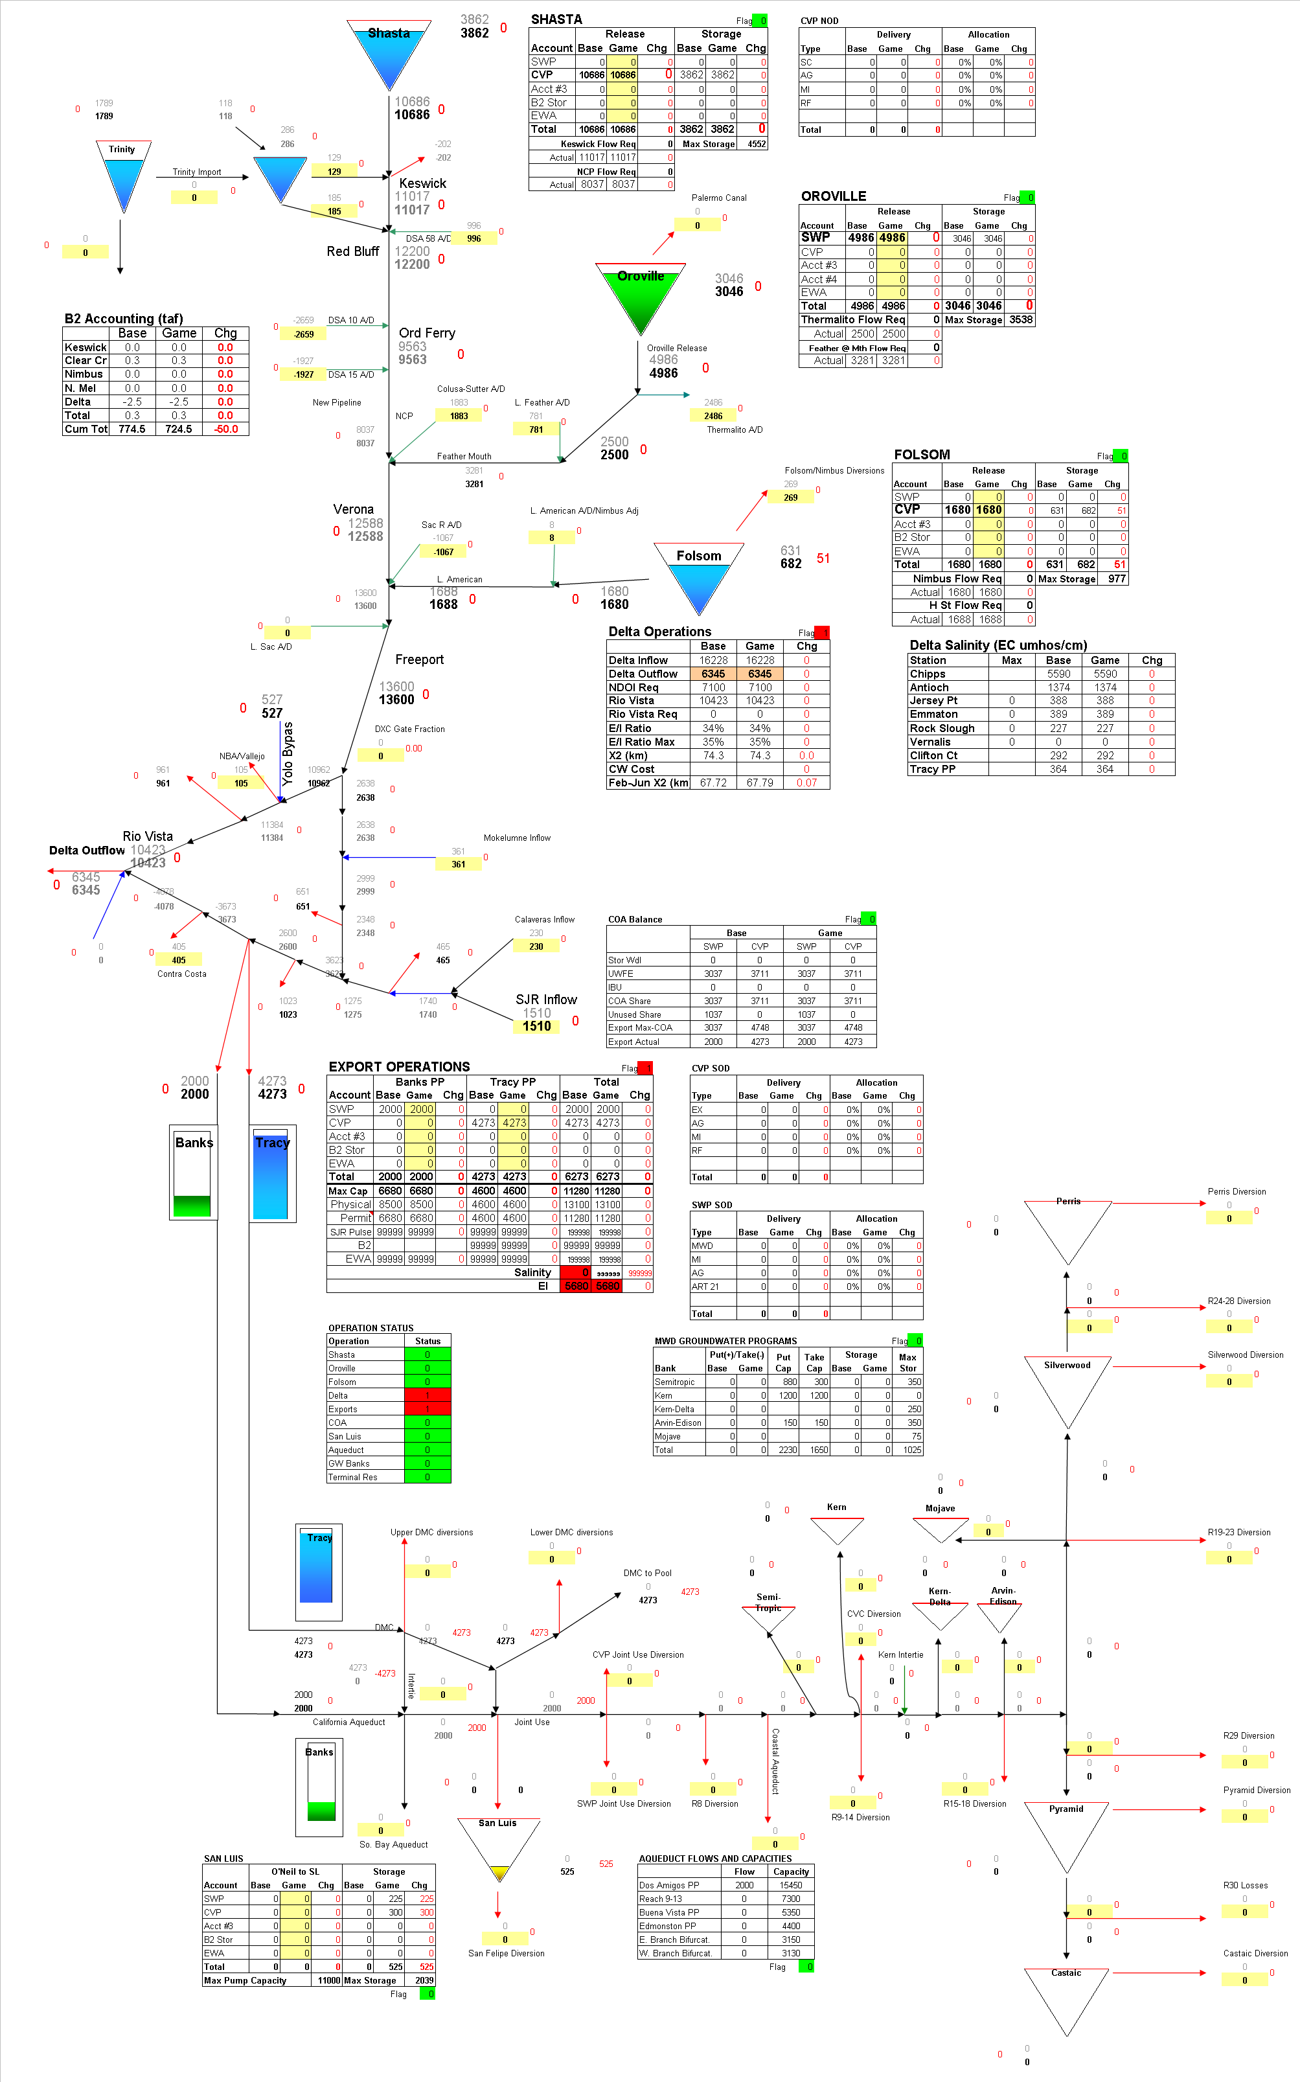 Figures 1. Gaming model schematic.

Figures 2a and 2b. Historical X2 position and American River flows for water years 2003-04.
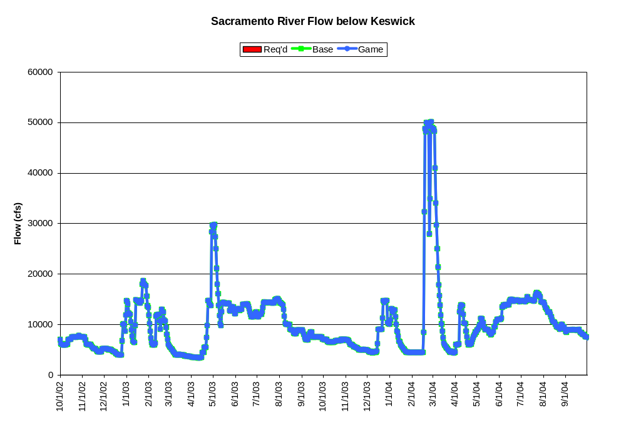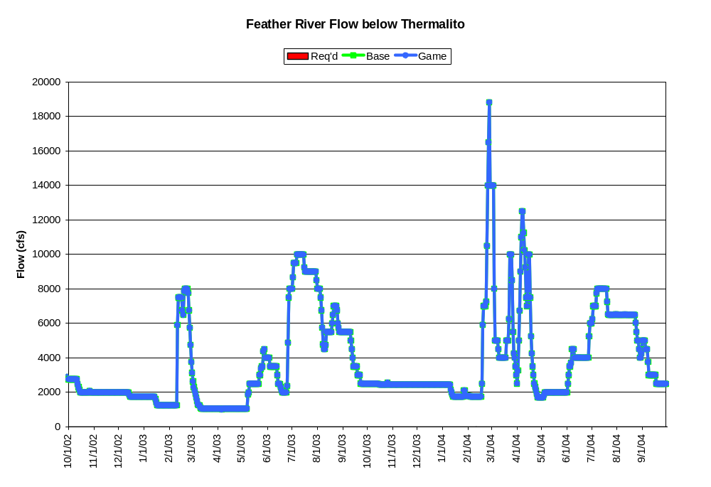Figures 2c and 2d. Historical Sacramento River and Feather River flows for water years 2003-04.
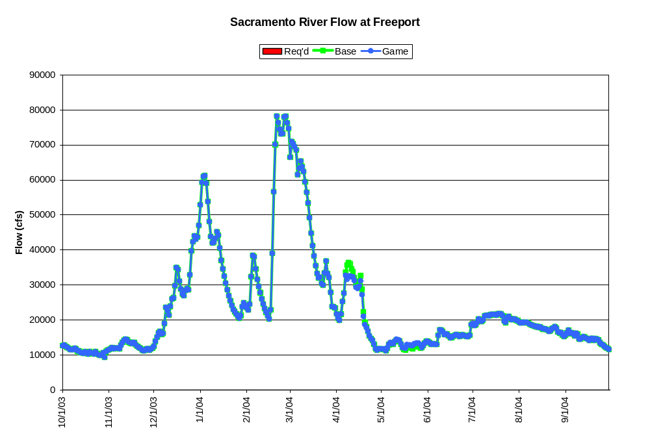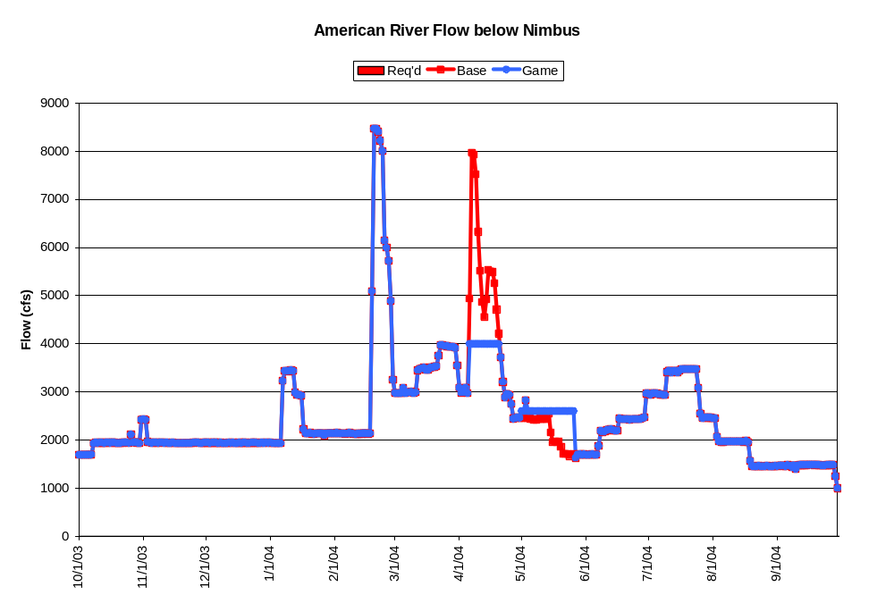 Figures 3a and 3b. Sacramento River Delta inflow and American River flow changes due to actions taken in Game 1.3 for water years 2003-04.
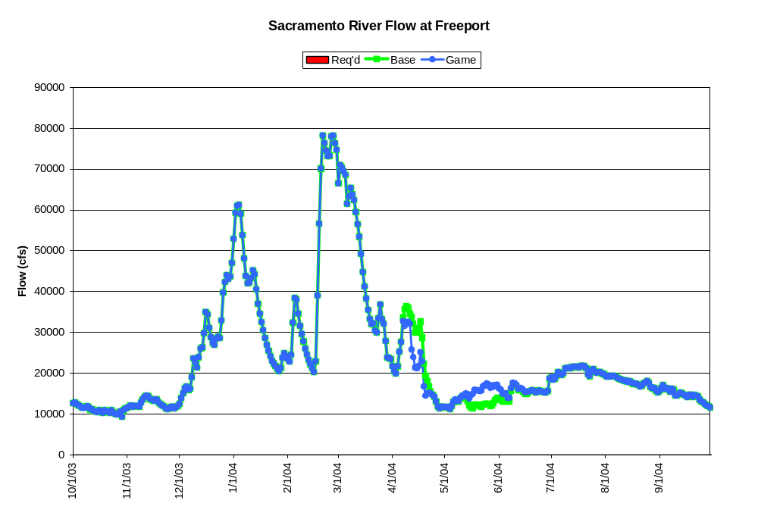 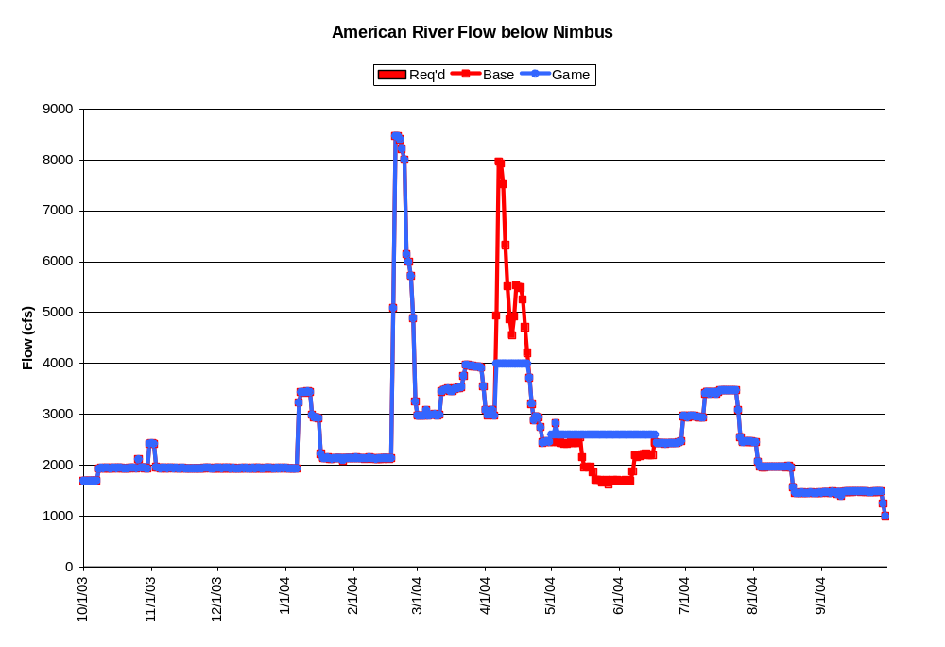 Figures 4a and 4b. Sacramento River Delta inflow and American River flow changes due to actions taken in Game 2.1 for water year 2004.
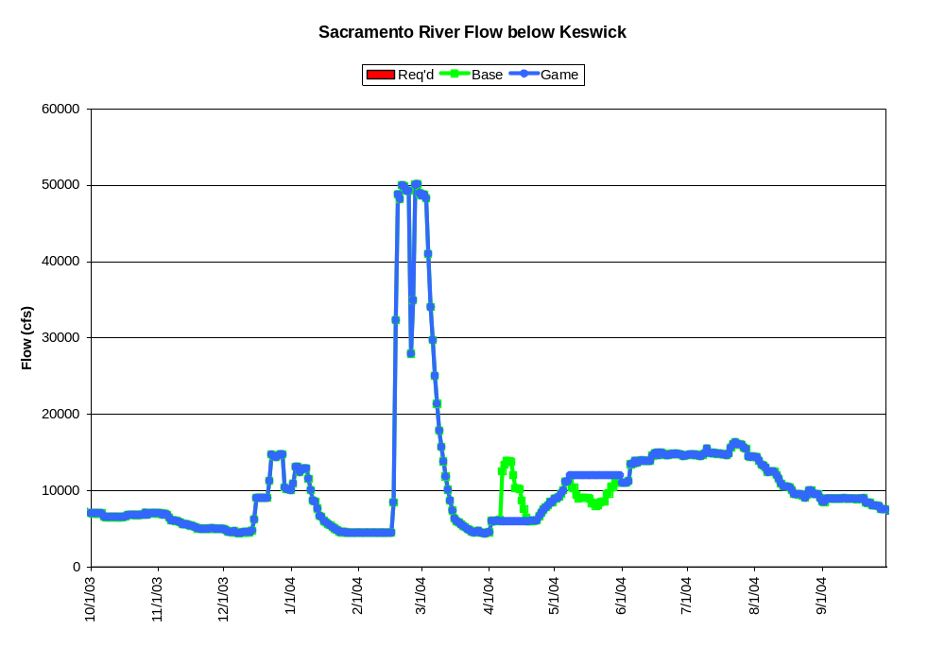 Figures 4c.Sacramento River below Keswick flow changes due to actions taken in Game 2.1 for water year 2004.
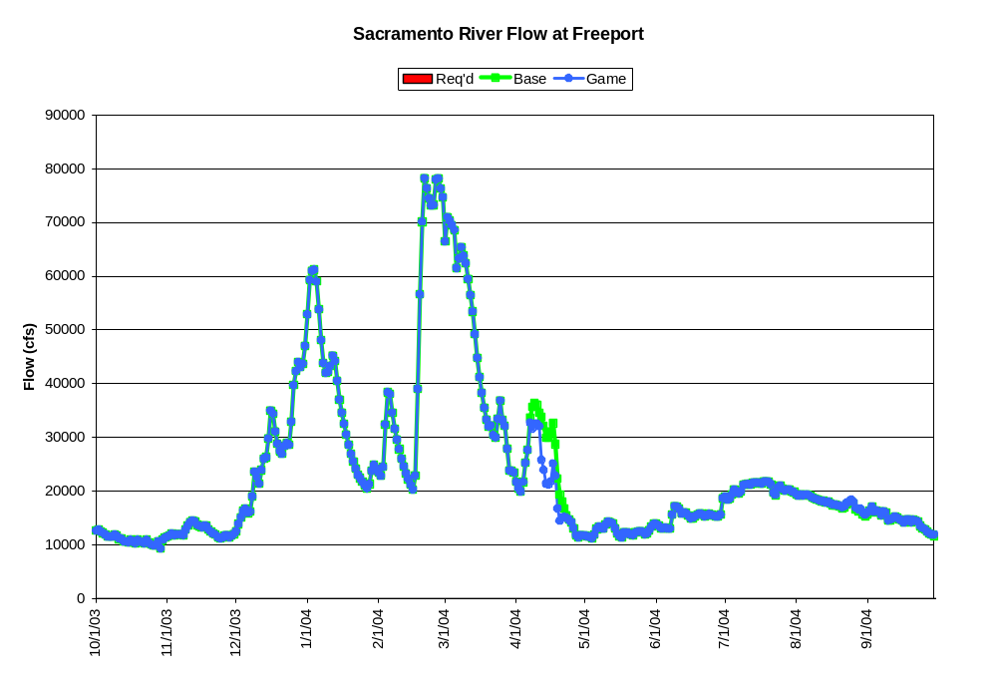 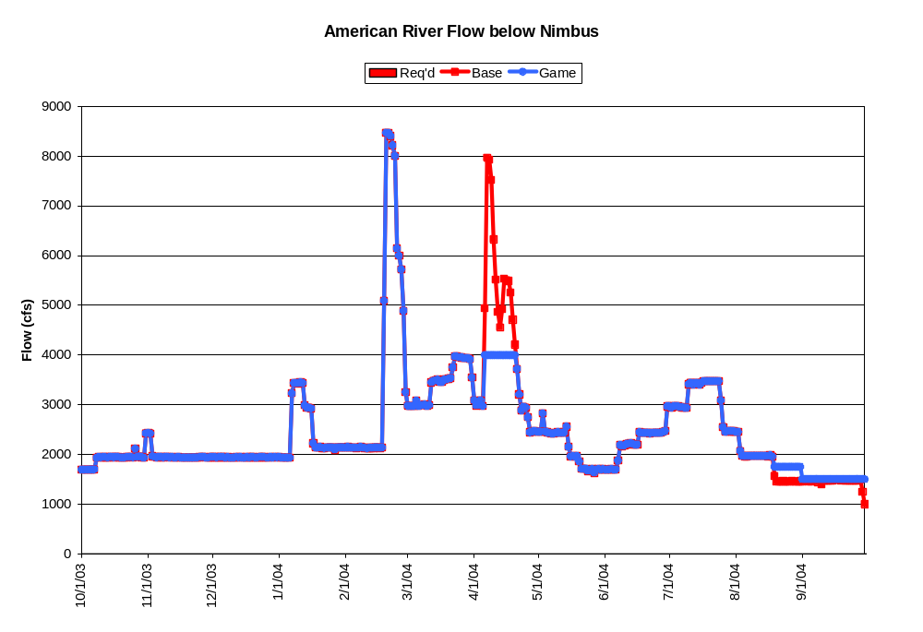 Figures 5a and 5b. Sacramento River Delta inflow and American River flow changes due to actions taken in Game 2.2 for water years 2003-04.
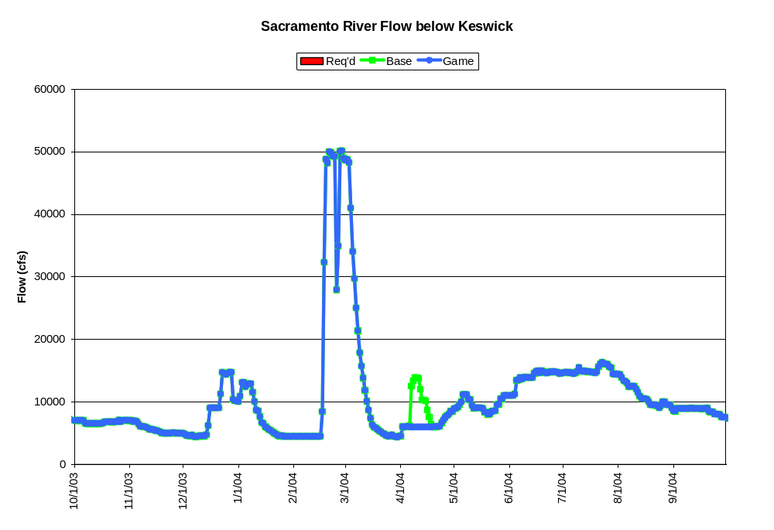 Figures 5c.Sacramento River below Keswick flow changes due to actions taken in Game 2.2 for water year 2004 (summer/fall.releases for exports not simulated)..
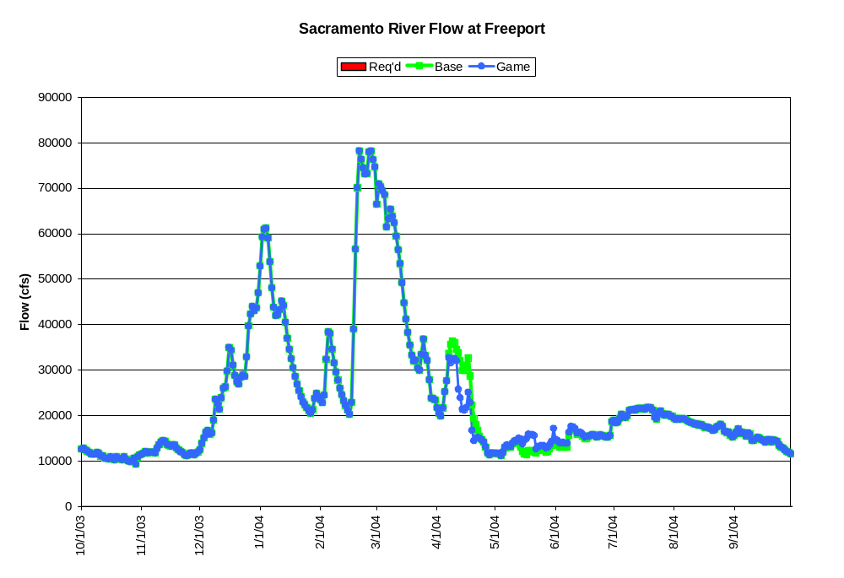 Figures 6a and 6b. Sacramento River Delta inflow and American River flow changes due to actions taken in Game 2.3 for water years 2003-04.
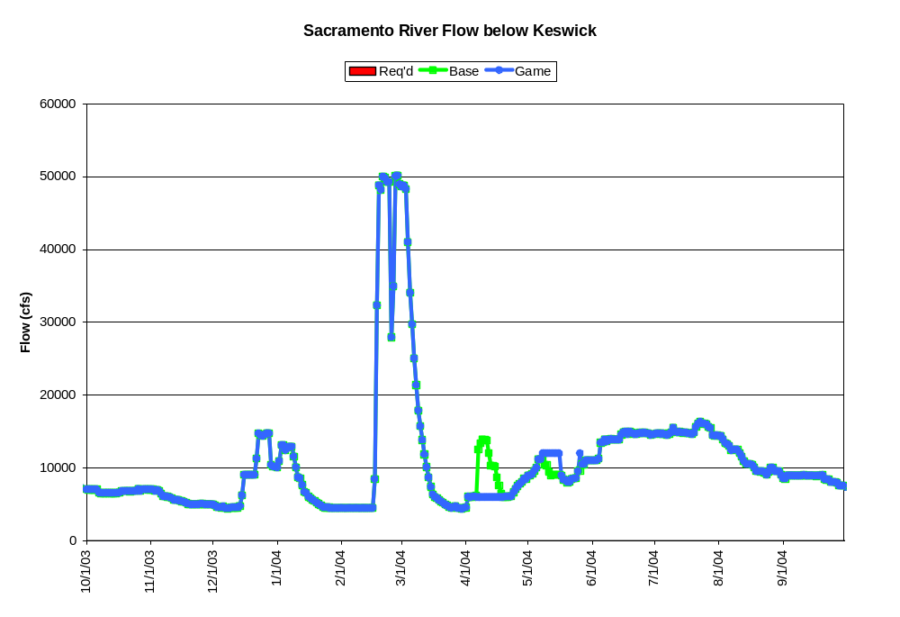 Figures 6c.Sacramento River below Keswick flow changes due to actions taken in Game 2.3 for water years 2003-04 (summer/fall.releases for exports not simulated)..
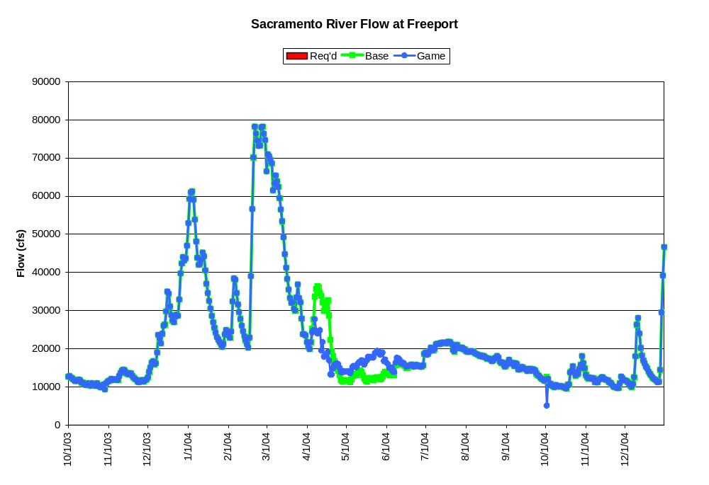 Figures 7a and 7b. Sacramento River Delta inflow and American River flow changes due to actions taken in Game 3.1 for water years 2003-04.
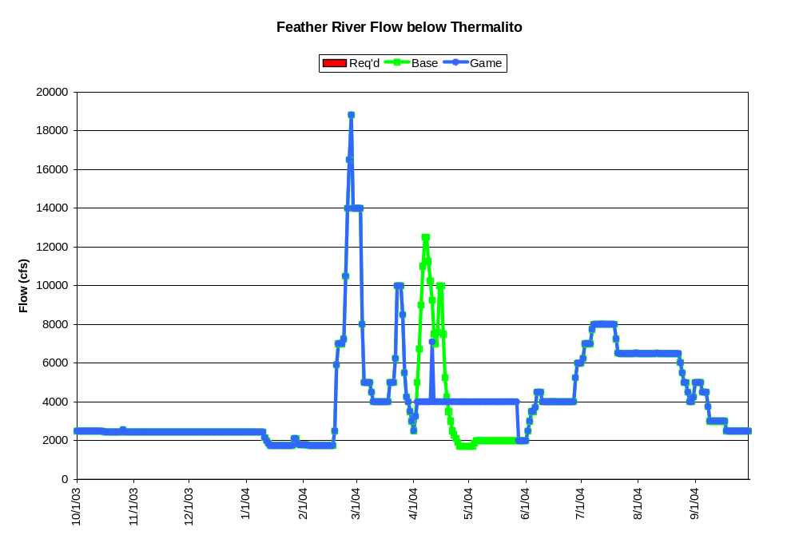 Figures 7c and 7d.Sacramento River below Keswick and Feather River below Thermalito flow changes due to actions taken in Game 3.1 for water years 2003-04.
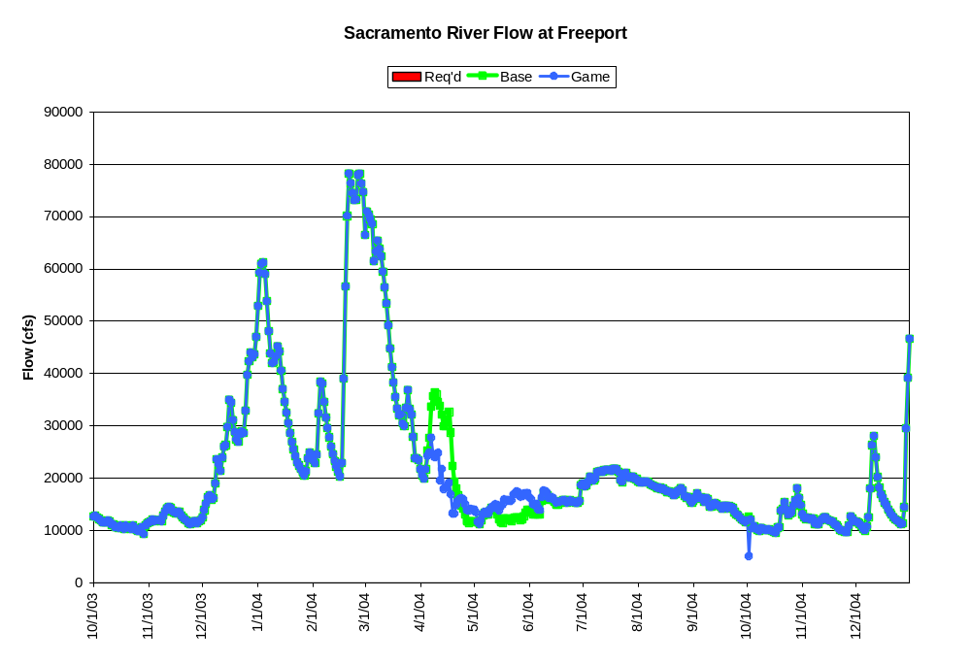 Figures 8a and 8b. Sacramento River Delta inflow and American River flow changes due to actions taken in Game 3.3 for water years 2003-04.
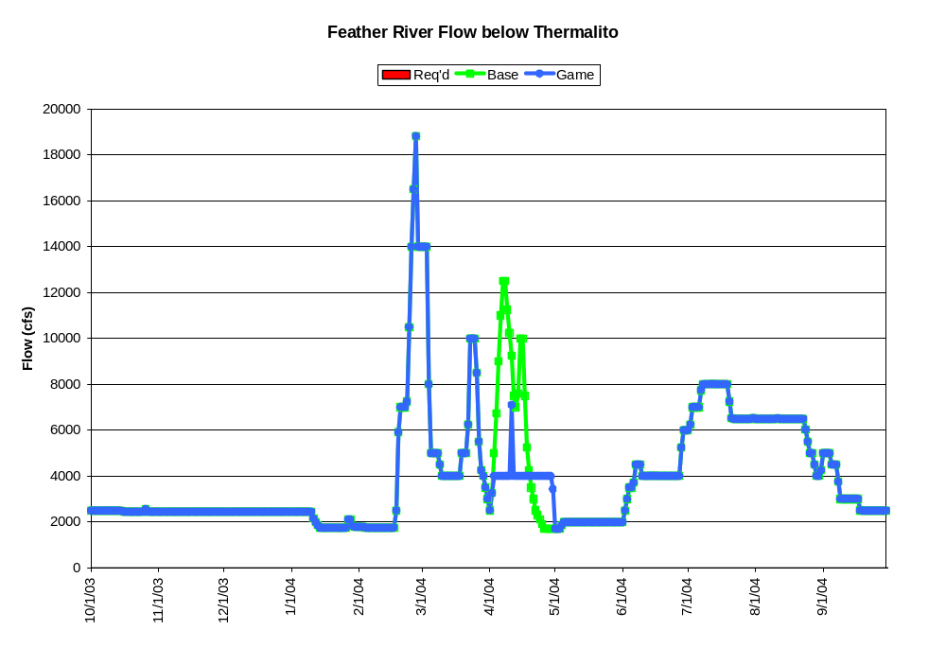 Figures 8c and 8d.Sacramento River below Keswick and Feather River below Thermalito flow changes due to actions taken in Game 3.3 for water years 2003-04.

